# CS 499 Module One Assignment Template

Complete this template by replacing the bracketed text with the relevant information.

1. **Self-Introduction:** Address all of the following questions to introduce yourself.
   1. How long have you been in the Computer Science program?

I am pursuing my bachelor degree near to 2 years.

* 1. What have you learned while in the program? List three of the most important concepts or skills you have learned.

1. "Programming languages such as Java and Python"
2. "Understanding of algorithms and data structures"
3. "Experience with software development life cycles"
   1. Discuss the specific skills you aim to demonstrate through your enhancements to reach each of the course outcomes.

Specific Skills in UI Design

Usability and Accessibility Improvements:

Skill Description: Enhance the usability and accessibility of software applications to ensure they can be effectively used by a diverse range of users, including those with disabilities. This includes implementing responsive design principles, color contrast adjustments for better visibility, and navigation improvements for ease of use.

Course Outcome Alignment: This skill directly supports the outcome of designing computing solutions that manage trade-offs involved in design choices, as well as ensuring that applications are accessible and usable by diverse audiences.

Visual Design and Aesthetics:

Skill Description: Apply principles of visual design including layout, color theory, typography, and user feedback cues to create aesthetically pleasing and functionally clear interfaces. This involves using design tools and software to create mock-ups and prototypes before implementation.

Course Outcome Alignment: Improving the visual aspect of interfaces contributes to the delivery of professional-quality communications that are technically sound and adapted to specific audiences—aligning with course outcomes related to effective communication and audience-centric design.

Interaction Design and User Experience (UX):

Skill Description: Develop interactive elements and improve overall user experience by creating intuitive navigation and simplifying complex processes. This includes the use of animations, transitions, and consistent design patterns to guide user behavior throughout the application.

Course Outcome Alignment: This skill demonstrates the ability to design and evaluate computing solutions based on algorithmic principles and standards, focusing on how users interact with the software, thereby optimizing user satisfaction and engagement.

Prototyping and Testing:

Skill Description: Create iterative prototypes and conduct user testing sessions to gather feedback and refine the interface. Use tools for creating high-fidelity prototypes that simulate the final product, and apply testing methodologies to ensure the interface meets user requirements.

Course Outcome Alignment: Prototyping and testing are crucial in software testing, automation, and quality assurance. This skill aligns with the course outcomes related to implementing computer solutions that are thoroughly tested and reviewed, ensuring reliability and functionality.

Cross-Platform Consistency:

Skill Description: Ensure that UI designs are consistent across different platforms and devices. This involves adapting layouts and features to fit various screen sizes and operating systems without compromising on functionality or aesthetic.

Course Outcome Alignment: This skill supports the course outcome of developing computing solutions that accomplish industry-specific goals, acknowledging the diverse environments in which software operates today.

By focusing on these skills and clearly describing how they contribute to achieving the course outcomes, I establish a strong linkage between my practical enhancements and the theoretical objectives of the course. This approach not only demonstrates my technical abilities but also highlights my understanding of the broader impact of UI design in the field of computer science.

* 1. How do the specific skills you will demonstrate align with your career plans related to your degree?

As a QA analyst with a background in automation testing, demonstrating specific skills in this area aligns strongly with both my immediate job functions and my broader career aspirations within the field of computer science and quality assurance. Here’s how these skills can play a crucial role:

1. Automation Testing Skills:

Career Relevance: Automation is a cornerstone in modern QA processes, significantly enhancing testing efficiency and accuracy. By demonstrating proficiency in automation testing, you are directly contributing to your core responsibilities as a QA analyst. This skill set helps in designing and implementing automated test scripts that reduce manual effort, increase coverage, and accelerate testing cycles, thus improving the overall product quality and release speed.

2. Scripting and Programming Proficiencies:

Career Relevance: Proficiency in scripting languages (like Python, JavaScript, or Ruby) and testing frameworks (such as Selenium, TestNG, or Cucumber) is crucial for creating effective automation scripts. These technical skills are essential for a QA analyst to build robust, repeatable, and scalable test automation solutions that can handle complex test scenarios and integrate with continuous integration/continuous deployment (CI/CD) pipelines.

3. Understanding of Software Development Life Cycle (SDLC):

Career Relevance: A deep understanding of the SDLC, including Agile methodologies, enhances your ability to integrate testing phases effectively into the development process. This knowledge ensures that you can advocate for best practices in test-driven development (TDD) and behavior-driven development (BDD), crucial for early bug detection and reducing the cost of fixing defects.

4. Continuous Integration and Continuous Deployment (CI/CD):

Career Relevance: Knowledge and experience with CI/CD pipelines are essential for modern QA practices. Being skilled in integrating automated tests into CI/CD pipelines aligns with the industry trend towards DevOps and agile methodologies, where rapid deployment cycles and high reliability are critical. This capability allows you to contribute significantly to the efficiency and effectiveness of the development process in your role.

5. Problem-Solving and Analytical Skills:

Career Relevance: Effective problem-solving skills in identifying, analyzing, and resolving software bugs and bottlenecks in test scripts are central to the QA role. These skills ensure that you can maintain high-quality standards and contribute to the overall stability and performance of the software products.

6. Communication and Collaboration:

Career Relevance: The ability to communicate clearly with development teams, product managers, and other stakeholders about testing strategies, results, and recommendations is crucial. This skill enhances team synergy and ensures that testing insights are effectively incorporated into the development process, leading to better product outcomes.

* 1. How does this contribute to the specialization you are targeting for your career?

1. Advanced Automation Testing Capabilities:

Specialization Contribution: Mastering automation testing tools and frameworks like Selenium, Appium, or Jenkins places you at the forefront of the QA field. Specializing in automation testing prepares you to handle complex, scalable testing environments that are crucial for modern, agile-driven software development processes. This specialization is highly valued as it directly impacts the efficiency and reliability of software products.

2. Programming and Scripting Skills:

Specialization Contribution: Skills in scripting languages (e.g., Python, JavaScript) necessary for writing test scripts are essential for advanced QA roles. This expertise not only helps in creating and maintaining tests but also in understanding the codebase, which is crucial for effective testing and debugging. It enables you to create more sophisticated, dynamic tests and contributes to your ability to work closely with development teams.

3. CI/CD Integration:

Specialization Contribution: Proficiency in integrating automated tests into CI/CD pipelines is a critical component of modern DevOps practices. Specializing in this area allows you to facilitate faster, more frequent releases with assured quality, making it a key skill for companies aiming to improve their deployment cycles and responsiveness to market changes.

4. Quality Assurance Strategy and Planning:

Specialization Contribution: Developing a strategic approach to QA, including test planning, test case design, and the implementation of testing methodologies, positions you as a leader in ensuring software quality. This contributes to a deeper understanding of quality from a business perspective, helping to align testing processes with organizational goals.

5. Security and Performance Testing:

Specialization Contribution: As software systems become increasingly complex, the demand for specialists in security and performance testing grows. Skills in these areas allow you to contribute to the robustness and user satisfaction of software products, areas that are often critical in user retention and business success.

6. Data Analysis and Metrics:

Specialization Contribution: Skills in analyzing testing data and metrics to derive actionable insights about software quality and testing efficiency are crucial. This analytical capability helps optimize testing processes and improves the overall software development lifecycle, aligning with the goals of organizations focused on data-driven decision-making.

1. **ePortfolio Set Up:**
   1. Submit a **screen capture** of your ePortfolio home page that clearly shows your URL.
      1. You already have a repository in GitHub where you uploaded projects in previous courses. Your ePortfolio will reside in GitHub but can link to work at other sites, such as Bitbucket.
   2. Use the GitHub Pages link in the Resource section for directions on:
      1. How to create your GitHub website and publish code to GitHub Pages
      2. Issues, such as adding links to other sites
   3. Paste a screenshot of your GitHub Homepage with your URL clearly showing in the space below.

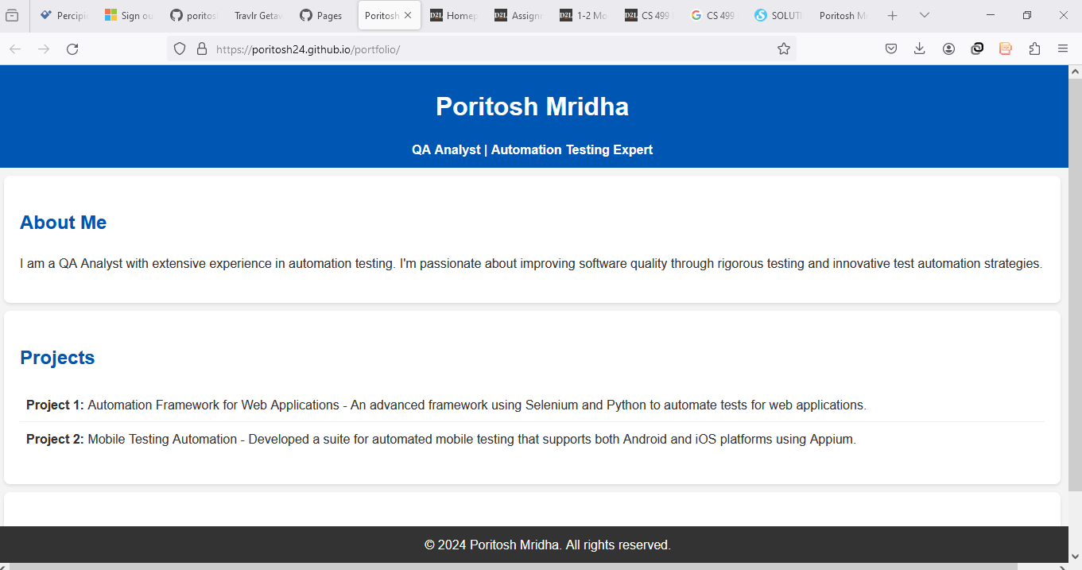

**Updated Screenshot:**

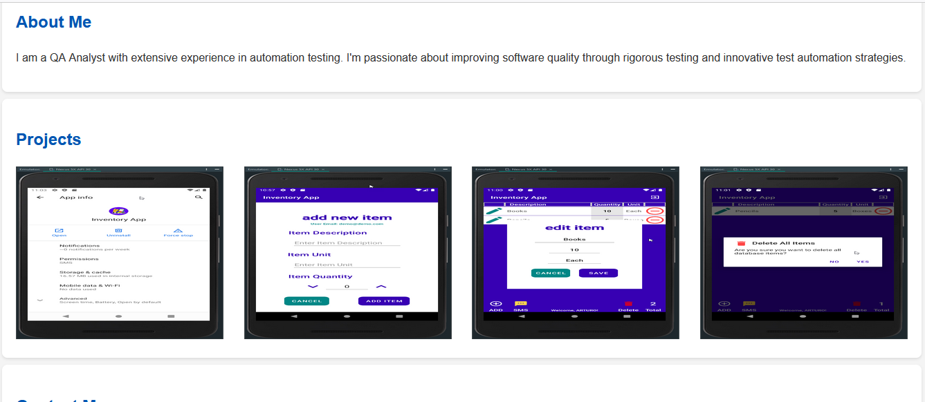

1. **Enhancement Plan:** 
   1. **Category One:** Software Engineering and Design
      1. **Select an** **artifact** that is **aligned with** **the** software engineering and design **category** and explain its origin. Submit a file containing the code for the artifact you choose with your enhancement plan.

Artifact: Inventory App – Android Mobile App

Origin: CS360 Mobile Architecture and Programming

Description: This is an Android mobile app developed as part of the CS360 course. The app allows users to manage an inventory by adding, viewing, and deleting items. However, the current implementation has limitations, such as the inability to add more than one item in the ItemActivity list and a lack of login capabilities.

Note: Your artifact may be work from the following courses:

* IT 145: Foundation in Application Development
* CS 250: Software Development Lifecycle
* CS 260: Data Structures and Algorithms
* IT 315: Object Oriented Analysis and Design
* CS 320: Software Testing, Automation, and Quality Assurance
* CS 330: Computational Graphics and Visualization
* CS 340: Advanced Programming Concepts
* CS 350: Emerging Systems Architectures and Technologies
* CS 360: Mobile Architecture and Programming
* IT 365: Operating Environments
* IT 380: Cybersecurity and Information Assurance
* CS 405: Secure Coding
* CS 410: Reverse Software engineering
* IT 340: Network and Telecommunication Management
* IT 380: Cybersecurity and Information Assurance
  + 1. **Describe** a practical, well-illustrated **plan** for enhancement in alignment with the category, including a pseudocode or flowchart that illustrates the planned enhancement.

Enhancement Plan:

Database CRUD Functionality: Improve the database operations to support creating, reading, updating, and deleting (CRUD) multiple items.

Pseudocode:

function addItem(item):

connect to database

insert item into items table

close connection

function updateItem(itemId, newItemDetails):

connect to database

update item in items table where itemId = newItemDetails.itemId

close connection

function deleteItem(itemId):

connect to database

delete from items table where itemId = itemId

close connection

function deleteAllItems():

connect to database

delete from items table

close connection

Login and Password Recovery: Implement a login activity with the ability to recover forgotten passwords.

Pseudocode:

function login(username, password):

connect to database

query user table where username = username and password = password

if user exists:

return login success

else:

return login failure

close connection

function recoverPassword(email):

connect to database

query user table where email = email

if email exists:

send recovery email to user

return success

else:

return failure

close connection

Item Management in ItemActivity: Enhance the ItemActivity to support adding, editing, and deleting multiple items.

Pseudocode:

function displayItems():

connect to database

query all items from items table

display items in list view

close connection

function addItemButtonClicked():

get item details from user

addItem(item)

refresh item list

function editItemButtonClicked(itemId):

get new item details from user

updateItem(itemId, newItemDetails)

refresh item list

function deleteItemButtonClicked(itemId):

deleteItem(itemId)

refresh item list

function deleteAllItemsButtonClicked():

deleteAllItems()

refresh item list

For this category of enhancement, consider improving a piece of software, transferring a project into a different language, reverse engineering a piece of software for a different operating system, or expanding a project’s complexity. These are just recommendations. Consider being creative and proposing an alternative enhancement to your instructor.

Think about what additions to include to complete the enhancement criteria in this category. Since one example option is to port to a new language, that is the kind of scale that is expected. This does not mean you need to port to a new language but instead have an equivalent scale of enhancement. Underlying expectations of any enhancement include fixing errors, debugging, and cleaning up comments, but these are not enhancements themselves.

* + 1. Explain how the planned enhancement will **demonstrate** specific **skills** and align with course outcomes.
       1. Identify and describe the specific skills you will demonstrate that align with the course outcome.

Database Management: By improving the CRUD functionality, I will demonstrate skills in managing SQLite databases, ensuring efficient data handling.

User Authentication: Implementing the login and password recovery features will showcase my ability to handle user authentication securely.

Android Development: Enhancing the ItemActivity will illustrate my proficiency in Android development, particularly in creating dynamic and interactive user interfaces.

* + - 1. Select one or more of the course outcomes below that your enhancement will align with.

[CS-499-03] Design and evaluate computing solutions that solve a given problem using algorithmic principles and computer science practices and standards appropriate to its solution while managing the trade-offs involved in design choices.

[CS-499-04] Demonstrate an ability to use well-founded and innovative techniques, skills, and tools in computing practices to implement computer solutions that deliver value and accomplish industry-specific goals.

Course Outcomes:

* Employ strategies for building collaborative environments that enable diverse audiences to support organizational decision-making in the field of computer science.
* Design, develop, and deliver professional-quality oral, written, and visual communications that are coherent, technically sound, and appropriately adapted to specific audiences and contexts.
* Design and evaluate computing solutions that solve a given problem using algorithmic principles and computer science practices and standards appropriate to its solution while managing the trade-offs involved in design choices.
* Demonstrate an ability to use well-founded and innovative techniques, skills, and tools in computing practices for the purpose of implementing computer solutions that deliver value and accomplish industry-specific goals.
* Develop a security mindset that anticipates adversarial exploits in software architecture and designs to expose potential vulnerabilities, mitigate design flaws, and ensure privacy and enhanced security of data and resources.
  1. **Category Two:** Algorithms and Data Structures

1. **Select an artifact** that is **aligned with the** algorithms and data structures **category** and explain its origin. Submit a file containing the code for the artifact you choose with your enhancement plan. You may choose work from the courses listed under Category One.

Artifact: Authentication and Monitoring System

Origin: IT145 Foundation in Application Development

Description: This system was developed to authenticate users and monitor activities within a specific environment. The current implementation is basic and runs in a terminal console.

1. **Describe** a practical, well-illustrated **plan** for enhancement in alignment with the category, including a pseudocode or flowchart that illustrates the planned enhancement.

Enhancement Plan:

Implement a Dashboard: Add a graphical user interface (GUI) for a monitoring dashboard.

Pseudocode:

function displayDashboard(user):

if user.isAuthenticated():

show dashboard

else:

show login screen

function monitorActivities():

connect to database

fetch activity data

display data in dashboard

close connection

Authentication and Authorization: Enhance the authentication system to differentiate user roles and access levels.

Pseudocode:

function authenticateUser(username, password):

connect to database

query user table where username = username and password = password

if user exists:

if user.role == 'admin':

grant admin access

else if user.role == 'user':

grant user access

else:

deny access

close connection

Activity Logging: Add functionality to log user activities and display them on the dashboard.

Pseudocode:

function logActivity(user, activity):

connect to database

insert activity into activity_log table with user details

close connection

function displayActivityLog():

connect to database

query all activities from activity_log table

display activities in dashboard

close connection

For this category of enhancement, consider improving the efficiency of a project or expanding the complexity of the use of data structures and algorithms for your artifact. These are just recommendations. Consider being creative and proposing an alternative enhancement to your instructor. Note: You only need to choose one type of enhancement per category.

Think about what additions to include to complete the enhancement criteria in this category. Since one example option is to port to a new language, that is the kind of scale that is expected. Perhaps you might increase the efficiency and time complexity of an algorithm in an application and detail the logic of the increased time complexity. Remember, you do not need to port to a new language but instead have an equivalent scale of enhancement. Underlying expectations of any enhancement include fixing errors, debugging, and cleaning up comments, but these are not enhancements themselves.

1. Explain how the planned enhancement will **demonstrate** specific **skills** and align with course outcomes.
   1. Identify and describe the specific skills you will demonstrate to align with the course outcome.

Algorithm Design: Enhancing authentication and authorization will show my ability to design efficient algorithms for security.

Data Structures: Implementing activity logging will demonstrate my understanding of data structures to store and retrieve user activities effectively.

GUI Development: Developing a dashboard will illustrate my skills in creating user-friendly interfaces using appropriate tools and frameworks.

* 1. Select one or more of the course outcomes listed under Category One that your enhancement will align with.

[CS-499-01] Employ strategies for building collaborative environments that enable diverse audiences to support organizational decision-making in the field of computer science.

[CS-499-05] Develop a security mindset that anticipates adversarial exploits in software architecture and designs to expose potential vulnerabilities, mitigate design flaws, and ensure privacy and enhanced security of data and resources.

* 1. **Category Three: Databases**
     1. **Select an artifact** that is **aligned with the** databases **category** and explain its origin. Submit a file containing the code for the artifact you choose with your enhancement plan. You may choose work from the courses listed under Category One.

Artifact: Salvare Search for Rescue App

Origin: CS340 Client/Server Development

Description: This app was created to facilitate search and rescue operations. It involves a client-server architecture using Python and MongoDB.

* + 1. **Describe** a practical, well-illustrated **plan** for enhancement in alignment with the category, including a pseudocode or flowchart that illustrates the planned enhancement.

Enhancement Plan:

Local Environment Setup: Reproduce the application on a local machine.

Pseudocode:

setup local environment:

install Python

install MongoDB

clone repository from Apporto platform

configure local settings

Improve Dashboard GUI: Refine the graphical user interface of the dashboard.

Pseudocode:

function enhanceDashboard():

redesign layout using Dash framework

add visual elements for better user experience

integrate with MongoDB to fetch and display data

Documentation: Update documentation for easier implementation on different environments.

Pseudocode:

function updateDocumentation():

detail environment setup steps

provide configuration guidelines

explain code structure and functionality

For this category of enhancement, consider adding more advanced concepts of MySQL, incorporating data mining, creating a MongoDB interface with HTML/JavaScript, or building a full stack with a different programming language for your artifact. These are just recommendations; consider being creative and proposing an alternative enhancement to your instructor. Note: You only need to choose one type of enhancement per category.

Think about what additions to include to complete the enhancement criteria in this category. Since one example option is to port to a new language, that is the kind of scale that is expected. Perhaps you might increase the efficiency and time complexity of an algorithm in an application and detail the logic of the increased time complexity. Remember, you do not need to port to a new language but instead have an equivalent scale of enhancement. Underlying expectations of any enhancement include fixing errors, debugging, and cleaning up comments, but these are not enhancements themselves.

* + 1. Explain how the planned enhancement will **demonstrate** specific **skills** and align with course outcomes.
       1. Identify and describe the specific skills you will demonstrate that align with the course outcome.

Database Management: Demonstrating the use of MongoDB and Python integration will showcase my database management skills.

GUI Development: Enhancing the dashboard will illustrate my ability to create effective user interfaces.

Documentation: Updating the documentation will show my ability to produce clear and comprehensive technical documents.

* + - 1. Select one or more of the course outcomes listed under Category One that your enhancement will align with.

[CS-499-03] Design and evaluate computing solutions that solve a given problem using algorithmic principles and computer science practices and standards appropriate to its solution while managing the trade-offs involved in design choices.

[CS-499-04] Demonstrate an ability to use well-founded and innovative techniques, skills, and tools in computing practices to implement computer solutions that deliver value and accomplish industry-specific goals.

1. **ePortfolio Overall Skill Set**
   1. Accurately describe the **skill set** to be illustrated by the **ePortfolio** **overall**.
      1. Skills and outcomes planned to be illustrated in the code review

Secure Coding Practices: Ensuring code security from the initiation phase to reduce vulnerabilities.

Code Optimization: Enhancing code structure, style, and performance.

Debugging and Testing: Identifying and correcting errors to improve functionality.

* + 1. Skills and outcomes planned to be illustrated in the narratives

Software Development Lifecycle: Applying SDLC concepts to plan and execute enhancements.

Collaboration: Building collaborative environments for better decision-making.

Security Mindset: Anticipating and mitigating security risks in software design.

* + 1. Skills and outcomes planned to be illustrated in the professional self-assessment

Motivation and Organization: Demonstrating a strong motivation to excel in computer science and an organized approach to learning.

Programming Proficiency: Showcasing proficiency in multiple programming languages and development tools.

Problem-Solving: Highlighting natural skills in solving logical problems and implementing industry best practices.