MODULE 3-2 MILESTONE TWO: ENHANCEMENT ONE: SOFTWARE DESIGN AND ENGINEERING

CS-499 Computer Science Capstone

Southern New Hampshire University

Submitted By:

Poritosh Mridha

May 1, 2024

This document is a narrative that accompanies the improvements made to the software design and engineering artifact. It elucidates why this specific artifact was chosen for inclusion in this category of our ePortfolio and reflects on the creation process. The narrative emphasizes the learning experiences gained during the artifact's development (Southern New Hampshire University, 2024).

**Prompt**

The artifact chosen for the software design and engineering category is the mobile application Inventory App. This app aims to track an inventory of items using Android mobile devices. The software was planned, designed, and developed as part of the CS360 Mobile Architecture and Programming course in the computer science curriculum. The application was created using the JAVA programming language and integrated with the SQLite relational database. The development and programming tool utilized was the Android Studio IDE, and the app was tested and run using a Nexus device emulator within Android Studio.

This artifact involved a comprehensive software design and engineering process. It includes design considerations for user experience and user interaction across various screens and actions within the application. Ensuring the intuitive use of the application and its features was achieved through the use of industry-standard icons and symbols. Engineering practices such as validating input data, designing with a security mindset, and implementing a default deny policy were employed. The process involved design and engineering considerations regarding the relationships and functionalities of algorithms and data structures between different classes and methods, as well as the database layouts and source code. A relational database was used to store the data that users created, read, updated, and deleted during the application's operation and use.

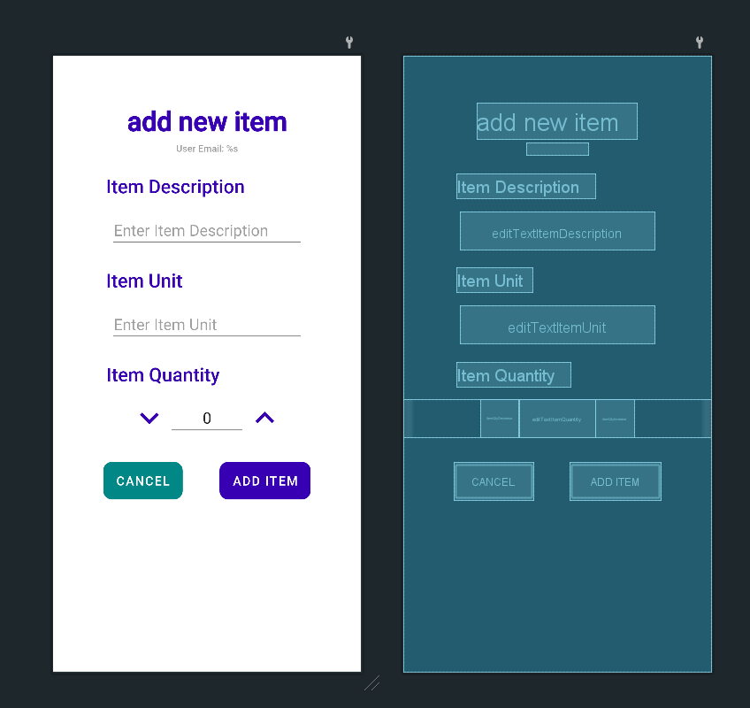

*Figure 1 Design of Add Item Activity Layout*

Through the design and development of the mobile application, we demonstrate our proficiency in software design, addressing and interpreting user needs, and integrating these requirements into a cohesive structure of related activities. Our approach involves creating programs that merge the presentation and layout aspects of the user interface with the application’s programmatic elements.

Significant enhancements to the artifact made the application fully functional by incorporating complete CRUD functionality for items and refining the functionality, structure, and efficiency of the SQLHelper class functions and methods. These enhancements ensure we meet the objective of designing and evaluating computing solutions that address specific problems using algorithmic principles and computer science practices, adhering to relevant standards while managing the trade-offs inherent in design choices.

We adhere to mobile development principles and best practices, utilizing user-centered design principles and industry standards throughout the application's development. Applying user-centered design principles highlights our capability to employ well-established and innovative techniques, skills, and tools in computing to implement solutions that provide value and meet industry-specific goals. We also implement and practice quality assurance techniques effective in identifying and mitigating vulnerabilities.

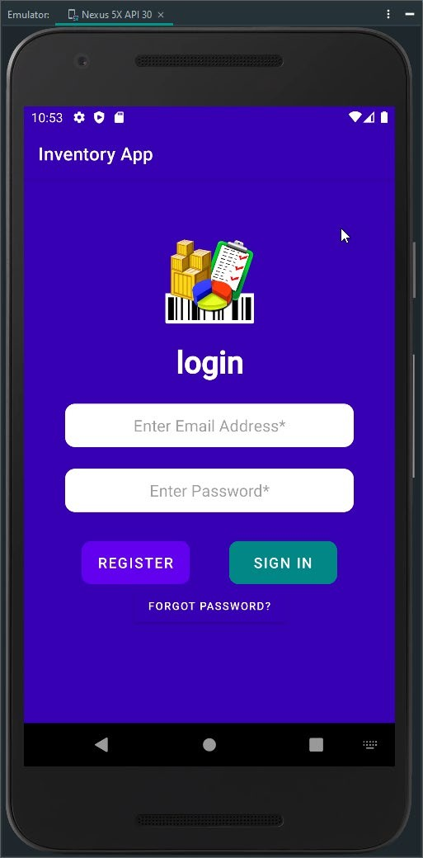 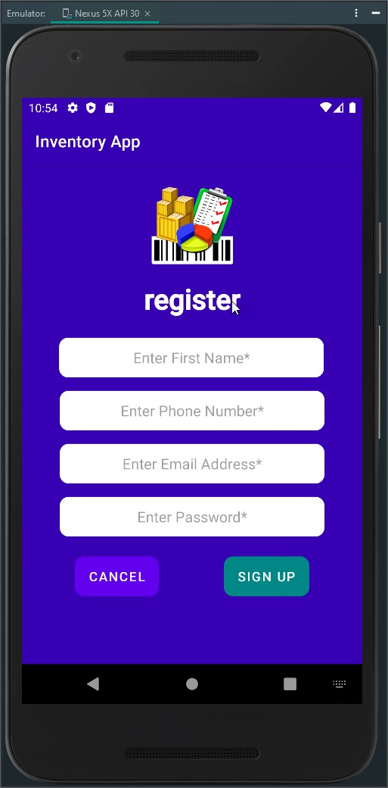

*Figure 2 Login Activity and Register Activity Screenshot*

We authenticated users based on their name, phone number, and email as part of their credentials, and implemented a mechanism for password recovery in case of forgetfulness, demonstrating our commitment to a zero-trust security ethic. This highlights our security-first mindset throughout the development process, where we proactively anticipate potential adversarial exploits within the software architecture and design to uncover vulnerabilities, mitigate design flaws, and ensure the privacy and security of data and resources.

We incorporate security measures from the initiation phase through to product assurance, testing, and compatibility checks throughout the entire software development life cycle. We adhere to secure coding standards relevant to the target development language and platform, ensuring robust security practices are maintained at every stage.

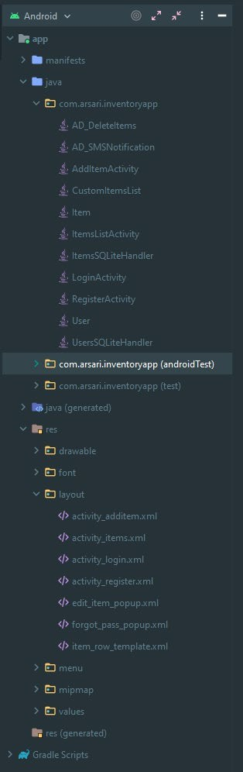 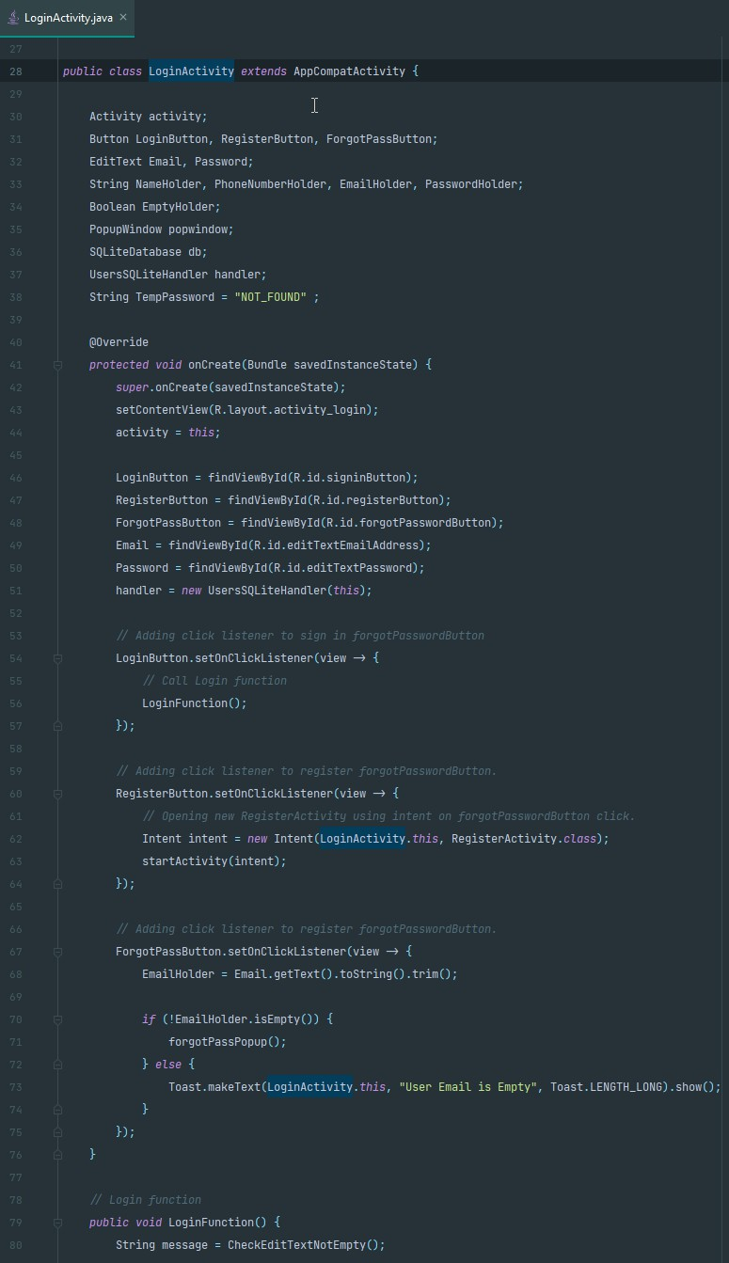

*Figure 3 JAVA Files Structure and Sample of Coding Formatting*

We adhere to industry-standard Java code best practices and techniques, including in-line comments, appropriate naming conventions, formatting, and indentation in alignment with proper coding standards, which makes the code more readable and enhances the organization of the application code. Global variables are identified with camelCase CapWords names, while method scope variables are identified with camelCase lowercase names or lowercase dash_names. Java class files are named using camelCase CapWords, and layout files are named with lowercase names. Whenever possible, class method names reflect the method's purpose and action. Comment statements in the code provide summaries of the class and method functionalities. Methods that override those from their superclass are named using camelCase with an initial lowercase word, whereas methods that do not override superclass methods are named using camelCase with CapWords.

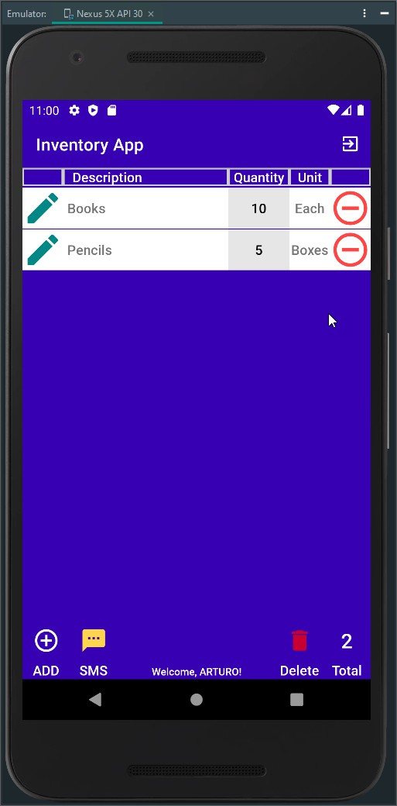 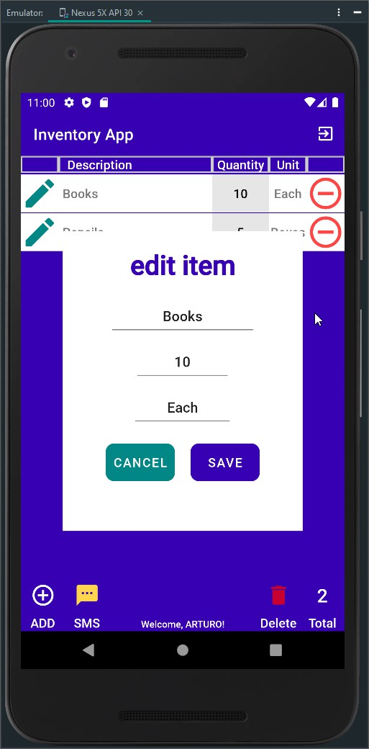

*Figure 4 Items Activity List and Item Edit Feature Screenshot*

As a designer and engineer, I begin by planning and programming the purpose of my idea and identifying my target audience. Each audience is unique, and it is crucial to understand and incorporate their needs into the development process, prioritizing the most important or desired features first. This approach is akin to ranking tasks to be included in the app at its initial launch. It is essential to examine competitive apps and analyze their design strategies to address the UI/UX for our app and how they implement similar features. Therefore, researching the app store or the internet to find comparable apps to our concept is a vital step in the development process.

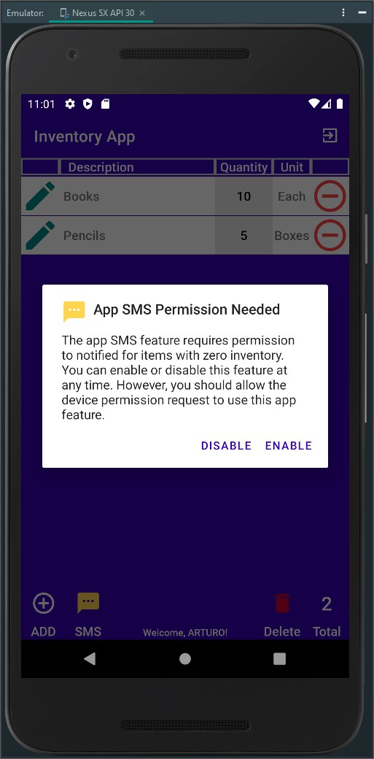 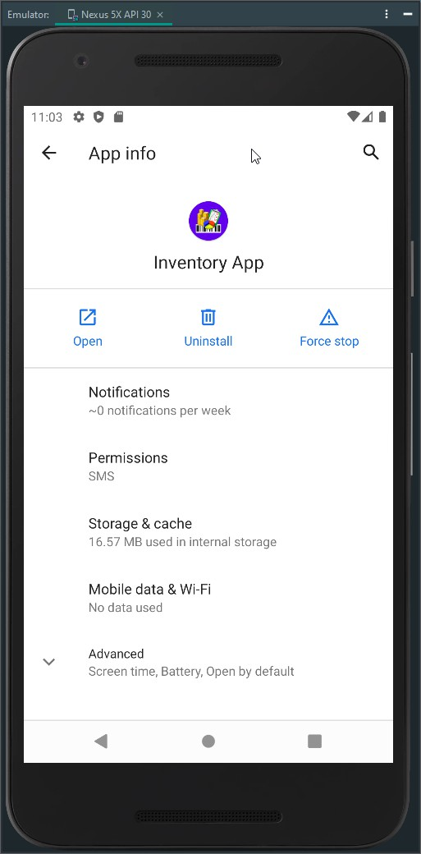

*Figure 5 SMS Alert Dialog and App Info Screenshot*

There is extensive information on the mobile application design process, and understanding this process is essential to producing a high-quality app that will be well-received by our target audience. It is impractical to think that one person can create an excellent application alone. Throughout the entire app design and development process, from initial planning to finalization, it is vital to seek assistance to understand our strengths and weaknesses. To achieve success, we must build a collaborative team that can help us comprehend and implement best practices in mobile app development. Our focus should be on integrating design components and programmatic code, continuously seeking opportunities to improve and innovate the mobile app to address challenges effectively.