Customer: Clinent, who gets service by vendor.
Vendor: Service center owner.
Employee: He actually handles service of customers.
Admin: He has an authority to ADD and DELETE Vendors.

Customer:

left to right direction
Customer-->(login)
Customer-->(Register)
Customer-->(Servicing Task)
Customer-->(Invoice)
Customer-->(Feedback)

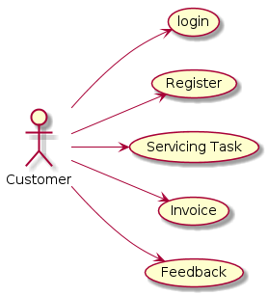

Vendor:

left to right direction
vendor-->(login)
vendor-->(New customer Registration)
vendor-->(Customer Search)
vendor-->(Servicing Task)
vendor-->(Job Assignment)
vendor-->(Invoice Generation)
vendor-->(Employee Management)

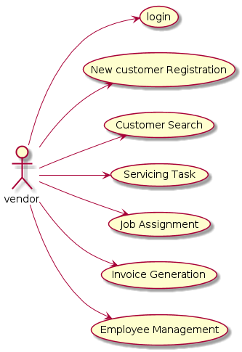

Employee:

left to right direction
Employee-->(login)
Employee-->(Register)
Employee-->(Update Process)
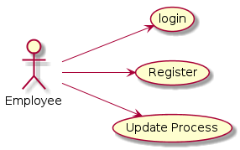

Admin:

left to right direction
Admin-->(login)
Admin-->(Vendor Managvement)
Admin-->(Employee Management)
Admin-->(Report Generation)

