Solitaire
Solitaire online game by Michael Bausano.

GitHub

How does Klondike work
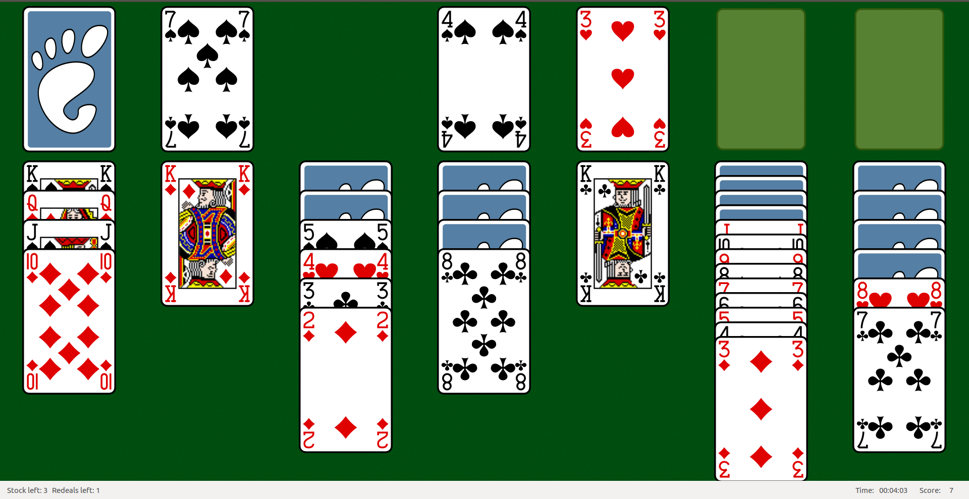
Klondike is the most known of all solitaire card games. The goal is to sort all cards of the same suit on top right piles in ascending order. There are seven piles with a total of 28 cards in the beginning and a deck with 24 cards.

Authorization
There is Login link in the navigation menu. If the user is logged in, it redirects to user information page, where a user can logout or change his password. A guest gets redirected to a login & register page (see wireframe wf_auth).

Scoreboard
Upon clicking the Highscore link in the menu, a simple table sorted by number of points is printed. If a current user has a score in the TOP 10, the line is highlighted (see wireframe wf_highscore).
The score is based on the time that passes since the beginning of the game and the number of moves a player did.

Game
There are 13 piles I call registers. All registers extend stack data type class and are indexed (see wireframe wf_game). The player has an option to start a new game with a fresh deck of cards (reshuffled) or reset the current deck to its starting position.

Starting position
When the game starts, there are 24 cards in D[0] register. F and D[1] registers are empty. On each of P[0 - 6] registers, there are x+1 cards and only the top one is revealed.
Available player actions:
- one in D[0] → D[1]
- ∀ in D[1] → D[0]
- { , } in P[x] ←→ P[y]
- one in D[1] → P[x], F[x]
- one in P[x] ←→ F[x]
The player’s goal is to move the cards around the registers so that he manages to reveal all cards on the table. The game ends when all 52 cards are in F registers.

Timer
There is a timer running in the background for the first 10 minutes of the game (that is the time limit for a player to even score some points). The timer triggers each second, decreasing the players score by one and printing it out.

Move validation
There are two main validation methods when moving the cards:
canBePutOn
Serves to move cards on and around the P registers. The method checks if the value of top last card from to register is one higher than the first card in from array and if colour differs.
canBeFlushed
Serves to move cards on F registers. Both cards have to share colour and the moved card has to have value one higher.

Extras
There is a comment section on the high score page where registered users can add comments.
In the game you can ask for a hint by clicking Hint button. This will trigger an AJAX request on PHP script that is going to try giving you an advice.
For higher page usability a confirmation box is implemented in New game and Restart game buttons.
A help page includes the rules of Klondike and some brief history of Solitaire (see wireframe wf_help).
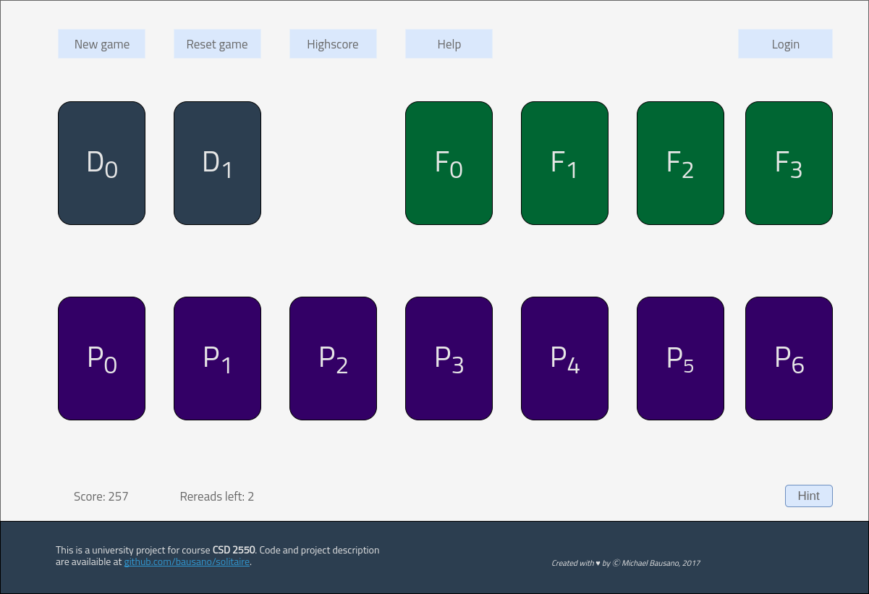
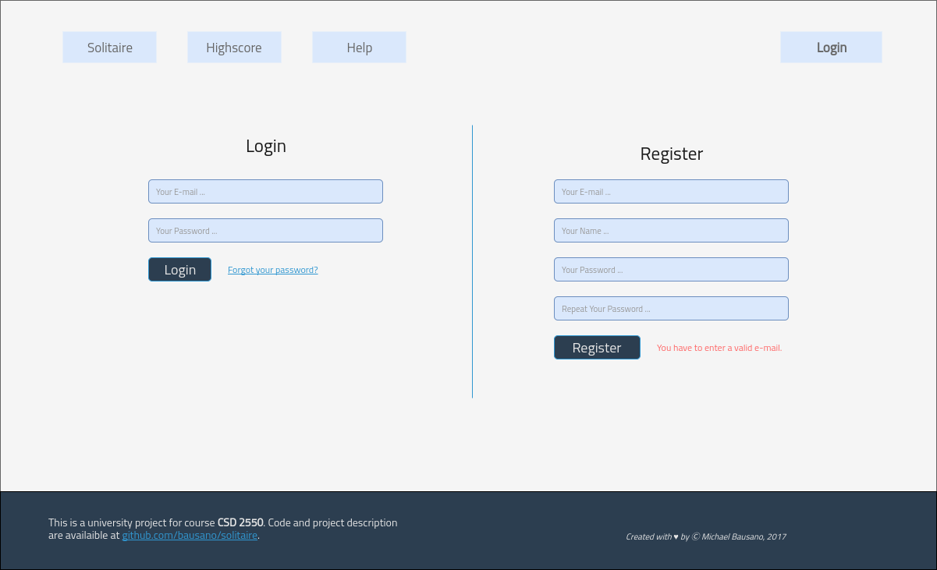
wf_game
wf_auth
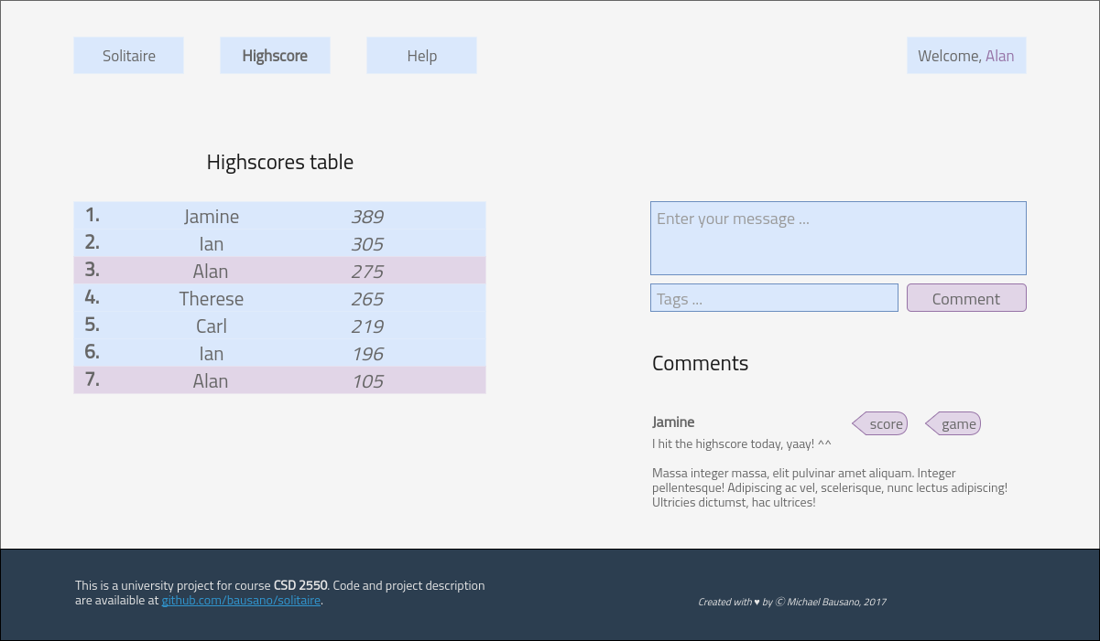
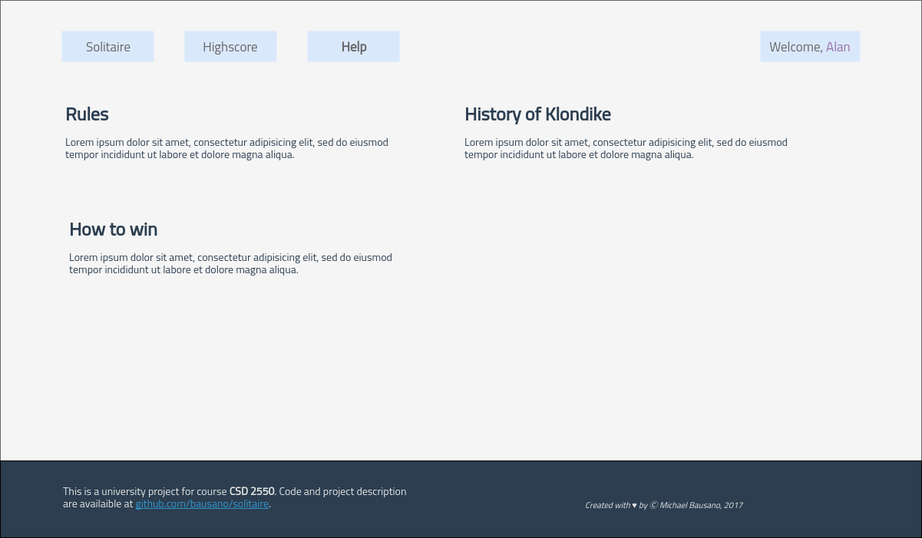
wf_highscore
wf_help

