**COMP 122L Intro to Assembly Programming Fall 2023**

**Student: Instructor: Dr. Jeff Drobman**

**Lab #:** LAB FORM

Requirements 

1. reqt1

2. reqt2

Inputs

*paste here screenshots of all inputs (not code): .data segment & GUI/console*

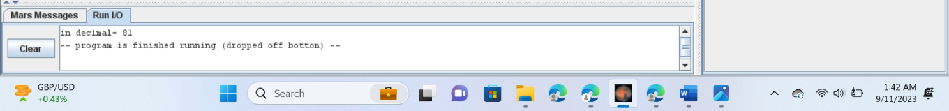

Outputs (note: you must execute the code to get outputs)

*paste here screenshots of all outputs (not code): console/GUI, .data, .heap, registers*

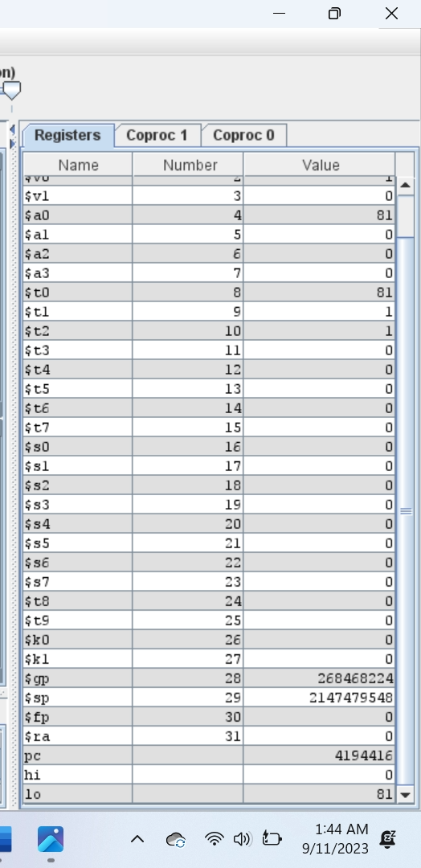

Process (algorithms): *source code*

*(paste original syntax colored view here; include line numbers – make legible)*

Debugging/Testing (if any issues)