HTC CORE
Molasses Trading Management System

━━━━━━━━━━━━━━━━━━━━━━━━━━━━━━━━━━━━━━━━━━━━━━━━━━

UAT Process Guide & System Documentation

Version: 1.0
Document Type: User Acceptance Testing (UAT) Process Guide
Platform: Heindrich Trading Corporation — HTC Core
Prepared: September 2026

Table of Contents
1. System Overview
2. User Roles & Actors
2.1 Account Lifecycle
3. End-to-End Business Process Flow
4. Detailed Process Steps by Actor
4.1 Administrator
4.2 Operations Management
4.3 Finance Officer
4.4 Invoicing Officer
5. Transaction Status Lifecycle
6. Loan Facility Lifecycle
7. Invoice Suggestion System
8. Variance & Dispute System
9. Supporting Features
10. Navigation Map
11. UAT Test Scenarios
12. Default Test Accounts
13. Dashboard Visibility Matrix
14. Use Case Diagrams
14.1 System Use Case Diagram
14.2 End-to-End Process Swimlane
14.3 Actor Responsibilities & Process Ownership

1. System Overview
HTC Core is an end-to-end enterprise platform for managing the bulk molasses trading lifecycle — from supplier sourcing and purchase orders, through logistics and delivery, to customer invoicing, bank loan capital management, and financial reconciliation.
The system is built on Django (Python) with a role-based access control architecture, audit trail logging, team collaboration chat, and an AI-powered Copilot assistant. It serves as the digital backbone for Heindrich Trading Corporation's operations.

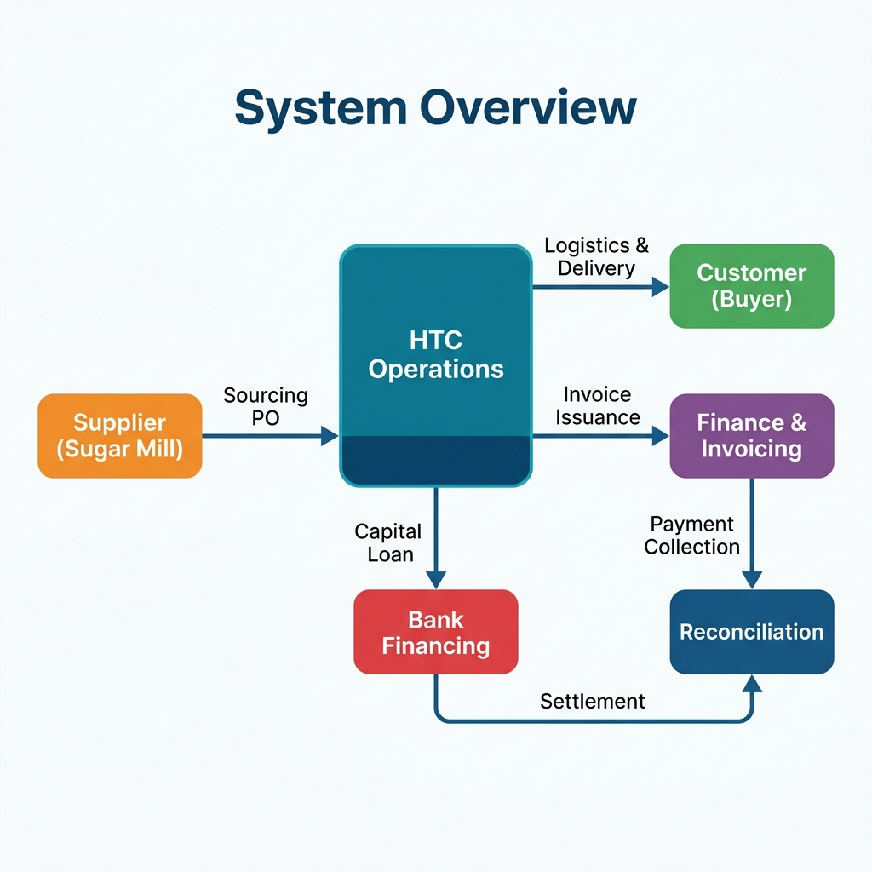
Figure 1.1 — HTC Core System Overview

The platform covers the following core business functions:
- Supplier & Customer Relationship Management (CRM)
- Purchase Order / Transaction Cluster management with approval workflow
- Logistics tracking with automated variance & shrinkage monitoring
- Sales Invoice management with AI-suggested pricing & partial billing
- Capital Loan facility management with dual-verification workflow
- Financial reconciliation with automated cash voucher generation
- Molasses Release Order (MRO) registry with Excel import
- CHAI quality certification record management
- Real-time dashboard with role-specific KPIs and charts
- Team chat & notification system for cross-functional collaboration
- Complete audit trail for regulatory compliance

2. User Roles & Actors
The system enforces Role-Based Access Control (RBAC). Each user is assigned exactly one role upon account approval by the Administrator.
# | Role | System Code | Primary Responsibilities
1 | Administrator | administrator | Full system access. User management, account approval, executive approvals, database management, system configuration. Acts as the company owner/GM.
2 | Operations Management | operations_management | Create & manage Purchase Orders (PO/Transaction Clusters), manage logistics & shipments, approve/reject transactions, supplier & customer CRM, MRO management.
3 | Finance | finance | Manage Capital Loans (create, settle), financial reconciliation, payment matching, cash voucher oversight, view transactions.
4 | Invoicing | invoicing | Create & manage Sales Invoices, track invoice status (Draft → Issued → Paid), download invoice PDFs, view transactions.

IMPORTANT: Administrator and Operations Management can approve/reject transactions and loans. Finance can propose loans but requires Ops/Admin verification. Invoicing has read-only access to transactions but full control over invoice creation. All roles can view the Dashboard, Team Chat, and Documents.

2.1 Account Lifecycle
New users follow a self-registration and admin-approval workflow before gaining access:
Step 1: User visits the Sign Up page and registers with username, email, and password.
Step 2: Account is created with is_active=False (pending approval). User cannot login yet.
Step 3: Administrator navigates to User Management and reviews pending user accounts.
Step 4: Admin clicks Approve and assigns an appropriate role to the user.
Step 5: User can now login. Optionally enables Two-Factor Authentication (2FA) from their Profile page.

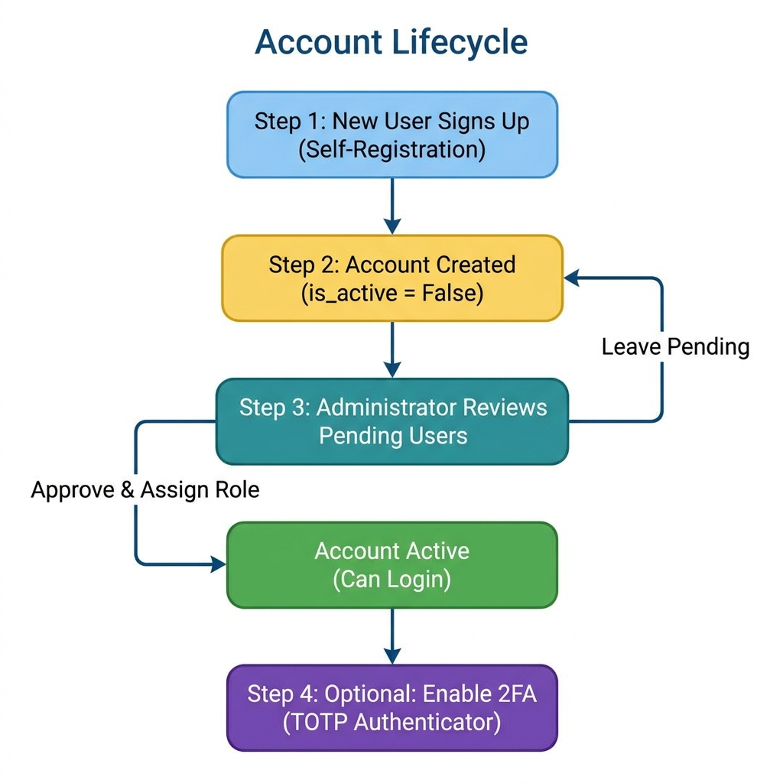
Figure 2.1 — Account Lifecycle Flowchart

3. End-to-End Business Process Flow
This section documents the complete lifecycle of a single molasses trade from initial setup to final closure. The process involves coordination between all four user roles across eight distinct phases.

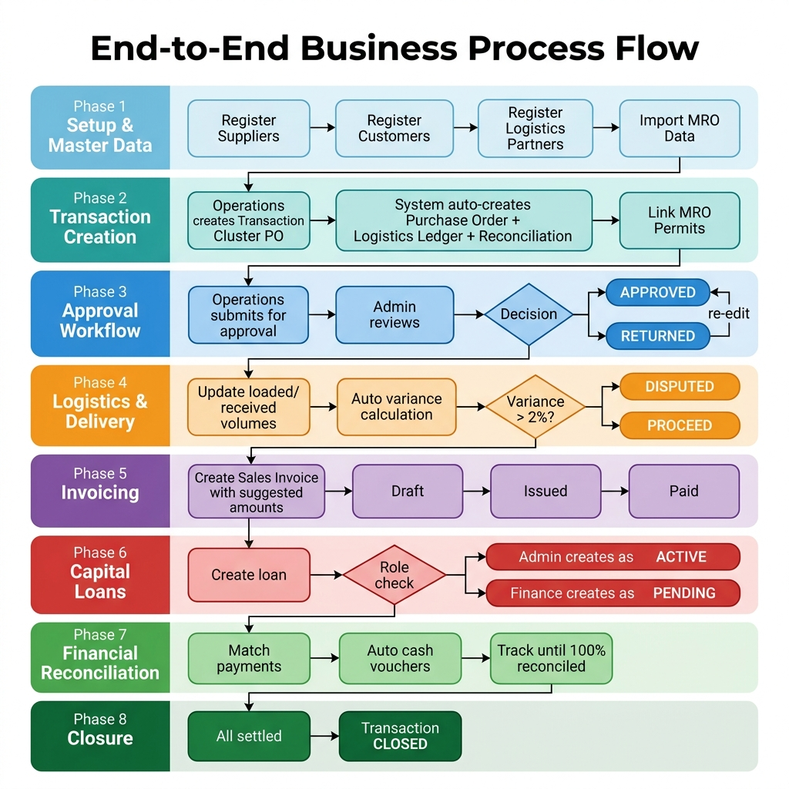
Figure 3.1 — End-to-End Business Process Flow (8 Phases)

Phase 1: Setup & Master Data
Register suppliers (sugar mills), customers (buyers), logistics partners, and import Molasses Release Order (MRO) data. This foundational data must be in place before transactions can be created.

Phase 2: Transaction Creation
Operations Management creates a Transaction Cluster (PO) specifying the customer, supplier, volume (MT), sourcing price (₱/MT), and customer selling price (₱/MT). The system automatically creates the associated Purchase Order, Logistics Ledger, and Financial Reconciliation records. MRO permits can be linked to the transaction.

Phase 3: Approval Workflow
Operations submits the transaction for executive approval. An Administrator or Operations Manager reviews the deal and either Approves it (moving to Active status) or Returns/Rejects it with mandatory comments explaining the reason.

Phase 4: Logistics & Delivery
Operations updates the logistics ledger with loaded and received volumes, vessel ID, and logistics partner details. The system automatically calculates variance percentage and flags disputes when shrinkage exceeds the 2% tolerance threshold.

Phase 5: Invoicing
The Invoicing Officer creates Sales Invoices for the transaction. The system provides suggestive pricing based on the PO selling price, supporting partial billing (invoicing in portions). Invoice status progresses: Draft → Issued → Paid.

Phase 6: Capital Loans
Finance creates Capital Loan facilities to fund the transaction. If created by Finance, the loan requires Ops/Admin verification before becoming Active. Settlement follows a similar dual-verification process.

Phase 7: Financial Reconciliation
Finance matches customer payments to expense categories (sourcing, tracking fees, barge fees, logistics deposit). The system auto-generates Cash Vouchers for each match. Progress is tracked until 100% reconciled.

Phase 8: Closure
When all payments are matched, all invoices are paid, and all loans are settled, the transaction is marked as Closed.

4. Detailed Process Steps by Actor

4.1 Administrator
Step | Action | Location | Expected Result
1 | Login with admin credentials | /accounts/login/ | Dashboard loads with executive overview
2 | Approve pending user accounts | User Management page | User becomes active with assigned role
3 | Review & approve/reject submitted POs | Transaction Detail page | PO status changes to Approved/Returned
4 | Verify loan creation proposals | Loan Facilities page | Loan becomes ACTIVE
5 | Verify loan settlement clearance | Loan Facilities page | Loan becomes CLOSED
6 | View audit trail | Transaction Detail → Audit tab | Full history of all changes
7 | Manage database (import/clear) | Excel Import / Clear Database | Data imported or cleared
8 | Edit user profiles & reset passwords | User Management page | User updated

4.2 Operations Management
Step | Action | Location | Expected Result
1 | Register new Suppliers & Customers | Suppliers & Customers tab | Partner card appears in CRM
2 | Create Transaction Cluster (PO) | New Transaction form | Cluster created with PO, Logistics, Reconciliation
3 | Set selling price, volume, CHAI specs | Transaction form | PO details saved
4 | Link MRO permits to transaction | Transaction Detail → MRO section | MRO linked, tons counted
5 | Submit transaction for approval | Transaction Detail → Submit button | Status → Pending Approval
6 | Update logistics (loaded/received vol) | Transaction Detail → Logistics tab | Variance auto-calculated
7 | Manage shipment tracking & disputes | Logistics Monitor page | Shipment status tracked
8 | Approve/reject transactions | Transaction Detail | Status changes
9 | Import MRO Excel data | MRO Registry page | MRO records created
10 | Use Copilot AI assistant | Transaction Detail → Copilot tab | AI-generated insights

4.3 Finance Officer
Step | Action | Location | Expected Result
1 | Create Capital Loan facility | Loan Facilities page | Loan created (pending verification if Finance role)
2 | Submit loan settlement clearance | Loan Facilities → Settle button | Loan → Pending Settlement
3 | Match payments to expense categories | Reconciliation page | Payment matched, auto-voucher created
4 | Review cash vouchers | Transaction Detail / Loan page | Voucher records visible
5 | Download consolidated financial reports | Dashboard → Download Report | PDF report generated
6 | View analytics & supplier rankings | Analytics page | Ranking engine results

4.4 Invoicing Officer
Step | Action | Location | Expected Result
1 | Create Sales Invoice for transaction | Invoice Management or Transaction Detail | Invoice created with suggested amounts
2 | Use invoice suggestion (Quick Fill) | Invoice form → Quick Fill button | Amount auto-populated based on selling price
3 | Issue partial invoices (portions) | Create multiple invoices per transaction | Multiple invoices linked to same cluster
4 | Mark invoice as Issued / Paid | Invoice list page | Status badge updates
5 | Download Invoice PDF | Invoice row → Download button | PDF generated & downloaded

5. Transaction Status Lifecycle
Every Transaction Cluster (Purchase Order) follows a defined status lifecycle from creation to closure. The transitions are enforced by the system and require specific role permissions.

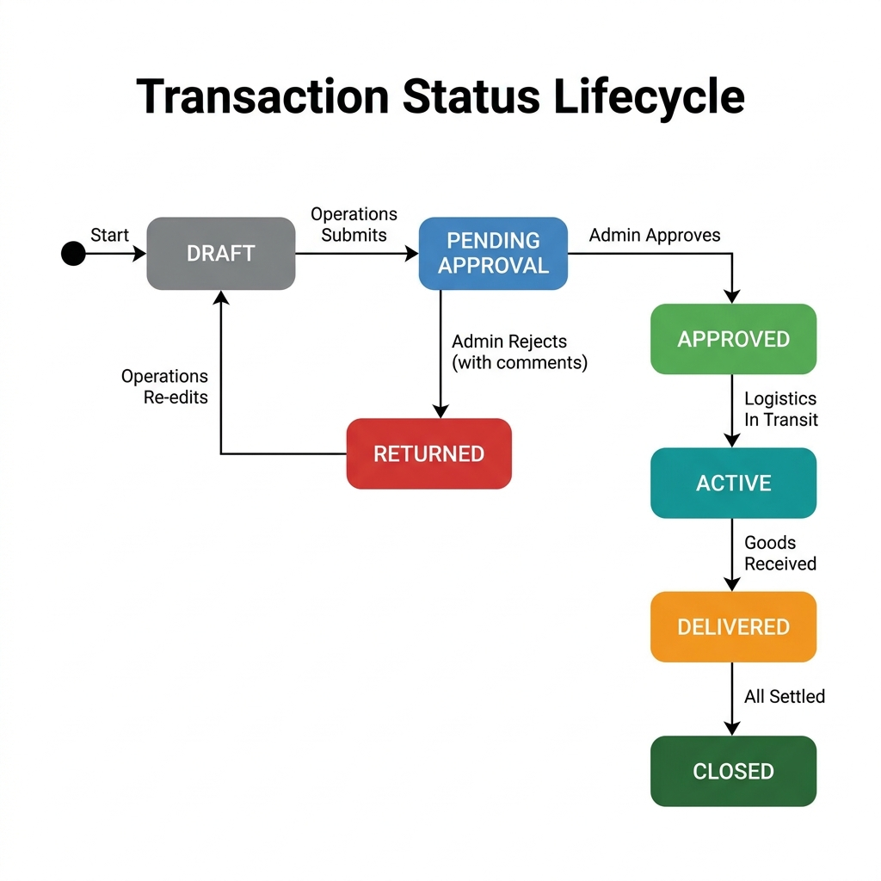
Figure 5.1 — Transaction Status Lifecycle State Diagram

Status | Meaning | Who Triggers
DRAFT | PO created, editing in progress | Operations (auto on create)
PENDING APPROVAL | Submitted for executive review | Operations
APPROVED | Executive has approved the deal | Administrator / Ops Management
RETURNED | Rejected with mandatory comments | Administrator / Ops Management
ACTIVE | Goods loaded, in transit | System / Operations
DELIVERED | Goods received at destination | Operations (logistics update)
CLOSED | Fully settled, reconciled, invoices paid | Operations / System

6. Loan Facility Lifecycle
Capital Loan facilities follow a dual-verification workflow to ensure proper financial controls. The lifecycle differs based on who creates the loan — Admin/Ops can create directly as Active, while Finance must go through a creation approval step.

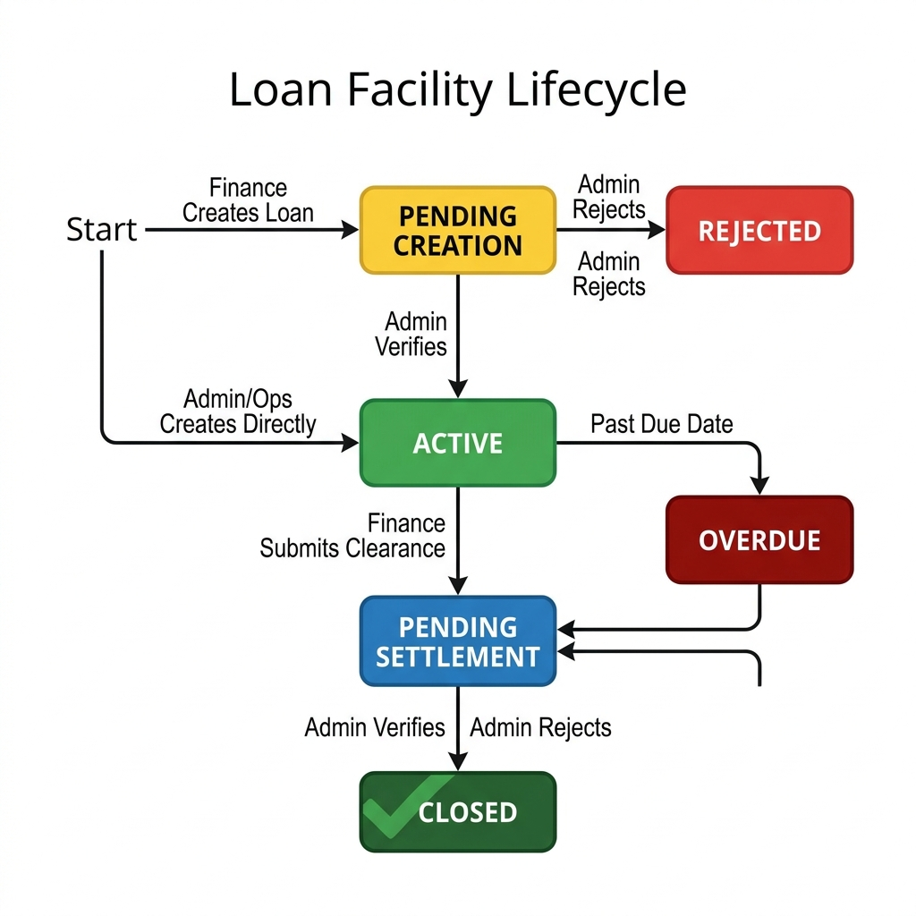
Figure 6.1 — Loan Facility Lifecycle State Diagram

Status | Meaning | Next Actions
PENDING CREATION | Finance submitted loan proposal | Admin/Ops: Approve → Active, or Reject
ACTIVE | Loan facility is live, interest accruing | Finance: Submit settlement clearance
PENDING SETTLEMENT | Settlement clearance advice submitted | Admin/Ops: Verify → Closed, or Reject → Active
CLOSED | Loan fully settled and verified | No further actions
OVERDUE | Past due date, not yet settled | Finance: Submit settlement clearance
REJECTED | Creation proposal rejected by Admin/Ops | Finance: Create a new loan
Key loan financial metrics tracked by the system:
- Daily Interest Cost = (Principal × Annual Rate / 365)
- Accrued Interest = Daily Interest × Days Outstanding
- Total Liability = Principal + Accrued Interest
- Funded Logistics Deposit = Logistics Fees × Deposit Percentage (default 50%)

7. Invoice Suggestion System
When creating a Sales Invoice, the system provides suggestive pricing insights based on the Purchase Order. This feature helps Invoicing Officers ensure billing accuracy and supports partial billing workflows.

How It Works
Suggested Total: PO Volume (MT) × Customer Selling Price (₱/MT)
Already Invoiced: Sum of all existing invoices for this transaction
Remaining Balance: Suggested Total − Already Invoiced
Quick Fill: One-click button fills the invoice amount field with the Remaining Balance

TIP: The suggestion panel accounts for partial invoicing. If 60% has already been invoiced, the Quick Fill will suggest the remaining 40%. This supports the real-world practice of sending invoices in portions as deliveries are completed.

Partial Billing Example
Step | Action | Invoice Amount | Remaining
1 | PO: 500 MT × ₱18,500 = ₱9,250,000 | — | ₱9,250,000
2 | Invoice #1 created (first delivery) | ₱5,000,000 | ₱4,250,000
3 | Invoice #2 created (final delivery) | ₱4,250,000 | ₱0 (Fully Invoiced)

8. Variance & Dispute System
When goods are loaded at the supplier and delivered to the customer, the system automatically calculates the volume variance (shrinkage) and flags shipments that exceed the tolerance threshold.

Automatic Calculations
Variance % = |Loaded Volume − Received Volume| / Loaded Volume × 100
Tolerance Threshold = 2% (configurable via VARIANCE_TOLERANCE_PERCENT setting)

Variance Result | System Action
≤ 2% | Within tolerance — proceed normally. Status: Pending Review / Delivered.
> 2% | DISPUTED — flagged for management resolution. Shipment status set to Disputed.

Dispute Resolution Options
Resolution Type | Description
Concede & Proceed As-Is | Accept the variance and proceed with original billing amounts.
Adjust Billing to Received Volume | Recalculate billing based on actual received volume instead of loaded.
Deduct Shortage Penalty from Logistics | Charge the logistics provider for the excess shrinkage.
Management Waiver (Brix/Evaporation) | Waive the variance due to natural product characteristics.

9. Supporting Features

9.1 Team Chat
- Transaction-scoped discussion threads for deal-specific communication
- Direct messaging between team members across departments
- System-generated operational notifications auto-posted on PO creation, approvals, rejections, and settlements

9.2 Notifications
- Role-based push notifications ensure the right people are informed at the right time:
- New PO creation → Finance & Invoicing officers notified
- PO submission for approval → Administrator notified
- PO approval/rejection → Operations team notified
- Loan creation/settlement → relevant roles notified
- Variance alerts → Management notified
- Notifications are categorized: Approval, Variance, Logistics, Loan, System

9.3 Copilot AI Assistant
- Natural language queries about business data and operations
- Example queries: 'What is the total volume this month?', 'Show me overdue loans', 'Which supplier has the lowest shrinkage?'
- Accessible from the Transaction Detail page

9.4 Document Registry
- Centralized view of all uploaded documents across all transactions
- Document types: MRO scans, Waybills, Delivery Receipts, Settlement documents
- Searchable by reference code, document type, and date

9.5 Analytics & Supplier Rankings
- Supplier scoring engine evaluating: cost efficiency, reliability, lead time, shrinkage rate
- Revenue distribution analysis by customer
- Historical shrinkage trends by supplier with disputed shipment counts

9.6 Audit Trail
- Full history tracking via django-simple-history on all critical models
- Every create/update on Transaction, PO, Logistics, Invoice, Voucher, and Loan is recorded with user and timestamp
- Immutable audit log (SystemAuditTrail) that cannot be edited or deleted
- Viewable on Transaction Detail → Audit tab

9.7 Two-Factor Authentication (2FA)
- Optional TOTP-based 2FA via authenticator app (Google Authenticator, Authy, etc.)
- 5 one-time backup codes generated on setup for recovery
- Daily device-remembering via signed cookie (24-hour validity)
- Enabled from user Profile page

10. Navigation Map
Complete URL reference and access control matrix for all system pages:

Page | URL | Access Roles
Dashboard | / | All authenticated users
Analytics | /analytics/ | Admin, Ops, Finance
Documents | /documents/ | All authenticated users
Transaction List | /operations/ | All authenticated users
New Transaction | /operations/new/ | Admin, Ops
Transaction Detail | /operations/<id>/ | All authenticated users
Logistics Monitor | /operations/logistics/ | All authenticated users
MRO Registry | /operations/mro/ | Admin, Ops
CHAI Records | /operations/chai/ | Admin, Ops
Stats Monitor | /operations/stats/ | Admin, Ops
Suppliers & Customers | /masters/partners/ | Admin, Ops, Finance
Customer Portfolio | /masters/client/<id>/ | Admin, Ops, Finance
Supplier Portfolio | /masters/supplier/<id>/ | Admin, Ops, Finance
Invoice Management | /finance/invoices/ | Admin, Finance, Invoicing
Loan Facilities | /finance/loans/ | Admin, Finance
Reconciliation | /finance/reconciliation/<id>/ | All authenticated users
User Management | /accounts/users/ | Admin, Ops
Profile | /accounts/profile/ | All authenticated users
Team Chat | /chat/ | All authenticated users
Notifications | /audit/notifications/ | All authenticated users

11. UAT Test Scenarios
The following test scenarios cover the critical business workflows that must be validated during UAT. Each scenario should be executed end-to-end with the specified user roles.

Scenario 1: Complete Trade Lifecycle
1. Admin creates a Supplier (e.g., 'BUSCO Sugar Mill') and Customer (e.g., 'San Miguel Corp')
2. Ops creates a Transaction Cluster: 500 MT @ ₱15,000/MT sourcing, ₱18,500/MT selling
3. Ops submits the transaction for approval
4. Admin approves the transaction
5. Ops updates logistics: Loaded 500 MT, Received 495 MT (1% variance — within tolerance)
6. Invoicing creates a Sales Invoice for ₱9,250,000 (full amount) or partial
7. Finance creates a Capital Loan (₱7,500,000 from BDO, 12% annual, 30 days)
8. Admin verifies the loan → ACTIVE
9. Finance matches payments in Reconciliation (Sourcing ₱7,500,000 + Logistics fees)
10. Finance submits loan settlement clearance
11. Admin verifies settlement → CLOSED
12. Verify Dashboard metrics, Charts, and Audit Trail reflect all actions

Scenario 2: Variance Dispute
1. Create a transaction for 1,000 MT
2. Update logistics: Loaded 1,000 MT, Received 960 MT (4% variance — exceeds 2% tolerance)
3. Verify system flags the shipment as DISPUTED
4. Resolve dispute with appropriate resolution type
5. Verify variance alert appears on Dashboard and Logistics Monitor

Scenario 3: Partial Invoicing
1. Create a transaction with Selling Price ₱18,500/MT × 500 MT = ₱9,250,000
2. Create Invoice #1 for ₱5,000,000 (partial — first delivery)
3. Verify invoice suggestion panel shows remaining ₱4,250,000
4. Create Invoice #2 for ₱4,250,000 (remaining balance)
5. Verify total invoiced matches expected ₱9,250,000

Scenario 4: Loan Verification Workflow
1. Finance creates a loan → Status should be: Pending Creation
2. Admin rejects the loan (with comments)
3. Finance creates a new corrected loan
4. Admin approves → Status: ACTIVE
5. Finance submits settlement clearance → Status: Pending Settlement
6. Admin verifies settlement → Status: CLOSED

Scenario 5: User Management & Security
1. New user signs up via the registration page
2. Verify account appears as inactive/pending in User Management
3. Admin approves the user with a specific role assignment
4. User logs in successfully with assigned permissions
5. User enables 2FA from Profile page
6. User logs out and logs back in — 2FA code required
7. Verify user can only access pages allowed by their role

12. Default Test Accounts (Post-Wipe)
The following accounts have been prepared for UAT testing. Each account corresponds to one of the four system roles to enable comprehensive testing of role-based access controls.

Username | Role | Purpose
admin | Administrator | Primary admin/owner account — full system access
ops_mgmt | Operations Management | Operations team lead — PO creation, logistics, approvals
finance_officer | Finance | Finance team member — loans, reconciliation, payments
invoicing_officer | Invoicing | Billing & invoicing team member — invoice creation, PDFs

CAUTION: All test data has been wiped. The database is clean and ready for UAT. Create fresh supplier, customer, and logistics partner records before beginning test scenarios.

13. Dashboard Visibility Matrix by Role
The following matrix shows which dashboard sections are visible to each user role. This can be used to verify correct role-based rendering during UAT.

Dashboard Section | Admin | Ops Mgmt | Finance | Invoicing
Revenue / Expenses / Profit cards | ✅ | ✅ | ✅ | ✅
Monthly P&L Chart | ✅ | ✅ | ✅ | ✅
Weekly Cash Flow Chart | ✅ | ✅ | ✅ | ✅
Recent Transactions list | ✅ | ✅ | ✅ | ✅
Variance Alerts | ✅ | ✅ | ❌ | ❌
Active Shipments count | ✅ | ✅ | ❌ | ❌
MRO Mill Balances | ✅ | ✅ | ❌ | ❌
Loan Exposure / Overdue | ✅ | ❌ | ✅ | ❌
Pending Verification Queue | ✅ | ✅ | ✅ | ❌
Draft / Unpaid Invoices count | ✅ | ❌ | ✅ | ✅
Pending Invoices list | ❌ | ❌ | ❌ | ✅

14. Use Case Diagrams
This section presents formal UML Use Case diagrams that illustrate which actors interact with which system functions, and how the end-to-end process flows across all four user roles from start to finish.

14.1 System Use Case Diagram
The following Use Case diagram shows all four actors (Administrator, Operations Management, Finance Officer, and Invoicing Officer) and their interactions with the HTC Core system. Use cases are grouped by functional area: Account Management, Master Data, Transaction Management, Logistics, Finance, and Invoicing.

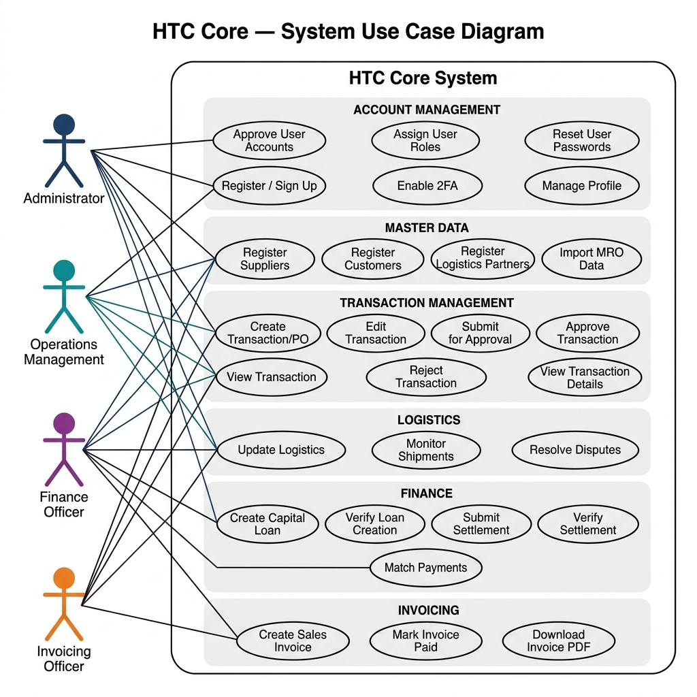
Figure 14.1 — HTC Core System Use Case Diagram

Key observations from the Use Case diagram:
- The Administrator has the broadest scope — involved in approvals across all phases (user accounts, transactions, loans, settlements).
- Operations Management is the primary creator of business transactions and logistics data.
- Finance Officer focuses on capital management (loans) and payment reconciliation.
- Invoicing Officer has a narrow but critical scope — invoice creation, issuance, and billing management.
- All actors share access to the Dashboard, Team Chat, Notifications, and Document Registry.
- Cross-role interactions occur at approval gates: Operations submits → Admin approves; Finance proposes → Admin verifies.

Use Case Summary by Actor
Actor | Primary Use Cases | Count | Process Phases
Administrator | User management, PO approval/rejection, loan verification, settlement verification, database management | 8 | 1, 3, 6
Operations Management | Register partners, create/edit POs, submit for approval, update logistics, monitor shipments, resolve disputes, MRO import | 10 | 1, 2, 3, 4
Finance Officer | Create loans, submit settlement, match payments, reconciliation, financial reporting, analytics | 7 | 6, 7
Invoicing Officer | Create invoices, Quick Fill suggestions, partial billing, mark paid, download PDFs | 5 | 5

14.2 End-to-End Process Flow (Swimlane Diagram)
The swimlane activity diagram below maps the complete end-to-end business process across all four actor lanes. Each column represents an actor, and the flow moves from top (setup) to bottom (closure), clearly showing which role is responsible for each step and where handoffs occur between departments.

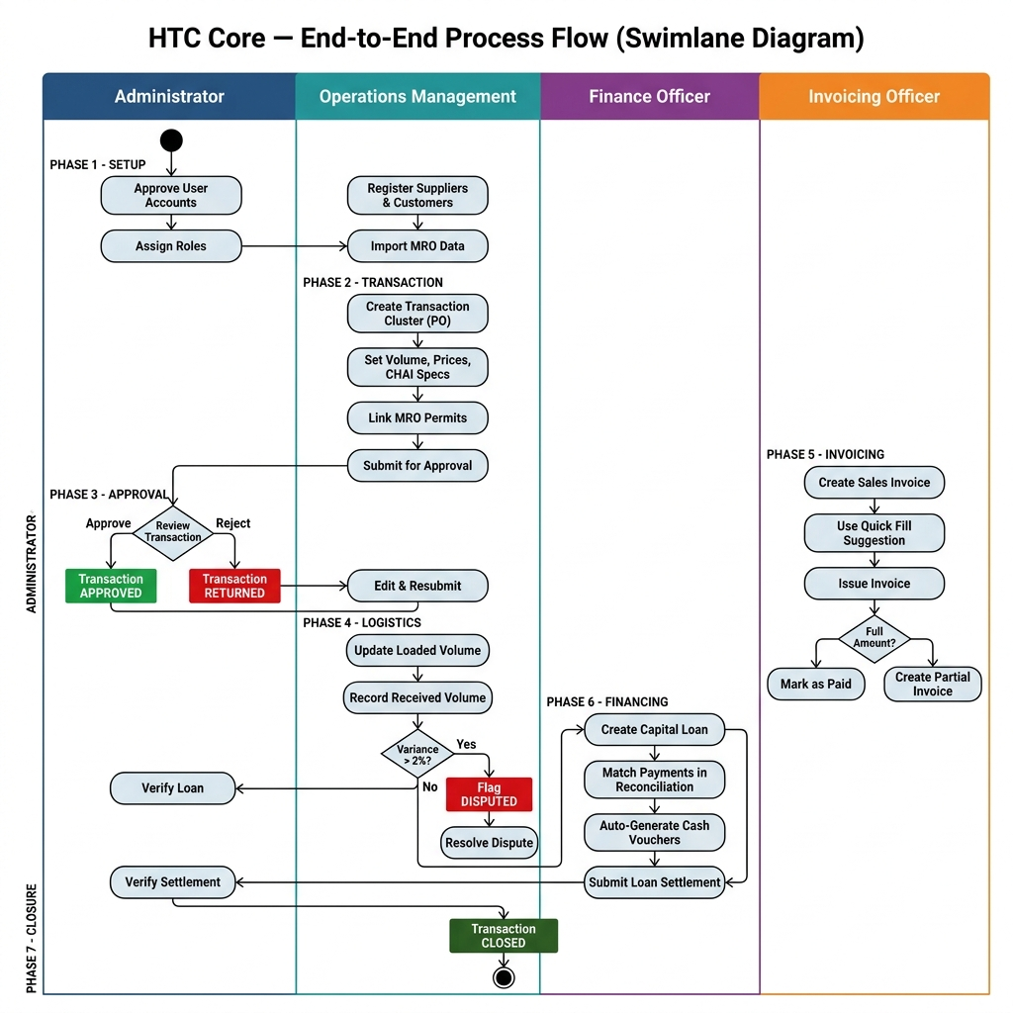
Figure 14.2 — End-to-End Process Swimlane Activity Diagram

Process handoff points between actors:
Operations → Administrator: When a Purchase Order is submitted for executive approval. The Admin reviews and either approves or returns with comments.
Administrator → Operations: After approval, control returns to Ops for logistics execution (loading, delivery, receiving).
Operations → Invoicing: Once delivery is confirmed, the Invoicing Officer creates Sales Invoices based on the PO selling price.
Operations → Finance: Parallel to invoicing, Finance creates Capital Loan facilities to fund the transaction.
Finance → Administrator: Loan creation proposals and settlement clearance require Admin/Ops verification.
Finance → System: Upon 100% payment reconciliation and all settlements complete, the transaction can be closed.

14.3 Actor Responsibilities & Process Ownership
The following diagram provides a consolidated view of each actor's responsibilities, mapped to the specific business process phases they own. This serves as a quick reference for understanding who does what and when.

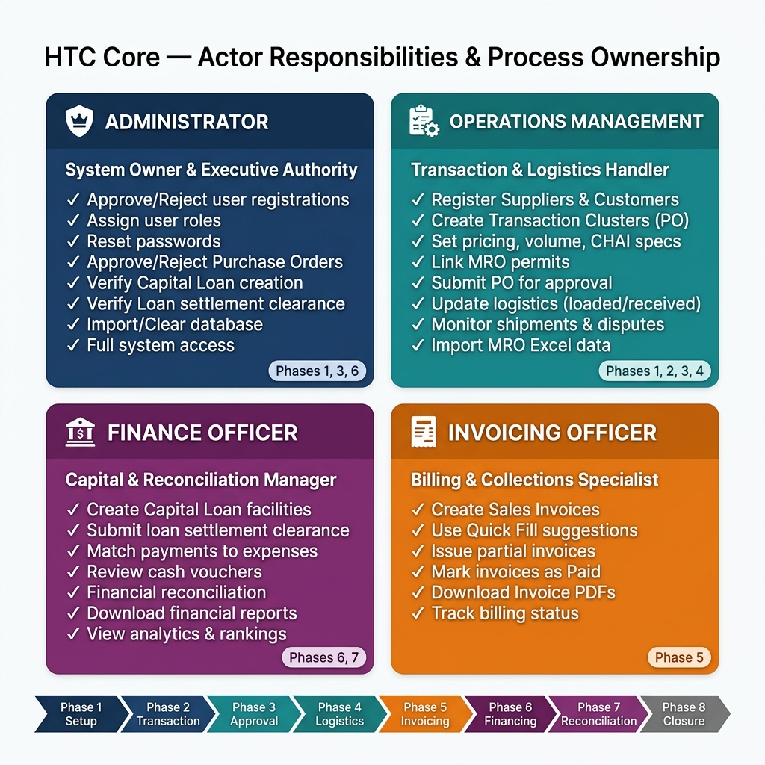
Figure 14.3 — Actor Responsibilities & Process Ownership Matrix

Process phase ownership breakdown:

Phase | Name | Primary Owner | Supporting Actors | Key Deliverables
1 | Setup & Master Data | Admin + Ops | — | Suppliers, Customers, Logistics Partners, MRO data registered
2 | Transaction Creation | Operations | — | Transaction Cluster (PO) created with pricing, volume, specs
3 | Approval Workflow | Administrator | Operations | PO approved or returned with comments
4 | Logistics & Delivery | Operations | Admin (disputes) | Volumes recorded, variance calculated, disputes resolved
5 | Invoicing | Invoicing | Finance | Sales Invoices created, issued, and tracked
6 | Capital Financing | Finance + Admin | — | Loans created, verified, settled, and closed
7 | Reconciliation | Finance | — | Payments matched, vouchers generated, 100% reconciled
8 | Closure | System | All actors | Transaction fully settled and archived

KEY DESIGN PRINCIPLE: The dual-verification pattern is a core governance mechanism: Finance proposes → Admin/Ops verifies. This applies to Loan Creation, Loan Settlement, and Transaction Approval. No single role can complete a financial commitment alone, ensuring separation of duties and audit compliance.

— End of Document —

HTC Core UAT Process Guide v1.0 · September 2026
Heindrich Trading Corporation

