Astana IT University
Faculty of Computer Science
WEB TECHNOLOGIES 1 (FRONT END) — MIDTERM PROJECT REPORT
Topic: REQUIEM
Group: IT-2506
Team Members: Ramazanov Maxsutkhan (S1), Ramazanov Madiyar (S2), Omirkhan Miras (S3), Daniil Tsoy (S4)
GitHub Repository: https://github.com/your-username/requiem
Deployed Website: https://your-username.github.io/requiem/
1. Team Members & Individual Contributions
Team Member | Role & Assigned Pages | Technical Contribution
Ramazanov Maxsutkhan (S1) | Team Lead / Tariffs  Page: pricing.html | Developed pricing architecture, pure mobile-first CSS Grid tariffs, Bootstrap FAQ accordion, and overall repository design tokens.
Ramazanov Madiyar (S2) | UI Showcase Specialist  Pages: index.html, zones.html | Built welcome arena hero, live club counter cards, hardware specs catalog (RTX 4090 / 360Hz), and atmosphere carousel.
Omirkhan Miras (S3) | Esports Data Specialist  Page: tournaments.html | Implemented mandatory semantic table (<table>) for tournaments with responsive wrapper, seasonal leaderboard, and tournament regulations.
Daniil Tsoy (S4) | UX & Forms Specialist  Pages: booking.html, about.html | Developed mandatory interactive form (<form>) with HTML5 validation and semantic labels, club rules, and location map.
2. Project Topic & Target Audience Rationale
• Topic: "REQUIEM" — official website for a premier esports center and gaming venue.
• Target Audience: University students and competitive gamers.
• Why this topic: Due to the high cost of flagship hardware (RTX 4080/4090, 360Hz displays), university students require an accessible, high-performance venue for recreational gaming and collegiate esports training. REQUIEM offers budget-conscious student packages (e.g. Night Marathon), soundproof 5v5 boot camps for team practice, and low-latency LAN infrastructure near campus.
3. Visual Style & Design System
• Palette: Matte Dark-Violet aesthetic. Deep charcoal background (#0b0a10), uniform matte gray surface cards (#191825 / #222033), light-gray hardware and specification typography (#cbd5e1), crisp white headings (#ffffff), and soft lavender accents (#c4b5fd). All neon glows were completely removed in favor of clean, comfortable contrast.
• Typography: "Rajdhani" for bold athletic headings and "Inter" for high-legibility body text.
• Design Elements: Subtle borders, clean corner radii (6px), comfortable carousel navigation padding, and uniform card styling across all sections.
4. Technical Implementation (Course Topics)
• Mandatory Semantic Table (tournaments.html): Built using <table>, <thead>, <tbody>, <tr>, <th>, <td>. Enclosed in .table-responsive to guarantee smooth horizontal scrolling without page overflow on 375px screens.
• Mandatory Interactive Form (booking.html): Implemented via <form> with full HTML5 validation (required, type="date", type="tel"), accessible <label for> matching input IDs, select dropdowns, custom checkboxes, and textareas.
• CSS Grid & Flexbox: Used for complex layouts including the 4-tier pricing grid, leaderboard rankings, and station specs.
• Bootstrap 5.3: 12-column grid system, collapsible hamburger navbar, dark theme tokens (data-bs-theme="dark"), and accordion components integrated with custom styles.
• Responsiveness: Every page is fully responsive at 375px (mobile), 768px (tablet), and 1280px (desktop) with zero horizontal overflow.
5. Screenshots of All 6 Pages Across Viewports
• Page 1: index.html (Home / Welcome Arena)
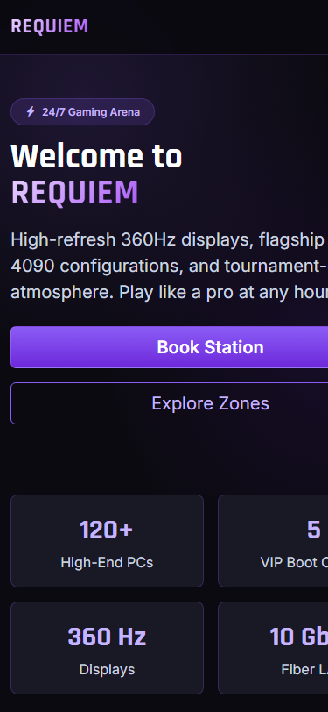
Page 1: index.html (Home / Welcome Arena) — 375px (Mobile)
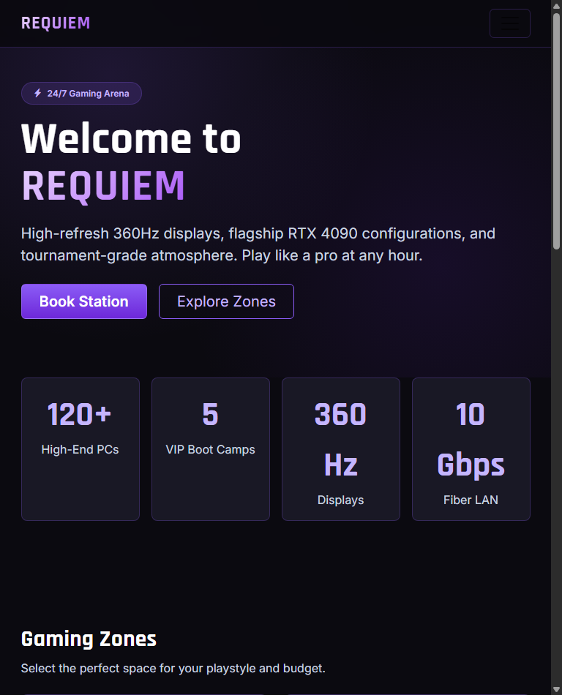
Page 1: index.html (Home / Welcome Arena) — 768px (Tablet)
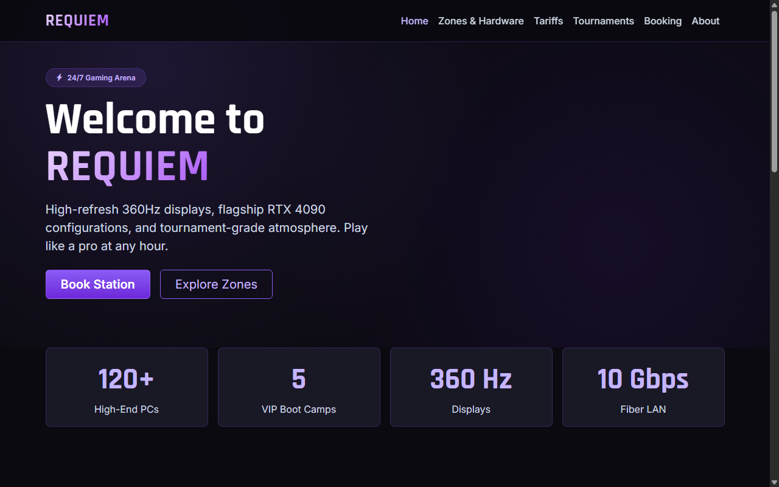
Page 1: index.html (Home / Welcome Arena) — 1280px (Desktop)
• Page 2: zones.html (Hardware & Zones Catalog)
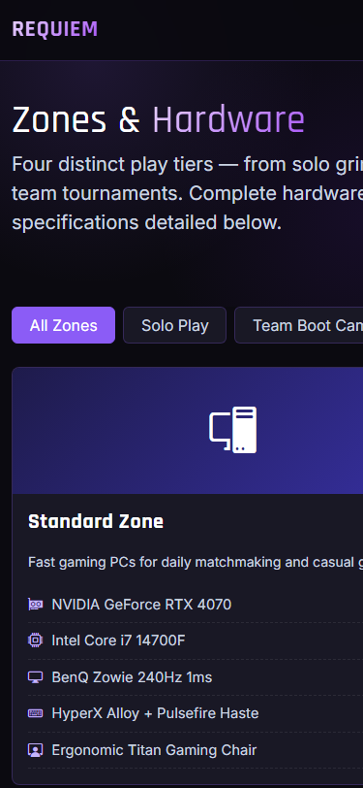
Page 2: zones.html (Hardware & Zones Catalog) — 375px (Mobile)
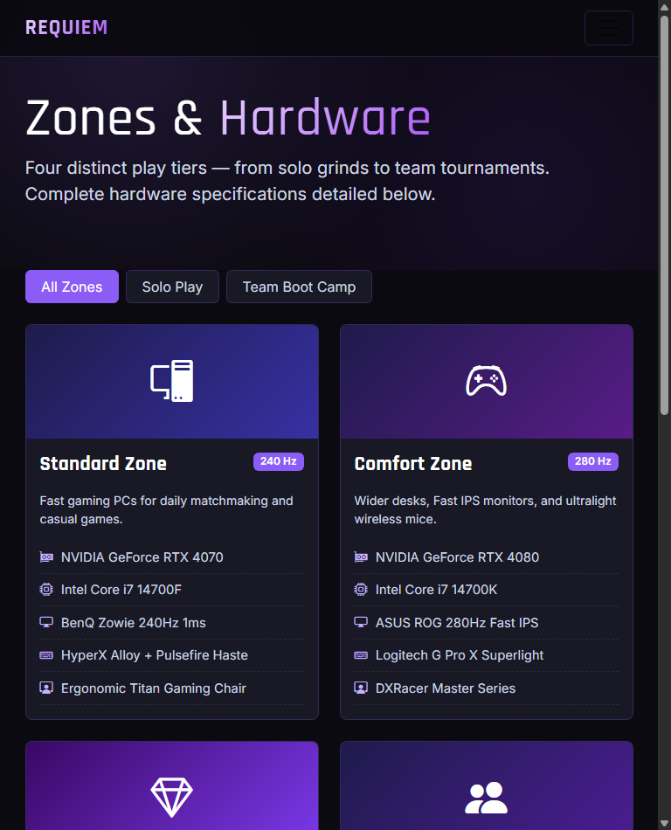
Page 2: zones.html (Hardware & Zones Catalog) — 768px (Tablet)
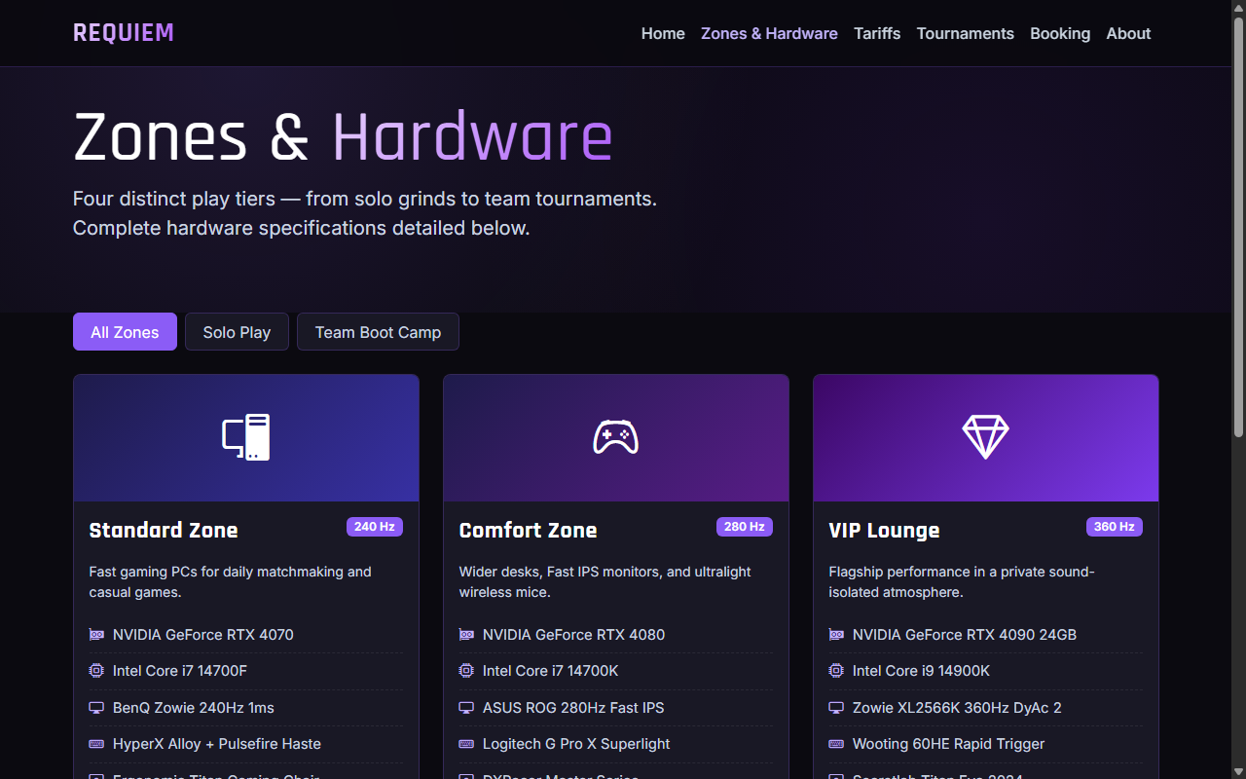
Page 2: zones.html (Hardware & Zones Catalog) — 1280px (Desktop)
• Page 3: pricing.html (Pricing & Packages)
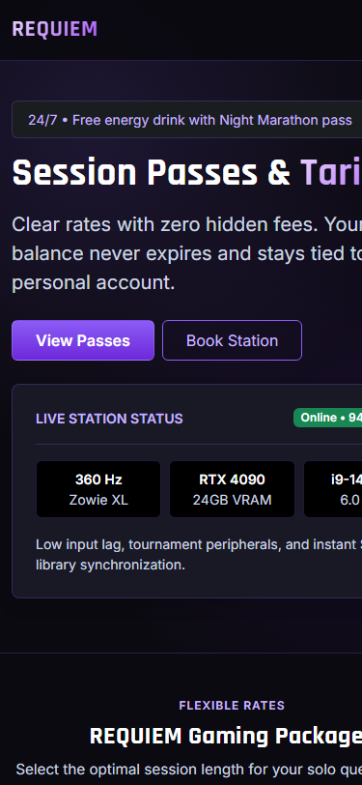
Page 3: pricing.html (Pricing & Packages) — 375px (Mobile)
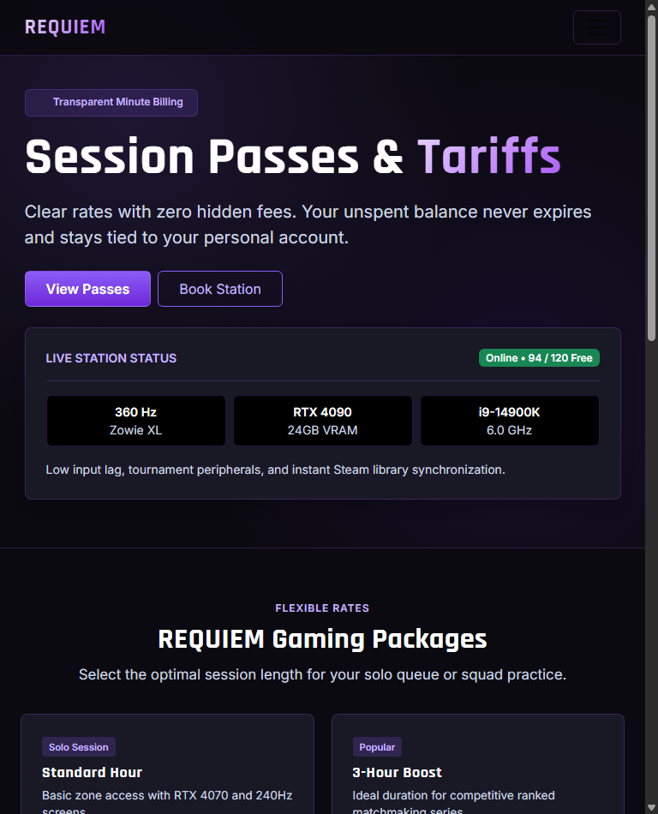
Page 3: pricing.html (Pricing & Packages) — 768px (Tablet)
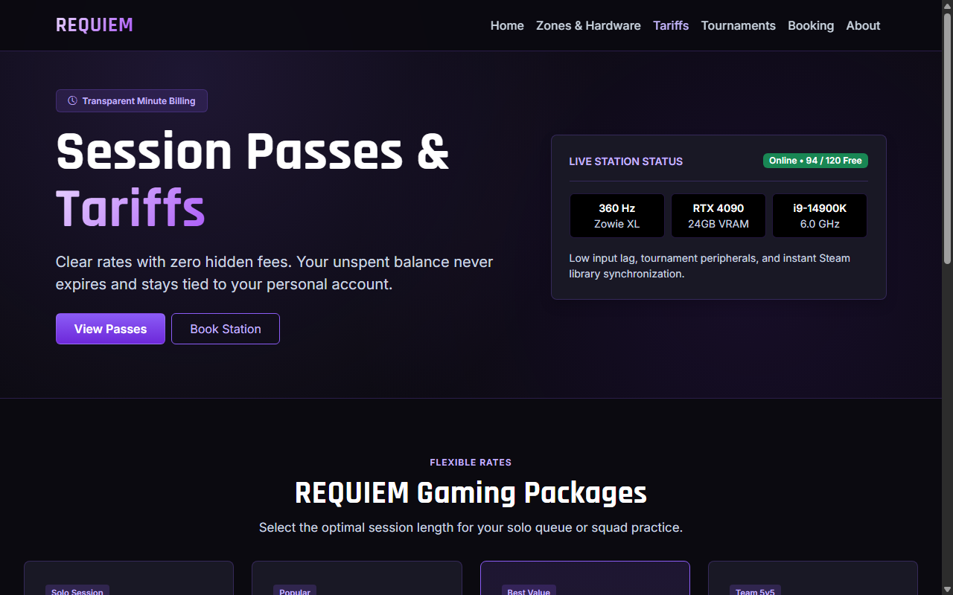
Page 3: pricing.html (Pricing & Packages) — 1280px (Desktop)
• Page 4: tournaments.html (Mandatory Table & Tournaments)
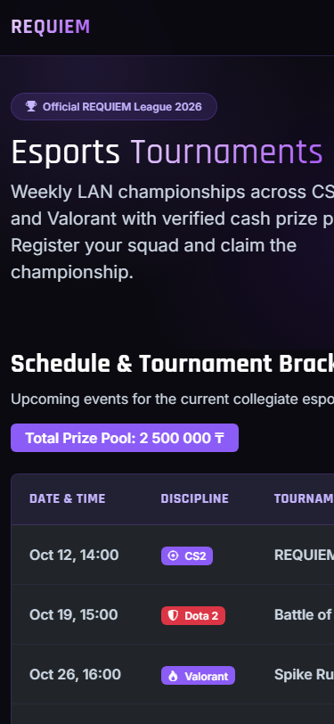
Page 4: tournaments.html (Mandatory Table & Tournaments) — 375px (Mobile)
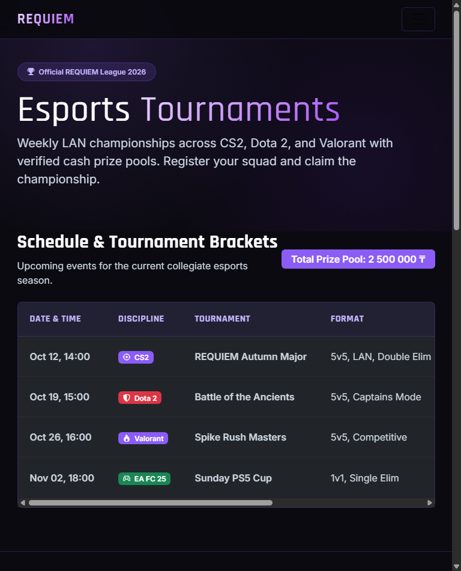
Page 4: tournaments.html (Mandatory Table & Tournaments) — 768px (Tablet)
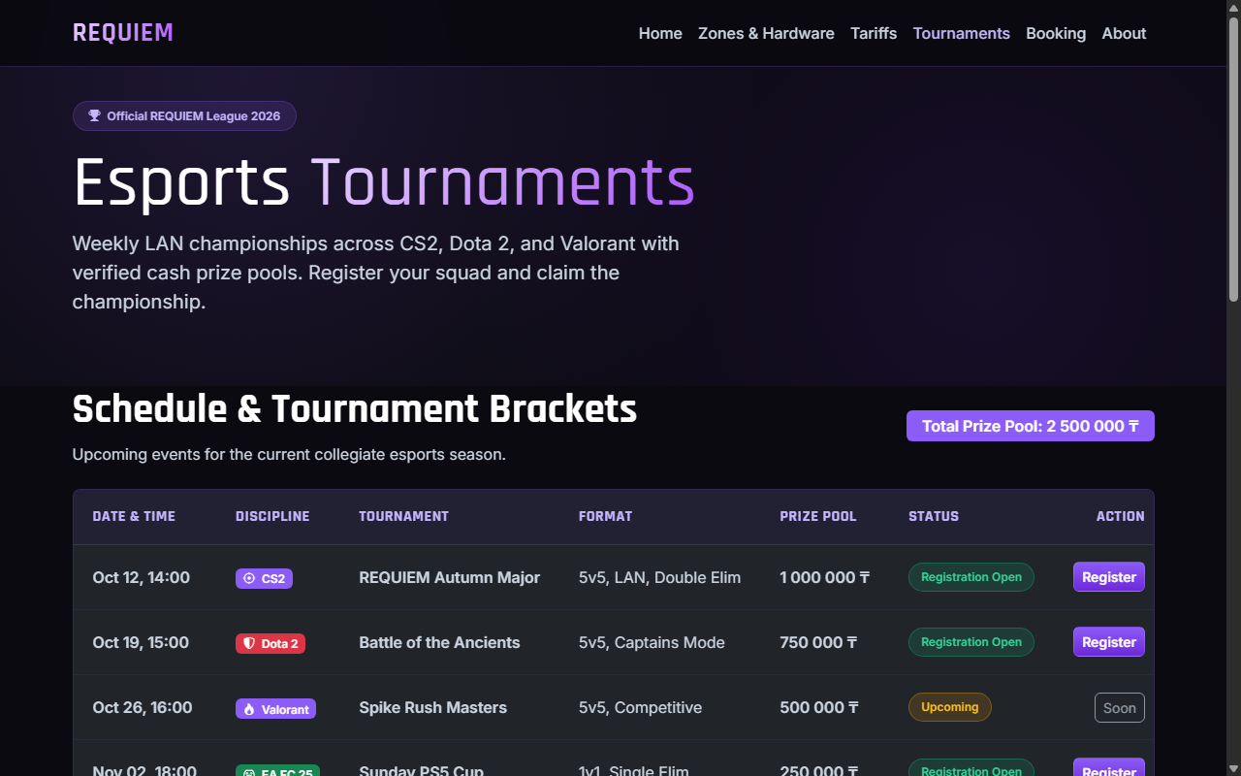
Page 4: tournaments.html (Mandatory Table & Tournaments) — 1280px (Desktop)
• Page 5: booking.html (Mandatory Form & Station Reservation)
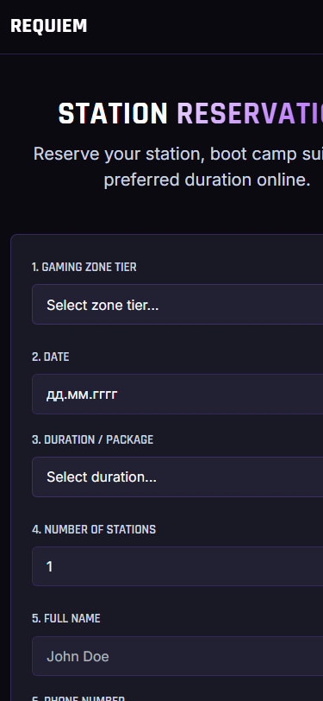
Page 5: booking.html (Mandatory Form & Station Reservation) — 375px (Mobile)
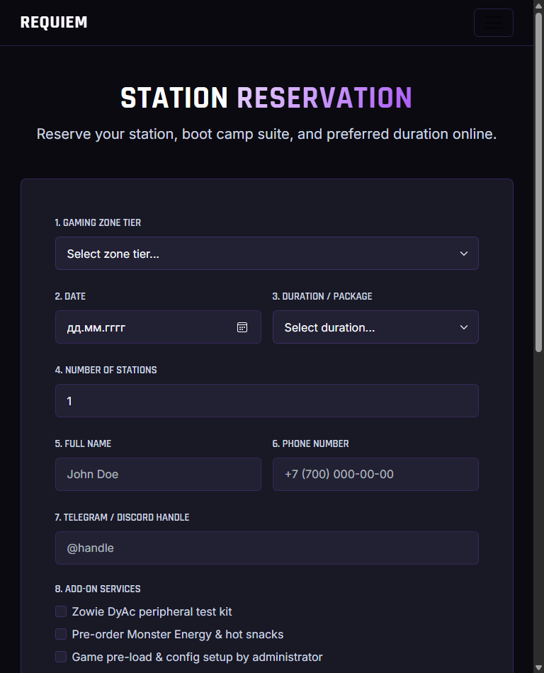
Page 5: booking.html (Mandatory Form & Station Reservation) — 768px (Tablet)
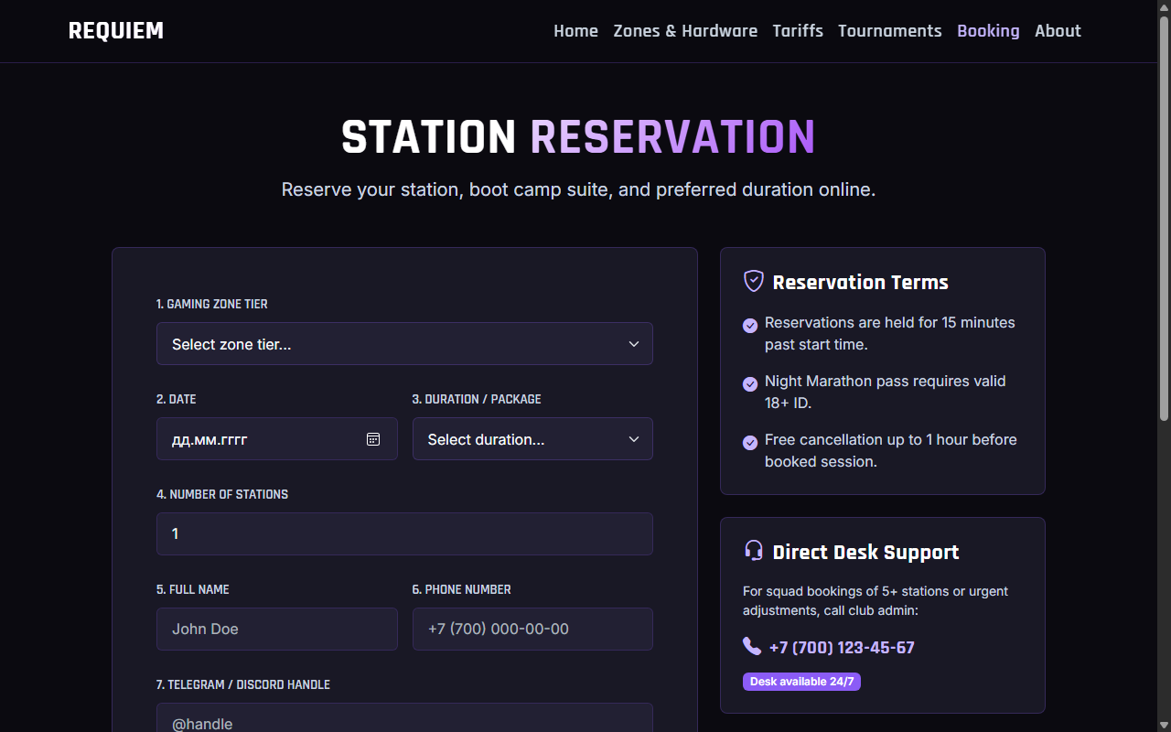
Page 5: booking.html (Mandatory Form & Station Reservation) — 1280px (Desktop)
• Page 6: about.html (Venue, Rules & Contacts)
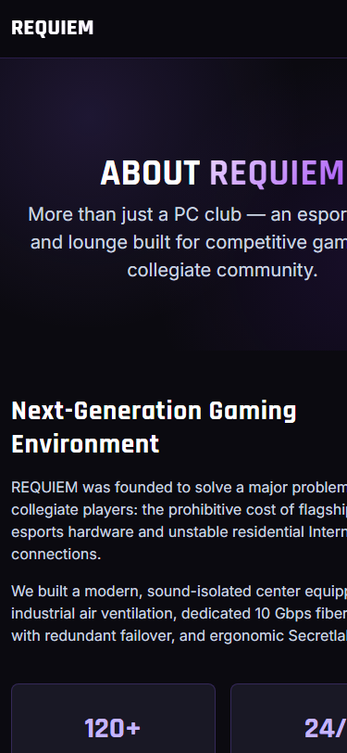
Page 6: about.html (Venue, Rules & Contacts) — 375px (Mobile)
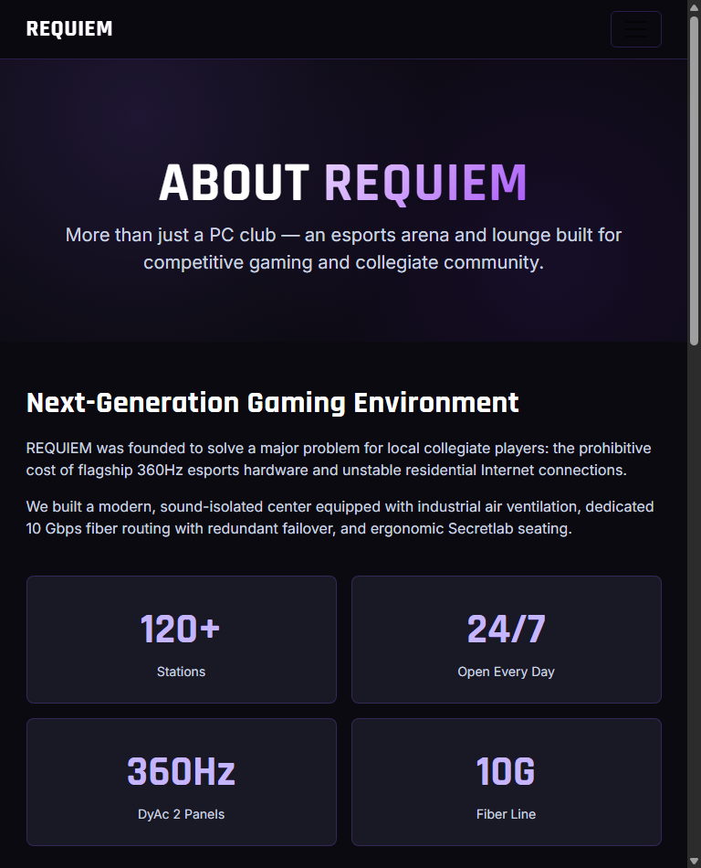
Page 6: about.html (Venue, Rules & Contacts) — 768px (Tablet)
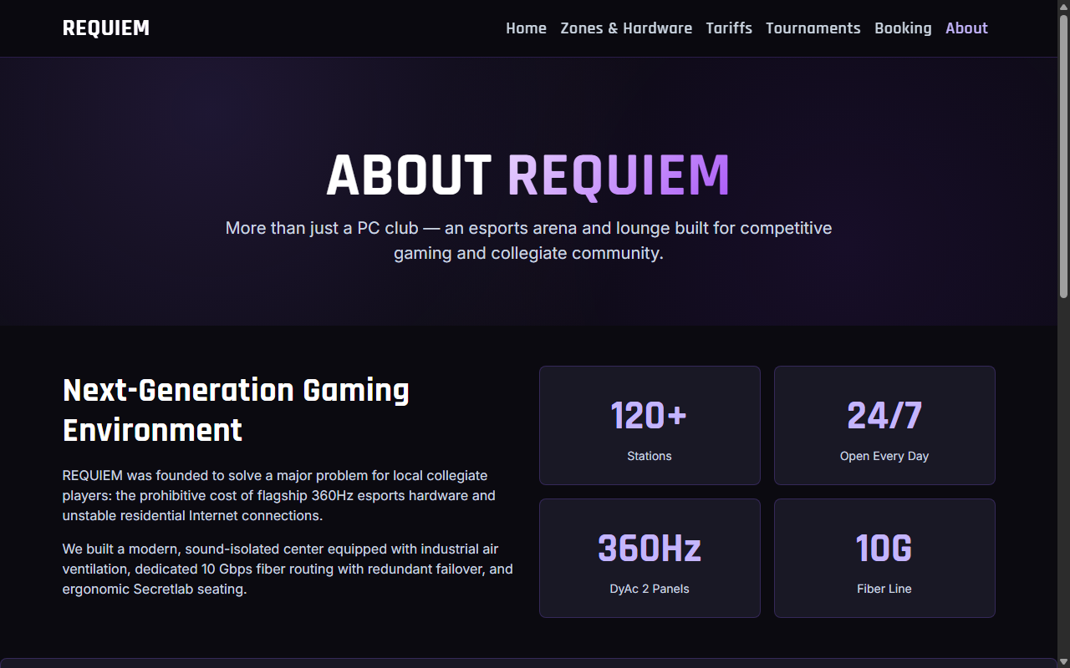
Page 6: about.html (Venue, Rules & Contacts) — 1280px (Desktop)
6. Conclusion
In this Midterm project, our 4-person team engineered a complete 6-page responsive web portal for REQUIEM. We successfully combined semantic HTML5, accessible form architecture, tabular data presentation, and mobile-first responsive design under a cohesive matte dark-violet visual identity. The website functions seamlessly across all target viewports without horizontal scroll.

