Astana IT University
Assignment #4 Report
Forms and Validation (HTML + Bootstrap)
Student: Ramazanov Maxsutkhan | Group: IT-2506
GitHub Repository: https://github.com/poroshok13/webtech4.git

Task 1. Book a Train Ticket (Bootstrap Forms + Custom CSS)
In Task 1, the design of a train ticket booking interface was faithfully reproduced using Bootstrap 5.3 form components and layout utilities, with custom CSS styling applied on top. Zero fixed widths and zero absolute positioning were used, ensuring a fully responsive and clean layout.
Key implementation details:
• Typography & Palette: Applied Google Font 'Montserrat' across all elements. Used the required color palette: primary teal (#0F6B5F), warm amber accent (#F2A93B), deep dark text (#16302B), light neutral background (#F4F7F5), and soft border tint (#E6EFEC).
• Trip Type Selection: Built with two mutually exclusive radio inputs styled as rounded segment pill buttons using Bootstrap's .btn-check mechanism.
• Floating Labels: 'From' and 'To' inputs use Bootstrap's .form-floating components, rendering side-by-side on desktop and stacking neatly on mobile screens.
• Date & Passenger Inputs: Departure date (required), Return date (optional for one-way journeys), and Passengers dropdown (.form-select, constrained to 1–6 adults).
• Carriage Class: A group of three accessible radio inputs ('Seat', 'Coupé', 'Sleeper') with connected labels.
• Input Group & Checkboxes: Phone input features a styled '+7' country prefix badge. Two custom-styled checkboxes are included, with the rules agreement marked required.
• Mobile Order Requirement: On mobile phones (375px), the 'Find trains' button appears ABOVE the 'Clear' button without altering the HTML order. This is achieved via Flexbox utilities: the container uses 'd-flex flex-column flex-sm-row justify-content-sm-end gap-2', with 'Clear' assigned 'order-2 order-sm-1' and 'Find trains' assigned 'order-1 order-sm-2'. The 'Clear' button uses type='reset' to flush form values.

Comparison: Task 1 Original Specification vs Implemented Result
Figure 1.1: Original Assignment Specification (1280px and 375px)
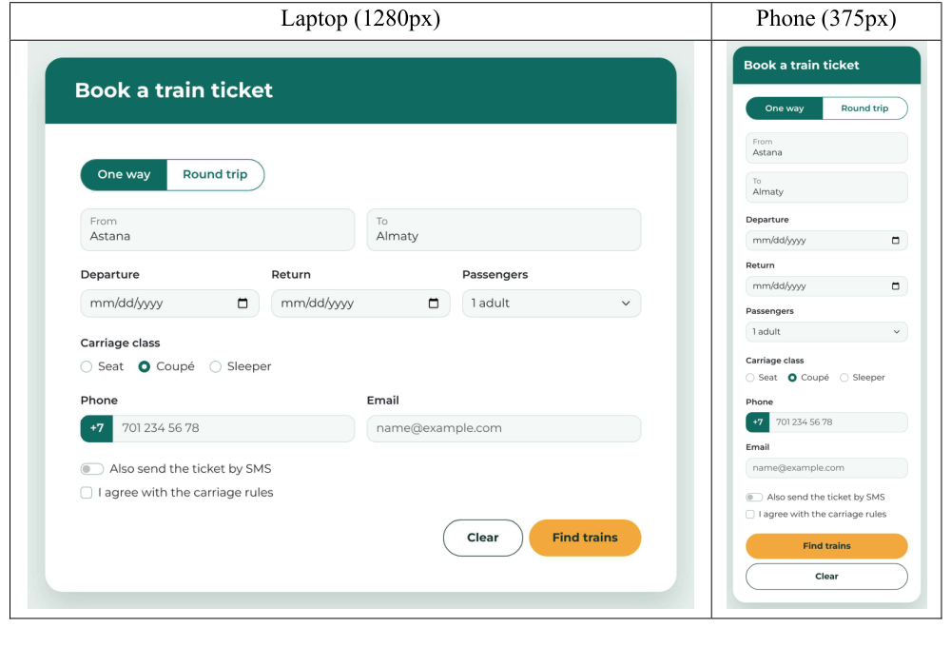
Figure 1.2: Implemented Task 1 at 1280px (Desktop / Laptop View)
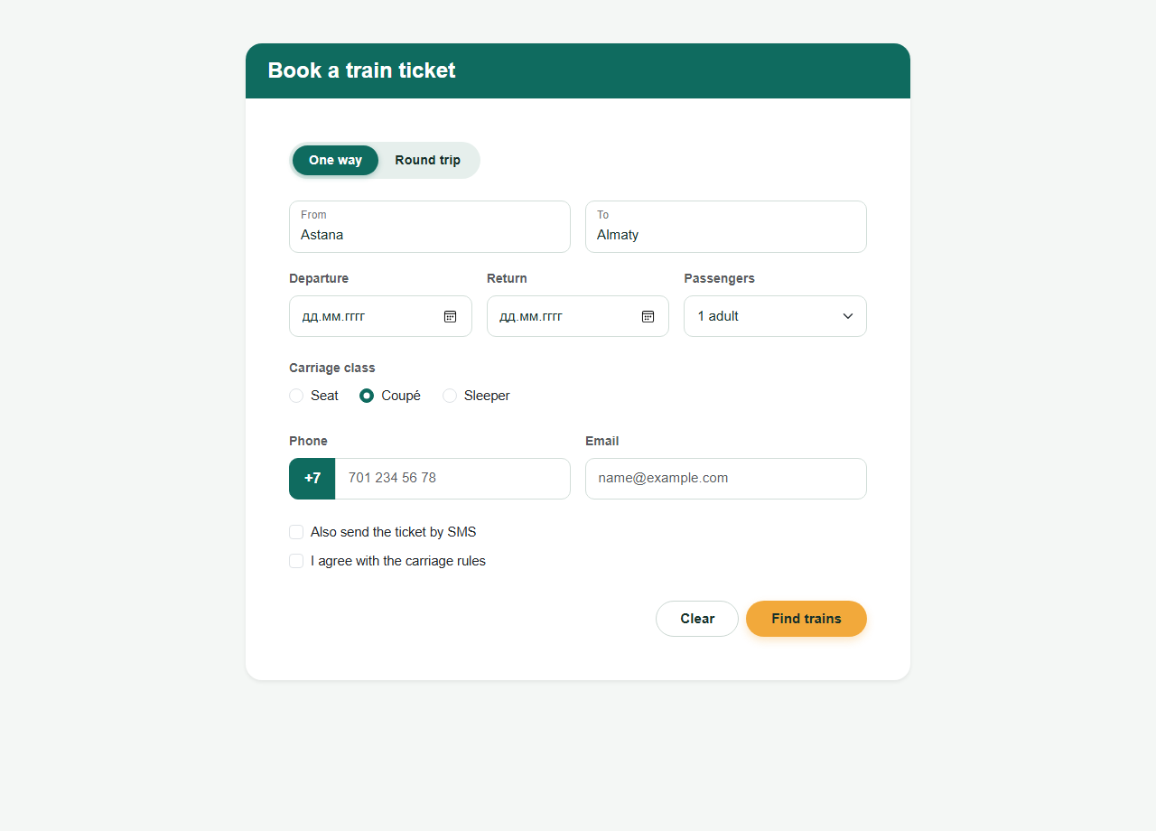
Figure 1.3: Implemented Task 1 at 375px (Mobile Phone View)
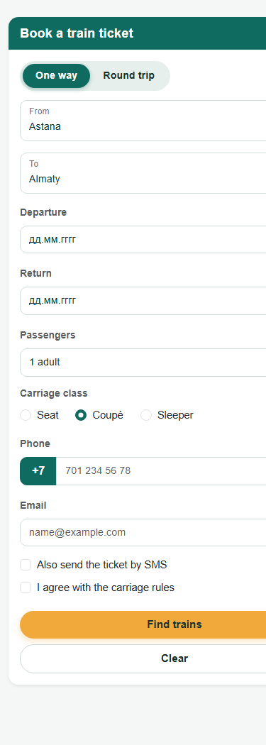

Task 2. Registration for AITU Hack 2026 (HTML Validation)
In Task 2, an accessible student hackathon registration form was engineered strictly with native HTML5 validation attributes. In accordance with the prompt constraints, NO JavaScript validation and NO regex pattern attributes were utilized; instead, appropriate semantic input types and bounds (type, required, min, max, step, minlength, maxlength) were configured so the browser inherently validates data.
Deferred Error Display with :user-invalid:
A critical requirement is that validation error indicators (red borders and .invalid-feedback messages) must NEVER show when the page first opens, but only after the user has interacted with/modified a field. This is implemented using the modern CSS pseudo-classes :user-invalid and :user-valid:
input:user-invalid, select:user-invalid, textarea:user-invalid { border-color: #f43f5e; }
:user-invalid ~ .invalid-feedback, .field-group:has(:user-invalid) > .invalid-feedback { display: block; }
Furthermore, styling was created in an aesthetic dark black and purple theme.

Table 2.1: Native Validation Rules and Test Verification
Field | Rule | HTML Implementation | Must Accept | Must Reject | Result
Full name * | 2–40 characters | type="text" required minlength="2" maxlength="40" | Anna-Maria Lee | A | PASS (Refuses single char)
University email * | Valid email address | type="email" required | a.fedenko@astanait.edu.kz | a.fedenko  a.fedenko@ | PASS (Rejects missing @ and domain)
Age * | Whole number 16 to 30 | type="number" required min="16" max="30" step="1" | 18 | 15, 31 | PASS (Range underflow/overflow)
Team size * | Whole number 1 to 4 | type="number" required min="1" max="4" step="1" | 4 | 5, 2.5 | PASS (step="1" blocks decimal 2.5)
Track * | Web, Mobile, AI, GameDev | select required with disabled placeholder | Web | Choose... | PASS (Blocks default empty prompt)
Arrival day * | 20–22 November 2026 | type="date" required min="2026-11-20" max="2026-11-22" | 21.11.2026 | 25.11.2026 | PASS (Blocks out-of-range dates)
Check-in time * | 09:00–18:00, every 30 min | type="time" required min="09:00" max="18:00" step="1800" | 10:30 | 10:15, 19:00 | PASS (1800s enforces 30m granularity)
Entry fee * | 0–5000 ₸, steps of 500 ₸ | type="number" required min="0" max="5000" step="500" | 1500 | 1250, 6000 | PASS (step mismatch on 1250)
Experience level * | One of three radios | type="radio" name="experienceLevel" required | Beginner | Nothing chosen | PASS (Form submission blocked)
GitHub profile | Optional full link | type="url" (no required) | (empty)  https://github.com/... | github.com/... | PASS (Requires https:// if entered)
Password * | 8–20 characters | type="password" required minlength="8" maxlength="20" | Astana2026 | short | PASS (Blocks passwords < 8 chars)
Motivation * | 50–300 characters | textarea required minlength="50" maxlength="300" | 120 chars | 49 characters | PASS (Blocks texts < 50 chars)
Rules agreement * | Checkbox ticked | type="checkbox" required | Ticked | Not ticked | PASS (Required checkbox enforcement)

Figure 2.1: Task 2 Initial State (Errors are hidden before user interaction)
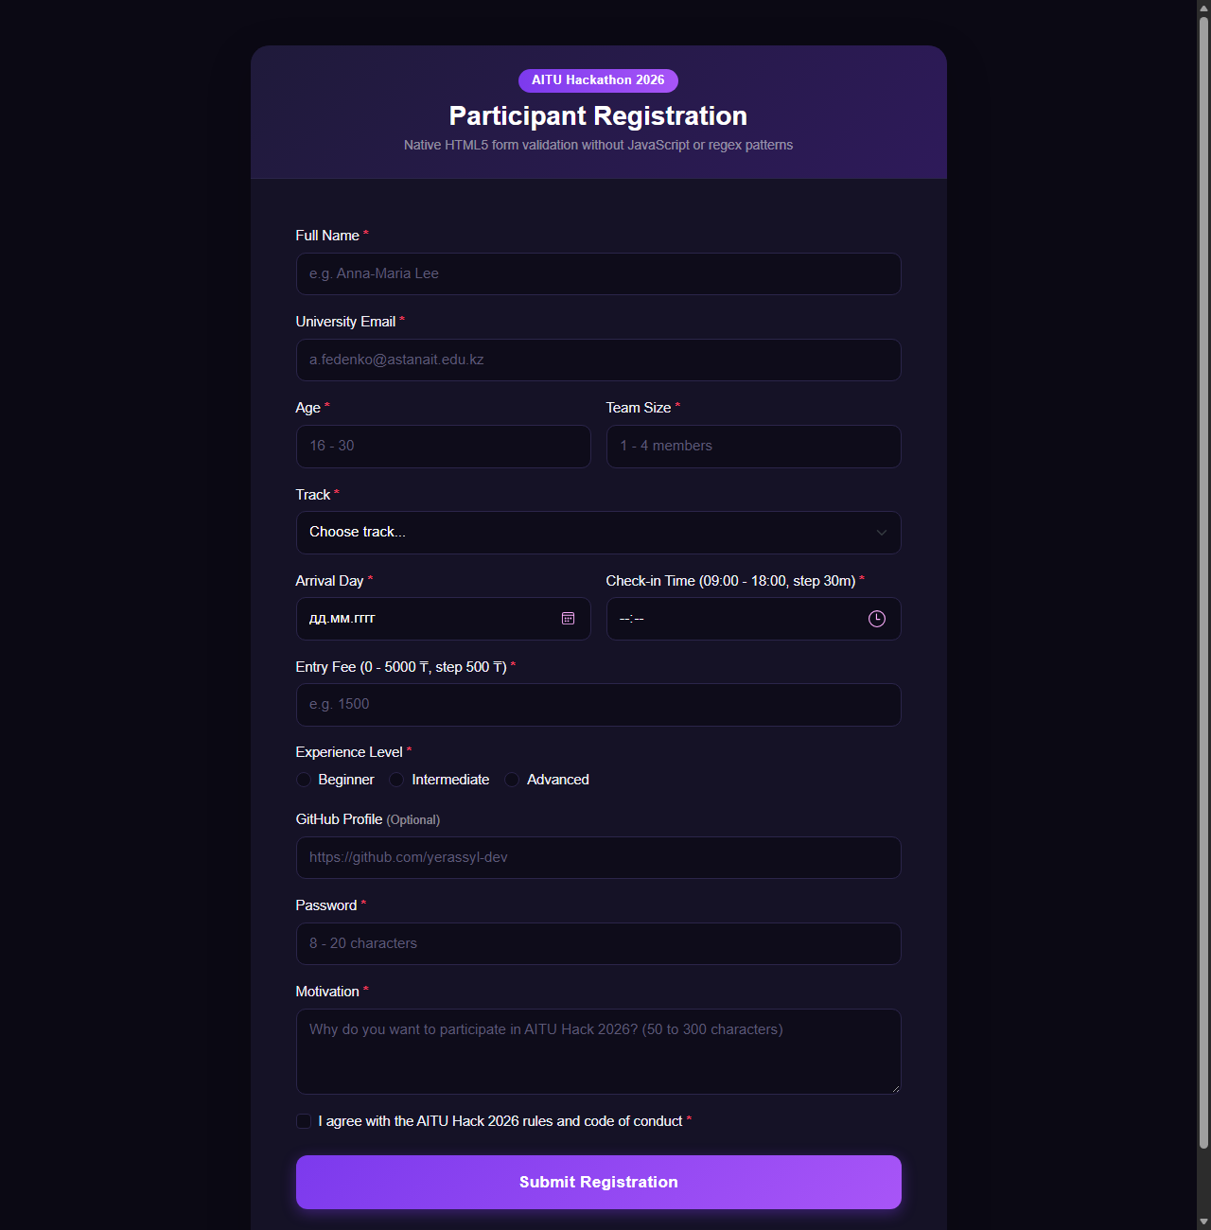
Figure 2.2: Task 2 Invalid Input State (Showing red borders and .invalid-feedback)
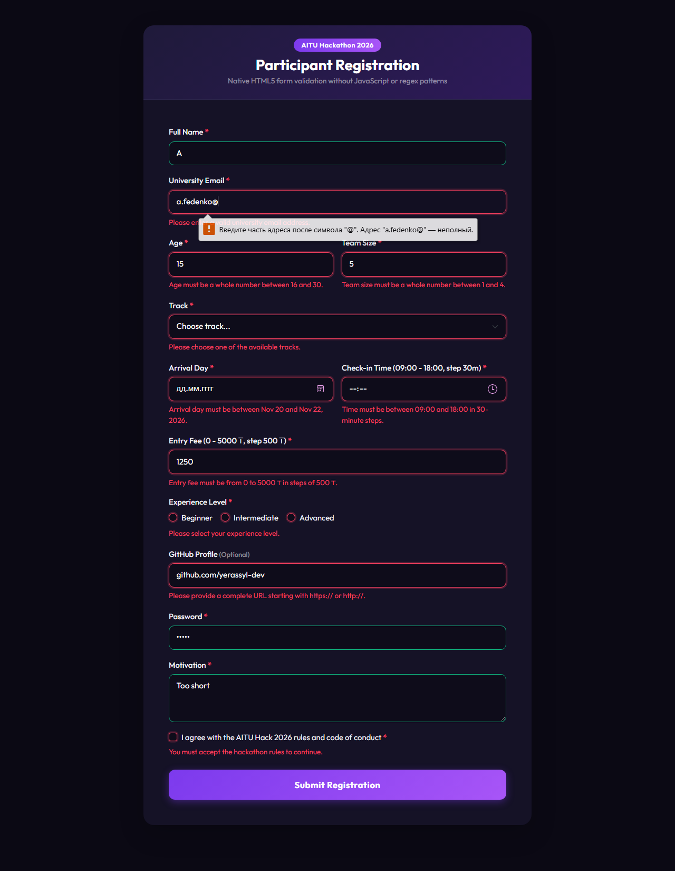
Figure 2.3: Task 2 Valid Input State (Successful verification of all criteria)
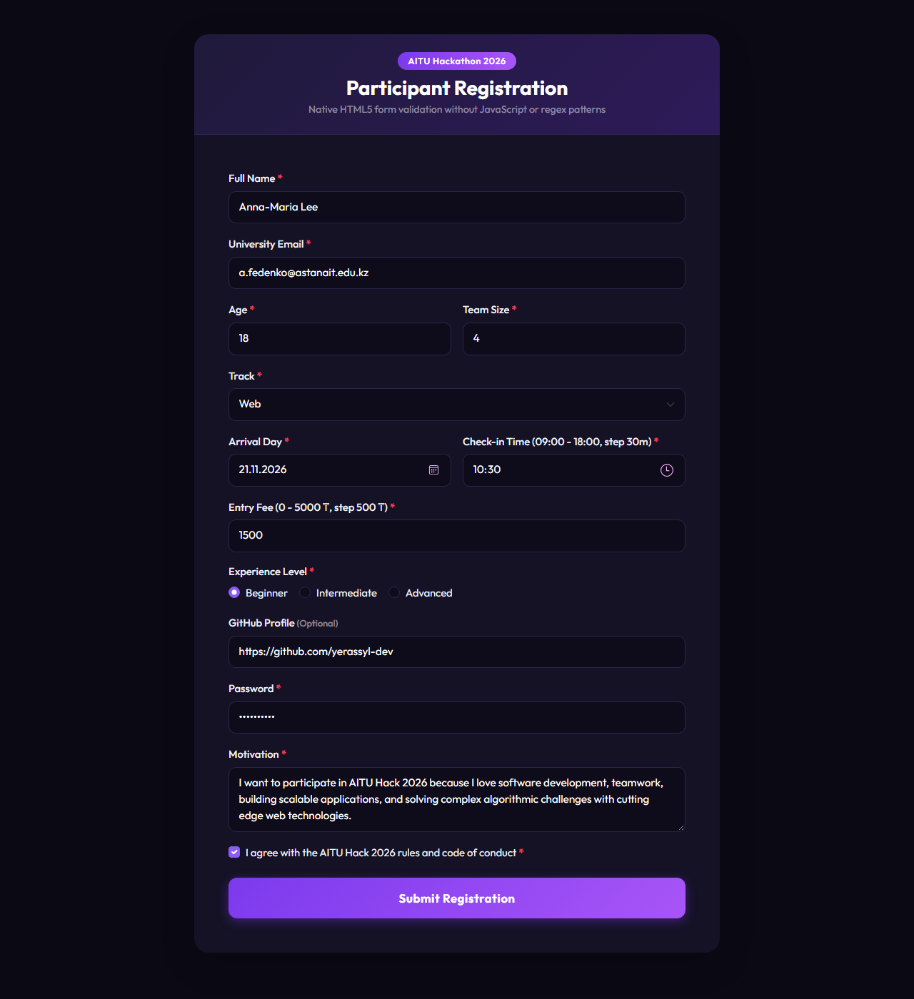

Task 3. Fix a Bad Form (HTML + Bootstrap)
A published café table reservation form was audited for usability, accessibility, keyboard navigation, and data submission flaws. A total of 12 distinct issues were identified, analyzed from the end-user perspective, and rectified in task3.html using Bootstrap 5.3.

Table 3.1: Audit of Problems and Applied Solutions
No. | Line of Code | Problem for User / System | How It Was Fixed
1 | <div class="btn btn-primary">Reserve</div> | A <div> cannot receive keyboard Tab focus, cannot be triggered by Enter, and clicking it does not submit form data or trigger HTML validation. Data is never sent. | Replaced with a semantic <button type="submit" class="btn btn-reserve-submit">Reserve Table</button>.
2 | Missing name attributes on inputs, select, textarea | Form inputs without a 'name' attribute are completely excluded from HTTP request payloads upon submission. The server receives empty form data. | Added descriptive name attributes (name="userName", name="email", name="phone", name="guests", etc.).
3 | <input type="radio" name="inside" ...>  <input type="radio" name="terrace" ...> | Different name attributes break mutual exclusivity. Users can tick both inside and terrace simultaneously, causing ambiguous reservation states. | Unified under a single name attribute: name="seating" with value="inside" and value="terrace".
4 | <input type="radio" ... id="date"> | Duplicate ID: id="date" was already used on the date input above. Duplicate IDs violate HTML W3C standards and break assistive technologies. | Gave each element a distinct, unique ID (id="seatingInside", id="seatingTerrace").
5 | <label for="guests">Guests</label>  <input ... id="people"> | Label 'for' attribute does not match input id ('guests' vs 'people'). Clicking the label does not focus the input; screen readers fail to associate them. | Synchronized label and input identifiers: <label for="guestsCount"> and <input id="guestsCount">.
6 | <label>Phone</label>  <input type="text" id="phone"> | Orphaned label without 'for' attribute. Clicking the label text does nothing, reducing touch hit targets and impairing accessibility. | Added explicit association: <label for="userPhone">Phone</label> and <input id="userPhone">.
7 | Name & Email inputs lack <label> tags | Inputs rely solely on placeholders. Placeholders disappear once typing starts, placing memory burden on users and failing WCAG accessibility guidelines. | Added persistent <label> elements with descriptive text for both Name and Email.
8 | type="text" used for phone, guests, email, date | Generic text inputs prevent mobile devices from displaying appropriate virtual keyboards (numeric keypad, @ sign, date pickers) and prevent format checks. | Used specific semantic types: type="email", type="tel", type="number" (min=1, max=20), and type="date".
9 | <input type="checkbox"> I agree... | Checkbox lacks a connected <label>. Users cannot tap the text to toggle the checkbox, which is cumbersome on touchscreens. | Wrapped with <label for="agreeTerms" class="form-check-label"> and assigned matching ID.
10 | <select>  <option>Lunch</option>... | <select> lacks name attribute, and <option> tags lack value attributes. No disabled prompt option is provided to prevent accidental submissions. | Added name="mealType", explicit value attributes (value="lunch", value="dinner"), and a disabled prompt option.
11 | Absence of required attributes | No validation constraints existed, permitting accidental submission of completely blank table reservations. | Added 'required' attribute to mandatory fields (Name, Email, Phone, Guests, Date, Meal Time, Terms).
12 | No responsive layout or Bootstrap grid | Controls were unformatted inline elements with no spacing or responsive columns, breaking layout on mobile phones. | Enclosed within Bootstrap 5 responsive grid (.row, .col-12, .col-md-6) with modern dark card styling.

Alternative Fixes and Design Decisions for 2 Problems
1. Problem #1 (<div class="btn"> vs Button Element):
• Alternative Fix: Using an input submit element: <input type="submit" class="btn btn-primary" value="Reserve Table">.
• Why our choice was chosen: We chose <button type="submit"> over <input type="submit"> because the button element provides greater flexibility for nested content (e.g., custom SVG icons, loading spinners, and styled typography) while maintaining complete native form submission and keyboard accessibility.
2. Problem #3 (Broken Seating Radio Group):
• Alternative Fix: Replacing the radio group with a dropdown select element: <select name="seating"><option value="inside">Inside</option><option value="terrace">Terrace</option></select>.
• Why our choice was chosen: Since there are only two mutually exclusive seating options, radio buttons are superior in usability. Radio buttons expose all available options simultaneously without requiring an additional click to open a menu, enabling faster one-tap selection on mobile devices.
Figure 3.1: Rebuilt Café Reservation Form at 1280px (Desktop View)
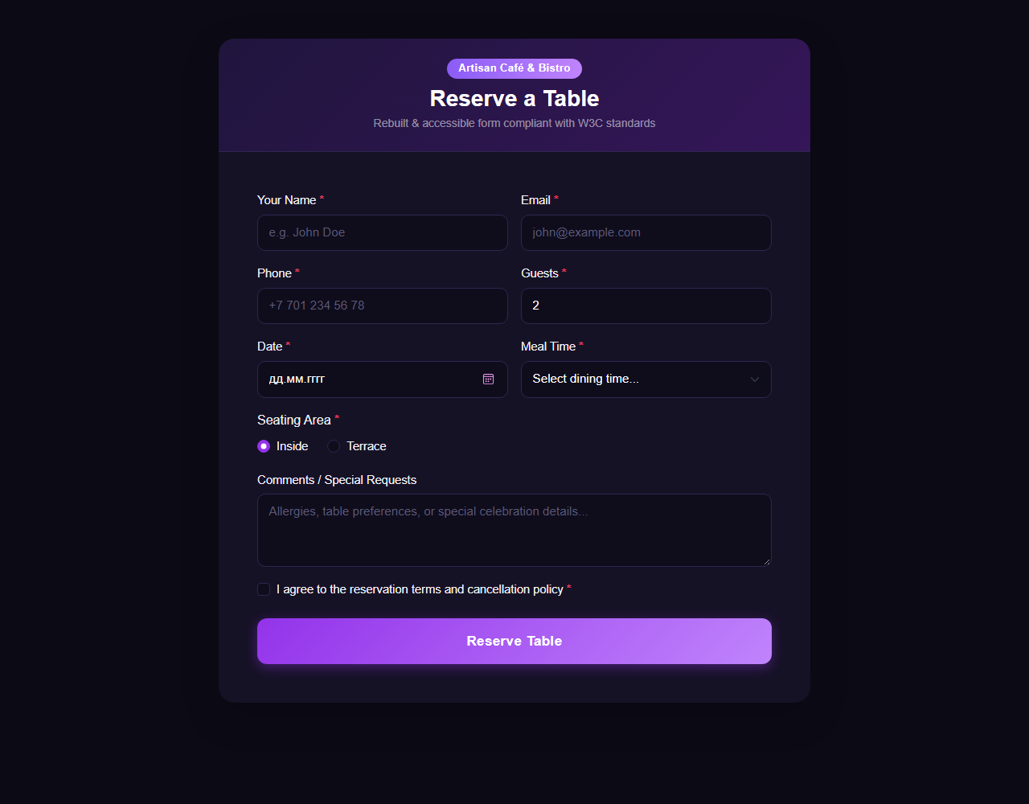
Figure 3.2: Rebuilt Café Reservation Form at 375px (Mobile Phone View)
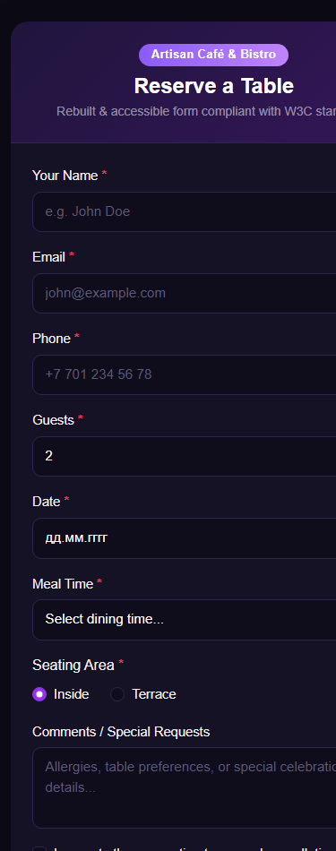

Conclusion
Through completing Assignment 4, several fundamental web engineering competencies were reinforced:
1. Advanced Native HTML5 Validation: Experienced firsthand the power of built-in browser validation mechanisms. By using appropriate semantic types, boundaries (min, max), step intervals (e.g. step=1800 for 30-minute time intervals), and length constraints, robust client-side validation can be achieved without writing fragile JavaScript regex patterns.
2. Modern User Experience with :user-invalid: Mastered the integration of CSS pseudo-classes (:user-invalid and :user-valid) to ensure error feedback is unobtrusive and presented only when a user actually interacts with a field.
3. Responsive Layouts & Flexbox Ordering: Implemented mobile-first layouts using Bootstrap 5.3 utilities and custom CSS, effectively solving real-world responsive constraints such as reordering action buttons on mobile screens without polluting or rearranging the underlying HTML document structure.
4. Web Accessibility & Usability (WCAG): Gained deep practical awareness of common accessibility traps in web forms—orphaned labels, missing name attributes, duplicate IDs, non-interactive div buttons, and inaccessible placeholders—and learned how to build accessible, keyboard-operable, and W3C-valid web applications.

Submission Details
• Author: Ramazanov Maxsutkhan
• Group: IT-2506
• Course: Web Technologies
• GitHub Repository: https://github.com/poroshok13/webtech4.git

