Computer Assignment 2

CPE 261456 (Introduction to Computational Intelligence)

โดย

นายพีรณัฐ ธารทะเลทอง

รหัสนักศึกษา 550610530

เสนอ

ผศ.ดร. ศันสนีย์ เอื้อพันธ์วิริยะกุล

คณะวิศวกรรมศาสตร์ มหาวิทยาลัยเชียงใหม่

**Steak Fuzzy Logic Simulator**

เป็นระบบควบคุมความแรงของไฟในการย่างสเต็ก

**ลักษณะการทำงานของระบบ รวมถึง rules ที่ใช้**

**Input**

1. เวลา (Time) มี 3 ระดับคือ SHORT MEDIUM LONG

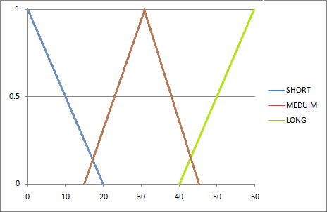Membership function

1. ขนาด (Size) มี 3 ระดับคือ SMALL MEDIUM BIG

Membership function

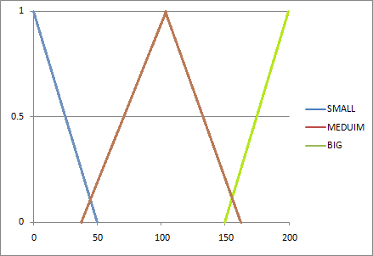

1. ความแข็งของเนื้อ (Hardness) มี 3 ระดับคือFEW MEDIUM VERY

Membership function

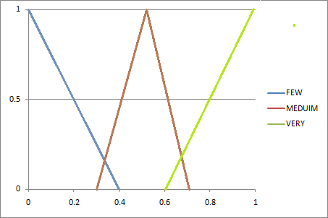

**Output**

ความแรงของไฟที่จะใช้ย่างสเต็ก (Fire) มี 3 ระดับคือ SOFT MEDIUM HARD

Membership function

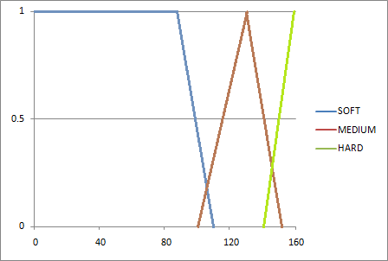

**Rules**

1. If Time is **SHORT** and Size is **SMALL** and Hardness is **FEW** then Fire is **SOFT**
2. If Time is **SHORT** and Size is **SMALL** and Hardness is **MEDIUM** then Fire is **SOFT**
3. If Time is **SHORT** and Size is **SMALL** and Hardness is **BIG** then Fire is **SOFT**
4. If Time is **SHORT** and Size is **MEDIUM** and Hardness is **FEW** then Fire is **HARD**
5. If Time is **SHORT** and Size is **MEDIUM** and Hardness is **MEDIUM** then Fire is **HARD**
6. If Time is **SHORT** and Size is **MEDIUM** and Hardness is **BIG** then Fire is **HARD**
7. If Time is **SHORT** and Size is **BIG** and Hardness is **FEW** then Fire is **HARD**
8. If Time is **SHORT** and Size is **BIG** and Hardness is **MEDIUM** then Fire is **HARD**
9. If Time is **SHORT** and Size is **BIG** and Hardness is **BIG** then Fire is **HARD**
10. If Time is **MEDIUM** and Size is **SMALL** and Hardness is **FEW** then Fire is **SOFT**
11. If Time is **MEDIUM** and Size is **SMALL** and Hardness is **MEDIUM** then Fire is **SOFT**
12. If Time is **MEDIUM** and Size is **SMALL** and Hardness is **BIG** then Fire is **SOFT**
13. If Time is **MEDIUM** and Size is **MEDIUM** and Hardness is **FEW** then Fire is **MEDIUM**
14. If Time is **MEDIUM** and Size is **MEDIUM** and Hardness is **MEDIUM** then Fire is **MEDIUM**
15. If Time is **MEDIUM** and Size is **MEDIUM** and Hardness is **BIG** then Fire is **MEDIUM**
16. If Time is **MEDIUM** and Size is **BIG** and Hardness is **FEW** then Fire is **HARD**
17. If Time is **MEDIUM** and Size is **BIG** and Hardness is **MEDIUM** then Fire is **HARD**
18. If Time is **MEDIUM** and Size is **BIG** and Hardness is **BIG** then Fire is **HARD**
19. If Time is **LONG** and Size is **SMALL** and Hardness is **FEW** then Fire is **SOFT**
20. If Time is **LONG** and Size is **SMALL** and Hardness is **MEDIUM** then Fire is **SOFT**
21. If Time is **LONG** and Size is **SMALL** and Hardness is **BIG** then Fire is **SOFT**
22. If Time is **LONG** and Size is **MEDIUM** and Hardness is **FEW** then Fire is **SOFT**
23. If Time is **LONG** and Size is **MEDIUM** and Hardness is **MEDIUM** then Fire is **SOFT**
24. If Time is **LONG** and Size is **MEDIUM** and Hardness is **BIG** then Fire is **SOFT**
25. If Time is **LONG** and Size is **BIG** and Hardness is **FEW** then Fire is **HARD**
26. If Time is **LONG** and Size is **BIG** and Hardness is **MEDIUM** then Fire is **HARD**
27. If Time is **LONG** and Size is **BIG** and Hardness is **BIG** then Fire is **HARD**

**Simulation ของระบบ**

สมมติให้ Input Time = 40, Size = 100, Hardness = 0.5

1. 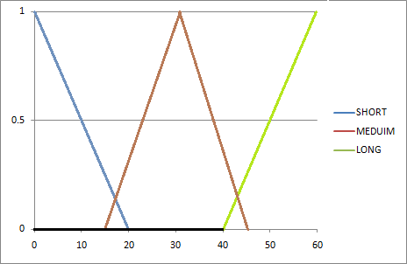If Time is **SHORT** and Size is **SMALL** and Hardness is **FEW** then Fire is **SOFT**

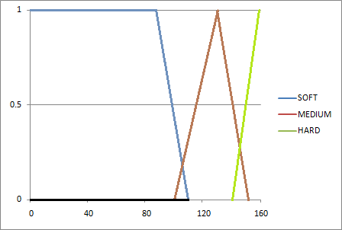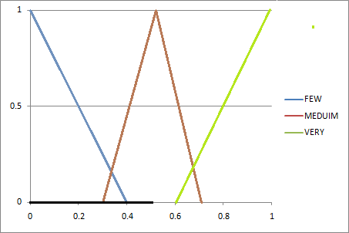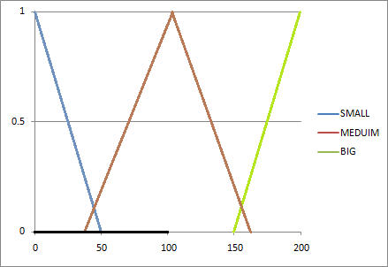

1. If Time is **SHORT** and Size is **SMALL** and Hardness is **MEDIUM** then Fire is **SOFT**

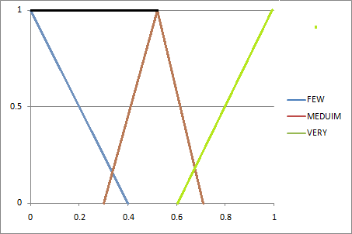

1. If Time is **SHORT** and Size is **SMALL** and Hardness is **BIG** then Fire is **SOFT**



1. If Time is **SHORT** and Size is **MEDIUM** and Hardness is **FEW** then Fire is **HARD**

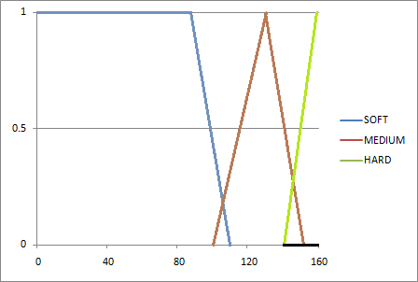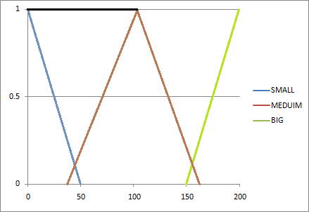

1. If Time is **SHORT** and Size is **MEDIUM** and Hardness is **MEDIUM** then Fire is **HARD**



1. If Time is **SHORT** and Size is **MEDIUM** and Hardness is **BIG** then Fire is **HARD**
2. If Time is **SHORT** and Size is **BIG** and Hardness is **FEW** then Fire is **HARD**



1. If Time is **SHORT** and Size is **BIG** and Hardness is **MEDIUM** then Fire is **HARD**
2. If Time is **SHORT** and Size is **BIG** and Hardness is **BIG** then Fire is **HARD**



1. If Time is **MEDIUM** and Size is **SMALL** and Hardness is **FEW** then Fire is **SOFT**

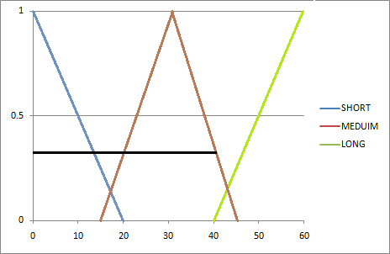

1. If Time is **MEDIUM** and Size is **SMALL** and Hardness is **MEDIUM** then Fire is **SOFT**
2. If Time is **MEDIUM** and Size is **SMALL** and Hardness is **BIG** then Fire is **SOFT**
3. If Time is **MEDIUM** and Size is **MEDIUM** and Hardness is **FEW** then Fire is **MEDIUM**

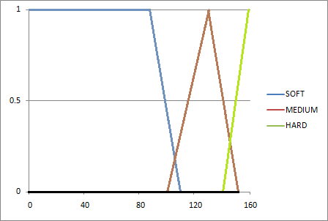

1. If Time is **MEDIUM** and Size is **MEDIUM** and Hardness is **MEDIUM** then Fire is **MEDIUM**

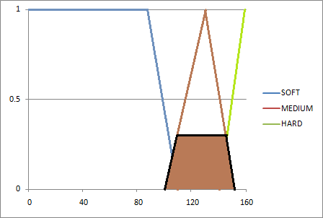

1. If Time is **MEDIUM** and Size is **MEDIUM** and Hardness is **BIG** then Fire is **MEDIUM**



1. If Time is **MEDIUM** and Size is **BIG** and Hardness is **FEW** then Fire is **HARD**
2. If Time is **MEDIUM** and Size is **BIG** and Hardness is **MEDIUM** then Fire is **HARD**
3. If Time is **MEDIUM** and Size is **BIG** and Hardness is **BIG** then Fire is **HARD**
4. If Time is **LONG** and Size is **SMALL** and Hardness is **FEW** then Fire is **SOFT**
5. If Time is **LONG** and Size is **SMALL** and Hardness is **MEDIUM** then Fire is **SOFT**
6. If Time is **LONG** and Size is **SMALL** and Hardness is **BIG** then Fire is **SOFT**
7. If Time is **LONG** and Size is **MEDIUM** and Hardness is **FEW** then Fire is **SOFT**
8. If Time is **LONG** and Size is **MEDIUM** and Hardness is **MEDIUM** then Fire is **SOFT**
9. If Time is **LONG** and Size is **MEDIUM** and Hardness is **BIG** then Fire is **SOFT**
10. If Time is **LONG** and Size is **BIG** and Hardness is **FEW** then Fire is **HARD**
11. If Time is **LONG** and Size is **BIG** and Hardness is **MEDIUM** then Fire is **HARD**
12. If Time is **LONG** and Size is **BIG** and Hardness is **BIG** then Fire is **HARD**

**Output ที่ได้**

จากนั้นทำ defuzzification โดยการหา centroid

ซึ่งได้ค่าความแรงของไฟ = 124.99999999999984 °c

**การทดลอง**

ให้ Input Time = 20, Size = 190, Hardness = 0.9

Output fire = 151.81632653061232 °c

ให้ Input Time = 40, Size = 100, Hardness = 0.5

Output fire = 124.99999999999984 °c

ให้ Input Time = 41, Size = 150, Hardness = 0.5

Output fire = 95.14259453781511 °c

**วิเคราะห์ผลการทดลอง**

จากการทดลองโดยการปรับค่า เวลาที่จะใช้ (Time), ขนาดของเนื้อ(Size), ความแข็งของเนื้อ (Hardness) คำตอบที่ได้นั้นเป็นไปตามกฎที่ได้ตั้งไว้ข้างต้น ซึ่งกฎนี้สามารถปรับเปลี่ยนได้ตามความเหมาะสม

**Code** (https://github.com/porpeeranut/Computational_Intelligence_Assignment2 )

**// Main.java**

import java.util.ArrayList;

import java.util.HashMap;

public class Main {

public static void main(String[] args) {

HashMap<Enum, Graph> mfTime = new HashMap<Enum, Graph>();

mfTime.put(TimeLevel.SHORT, new Graph(0, 20));

mfTime.put(TimeLevel.MEDIUM, new Graph(15, 45));

mfTime.put(TimeLevel.LONG, new Graph(40, 60));

HashMap<Enum, Graph> mfSize = new HashMap<Enum, Graph>();

mfSize.put(SizeLevel.SMALL, new Graph(0, 50));

mfSize.put(SizeLevel.MEDIUM, new Graph(40, 160));

mfSize.put(SizeLevel.BIG, new Graph(150, 200));

HashMap<Enum, Graph> mfHardness = new HashMap<Enum, Graph>();

mfHardness.put(HardnessLevel.FEW, new Graph(0, 0.4));

mfHardness.put(HardnessLevel.MEDIUM, new Graph(0.3, 0.7));

mfHardness.put(HardnessLevel.VERY, new Graph(0.6, 1));

HashMap<Enum, Graph> mfFire = new HashMap<Enum, Graph>();

mfFire.put(FireLevel.SOFT, new Graph(90, 110));

mfFire.put(FireLevel.MEDIUM, new Graph(100, 150));

mfFire.put(FireLevel.HARD, new Graph(140, 160));

HashMap<Fuzzy, Data> input = new HashMap<Fuzzy, Data>() ;

input.put(Fuzzy.TIME, new Data(mfTime, new Range(0, 60, 1)));

input.put(Fuzzy.SIZE, new Data(mfSize, new Range(0, 200, 1)));

input.put(Fuzzy.HARDNESS, new Data(mfHardness, new Range(0, 1, 0.05)));

HashMap<Fuzzy, Data> output = new HashMap<Fuzzy, Data>();

output.put(Fuzzy.FIRE, new Data(mfFire, new Range(0, 160, 1)));

ArrayList<Rule> rules = new ArrayList<Rule>();

/*addRule(TimeLevel.SHORT, SizeLevel.SMALL, HardnessLevel.FEW, FireLevel.SOFT, rules);

addRule(TimeLevel.SHORT, SizeLevel.SMALL, HardnessLevel.MEDIUM, FireLevel.MEDIUM, rules);

addRule(TimeLevel.SHORT, SizeLevel.SMALL, HardnessLevel.VERY, FireLevel.MEDIUM, rules);

addRule(TimeLevel.SHORT, SizeLevel.MEDIUM, HardnessLevel.FEW, FireLevel.MEDIUM, rules);

addRule(TimeLevel.SHORT, SizeLevel.MEDIUM, HardnessLevel.MEDIUM, FireLevel.HARD, rules);

addRule(TimeLevel.SHORT, SizeLevel.MEDIUM, HardnessLevel.VERY, FireLevel.HARD, rules);

addRule(TimeLevel.SHORT, SizeLevel.BIG, HardnessLevel.FEW, FireLevel.MEDIUM, rules);

addRule(TimeLevel.SHORT, SizeLevel.BIG, HardnessLevel.MEDIUM, FireLevel.HARD, rules);

addRule(TimeLevel.SHORT, SizeLevel.BIG, HardnessLevel.VERY, FireLevel.HARD, rules);

addRule(TimeLevel.MEDIUM, SizeLevel.SMALL, HardnessLevel.FEW, FireLevel.SOFT, rules);

addRule(TimeLevel.MEDIUM, SizeLevel.SMALL, HardnessLevel.MEDIUM, FireLevel.SOFT, rules);

addRule(TimeLevel.MEDIUM, SizeLevel.SMALL, HardnessLevel.VERY, FireLevel.MEDIUM, rules);

addRule(TimeLevel.MEDIUM, SizeLevel.MEDIUM, HardnessLevel.FEW, FireLevel.SOFT, rules);

addRule(TimeLevel.MEDIUM, SizeLevel.MEDIUM, HardnessLevel.MEDIUM, FireLevel.MEDIUM, rules);

addRule(TimeLevel.MEDIUM, SizeLevel.MEDIUM, HardnessLevel.VERY, FireLevel.HARD, rules);

addRule(TimeLevel.MEDIUM, SizeLevel.BIG, HardnessLevel.FEW, FireLevel.MEDIUM, rules);

addRule(TimeLevel.MEDIUM, SizeLevel.BIG, HardnessLevel.MEDIUM, FireLevel.HARD, rules);

addRule(TimeLevel.MEDIUM, SizeLevel.BIG, HardnessLevel.VERY, FireLevel.HARD, rules);

addRule(TimeLevel.LONG, SizeLevel.SMALL, HardnessLevel.FEW, FireLevel.SOFT, rules);

addRule(TimeLevel.LONG, SizeLevel.SMALL, HardnessLevel.MEDIUM, FireLevel.SOFT, rules);

addRule(TimeLevel.LONG, SizeLevel.SMALL, HardnessLevel.VERY, FireLevel.MEDIUM, rules);

addRule(TimeLevel.LONG, SizeLevel.MEDIUM, HardnessLevel.FEW, FireLevel.SOFT, rules);

addRule(TimeLevel.LONG, SizeLevel.MEDIUM, HardnessLevel.MEDIUM, FireLevel.SOFT, rules);

addRule(TimeLevel.LONG, SizeLevel.MEDIUM, HardnessLevel.VERY, FireLevel.MEDIUM, rules);

addRule(TimeLevel.LONG, SizeLevel.BIG, HardnessLevel.FEW, FireLevel.MEDIUM, rules);

addRule(TimeLevel.LONG, SizeLevel.BIG, HardnessLevel.MEDIUM, FireLevel.MEDIUM, rules);

addRule(TimeLevel.LONG, SizeLevel.BIG, HardnessLevel.VERY, FireLevel.HARD, rules);*/

addRule(TimeLevel.SHORT, SizeLevel.SMALL, HardnessLevel.FEW, FireLevel.SOFT, rules);

addRule(TimeLevel.SHORT, SizeLevel.SMALL, HardnessLevel.MEDIUM, FireLevel.SOFT, rules);

addRule(TimeLevel.SHORT, SizeLevel.SMALL, HardnessLevel.VERY, FireLevel.SOFT, rules);

addRule(TimeLevel.SHORT, SizeLevel.MEDIUM, HardnessLevel.FEW, FireLevel.HARD, rules);

addRule(TimeLevel.SHORT, SizeLevel.MEDIUM, HardnessLevel.MEDIUM, FireLevel.HARD, rules);

addRule(TimeLevel.SHORT, SizeLevel.MEDIUM, HardnessLevel.VERY, FireLevel.HARD, rules);

addRule(TimeLevel.SHORT, SizeLevel.BIG, HardnessLevel.FEW, FireLevel.HARD, rules);

addRule(TimeLevel.SHORT, SizeLevel.BIG, HardnessLevel.MEDIUM, FireLevel.HARD, rules);

addRule(TimeLevel.SHORT, SizeLevel.BIG, HardnessLevel.VERY, FireLevel.HARD, rules);

addRule(TimeLevel.MEDIUM, SizeLevel.SMALL, HardnessLevel.FEW, FireLevel.SOFT, rules);

addRule(TimeLevel.MEDIUM, SizeLevel.SMALL, HardnessLevel.MEDIUM, FireLevel.SOFT, rules);

addRule(TimeLevel.MEDIUM, SizeLevel.SMALL, HardnessLevel.VERY, FireLevel.SOFT, rules);

addRule(TimeLevel.MEDIUM, SizeLevel.MEDIUM, HardnessLevel.FEW, FireLevel.MEDIUM, rules);

addRule(TimeLevel.MEDIUM, SizeLevel.MEDIUM, HardnessLevel.MEDIUM, FireLevel.MEDIUM, rules);

addRule(TimeLevel.MEDIUM, SizeLevel.MEDIUM, HardnessLevel.VERY, FireLevel.MEDIUM, rules);

addRule(TimeLevel.MEDIUM, SizeLevel.BIG, HardnessLevel.FEW, FireLevel.HARD, rules);

addRule(TimeLevel.MEDIUM, SizeLevel.BIG, HardnessLevel.MEDIUM, FireLevel.HARD, rules);

addRule(TimeLevel.MEDIUM, SizeLevel.BIG, HardnessLevel.VERY, FireLevel.HARD, rules);

addRule(TimeLevel.LONG, SizeLevel.SMALL, HardnessLevel.FEW, FireLevel.SOFT, rules);

addRule(TimeLevel.LONG, SizeLevel.SMALL, HardnessLevel.MEDIUM, FireLevel.SOFT, rules);

addRule(TimeLevel.LONG, SizeLevel.SMALL, HardnessLevel.VERY, FireLevel.SOFT, rules);

addRule(TimeLevel.LONG, SizeLevel.MEDIUM, HardnessLevel.FEW, FireLevel.SOFT, rules);

addRule(TimeLevel.LONG, SizeLevel.MEDIUM, HardnessLevel.MEDIUM, FireLevel.SOFT, rules);

addRule(TimeLevel.LONG, SizeLevel.MEDIUM, HardnessLevel.VERY, FireLevel.SOFT, rules);

addRule(TimeLevel.LONG, SizeLevel.BIG, HardnessLevel.FEW, FireLevel.HARD, rules);

addRule(TimeLevel.LONG, SizeLevel.BIG, HardnessLevel.MEDIUM, FireLevel.HARD, rules);

addRule(TimeLevel.LONG, SizeLevel.BIG, HardnessLevel.VERY, FireLevel.HARD, rules);

SteakFuzzyLogic steakFuzzy = new SteakFuzzyLogic(input, output, rules);

//System.out.println(steakFuzzy.defuz(20, 190, 0.9)+" °c\n"); //> 150

//System.out.println(steakFuzzy.defuz(40, 100, 0.5)+" °c\n"); //>124

System.out.println(steakFuzzy.defuz(41, 150, 0.9)+" °c\n"); //>95

}

static void addRule(TimeLevel tLevel, SizeLevel sLevel, HardnessLevel hLevel, FireLevel fLevel, ArrayList<Rule> rules) {

ArrayList<RuleData> ifRule = new ArrayList<RuleData>();

ifRule.add(new RuleData(Fuzzy.TIME, tLevel));

ifRule.add(new RuleData(Fuzzy.SIZE, sLevel));

ifRule.add(new RuleData(Fuzzy.HARDNESS, hLevel));

RuleData thenRule = new RuleData(Fuzzy.FIRE, fLevel);

rules.add(new Rule(ifRule, thenRule));

}

}

// SteakFuzzyLogic.java

import java.util.ArrayList;

import java.util.HashMap;

import java.util.Map.Entry;

public class SteakFuzzyLogic {

HashMap<Fuzzy, Data> input;

HashMap<Fuzzy, Data> output;

ArrayList<Rule> rules;

double maxFireSoft = 0;

double maxFireMed = 0;

double maxFireHard = 0;

public SteakFuzzyLogic(HashMap<Fuzzy, Data> input, HashMap<Fuzzy, Data> output, ArrayList<Rule> rules) {

this.input = input;

this.output = output;

this.rules = rules;

}

double defuz(double time, double size, double hardness) {

maxFireSoft = 0;

maxFireMed = 0;

maxFireHard = 0;

int r = 1;

boolean debug = false;

for(Rule rule : rules) {

double minInRule = 1;

if (debug) {

System.out.print ("#"+r+" ");

}

for(RuleData ruleData : rule.ifRule) {

// ifRule.add(new RuleData(Fuzzy.TIME, TimeLevel.SHORT));

// input.put(Fuzzy.TIME, new Data(mfTime, new Range(0, 60, 1)));

double tmp = 0;

if (ruleData.fuzzy == Fuzzy.TIME) {

if (ruleData.level == TimeLevel.SHORT) {

tmp = input.get(Fuzzy.TIME).mf.get(TimeLevel.SHORT).getFuzzyValDown(time);

if (debug) {

System.out.print ("SHORT->"+tmp);

}

} else if (ruleData.level == TimeLevel.MEDIUM) {

tmp = input.get(Fuzzy.TIME).mf.get(TimeLevel.MEDIUM).getFuzzyValTriangle(time);

if (debug) {

System.out.print ("MED->"+tmp);

}

} else if (ruleData.level == TimeLevel.LONG) {

tmp = input.get(Fuzzy.TIME).mf.get(TimeLevel.LONG).getFuzzyValUp(time);

if (debug) {

System.out.print ("LONG->"+tmp);

}

}

} else if (ruleData.fuzzy == Fuzzy.SIZE) {

if (ruleData.level == SizeLevel.SMALL) {

tmp = input.get(Fuzzy.SIZE).mf.get(SizeLevel.SMALL).getFuzzyValDown(size);

if (debug) {

System.out.print (" SMALL->"+tmp);

}

} else if (ruleData.level == SizeLevel.MEDIUM) {

tmp = input.get(Fuzzy.SIZE).mf.get(SizeLevel.MEDIUM).getFuzzyValTriangle(size);

if (debug) {

System.out.print (" MED->"+tmp);

}

} else if (ruleData.level == SizeLevel.BIG) {

tmp = input.get(Fuzzy.SIZE).mf.get(SizeLevel.BIG).getFuzzyValUp(size);

if (debug) {

System.out.print (" BIG->"+tmp);

}

}

} else if (ruleData.fuzzy == Fuzzy.HARDNESS) {

if (ruleData.level == HardnessLevel.FEW) {

tmp = input.get(Fuzzy.HARDNESS).mf.get(HardnessLevel.FEW).getFuzzyValDown(hardness);

if (debug) {

System.out.print (" FEW->"+tmp);

}

} else if (ruleData.level == HardnessLevel.MEDIUM) {

tmp = input.get(Fuzzy.HARDNESS).mf.get(HardnessLevel.MEDIUM).getFuzzyValTriangle(hardness);

if (debug) {

System.out.print (" MED->"+tmp);

}

} else if (ruleData.level == HardnessLevel.VERY) {

tmp = input.get(Fuzzy.HARDNESS).mf.get(HardnessLevel.VERY).getFuzzyValUp(hardness);

if (debug) {

System.out.print (" VERY->"+tmp);

}

}

}

/*for (int i = 0;i < tmp * 100.0;i++) {

System.out.print("*");

}

System.out.println("*");*/

if (minInRule > tmp && tmp >= 0)

minInRule = tmp;

}

if (rule.thenRule.level == FireLevel.SOFT) {

if (debug) {

System.out.println(" soft = "+minInRule);

}

if (maxFireSoft < minInRule)

maxFireSoft = minInRule;

} else if (rule.thenRule.level == FireLevel.MEDIUM) {

if (debug) {

System.out.println(" med = "+minInRule);

}

if (maxFireMed < minInRule)

maxFireMed = minInRule;

} else if (rule.thenRule.level == FireLevel.HARD) {

if (debug) {

System.out.println(" heig = "+minInRule);

}

if (maxFireHard < minInRule)

maxFireHard = minInRule;

}

r++;

}

if (debug) {

System.out.println(maxFireSoft);

System.out.println(maxFireMed);

System.out.println(maxFireHard);

}

double start = output.get(Fuzzy.FIRE).range.start;

double end = output.get(Fuzzy.FIRE).range.end;

double step = output.get(Fuzzy.FIRE).range.step;

double startSoft = output.get(Fuzzy.FIRE).mf.get(FireLevel.SOFT).x_start;

double endSoft = output.get(Fuzzy.FIRE).mf.get(FireLevel.SOFT).x_end;

double startMed = output.get(Fuzzy.FIRE).mf.get(FireLevel.MEDIUM).x_start;

double endMed = output.get(Fuzzy.FIRE).mf.get(FireLevel.MEDIUM).x_end;

double startHard = output.get(Fuzzy.FIRE).mf.get(FireLevel.HARD).x_start;

double endHard = output.get(Fuzzy.FIRE).mf.get(FireLevel.HARD).x_end;

double sum1 = 0;

double sum2 = 0;

for (double x = start;x <= end;x += step) {

double ySoft = 0;

double yMed = 0;

double yHard = 0;

if (x <= endSoft) {

ySoft = output.get(Fuzzy.FIRE).mf.get(FireLevel.SOFT).getFuzzyValDown(x);

if (ySoft > maxFireSoft)

ySoft = maxFireSoft;

}

if (x >= startMed && x <= endMed) {

yMed = output.get(Fuzzy.FIRE).mf.get(FireLevel.MEDIUM).getFuzzyValTriangle(x);

if (yMed > maxFireMed)

yMed = maxFireMed;

}

if (x >= startHard) {

yHard = output.get(Fuzzy.FIRE).mf.get(FireLevel.HARD).getFuzzyValUp(x);

if (yHard > maxFireHard)

yHard = maxFireHard;

}

double max = max(ySoft, yMed, yHard);

/*for (int i = 0;i < max * 100.0;i++) {

System.out.print(" ");

}

System.out.println("*");*/

sum1 += max*x;

sum2 += max;

}

if (sum2 == 0)

sum2 = 1;

return sum1/sum2;

}

double max(double ySoft, double yMed, double yHard) {

if (ySoft > yMed) {

if (ySoft > yHard)

return ySoft;

else

return yHard;

} else {

if (yMed > yHard)

return yMed;

else

return yHard;

}

}

}

// Graph.java

import java.util.ArrayList;

import java.util.Map.Entry;

public class Graph {

public double x_start;

public double x_end;

public Graph(double x_start, double x_end) {

this.x_start = x_start;

this.x_end = x_end;

}

double getFuzzyValDown(double x) {

double m = (1/(x_start-x_end));

double c = -m*x_end;

double y = m*x + c;

return (y > 1) ? 1 : (y < 0) ? 0 : y;

}

double getFuzzyValTriangle(double x) {

double center = x_start+(x_end-x_start)/2.0;

if (x < center) {

double x_end = center;

double m = (-1/(x_start-x_end));

double c = -m*x_start;

double y = m*x + c;

return (y > 1) ? 1 : (y < 0) ? 0 : y;

} else {

double x_start = center;

double m = (1/(x_start-x_end));

double c = -m*x_end;

double y = m*x + c;

return (y > 1) ? 1 : (y < 0) ? 0 : y;

}

}

double getFuzzyValUp(double x) {

double m = (-1/(x_start-x_end));

double c = -m*x_start;

double y = m*x + c;

return (y > 1) ? 1 : (y < 0) ? 0 : y;

}

}

// Data.java

**import** java.util.HashMap;

**public** **class** Data {

Enum fuzzy;

**public** HashMap<Enum, Graph> mf;

**public** Range range;

**public** Data(HashMap<Enum, Graph> mf, Range range) {

//this.fuzzy = fuzzy;

**this**.mf = mf;

**this**.range = range;

}

}

// TimeLevel.java

**public** **enum** TimeLevel {

*SHORT*, *MEDIUM*, *LONG*

}

// SizeLevel.java

**public** **enum** SizeLevel {

*SMALL*, *MEDIUM*, *BIG*

}

// HardnessLevel.java

**public** **enum** HardnessLevel {

*FEW*, *MEDIUM*, *VERY*

}

// FireLevel.java

**public** **enum** FireLevel {

*SOFT*, *MEDIUM*, *HARD*

}

// Fuzzy.java

**public** **enum** Fuzzy {

*TIME*, *SIZE*, *HARDNESS*, *FIRE*

}

// Range.java

**public** **class** Range {

**double** start;

**double** end;

**double** step;

**public** Range(**double** start, **double** end, **double** step) {

**this**.start = start;

**this**.end = end;

**this**.step = step;

}

}

// Rule.java

import java.util.ArrayList;

import java.util.Map.Entry;

public class Rule {

public ArrayList<RuleData> ifRule;

public RuleData thenRule;

public Rule(ArrayList<RuleData> ifRule, RuleData thenRule) {

this.ifRule = ifRule;

this.thenRule = thenRule;

}

}

// RuleData.java

RuleData**public** **class** RuleData {

**public** Enum fuzzy;

**public** Enum level;

**public** RuleData(Enum fuzzy, Enum level) {

**this**.fuzzy = fuzzy;

**this**.level = level;

}

}