**Name, Surname: Kamil Kangarli**

You can add print screens. Make answers understandable for me ☺.

#yum install bash* --- why do you need bash-compleation rpm ?

It does helps users type their commands more quickly and easily by press the Tab key while typing a command.

1. #history , #man # command –help. Try to not to forget
2. #cd /root
3. List all files include all hidden files.
4. What is linux hidden files. Create new hidden file.

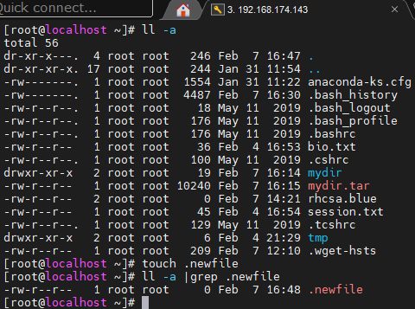

1. Run these commands:

#echo salam.

#echo "Linux was created by Linus Torvalds" > bio.txt

#echo “Elbrus Elvin ” > session.txt

#cat session.txt

#echo “ Bomba oglandilar ” >> session.txt

#cat session.txt

1. Run.

#a=5

#color = blue

#echo $a

#echo a

#echo $color

Try to understand difference.

