
ANCIENT GREECE
Background Information 5:
Greek Vases

If you visit any museum with an ancient Greek collection you are sure to come across a number of Greek vases. Greek pottery was traded all over the Mediterranean world. Due to the durability of the vases, a vast amount of Greek pottery survives.

The first Greek pottery appeared in around 6000BC. By about 1800BC, pottery was thrown on the wheel. The following information is a guide to the three of the most commonly used terms describing ancient Greek pottery.

Geometric:
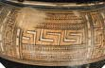
Geometric pottery appears in the period 900 – 700BC (commonly called the Geometric period). This type of pottery gets its name from the rectilinear designs that appear on the vases. In the eighth century BC humans and animals begin to appear on vases. These figures are also highly simplified and angular.

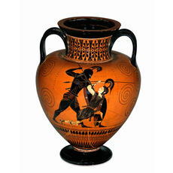
Black Figure Pottery:

This type of pottery appears around 620BC. It applies to pottery where the main figures are in black. This type of pottery is achieved by painting on a thin layer of liquid clay is painted on to the unfired pot. Details on the figures were achieved by scraping a way this wash. Due to the high iron content of the clay it turns brown or black when fired.


Red Figure

Red figure pottery appears from around 530BC. The name applies to pottery where the main figures are in red against a black background. This is achieved by reversing the process detailed for black figure pottery.

