What we did learn from the PAS educational resources?
The Portable Antiquities Scheme (PAS) Generic Learning Outcomes, notes for teachers & evaluation sheet

This evaluation relates to either the session that you have had with your local Finds Liaison Officer or the PASt explorers web-based educational resource

It uses the Inspiring Learning for All framework developed by the Museums, Libraries and Archives Council, in conjunction with DfES

It aims to evaluate consistently the following generic learning outcomes (GLOs), which can sometimes be tricky to quantify and qualify

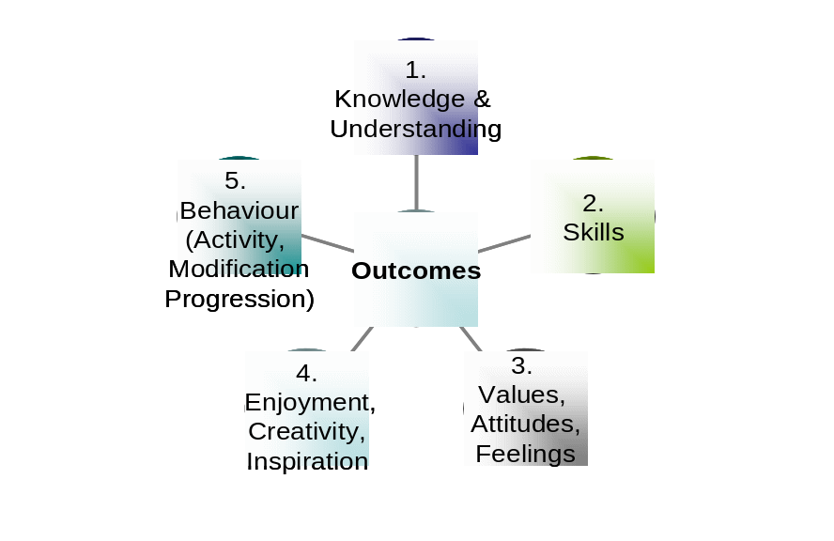

The questions on the evaluation form are colour coded to correspond to the GLOs.
Red corresponds to GLO 1, Knowledge and Understanding
Blue corresponds to GLO 2, Skills
Green corresponds to GLO 3, Values, attitudes, feelings
Pink corresponds to GLO 4, Enjoyment, Creativity, and Inspiration
And Brown corresponds to GLO 5, Behaviour (Activity, Modification, and Progression)

- In order for us to make our learning and teaching resources better not only for your pupils, but for you and other teachers, we would be very grateful if you could fill in the evaluation form

- By adding your contact details at the bottom of the sheet you will be entered in to a prize draw where the winner will receive a copy of the book ‘Treasure’ by Ian Leins!

If you would like to talk to us, please call the PAS Education Co-ordinator on 020 7323 8618 or email at cpaynton@thebritishmuseum.ac.uk

Thank you for your help and we hope that you’ve enjoyed using these resources!

How well did the session support your group’s school work?

How well did the session support your group’s learning in terms of delivery, resources and content?

Do you think that your class has developed their key skills, communication skills, information management and been helped to develop new skills, for example using ICT in a new way, critical thinking about history or presenting an interpretation of the past by this session?

Do you think that your class has learned new facts or information like what type of type of objects people used and lost in the past or what archaeological evidence comes form finds?

Did your class’ feelings and perceptions about life in the past change as a result of this session?

Did their opinions about themselves and others, such as self-esteem and empathy, change?

Did your class enjoy the session?

Did you enjoy the session?

Did you learn any new ways of looking at the past?

Did your class seem more interested in learning about their past after the session?

Did any of your group do something that they thought they weren’t good at today?

Which part of the session was most useful and why?

Which part of the session was least useful and why?

Do you have any other comments about today or about our free resources on the web?

Your contact details:

