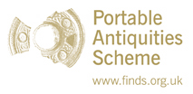
The skeleton Game and ‘Rot or Not?’ (STEM activity)
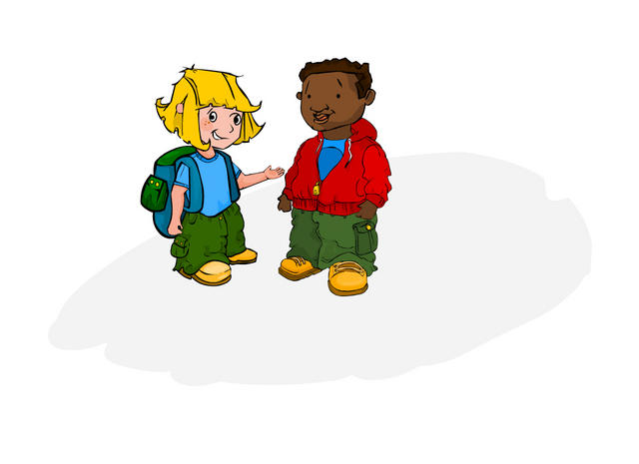
ww
www

www.pastexplorers/.org.uk
Contents:

- Learning Objectives and anticipated outcomes
- National Curriculum and Cross-curricular links
- Background information- teachers note on what archaeology is and why use these particular resources (finds, people and web-based)
- Activity 1: Rot or Not? (And variation)
- Activity 2: practical web-based interactives from www.pastexplorers.org.uk
- Resources List
- Suggestions for Extended Learning

Learning Objectives:
- To support and reinforce the KS2 history curriculum in Science Technology Engineering & Maths
- To show how archaeological evidence can be used in systematic STEM enquiries
- To develop skills in enquiry, interpretation and analysis of data
- To provide cross-curricular links between history, ICT, STEM, geography
- To provide enrichment and inspiring learning within the STEM curriculum at KS2 and 3

Outcomes:
- To provide children with an opportunity to apply their questioning, reasoning and analytical skills to real archaeological data
- To show children that their STEM skills can be used with a variety of subject matter and situations
- To also impart an understanding of how archaeology works with particular reference to burial and artefacts
National Curriculum and Cross-curricular links:
Sc1 Scientific enquiry
Sc2 Life processes and living things
Sc3 Materials and their properties
1) Grouping and classifying materials
2) Changing materials
3) Separating mixtures of materials
Sc4 Physical processes
Ma2 Number and algebra
Ma3 Shape, space and measures
Ma4 Handling data
1) Using and applying handling data
2) Processing, representing and interpreting data

Cross-curricular:
History
History & ICT
Geography
Geography & ICT
Art & Design

Teacher:
If real finds are available, get the children to sort them by material and decided whether they have changed in the ground-start of their thinking by talking about how cars become rusty and how metals especially change colour as the irreversible chemical changes occur in situ. (Within the burial environment)
You can do with this modern objects too- look at the contents of the classroom bin or a collection of objects that either you or the children have brought in and work out whether it will rot or not.You can either use the table provide for individuals, table groups or on the whiteboard for the whole class.
Next, choose a child from the class, or ask for a volunteer.
The volunteer is going to pretend to be a dead body and lie down on a table at the front of the class!
The children will, either in table groups or as a class, decide where on the body the finds that they are looking at pictures of would be worn, or which part of the grave they would be found in and then, one object at a time, place the pictures of finds on the ‘dead’ child.
Next, ask the children to think about what objects are important to them and what they show or mean. If they were people from ancient times, what would they like to be buried with? NB You can use the saved searches on www.finds.org.uk here, via your interactive whiteboard, or set this as homework prior to the lesson, or give the children some group or library time to go and find out.
Hand out the skeleton sheets and ask them to annotate them, writing on the objects that they would choose to be buried with. Engage the class in a plenary, asking the children what other things they think might have been buried with the person. Introduce the topic of beliefs and customs connected with death, burial and the afterlife, e.g. a final feast and drink for the dead, symbols of a person’s status, wealth or trade in life, religious objects, heirlooms.

Extension:
You can introduce elements of comparative religious studies here, the differences between pagan and non-pagan beliefs. Are Christians, Jews, Muslims, Buddhists, Hindus, Sikhs buried with symbols or special objects? Why?
Can the children think of any other examples?

After the children have discussed this and filled in the materials (Rot, or Not?) table, get them to present their findings graphically.
Are there any patterns?
Are there more of certain types of materials with a group of old objects or artefacts, when compared with more modern objects?
What seems to survive the best?
Have they found any examples of reversible changes?
Why do they think that this is?

Rot, or Not?
Name ………………
Class ………………
Date ………………
Use this sheet to put the finds that you would like to be buried with on the skeleton! Think: where would the finds be, next to your head, fingers, feet? Would they survive in the ground, or would they rot away? Fill in the table!
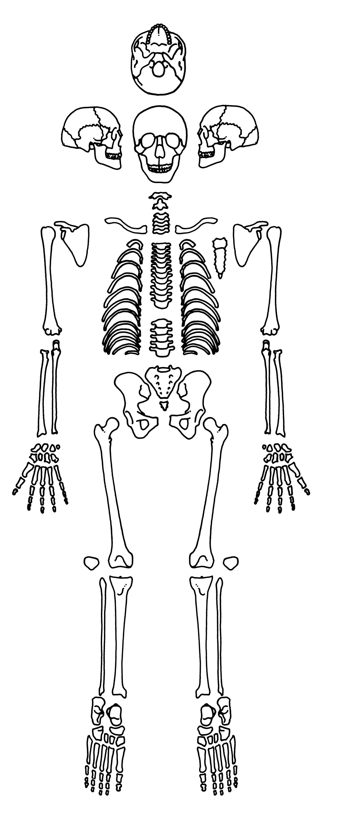

Object/find | Material | Rot? | Not? | Reversible change? | Irreversible change?
Apple core | Organic | Yes |  |  | Yes
Iron nail | Iron (metal) | Yes |  |  | Yes

