Illustrating Pottery

When illustrating pottery there are a number of specific pieces of information that you need to record. These include:

- A scaled drawing of the sherd of pottery
- A scaled drawing of the thickness of the sherd
- If the pottery is decorated then a drawn likeness of the pottery to scale
- If the sherd is from the base or the rim then an indication of the diameter and size of the pot

The final point below is what a pottery report would contain. If you wish to answer some of these points then do so.

- A written description of the fabric (what the pot is made up of) with any inclusions (grit or stone within the makeup). The colour and condition of the pottery. What class or type of pottery it is and how it fits into the site or county type series.

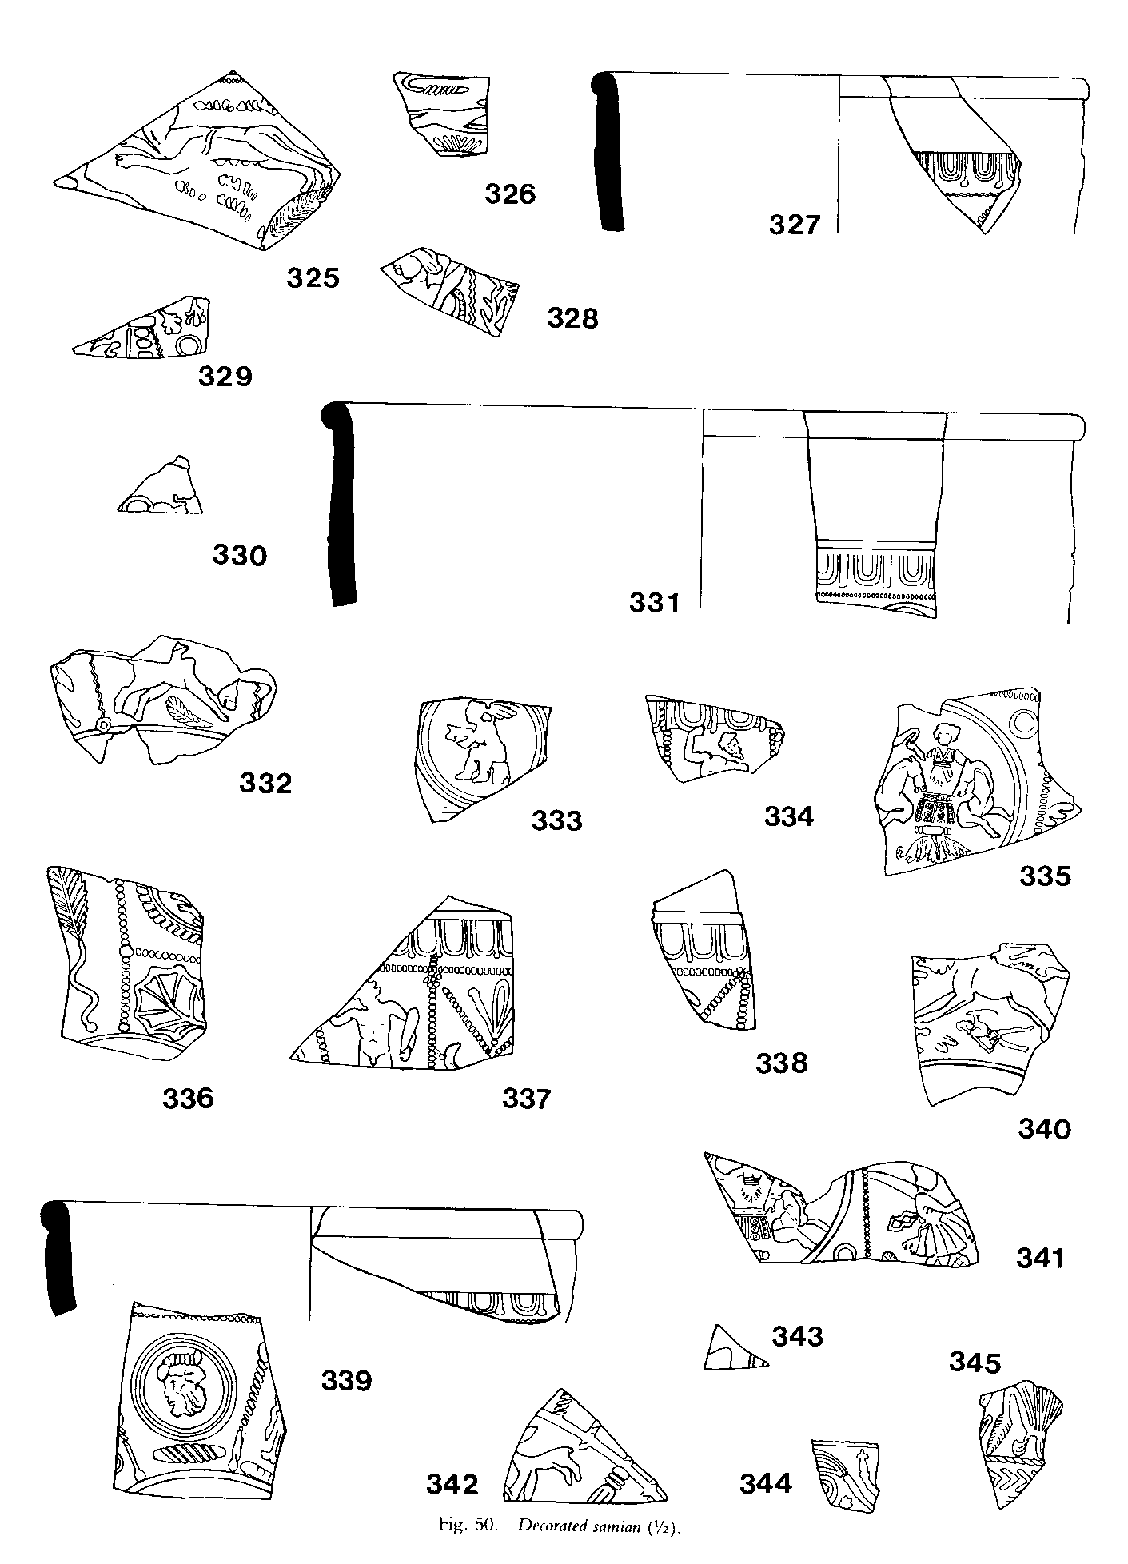

For further information on pottery look at the following internet sites:
www.worcestershireceramics.org
potweb.ashmol.ox.ac.uk/
Examples of Decorated Samian Pottery from excavations in Kent
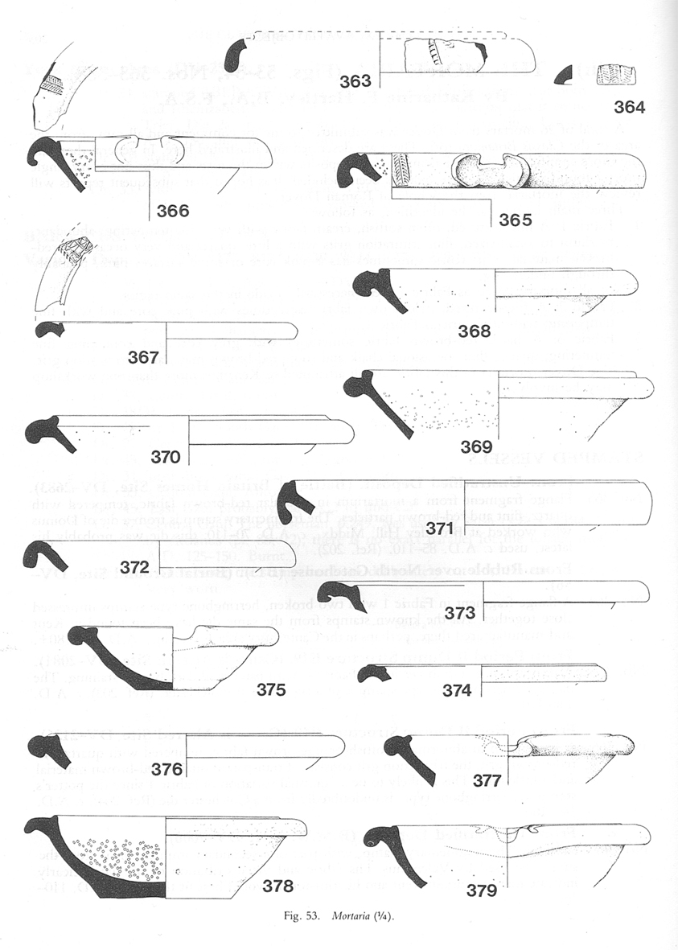

Examples of Mortaria from excavations in Dover, Kent

