Activities to be completed before the next session on Artefacts

I would like everyone to visit each of the websites below (by the next time I come in) and choose one artefact to report back on. The report should include a large photo of the chosen artefact (copied from the website). Your report should also cover the questions below and will need to presented to the rest of the group. This should take no more than one minute. You should attempt all questions but some of the information may be limited. Do not worry about this, it is not a test. If you have any questions then either ask your teacher or email me: peter.reavill@shropshire-cc.gov.uk

Websites
www.finds.org.uk

www.findsdatabase.org.uk

www.findsdatabase.org.uk/hms/wwwsearch.php?action=searchpage&expand=24,627

www.darwincountry.org

http://www.thebritishmuseum.ac.uk/compass/index.html

Questions:

What I want to know about the artefact you choose is:

- What it is? (i.e. brooch, axe, pendant, etc)

- Which period it is from? (Bronze Age, Roman, Medieval etc)

- What it is made of? (stone, bronze, pottery etc)

- What might the object have been used for? (sewing, chopping wood, decoration)?

- Where it was found?

- What type of site it could have been found on? (domestic, military etc. If it is a stray find, i.e. not found on a site, then explain why)

- What might this artefact tell us about life in that period?

- What other types of archaeological artefacts might be found with it?
Example:

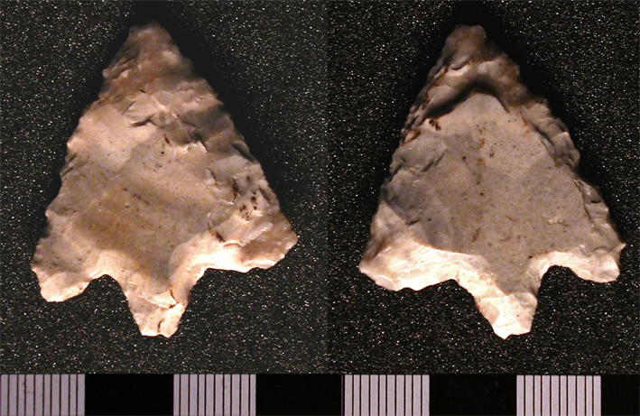

- Barbed and Tanged Arrowhead
- Late Neolithic / Early Bronze Age
- Flint or chert (chert is a stone similar to flint)
- It is an arrowhead and could have been used for hunting
- Shropshire / Clun Valley
- It could have been found on a domestic site or be a stray find (if it was a stray find it is likely to have been lost during hunting activities
- It suggests that metal work is very rare if not unknown. It also suggests that there are areas where hunting could occur. It suggests that the life style of the people at the time relies on hunting as well as farming.
- If it was found in a hunting context then very few finds would be found with it. If it was found in a domestic setting then the type of finds could include animal bones, pottery, other flint artefacts and debris from making them.

