Date:
Class:
Lesson No: 5
Title: Architecture
Previous homework:
Lesson outline:
Time: /
ActivityEncourage students to drawer out key features of Mughal architecture by contrasting it with a Hindu temple.

In pairs
10 minsIn pairs, ask pupils to compare two pictures: 1 of a Mughal building and one of a Hindu temple. What do they notice about; structure, design and decoration?

FeedbackDraw class back together, and reinforce these key differences from their 10 minsobservations:

HINDUMUGHAL

1) more ‘organic’ in design1) highly symmetrical, balanced in design

2) lots of variety, ‘busy’ decoration2) very controlled decoration, often with geometric patterns – mathematical in design

3) lots of figures, animals etc3) no representation of the human form – focus definitely on pattern

The Mughals did not like the ‘fussy’ approach of Hindu design and Islam forbids the representation of the human form. In addition, mathematics and geometry are seen as reflected the perfect order of Allah.

Resources needed:
Access to website
Picture of a Mughal building and a Hindu temple
Architectural and Decorative Features – Test sheet
Refer to Staff Background sheet, Islam & Architecture

Lesson objectives / desired learning outcomes:
To learn the style & features of Mughal architecture
To appreciate the religious / political aspects of architectural structures

Introduction:
Architecture characterises much of the Mughal rule – what they are famous for
As well as their signature on India, architectural endeavours were visual stamps of authority & rule.
The Mughal style was essentially an Islamic style – therefore their architecture is a visual dialogue which speaks of wealth, Islam, authority and rule.

Lesson outline:

Time: /
Activity

15 minsGive class 10-15 mins to thoroughly read and familiarise themselves with the Taj Mahal interactive 3D model, on the website. Tell them that you will then ‘test’ their knowledge of architectural features, with a picture of another Mughal building of similar features.

10 mins‘Architectural & Decorative Features – Test Sheet’
See labelling activity sheet – looks at architectural and decorative features.
Give 1 point for a correct ‘label’ and an extra point for explanation / qualifiers

5 minsApplication and reflection
Class discussion

Remind pupils that travellers to India in the 16th century, were greatly impressed with Mughal art and architecture. Can look for their influence today, in our architecture

e.g. the Brighton Pavillion
Conclusion:
Homework: If you have time over / want to complete for homework, use the Mosque worksheet to revisit pupils’ understanding of Islam through the architecture of the Mosque
Architectural and Decorative Features – Test Sheet

Dome

Iwan

Turret
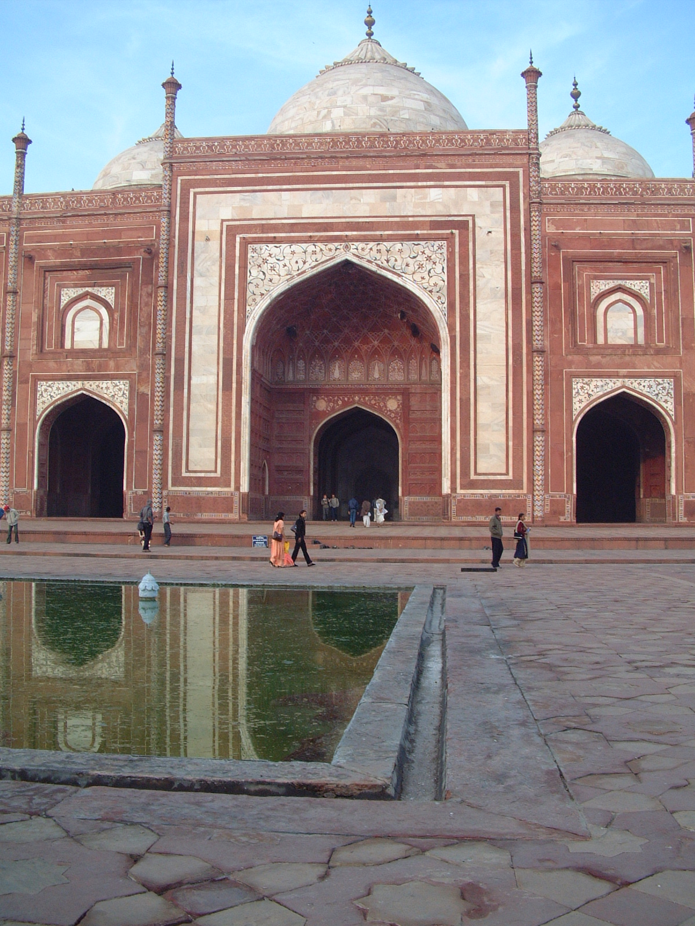
Lancet arch

Pietra-dura inlay

floral motifs
Formal garden /
Charbagh

Geometric pattern

Architectural and Decorative Features – Test Sheet

