PORTAVA PASSPORT
Engineering Architecture & Mobile Design Specification
Canonical implementation target · Mobile-first · iOS + Android
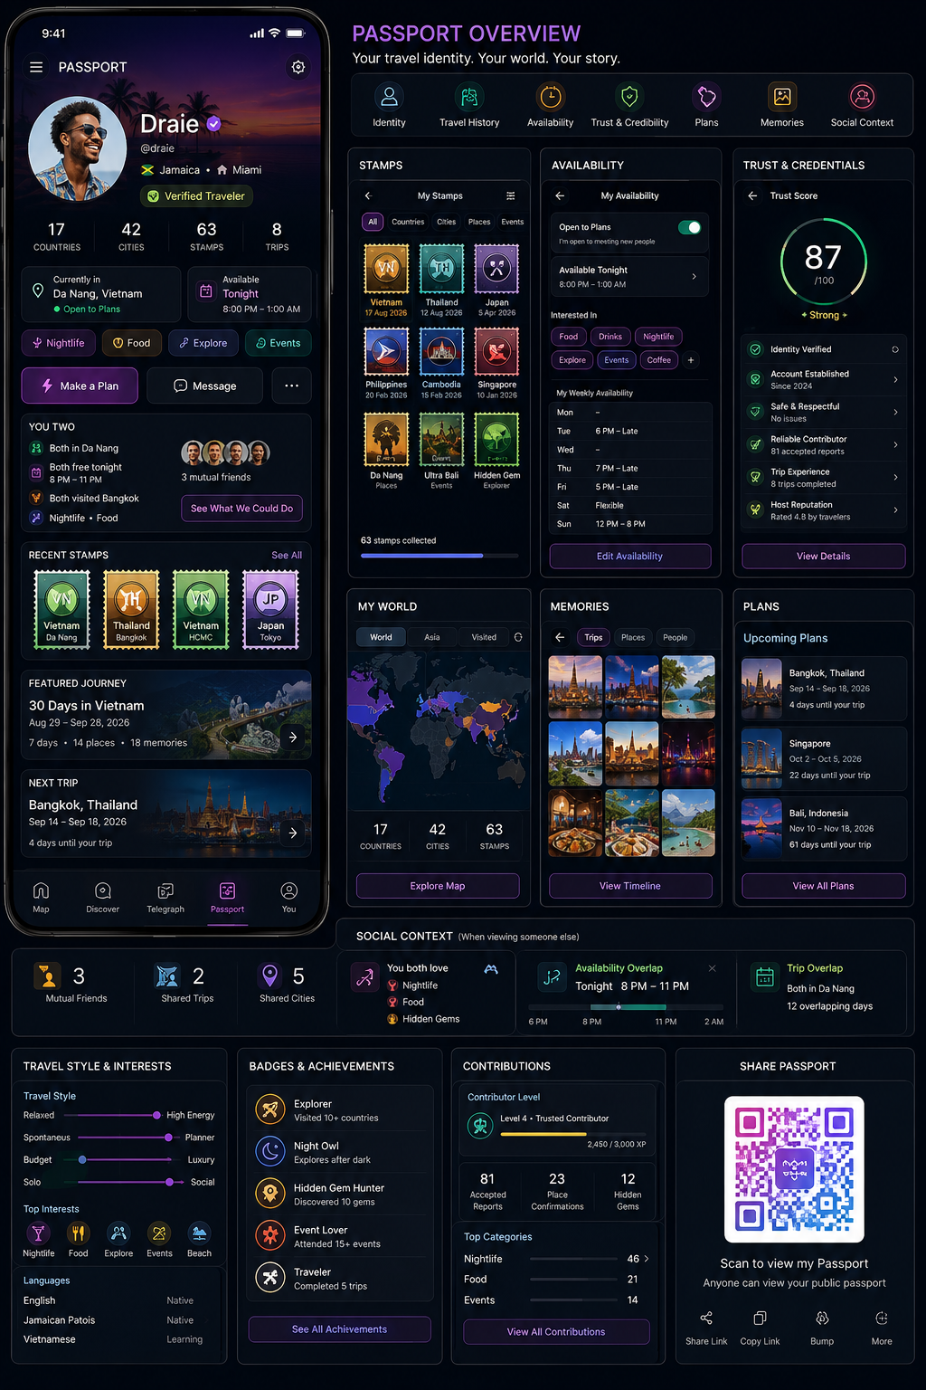
Concept visual: Passport Home, stamps, availability, trust, My World, memories, plans and social context

1. Canonical Product Definition
Passport is Portava’s portable human identity layer. It is not merely a profile page: it is the privacy-aware, context-aware representation of a traveler that other Portava systems can query for identity, travel history, current state, availability, intent, trust, credentials, reputation, plans, shared context and permitted actions.
System shorthand
Passport = WHO · Availability = WHEN · Intent = WHAT · Trust = CAN / SHOULD · Map = WHERE · Compass = WHAT NEXT
Identity + Travel History + Current State + Availability + Intent + Trust + Credentials + Reputation + Social Context + Experience History + Plans + Privacy + Viewer Relationship + Action Eligibility
↓
Passport Projection
2. Ten Primary Passport Surfaces
# | Surface | Purpose
1 | Passport Home | Main travel/social identity
2 | Stamps | Earned and verified travel proof
3 | Journeys | Trips and chronological travel history
4 | Memories | Travel media and Shared Moments
5 | Plans | Upcoming Trips and destinations
6 | Availability | Free time, Open to Plans and current intent
7 | Trust & Credentials | Trust Score, verification and reputation
8 | Travel Identity | Languages, interests and travel style
9 | My World | Personal geographic travel history
10 | Shared Context | Viewer-to-owner overlap and actionable context
PassportShell
├─ PassportHome
├─ Stamps
├─ Journeys
├─ Memories
├─ Plans
├─ Availability
├─ TrustCredentials
├─ TravelIdentity
├─ MyWorld
└─ SharedContext
3. Passport Home Design
- Travel hero/cover with circular profile photo overlapping the hero.
- Name, @handle, verification mark, home country and optional home base immediately visible.
- Current travel state and Availability/Open to Plans near the top, not buried below media.
- Trust summary visible as a concise score/label with drill-down.
- Travel stats: countries, cities, stamps and Trips.
- Primary viewer actions: Follow, Make a Plan, Message, More. Owner actions: Edit Passport, Set Availability, My World, Share Passport.
- High-priority previews: Shared Context, recent stamps, Featured Journey, next Trip and memories.
PASSPORT
[ Travel Hero ]
[PHOTO] Name ✓ @handle
Country · Home base
✈ Traveling · Da Nang
🟢 Open to Plans · Free 8 PM–1 AM
Nightlife · Food · Explore
Trust 87 · Strong
17 Countries · 42 Cities · 63 Stamps
[Make a Plan] [Message] […]
YOU TWO → Shared context + See What You Could Do
RECENT STAMPS
FEATURED JOURNEY
NEXT TRIP
MEMORIES
4. Viewer Context and Server-Side Projection
Do not create separate profile systems for self, public, Trips, Buddy, Discovery or Telegraph. Build one Passport projection system with context-specific views. Privacy filtering must happen before data reaches the mobile client.
type PassportViewerContext =
| 'self' | 'public' | 'follower' | 'following'
| 'trip_crew' | 'trip_host'
| 'buddy_customer' | 'buddy_provider' | 'event_group';
Canonical User Data → Passport Context Resolver → Viewer Relationship → Privacy Policy → Trust/Eligibility Policy → Projection Builder → Passport View Model → Mobile UI
5. Current Traveler State
- Separate permanent identity from temporary traveler state.
- Supported examples: Home, Traveling, Exploring, Open to Plans, At Event, With Crew, Unavailable.
- Every temporary state requires validFrom and expiration semantics.
- Broad city context may be projected; exact location is never ordinary Passport data.
6. Availability Architecture
Availability is a first-class Passport domain because it determines whether a real-world social opportunity is actionable. Available does not mean open to strangers.
Type | Example
Recurring | Friday 6 PM–late
Trip-specific | Da Nang: free after 7 PM
One-time | Tonight 8 PM–1 AM
Plan-derived | Free between dinner and event
Social | Open to meeting people
Activity | Food · Nightlife · Explore
Group | Small groups / crew only
Radius | Willing to travel ~20 min
interface AvailabilityWindow {
id: string; userId: string;
type: 'recurring'|'trip'|'one_time'|'derived';
startAt: string; endAt: string; tripId?: string;
openToPlans: boolean; intents: IntentType[];
groupPreference?: GroupPreference; maxTravelMinutes?: number;
visibility: VisibilityPolicy;
source: 'explicit'|'plan_derived'; expiresAt?: string;
}
7. Availability Screen Design
MY AVAILABILITY
Open to Plans ON
Available Tonight · 8 PM–1 AM
Interested In: [Food] [Drinks] [Nightlife] [Explore] [Events]
Group Preference: Small groups
Travel Distance: Up to 20 minutes
WEEKLY
Mon —
Tue 6 PM–Late
Wed —
Thu 7 PM–Late
Fri 5 PM–Late
Sat Flexible
Sun 12 PM–8 PM
[ Edit Availability ]
Never publicly convert inferred availability into an explicit-looking status. Inference may trigger a private prompt such as “Free tonight?”; only an explicit answer should become public/shared availability.
8. Open to Plans and Intent
type SocialAvailability = 'open'|'maybe'|'crew_only'|'following_only'|'not_open';
- Availability answers “Can I do something?” Open to Plans answers “Do I want social invitations?”
- Temporary intent is distinct from long-term interests and should carry a TTL or explicit clear action.
- Current intent examples: Food, Drinks, Nightlife, Explore, Events, Meet Travelers.
- Compass and Discovery should weight explicit current intent more heavily than generic interests.
9. Trust Architecture
Retain the 0–100 Trust Score internally and, where appropriate, visibly. Do not make it a single universal authorization number. Trust must be domain-specific, confidence-aware and explainable.
Trust Evidence → Trust Events → Domain Trust → Trust Confidence → Policy/Eligibility → Passport Trust Projection
Domain | Example presentation
Overall | Strong
Traveler | Strong
Trip Guest | Strong
Trip Host | Established
Contributor | Excellent
Buddy | Not applicable
10. Trust & Credentials Design
TRUST & CREDENTIALS
87 / 100
Strong
✓ Identity Verified
✓ Established Account
✓ Safe & Respectful · Good standing
✓ Reliable Contributor · 81 accepted reports
✓ Trip Experience · 8 trips completed
★ Host Reputation · 4.8
[ View Details ]
- Do not expose private report counts, moderation evidence or sensitive safety history to other users.
- Trust confidence matters: an 82 with high evidence is not equivalent to an 82 with little evidence.
- Public copy for low-evidence accounts should avoid stigmatizing new users; e.g. “New Traveler · Verified.”
- Trust changes must be internally replayable from evidence/events.
11. Trust Capabilities
Trust Evidence + Domain Policy → Capabilities
canJoinPublicTrip
canHostTrip
canCreateLargePlan
canUseCrewLocation
canContributeLiveIntel
canBecomeBuddy
canProvideVisaBuddyService
Authorization is server-side. Passport may display positive credentials generated by these capabilities, but the client must not infer authorization from a displayed score.
12. Stamps and Provenance
Stamp type | Examples
Country | Vietnam
City | Da Nang
Place | Landmark or venue
Event | Festival
Experience | Diving
Hidden Gem | Discovery
Trip | Completed journey
Contributor | Trusted reporter
Buddy | Completed experience
Milestone | 10 countries
Special | Campaign / seasonal
type StampSource = 'self_reported'|'system_observed'|'trip_derived'|'event_verified'|'contribution_earned'|'buddy_derived'|'partner_verified'|'admin_issued';
type StampVerification = 'decorative'|'reported'|'verified';
Self-reported or decorative stamps must never visually impersonate verified stamps. Verified travel facts should be derived from canonical provenance, not editable profile fields.
13. Stamp Design
- Premium collectible appearance with perforated/passport-stamp edges.
- Unique country/city/event motifs rather than identical generic badges.
- Issue date and verification treatment visible in detail view.
- Metallic accents and subtle depth may distinguish premium/earned states.
- Stamp detail can link to Journey and My World while respecting historical-location privacy.
14. Journeys and Featured Journey
- Journeys are chronological Passport projections of canonical Trip/travel records.
- Group by year, country/city and Trip.
- Show permitted dates, places, memories, stamps, Shared Moments and people context.
- Allow one Featured Journey such as “30 Days in Vietnam.”
- Featured Journey can include route, timeline, places, memories, stamps, people, events and recommendations.
15. Memories and Shared Memories
- Memories are travel-contextual, not a generic media grid.
- Views: Trips, Places, People, Timeline and Map.
- Retain permitted place, city, Trip, date, people, event and stamp context.
- Shared history can surface “You were here together” or “Our Da Nang Trip” when both viewers have rights to the underlying records.
16. Plans and Trip Overlap
- Passport must represent future travel as well as past travel.
- Upcoming Trips require per-plan visibility controls.
- When viewing another Passport, compute Trip overlap such as “You’ll both be in Bangkok Sep 14–17.”
- Provide an action such as “Connect for Bangkok” when policy and eligibility permit.
17. Shared Context — ME ↔ THEM
Shared Context is calculated for the viewer relationship rather than stored as a permanent dating-style match score.
Possible Shared Context
• Both in Da Nang
• Both free tonight
• 3 mutual follows
• 2 shared cities
• Nightlife + Food overlap
• Both going to Bangkok
• 1 previous Trip together
• 2 Shared Moments
Do not create a dating match score
Use explainable descriptions such as “Strong travel overlap” and show the contributing facts.
18. See What You Could Do — Compass Handoff
Passport A + Passport B + Availability Overlap + Intent Overlap + Trust Eligibility + Current City + Trip Constraints + Live Map → Compass → Candidate Experiences
Example result: “You’re both free 8–11 PM. Here are three things that fit both of you.” This is a core bridge from identity to real-world interaction.
19. Travel Identity
Dimension | Examples
Interests | Nightlife, Food, Events
Travel pace | Relaxed ↔ Packed
Planning | Spontaneous ↔ Planner
Spend style | Budget ↔ Luxury
Social | Solo ↔ Social
Discovery | Famous spots ↔ Hidden gems
Energy | Low ↔ High
Rhythm | Early riser ↔ Night owl
Group style | 1:1 / small / large groups
Languages | Native / Fluent / Conversational / Learning
Inferred Travel DNA such as Night Explorer, Hidden Gem Hunter or Food Driven must be explainable and user-controlled: Show, Hide, or Not Me.
20. Contributions, Expertise and Reputation
CONTRIBUTIONS
Level 4 · Trusted Contributor
81 accepted reports · 23 confirmations · 12 hidden gems
Top expertise: Nightlife · Food · Events
- Reputation should reflect usefulness and qualified real-world evidence, not follower count alone.
- Paid contributions must never increase factual confidence merely because they are paid.
- Experience-based expertise such as “Knows Bangkok well” should be derived from legitimate history and contribution quality.
- Host and Buddy reputations are contextual Passport projections, not separate identity systems.
21. Context-Specific Passport Projections
Consumer | Projection should emphasize
Discovery | Identity, verification, availability, Open to Plans, shared context, permitted trust summary
Trips | Identity, relevant trust eligibility, languages, travel style, host/guest context
Buddy | Identity, Buddy verification, services, languages, availability, service area, completion/reputation
Map | Aggregate or permission-appropriate presence only
Telegraph | Identity + relevant shared context in conversation header
Compass | Permitted identity, availability, intent, trust capabilities, Trip/shared context
Safety | Restricted purpose-specific context only
22. Privacy Model
type Visibility = 'public'|'followers'|'following'|'crew'|'private';
Field | Default recommendation
Name / handle | Public
Profile photo | Public
Verification | Public
Home country | User controlled
Home base | User controlled
Current city | User controlled
Availability | User controlled
Open to Plans | User controlled
Travel history | User controlled
Stamps | Public / user controlled
Memories | Per-item
Plans | Private or followers by default
Languages | User controlled
Travel style | User controlled
Trust summary | Contextual
Exact location | Never normal Passport data
23. Location Boundary
Hard rule
Passport may say “Traveling in Da Nang.” It should not ordinarily expose exact coordinates or “42 meters from Sky36.” Exact location belongs to purpose-bound Presence systems such as Trip Crew, Locate My Friends, Safe Return or explicit temporary sharing.
24. Blocking and Safety Propagation
A Passport block must propagate across Discovery, Telegraph, Trips, Presence, Map, Shared Moments, Bump, Buddy and Compass social recommendations. Do not implement blocking independently per surface.
25. QR Passport and Bump
- Share Passport options: QR, Share Link, Copy Link, Bump.
- QR projection is deliberately minimal: photo, first name, @handle, verification, permitted home country/interests, Follow/Connect.
- Scanning a QR never bypasses privacy policy.
- Future Passport Bump should require affirmative exchange/confirmation; passive proximity alone must not reveal profiles.
26. My World
WORLD → Country → City → Trip → Places → Memories / Stamps
My World is the personal geographic travel-history view. Main Map answers “What is happening now?” My World answers “Where has my story happened?” They can deep-link but must not merge truth models.
27. Design System
- Dark-mode first with deep navy/black surfaces.
- Purple as the Passport identity accent.
- Gold for premium/earned travel identity and collectible stamps.
- Green for verification and positive trust states.
- Blue/teal for availability and social context.
- Use a travel hero image, circular overlapping portrait, rounded cards and restrained glass effects.
- Color is never the only status indicator; pair it with text/iconography.
28. Mobile Component Structure
/features/passport
/screens
PassportScreen.tsx · StampsScreen.tsx · JourneysScreen.tsx
MemoriesScreen.tsx · PlansScreen.tsx · AvailabilityScreen.tsx
TrustScreen.tsx · TravelIdentityScreen.tsx · MyWorldScreen.tsx
SharedContextScreen.tsx
/components
PassportHero.tsx · TravelerStateCard.tsx · AvailabilityCard.tsx
TrustSummary.tsx · StampStrip.tsx · StampCard.tsx · JourneyCard.tsx
MemoryGrid.tsx · PlanCard.tsx · SharedContextCard.tsx
TravelStyleCard.tsx · ContributionCard.tsx · CredentialBadge.tsx
PassportActions.tsx · PassportQrSheet.tsx
/services
passportProjection.ts · availability.ts · trustProjection.ts
sharedContext.ts · passportPrivacy.ts
29. Passport Aggregate Contract
interface PassportProjection {
userId: string;
identity: PassportIdentity;
travelerState?: TravelerState;
availability?: AvailabilityProjection;
intent?: IntentProjection;
trust?: TrustProjection;
credentials: CredentialProjection[];
stats: TravelStats;
stamps: StampProjection[];
featuredJourney?: JourneyProjection;
upcomingPlans: PlanProjection[];
memories: MemoryProjection[];
travelIdentity?: TravelIdentityProjection;
sharedContext?: SharedContextProjection;
capabilities: PassportActionCapabilities;
viewerContext: PassportViewerContext;
}
30. Actions Must Be Server-Projected
{
"actions": {
"can_follow": true,
"can_message": true,
"can_make_plan": true,
"can_invite_trip": false,
"can_view_availability": true,
"can_view_trust": true
}
}
Do not let the client recreate policy with rules such as “if trust > 60 show Make Plan.” The server owns authorization and viewer-specific action eligibility.
31. Loading, Caching and Expiration
Identity → Viewer Relationship → Privacy Projection → Current State → Availability → Trust Summary → Shared Context → Stamps/History → Plans/Memories
- Cache relatively static identity, stamp metadata, travel stats, travel identity and permitted public journeys.
- Use short TTLs for Availability, current state, Open to Plans, Shared Context, Trust projection and capabilities.
- Explicitly expire Availability, temporary intent, Open to Plans, event Passport, temporary sharing and location projections.
- Never render stale Availability as current.
32. Telemetry
- passport_viewed / passport_shared / passport_qr_scanned
- availability_set / availability_expired / open_to_plans_enabled
- stamp_issued / stamp_verified / stamp_viewed
- trust_summary_viewed
- shared_context_viewed / make_plan_started
- journey_viewed / memory_viewed / my_world_opened
- follow_from_passport / message_from_passport / trip_invite_from_passport
33. Implementation Phases
Phase | Scope
1 — Identity Foundation | Passport Shell, hero, identity, verification, stats, privacy
2 — Travel Identity | Stamps, Journeys, Memories, My World
3 — State & Availability | Current city, Availability, Open to Plans, temporary intent
4 — Trust | Trust summary, credentials, domain trust, capability projection
5 — Shared Context | Mutuals, overlap, availability intersection, Trip overlap
6 — Real-World Action | Make a Plan, Compass integration, Trip invitations
7 — Reputation | Contributor identity, host reputation, expertise
8 — Sharing | QR Passport, Bump Passport, temporary event Passport
9 — Intelligence | Travel DNA, yearbook, deeper Experience Graph
34. Explicit Non-Goals
- Not a generic Instagram profile.
- Not a dating profile or compatibility score.
- Not a raw exact-location screen.
- Not a place where users self-award verification.
- Not a public moderation record.
- Not a Trust leaderboard.
- Not permanent exposure of future travel plans.
- Not a duplicate database for Trips, Buddy, Memory, Map or Presence.
35. Engineering North Star
Two travelers view one another. Portava determines that both are in the same city, both explicitly free tonight, both open to plans, both interested in nightlife, eligible under trust policy, and share relevant social/travel context. Passport presents that context and offers “See What You Could Do.” Compass combines the two permitted Passport projections with live Map intelligence, proposes suitable experiences, the users form a plan, Telegraph coordinates it, and the resulting real-world experience can later become Memory, Trip history, qualified contribution or Stamp evidence.
Complete Passport loop
PASSPORT → AVAILABILITY → TRUST → SHARED CONTEXT → COMPASS → MAP → PLAN → TELEGRAPH → REAL-WORLD EXPERIENCE → MEMORY → STAMP → PASSPORT
Canonical architecture rule
Passport is the canonical, privacy-aware and context-aware representation of a human throughout Portava. Other surfaces request the appropriate Passport projection instead of rebuilding identity, availability, trust and social context independently.

