1

Tree and site details
Species: Eucalypt – High Strength (ironbark / spotted gum type)
Location: home

Key inputs
DBH (cm) | 32.0
Height (m) | 16.0
Crown diameter (m) | 12.0
Cavity inner diameter (cm) | 0.5
Design wind speed (m/s) | 55.0
Site factor | 1.0

Observed structural defects / decay indicators
- Bracket fungi on stem or base
- Cavity with visible decay
- Longitudinal cracks / shear planes
- Basal/root-plate decay symptoms
- Included bark / compromised unions
Defect strength factor k_defect: 0.41

Numerical results
Safety factor at design wind speed (SF): 0.20
Bending stress at governing section: 106.13 MPa
Estimated wind-to-failure speed (SF ≈ 1): 24.3 m/s

Decay / residual wall
Current residual wall (from DBH and cavity): 98% of diameter.

Graphs
Figure 1 – Safety factor versus wind speed
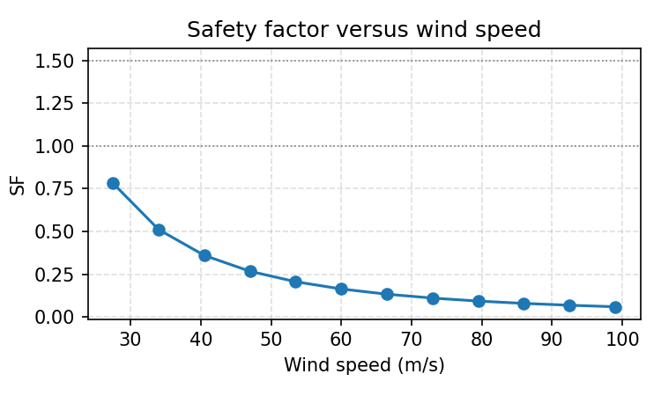
Figure 2 – Safety factor versus residual wall thickness
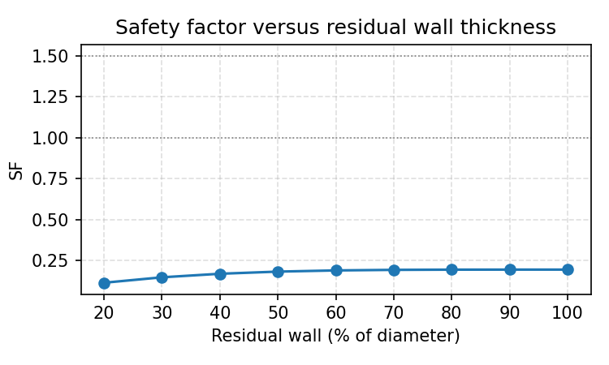
Figure 3 – Safety factor versus crown reduction (%)
