Technology Adoption in the Presence of Network Externalities: A Web-Based Classroom Game
Step-by-Step Instructions

JAMES R WOLF JR.

THOMAS E. PORTEGYS*

This Draft
October 26, 2005
*James R. Wolf Jr., is a graduate student at the Fisher College of Business, Ohio State University, 400 Fisher Hall, 2100 Neil Avenue, Columbus, OH 43210; email: wolf.206@osu.edu, and an Assistant Professor of Information Systems, School of Information Technology, Illinois State University, Campus Box 5150, Normal, IL 61790-5150; email: jrwolf@ilstu.edu. Thomas E. Portegys is an Assistant Professor of Computer Science, at the School of Information Technology, Illinois State University, Campus Box 5150, Normal, IL 61790-5150; email: portegys@ilstu.edu.

Introduction

Extant literature suggests that network externalities can result in the dominance of one technology even if it is inferiority to an alternate technology. As Ruebeck, Stafford, Tynan, Alpert, Ball, and Butkevich (2003) note, network externalities exist when the value of a product or service to a consumer depends on the number of other people using a compatible product or service. Katz and Shapiro (1985) noted that these externalities may be direct or indirect. Direct network effects are those benefits generated through a direct physical effect of the number of users on the value of a product or service. For example, MSN Messenger users can only send instant messages to others using the MSN Messenger software. As a result, each additional MSN Messenger user directly affects the value of the product. With indirect network effects, consumption benefits do not depend directly on the number of users but are "market mediated." For example, as more people adopt the Linux computer operating system more software developers will start to produce Linux versions of their products.

The goal of this paper is to describe a customizable web-based classroom game which can be used to demonstrate the effects of network externalities on the adoption of new technologies. The game is web-based adaptation of Ruebeck et al.'s (2003) network externalities game. In the basic game, players choose one of a number of competing technologies whose utility depends on the number of others choosing the same technology. In subsequent variations, we introduce sequential choice, imperfect information, heterogeneity, “lock-in” and switching costs. The game is freely available and can be played in a networked lab setting or via the Internet.

Obtaining and Installing the Software
The Game Master application requires a recent version of Java, e.g. 1.4, available at java.sun.com. The application can be downloaded from:

www.itk.ilstu.edu/faculty/portegys/programs/UtilityGame/GameMaster.jar

The jar file contains all the source code, associated files, build command, HTML files, and the Master executable code. It can be started on most Windows systems by simply double-clicking the jar file; otherwise, the following command will start it:

java –jar GameMaster.jar

The source files can be unpacked from the jar file with the jar tool that comes with Java, or with an archiving tool such as WinRAR, available at www.rarlab.com. The system can then be built by clicking the buildgame.bat file, and tested with the rungame.bat file.

The Game Player is a signed Java applet that will run in most browsers, including Internet Explorer. It is available at:

www.itk.ilstu.edu/faculty/portegys/programs/UtilityGame/gameplayer.html

If you want to install the Player applet on your web server, copy gameplayer.html (included in the jar file), and GamePlayer.jar to the server. The MasterHost parameter in gameplayer.html can be set to the IP address of the Master host, which will allow players to connect to it.

The Player applet communicates with the Master via Java RMI (Remote Method Invocation), necessitating the signing of the applet with the jarsigner command, invoked from the buildgame.bat script. The jarsigner command expects to find a public/private key pair on your computer having the alias “ugame”. This can be created with the keytool command as follows:

keytool -genkey -alias ugame -keypass your_password

Upon connecting to the Master, your computer may prompt you to unblock a network connection to allow RMI to proceed.

Operating Instructions

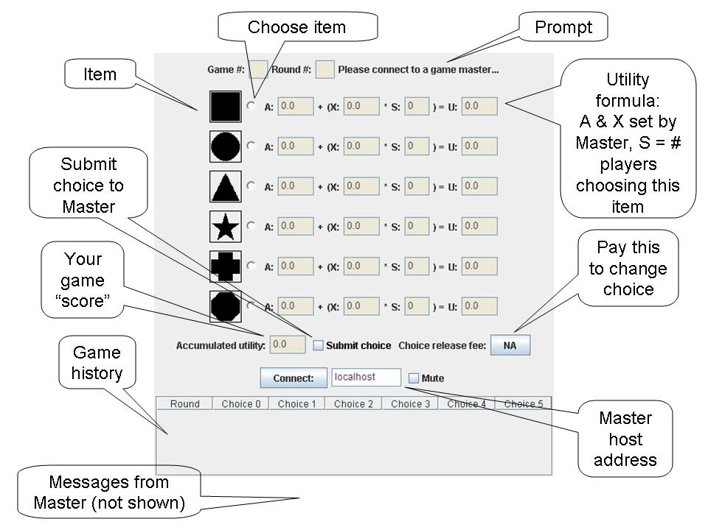
Figure 1 – The Game Player Applet.
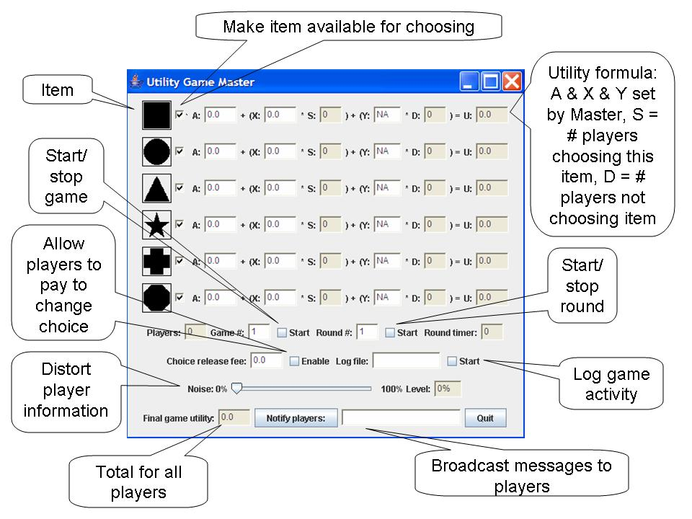
Figure 2 – Game Master Application.

Figure 1 shows the Player applet after initialization. Figure 2 shows the Master application after initialization.

Instructions for four types of games

This software will allow users to conduct several different types of games designed to demonstrate network externality’s affect on consumer utility, herding behavior and standardization. In addition, the workshop will demonstrate several ways that the game can be customized to address additional topics related to network externalities.
In each game participant must decide which of the available brands to buy. The utility the participants receive depends on the brand they choose, as well as the number of other participants that also choose that brand. Each game will have slightly different rules, as explained below.

The remainder of the paper will provide participants with step-by-step instructions for running five variations of the game which demonstrate network externality’s affect on consumer utility, herding behavior and standardization. As this game is based closely on Ruebeck et al.'s (2003) network externalities game, we will start off by replicating their four games. The paper concludes by detailing several features that allow the game to be customized to address additional topics related to network externalities.
In each of these games, players’ utilities are determined by the player’s choices and the choices of the other participants according to the utility schedule entered into the Game Master. Before starting the game session, the facilitator should enter the values. A represents the participant’s utility from choosing a product or technology and X represents the utility derived from participants choosing the same (S) product or technology.

Ruebeck et al. (2003) use different notation but suggest setting a/x somewhere between n/2 and n, where n is the number of participants each round.

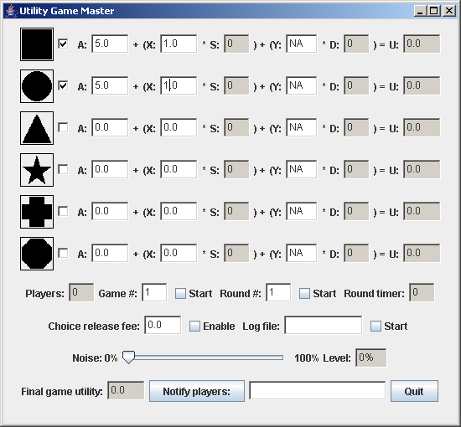

Figure 3. The Game Master Application.

Figure 3 shows a setup that includes a choice of two different technologies and a utility function of both technologies of μ = 5+1*S, where S is the number of participants that choose the same product or technology. While not used in this setting, Y represents the utility derived from participants choosing a different (D) product or technology. In these games, symbols act as proxies of the technology or product choices. It is important to note that the symbols and the order of the symbols are randomized so that each participant does not see the same symbol choices.
Game 1 – Simultaneous Choice

In the first game, participants choose one of a number symbols and their one time choice determines their utility for 10 rounds. Ruebeck et al. (2003) gave their participants a choice between two symbols, but our software allows for up to six options. Adding or subtracting the number of options is accomplished by selecting or deselecting the checkbox next to a symbol on the Game Master. In addition, while we use ten rounds for this game, the others may choose to use a different number of rounds.

Prior to beginning the game, the facilitator should set the desired utilities and the number of choice options. Participants should be informed that their utility for each round will be determined by the number of people who have chosen the same technology and that their choice of symbol will determine their utility for the entire game (e.g., 10 rounds). Participants make their choice by selecting the check box next to the desired symbol and then selecting the Submit Choice checkbox.

To begin the game the facilitator selects the Start/Stop Game checkbox and then the Start/Stop Round checkbox. After all participants have made their choice, the facilitator selects the Start/Stop Round checkbox ending the round. To move to the 10th round, the facilitator enters the number 10 into the Round # textbox and starts and then stops the round. The software will then calculate each player’s utility for rounds 2-10. Finally, the facilitator selects the Start/Stop Round checkbox ending the game. Each participant will be shown their total utility for the game as well as round by round summaries.
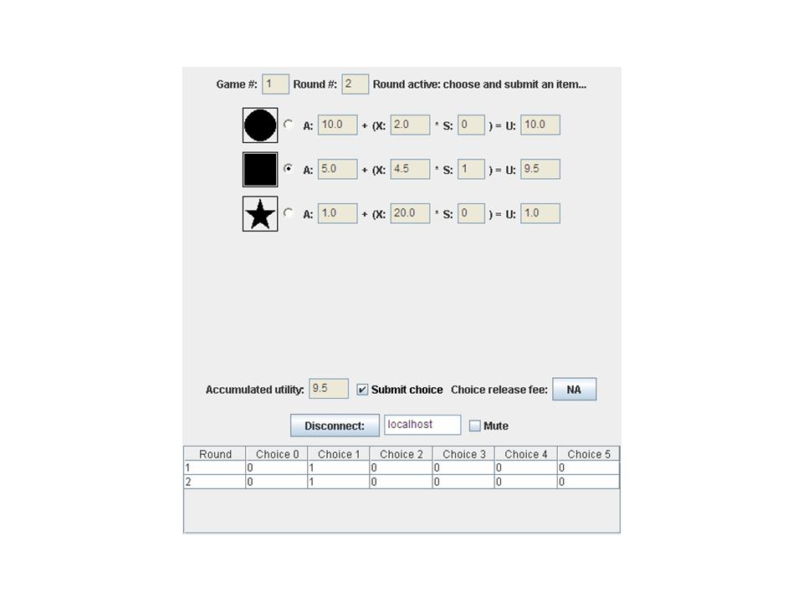Figure 4 – Player During Round 2 of Game 1.

Game 2 – Sequential Choice

In this game, participants can now decide in each period whether to choose a symbol or not. However, once a symbol is chosen, participants cannot change their choices.

Prior to beginning the game, the facilitator should set the desired utilities and the number of choice options. Participants should be informed that in any round that they may elect not to make a choice, but that they will receive a utility of zero for that round. After they have selected a symbol, their choice of symbol will determine their utility not only for that round, but also for the remaining rounds. As in Game 1, participant’s utility for each round is determined by the number of people who have chosen the same technology. Again, participants make their choice by selecting the check box next to the desired symbol and then selecting the Submit Choice checkbox.

To begin the game the facilitator selects the Start/Stop Game checkbox and then the Start/Stop Round checkbox. After each participant has had enough time to make their choice, the facilitator selects the Start/Stop Round checkbox ending the round. When sufficient players have chosen, or time has passed (a timer is available for as a convenience), the facilitator selects the Start/Stop Round checkbox ending the round.
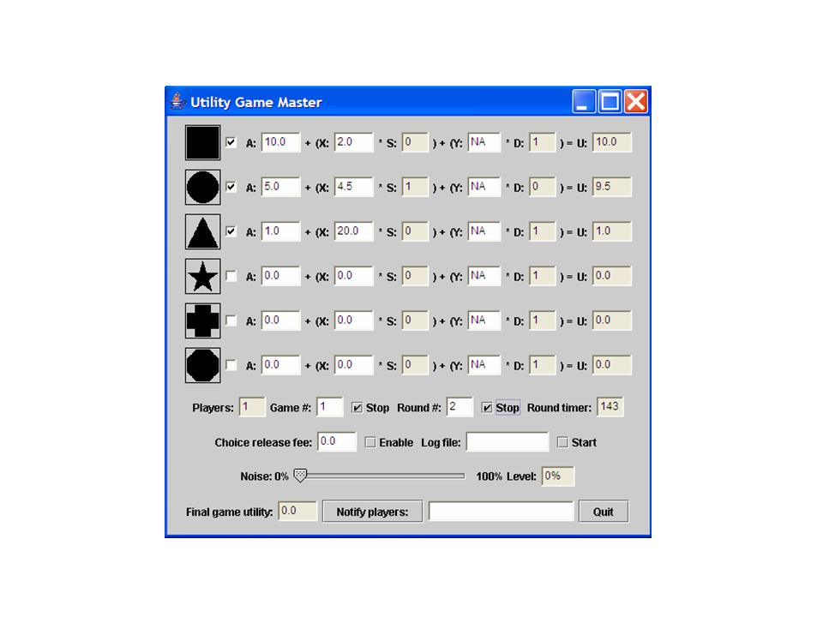
Figure 5 – Game Master During Game.

The number of players choosing the various items is now visible in the S box for each item.

Prior to ending the round, the facilitator may want to inform the participants that the round will be ending soon and that they are not required to make a choice, but will receive a utility of zero for the round if the fail to make a choice. The facilitator may choose to relay this information verbally or may use the software’s Notify players feature. To use this feature, the facilitator simply types a message into the text box and selects the Notify players push button. The message will be broadcast to all players and will appear at the bottom of their screens.

To start the next round, the facilitator selects the Start/Stop Round checkbox. At the beginning of the next round, the player can observe the S values for each item as well as his accumulated utility. Each participant’s accumulated total as well as a tabular history of the game is displayed.

Again, after an appropriate amount of time the facilitator ends the round by selecting the Start/Stop Round checkbox. This is continued for as many rounds as it takes until all participants have selected a symbol. At this point, the facilitator ends the game by entering the number 10 into the Round # textbox and then starting and stopping the round. The software will then calculate each player’s utility for the remaining rounds. Finally, the facilitator selects the Start/Stop Round checkbox ending the game. Each participant will be shown their total utility for the game as well as round by round summaries.

Game 3– Sequential Choice with a Noisy Signal

This game is only different from game 2 in the information participants receive each period about the number of people who have chosen each technology. In game 2, after each round participants were shown a summary of all participant choices. In game 3, after each round participants will be shown a “noisy” summary of all participant choices. By setting the level of noise, the facilitator can adjust the “noisiness” of this signal. For example, if the facilitator sets the noise level to 50%, each participant’s choice will have a 50% chance of being displayed. The level of noise is set by the Game Master Application and this setting determines the likelihood that each choice will be displayed. However, whether or not the choice is displayed is determined by each participant’s Player Applet. As a result, it is likely that participants will see differing results.

Again, each player’s utility for the round is based on the known number of people choosing the same technology, i.e., the number that has been revealed.

This is continued for as many rounds as it takes until all participants have selected a symbol. At this point, the facilitator ends the game by entering the number 10 into the Round # textbox and then starting and stopping the round. The software will then calculate each player’s utility for the remaining rounds. Finally, the facilitator selects the Start/Stop Round checkbox ending the game. At this point, each participant will be shown their total utility for the game as well as actual round by round summaries.

Game 4– Sequential Choice with Changing Utilities and Switching Costs

This round differs from Round 3 in the following way. After the third period, one of the symbols will be randomly chosen to provide a higher utility than the other. Ruebeck et al. (2003) suggest flipping a coin to choose which technology to change. The authors also suggest that for smaller classes that it might be helpful to select the smaller of the networks. After the change in the selected technology’s utility, if a participant has chosen a symbol, they can change to another symbol but must pay to do so. The cost for switching to another symbol is set by entering the amount in the Choice release fee textbox. Ruebeck et al. (2003) propose increasing the utility of the selected technology by a/4 and setting the switching costs to a.

Game 5– Sequential Choice with a Universal Technology

Game five differs from game two it that one of the technology choices will have a utility function in which participants’ utility for choosing that technology will be affected by the by the number of people who have chosen the same technology and by the number of people that have chosen a different technology. Y represents the utility derived from participants choosing a different (D) technology.

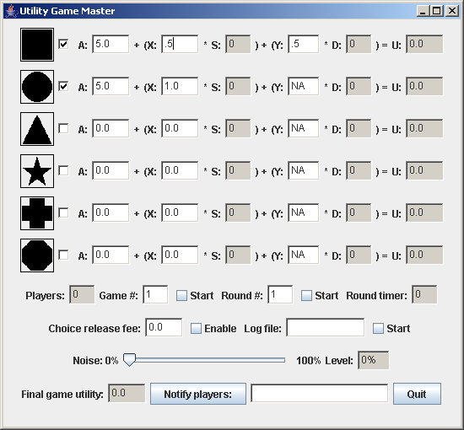

Figure 6 – Game Master Application Game 5.

Figure 6 shows a game setup that includes a choice of two different technologies. The first technology has a utility function of μ = 5 + 0.5*S + 0.5*D, where S is the number of participants that choose the same technology and D is the number of participants choosing a different technology

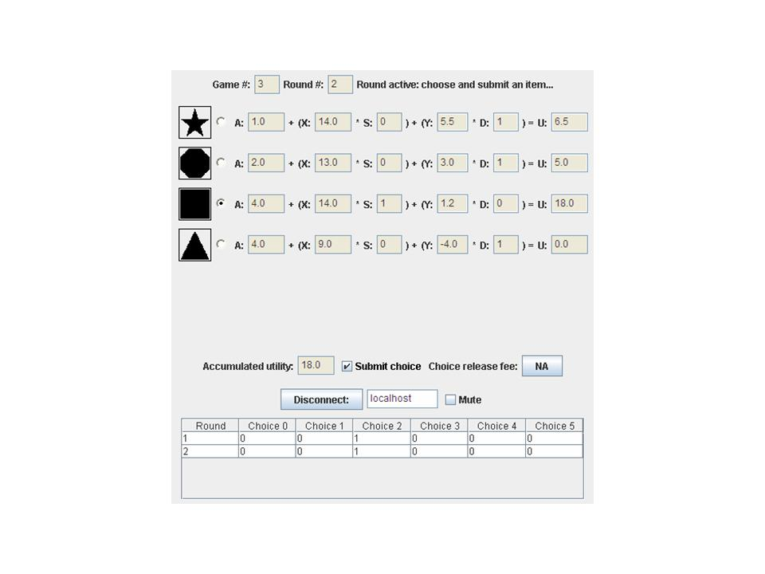Figure 7 – Y and D Visible to Player.

Special Controls

Choice Release Fee: The Master can use this to set a fee that players can choose to pay to release their submitted item choice, thus freeing them to make another choice.

Noise: The Master can introduce noise into the S values visible to the players by using this control. As an example, suppose the Master sets this value to 50%, and a particular item S value has a value of 10. In this case 10 coin tosses (representing the 50% noise) are made and the number of heads become the visible S value; so on average the player would see S as 5. Notice that at a noise level of 100% all players see S equal to 0 and thus have no idea of what items have been chosen (other than their own choice). The noise determination occurs independently for each player which will likely result in different visible S values for each.

The Y Parameter: Initially this is set of NA (not available), which means that the Y and D values are not visible to players. Setting Y to a numeric value results in the screen views shown in Figures 5 and 6. The D value represents the number of players who have not chosen an item. This is multiplied by the value of Y and added into the utility value of the item.
References

Katz M. L., and C. Shapiro, “Network externalities, competition, and compatibility,” American Economic Review 75: 424-440, 1985.

Ruebeck,C, S. Stafford, N. Tynan, W. Alpert, G. Ball and B. Butkevich "Network Externalities and Standardization: A Classroom Demonstration," Southern Economic Journal, Vol. 69: 1000-08, 2003

