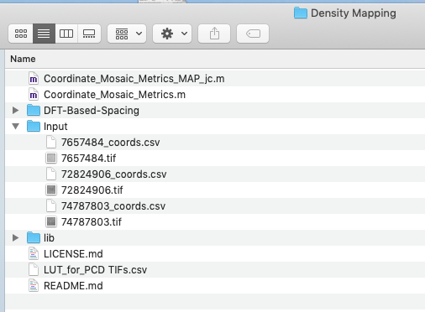
Step 1 – Use coord files to produce density matrices

Run the Coordinate_Mosaic_Metrics_MAP_jc.m script (now named Coordinate_Mosaic_Metrics_Map.m)

This requires an “Input” folder that contains the coordinate file and corresponding .tif foveal montage image from which the coordinates were derived. A LUT file with image scale information is also required.

This code is fairly slow. The larger the “window”, the slower it will take.
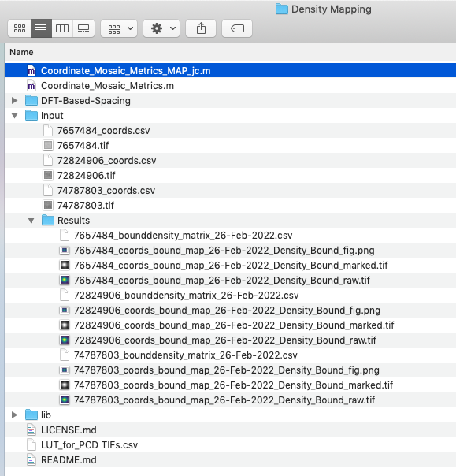
Once you run the code, the folder should look like this, where a bound density matrix is generated for each set of cone coordinates, along with 3 images of the density map.

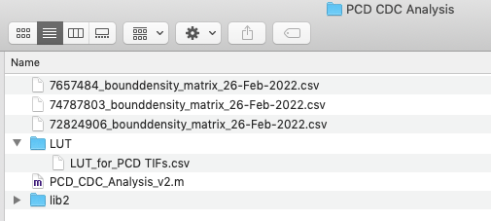
Step 2 – The next processing step is the PCD and CDC analysis. Copy or move the density matrix files from the first step into the “PCD_CDC” folder located in the “MAP_Analysis” folder.

This script (PCD_CDC_Analysis_v2.m, now called PCD_CDC_Analysis.m) will run fast. After running, you will get 3 files per density matrix – a grayscale density map with the CDC & PCD location indicated, the 80% isodensity contour and best-fit ellipse also with the CDC & PCD locations marked, and then the coordiates of the 80% isodensity contour (as a .csv file). A summary data sheet is also generated.

Step 3 (optional) – You can also run the Contour_Overlay script on some or all of the density matrices. This will give you a .csv file and an image of the 75%-95% isodensity contours. A summary sheet with the center locations of each contout is also provided.

Step 4 – Once you have the x,y PCD & CDC locations for each subject from each grader you can Compare Observers to generate a graph of the 95% confidence ellipses of these locations.

