

Cyclone® IV GX Device Layout Review Worksheet

This document is intended to guide you in completing a board layout review using an Altera Cyclone IV GX device. The technical content is divided into focus areas such as Power Planes and Stack Up, Critical Signals, Component Mounting and Connectors.

Focus areas consist of References, Points to Consider, Review Comments and Additional Comments sub-sections. The Power Planes section has some additional power related tables.

Each section provides References associated with that particular area. Other references are also provided in the Appendix.

The Points to Consider section provide a list of best practices for layout review for a particular focus area. Review these points before and during the board layout review. Detailed board level simulation is the recommended way to assure board success, specifically for high-speed/Multi-Gbps systems. In the absence of board level simulation, following the best practices will increase the probability of a successful outcome.

After reviewing the Points to Consider section for each focus area, you can review each item associated with that focus area on your board. The Review Comments section is provided to write down related comments, along with any possible screen captures. These comments can later be passed on to the board layout engineer to implement the recommended changes. Below is a sample of a Review Comments table. You can copy and paste these tables as required to address all related items in that particular section.

Signal/Net name: VCC
Comments: No ground plane next to the VCC plane. Inter-plane capacitance is not utilized. Change stack up to add/move ground plane adjacent to the VCC plane….

Each focus area provides you an opportunity to add further comments in the Additional Comments area.

Figures referenced in multiple sections have been placed in the Appendix. Otherwise, each figure is placed in its relevant section.

Each page provides hyperlinks for easy navigation throughout this document.

Altera strongly recommends board designers simulate all I/O interfaces with the device IBIS models, and all transceiver interfaces with HSPICE models.

Altera strongly recommends a Quartus II project be compiled to completion prior to committing to board layout. There are many I/O related placement restrictions and VCCIO requirements for the I/O standards used in the device. If you do not have a complete Quartus II project, then at a minimum a top level project should be used with all I/O pins defined, placed, and apply all of the configurable options that you plan to use such as on chip termination, programmable current strength, programmable weak pull up resistor, PCI Clamp Diode, etc....

All I/O related Megafunctions should also be included in the minimal project, including, but not limited to, external memory interfaces, PLLs, altlvds, altgx/altgxb and altddio. You can use the I/O Analysis tool in the Quartus II Pin Planner to validate the pinout in Quartus II software to assure there are no conflicts with the device rules and guidelines.

This worksheet should only be used as a recommendation, not as a specification.

Index

Legal Note

Section I: Power Planes and Stack Up

Section II: Critical Signals

a: High Speed Transceiver (GX) Signals

b: LVDS and other Differential Signals

c: Clocks

d: External Memory Interfaces

Section III: Component Mounting

Section IV: Connectors

Appendix and References

Document Revision History

Legal Note:

PLEASE REVIEW THE FOLLOWING TERMS AND CONDITIONS CAREFULLY BEFORE USING THIS LAYOUT REVIEW WORKSHEET (“WORKSHEET”) PROVIDED TO YOU. BY USING THIS WORKSHEET, YOU INDICATE YOUR ACCEPTANCE OF SUCH TERMS AND CONDITIONS, WHICH CONSTITUTE THE LICENSE AGREEMENT ("AGREEMENT") BETWEEN YOU AND ALTERA CORPORATION OR ITS APPLICABLE SUBSIDIARIES ("ALTERA").

1. Subject to the terms and conditions of this Agreement, Altera grants to you, for no additional fee, a non-exclusive and non-transferable right to use this Worksheet for the sole purpose of determining the validity of the pin connections of an Altera programmable logic device-based design in your printed circuit board layout. You may not use this Worksheet for any other purpose. There are no implied licenses granted under this Agreement, and all rights, except for those granted under this Agreement, remain with Altera.

2. Altera does not guarantee or imply the reliability, or serviceability, of this Worksheet or other items provided as part of this Worksheet. This Worksheet is provided 'AS IS'. ALTERA DISCLAIMS ALL WARRANTIES, EXPRESS OR IMPLIED, INCLUDING THE IMPLIED WARRANTIES OF MERCHANTABILITY, FITNESS FOR A PARTICULAR PURPOSE, AND NON-INFRINGEMENT. UNLESS OTHERWISE EXPRESSLY PROVIDED IN WRITING, ALTERA HAS NO OBLIGATION TO PROVIDE YOU WITH ANY SUPPORT OR MAINTENANCE.

3. In no event shall the aggregate liability of Altera relating to this Agreement or the subject matter hereof under any legal theory (whether in tort, contract, or otherwise), exceed One Hundred US Dollars (US$100.00). In no event shall Altera be liable for any lost revenue, lost profits, or other consequential, indirect, or special damages caused by your use of this Worksheet even if advised of the possibility of such damages.

4. This Agreement may be terminated by either party for any reason at any time upon 30-days’ prior written notice. This Agreement shall be governed by the laws of the State of California, without regard to conflict of law or choice of law principles. You agree to submit to the exclusive jurisdiction of the courts in the County of Santa Clara, State of California for the resolution of any dispute or claim arising out of or relating to this Agreement. The parties hereby agree that the party who is not the substantially prevailing party with respect to a dispute, claim, or controversy relating to this Agreement shall pay the costs actually incurred by the substantially prevailing party in relation to such dispute, claim, or controversy, including attorneys' fees. Failure to enforce any term or condition of this Agreement shall not be deemed a waiver of the right to later enforce such term or condition or any other term or condition of the Agreement.

BY USING THIS WORKSHEET, YOU ACKNOWLEDGE THAT YOU HAVE READ THIS AGREEMENT, UNDERSTAND IT, AND AGREE TO BE BOUND BY ITS TERMS AND CONDITIONS. YOU AND ALTERA FURTHER AGREE THAT IT IS THE COMPLETE AND EXCLUSIVE STATEMENT OF THE AGREEMENT BETWEEN YOU AND ALTERA, WHICH SUPERSEDES ANY PROPOSAL OR PRIOR AGREEMENT, ORAL OR WRITTEN, AND ANY OTHER COMMUNICATIONS BETWEEN YOU AND ALTERA RELATING TO THE SUBJECT MATTER OF THIS AGREEMENT.

Index
Device Pin Connection Guidelines
AN 528: PCB Dielectric Material Selection and Fiber Weave Effect on High-Speed Channel Routing (PDF)
Arria II GX Device Family Errata Sheet (PDF)

Points to Consider

- Power planes whether full plane or split plane should have an adjacent GND.

- Power and GND plane separation should be thin in order to increase coupling and interplane capacitance (3-4 mils is typical) .

- Power pins should be connected directly to their related power planes to minimize inductance. Avoid using narrow traces to connect device power pins to the power source/plane. The board designer should refer to regulator manufacturer guidelines.

- Split plane separation should be between 25 to 100 mils (Figure A-2).

- Do not share a single via with multiple power pins. Each power pin should have at least one dedicated via connection to the power plane.

Index

Power Planes

Altera Power Rail Name (Voltage Level) | Customer Power Rail Name
VCCL_GXB (1.2V)
VCCH_GXB (2.5V)
VCCA_GXB (2.5V)
VCCINT (1.2V)
VCCD_PLL (1.2V)
VCCA (2.5V)
VCCIO[3:9] (1.2V, 1.5V, 1.8V, 2.5V, 3.0V, or 3.3V)
VCC_CLKIN[3,8] (2.5V when used for differential clock input power)
VREFB[3..8]N[0..2] (VCCIO/2 of its bank, GND or VCCIO if unused)

Index Top of section

Board Stack up
Layer # | Layer Type (Signal, GND, Power) | Altera Name or signal type | Spacing | Notes
L1
L2
L3
L4
L5
L6
L7
L8
L9
L10
L11
L12
L13
L14

Index Top of section
Review Comments

Signal/Net name:
Comments:

Signal/Net name:
Comments:

Signal/Net name:
Comments:

Signal/Net name:
Comments:

Signal/Net name:
Comments:

Signal/Net name:
Comments:

Additional Comments

Index Top of section

Section II: Critical Signals

Part A: High Speed Transceiver (GX) signals

References
AN 529: Via Optimization Techniques for High-Speed Channel Designs (PDF)
AN 530: Optimizing Impedance Discontinuity Caused by Surface Mount Pads for High-Speed Channel Designs (PDF)

Points to Consider

- Transceiver signals should be routed completely on a single layer with the exception of via transitions from component layer to the routing layer (Figure A-3).

- Transceiver differential pairs should be routed on layers such that a via-stub is not produced. Back drilling is a good way to eliminate via stubs and reduce reflections (Figure A-3).

- For the traces routed on same layer as the associated transceiver pad, pad-to-plane coupling can increase capacitive discontinuity at the pads. Create a cut-out in the reference ground/power reference plane, beneath the transceiver pads to reduce the capacitive discontinuity from pad-to-plane coupling. Please refer to “AN 530: Optimizing Impedance Discontinuity Caused by Surface Mount Pads for High-Speed Channel Designs” in the references section above.

- When transitioning from one layer to another (perhaps to route to an AC coupling capacitor), return path vias must be placed where the signal changes its reference (Figure A-7). Please refer to “AN 529: Via Optimization Techniques for High-Speed Channel Designs” in the references section above.

- Do not use via pads in the inner layers to preserve signal integrity (Figure A-4).

- Transceiver signals should not be routed over splits in their reference plane.

- P & N pairs of transceiver differential signals should be routed as differential pairs, while meeting differential required impedances. Avoid multilayer broadside routing. Tight coupling provides better common mode noise rejection.
Index
- If P & N trace skew matching “meandering” is required, it should be distributed throughout the trace length.

- P & N legs of the differential transceiver signals should matched. Typically these signals are matched within +/-5mils

  - Differential trace lengths should be matched. Figure A-5 shows a good practice on the right side and a bad practice on the left side.

- For protocols that have more than one channel, the channel-to-channel routing skew should be within the specific protocol specification. The board design engineer should verify if this skew complies with their protocol specific requirements.

- Channel-to-channel spacing between transceiver differential pairs on a common layer should be no less than 3x the distance of the signal layer to the reference plane.

- Single ended signal to differential pair spacing on a common layer should be no less than 3x the distance of the signal layer to the reference plane.

- In case of external termination, place the resistors as close to the transceiver pins as possible (within 1/5 length of the rise time). Use low ESR, 1% resistors for better impedance matching.

- Use 45 degree traces or arc to minimize signal discontinuity on transceiver traces.

- For data rates greater than 8Gbps, use constant radius corners.

- Keep the parasitic loading the same on both differential signal traces.

- Keep differential drivers and receivers as close to their associated connectors as possible.

- When a differential signal traces are separated to route to a connector like SMAs, the trace width should change from a differential trace width to two single ended trace widths.

Index Top of the Section
Review Comments

Signal/Net name:
Comments:

Signal/Net name:
Comments:

Signal/Net name:
Comments:

Signal/Net name:
Comments:

Signal/Net name:
Comments:

Signal/Net name:
Comments:

Additional Comments

Index Top of the Section
Part B: LVDS & Other Differential Signals

References

AN 529: Via Optimization Techniques for High-Speed Channel Designs (PDF)
AN 530: Optimizing Impedance Discontinuity Caused by Surface Mount Pads for High-Speed Channel Designs (PDF)

Points to Consider

- Differential signals should be routed completely on a single layer with the exception of via transitions from component layer to the routing layer (Figure A-3).

- Differential pairs should be routed on layers such that a via-stub is not produced. Back drilling is a good way to eliminate via stubs and reduce reflections (Figure A-3).

- For the traces routed on same layer as the associated transceiver pad, pad-to-plane coupling can increase capacitive discontinuity at the pads. Create a cut-out in the reference ground/power reference plane, beneath the transceiver pads to reduce the capacitive discontinuity from pad-to-plane coupling. Please refer to “AN 530: Optimizing Impedance Discontinuity Caused by Surface Mount Pads for High-Speed Channel Designs” in the references section above.

- When transitioning from one layer to another (perhaps to route to an AC coupling capacitor), return path vias must be placed where the signal changes its reference (Figure A-7). Please refer to “AN 529: Via Optimization Techniques for High-Speed Channel Designs” in the references section above.

- Do not use via pads on the inner layers to preserve signal integrity (Figure A-4).

- Differential signals should not be routed over splits in their reference plane.

- P & N pairs of the differential signals should be routed as differential pairs, while meeting differential required impedances. Avoid multilayer broadside routing. Tight coupling provides better common mode noise rejection.

- If P & N trace skew matching “meandering” is required, it should be distributed throughout the trace length.

Index

- P & N pairs of differential signals should be skew matched to the protocol requirements. Typically this is data rate dependent. Typically match the time delays of the P & N traces in a differential pair to about 1% the UI. The board design engineer should verify if this skew complies with their protocol specific requirements.

- For protocols that have more than one channel, the channel-to-channel routing skew should be within the specific protocol specification. The board design engineer should verify if this skew complies with their protocol specific requirements.

- Channel-to-channel spacing between differential pairs on a common layer should be no less than 3x the distance of the signal layer to the reference plane.

- Single ended signal to differential pair spacing on a common layer should be no less than 3x the distance of the signal layer to the reference plane.

- In case of external termination, place the resistors as close to the differential pins as possible (within 1/5 length of the rise time). Use low ESR, 1% resistors for better impedance matching.

- Use 45 degree traces or arc to minimize signal discontinuity on differential traces.

- Keep the parasitic loading the same on both differential signal traces.

- Keep differential drivers and receivers as close to their associated connectors as possible.

- Differential trace lengths should be matched. Figure A-5 shows a good practice on the right side and a bad practice on the left side.

Index Top of the Section
Review Comments

Signal/Net name:
Comments:

Signal/Net name:
Comments:

Signal/Net name:
Comments:

Signal/Net name:
Comments:

Signal/Net name:
Comments:

Signal/Net name:
Comments:

Additional Comments

Index Top of Section

Part C: Clocks

Points to consider

- Clock drivers should be located adjacent to clock oscillators.

- Keep clock traces as straight as possible. Avoid T-junctions and right angle in routing. Instead use 45 degrees.

- Do not use multiple signal layers for clock signals.

- Do not use via in clock transmission lines. Via can cause impedance change and reflections.

- Place a ground plane next to the outer layer to minimize noise. If you use an inner layer to route the clock trace, sandwich the layer between reference planes.

- Terminate clock signals to minimize reflections. Board designer should verify topology using IBIS simulation.

- Use point-to-point clock traces as much as possible.

- For differential clock traces, make sure D > 2S to minimize the crosstalk between the two differential pairs (Figure 2-1).

Figure 2-1 Differential clocks’ spacing

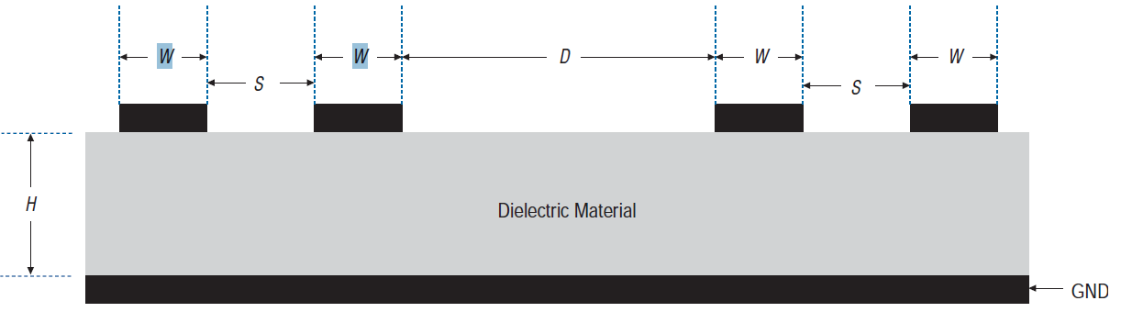

- Keep the distance between the differential traces (S) constant over the entire trace length.

Index
- Keep the length of the two differential traces the same to minimize the skew and phase.

- Avoid using multiple vias to avoid impedance mismatch and higher inductance.

- With minimum trace lengths, route high-speed clock and high-speed USB differential pairs.

- Maintain maximum possible distance between high-speed clocks/periodic signals to high speed differential pairs and any connector leaving the PCB (such as, I/O connectors, control and signal headers, or power connectors).

- Route all traces over continuous GND or power planes with no interruptions.

- Minimize the length of high-speed clock and periodic signal traces that run parallel to high speed signal lines to minimize crosstalk. The minimum suggested spacing to clock signals is 3x the distance to the closest reference plane.

- Use a lower impedance transmission line when a clock driver serving many loads as it passes through the transmission line.

- Use the return path vias, when signal transitions from one layer to another (Figure A-7).

- Synchronous clocks should be matched in delay. Ensure clocks are routed on the same layer as each other to minimize layer to layer differences in propagation velocity.

Index Top of Section

- Star routing considerations: In star routing, the clock signal travels to all the devices at the same time, as shown in the following diagram. Therefore, all trace lengths between the clock source and devices must be matched to minimize the clock skew. Each load should be identical to minimize signal integrity problems. In star routing, you must match the impedance of the main bus with the impedance of the long trace that connects to multiple devices (Figure 2-3).

Figure 2-3 Star routing

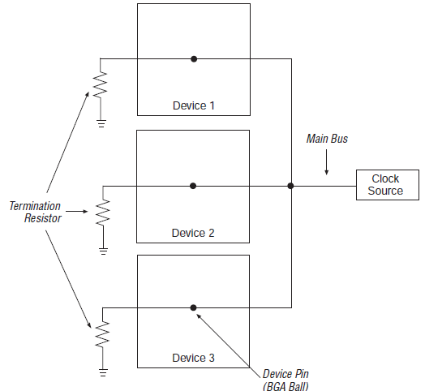

Index Top of Section

- If a clock source connects to multiple clock pins, use daisy chain connection without stubs (Figure 2-4).

Figure 2-4 Daisy chain connectivity

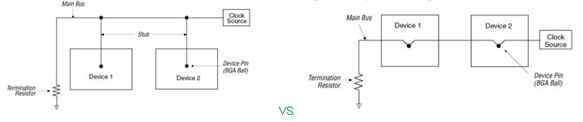

Index Top of Section
Review Comments

Signal/Net name:
Comments:

Signal/Net name:
Comments:

Signal/Net name:
Comments:

Signal/Net name:
Comments:

Signal/Net name:
Comments:

Signal/Net name:
Comments:

Additional Comments

Index Top of Section

Part D: Memory Interfaces

DDR2

References

Board Layout Guidelines (PDF) (External Memory Interface Handbook, Volume 2)

Points to consider

- Use 45° angles (not 90° corners).

- Avoid T-Junctions for critical nets or clocks.

- Disallow signals across split planes.

- Avoid routing memory signals closer than 0.025 inch (0.635 mm) to other signals.

- All data, address, and command signals must have matched length traces ±0.250 inches (6.35 mm).

- All signals within a given Byte Lane Group should be matched length with maximum deviation of ±0.050 inches (1.27 mm).

- All signals within a given Byte Lane Group should be routed identically. i.e. on the same layer, with the same number of vias.

Clock Routing

- Clocks should be routed on inner layers with outer-layer run lengths held to under 500 mils (12.7 mm).

- Clock signals should maintain a10-mil (0.254 mm) spacing from other nets.

- Clocks should maintain a length-matching between clock pairs of ±30 mils (0.762 mm).

Index

- Differential clocks should maintain a length-matching between P and N signals of ±15 mils (0.381 mm), routed in parallel.

- Space between different pairs should be at least three times the space between the differential pairs and must be routed differentially (5-mil trace, 10-15 mil space on centers) and be equal in length to the typical length of the signals in the Address, Command and control group (4.5 inches max length from FPGA to DIMM).

Address and Command Routing

- Un-buffered address and command lines are more susceptible to cross-talk and are generally noisier than buffered address or command lines. Therefore, un-buffered address and command signals should be routed on a different layer than data signals (DQ) and data mask signals (DM) and with greater spacing.

- Do not route differential clock (CK) and clock enable (CKE) signals close to address signals.

Index Top of Section
Review Comments

Signal/Net name:
Comments:

Signal/Net name:
Comments:

Signal/Net name:
Comments:

Signal/Net name:
Comments:

Signal/Net name:
Comments:

Signal/Net name:
Comments:

Additional Comments

Index Top of Section
Section III: Component Mounting

This section will address component mounting, specifically the PCB features associated with mounting components related to the Altera FPGA. This will look at areas like proper use of vias, trace widths, and board layout features used in mounting decoupling, termination, and AC coupling components.

References

AN 114: Designing with High-Density BGA Packages for Altera Devices (PDF)

Points to Consider

- For recommendations on BGA mounting, including pad and via size recommendations, use of Non Solder Mask Defined or Solder Mask Defined pads, suggested “dog bone” patterns and dimensions to maximize trace routing between vias and pads, please refer to “AN 114: Designing with High-Density BGA Packages for Altera Devices” in the references section above.

- Component connections to the power and ground planes must have a dedicated 1:1 mapping for vias to component connection. Via sharing should not be implemented.

- Keep the power and ground vias as close as possible to their respective pads to minimize inductance. See Figure 3-1 and Table 3-1 below.

- Use wide connecting trace from power and ground vias to their respective pads. See Figure 3-1 and Table 3-1 below.

- Use larger via drill diameters when possible. See Figure 3-1 and Table 3-1 below.

Index

Figure 3-1 Various Capacitor Layout Topologies

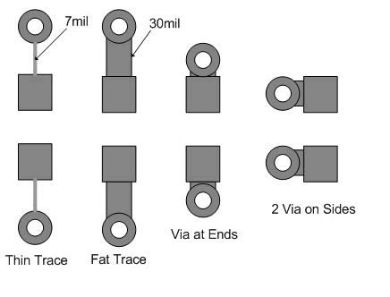
Table 3-1 Mounting Inductance Comparison

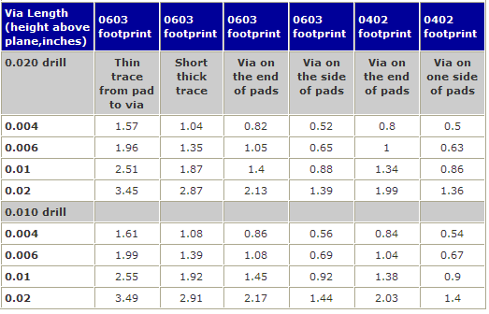

Index Top of Section

- See Figure 3-2 for other recommended via placement configuration. These further reduce mounting inductance at the expense of additional vias.

Figure 3-2 Via Placement Styles that Yield Lower Mounting Inductance

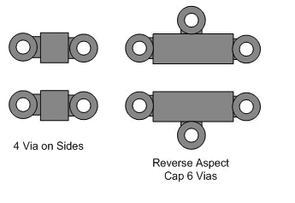

- Special capacitors and mounting techniques, such as X2Y capacitors, provide reduced mounting inductance when mounted properly. See the PDN Tool for your device, specifically the sheet X2Y_Mount.

Index Top of Section

- Via on side routing is better than via on end as it reduces loop inductance. See Figure 3-3 below.

Figure 3-3 Decoupling Capacitor Mounting. Via-On-Side is preferred mounting method.

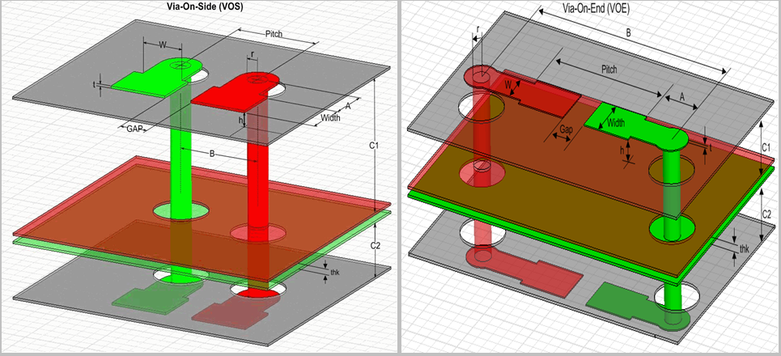

- Decoupling components should be located on the side of the board closest to the power plane they are decoupling.

- Trace width for termination should not introduce impedance changes, when traversing from pad to via.

- Do not share a single via with multiple power pins. Each power pin should have at least one dedicated via connection to the power plane.

- High-speed controlled impedance signals coming into FPGA pad “dog bone”:
- Put “anti-pad” on current reference plane (cut out of closest reference plan for that shape), causing reference planes for this signal to change to new reference plane further away, thus compensating/preventing the impedance mismatch.
- Pad and trace from pad to via can significantly affect impedance of signal.

Index Top of Section
Review Comments

Component name:
Comments:

Component name:
Comments:

Component name:
Comments:

Component name:
Comments:

Component name:
Comments:

Component name:
Comments:

Additional Comments

Index Top of Section

Section IV: Connectors

Points to Consider

- Use the same considerations as listed in Part-1: High Speed Transceiver (GX) signals with respect to via stubs at connector pins

- Place return path vias at the connector when layer transitions occur (Figure A-7).

- "Tear-dropping" is a method used to reduce impedance discontinuity when going from a wide pin and trace to a narrow pin or trace. For example, in Figure 4-1 a, the dimensions of an SMA connector which has a 50-mil diameter center pin, but the board traces might be 5-mils wide, it is recommended to use tear-dropping in this scenario. A screen capture of how Altera used tear-dropping on the Stratix GX development board is shown in Figure 4-1 b.

Figure 4-1 a) SMA Connector b) Tear dropping on one of Altera boards
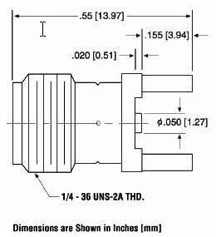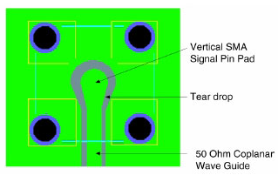

Index
Review Comments

Connector name:
Comments:

Connector name:
Comments:

Connector name:
Comments:

Connector name:
Comments:

Connector name:
Comments:

Connector name:
Comments:

Additional Comments

Index Top of Section

Appendix-A

References

Board Design Resource Guide

High-Speed Board Design Advisor

Board Layout Guidelines (PDF) (External Memory Interface Handbook, Volume 2)

AN 114: Designing with High-Density BGA Packages for Altera Devices (PDF)

AN 528: PCB Dielectric Material Selection and Fiber Weave Effect on High-Speed Channel Routing (PDF)

AN 529: Via Optimization Techniques for High-Speed Channel Designs (PDF)

AN 530: Optimizing Impedance Discontinuity Caused by Surface Mount Pads for High-Speed Channel Designs (PDF)

Device Pin Connection Guidelines

Cyclone IV Device Family Errata Sheet (PDF)

Index
Figures and Tables

Figure A-1 Stratix IV FPGA Rev. B board stack-up example
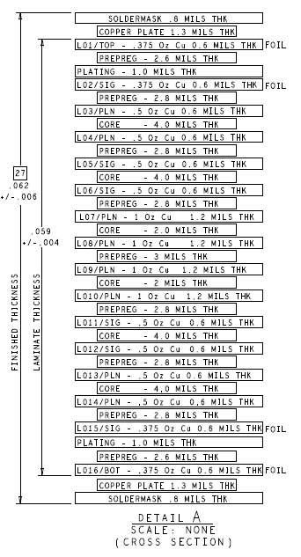

Index Top of section

Figure A-2: Split plane separation should be between 25 to 100 mils

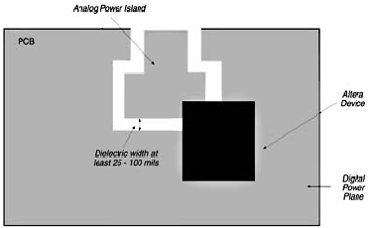

Figure A-3: Avoid via stubs for critical signals

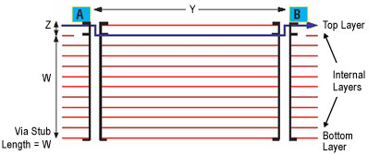 VS. 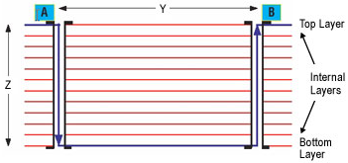

Index Top of section

Figure A-4 Avoid via pads in inner signal layer as shown in the following diagram
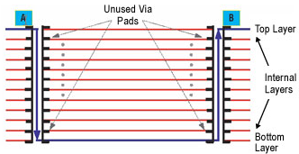

Figure A-5 Differential trace length matching - Figure on the right hand side would be a good practice for trace length matching.
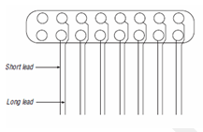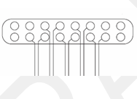

Index Top of section

Figure A-6 Loose coupling and ground reference example
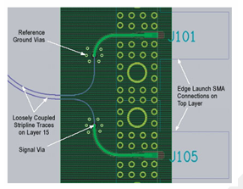

Figure A-7 Return path vias
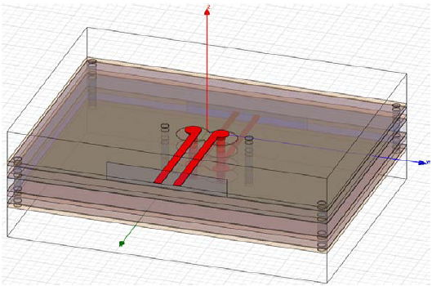

Index Top of section
Table A-1 Example of a completed stack-up table (the voltage rail names may not match this particular device family)

Layer # | Layer Type (Signal, GND, Power) | Altera Name or signal type | Spacing | Comments
L1 | Signal | XCVR Routing (PCIe signals) |  | FPGA mounted on the top
 |  |  | 4
L2 | GND | GND
 |  |  | 3
L3 | XCVR_1V2A, XCVR_3V0A, | VCCT, VCCR, VCCL, VCCA_L/R
 |  |  | 4
L4 | Signal | DDR2, Gen Routing
 |  |  | 4
L5 | Signal | DDR2, Gen Routing
 |  |  | 4
L6 | GND | GND
 |  |  | 3
L7 | 0V9D | VCC
 |  |  | 8
L8 | 2V5A, 2V5D | VCCA_PLL, VCCIO1,
 |  |  | 3
L9 | GND | GND
 |  |  | 4
L10 | Signal | DDR2, Gen Routing
 |  |  | 4
L11 | Signal | DDR2 Gen Routing
 |  |  | 4
L12 | 3V3D | VCCIO6
 |  |  | 3
L13 | GND | GND
 |  |  | 4
L14 | Signal | XCVR Routing |  | Decoupling on the bottom

Index Top of section
Document Revision History

Revision | Changes Made | Date
V1.0 | Initial release. | April 2010

Index

