Titanic - Predicting Surviors

Ryan Porter

3/5/2020

The goal is to predict how many people survived and didn’t survive the Titanic disaster. Below are different methods that I used in order to predict surivorship.

## Loading the Data

Loading the data was simple but I opted to work on the project on my local computer rather than kaggle’s workbook. I did this because I wanted to use GitHub for the project since I work on my laptop and a desktop.

#loading packages  
library(tidyverse)  
library(caret)  
library(rpart)  
library(VIM)  
library(naniar)  
library(car)  
library(MASS)  
library(fastAdaboost)  
library(mda)  
  
#loading the data  
list.files(path = "C:/Users/Ryan/Documents/titanic")

## [1] "feature_engineering.R" "gender_submission.csv" "README.md"   
## [4] "submission.csv" "submission_ada.csv" "submission_fda.csv"   
## [7] "submission_rf.csv" "submission_svm.csv" "test.csv"   
## [10] "titanic.Rproj" "titanic_code.R" "titanic_markdown.docx"   
## [13] "titanic_markdown.Rmd" "titanic_markdown_files" "train.csv"

train_data <- read_csv("C:/Users/Ryan/Documents/titanic/train.csv")  
test_data <- read_csv("C:/Users/Ryan/Documents/titanic/test.csv")

## Desciptive Statistics

I made a table of each of the variables that way I know what values they were able to have. I also graphed a few of the combinations in order to determine if there were any correlations that was easily detectable. First class and fare had the biggest spread when looking at the second graph. Also, I know sex is going to play an important factor since at that time men were expect to let women escape before them. Children are probably also more likely to survive since older people would want the kids to escape.

table(train_data$Pclass)

##   
## 1 2 3   
## 216 184 491

table(train_data$Survived)

##   
## 0 1   
## 549 342

table(train_data$Age)

##   
## 0.42 0.67 0.75 0.83 0.92 1 2 3 4 5 6 7 8 9 10 11   
## 1 1 2 2 1 7 10 6 10 4 3 3 4 8 2 4   
## 12 13 14 14.5 15 16 17 18 19 20 20.5 21 22 23 23.5 24   
## 1 2 6 1 5 17 13 26 25 15 1 24 27 15 1 30   
## 24.5 25 26 27 28 28.5 29 30 30.5 31 32 32.5 33 34 34.5 35   
## 1 23 18 18 25 2 20 25 2 17 18 2 15 15 1 18   
## 36 36.5 37 38 39 40 40.5 41 42 43 44 45 45.5 46 47 48   
## 22 1 6 11 14 13 2 6 13 5 9 12 2 3 9 9   
## 49 50 51 52 53 54 55 55.5 56 57 58 59 60 61 62 63   
## 6 10 7 6 1 8 2 1 4 2 5 2 4 3 4 2   
## 64 65 66 70 70.5 71 74 80   
## 2 3 1 2 1 2 1 1

table(train_data$Embarked)

##   
## C Q S   
## 168 77 644

table(train_data$SibSp)

##   
## 0 1 2 3 4 5 8   
## 608 209 28 16 18 5 7

table(train_data$Parch)

##   
## 0 1 2 3 4 5 6   
## 678 118 80 5 4 5 1

aggr(train_data, prop = FALSE, combined = TRUE, numbers = TRUE, sortVars = TRUE, sortCombs = TRUE)

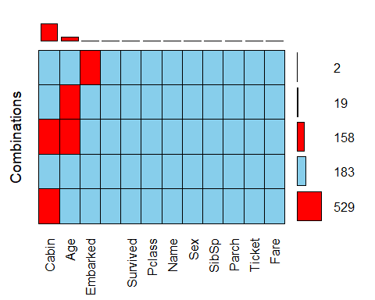

##   
## Variables sorted by number of missings:   
## Variable Count  
## Cabin 687  
## Age 177  
## Embarked 2  
## PassengerId 0  
## Survived 0  
## Pclass 0  
## Name 0  
## Sex 0  
## SibSp 0  
## Parch 0  
## Ticket 0  
## Fare 0

train_data %>%  
 ggplot(aes(Age)) +  
 geom_bar(stat = "count") #a lot of people under 40

## Warning: Removed 177 rows containing non-finite values (stat_count).

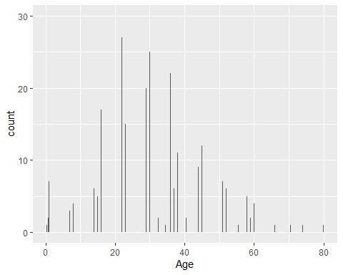

train_data %>%  
 ggplot(aes(Pclass, Fare)) +  
 geom_boxplot(aes(group = Pclass)) #first class has biggest spread

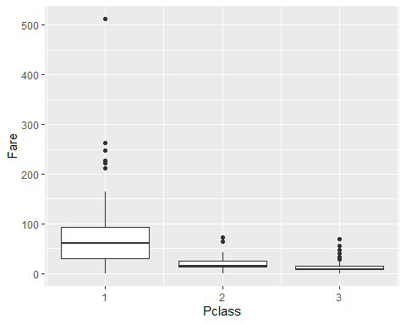

train_data %>%  
 ggplot(aes(Survived, Age)) +  
 geom_boxplot(aes(group = Survived))

## Warning: Removed 177 rows containing non-finite values (stat_boxplot).

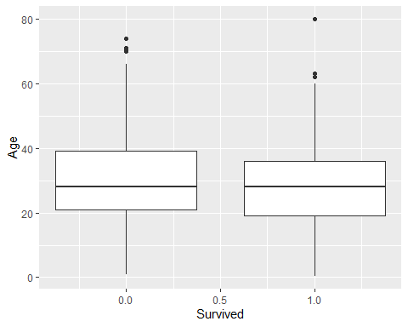

train_data %>%  
 ggplot(aes(Parch, Age)) +  
 geom_boxplot(aes(group = Parch))

## Warning: Removed 177 rows containing non-finite values (stat_boxplot).

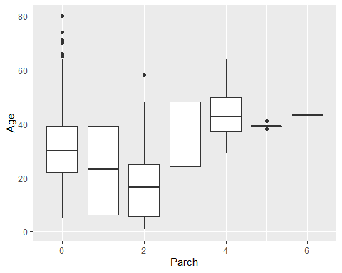

## Feature Engineering

There were only two different features that I decided to create. I was looking at doing something with tickets and cabin but after looking at public workbooks decided against it. In cabin there were so many of the values missing that it would not be a very accurate model with all the imposed numbers. Ticket did not seem to improve many of the scores that I look at so decided to spend time elsewhere.

Family size, I saw the idea on a lot of the public workbooks so I decided to see if it would help my model. I categorized it into three different categories so it would be easy to run analysis and not have too many categories. The other variable that I created was the title that the person had. This varaible ended up not helping me since it added no value when prediciting but decide to leave it. There were two missing values in Embarked, so I gave them the most common embarked location since they fit the demographic.

table(train_data$Embarked)

##   
## C Q S   
## 168 77 644

table(is.na(train_data$Embarked)) #two missing values

##   
## FALSE TRUE   
## 889 2

table(is.na(test_data$Embarked))

##   
## FALSE   
## 418

#only two embarked where missing from all the data  
train_data <- train_data %>% mutate(Embarked = ifelse(is.na(Embarked), "S", Embarked))  
  
#family size  
train_data$FamilySize <-train_data$SibSp + train_data$Parch + 1 #plus one so everyone has a value  
train_data$FamilySized[train_data$FamilySize == 1] <- 'Single'

train_data$FamilySized[train_data$FamilySize < 5 & train_data$FamilySize >= 2] <- 'Small'   
train_data$FamilySized[train_data$FamilySize >= 5] <- 'Big'   
train_data$FamilySized=as.factor(train_data$FamilySized)  
  
table(train_data$FamilySized)

##   
## Big Single Small   
## 62 537 292

test_data$FamilySize <-test_data$SibSp + test_data$Parch + 1   
test_data$FamilySized[test_data$FamilySize == 1] <- 'Single'

test_data$FamilySized[test_data$FamilySize < 5 & test_data$FamilySize >= 2] <- 'Small'   
test_data$FamilySized[test_data$FamilySize >= 5] <- 'Big'   
test_data$FamilySized=as.factor(test_data$FamilySized)  
  
table(test_data$FamilySized)

##   
## Big Single Small   
## 20 253 145

##Engineer features based on title  
train_data <- mutate(train_data, title_orig = factor(str_extract(Name, "[A-Z][a-z]*\\.")))  
test_data <- mutate(test_data, title_orig = factor(str_extract(Name, "[A-Z][a-z]*\\.")))  
  
table(train_data$title_orig)

##   
## Capt. Col. Countess. Don. Dr. Jonkheer. Lady. Major.   
## 1 2 1 1 7 1 1 2   
## Master. Miss. Mlle. Mme. Mr. Mrs. Ms. Rev.   
## 40 182 2 1 517 125 1 6   
## Sir.   
## 1

table(test_data$title_orig)

##   
## Col. Dona. Dr. Master. Miss. Mr. Mrs. Ms. Rev.   
## 2 1 1 21 78 240 72 1 2

## Dealing with Missing Data

The category that had the most missing data was Age, but I still wanted to use it as a factor. I used the same process that was covered in class since it seemed to be the best method for imposing records. The second part is preprocessing the data sets, so I don’t have to do it later with each model.

## Create test & train datasets ##  
test_index <- createDataPartition(train_data$Survived, times=1,p=0.5, list=FALSE)  
test_set <- train_data[test_index,]  
train_set <- train_data[-test_index,]  
  
#predict ages into misses values  
#log sibsip + 1, because it has a big negative, sibsip right scewed   
  
miss_var_summary(train_set)

## # A tibble: 15 x 3  
## variable n_miss pct_miss  
## <chr> <int> <dbl>  
## 1 Cabin 343 77.1  
## 2 Age 74 16.6  
## 3 PassengerId 0 0   
## 4 Survived 0 0   
## 5 Pclass 0 0   
## 6 Name 0 0   
## 7 Sex 0 0   
## 8 SibSp 0 0   
## 9 Parch 0 0   
## 10 Ticket 0 0   
## 11 Fare 0 0   
## 12 Embarked 0 0   
## 13 FamilySize 0 0   
## 14 FamilySized 0 0   
## 15 title_orig 0 0

linearMod <- lm(Age ~ Pclass + Sex + log(SibSp+1) + Parch + Fare, data=train_set)  
#look at the model  
summary(linearMod)

##   
## Call:  
## lm(formula = Age ~ Pclass + Sex + log(SibSp + 1) + Parch + Fare,   
## data = train_set)  
##   
## Residuals:  
## Min 1Q Median 3Q Max   
## -32.607 -9.276 -0.799 8.535 44.594   
##   
## Coefficients:  
## Estimate Std. Error t value Pr(>|t|)   
## (Intercept) 45.79439 2.68864 17.033 < 2e-16 ***  
## Pclass -6.86452 1.00383 -6.838 3.38e-11 ***  
## Sexmale 4.31549 1.52285 2.834 0.00486 **   
## log(SibSp + 1) -8.00873 1.63687 -4.893 1.49e-06 ***  
## Parch -1.26685 0.86098 -1.471 0.14204   
## Fare -0.01414 0.01561 -0.906 0.36565   
## ---  
## Signif. codes: 0 '***' 0.001 '**' 0.01 '*' 0.05 '.' 0.1 ' ' 1  
##   
## Residual standard error: 13.4 on 365 degrees of freedom  
## (74 observations deleted due to missingness)  
## Multiple R-squared: 0.2324, Adjusted R-squared: 0.2218   
## F-statistic: 22.1 on 5 and 365 DF, p-value: < 2.2e-16

#does it meet the assumptions of a linear model? How do the residuals look  
plot(linearMod) # all assumptions are meet

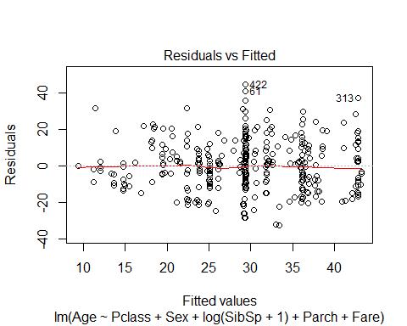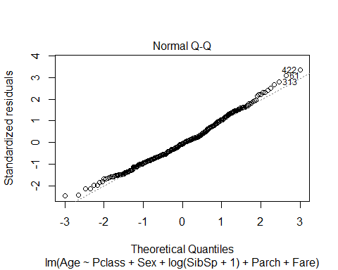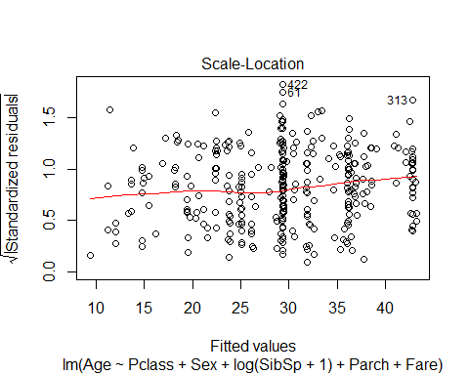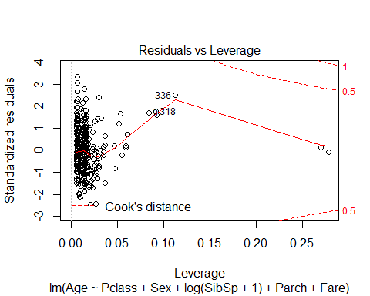

#check other assumptions of linear model  
dwt(linearMod) #check for independent errors - want values close to 2.

## lag Autocorrelation D-W Statistic p-value  
## 1 -0.05550828 2.106647 0.288  
## Alternative hypothesis: rho != 0

vif(linearMod) #check the variance inflation factor - values greater than 10 are problematic

## Pclass Sex log(SibSp + 1) Parch Fare   
## 1.507563 1.094314 1.166366 1.239050 1.524788

#predict the age based on the model  
Age_pre_train <- round(predict(linearMod, train_set))  
Age_pre_test_set <- round(predict(linearMod, test_set))  
Age_pre_test_data <- round(predict(linearMod, test_data))  
#set our ages for all three sets  
train_set <- train_set %>% mutate(Age_new = ifelse(is.na(Age), Age_pre_train, Age))  
test_set <- test_set %>% mutate(Age_new = ifelse(is.na(Age), Age_pre_test_set, Age))  
test_data <- test_data %>% mutate(Age_new = ifelse(is.na(Age), Age_pre_test_data, Age))  
  
  
#preprocess for the models you want to run after feature engineering  
#it is important for models like knn  
preProc <- preProcess(test_set[, c("Age_new", "SibSp", "Parch", "Fare")], method=c("center", "scale"))  
test_set <- predict(preProc, test_set)  
preProc2 <- preProcess(train_set[, c("Age_new", "SibSp", "Parch", "Fare")], method=c("center", "scale"))  
train_set <- predict(preProc2, train_set)  
preProc3 <- preProcess(test_data[, c("Age_new", "SibSp", "Parch", "Fare")], method=c("center", "scale"))  
test_data <- predict(preProc3, test_data)

## Feature Selection

I used a few different methods for feature selection. This first method I used was looking at other public workbooks and determining what variables a lot of the higher scoring methods used. I also used trial and error to see if certain features where valuable in changing the accuracy score. The best model from the linear regression method was also helpful determining which variables were useful. The variables that I determined as important are Pclass, Age, Sex, Family Size, and Embarked.

#summary(bestModel1) table used for feature selection

#aggr(train_data, prop = FALSE, combined = TRUE, numbers = TRUE, sortVars = TRUE, sortCombs = TRUE)

## Linear Regression

Linear Regression with stepwise. I submitted this one first since I would use it as a baseline for the future models that I used.

stepwise1 <- glm(Survived ~ factor(Pclass) + Age_new + Sex + FamilySized + Embarked,   
 data=train_set,   
 family = "binomial")  
  
bestModel1 <- stepAIC(stepwise1, direction="both") #stepwise in both directions

## Start: AIC=411.16  
## Survived ~ factor(Pclass) + Age_new + Sex + FamilySized + Embarked  
##   
## Df Deviance AIC  
## - Embarked 2 393.77 407.77  
## <none> 393.16 411.16  
## - FamilySized 2 410.34 424.34  
## - Age_new 1 422.31 438.31  
## - factor(Pclass) 2 456.54 470.54  
## - Sex 1 471.30 487.30  
##   
## Step: AIC=407.77  
## Survived ~ factor(Pclass) + Age_new + Sex + FamilySized  
##   
## Df Deviance AIC  
## <none> 393.77 407.77  
## + Embarked 2 393.16 411.16  
## - FamilySized 2 412.56 422.56  
## - Age_new 1 423.01 435.01  
## - factor(Pclass) 2 460.53 470.53  
## - Sex 1 476.71 488.71

summary(bestModel1)

##   
## Call:  
## glm(formula = Survived ~ factor(Pclass) + Age_new + Sex + FamilySized,   
## family = "binomial", data = train_set)  
##   
## Deviance Residuals:   
## Min 1Q Median 3Q Max   
## -2.4784 -0.6378 -0.3630 0.6154 2.4951   
##   
## Coefficients:  
## Estimate Std. Error z value Pr(>|z|)   
## (Intercept) 0.4172 0.6339 0.658 0.510500   
## factor(Pclass)2 -1.1462 0.3755 -3.052 0.002272 **   
## factor(Pclass)3 -2.6664 0.3680 -7.246 4.28e-13 ***  
## Age_new -0.8286 0.1662 -4.984 6.22e-07 ***  
## Sexmale -2.3484 0.2805 -8.371 < 2e-16 ***  
## FamilySizedSingle 2.4477 0.6539 3.743 0.000182 ***  
## FamilySizedSmall 2.3515 0.6406 3.671 0.000242 ***  
## ---  
## Signif. codes: 0 '***' 0.001 '**' 0.01 '*' 0.05 '.' 0.1 ' ' 1  
##   
## (Dispersion parameter for binomial family taken to be 1)  
##   
## Null deviance: 598.16 on 444 degrees of freedom  
## Residual deviance: 393.77 on 438 degrees of freedom  
## AIC: 407.77  
##   
## Number of Fisher Scoring iterations: 5

survived_hat <- predict(bestModel1, test_set, type="response")  
survived_pred <- factor(ifelse(survived_hat >0.5, 1, 0))  
confusionMatrix(survived_pred, factor(test_set$Survived)) #82.06%

## Confusion Matrix and Statistics  
##   
## Reference  
## Prediction 0 1  
## 0 243 42  
## 1 38 123  
##   
## Accuracy : 0.8206   
## 95% CI : (0.7818, 0.8551)  
## No Information Rate : 0.63   
## P-Value [Acc > NIR] : <2e-16   
##   
## Kappa : 0.6133   
##   
## Mcnemar's Test P-Value : 0.7373   
##   
## Sensitivity : 0.8648   
## Specificity : 0.7455   
## Pos Pred Value : 0.8526   
## Neg Pred Value : 0.7640   
## Prevalence : 0.6300   
## Detection Rate : 0.5448   
## Detection Prevalence : 0.6390   
## Balanced Accuracy : 0.8051   
##   
## 'Positive' Class : 0   
##

## Support Vector Machine

I saw a few people that used SVM on Kaggle so decided to try it out for myself. It was my first time using this model but was pretty straight forward and worked pretty well.

caret_svm <- train(factor(Survived) ~ factor(Pclass) + Age_new + Sex + FamilySized + Embarked,   
 data=train_set, method='svmRadial',   
 trControl=trainControl(method="cv", number=5))  
caret_svm

## Support Vector Machines with Radial Basis Function Kernel   
##   
## 445 samples  
## 5 predictor  
## 2 classes: '0', '1'   
##   
## No pre-processing  
## Resampling: Cross-Validated (5 fold)   
## Summary of sample sizes: 355, 357, 356, 356, 356   
## Resampling results across tuning parameters:  
##   
## C Accuracy Kappa   
## 0.25 0.7842555 0.5246954  
## 0.50 0.7954670 0.5528177  
## 1.00 0.7953910 0.5553140  
##   
## Tuning parameter 'sigma' was held constant at a value of 0.1672242  
## Accuracy was used to select the optimal model using the largest value.  
## The final values used for the model were sigma = 0.1672242 and C = 0.5.

solution_svm <- predict(caret_svm, test_set, type = "raw")  
#survived_svm <- factor(ifelse(solution_svm > 0.5, 1, 0))  
confusionMatrix(solution_svm, factor(test_set$Survived)) #82.96%

## Confusion Matrix and Statistics  
##   
## Reference  
## Prediction 0 1  
## 0 261 56  
## 1 20 109  
##   
## Accuracy : 0.8296   
## 95% CI : (0.7914, 0.8633)  
## No Information Rate : 0.63   
## P-Value [Acc > NIR] : < 2.2e-16   
##   
## Kappa : 0.6172   
##   
## Mcnemar's Test P-Value : 5.95e-05   
##   
## Sensitivity : 0.9288   
## Specificity : 0.6606   
## Pos Pred Value : 0.8233   
## Neg Pred Value : 0.8450   
## Prevalence : 0.6300   
## Detection Rate : 0.5852   
## Detection Prevalence : 0.7108   
## Balanced Accuracy : 0.7947   
##   
## 'Positive' Class : 0   
##

## Knn - K Nearest Neighbors

I used Knn because it is a model that I am fairly familiar with since we used it a lot last semester. It performed one of the worsts but that could have been improved with better tuning of the parameters.

train_knn <- train(factor(Survived) ~ Age_new + Sex + factor(Pclass) + FamilySized,   
 method = "knn",   
 data = train_set,  
 tuneGrid = data.frame(k=seq(1,101,2)))  
  
plot(train_knn)

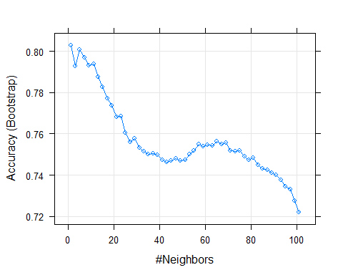

train_knn$bestTune #13 neighbors

## k  
## 1 1

y_hat_knn_prob <- predict(train_knn, test_set, type = "prob")  
y_hat_knn <- predict(train_knn, test_set)  
confusionMatrix(y_hat_knn, factor(test_set$Survived)) #78.7%

## Confusion Matrix and Statistics  
##   
## Reference  
## Prediction 0 1  
## 0 244 58  
## 1 37 107  
##   
## Accuracy : 0.787   
## 95% CI : (0.746, 0.8241)  
## No Information Rate : 0.63   
## P-Value [Acc > NIR] : 6.271e-13   
##   
## Kappa : 0.5308   
##   
## Mcnemar's Test P-Value : 0.04017   
##   
## Sensitivity : 0.8683   
## Specificity : 0.6485   
## Pos Pred Value : 0.8079   
## Neg Pred Value : 0.7431   
## Prevalence : 0.6300   
## Detection Rate : 0.5471   
## Detection Prevalence : 0.6771   
## Balanced Accuracy : 0.7584   
##   
## 'Positive' Class : 0   
##

## Random Forest

I actually got one of the best predictions from random forest which is to be expect since it’s such a robust model. This model tied with FDA for second best performing model when I submitted to Kaggle.

train_rf <- train(factor(Survived) ~ factor(Pclass) + Age_new + Sex + FamilySized + Embarked,  
 method = "rf",  
 data=train_set,  
 tuneGrid = data.frame(mtry=seq(1,20,2)))  
  
y_hat_rf_prob <-predict(train_rf, test_set, type="prob")  
y_hat_rf <- predict(train_rf, test_set)  
confusionMatrix(y_hat_rf, factor(test_set$Survived)) #81.84

## Confusion Matrix and Statistics  
##   
## Reference  
## Prediction 0 1  
## 0 255 55  
## 1 26 110  
##   
## Accuracy : 0.8184   
## 95% CI : (0.7794, 0.8531)  
## No Information Rate : 0.63   
## P-Value [Acc > NIR] : < 2.2e-16   
##   
## Kappa : 0.5958   
##   
## Mcnemar's Test P-Value : 0.001864   
##   
## Sensitivity : 0.9075   
## Specificity : 0.6667   
## Pos Pred Value : 0.8226   
## Neg Pred Value : 0.8088   
## Prevalence : 0.6300   
## Detection Rate : 0.5717   
## Detection Prevalence : 0.6951   
## Balanced Accuracy : 0.7871   
##   
## 'Positive' Class : 0   
##

## AdaBoost

Had a lot of hope for this model and was the last model for my submission which actually gave me my best score of 80%. It took forever to run so with more time I would like to go back through and try tuning it even better.

train_ada <- train(factor(Survived) ~ factor(Pclass) + Age_new + Sex + FamilySized + Embarked,  
 data = train_set,  
 method = "adaboost",  
 tuneGrid = data.frame(nIter = seq(1,101,5), method = "adaboost"))  
  
ggplot(train_ada, highlight = TRUE)

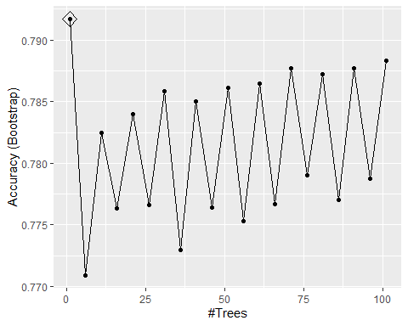

y_hat_ada_prob <- predict(train_ada, test_set, type = "prob")  
y_hat_ada <- predict(train_ada, test_set, type = "raw")  
confusionMatrix(y_hat_ada, factor(test_set$Survived)) #80.27

## Confusion Matrix and Statistics  
##   
## Reference  
## Prediction 0 1  
## 0 258 65  
## 1 23 100  
##   
## Accuracy : 0.8027   
## 95% CI : (0.7627, 0.8386)  
## No Information Rate : 0.63   
## P-Value [Acc > NIR] : 1.899e-15   
##   
## Kappa : 0.5533   
##   
## Mcnemar's Test P-Value : 1.239e-05   
##   
## Sensitivity : 0.9181   
## Specificity : 0.6061   
## Pos Pred Value : 0.7988   
## Neg Pred Value : 0.8130   
## Prevalence : 0.6300   
## Detection Rate : 0.5785   
## Detection Prevalence : 0.7242   
## Balanced Accuracy : 0.7621   
##   
## 'Positive' Class : 0   
##

## FDA

Decided to try Flexible Discriminant Analysis since it was the model that I gave the presentation on. It did not work that well with all the different combinations that I used for tuning it. There are two tuning parameters (degree and nprune) but got worse results when tuning so left it at default.

train_fda2 <- fda(factor(Survived) ~ Age_new + Sex + factor(Pclass) + FamilySized + Embarked,  
 method = mars,  
 degree = 2,  
 data = train_set)  
  
y_hat_fda2 <- predict(train_fda2, test_set)  
confusionMatrix(y_hat_fda2, factor(test_set$Survived)) #84.08%

## Confusion Matrix and Statistics  
##   
## Reference  
## Prediction 0 1  
## 0 264 54  
## 1 17 111  
##   
## Accuracy : 0.8408   
## 95% CI : (0.8035, 0.8735)  
## No Information Rate : 0.63   
## P-Value [Acc > NIR] : < 2.2e-16   
##   
## Kappa : 0.6419   
##   
## Mcnemar's Test P-Value : 1.934e-05   
##   
## Sensitivity : 0.9395   
## Specificity : 0.6727   
## Pos Pred Value : 0.8302   
## Neg Pred Value : 0.8672   
## Prevalence : 0.6300   
## Detection Rate : 0.5919   
## Detection Prevalence : 0.7130   
## Balanced Accuracy : 0.8061   
##   
## 'Positive' Class : 0   
##

## Prediction

I did five submissions which all gave me scores from 77% - 80%. The best scoring one was AdaBoost with the score of 80.382%. I did try using ensemble models, but they actually gave me a worse score so decided to focus my work in another direction. I do want to come back sometime over Spring Break and see if I can get an ensemble model to predict in the 80% range. I spent a lot of time getting the models to run and tried to tune them, but there is still a lot of room for improvement in that category.

survive_test <- predict(bestModel1, test_data, type = "response") #0 to 1 prediction of surival  
prediction <- factor(ifelse(survive_test > 0.5, 1, 0))  
submission <- test_data %>% dplyr::select(PassengerId) %>% mutate(Survived = prediction)  
head(submission)

## # A tibble: 6 x 2  
## PassengerId Survived  
## <dbl> <fct>   
## 1 892 0   
## 2 893 0   
## 3 894 0   
## 4 895 0   
## 5 896 1   
## 6 897 0

write.csv(submission, "submission.csv", row.names=FALSE)  
  
survive_test_svm <- predict(caret_svm, test_data, type = "raw") #0 to 1 prediction of surival  
submission_svm <- test_data %>% dplyr::select(PassengerId) %>% mutate(Survived = survive_test_svm)  
head(submission_svm)

## # A tibble: 6 x 2  
## PassengerId Survived  
## <dbl> <fct>   
## 1 892 0   
## 2 893 0   
## 3 894 0   
## 4 895 0   
## 5 896 0   
## 6 897 0

write.csv(submission_svm, "submission_svm.csv", row.names=FALSE)  
  
survive_test_rf <- predict(train_rf, test_data, type = "raw") #0 to 1 prediction of surival  
submission_rf <- test_data %>% dplyr::select(PassengerId) %>% mutate(Survived = survive_test_rf)  
head(submission_rf)

## # A tibble: 6 x 2  
## PassengerId Survived  
## <dbl> <fct>   
## 1 892 0   
## 2 893 0   
## 3 894 0   
## 4 895 0   
## 5 896 0   
## 6 897 0

write.csv(submission_rf, "submission_rf.csv", row.names=FALSE)  
  
survive_test_fda <- predict(train_fda2, test_data) #0 to 1 prediction of surival  
submission_fda <- test_data %>% dplyr::select(PassengerId) %>% mutate(Survived = survive_test_fda)  
head(submission_rf)

## # A tibble: 6 x 2  
## PassengerId Survived  
## <dbl> <fct>   
## 1 892 0   
## 2 893 0   
## 3 894 0   
## 4 895 0   
## 5 896 0   
## 6 897 0

write.csv(submission_fda, "submission_fda.csv", row.names=FALSE)  
  
survive_test_ada <- predict(train_ada, test_data, type = "raw") #0 to 1 prediction of surival  
submission_ada <- test_data %>% dplyr::select(PassengerId) %>% mutate(Survived = survive_test_ada)  
head(submission_rf)

## # A tibble: 6 x 2  
## PassengerId Survived  
## <dbl> <fct>   
## 1 892 0   
## 2 893 0   
## 3 894 0   
## 4 895 0   
## 5 896 0   
## 6 897 0

write.csv(submission_ada, "submission_ada.csv", row.names=FALSE)

