**Date Submitted: November 11, 2019**

**------------------------------------------------------------------------------------**

**Task 01:**

Youtube Link: https://youtu.be/9rmPEYZaULg

**Modified Code:**

/* TI-RTOS Header files */

**#include** <xdc/std.h>

**#include** <ti/sysbios/BIOS.h>

**#include** <ti/sysbios/knl/Task.h>

**#include** <ti/drivers/GPIO.h>

/* Example/Board Header files */

**#include** "ti_drivers_config.h" //enable ability to use red led. no other leds are defined.

//#include <ti/boards/CC1352R1_LAUNCHXL/Board.h>

//Board.h was not defined for CC1352 but boards folder has a defined version

//CC1352R1 header does not work with GPIO_write functions. Result is pin states are not changed

//Used syscfg tool to enable the green LED

**void** **myDelay**(**int** count);

/* Could be anything, like computing primes */

**#define** FakeBlockingSlowWork() myDelay(12000000)

**#define** FakeBlockingFastWork() myDelay(2000000)

Task_Struct workTask;

/* Make sure we have nice 8-byte alignment on the stack to avoid wasting memory */

**#pragma** DATA_ALIGN(workTaskStack, 8)

**#define** STACKSIZE 1024

**static** uint8_t workTaskStack[STACKSIZE];

**void** **doUrgentWork**(**void**)

{

**GPIO_write**(CONFIG_GPIO_LED_1, CONFIG_GPIO_LED_OFF);

FakeBlockingFastWork(); /* Pretend to do something useful but time-consuming */

**GPIO_write**(CONFIG_GPIO_LED_1, CONFIG_GPIO_LED_ON);

}

**void** **doWork**(**void**)

{

**GPIO_write**(CONFIG_GPIO_LED_0, CONFIG_GPIO_LED_OFF);

FakeBlockingSlowWork(); /* Pretend to do something useful but time-consuming */

**GPIO_write**(CONFIG_GPIO_LED_0, CONFIG_GPIO_LED_ON);

}

**void** **workTaskFunc**(UArg arg0, UArg arg1)

{

**while** (1) {

/* Do work */

doWork();

/* Wait a while, because doWork should be a periodic thing, not continuous.*/

myDelay(24000000);

}

}

/*

* * ======== main ========

*

*/

**int** **main**(**void**)

{

Board_init();

**GPIO_init**();

/* Set up the led task */

Task_Params workTaskParams;

Task_Params_init(&workTaskParams);

workTaskParams.stackSize = STACKSIZE;

workTaskParams.priority = 2;

workTaskParams.stack = &workTaskStack;

Task_construct(&workTask, workTaskFunc, &workTaskParams, NULL);

/* Start kernel. */

BIOS_start();

**return** (0);

}

/*

* ======== myDelay ========

* Assembly function to delay. Decrements the count until it is zero

* The exact duration depends on the processor speed.

*/

**__asm**( " .sect \".text:myDelay\"\n"

" .clink\n"

" .thumbfunc myDelay\n"

" .thumb\n"

" .global myDelay\n"

"myDelay:\n"

" subs r0, #1\n"

" bne.n myDelay\n"

" bx lr\n");

**------------------------------------------------------------------------------------**

**Task 02:**

**No video was done for Task 2 as the task focused on being able to use the ROV and Execution graph**

**Screenshots of ROV view and Execution Graph**

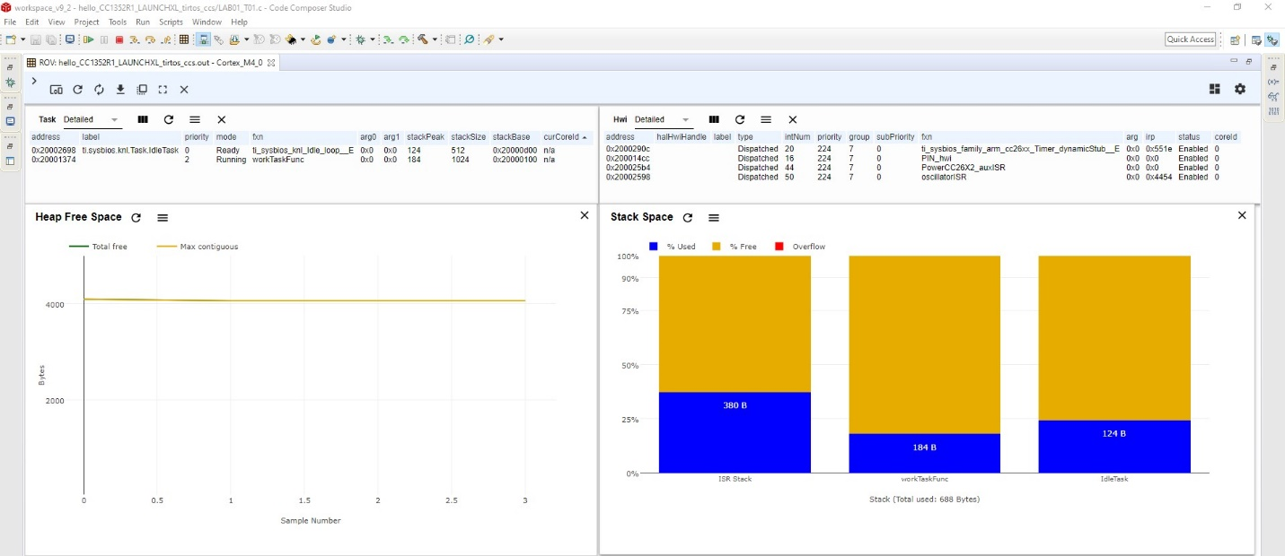

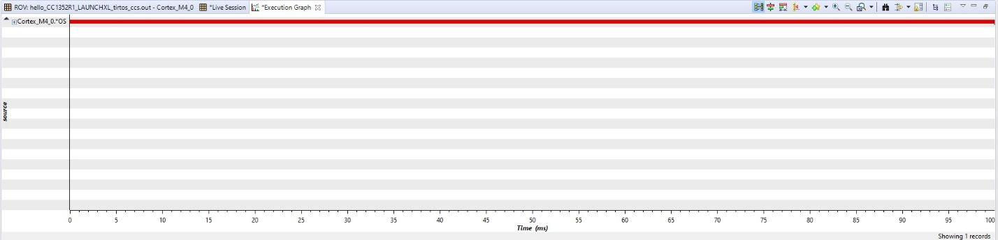

**Task 03:**

**Task 3 performs the same function as Task 1**

**Modified Code:**

/* TI-RTOS Header files */

**#include** <xdc/std.h>

**#include** <ti/sysbios/BIOS.h>

**#include** <ti/sysbios/knl/Task.h>

**#include** <ti/drivers/GPIO.h>

/* Example/Board Header files */

**#include** "ti_drivers_config.h" //enable ability to use red led. no other leds are defined.

//#include <ti/boards/CC1352R1_LAUNCHXL/Board.h>

//Board.h was not defined for CC1352 but boards folder has a defined version

//CC1352R1 header does not work with GPIO_write functions. Result is pin states are not changed

//Used syscfg tool to enable the green LED

**#include** <ti/sysbios/knl/Clock.h> //Used for clock_tickPeriod

**void** **myDelay**(**int** count);

/* Could be anything, like computing primes */

**#define** FakeBlockingSlowWork() myDelay(12000000)

**#define** FakeBlockingFastWork() myDelay(2000000)

Task_Struct workTask;

/* Make sure we have nice 8-byte alignment on the stack to avoid wasting memory */

**#pragma** DATA_ALIGN(workTaskStack, 8)

**#define** STACKSIZE 1024

**static** uint8_t workTaskStack[STACKSIZE];

**void** **doUrgentWork**(**void**)

{

**GPIO_write**(CONFIG_GPIO_LED_1, CONFIG_GPIO_LED_OFF);

FakeBlockingFastWork(); /* Pretend to do something useful but time-consuming */

**GPIO_write**(CONFIG_GPIO_LED_1, CONFIG_GPIO_LED_ON);

}

**void** **doWork**(**void**)

{

**GPIO_write**(CONFIG_GPIO_LED_0, CONFIG_GPIO_LED_OFF);

FakeBlockingSlowWork(); /* Pretend to do something useful but time-consuming */

**GPIO_write**(CONFIG_GPIO_LED_0, CONFIG_GPIO_LED_ON);

}

**void** **workTaskFunc**(UArg arg0, UArg arg1)

{

**while** (1) {

/* Do work */

doWork();

/* Wait a while, because doWork should be a periodic thing, not continuous.*/

//myDelay(24000000);

Task_sleep(500 * (1000 / Clock_tickPeriod));

}

}

/*

* * ======== main ========

*

*/

**int** **main**(**void**)

{

Board_init();

**GPIO_init**();

/* Set up the led task */

Task_Params workTaskParams;

Task_Params_init(&workTaskParams);

workTaskParams.stackSize = STACKSIZE;

workTaskParams.priority = 2;

workTaskParams.stack = &workTaskStack;

Task_construct(&workTask, workTaskFunc, &workTaskParams, NULL);

/* Start kernel. */

BIOS_start();

**return** (0);

}

/*

* ======== myDelay ========

* Assembly function to delay. Decrements the count until it is zero

* The exact duration depends on the processor speed.

*/

**__asm**( " .sect \".text:myDelay\"\n"

" .clink\n"

" .thumbfunc myDelay\n"

" .thumb\n"

" .global myDelay\n"

"myDelay:\n"

" subs r0, #1\n"

" bne.n myDelay\n"

" bx lr\n");

**Screenshots of ROV view and Execution Graph**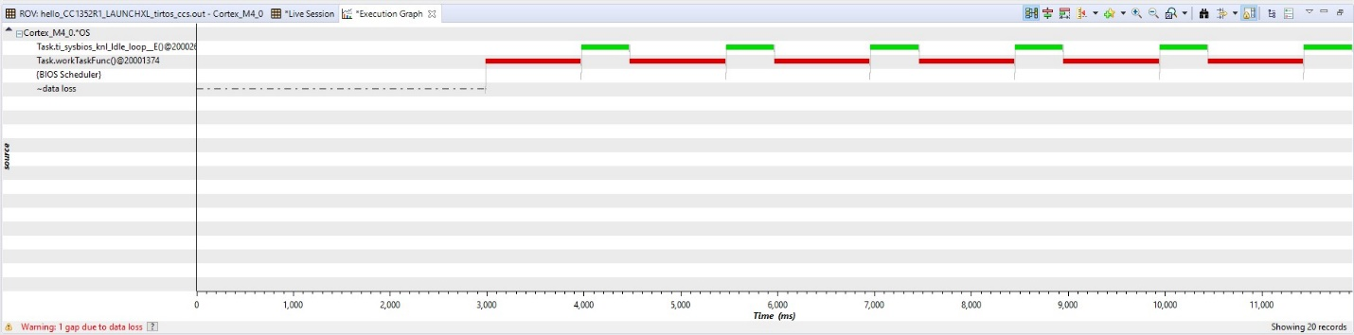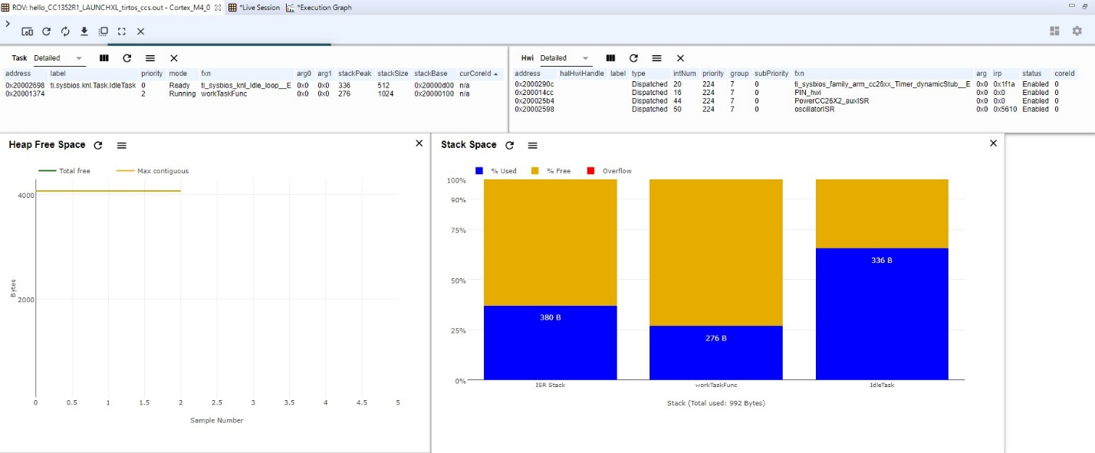

**------------------------------------------------------------------------------------**

**Task 04:**

Youtube Link: https://youtu.be/X1nR6OiCxjk

**Modified Code:**

/* TI-RTOS Header files */

**#include** <xdc/std.h>

**#include** <ti/sysbios/BIOS.h>

**#include** <ti/sysbios/knl/Task.h>

**#include** <ti/drivers/GPIO.h>

/* Example/Board Header files */

**#include** "ti_drivers_config.h" //enable ability to use red led. no other leds are defined.

//#include <ti/boards/CC1352R1_LAUNCHXL/Board.h>

//Board.h was not defined for CC1352 but boards folder has a defined version

//CC1352R1 header does not work with GPIO_write functions. Result is pin states are not changed

//Used syscfg tool to enable the green LED

**#include** <ti/sysbios/knl/Clock.h> //Used for clock_tickPeriod

**void** **myDelay**(**int** count);

/* Could be anything, like computing primes */

**#define** FakeBlockingSlowWork() myDelay(12000000)

**#define** FakeBlockingFastWork() myDelay(2000000)

Task_Struct workTask;

Task_Struct urgentWorkTask;

/* Make sure we have nice 8-byte alignment on the stack to avoid wasting memory */

**#pragma** DATA_ALIGN(workTaskStack, 8)

**#define** STACKSIZE 1024

**static** uint8_t workTaskStack[STACKSIZE];

**static** uint8_t urgentWorkTaskStack[STACKSIZE];

**void** **doUrgentWork**(**void**)

{

**GPIO_write**(CONFIG_GPIO_LED_1, CONFIG_GPIO_LED_OFF);

FakeBlockingFastWork(); /* Pretend to do something useful but time-consuming */

**GPIO_write**(CONFIG_GPIO_LED_1, CONFIG_GPIO_LED_ON);

}

**void** **doWork**(**void**)

{

**GPIO_write**(CONFIG_GPIO_LED_0, CONFIG_GPIO_LED_OFF);

FakeBlockingSlowWork(); /* Pretend to do something useful but time-consuming */

**GPIO_write**(CONFIG_GPIO_LED_0, CONFIG_GPIO_LED_ON);

}

**void** **workTaskFunc**(UArg arg0, UArg arg1)

{

**while** (1) {

/* Do work */

doWork();

/* Wait a while, because doWork should be a periodic thing, not continuous.*/

//myDelay(24000000);

Task_sleep(500 * (1000 / Clock_tickPeriod));

}

}

**void** **urgentWorkTaskFunc**(UArg arg0, UArg arg1)

{

**while** (1) {

/* Do work */

doUrgentWork();

/* Wait a while, because doWork should be a periodic thing, not continuous.*/

//myDelay(24000000);

Task_sleep(50 * (1000 / Clock_tickPeriod));

}

}

/*

* * ======== main ========

*

*/

**int** **main**(**void**)

{

Board_init();

**GPIO_init**();

/* Set up the led task */

Task_Params workTaskParams;

Task_Params_init(&workTaskParams);

workTaskParams.stackSize = STACKSIZE;

workTaskParams.priority = 2;

workTaskParams.stack = &workTaskStack;

Task_construct(&workTask, workTaskFunc, &workTaskParams, NULL);

workTaskParams.priority = 3;

workTaskParams.stack = &urgentWorkTaskStack;

Task_construct(&urgentWorkTask, urgentWorkTaskFunc, &workTaskParams, NULL);

/* Start kernel. */

BIOS_start();

**return** (0);

}

/*

* ======== myDelay ========

* Assembly function to delay. Decrements the count until it is zero

* The exact duration depends on the processor speed.

*/

**__asm**( " .sect \".text:myDelay\"\n"

" .clink\n"

" .thumbfunc myDelay\n"

" .thumb\n"

" .global myDelay\n"

"myDelay:\n"

" subs r0, #1\n"

" bne.n myDelay\n"

" bx lr\n");

**Screenshots of ROV view and Execution Graph**



**------------------------------------------------------------------------------------**