**Date Submitted: November 12, 2019**

**------------------------------------------------------------------------------------**

**Task 01 (ADC Gui):**

Youtube Link: https://youtu.be/0uyVUwZCRqo

**Modified Code:**

/* For usleep() */

**#include** <unistd.h>

**#include** <stdint.h>

**#include** <stddef.h>

/* Driver Header files */

**#include** <ti/drivers/GPIO.h>

**#include** <ti/drivers/ADC.h>

// #include <ti/drivers/I2C.h>

// #include <ti/drivers/SPI.h>

// #include <ti/drivers/UART.h>

// #include <ti/drivers/Watchdog.h>

/* Driver configuration */

**#include** "ti_drivers_config.h"

/* global variableS FOR GUI COMPOSER */

uint16_t adcValue = 0;

uint16_t threshold = 100;

uint16_t alert = 0;

/*

* ======== mainThread ========

*/

**void** \***mainThread**(**void** *arg0)

{

/* ~10 loops/second */

uint32_t time = 100000; // update ~10/second

/* Call driver init functions */

**GPIO_init**();

**ADC_init**();

// I2C_init();

// SPI_init();

// UART_init();

// Watchdog_init();

/* Open ADC Driver */

ADC_Handle adc;

ADC_Params params;

**ADC_Params_init**(&params);

adc = **ADC_open**(CONFIG_ADC_0, &params);

**if** (adc == NULL) {

// Error initializing ADC channel 0

**while** (1);

}

**while** (1) {

int_fast16_t res;

res = **ADC_convert**(adc, &adcValue);

**if** (res == ADC_STATUS_SUCCESS) {

**if**(adcValue >= threshold) {

**GPIO_write**(CONFIG_GPIO_LED_0, CONFIG_GPIO_LED_ON);

alert = 1;

} **else**{

**GPIO_write**(CONFIG_GPIO_LED_0, CONFIG_GPIO_LED_OFF);

alert = 0;

}

}

**usleep**(time);

}

}

**Screenshots of ROV view and SysCfg Modifications**

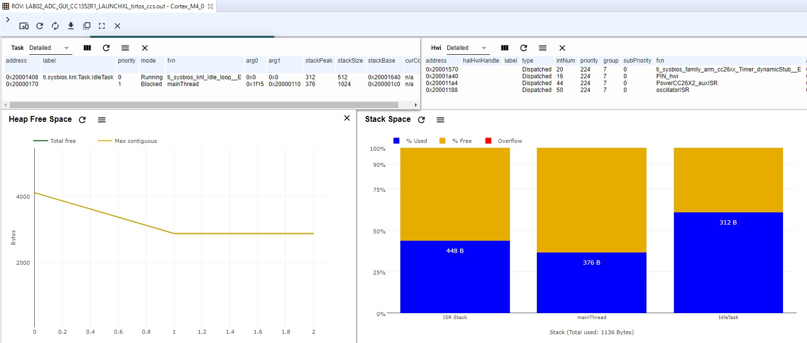

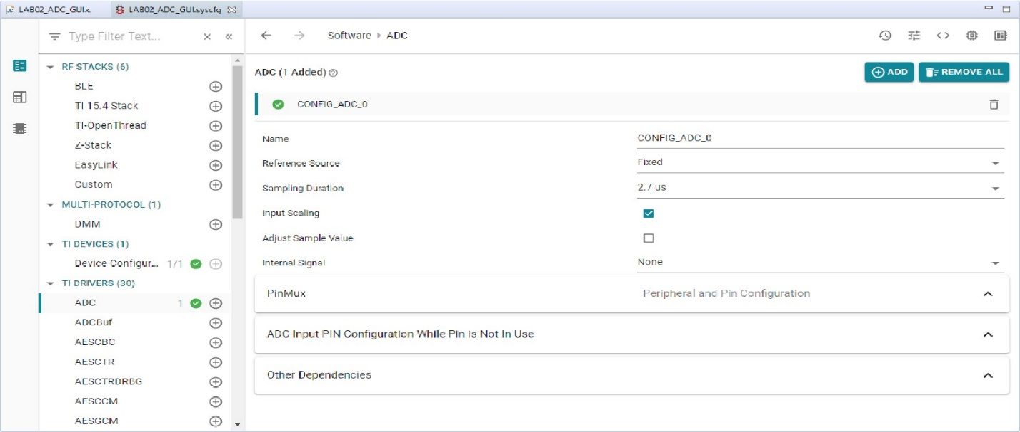

**------------------------------------------------------------------------------------**

**Task 02 (RTOS Example):**

Youtube Link: https://youtu.be/dQ99x-8o9Iw

**Modified Code:**

/*

* ======== empty.c ========

*/

/* For usleep() */

**#include** <unistd.h>

**#include** <stdint.h>

**#include** <stddef.h>

/* Driver Header files */

**#include** <ti/drivers/GPIO.h>

**#include** <ti/drivers/ADC.h>

**#include** <ti/display/Display.h>

// #include <ti/drivers/I2C.h>

// #include <ti/drivers/SPI.h>

// #include <ti/drivers/UART.h>

// #include <ti/drivers/Watchdog.h>

/* Driver configuration */

**#include** "ti_drivers_config.h"

/* global variableS FOR GUI COMPOSER */

uint16_t adcValue = 0;

uint16_t threshold = 100;

uint16_t trigger = 0;

/*

* ======== gpioButtonFxn0 ========

* Callback function for the GPIO interrupt on Board_GPIO_BUTTON0.

*/

**void** **gpioButtonFxn0**(uint_least8_t index)

{

/* Clear the GPIO interrupt and decrement threshold */

**if**(threshold < 250){ // Ensure threshold doesn't go below zero

threshold = 0;

}

**else** {

threshold -= 250; // decrement by 250

}

}

**void** **gpioButtonFxn1**(uint_least8_t index)

{

/* Clear the GPIO interrupt and increment threshold */

**if**(threshold > 4095){ // Ensure threshold doesn't go above max ADC range

threshold = 4095;

}

**else** {

threshold += 250; // increment by 250

}

}

/*

* ======== gpioButtonFxn1 ========

* Callback function for the GPIO interrupt on Board_GPIO_BUTTON1.

* This may not be used for all boards.

*/

/*

* ======== mainThread ========

*/

**void** \***mainThread**(**void** *arg0)

{

/* ~10 loops/second */

uint32_t time = 100000; // update ~10/second

/* Call driver init functions */

**GPIO_init**();

**ADC_init**();

// I2C_init();

// SDSPI_init();

// SPI_init();

// UART_init();

// Watchdog_init();

/* Open Display Driver */

Display_Handle displayHandle;

Display_Params displayParams;

Display_Params_init(&displayParams);

displayHandle = Display_open(Display_Type_UART, NULL);

/* Open ADC Driver */

ADC_Handle adc;

ADC_Params params;

**ADC_Params_init**(&params);

adc = **ADC_open**(CONFIG_ADC_0, &params);

**if** (adc == NULL) {

// Error initializing ADC channel 0

**while** (1);

}

/* install Button callback */

**GPIO_setCallback**(CONFIG_GPIO_BTN1, gpioButtonFxn0);

**GPIO_setCallback**(CONFIG_GPIO_BTN2, gpioButtonFxn1);

/* Enable interrupts */

**GPIO_enableInt**(CONFIG_GPIO_BTN1);

**GPIO_enableInt**(CONFIG_GPIO_BTN2);

**while** (1) {

int_fast16_t res;

res = **ADC_convert**(adc, &adcValue);

**if** (res == ADC_STATUS_SUCCESS) {

Display_printf(displayHandle, 1, 0, "ADC Reading %d", adcValue);

**if**(adcValue >= threshold){

**GPIO_write**(CONFIG_GPIO_LED_0, CONFIG_GPIO_LED_ON);

trigger = 1;

} **else**{

**GPIO_write**(CONFIG_GPIO_LED_0, CONFIG_GPIO_LED_OFF);

trigger = 0;

}

}

**usleep**(time);

}

}

**Screenshots of ROV view and SysCfg Modifications**



