**Date Submitted: November 21, 2019**

**------------------------------------------------------------------------------------**

**Task 01 :**

Youtube Link:

**Partner had device set to the modified transmit task**

**Screenshots:**

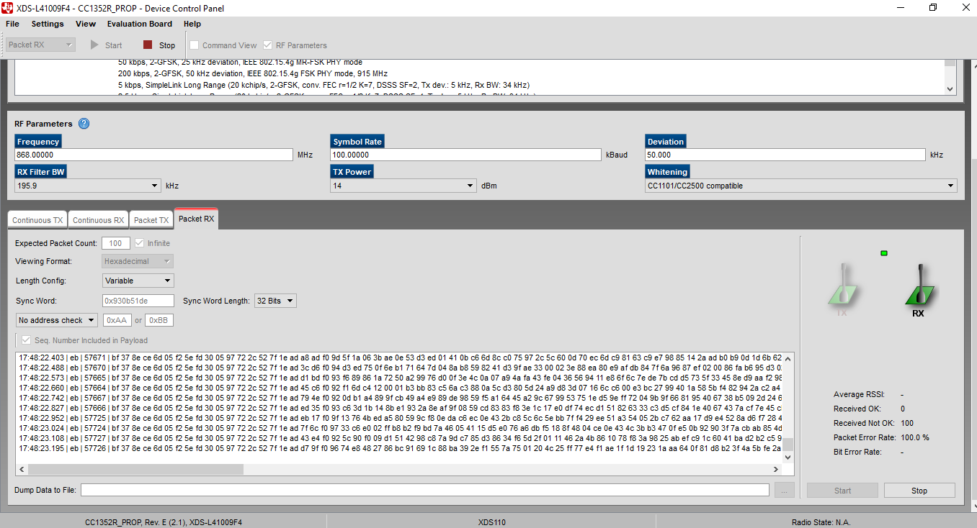

**------------------------------------------------------------------------------------**

**Task 02 :**

Youtube Link: https://youtu.be/DyW6vjJ6YLI

**Modified Code:**

/***** Includes *****/

/* Standard C Libraries */

**#include** <stdlib.h>

**#include** <unistd.h>

/* TI Drivers */

**#include** <ti/drivers/rf/RF.h>

**#include** <ti/drivers/PIN.h>

**#include** <ti/drivers/pin/PINCC26XX.h>

/* Driverlib Header files */

**#include** DeviceFamily_constructPath(driverlib/rf_prop_mailbox.h)

/* Board Header files */

**#include** "ti_drivers_config.h"

**#include** <ti_radio_config.h>

/***** Defines *****/

/* Do power measurement */

//#define POWER_MEASUREMENT

/* Packet TX Configuration */

**#define** PAYLOAD_LENGTH 30

**#ifdef** POWER_MEASUREMENT

**#define** PACKET_INTERVAL 5 /* For power measurement set packet interval to 5s */

**#else**

**#define** PACKET_INTERVAL 500000 /* Set packet interval to 500000us or 500ms */

**#endif**

/***** Prototypes *****/

/***** Variable declarations *****/

**static** RF_Object rfObject;

**static** RF_Handle rfHandle;

/* Pin driver handle */

**static** PIN_Handle ledPinHandle;

**static** PIN_State ledPinState;

**static** uint8_t packet[PAYLOAD_LENGTH];

**static** uint16_t seqNumber;

/*

* Application LED pin configuration table:

* - All LEDs board LEDs are off.

*/

PIN_Config pinTable[] =

{

CONFIG_PIN_RLED | PIN_GPIO_OUTPUT_EN | PIN_GPIO_LOW | PIN_PUSHPULL | PIN_DRVSTR_MAX,

**#ifdef** POWER_MEASUREMENT

**#if** defined(CONFIG_CC1350_LAUNCHXL)

CONFIG_DIO30_SWPWR | PIN_GPIO_OUTPUT_EN | PIN_GPIO_HIGH | PIN_PUSHPULL | PIN_DRVSTR_MAX,

**#endif**

**#endif**

PIN_TERMINATE

};

/***** Function definitions *****/

**void** \***mainThread**(**void** *arg0)

{

RF_Params rfParams;

**RF_Params_init**(&rfParams);

/* Open LED pins */

ledPinHandle = **PIN_open**(&ledPinState, pinTable);

**if** (ledPinHandle == NULL)

{

**while**(1);

}

**#ifdef** POWER_MEASUREMENT

**#if** defined(CONFIG_CC1350_LAUNCHXL)

/* Route out PA active pin to CONFIG_DIO30_SWPWR */

PINCC26XX_setMux(ledPinHandle, CONFIG_DIO30_SWPWR, PINCC26XX_MUX_RFC_GPO1);

**#endif**

**#endif**

RF_cmdPropTx.pktLen = PAYLOAD_LENGTH;

RF_cmdPropTx.pPkt = packet;

RF_cmdPropTx.startTrigger.triggerType = TRIG_NOW;

/* Request access to the radio */

**#if** defined(DeviceFamily_CC26X0R2)

rfHandle = RF_open(&rfObject, &RF_prop, (RF_RadioSetup*)&RF_cmdPropRadioSetup, &rfParams);

**#else**

rfHandle = **RF_open**(&rfObject, &RF_prop, (RF_RadioSetup*)&RF_cmdPropRadioDivSetup, &rfParams);

**#endif**// DeviceFamily_CC26X0R2

/* Set the frequency */

**RF_postCmd**(rfHandle, (RF_Op*)&RF_cmdFs, *RF_PriorityNormal*, NULL, 0);

**while**(1)

{

/* Create packet with incrementing sequence number and random payload */

packet[0] = (uint8_t)(seqNumber >> 8);

packet[1] = (uint8_t)(seqNumber++);

uint8_t i;

**for** (i = 2; i < PAYLOAD_LENGTH; i++)

{

packet[i] = **rand**();

}

/* Send packet */

RF_EventMask terminationReason = **RF_runCmd**(rfHandle, (RF_Op*)&RF_cmdPropTx,

*RF_PriorityNormal*, NULL, 0);

**switch**(terminationReason)

{

**case** RF_EventLastCmdDone:

// A stand-alone radio operation command or the last radio

// operation command in a chain finished.

**break**;

**case** RF_EventCmdCancelled:

// Command cancelled before it was started; it can be caused

// by RF_cancelCmd() or RF_flushCmd().

**break**;

**case** RF_EventCmdAborted:

// Abrupt command termination caused by RF_cancelCmd() or

// RF_flushCmd().

**break**;

**case** RF_EventCmdStopped:

// Graceful command termination caused by RF_cancelCmd() or

// RF_flushCmd().

**break**;

**default**:

// Uncaught error event

**while**(1);

}

uint32_t cmdStatus = ((**volatile** RF_Op*)&RF_cmdPropTx)->status;

**switch**(cmdStatus)

{

**case** PROP_DONE_OK:

// Packet transmitted successfully

**break**;

**case** PROP_DONE_STOPPED:

// received CMD_STOP while transmitting packet and finished

// transmitting packet

**break**;

**case** PROP_DONE_ABORT:

// Received CMD_ABORT while transmitting packet

**break**;

**case** PROP_ERROR_PAR:

// Observed illegal parameter

**break**;

**case** PROP_ERROR_NO_SETUP:

// Command sent without setting up the radio in a supported

// mode using CMD_PROP_RADIO_SETUP or CMD_RADIO_SETUP

**break**;

**case** PROP_ERROR_NO_FS:

// Command sent without the synthesizer being programmed

**break**;

**case** PROP_ERROR_TXUNF:

// TX underflow observed during operation

**break**;

**default**:

// Uncaught error event - these could come from the

// pool of states defined in rf_mailbox.h

**while**(1);

}

**#ifndef** POWER_MEASUREMENT

**PIN_setOutputValue**(ledPinHandle, CONFIG_PIN_RLED,!**PIN_getOutputValue**(CONFIG_PIN_RLED));

**#endif**

/* Power down the radio */

**RF_yield**(rfHandle);

**#ifdef** POWER_MEASUREMENT

/* Sleep for PACKET_INTERVAL s */

sleep(PACKET_INTERVAL);

**#else**

/* Sleep for PACKET_INTERVAL us */

**usleep**(PACKET_INTERVAL);

**#endif**

}

}

**Screenshots:**

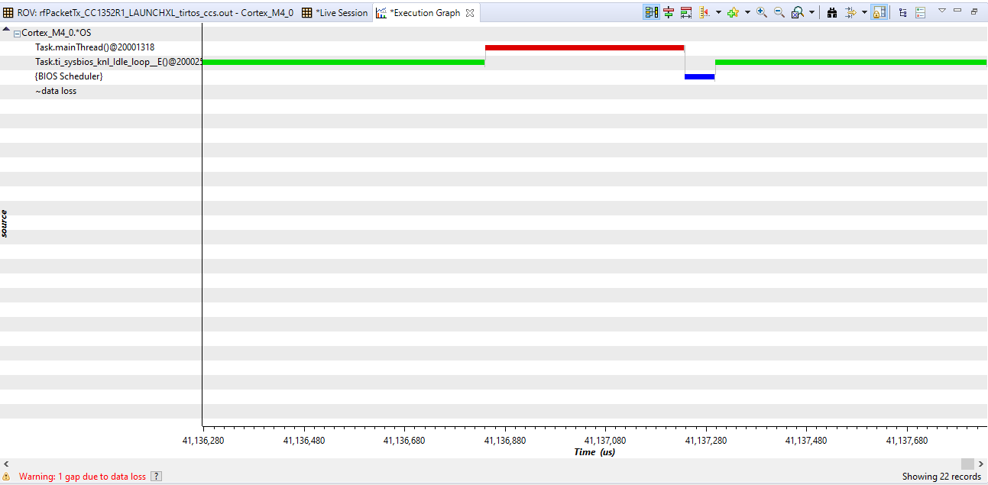

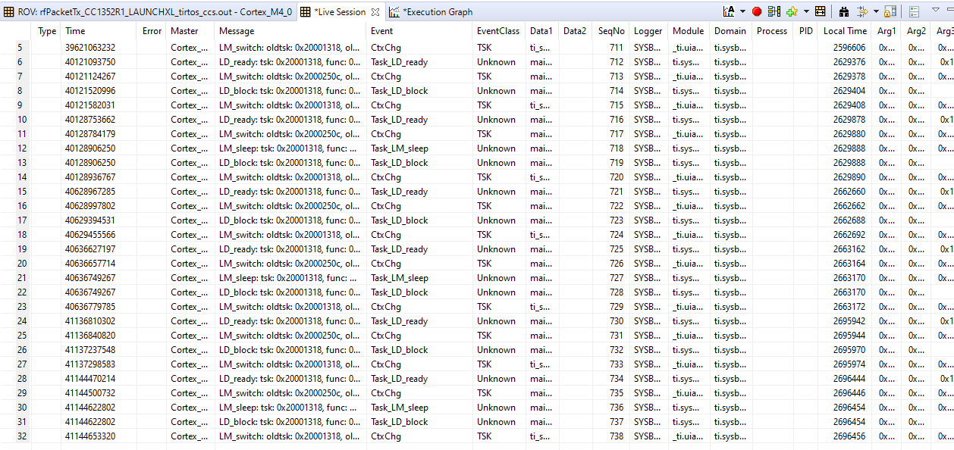

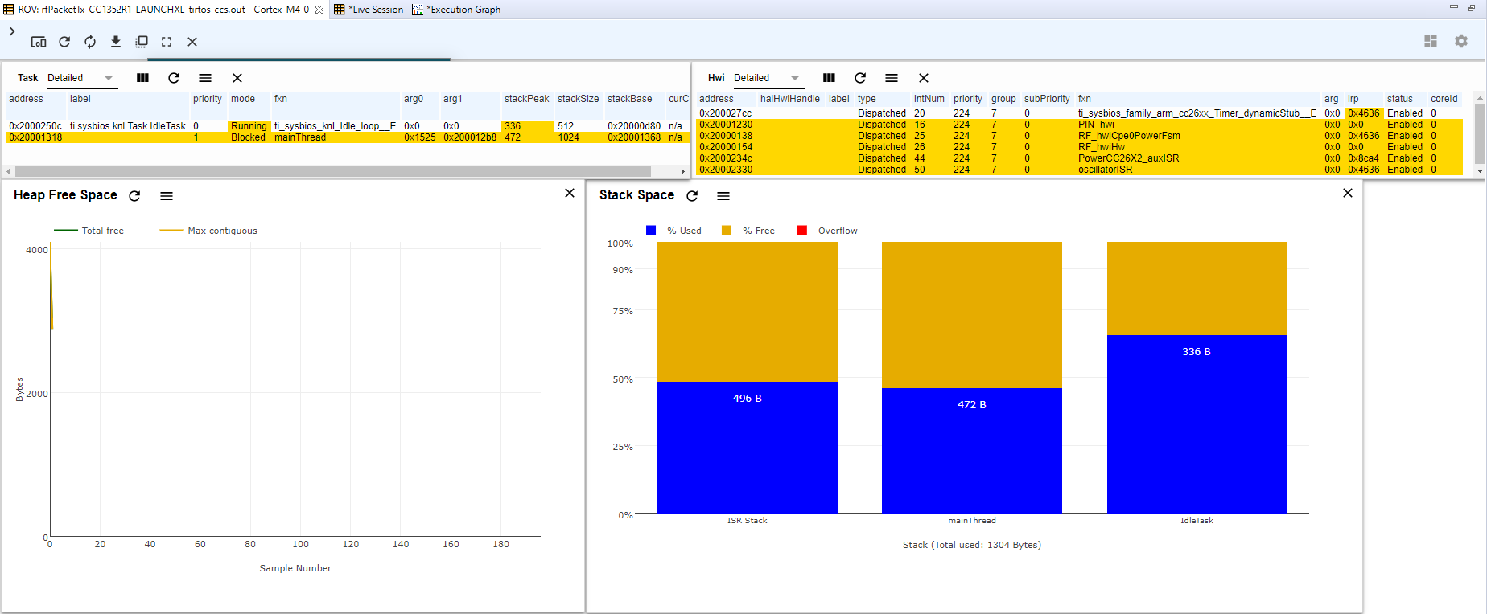

**------------------------------------------------------------------------------------**

**Task 03 :**

Youtube Link: https://youtu.be/KFcw3kwP4qE

**Modified Code:**

**Code is unmodified from previous task**

**Screenshots:**

**By default,RF Parameters changed in SysCfg rather than in SmartRF files**

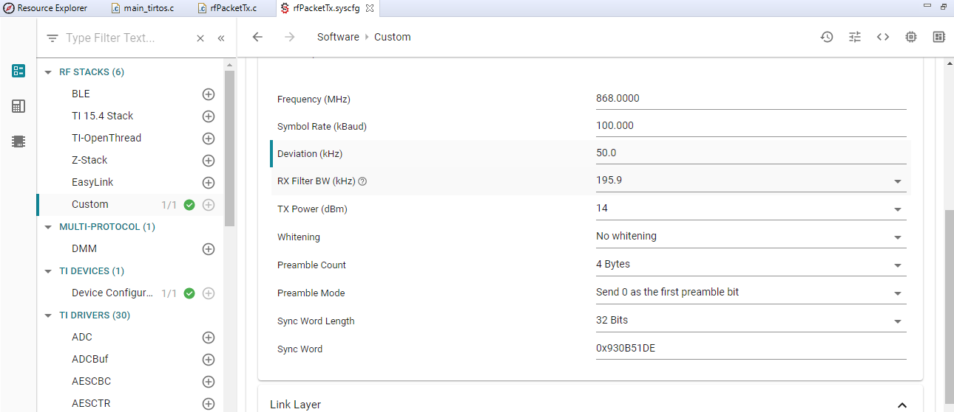

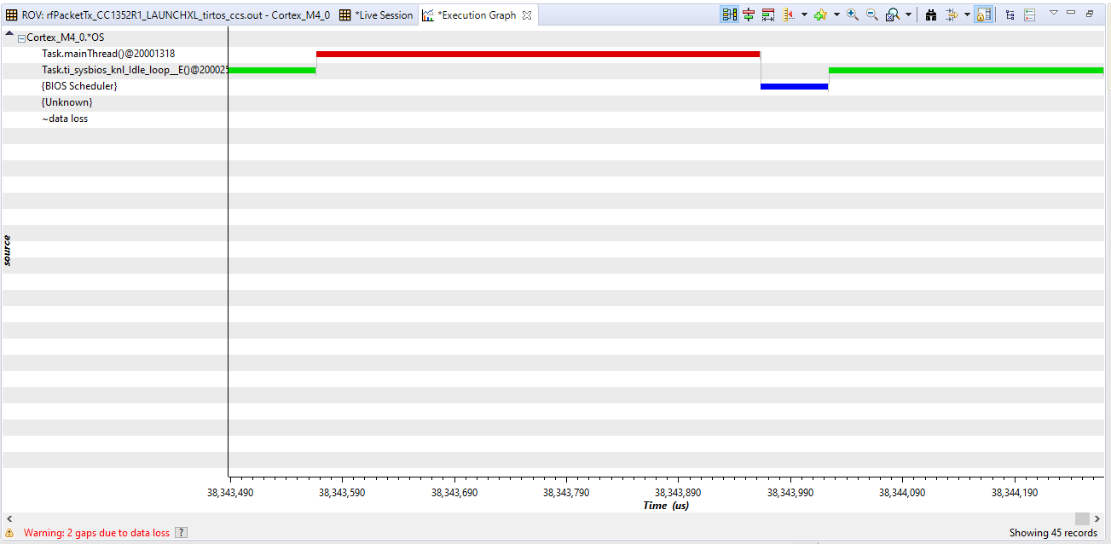

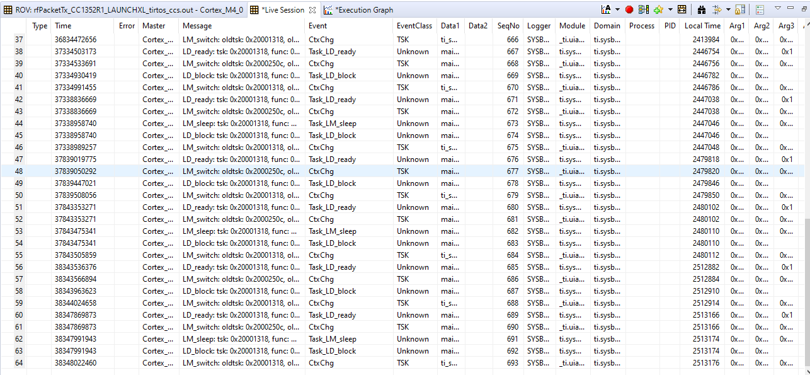

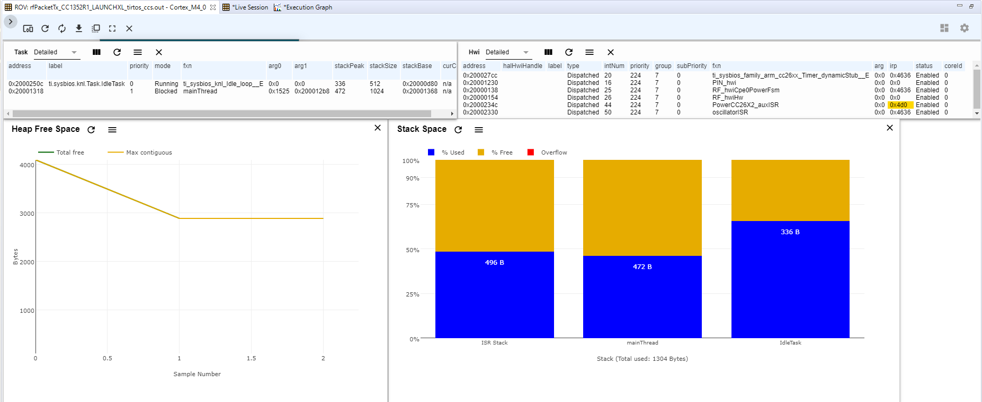

**------------------------------------------------------------------------------------**

**Task 04 :**

Youtube Link:

Like in Task 1, the TX device is set to transmit a ADC value

**Screenshots:**

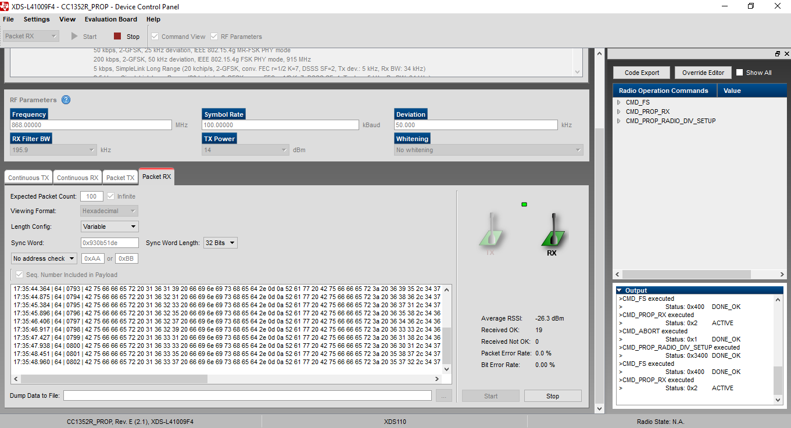

**------------------------------------------------------------------------------------**

**Task 05 :**

Youtube Link:

**Modified Code:**

/***** Includes *****/

/* Standard C Libraries */

**#include** <stdlib.h>

/* TI Drivers */

**#include** <ti/drivers/rf/RF.h>

**#include** <ti/drivers/PIN.h>

/* Driverlib Header files */

**#include** DeviceFamily_constructPath(driverlib/rf_prop_mailbox.h)

/* Board Header files */

**#include** "ti_drivers_config.h"

/* Application Header files */

**#include** "RFQueue.h"

**#include** <ti_radio_config.h>

/***** Defines *****/

/* Packet RX Configuration */

**#define** DATA_ENTRY_HEADER_SIZE 8 /* Constant header size of a Generic Data Entry */

**#define** MAX_LENGTH 30 /* Max length byte the radio will accept */

**#define** NUM_DATA_ENTRIES 2 /* NOTE: Only two data entries supported at the moment */

**#define** NUM_APPENDED_BYTES 2 /* The Data Entries data field will contain:

* 1 Header byte (RF_cmdPropRx.rxConf.bIncludeHdr = 0x1)

* Max 30 payload bytes

* 1 status byte (RF_cmdPropRx.rxConf.bAppendStatus = 0x1) */

/***** Prototypes *****/

**static** **void** **callback**(RF_Handle h, RF_CmdHandle ch, RF_EventMask e);

/***** Variable declarations *****/

**static** RF_Object rfObject;

**static** RF_Handle rfHandle;

/* Pin driver handle */

**static** PIN_Handle ledPinHandle;

**static** PIN_State ledPinState;

/* Buffer which contains all Data Entries for receiving data.

* Pragmas are needed to make sure this buffer is 4 byte aligned (requirement from the RF Core) */

**#if** defined(__TI_COMPILER_VERSION__)

**#pragma** DATA_ALIGN (rxDataEntryBuffer, 4);

**static** uint8_t

rxDataEntryBuffer[RF_QUEUE_DATA_ENTRY_BUFFER_SIZE(NUM_DATA_ENTRIES,

MAX_LENGTH,

NUM_APPENDED_BYTES)];

**#elif** defined(__IAR_SYSTEMS_ICC__)

**#pragma** data_alignment = 4

**static** uint8_t

rxDataEntryBuffer[RF_QUEUE_DATA_ENTRY_BUFFER_SIZE(NUM_DATA_ENTRIES,

MAX_LENGTH,

NUM_APPENDED_BYTES)];

**#elif** defined(__GNUC__)

**static** uint8_t

rxDataEntryBuffer[RF_QUEUE_DATA_ENTRY_BUFFER_SIZE(NUM_DATA_ENTRIES,

MAX_LENGTH,

NUM_APPENDED_BYTES)]

**__attribute__**((aligned(4)));

**#else**

**#error** This compiler is **not** supported.

**#endif**

/* Receive dataQueue for RF Core to fill in data */

**static** dataQueue_t dataQueue;

**static** rfc_dataEntryGeneral_t* currentDataEntry;

**static** uint8_t packetLength;

**static** uint8_t* packetDataPointer;

**static** uint8_t packet[MAX_LENGTH + NUM_APPENDED_BYTES - 1]; /* The length byte is stored in a separate variable */

/*

* Application LED pin configuration table:

* - All LEDs board LEDs are off.

*/

PIN_Config pinTable[] =

{

CONFIG_PIN_RLED | PIN_GPIO_OUTPUT_EN | PIN_GPIO_LOW | PIN_PUSHPULL | PIN_DRVSTR_MAX,

PIN_TERMINATE

};

/***** Function definitions *****/

**void** \***mainThread**(**void** *arg0)

{

RF_Params rfParams;

**RF_Params_init**(&rfParams);

/* Open LED pins */

ledPinHandle = **PIN_open**(&ledPinState, pinTable);

**if** (ledPinHandle == NULL)

{

**while**(1);

}

**if**( RFQueue_defineQueue(&dataQueue,

rxDataEntryBuffer,

**sizeof**(rxDataEntryBuffer),

NUM_DATA_ENTRIES,

MAX_LENGTH + NUM_APPENDED_BYTES))

{

/* Failed to allocate space for all data entries */

**while**(1);

}

/* Modify CMD_PROP_RX command for application needs */

/* Set the Data Entity queue for received data */

RF_cmdPropRx.pQueue = &dataQueue;

/* Discard ignored packets from Rx queue */

RF_cmdPropRx.rxConf.bAutoFlushIgnored = 1;

/* Discard packets with CRC error from Rx queue */

RF_cmdPropRx.rxConf.bAutoFlushCrcErr = 1;

/* Implement packet length filtering to avoid PROP_ERROR_RXBUF */

RF_cmdPropRx.maxPktLen = MAX_LENGTH;

RF_cmdPropRx.pktConf.bRepeatOk = 1;

RF_cmdPropRx.pktConf.bRepeatNok = 1;

/* Request access to the radio */

**#if** defined(DeviceFamily_CC26X0R2)

rfHandle = RF_open(&rfObject, &RF_prop, (RF_RadioSetup*)&RF_cmdPropRadioSetup, &rfParams);

**#else**

rfHandle = **RF_open**(&rfObject, &RF_prop, (RF_RadioSetup*)&RF_cmdPropRadioDivSetup, &rfParams);

**#endif**// DeviceFamily_CC26X0R2

/* Set the frequency */

**RF_postCmd**(rfHandle, (RF_Op*)&RF_cmdFs, *RF_PriorityNormal*, NULL, 0);

/* Enter RX mode and stay forever in RX */

RF_EventMask terminationReason = **RF_runCmd**(rfHandle, (RF_Op*)&RF_cmdPropRx,

*RF_PriorityNormal*, &callback,

RF_EventRxEntryDone);

**switch**(terminationReason)

{

**case** RF_EventLastCmdDone:

// A stand-alone radio operation command or the last radio

// operation command in a chain finished.

**break**;

**case** RF_EventCmdCancelled:

// Command cancelled before it was started; it can be caused

// by RF_cancelCmd() or RF_flushCmd().

**break**;

**case** RF_EventCmdAborted:

// Abrupt command termination caused by RF_cancelCmd() or

// RF_flushCmd().

**break**;

**case** RF_EventCmdStopped:

// Graceful command termination caused by RF_cancelCmd() or

// RF_flushCmd().

**break**;

**default**:

// Uncaught error event

**while**(1);

}

uint32_t cmdStatus = ((**volatile** RF_Op*)&RF_cmdPropRx)->status;

**switch**(cmdStatus)

{

**case** PROP_DONE_OK:

// Packet received with CRC OK

**break**;

**case** PROP_DONE_RXERR:

// Packet received with CRC error

**break**;

**case** PROP_DONE_RXTIMEOUT:

// Observed end trigger while in sync search

**break**;

**case** PROP_DONE_BREAK:

// Observed end trigger while receiving packet when the command is

// configured with endType set to 1

**break**;

**case** PROP_DONE_ENDED:

// Received packet after having observed the end trigger; if the

// command is configured with endType set to 0, the end trigger

// will not terminate an ongoing reception

**break**;

**case** PROP_DONE_STOPPED:

// received CMD_STOP after command started and, if sync found,

// packet is received

**break**;

**case** PROP_DONE_ABORT:

// Received CMD_ABORT after command started

**break**;

**case** PROP_ERROR_RXBUF:

// No RX buffer large enough for the received data available at

// the start of a packet

**break**;

**case** PROP_ERROR_RXFULL:

// Out of RX buffer space during reception in a partial read

**break**;

**case** PROP_ERROR_PAR:

// Observed illegal parameter

**break**;

**case** PROP_ERROR_NO_SETUP:

// Command sent without setting up the radio in a supported

// mode using CMD_PROP_RADIO_SETUP or CMD_RADIO_SETUP

**break**;

**case** PROP_ERROR_NO_FS:

// Command sent without the synthesizer being programmed

**break**;

**case** PROP_ERROR_RXOVF:

// RX overflow observed during operation

**break**;

**default**:

// Uncaught error event - these could come from the

// pool of states defined in rf_mailbox.h

**while**(1);

}

**while**(1);

}

**void** **callback**(RF_Handle h, RF_CmdHandle ch, RF_EventMask e)

{

**if** (e & RF_EventRxEntryDone)

{

/* Toggle pin to indicate RX */

**PIN_setOutputValue**(ledPinHandle, CONFIG_PIN_RLED,

!**PIN_getOutputValue**(CONFIG_PIN_RLED));

/* Get current unhandled data entry */

currentDataEntry = RFQueue_getDataEntry();

/* Handle the packet data, located at &currentDataEntry->data:

* - Length is the first byte with the current configuration

* - Data starts from the second byte */

packetLength = *(uint8_t*)(&currentDataEntry->data);

packetDataPointer = (uint8_t*)(&currentDataEntry->data + 1);

/* Copy the payload + the status byte to the packet variable */

**memcpy**(packet, packetDataPointer, (packetLength + 1));

RFQueue_nextEntry();

}

}

**Screenshots:**

**------------------------------------------------------------------------------------**

**Task 06 :**

Youtube Link:

**Modified Code:**

**Screenshots:**

**------------------------------------------------------------------------------------**

**Task 07 :**

Youtube Link:

**Modified Code:**

**Screenshots:**

**------------------------------------------------------------------------------------**