**Date Submitted: December 10, 2019**

A CC1352R1 will be set up as a collector module and a CC1350 will be setup as a sensor module.

**------------------------------------------------------------------------------------**

**Task 01 :**

Youtube Link: Task 3’s video showing both collector and sensor running https://youtu.be/Fz9JTOFhRGI

**Modified Code:**

**Code is not modified as the function shown below already displays a temperature value received from the sensor module.**

**void** Csf_deviceSensorDataUpdate(ApiMac_sAddr_t *pSrcAddr, int8_t rssi,

Smsgs_sensorMsg_t *pMsg)

{

CUI_ledToggle(csfCuiHndl, CONFIG_LED_GREEN);

**#ifndef** POWER_MEAS

CUI_statusLinePrintf(csfCuiHndl, deviceStatusLine, "Sensor - Addr=0x%04x, Temp=%d, RSSI=%d",

pSrcAddr->addr.shortAddr, pMsg->tempSensor.ambienceTemp, rssi);

CUI_statusLinePrintf(csfCuiHndl, numJoinDevStatusLine, "%x", getNumActiveDevices());

**#endif** /* endif for POWER_MEAS */

**#if** defined(MT_CSF)

MTCSF_sensorUpdateIndCB(pSrcAddr, rssi, pMsg);

**#endif** /* endif for MT_CSF */

}

**Screenshots**

**Collector is set for 50kbps and US-compatible PHY**

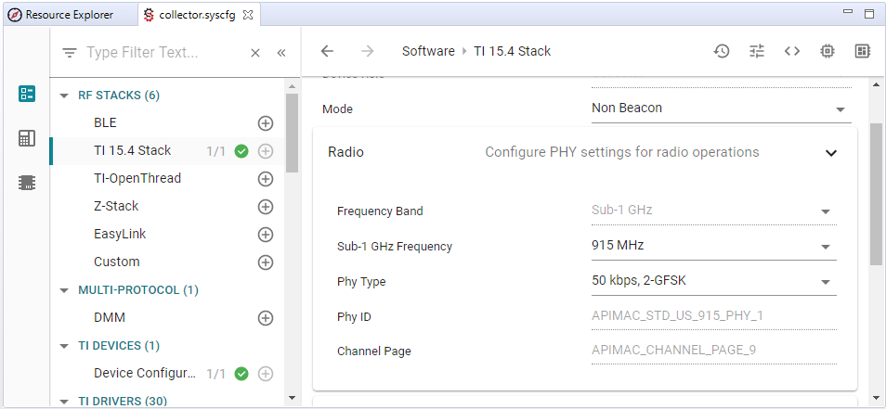

**Only Channel 10 is enabled.**

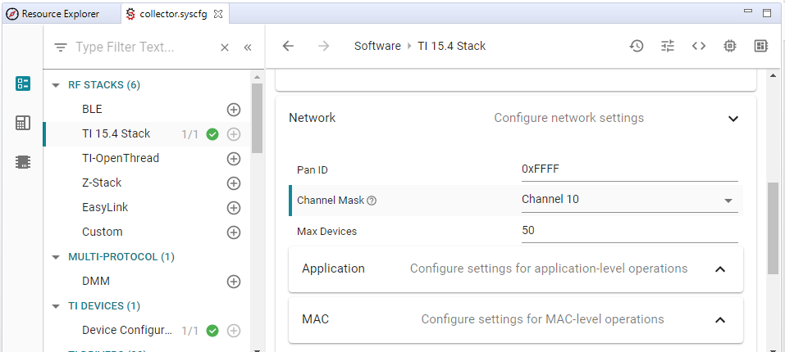

**------------------------------------------------------------------------------------**

**Task 02 :**

Youtube Link: Task 3’s video showing both collector and sensor running https://youtu.be/Fz9JTOFhRGI

**Modified Code:**

**Channel mask set to channel 10 using**

**#define** CONFIG_CHANNEL_MASK { 0x00, 0x04, 0x00, 0x00, 0x00, 0x00, \

0x00, 0x00, 0x00, 0x00, 0x00, 0x00, \

0x00, 0x00, 0x00, 0x00, 0x00 }

**Screenshots:**

**------------------------------------------------------------------------------------**

**Task 03 :**

Youtube Link: https://youtu.be/Fz9JTOFhRGI

**Modified Code:**

**Screenshots:**

**UART Screen capture**

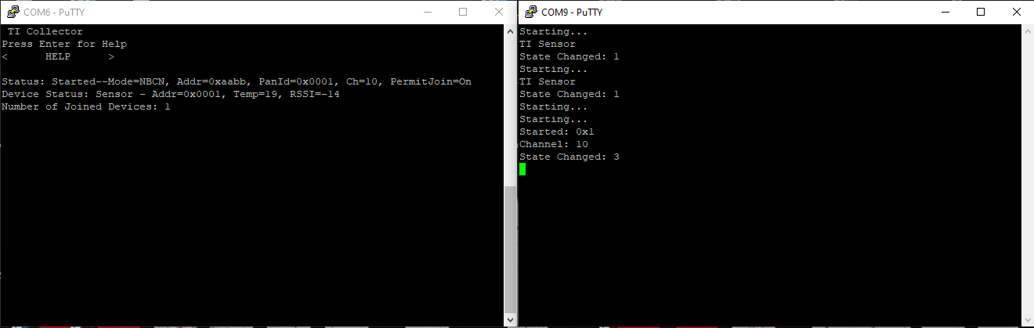

**------------------------------------------------------------------------------------**

**Task 04:**

Youtube Link: https://youtu.be/b_lpkOnEAV4

**Sensor Modification:**

**#define** CONFIG_REPORTING_INTERVAL 500

**Collector Modification:**

**Changed so that collector reports every second and polls ever 100ms.**

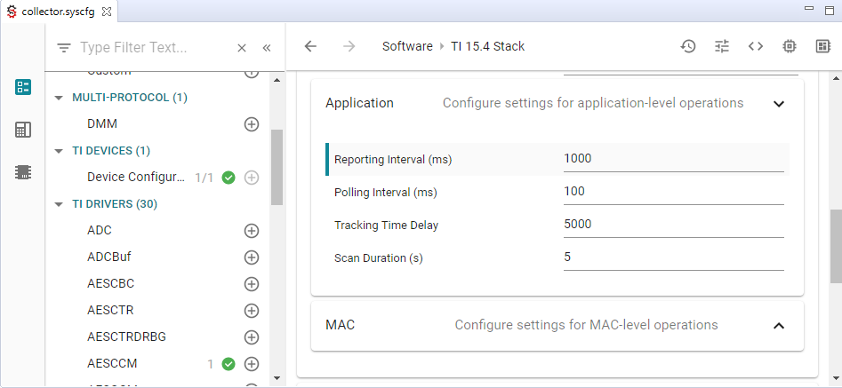

**Screenshots:**

**UART Screen capture**

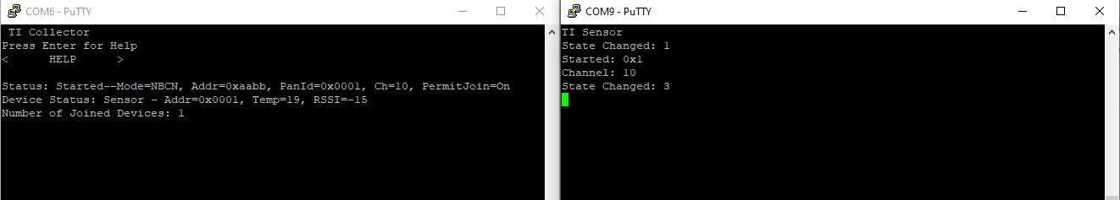

**------------------------------------------------------------------------------------**

**Task 05 (Remote Sensor 1):**

Youtube Link: https://youtu.be/QXWPbpAIJTk

Temperature.c Modifications:

Added global definitions

/* ======== Si7021 Registers ======== */

**#define** Si7021_TMP_REG 0xE3

**#define** Si7021_HUM_REG 0xE5

**#define** Si7021_ADDR 0x40;

Searches for Si7021 sensore

/* Try Si7021 */

txBuffer[0] = Si7021_TMP_REG;

i2cTransaction.slaveAddress = Si7021_ADDR;

**if** (!**I2C_transfer**(i2c, &i2cTransaction)) {

/* Could not resolve a sensor, error */

//Display_printf(display, 0, 0, "Error. No TMP sensor found!");

**while**(1);

}

**else** {

//Display_printf(display, 0, 0, "Detected Si7021 sensor.");

}

Changed how temperature is gathered from Si7021

**while** (1) {

**if** (**I2C_transfer**(i2c, &i2cTransaction)) {

/*

* Extract degrees C from the received data; see sensor datasheet.

* Make sure we are updating the global temperature variables

* in a thread-safe manner.

*/

**pthread_mutex_lock**(&temperatureMutex);

/*

* Extract degrees C from the received data;

* see Si7021 datasheet

*/

temperatureC = (rxBuffer[0] << 8) | (rxBuffer[1]);

temperatureC = (((175.72 * temperatureC)/ 65536) - 46.85);

temperatureF = (temperatureC*5)/9+32;

**pthread_mutex_unlock**(&temperatureMutex);

/* Send an alert if the temperature is too high!! */

**if** ((**int**)temperatureC >= HIGH_TEMP) {

sendAlert(temperatureC);

}

**else** {

clearAlert(temperatureC);

}

}

**Screenshots:**

**UART**

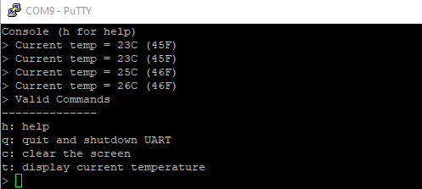

**------------------------------------------------------------------------------------**

**Task 06:**

Youtube Link: https://youtu.be/lJHNSgNNXW8

Modified Code:

Added following code to bottom of app.cfg

/* Include POSIX Support */

**var** Settings = xdc.useModule('ti.sysbios.posix.Settings');

In main_tirtos.c

Renamed main() to main_app() and commented out calls to Board_init(), GPIO_init() and BIOS_start().

In main.c

Added main_app(); towards the end and added the following line before the start of main()

Extern int main_app(void);

In sensor.opts, removed DBOAD_DISPLAY_USE_UART and DxBOARD_DISPLAY_USE_LCD

Screenshots:

UART Output



