**Date Submitted: September 24, 2019**

**Task 00: Execute provided code**

**Youtube Link: https://youtu.be/kP4MioswWSA**

**------------------------------------------------------------------------------------**

**Task 01:**

Youtube Link: https://youtu.be/j5rTLOqpxf4

**Modified Schematic (if applicable):**

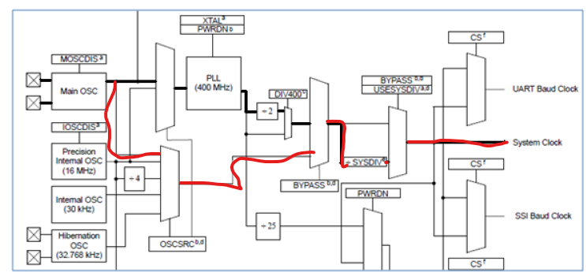

**Modified Code:**

uint8_t ui8PinData=2;

**int** **main**(**void**)

{

**SysCtlClockSet**(SYSCTL_USE_OSC|SYSCTL_OSC_MAIN);

//Running the main oscillator which has a 16MHz crystal

**SysCtlPeripheralEnable**(SYSCTL_PERIPH_GPIOF);

**GPIOPinTypeGPIOOutput**(GPIO_PORTF_BASE, GPIO_PIN_1|GPIO_PIN_2|GPIO_PIN_3);

**while**(1)

{

**GPIOPinWrite**(GPIO_PORTF_BASE, GPIO_PIN_1|GPIO_PIN_2|GPIO_PIN_3, ui8PinData);

**SysCtlDelay**(8000000/3);

//F=16MHz, to get delay of 0.5s, 16M * 0.5 = 8M, however the SYsCtlDelay takes 3 cycles so the number needs to be divided by 3

**GPIOPinWrite**(GPIO_PORTF_BASE, GPIO_PIN_1|GPIO_PIN_2|GPIO_PIN_3, 0x00);

**SysCtlDelay**(8000000/3);

// if(ui8PinData==8) {ui8PinData=2;} else {ui8PinData=ui8PinData*2;}

//Commented out to demonstrate only the red light blinking

}

}

**------------------------------------------------------------------------------------**

**Task 02:**

Youtube Link: https://youtu.be/QAuaSuvOjYM

**Modified Schematic (if applicable):**



**Modified Code:**

uint8_t ui8PinData=2;

**void** **blink**();

**int** **main**(**void**)

{

**SysCtlClockSet**(SYSCTL_USE_OSC|SYSCTL_OSC_MAIN);

//Running the main oscillator which has a 16MHz crystal

**SysCtlPeripheralEnable**(SYSCTL_PERIPH_GPIOF);

**GPIOPinTypeGPIOOutput**(GPIO_PORTF_BASE, GPIO_PIN_1|GPIO_PIN_2|GPIO_PIN_3);

/*

while(1)

{

GPIOPinWrite(GPIO_PORTF_BASE, GPIO_PIN_1|GPIO_PIN_2|GPIO_PIN_3, ui8PinData);

SysCtlDelay(8000000/3);

GPIOPinWrite(GPIO_PORTF_BASE, GPIO_PIN_1|GPIO_PIN_2|GPIO_PIN_3, 0x00);

SysCtlDelay(8000000/3);

if(ui8PinData==8) {ui8PinData=2;} else {ui8PinData=ui8PinData*2;} //The sequence of colors is BGR when ui8PinData is initialized at 4

//if(ui8PinData==2) {ui8PinData=8;} else {ui8PinData=ui8PinData/2;} //The sequence of colors is RGB when ui8PinData is initialized at 2

}

*/

**while**(1)

{

ui8PinData = 2; //R

blink();

ui8PinData = 8; //G

blink();

ui8PinData = 4; //B

blink();

ui8PinData = 10; //RG

blink();

ui8PinData = 6; //RB

blink();

ui8PinData = 12; //GB

blink();

ui8PinData = 14; //RGB

blink();

}

}

**void** **blink**() { //Since ui8PinData is a global variable, I don't to include it in the arguments

//blink will turn the pins on and off with the current ui8PinData value

**GPIOPinWrite**(GPIO_PORTF_BASE, GPIO_PIN_1|GPIO_PIN_2|GPIO_PIN_3, ui8PinData);

**SysCtlDelay**(8000000/3);

//F=16MHz, to get delay of 0.5s, 16M * 0.5 = 8M, however the SYsCtlDelay takes 3 cycles so the number needs to be divided by 3

**GPIOPinWrite**(GPIO_PORTF_BASE, GPIO_PIN_1|GPIO_PIN_2|GPIO_PIN_3, 0x00);

**SysCtlDelay**(8000000/3);

}

**------------------------------------------------------------------------------------**