**Date Submitted: October 29, 2019**

**------------------------------------------------------------------------------------**

**Goal: Create three tasks with each task being executed in order and repeating every 2 seconds (Task 1 occurs at 0.5s, Task 2 occurs at 1s, Task 3 occurs at 1.5s, Task 1 occurs again at 2s).**

**------------------------------------------------------------------------------------**

**Implementation: Task 1 is an ADC task using ADC0 CH3 and is connected to a potentiometer. Task 2 is a UART display task that will show the ADC value that was read. Task 3 will toggle the blue LED. Timer 2A is as a hardware interrupt and triggers 50ms (0.05s). When triggered, it calls the function TIMER_ISR which contains conditional statements and increments the value of i16InstanceCount. When this counter reaches 10, it posts the semaphore for the ADC task, at 20 it posts the UART semaphore and at 30 it posts the LED semaphore and resets the counter to 0;**

**------------------------------------------------------------------------------------**

**Schematics:**

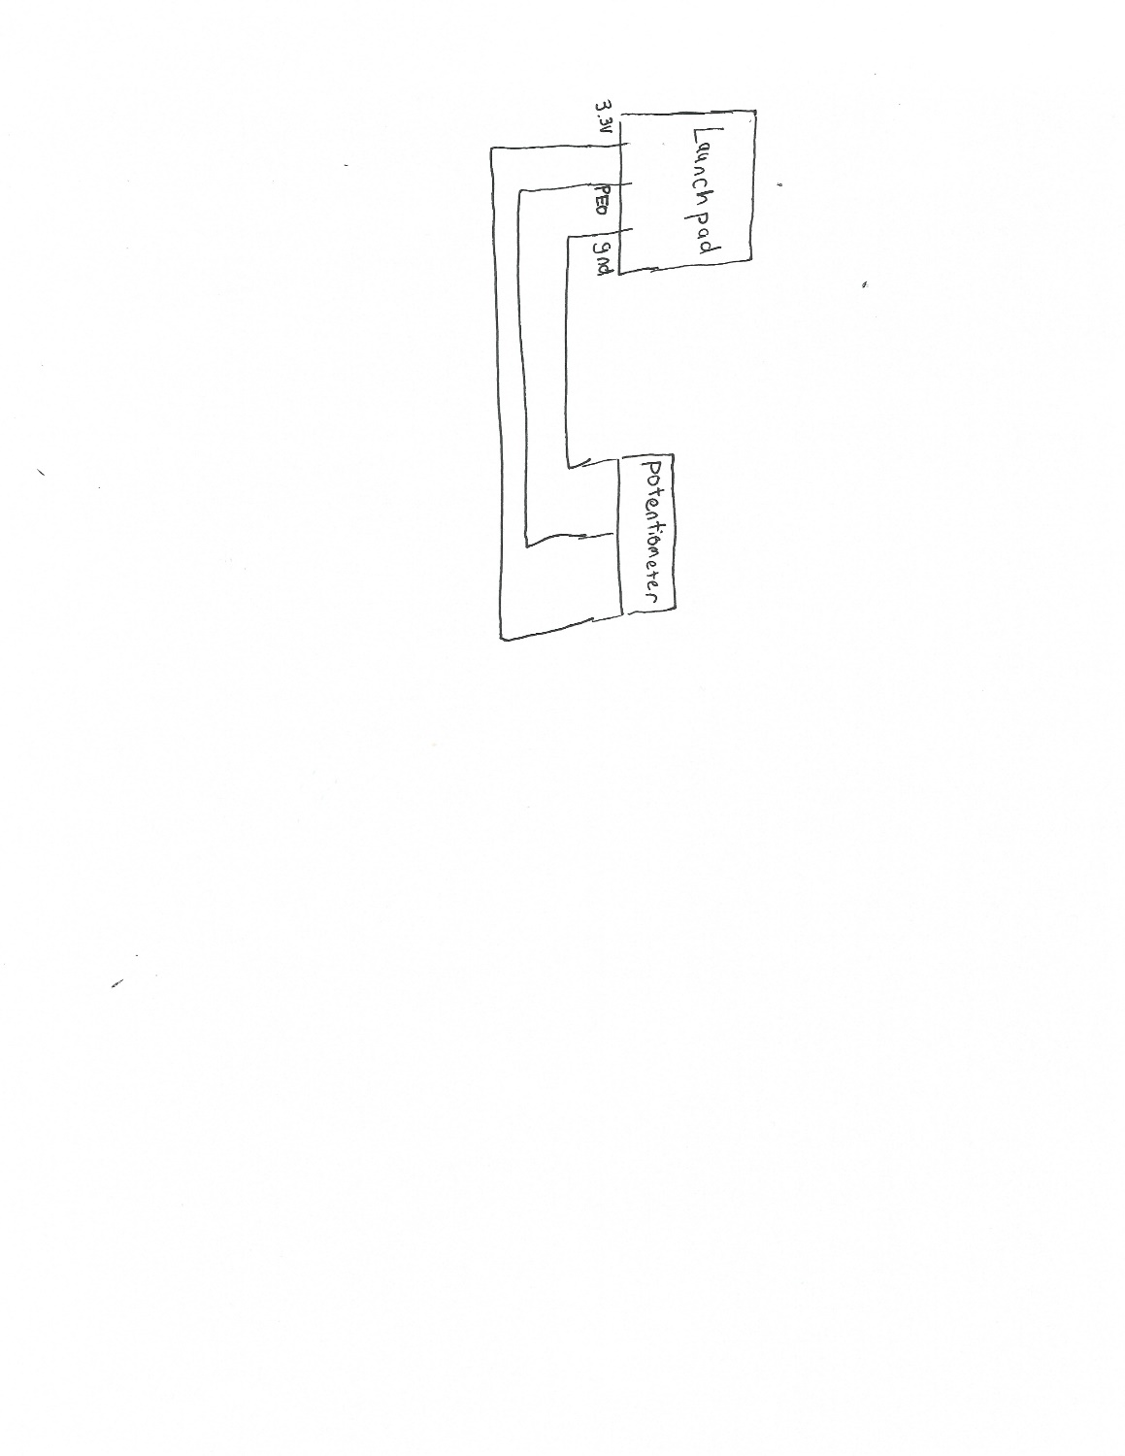

**------------------------------------------------------------------------------------**

**Video Link:**

**https://youtu.be/zj3-HeW4ZUg**

**------------------------------------------------------------------------------------**

**Screenshots:**

**Configuration:**

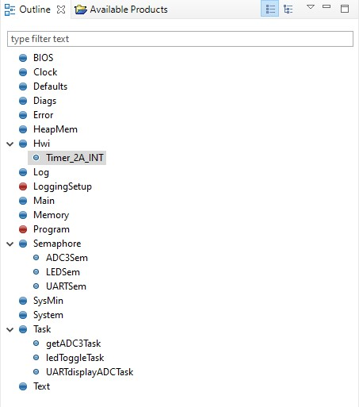

**Execution Graph Overview:**

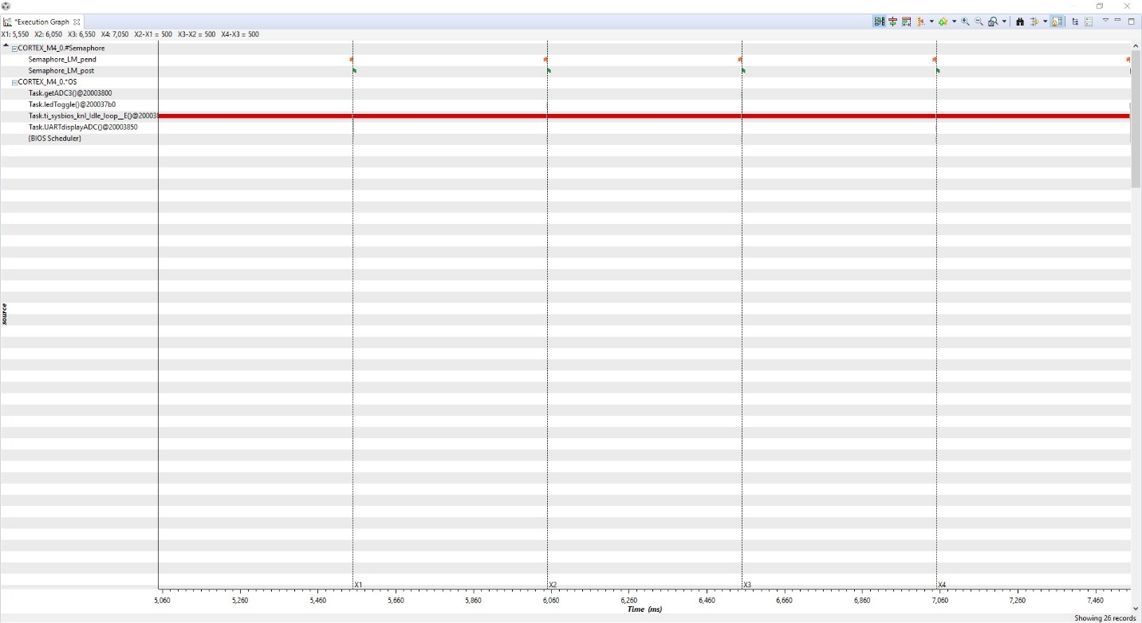

**500ms between each task, order in screenshot is uart, ledToggle, getADC3 then uart again**

**UART:**

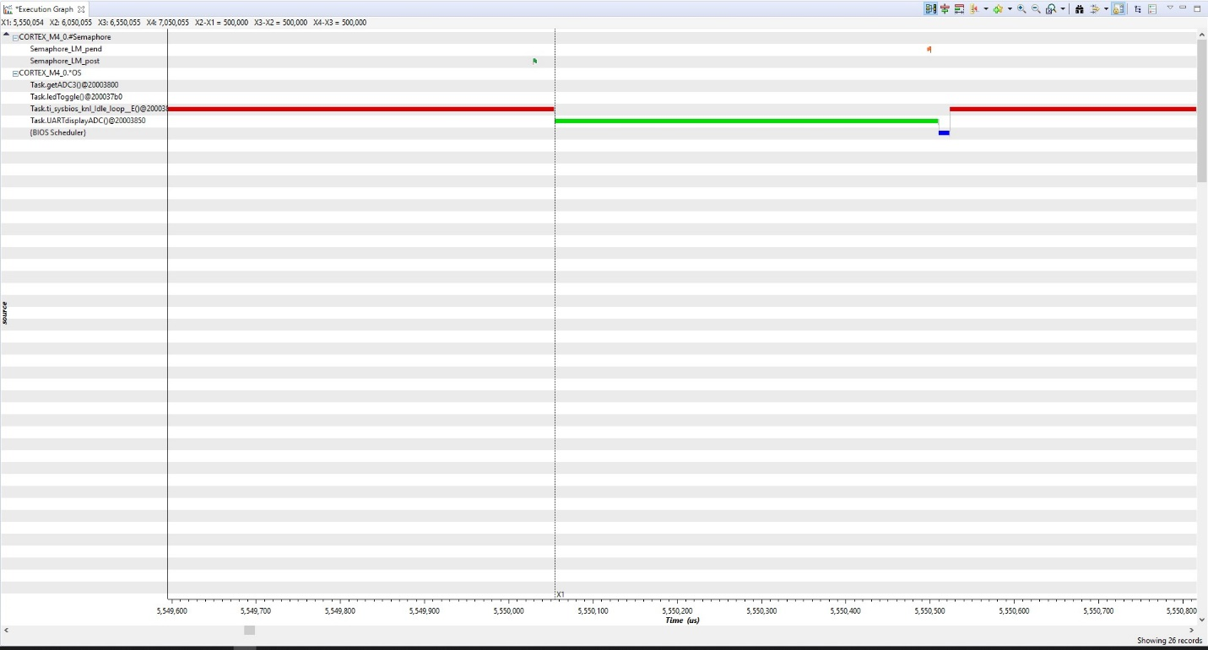

**ledToggle:**

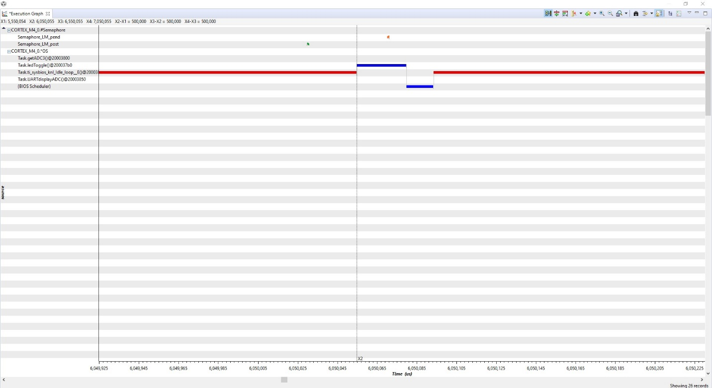

**getADC3:**

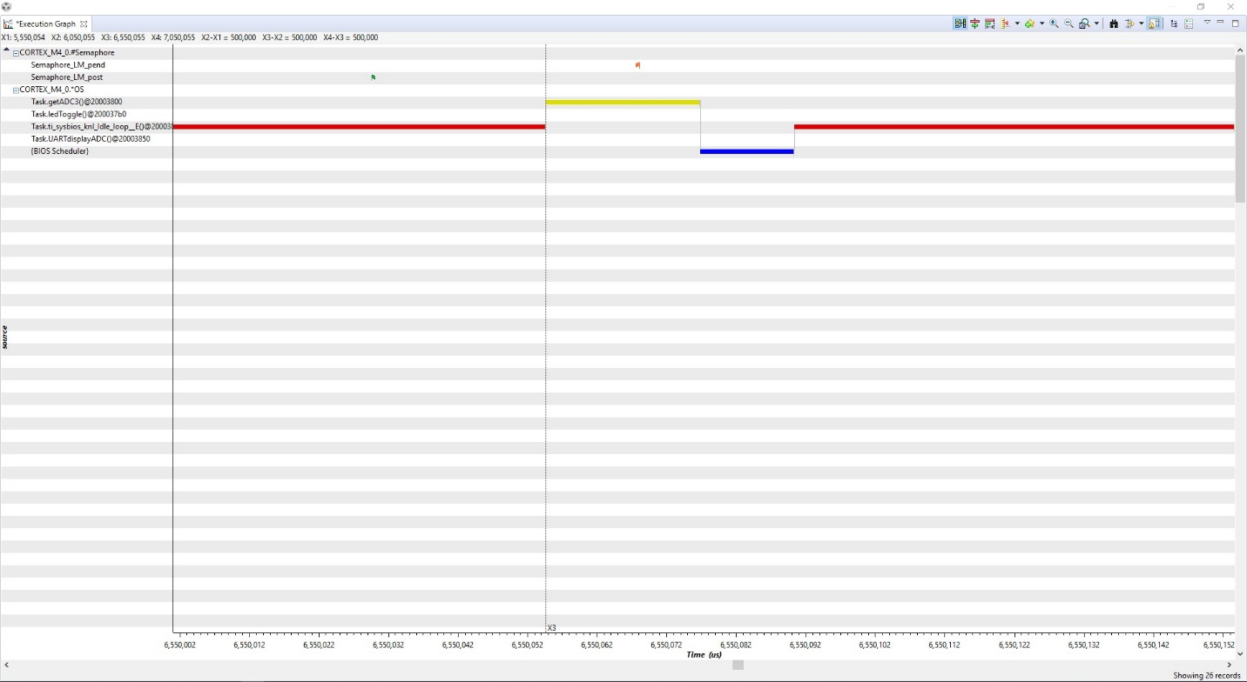

**------------------------------------------------------------------------------------**

**Conclusions:**

**------------------------------------------------------------------------------------**