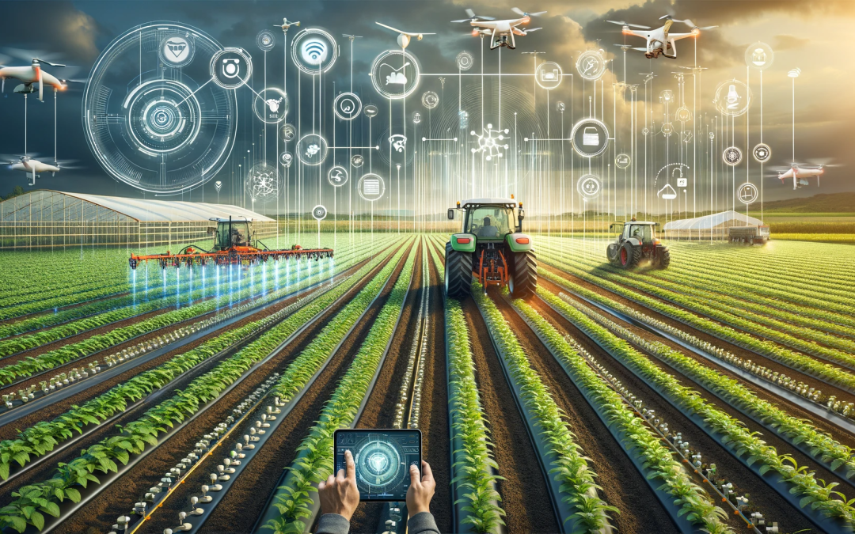**Technology in Agriculture**

**CSIT 100**

**Martha Portillo Mendoza**

**4/3/25**

Technology in farming-

Technology has become an essential part of our lives as it is seen everywhere in our daily lives. One may ask, what is technology? According to Britannica, technology is the application of scientific knowledge to the practical aims of human life. Technology is found everywhere from our smartphones, laptops, smart devices and cars and it doesn't necessarily have to be smart devices but tools and essentials like pencils, toothbrushes, coffeemakers, hammers, etc. Technology is found in farming as new smart devices have come to rise and become a relief for farmers as it helps produce efficiency, growth to their crops and reduce impact on the ecosystem. Farmers do not have to do hard labor anymore but are now assured that their crops will receive all the nutrients they need to produce good crops as well as supplying their consumers of good produce to receive their nutrients. Technology like GPS, machines, sensors, AI, drones and robots play a beneficial part in farming which this essay will present and describe the benefits and improvements in farming.

Technology and modern agriculture have made farmers' lives easier and successful, given the advancements and outcomes of high crop productivity. Based on the ***NIFA U.S Department of Agriculture***, technology has caused great impacts such as food price reductions by saving water, fertilizers and pesticides in which thanks to technology, farmers are able to monitor plant growth with sensors and drones. Agricultural technology has also reduced economic and environmental impacts by water scarcity and less runoff of chemicals such as herbicide which can be harmful to rivers and soil if there’s excessive use. Crop areas can now be monitored and get the care they need unlike before, crops would die due to excess or lack of nutrients and care.

The history of agricultural technology has gone through four revolutions as technology and ways to improve farming life have been revolutionized. According to the informative article ICL group, talks about the first revolution was when hunters improved their ways to find food by farming, the second revolution developed farming to sell or commerce, then machines were developed and now by the fourth revolution, farming has improved and continues to develop thanks to technology. The agriculture 4.0 company revolutionized farming, focusing on precision, robotics and new methods that will be discussed in this essay, to increase produce on farms while also being environmentally friendly.

Smart irrigation systems such as IoT (Internet of Things) is a new technology that uses sensors and connects devices all together in a network to also monitor soil based on humidity, weather conditions, moisture and plant growth (IEEE,2023). According to research done from Meticulous research, “the precision agriculture market is projected to reach $27.81 billion by 2031 of a growth rate of 12.9%.” (Martin Lowry, 2025) The results will show a huge growth and productivity in crops as the government and farms are spreading the usage of modern agricultural technology. The sensors will track and receive data from a computer or a mobile app of how much water is needed at a specific time which farmers will be able to program a schedule to give crops the water it needs. The outcomes will be efficient as it maintains crops healthy and reduces unnecessary water wastage by turning off automatically whenever it rains which without this new feature; crops can die or be overflowed, and it will be more waste than actual produce.

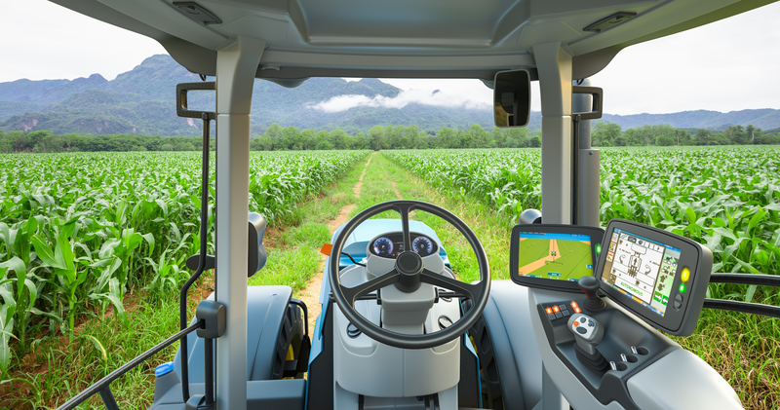 The GPS guided tractor is one of the technological advancements that has improved agriculture which these tractors could manage water and fertilizers by analyzing the targeted areas that need more care. Before GPS tractors, farmers would have to manually seed crops using a seeder plow which wasn't efficient as crops would receive double than they would actually need. One may ask who invented this new technology? According to NASA, John Deere engineers developed the Global Positioning System (GPS) using the ability of mapping which is beneficial in agriculture and monitor mass flow and moisture from sensors. GPS tractors are dependent on using satellite signals which helps obtain location data and the farmer will be able to see a map of the field on a screen to monitor crops and their progress. John Deere also developed a manual driving tractor to an automated tractor which can drive on its own. The tractors will navigate by itself by using lasers that will bounce off mobile transponders which are placed around the field. This new technology and strategy results in better crops and reduces environmental impacts as the screen can show areas that need improvement.

Trapview is a new technology of clear intelligence, smart reporting and forecasts pests which functions as a pest trap and photographs the type of pests that are eating their crops. This new tool is helpful for farmers as it can be impossible to know what areas and measures need to be taken to get rid of pests. Farmers would usually spray pests over their fields not knowing which areas don’t need pesticides. According to trapview.com about 11,844,706 tons of food have been saved and produced with the help of Trapview. Trapview not only helps you manage and see what areas in your field are being attacked but it also provides guidance and strategies to prevent pests in the future. This new tool should be essential as this could prevent stress damage, and labor from these pests.

Drones are another useful technological tool that could help farmers keep track of their crops. The Normalized Difference Vegetation Index (NDVI) drones could monitor crop growth and ensure healthy crops form a high view by using special imaging. The drone will inform a farmer by using colors that will determine if a plant is healthy or needs more assistance. The KRAY technology agricultural is also a self-driving drone that works by spraying fertilizers and pesticides on the fields by spraying in a 3D view as this helps farmers get their crops the exact amount of fertilizer needed, and it could also determine the right time crops will need it. According to the KRAY technology website, the KRAY drone is “capable to process up to 1,200 acres per day” and can operate at a 70-mph speed which saves the farmers time and money from hiring employees to do the work at a longer time.

Satellite Imagery in agriculture is also a major tool that farmers could use by viewing their crops from a higher point of view than drones. Although drones can be precise, satellites are also beneficial as it can recommend how to properly fertilize their crops based on weather conditions, soil moisture, canopy density, and chlorophyll content according to ARLULA.com.

Trace Genomics analyzes soil by its genetics or DNA to analyze soil strength. This helped farmers determine if the soil is in a stable state to grow crops. According to TraceGenomics.com, it uses a “DNA sequencing technology called metagenomics” as it can reveal soil microbiome. This new method and technology will give insight to farmers into how their soil is and how they should treat the soil. Not only that but it will also improve crop growth and provide a higher produce as soil is very important for plant growth. The results are beneficial and transformational as the intelligence from TraceComplete found in the Tracegenomics.com website; the revenues have increased from $105 and more an acre which thanks to this new technology and seed selections, crops can grow more efficiently.

The use of Artificial intelligence (AI) is also helpful in agriculture as it can predict weather, monitor crops and guide farmers on decisions they should take based on AI analysis. AI in simple terms is the artificial intelligence of computers that help perform tasks such as problem- solving and decision making. (NASA) We could use AI on our mobile devices, computers and other home devices which help with daily tasks and even in agriculture in which could perform tasks such as an automatic disease detection, detection on leaks in system, collect data from each acre and monitor vertical farming software to controls crops based on climates. AI could also recommend what fertilizer to use to ensure growth.

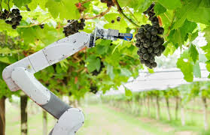

Robots are also starting to be seen in agriculture, and this can improve labor to a new level as the usage of robots can reduce labor costs while also reducing human labor errors. Robots could decrease waste as they will handle crops with more care. According to Cyberweld.co.uk, agricultural robots can help with planting, picking and packing fruit and vegetables. The types of robots that are used in agriculture are harvesting robots, seeding robots, picking and packing robots, pelletizing robots, spraying robots, monitoring and surveillance robots and livestock. A robot known as the TerraSentia will walk across the fields with the ability to scan 10 plants per second and receive field data such as stress response by viewing stem width, height and receive plant health according to earthsense.com. These robots are beneficial as it can send reports to your device on how to manage and care for their crops by doing a cloud-based data analysis.

Technology has become absolutely essential not only in daily lives tasks but also when it comes to farming. New agricultural technologies have been an easier way and transformational for farmers and their employees to improve their farm lifestyle and ways of farming as not having to work hard on farms and spend hours in the sun. With the help of drones, satellites, and robots, farmers can monitor their crops from inside their homes as well as receive full guidance and strategies to follow to maintain their crops such as corn, vegetables and fruits. By using GPS and IoT, it can provide precision of field data and establish new methods of water usage, fertilizers and pesticides to make higher yields, produce and make less waste with the help of data precision. Self-Driving tractors are also a helpful way for farmers to reduce labor costs or pay employees and replace human labor with self- driving tractors that improve planting by seeding fields with an accurate amount for plant and crops. AI has become widely known and useful tool for everyone and thankfully to farmers as well as AI can analyze data and perform tasks as recommendations on diseases and pests. I believe that with these new agricultural machines and technologies, farmers should consider and increase their usage as this creates a stress-free environment as well as not doing hard manual labor as much anymore.

Not only will this help farmers and their employees but also provide us with more food as it can help decrease world hunger and nourish our health. Many people nowadays are consuming unhealthy fast foods that do not nurture our bodies and cause a high rate of obesity. With more efficiency in farming, and high quality of fruits and vegetables, consumers can get the support they need, which in a major part can be thanks to agricultural technology.

Some disadvantages that Agricultural technology can cause is a reduction of jobs as most machines being created, farmers won’t need human labor anymore. Farmers could also lose their farming traditions as this can cause farmers to only depend on technology and AI guidance as well as causing farmers to lose their knowledge on basic farming strategies and creativity to prevent pesticides. Technology can also be a disadvantage for privacy as they can experience unauthorized access and breaches of their data from other networks. These modern agricultural technologies could also be unaffordable for some farmers due to the high prices of machines leading to only a limited number of farmers having access to the new technology which is a big disadvantage for farmers. There could be less productivity and weaker competition of traditional farmers to those who have the technologies and a bigger advantage.

Resources:

1. <https://www.nifa.usda.gov/topics/agriculture-technology>
2. <https://www.gao.gov/products/gao-24-105962#:~:text=Technologies%20can%20reduce%20the%20application,Environmental%20benefits>.
3. <https://www.icl-group.com/blog/technologies-revolutionizing-agriculture-agtech/>
4. <https://spinoff.nasa.gov/Spinoff2017/ee_1.html>
5. <https://tractorgpsapp.com/blogs/articles/how-does-gps-guidance-work-on-tractors>
6. <https://ieeexplore.ieee.org/document/10176528>
7. <https://www.globalagtechinitiative.com/digital-farming/iot-in-agriculture-how-technology-is-transforming-farming-practices/#:~:text=How%20is%20IoT%20Being%20Used,and%20environmental%20impacts%20on%20produce>.
8. <https://intellias.com/artificial-intelligence-in-agriculture/>
9. <https://www.arlula.com/why-satellite-imagery-is-a-game-changer-for-agriculture/#:~:text=What%20is%20the%20most%20common,diseases%2C%20and%20assess%20crop%20health>.
10. <https://www.croptracker.com/blog/drone-technology-in-agriculture.html>
11. <https://www.cyberweld.co.uk/robots-in-agriculture-and-farming>
12. <https://www.earthsense.co/terrasentia>
13. [**https://agriplanting.com/advantages-and-disadvantages-of-technology-in-agriculture/#google_vignette**](https://agriplanting.com/advantages-and-disadvantages-of-technology-in-agriculture/#google_vignette)
14. [**https://tracegenomics.com/innovation/**](https://tracegenomics.com/innovation/)