SampleSizeCalc: Traceable Sample Size Planning for Clinical Research in R
  - SoftwareX-oriented working draft, version 0.1
Portos (Yishan) Wang
Bingxin Cai
5 November 2026
Abstract
Sample size planning requires researchers to select a statistical design, specify defensible assumptions, and interpret the unit of the resulting requirement. These tasks can be difficult to audit when numerical results are separated from parameter meanings, formulas, and methodological sources. We present SampleSizeCalc, an open-source R package that brings these elements together in a common planning interface. Version 3.1.1 declares 46 legal design-task-outcome combinations across 24 design identifiers, covering trials, observational studies, precision estimation, diagnostic accuracy, and selected complex designs. Results retain design-specific sample-size units and provide mathematical expressions, calculation steps, and literature references. Three worked examples distinguish complete participants per arm, confirmed diagnostic cases and screening requirements, and bioequivalence sequence allocation. A reproducible evaluation includes 12 selected numerical comparisons with analytical checks, published examples, presize, and PowerTOST. All selected comparisons agree at the reported integer requirements. The same source archive completed full CRAN-style checks on Windows release, Windows R-devel, and Ubuntu release environments. The package is intended to support transparent planning and review; study assumptions and the suitability of each statistical method remain substantive design decisions.
Affiliation: Gansu Provincial Maternity and Child-care Hospital (Gansu Provincial Central Hospital), China. Corresponding author: Portos (Yishan) Wang, portos.wang@gmail.com.
Keywords: sample size; statistical power; clinical research; diagnostic accuracy; bioequivalence; reproducible research; R.
Draft status. This manuscript contains reproducible software results and illustrative planning scenarios. Items marked TO COMPLETE require author input before submission. The manuscript has not yet been placed in the publisher’s final template.

Motivation and significance
Sample size planning connects a research question to a feasible study. The required quantity may be a number of independent participants, matched pairs, clusters, diagnostic cases, or outcome events. The calculation also depends on choices about the estimand, anticipated effect or precision, variance, allocation, and testing convention. Established references provide detailed methods for these settings (Machin et al. 2018; Zhou et al. 2011; Hajian-Tilaki 2014). Turning a method into a reproducible study-planning record requires both correct computation and an explicit account of what its inputs and outputs mean.
The R ecosystem provides strong foundations for this work (R Core Team 2026). The pwr package implements standard power-analysis procedures (Champely 2020); presize focuses on precision-based planning (Haynes et al. 2021); and PowerTOST provides specialist functionality for equivalence and bioequivalence studies (Labes et al. 2025). These packages illustrate different levels of specialisation. A researcher working across trial, observational, and diagnostic projects may also need a consistent way to record assumptions and assemble the calculation into a protocol. Comparisons must respect the statistical conventions of each implementation, including whether a number denotes one group or the complete study.
SampleSizeCalc addresses this workflow through a common interface built on established methods. A calculation is identified by study design, statistical task, and outcome type. Its result combines numerical requirements with input parameters, sample-size units, a plain-text formula, a LaTeX expression, calculation steps, and methodological references. This representation is intended for clinical investigators, statistical collaborators, and educators who need to inspect how a planning result was obtained.
The contribution is a shared planning and reporting layer across several method families, with explicit links to their statistical conventions. This article describes its implementation, illustrates three planning workflows, and reports selected numerical verification. Table 1 positions the package relative to tools used as context or numerical comparators. It is a comparison of intended roles in this manuscript, rather than an exhaustive feature audit of every available planning package.
Software | Relevant role | Relationship to this work
pwr | Standard hypothesis-test power analysis | Context for existing general power functionality
presize | Precision-based sample size planning | Numerical comparator for Pearson-correlation precision
PowerTOST | Power and sample size for equivalence studies | Numerical comparator for two-period bioequivalence
SampleSizeCalc | Planning and reporting across multiple design families | Combines requirements, parameter roles, formulas, steps, and sources in a common result object
Table 1. Positioning of the software and the selected comparison packages.

Software description

Architecture and design choices
The public entry point is calculate(...). Its principal arguments are design, task, and outcome; additional named arguments describe the study. For example, a two-arm continuous-outcome test is selected with calculate("rct", "test", "mean", ...). Internally, a registry defines legal combinations, default resolutions for unambiguous designs, and the associated calculation route. This separates navigation of the design space from the implementation of each statistical calculation (Figure 1).
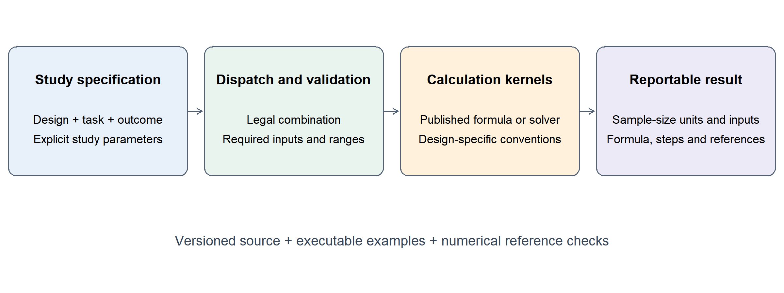
Software architecture. The diagram is a conceptual summary of the dispatcher, input checks, method kernels, and reporting object. It does not imply that all methods share the same statistical assumptions.
The interface resolves control arguments by exact name. This is relevant when short design-specific arguments, such as a precision margin named d, might otherwise be confused with longer argument names. Input checks include required parameters and design-specific bounds. Error messages identify the argument or combination requiring attention. Such checks support valid calls, while the scientific justification of an expected effect, prevalence, non-inferiority margin, or intracluster correlation remains the user’s responsibility.
Calculations are assembled into an S3 sample_size_result object. The object retains design-specific fields, such as n_per_group, total_n, target_state_cases_needed, or target_events_needed. It also stores formula, formula_latex, calculation_steps, reference, and, where available, parameter roles and methodological hints. Standard print() and summary() methods expose the report, and plot() supports selected visual diagnostics. Keeping these components together allows a result to be inspected interactively and its fields to be reused in a reproducible document.
Runtime imports are cli, rlang, and the standard R stats package. Plotting and document-generation tools are optional dependencies. This keeps the computational installation distinct from the additional tools needed to build a website or render a manuscript. The legacy sample_size_calculator() interface and its 17 historical keywords remain available. The examples in this article use the three-axis interface; historical parameter conventions should be checked when migrating existing paired or diagnostic workflows.

Functional scope and conventions
An executable inventory of version 3.1.1 contains 46 legal combinations and 24 distinct design identifiers (Table 2). These are counts of dispatcher entries, not counts of independently validated statistical methods. The its entry is experimental. The exported mrmc_power() helper for a multi-reader, multi-case diagnostic model is available separately from the three-axis registry.
Family | Design identifiers | Legal combinations
Trials | 6 | 16
Observational studies | 4 | 5
Single-sample estimation | 3 | 3
Diagnostic accuracy | 5 | 11
Complex and specialised designs | 6 | 11
Table 2. Functional inventory generated from the evaluated source archive. The complete list of design, task, and outcome combinations is supplied as tables/dispatch-inventory.csv.
Methods include normal-approximation calculations, Student t-based numerical solutions, binomial search, and design-specific procedures described in the methodological literature. Examples include diagnostic precision calculations (Zhou et al. 2011; Hajian-Tilaki 2014), two-stage phase II designs (Simon 1989), and bioequivalence planning using a noncentral t-based two-one-sided-tests approach (Phillips 1990; Julious 2004). The reporting layer preserves the distinction between required participants, events, cases, and clusters.
Conventions remain specific to each route. For example, alternative is currently consumed by the single-test diagnostic hypothesis-testing route; dropout is implemented by the cohort proportion-testing route. Other recruitment allowances in this article are applied explicitly after the complete-case requirement. Users should consult the parameter documentation for their selected design rather than assume that a control argument applies to every route. Similarly, canonical diagnostic AUC precision defaults to a binormal variance approximation, while an exponential alternative can be selected explicitly. The corresponding assumptions are part of the planning record.

Illustrative examples
The following scenarios use teaching inputs. They demonstrate calculations and interpretation, and do not constitute new clinical data or evidence of external adoption. A real study requires compatible evidence for each planning assumption and a prespecified analysis strategy.

A parallel-group continuous-outcome trial
Consider a blinded, equally allocated trial with baseline-to-week-12 systolic blood-pressure reduction as its endpoint. Suppose the anticipated mean reductions are 10 and 12 mmHg, with a common standard deviation of 3 mmHg for individual change scores. The objective is 80% power at two-sided alpha 0.05. A normal-theory starting expression is
$$n_{arm}≈\frac{2σ^{2}\{z_{1−α/2}+z_{1−β}\}^{2}}{δ^{2}}.$$
The trial route refines the requirement through the two-sample Student t-test power calculation. The reproducible call is:
trial <- SampleSizeCalc::calculate(
"rct", "test", "mean",
mean1 = 10, mean2 = 12, sd = 3,
alpha = 0.05, power = 0.80
)
The result is 37 complete participants per arm, or 74 in total. If 10% are expected to lack the primary endpoint, a separately documented allowance gives $⌈n_{arm}/0.90⌉=$ 42 recruits per arm. This allowance does not resolve bias from missing outcomes; it is a recruitment calculation.
Figure 2 varies the anticipated difference and target power while retaining the standard deviation and two-sided alpha. It demonstrates the effect of planning assumptions within the selected method, without making a performance comparison with another implementation.
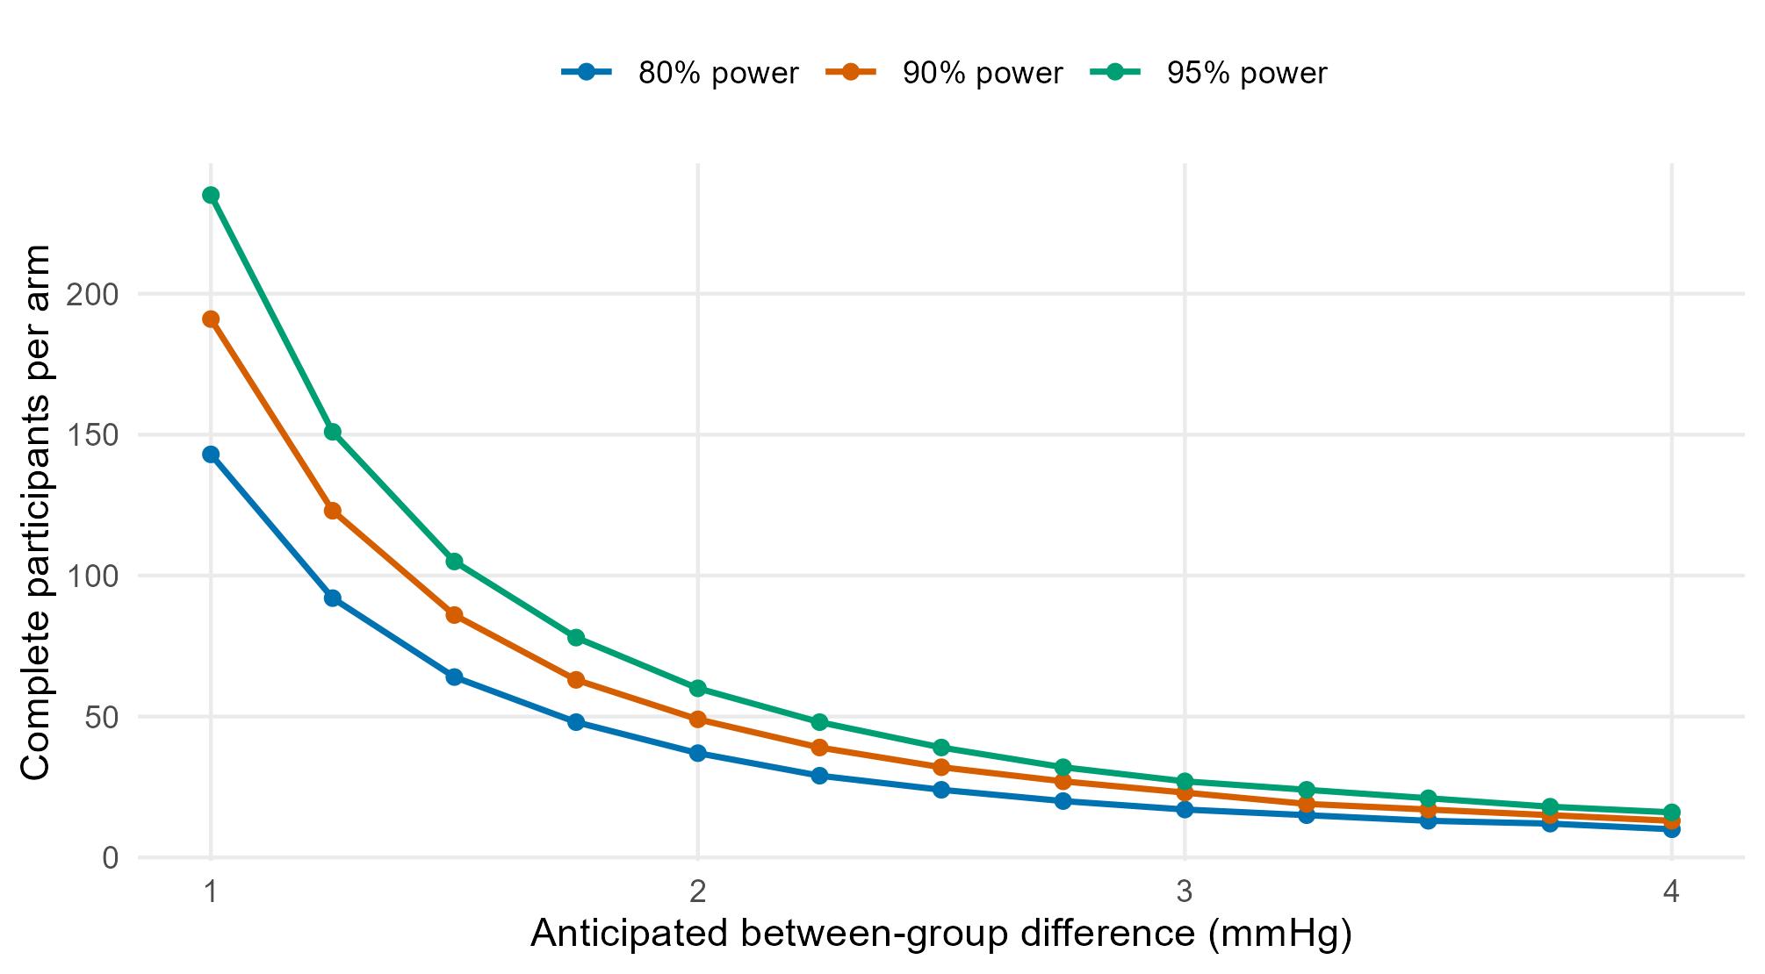
Sample-size sensitivity for the trial example. Standard deviation is 3 mmHg and two-sided alpha is 0.05. Points are evaluated inputs; lines connect those points. Counts refer to complete participants per arm before recruitment allowances.

Diagnostic precision and screening assurance
Suppose a referral clinic plans to estimate the sensitivity of a fixed-threshold test, with anticipated sensitivity 0.85 and a 95% confidence-interval half-width of 0.05. The normal-approximation case requirement is
$$n_{case}=\left\lceil \frac{z_{1−α/2}^{2} Se(1−Se)}{d^{2}}\right\rceil .$$
Using source-population prevalence 0.20 gives:
diagnostic <- SampleSizeCalc::calculate(
"diagAccuracy", "estimate", "proportion",
prob = 0.85, d = 0.05, prevalence = 0.20,
alpha = 0.05
)
screen_n <- SampleSizeCalc::screen_required(
diagnostic$target_state_cases_needed,
prevalence = 0.20, beta = 0.10
)
The requirement is 196 confirmed cases. An expectation-based conversion gives 980 screened participants. A 90% assurance of obtaining at least that many cases instead requires the smallest $N$ satisfying
$$P\{Binomial(N,0.20)≥196\}≥0.90.$$
The helper returns 1,061 screened participants. The replication script verifies both that this value meets the probability bound and that the preceding integer does not. This assurance concerns the number of cases under an assumed binomial prevalence model; it is distinct from power for a diagnostic hypothesis test. Specificity precision, reference-standard completeness, and uncertainty in prevalence require their own planning considerations (Zhou et al. 2011; Hajian-Tilaki 2014).

Two-period bioequivalence planning
Consider a two-treatment, two-period crossover study of one prespecified log-transformed pharmacokinetic endpoint. Assume within-subject coefficient of variation 0.25, expected geometric mean ratio 1.00, equivalence bounds 0.80 and 1.25, one-sided alpha 0.05, and target power 0.80:
be <- SampleSizeCalc::calculate(
"bioequivalence", "equivalence", "mean",
cv = 0.25, theta0 = 1.00,
margin_low = 0.80, margin_high = 1.25,
alpha = 0.05, power = 0.80
)
The requirement is 24 complete participants, or 12 per sequence. Changing the expected ratio to 0.95 increases the total to 28. Both requirements match PowerTOST::sampleN.TOST() under the corresponding settings. The example illustrates why a sequence-specific count must be distinguished from the complete-study count. Planning for additional pharmacokinetic endpoints, replicate designs, or regulatory conditions requires methods suited to those objectives (Phillips 1990; Julious 2004; Labes et al. 2025).

Verification and reproducibility
The replication script evaluates a frozen version-3.1.1 source archive, checks its SHA-256 identifier, generates the dispatcher inventory, recomputes the worked examples, and exports every numerical table and figure. The archive and evidence records accompany this working draft. No patient-level data are needed for these calculations.
Twelve selected numerical comparisons are supplied in tables/validation-full.csv; eight representative rows appear in Table 3. The comparison set includes analytical checks, published worked examples, Pearson-correlation precision from presize version 0.3.11, and bioequivalence requirements from PowerTOST version 1.5-7. Parameters and output units are aligned before comparison. Integer requirements agree for all 12 selected cases. The correlation comparisons return 867 and 219 participants for confidence-interval widths 0.10 and 0.20, respectively; the bioequivalence comparisons return 24 and 28 total participants for expected ratios 1.00 and 0.95.
Method | Unit | Package | Reference | Source
Proportion precision | Participants | 323 | 323 | Normal precision formula
Sensitivity precision | Cases | 246 | 246 | Zhou, Sec. 6.1.1
AUC, binormal variance | Cases | 46 | 46 | Zhou, Eq. 6.5
Correlation, CI width 0.10 | Participants | 867 | 867 | presize 0.3.11
Bioequivalence, GMR 1.00 | Total participants | 24 | 24 | PowerTOST 1.5-7
Cluster trial | Total participants | 172 | 172 | Machin, Ex. 12.1
Simon optimal design | Maximum participants | 29 | 29 | Machin, Ex. 17.2
Screening assurance | Screened participants | 1061 | 1061 | Binomial minimality
Table 3. Selected numerical comparisons. Source references are Machin et al. (2018) and Zhou et al. (2011) for the indicated book sections and examples, and Haynes et al. (2021) and Labes et al. (2025) for the comparator software. The complete table records all 12 comparisons. Unit definitions are essential: diagnostic case counts, maximum two-stage enrolment, and complete-study participant counts are different quantities.
The published anchors and comparator outputs provide regression evidence at specified inputs. They do not establish power or confidence-interval coverage throughout the parameter space. Agreement between two implementations of a shared formula is also narrower evidence than independent statistical validation. Accordingly, this manuscript reports selected agreement without claiming that all 46 dispatcher entries have undergone comprehensive external validation.
Software-engineering evidence complements these numerical comparisons. On 5 November 2026, the evaluated source archive completed full R CMD check --as-cran runs on Windows 11 with R 4.6.1, Windows R-devel (3 November 2026, revision 90835), and Ubuntu 24.04.4 with R 4.6.1 under WSL2. Each run finished with zero errors, zero warnings, and one New submission note. Tests, examples including donttest examples, all four vignette rebuilds, and PDF and HTML manual checks completed. A separate development run recorded 630 passing assertions, with no failures, errors, warnings, or skips. Historical logs and the reproduction session are retained in the evidence directory. These checks document installation, code, documentation, and regression behaviour; CRAN-style checking is not a certification of statistical or clinical validity.

Impact and limitations
The intended use is a planning workflow in which an investigator and a statistical collaborator can review the same inputs, numerical requirements, and methodological provenance. The returned fields can be incorporated into a protocol or teaching document, and sensitivity plots can make assumptions visible during discussion. The diagnostic example demonstrates a concrete benefit of explicit units: expected screening capacity and a probability-based case-accrual requirement can be considered separately. The bioequivalence example similarly makes sequence allocation visible.
Current evidence in this manuscript consists of executable examples, selected numerical comparisons, documentation, and software checks. External adoption, usability outcomes, and improvements in research decisions have not been measured here. TO COMPLETE: add a documented research workflow, external use case, or specific researcher feedback if available. The teaching examples should remain identified as illustrative rather than be described as deployment evidence. A future user evaluation could examine whether researchers correctly interpret sample-size units and retain the assumptions needed to reproduce a calculation.
Several statistical boundaries deserve attention. An analytically correct requirement can still be inappropriate when its variance, prevalence, effect, correlation, or analysis-model assumptions do not match the proposed study. AUC variance alternatives can produce different answers; approximation choice should therefore be stated. Recruitment inflation is route-specific, and a single alternative argument does not reconfigure every testing procedure. The experimental interrupted-time-series route should be treated as a simplified planning aid. Prediction-model planning includes selected criteria and an events-per-variable option; it should not be described as a complete implementation of all criteria discussed by Riley et al. (2020). Software output does not establish an appropriate clinical margin, anticipated treatment benefit, or acceptable missing-data strategy.
The comparative evidence also has a limited scope. The present evaluation does not claim a runtime advantage, superior sample-size estimates, or improved operating characteristics over specialist tools. A broader comparison could examine additional packages, parameter ranges, and disagreement caused by different conventions. Development priorities include stronger scope signalling for design-specific controls and expanded validation of less commonly used designs.

Conclusions
SampleSizeCalc combines established sample-size and power calculations with a common representation of inputs, sample-size units, formulas, calculation steps, and methodological references. Version 3.1.1 provides 46 registered combinations across 24 design identifiers, illustrated here by trial, diagnostic, and bioequivalence workflows. Reproducible numerical comparisons and cross-platform package checks support the documented implementation at the evaluated settings. The software offers a basis for auditable planning records, while further validation and research-use evidence should accompany claims about its practical impact.

Code metadata and availability
Item | Description
Current code version | SampleSizeCalc 3.1.1
Code repository | https://github.com/portos-wang/Sample_Size_Calc
Permanent version link | TO COMPLETE: identify the final immutable release tag and archived software DOI
Reproducible evaluation | replicate.R, the source archive, exported tables, figures, and evidence records accompanying this draft
Legal code licence | MIT
Version control system | Git
Language and environment | R >= 4.0.0; runtime imports cli, rlang, and stats
Documentation | https://rpackages.portos.wang/sample_size_calc/
Support contact | portos.wang@gmail.com
The evaluated archive is identified in evidence/verification.json. TO COMPLETE: confirm the final distribution links, the status of CRAN availability, and an enduring public archive for the evaluated source and replication materials before submission.

Author declarations
CRediT authorship statement. TO COMPLETE: both authors should confirm their actual contributions and approve the final authorship statement.
Funding. TO COMPLETE: provide the relevant funding sources and grant identifiers, or confirm that no specific funding was received.
Declaration of competing interest. TO COMPLETE: authors should provide their declaration after reviewing relevant financial and non-financial interests.
Data availability. This manuscript uses illustrative planning inputs and published numerical examples. Numerical outputs, the computational source, and replication scripts are included with the working draft. TO COMPLETE: replace the working-draft location with the final public archive identifier.

References
Champely, Stephane. 2020. pwr: Basic Functions for Power Analysis. https://doi.org/10.32614/CRAN.package.pwr.
Hajian-Tilaki, Karimollah. 2014. “Sample Size Estimation in Diagnostic Test Studies of Biomedical Informatics.” Journal of Biomedical Informatics 48: 193–204. https://doi.org/10.1016/j.jbi.2014.02.013.
Haynes, Alan G., Armando Lenz, Odile Stalder, and Andreas Limacher. 2021. “presize: An R-Package for Precision-Based Sample Size Calculation in Clinical Research.” Journal of Open Source Software 6 (60): 3118. https://doi.org/10.21105/joss.03118.
Julious, Steven A. 2004. “Sample Sizes for Clinical Trials with Normal Data.” Statistics in Medicine 23 (12): 1921–86. https://doi.org/10.1002/sim.1783.
Labes, Detlew, Helmut Schütz, and Benjamin Lang. 2025. PowerTOST: Power and Sample Size for (Bio)equivalence Studies. https://doi.org/10.32614/CRAN.package.PowerTOST.
Machin, David, Michael J. Campbell, Say Beng Tan, and Swee Hung Tan. 2018. Sample Sizes for Clinical, Laboratory and Epidemiology Studies. 4th ed. John Wiley & Sons.
Phillips, K. F. 1990. “Power of the Two One-Sided Tests Procedure in Bioequivalence.” Journal of Pharmacokinetics and Biopharmaceutics 18 (2): 137–44. https://doi.org/10.1007/BF01063556.
R Core Team. 2026. R: A Language and Environment for Statistical Computing. R Foundation for Statistical Computing. https://doi.org/10.32614/R.manuals.
Riley, Richard D., Joie Ensor, Kym I. E. Snell, et al. 2020. “Calculating the Sample Size Required for Developing a Clinical Prediction Model.” BMJ 368: m441. https://doi.org/10.1136/bmj.m441.
Simon, Richard. 1989. “Optimal Two-Stage Designs for Phase II Clinical Trials.” Controlled Clinical Trials 10 (1): 1–10. https://doi.org/10.1016/0197-2456(89)90015-9.
Zhou, Xiao-Hua, Nancy A. Obuchowski, and Donna K. McClish. 2011. Statistical Methods in Diagnostic Medicine. 2nd ed. John Wiley & Sons. https://doi.org/10.1002/9780470906514.

