CS1
Unit 1
8 warm-ups · 32 vocabulary terms
By the end of this unit, I can…
- ☐ I can find a point's (x, y) on the CMU canvas.
- ☐ I can explain why y increases going down.
- ☐ I can write Circle(cx, cy, r) for a circle I see.
- ☐ I can write Rect(left, top, w, h) for a rectangle.
- ☐ I can name the shape functions Oval, Line, and Star.
- ☐ I can read the arguments a Star needs.
- ☐ I can set a shape's fill color.
- ☐ I can add a border and set its width.
- ☐ I can predict which shape is drawn on top.
- ☐ I can use opacity to see through a shape.
- ☐ I can put text on the canvas with Label.
- ☐ I can position and size a Label.
- ☐ I can rotate a shape with rotateAngle.
- ☐ I can describe a rotation in degrees.
- ☐ I can read a multi-shape drawing and list its shapes.
- ☐ I can plan a small scene before I code it.
How to use these pages
Each warm-up is two pages. Page 1 is the header, the START HERE strip (A–E), and Vocabulary. Page 2 is Part 1 (everyone) and Part 2 (keep going if you finish early). Mark your own or a partner’s work — it does not count against you.

Name | Date | Period
Partner | Points ___ / ___ | Marked by
Warm-up 1 — The CMU coordinate plane
START HERE
A | Pace check — circle one: ( ) feeling good ( ) a bit distracted ( ) stuck — I could use help
B | ☐ got it ☐ shaky ☐ not yet I can find a point's (x, y) on the CMU canvas.
C | ☐ got it ☐ shaky ☐ not yet I can explain why y increases going down.
D | Looking back at last class — one thing that clicked, and one thing still fuzzy:
E | Something you are looking forward to this week:
Vocabulary — write each in your own words
coordinate plane

origin

x-coordinate

y-coordinate

Part 1 — core work
The origin (0, 0) is the TOP-LEFT corner of the CMU canvas. On the grid, mark the point (200, 100) with a dot and label it.
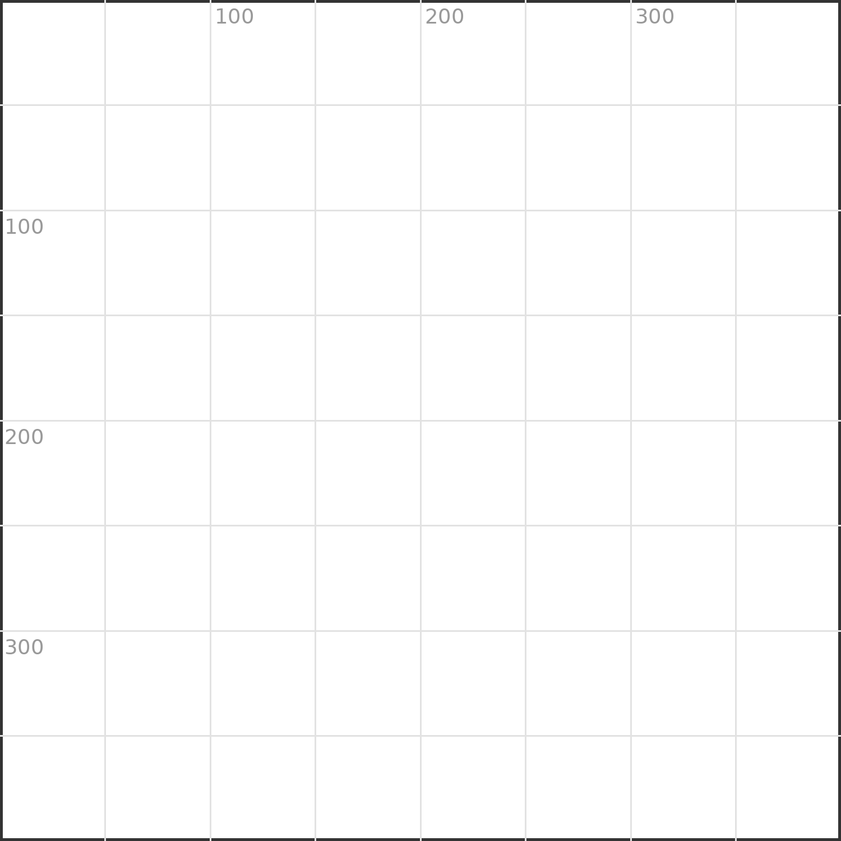
Write the (x, y) coordinates of the dot drawn below.

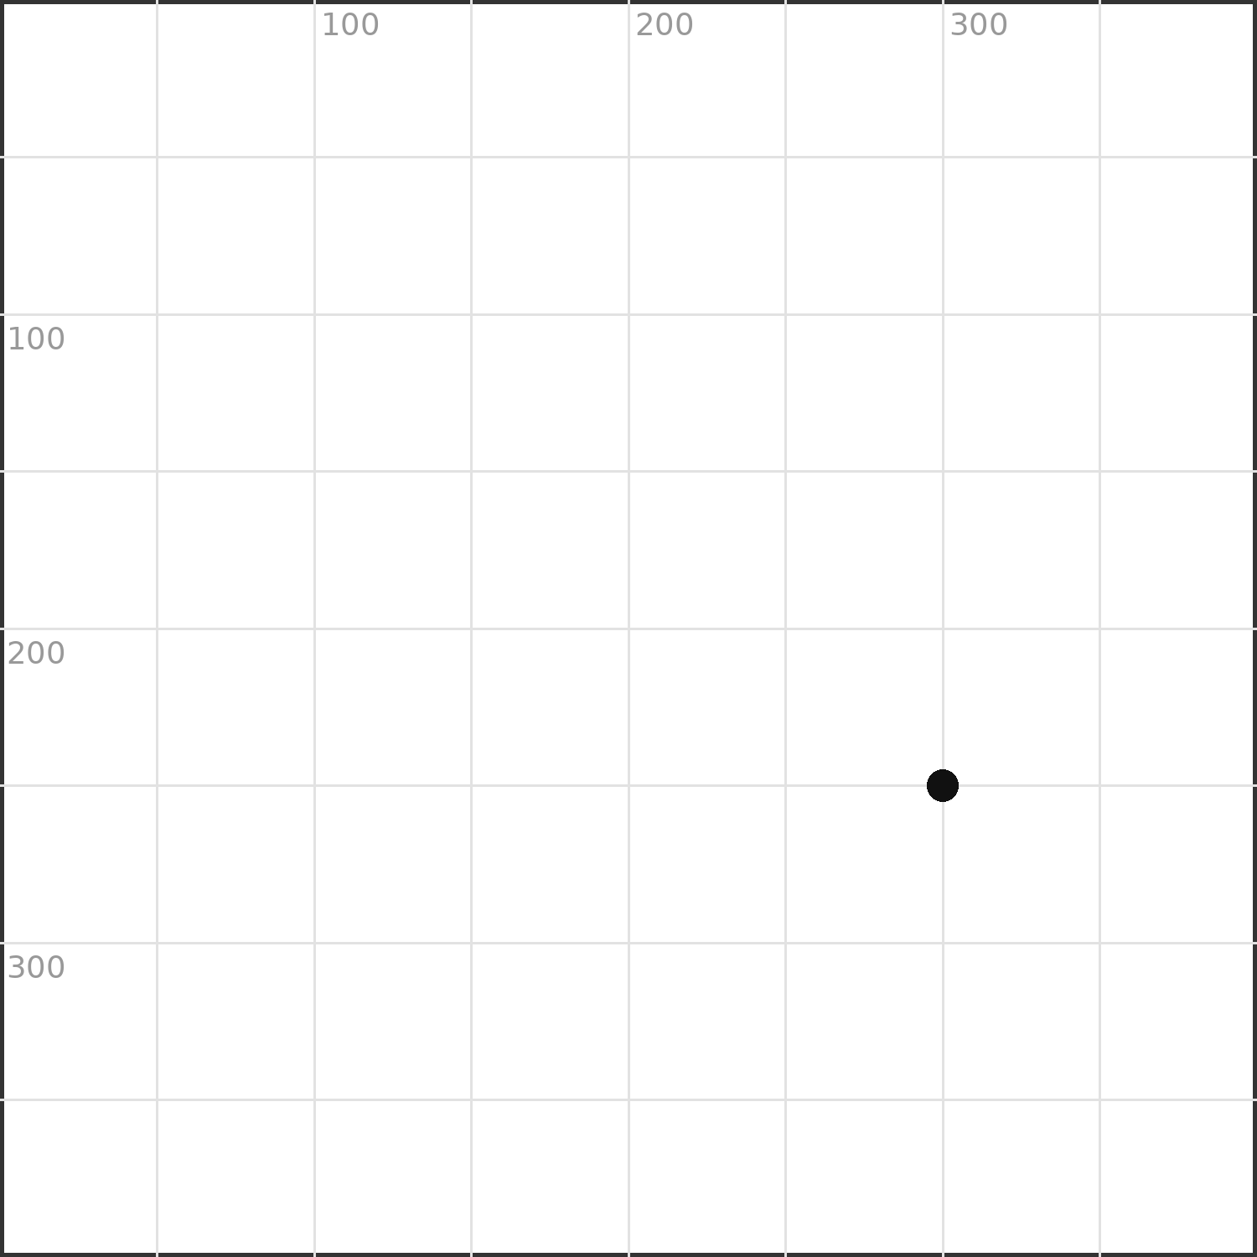
In CMU graphics y counts DOWN. Which point is LOWER on the screen: (100, 50) or (100, 350)? Explain in one sentence.

PART 2 — keep going if you finish early.
Name the corner each point lands in: (0, 400), (400, 0), (400, 400).

Name | Date | Period
Partner | Points ___ / ___ | Marked by
Warm-up 2 — Circle and Rect
START HERE
A | Pace check — circle one: ( ) feeling good ( ) a bit distracted ( ) stuck — I could use help
B | ☐ got it ☐ shaky ☐ not yet I can write Circle(cx, cy, r) for a circle I see.
C | ☐ got it ☐ shaky ☐ not yet I can write Rect(left, top, w, h) for a rectangle.
D | Looking back at last class — one thing that clicked, and one thing still fuzzy:
E | A person you could ask for help if you get stuck:
Vocabulary — write each in your own words
Circle

Rect

radius

argument

Part 1 — core work
Two circles are drawn below.
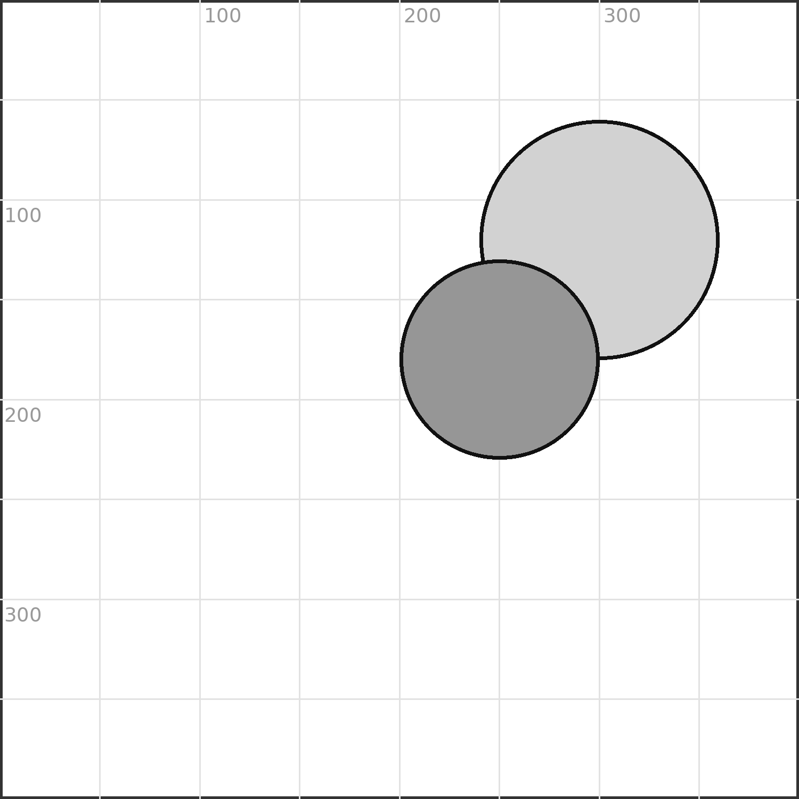
Circle(centerX, centerY, radius)
Write the CMU code for the SMALLER circle using the pattern above.

A Rect starts at its TOP-LEFT corner: Rect(left, top, width, height). Write the code for a box 150 wide and 80 tall whose top-left is (60, 260).

PART 2 — keep going if you finish early.
Change the big circle's radius to 90. Does it grow toward the center or toward the edge? Explain.

Name | Date | Period
Partner | Points ___ / ___ | Marked by
Warm-up 3 — Ovals, lines, and stars
START HERE
A | Pace check — circle one: ( ) feeling good ( ) a bit distracted ( ) stuck — I could use help
B | ☐ got it ☐ shaky ☐ not yet I can name the shape functions Oval, Line, and Star.
C | ☐ got it ☐ shaky ☐ not yet I can read the arguments a Star needs.
D | Looking back at last class — one thing that clicked, and one thing still fuzzy:
E | One thing that is going well outside of this class:
Vocabulary — write each in your own words
Oval

Line

Star

points (of a star)

Part 1 — core work
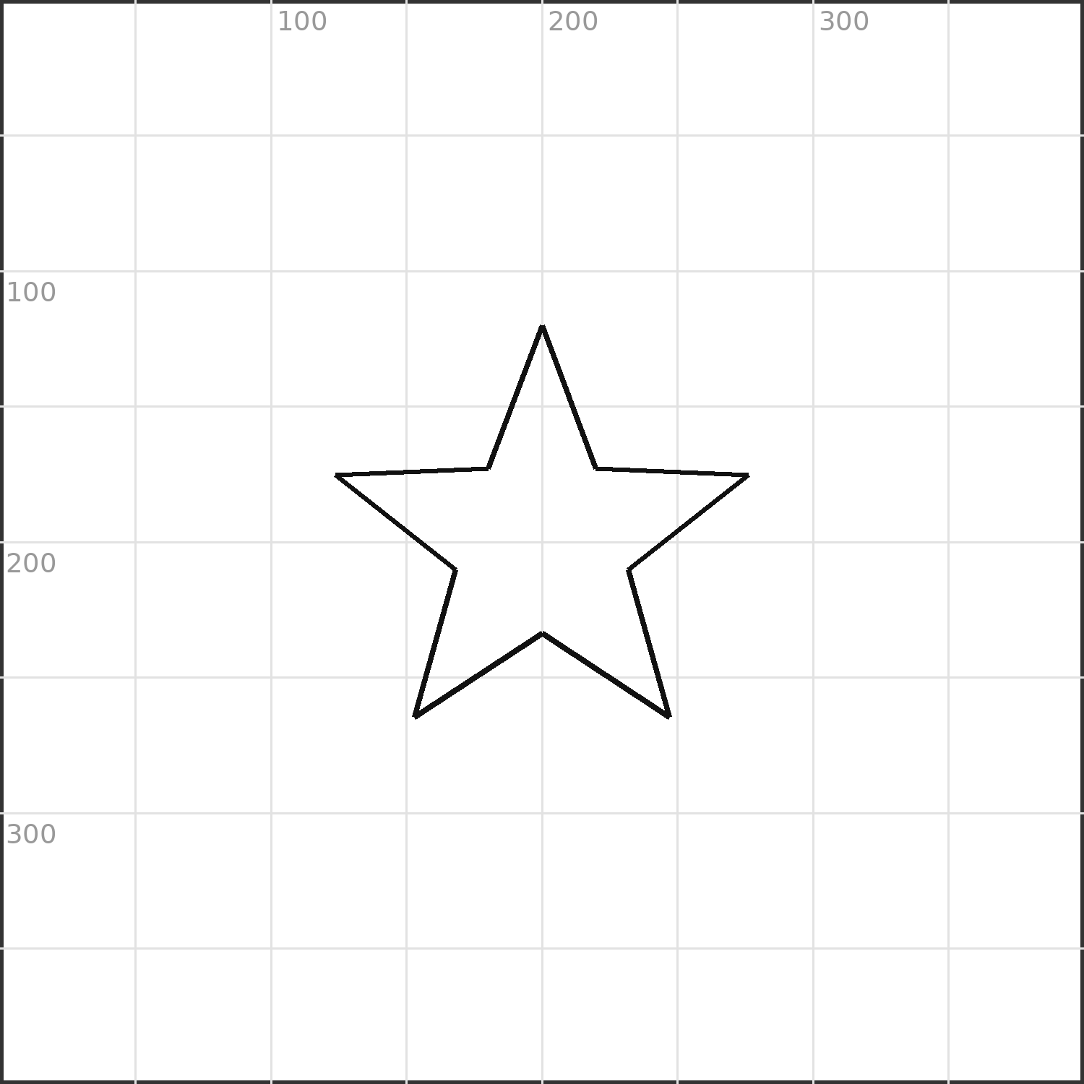
This star was made with Star(200, 200, 80, 5). What does the last number, 5, control?

Write a Line from the top-left corner (0, 0) to the point (250, 300).

PART 2 — keep going if you finish early.
An Oval uses a width and a height instead of one radius: Oval(cx, cy, width, height). Write an Oval centered at (200, 200) that is 160 wide and 90 tall.

Name | Date | Period
Partner | Points ___ / ___ | Marked by
Warm-up 4 — Colors: fill and border
START HERE
A | Pace check — circle one: ( ) feeling good ( ) a bit distracted ( ) stuck — I could use help
B | ☐ got it ☐ shaky ☐ not yet I can set a shape's fill color.
C | ☐ got it ☐ shaky ☐ not yet I can add a border and set its width.
D | Looking back at last class — one thing that clicked, and one thing still fuzzy:
E | If you finish early today, what will you try next?
Vocabulary — write each in your own words
fill

border

borderWidth

color name

Part 1 — core work
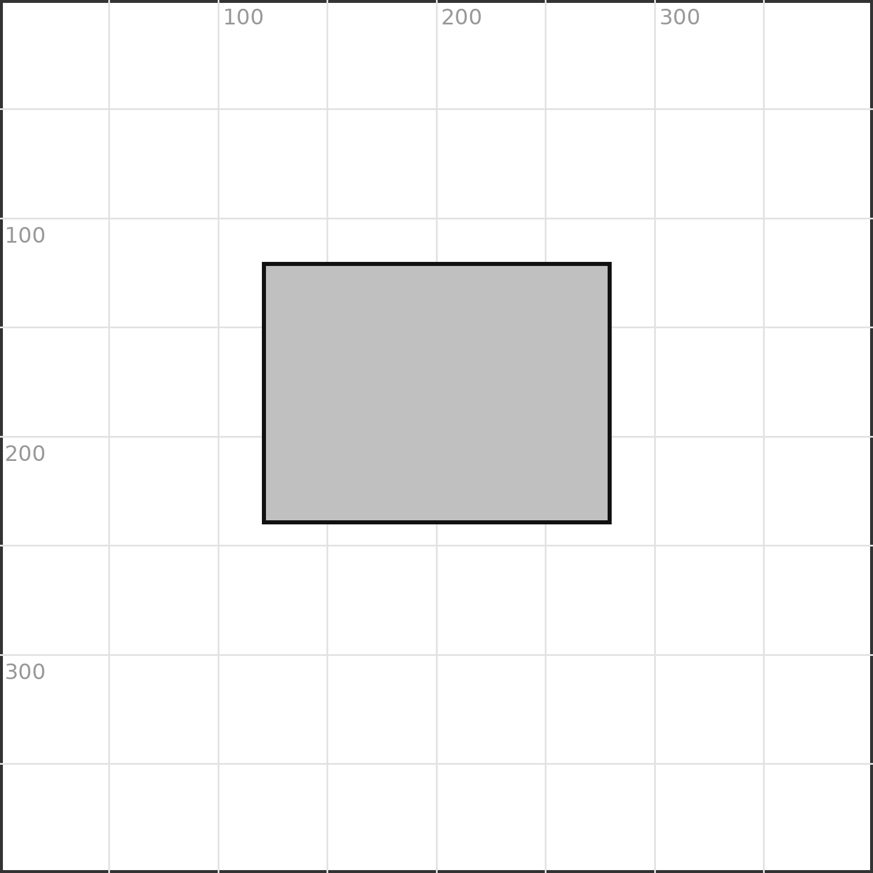
The gray box below is filled gray. Write the Rect code that fills it gray AND adds a black border 4 pixels wide.

Rect(120, 120, 160, 120, fill='gray', border='black', borderWidth=4)
Name two different ways you could make this box look lighter.

PART 2 — keep going if you finish early.
Colors can be named ('crimson') or built with rgb(r, g, b). Write an rgb() color you think would look orange.

Name | Date | Period
Partner | Points ___ / ___ | Marked by
Warm-up 5 — Opacity and layering
START HERE
A | Pace check — circle one: ( ) feeling good ( ) a bit distracted ( ) stuck — I could use help
B | ☐ got it ☐ shaky ☐ not yet I can predict which shape is drawn on top.
C | ☐ got it ☐ shaky ☐ not yet I can use opacity to see through a shape.
D | Looking back at last class — one thing that clicked, and one thing still fuzzy:
E | A goal — small is fine — for this class period:
Vocabulary — write each in your own words
layering (draw order)

on top

opacity

overlap

Part 1 — core work
Two boxes overlap. The one listed LAST in the code is drawn on top.
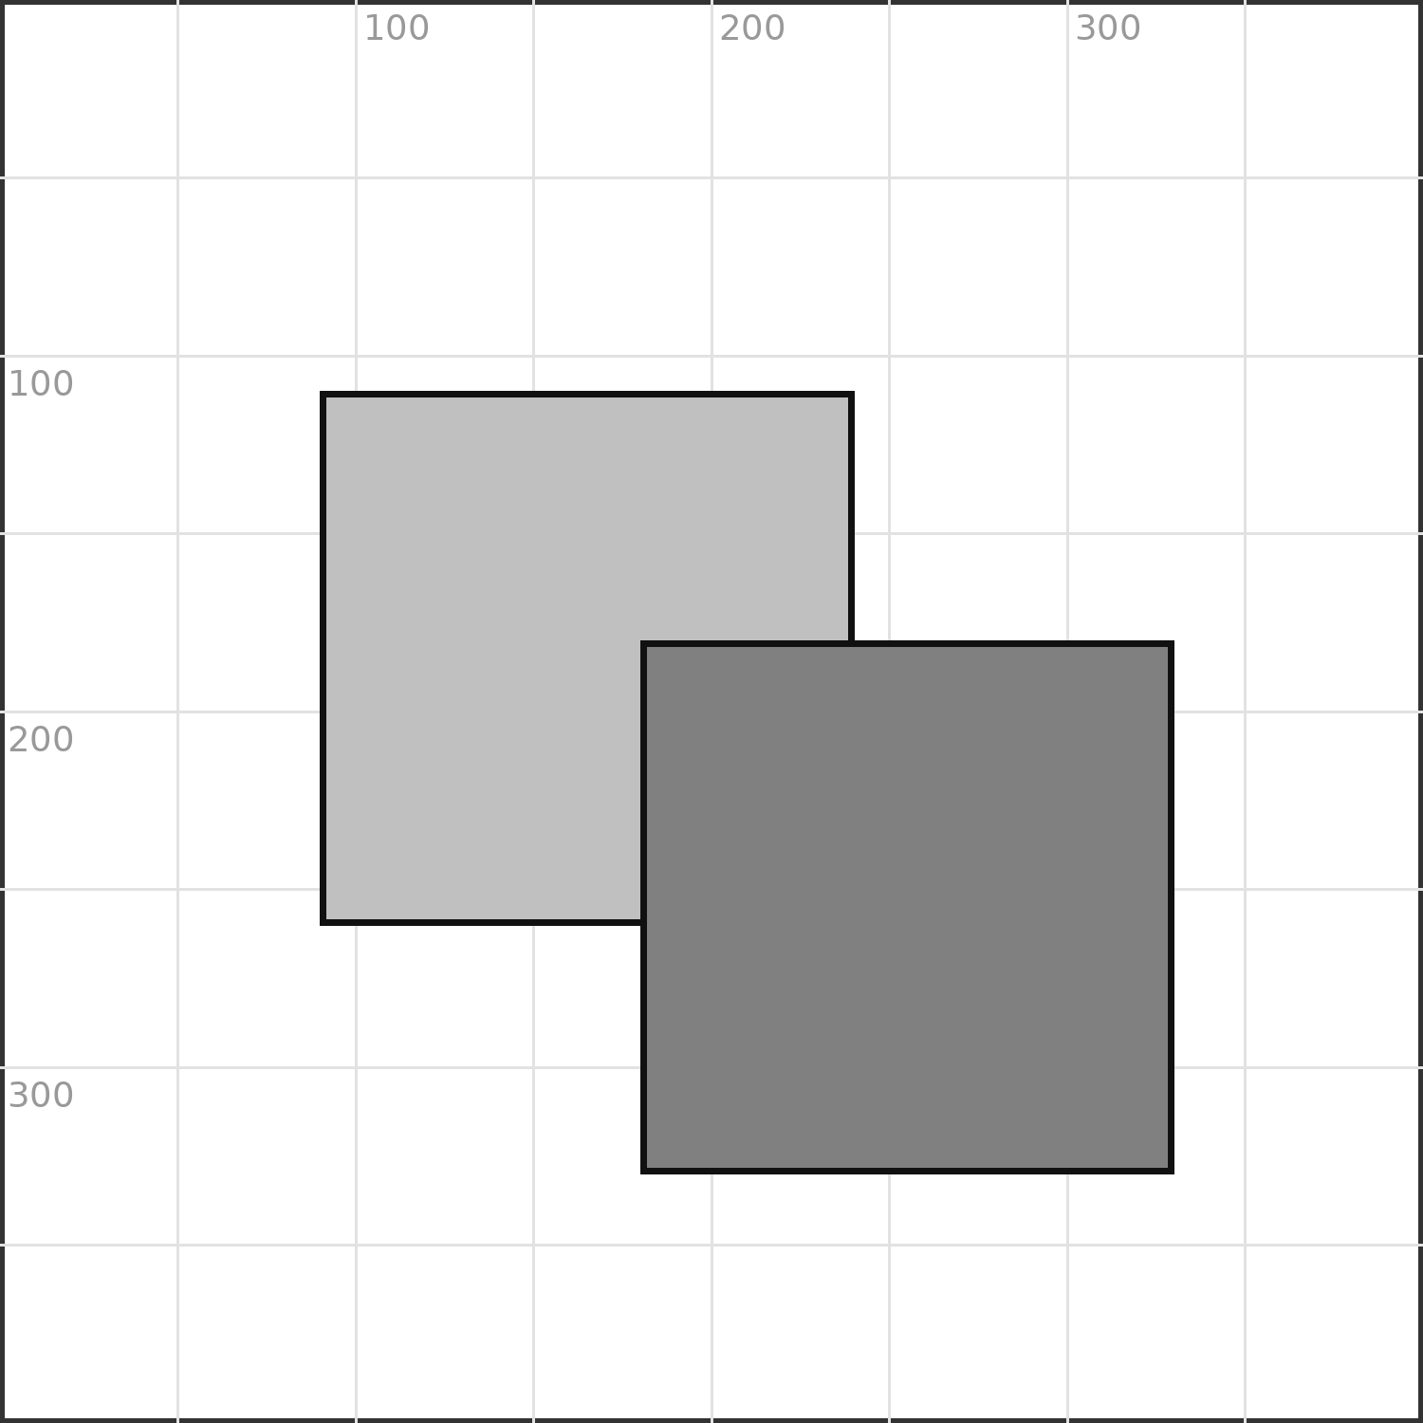
Which box is on top — the lighter one or the darker one? How can you tell?

You want the LIGHT box on top instead. What do you change about the order of your two Rect lines?

PART 2 — keep going if you finish early.
opacity runs from 0 (invisible) to 100 (solid). What opacity would make a shape a faint 'ghost' you can still see through?

Name | Date | Period
Partner | Points ___ / ___ | Marked by
Warm-up 6 — Labels and text
START HERE
A | Pace check — circle one: ( ) feeling good ( ) a bit distracted ( ) stuck — I could use help
B | ☐ got it ☐ shaky ☐ not yet I can put text on the canvas with Label.
C | ☐ got it ☐ shaky ☐ not yet I can position and size a Label.
D | Looking back at last class — one thing that clicked, and one thing still fuzzy:
E | One word for how today is going so far:
Vocabulary — write each in your own words
Label

value (the text)

size (font)

align

Part 1 — core work
Label('Score: 0', 200, 40, size=20, fill='black')
In the Label above, which part is the text shown on screen? Which two numbers place it on the canvas?

Write a Label that shows your name, centered near the top of the canvas.

PART 2 — keep going if you finish early.
A Label is centered on its (x, y) by default. If your Label runs off the right edge, what could you change about its x?

Name | Date | Period
Partner | Points ___ / ___ | Marked by
Warm-up 7 — Rotating shapes
START HERE
A | Pace check — circle one: ( ) feeling good ( ) a bit distracted ( ) stuck — I could use help
B | ☐ got it ☐ shaky ☐ not yet I can rotate a shape with rotateAngle.
C | ☐ got it ☐ shaky ☐ not yet I can describe a rotation in degrees.
D | Looking back at last class — one thing that clicked, and one thing still fuzzy:
E | Something you are looking forward to this week:
Vocabulary — write each in your own words
rotateAngle

degrees

clockwise

centerX / centerY

Part 1 — core work

rotateAngle turns a shape a number of degrees, clockwise. Add rotateAngle so the star below turns 36 degrees.

Star(200, 200, 80, 5, rotateAngle=36)
A full turn is 360 degrees. What rotateAngle brings a shape back to exactly where it started?

PART 2 — keep going if you finish early.
Rectangles rotate around their center too. In words, predict what Rect(150, 150, 200, 40, rotateAngle=90) would look like.

Name | Date | Period
Partner | Points ___ / ___ | Marked by
Warm-up 8 — Putting it together: a scene
START HERE
A | Pace check — circle one: ( ) feeling good ( ) a bit distracted ( ) stuck — I could use help
B | ☐ got it ☐ shaky ☐ not yet I can read a multi-shape drawing and list its shapes.
C | ☐ got it ☐ shaky ☐ not yet I can plan a small scene before I code it.
D | Looking back at last class — one thing that clicked, and one thing still fuzzy:
E | A person you could ask for help if you get stuck:
Vocabulary — write each in your own words
composition

comment (#)

canvas

plan

Part 1 — core work
Read the scene below. List every shape you see, in the order you would draw them (back to front).

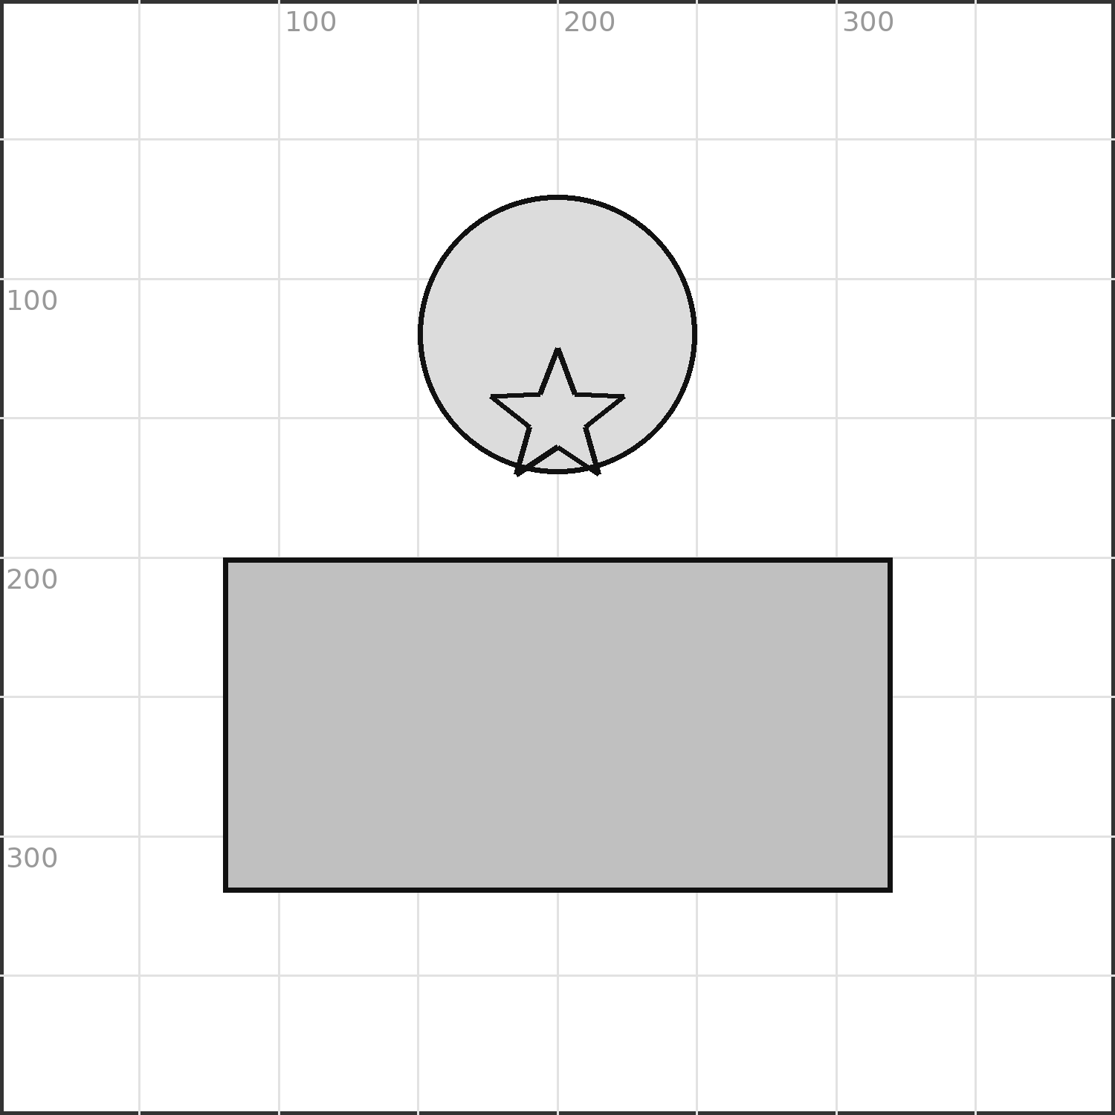
A comment starts with #. Write a one-line comment that explains the star in this scene.

PART 2 — keep going if you finish early.
Plan your own scene.
Sketch a simple scene — a house, a face, a robot — on the grid. Label at least three shapes with their function names (Circle, Rect, …).


CS1
Unit 2
6 warm-ups · 24 vocabulary terms
By the end of this unit, I can…
- ☐ I can build a color with rgb(r, g, b).
- ☐ I can use opacity as a number from 0 to 100.
- ☐ I can create a variable and give it a value.
- ☐ I can explain what the = sign does.
- ☐ I can tell an integer from a float from a string.
- ☐ I can recognize a Boolean value.
- ☐ I can evaluate an arithmetic expression.
- ☐ I can use the operators + - * / // %.
- ☐ I can use a variable to position a shape.
- ☐ I can change one variable to move several shapes.
- ☐ I can choose clear variable names.
- ☐ I can find a simple bug in an expression.
How to use these pages
Each warm-up is two pages. Page 1 is the header, the START HERE strip (A–E), and Vocabulary. Page 2 is Part 1 (everyone) and Part 2 (keep going if you finish early). Mark your own or a partner’s work — it does not count against you.

Name | Date | Period
Partner | Points ___ / ___ | Marked by
Warm-up 11 — Color by number
START HERE
A | Pace check — circle one: ( ) feeling good ( ) a bit distracted ( ) stuck — I could use help
B | ☐ got it ☐ shaky ☐ not yet I can build a color with rgb(r, g, b).
C | ☐ got it ☐ shaky ☐ not yet I can use opacity as a number from 0 to 100.
D | Looking back at last class — one thing that clicked, and one thing still fuzzy:
E | A goal — small is fine — for this class period:
Vocabulary — write each in your own words
rgb

gradient

opacity (0–100)

channel (r, g, b)

Part 1 — core work
fill = rgb(255, 140, 0)
Each rgb channel goes 0–255. What color is rgb(0, 0, 0)? What about rgb(255, 255, 255)?

A gradient blends two colors across a shape. Name two colors you would blend for a sunset.

PART 2 — keep going if you finish early.
Write an rgb() color for your favorite color, then explain what your three numbers do.

Name | Date | Period
Partner | Points ___ / ___ | Marked by
Warm-up 12 — Variables
START HERE
A | Pace check — circle one: ( ) feeling good ( ) a bit distracted ( ) stuck — I could use help
B | ☐ got it ☐ shaky ☐ not yet I can create a variable and give it a value.
C | ☐ got it ☐ shaky ☐ not yet I can explain what the = sign does.
D | Looking back at last class — one thing that clicked, and one thing still fuzzy:
E | One word for how today is going so far:
Vocabulary — write each in your own words
variable

assignment (=)

value

name (identifier)

Part 1 — core work
score = 0
name = 'Robo'
In score = 0, which side is the NAME and which side is the VALUE? What does the = actually do?

Create a variable called lives and set it to 3.

PART 2 — keep going if you finish early.
After lives = 3, you run lives = lives - 1. What is lives now, and why?

Name | Date | Period
Partner | Points ___ / ___ | Marked by
Warm-up 13 — Data types
START HERE
A | Pace check — circle one: ( ) feeling good ( ) a bit distracted ( ) stuck — I could use help
B | ☐ got it ☐ shaky ☐ not yet I can tell an integer from a float from a string.
C | ☐ got it ☐ shaky ☐ not yet I can recognize a Boolean value.
D | Looking back at last class — one thing that clicked, and one thing still fuzzy:
E | Something you are looking forward to this week:
Vocabulary — write each in your own words
integer (int)

float

string

Boolean

Part 1 — core work
Label each value with its type — int, float, string, or Boolean: 7 · 3.5 · 'hello' · True

Why do we put quotes around a string but not around a number?

PART 2 — keep going if you finish early.
The value '7' and the value 7 look alike. How are they different to the computer?

Name | Date | Period
Partner | Points ___ / ___ | Marked by
Warm-up 14 — Expressions and operators
START HERE
A | Pace check — circle one: ( ) feeling good ( ) a bit distracted ( ) stuck — I could use help
B | ☐ got it ☐ shaky ☐ not yet I can evaluate an arithmetic expression.
C | ☐ got it ☐ shaky ☐ not yet I can use the operators + - * / // %.
D | Looking back at last class — one thing that clicked, and one thing still fuzzy:
E | A person you could ask for help if you get stuck:
Vocabulary — write each in your own words
expression

operator

// (integer divide)

% (remainder)

Part 1 — core work
total = 3 * 4 + 2
Evaluate each expression: 3 * 4 + 2 · 10 // 3 · 10 % 3

Which happens first in 3 * 4 + 2 — the * or the + ? Why?

PART 2 — keep going if you finish early.
Use % (remainder) to decide whether 17 is even or odd. What expression tells you, and what does it give?

Name | Date | Period
Partner | Points ___ / ___ | Marked by
Warm-up 15 — Variables that draw
START HERE
A | Pace check — circle one: ( ) feeling good ( ) a bit distracted ( ) stuck — I could use help
B | ☐ got it ☐ shaky ☐ not yet I can use a variable to position a shape.
C | ☐ got it ☐ shaky ☐ not yet I can change one variable to move several shapes.
D | Looking back at last class — one thing that clicked, and one thing still fuzzy:
E | One thing that is going well outside of this class:
Vocabulary — write each in your own words
parameter

reuse

update

expression in a call

Part 1 — core work
x = 100
Circle(x, 200, 30)
Circle(x + 120, 200, 30)
Both circles use x. On the grid, plot them for x = 100. Then plot where they move if x becomes 180.

Why is using a variable for x better than typing the number twice?

PART 2 — keep going if you finish early.
Add a third circle that is always 120 to the right of the second one. Write its center x using the variable x.

Name | Date | Period
Partner | Points ___ / ___ | Marked by
Warm-up 16 — Naming and debugging
START HERE
A | Pace check — circle one: ( ) feeling good ( ) a bit distracted ( ) stuck — I could use help
B | ☐ got it ☐ shaky ☐ not yet I can choose clear variable names.
C | ☐ got it ☐ shaky ☐ not yet I can find a simple bug in an expression.
D | Looking back at last class — one thing that clicked, and one thing still fuzzy:
E | If you finish early today, what will you try next?
Vocabulary — write each in your own words
identifier

readability

debugging

comment (#)

Part 1 — core work
Which name is clearer for a player's score — s or score? Why does it matter once the program gets long?

livs = 3
lives = livs - 1
This code has a typo bug. Find it and write the corrected two lines.

PART 2 — keep going if you finish early.
Add a comment (#) that explains what lives = lives - 1 does in a game.

