CS1
Unit 2
6 warm-ups · 24 vocabulary terms
By the end of this unit, I can…
- ☐ I can build a color with rgb(r, g, b).
- ☐ I can use opacity as a number from 0 to 100.
- ☐ I can create a variable and give it a value.
- ☐ I can explain what the = sign does.
- ☐ I can tell an integer from a float from a string.
- ☐ I can recognize a Boolean value.
- ☐ I can evaluate an arithmetic expression.
- ☐ I can use the operators + - * / // %.
- ☐ I can use a variable to position a shape.
- ☐ I can change one variable to move several shapes.
- ☐ I can choose clear variable names.
- ☐ I can find a simple bug in an expression.
How to use these pages
Each warm-up is two pages. Page 1 is the header, the START HERE strip (A–E), and Vocabulary. Page 2 is Part 1 (everyone) and Part 2 (keep going if you finish early). Mark your own or a partner’s work — it does not count against you.

Name | Date | Period
Partner | Points ___ / ___ | Marked by
Warm-up 11 — Color by number
START HERE
A | Pace check — circle one: ( ) feeling good ( ) a bit distracted ( ) stuck — I could use help
B | ☐ got it ☐ shaky ☐ not yet I can build a color with rgb(r, g, b).
C | ☐ got it ☐ shaky ☐ not yet I can use opacity as a number from 0 to 100.
D | Looking back at last class — one thing that clicked, and one thing still fuzzy:
E | A goal — small is fine — for this class period:
Vocabulary — write each in your own words
rgb

gradient

opacity (0–100)

channel (r, g, b)

Part 1 — core work
fill = rgb(255, 140, 0)
Each rgb channel goes 0–255. What color is rgb(0, 0, 0)? What about rgb(255, 255, 255)?

A gradient blends two colors across a shape. Name two colors you would blend for a sunset.

PART 2 — keep going if you finish early.
Write an rgb() color for your favorite color, then explain what your three numbers do.

Name | Date | Period
Partner | Points ___ / ___ | Marked by
Warm-up 12 — Variables
START HERE
A | Pace check — circle one: ( ) feeling good ( ) a bit distracted ( ) stuck — I could use help
B | ☐ got it ☐ shaky ☐ not yet I can create a variable and give it a value.
C | ☐ got it ☐ shaky ☐ not yet I can explain what the = sign does.
D | Looking back at last class — one thing that clicked, and one thing still fuzzy:
E | One word for how today is going so far:
Vocabulary — write each in your own words
variable

assignment (=)

value

name (identifier)

Part 1 — core work
score = 0
name = 'Robo'
In score = 0, which side is the NAME and which side is the VALUE? What does the = actually do?

Create a variable called lives and set it to 3.

PART 2 — keep going if you finish early.
After lives = 3, you run lives = lives - 1. What is lives now, and why?

Name | Date | Period
Partner | Points ___ / ___ | Marked by
Warm-up 13 — Data types
START HERE
A | Pace check — circle one: ( ) feeling good ( ) a bit distracted ( ) stuck — I could use help
B | ☐ got it ☐ shaky ☐ not yet I can tell an integer from a float from a string.
C | ☐ got it ☐ shaky ☐ not yet I can recognize a Boolean value.
D | Looking back at last class — one thing that clicked, and one thing still fuzzy:
E | Something you are looking forward to this week:
Vocabulary — write each in your own words
integer (int)

float

string

Boolean

Part 1 — core work
Label each value with its type — int, float, string, or Boolean: 7 · 3.5 · 'hello' · True

Why do we put quotes around a string but not around a number?

PART 2 — keep going if you finish early.
The value '7' and the value 7 look alike. How are they different to the computer?

Name | Date | Period
Partner | Points ___ / ___ | Marked by
Warm-up 14 — Expressions and operators
START HERE
A | Pace check — circle one: ( ) feeling good ( ) a bit distracted ( ) stuck — I could use help
B | ☐ got it ☐ shaky ☐ not yet I can evaluate an arithmetic expression.
C | ☐ got it ☐ shaky ☐ not yet I can use the operators + - * / // %.
D | Looking back at last class — one thing that clicked, and one thing still fuzzy:
E | A person you could ask for help if you get stuck:
Vocabulary — write each in your own words
expression

operator

// (integer divide)

% (remainder)

Part 1 — core work
total = 3 * 4 + 2
Evaluate each expression: 3 * 4 + 2 · 10 // 3 · 10 % 3

Which happens first in 3 * 4 + 2 — the * or the + ? Why?

PART 2 — keep going if you finish early.
Use % (remainder) to decide whether 17 is even or odd. What expression tells you, and what does it give?

Name | Date | Period
Partner | Points ___ / ___ | Marked by
Warm-up 15 — Variables that draw
START HERE
A | Pace check — circle one: ( ) feeling good ( ) a bit distracted ( ) stuck — I could use help
B | ☐ got it ☐ shaky ☐ not yet I can use a variable to position a shape.
C | ☐ got it ☐ shaky ☐ not yet I can change one variable to move several shapes.
D | Looking back at last class — one thing that clicked, and one thing still fuzzy:
E | One thing that is going well outside of this class:
Vocabulary — write each in your own words
parameter

reuse

update

expression in a call

Part 1 — core work
x = 100
Circle(x, 200, 30)
Circle(x + 120, 200, 30)
Both circles use x. On the grid, plot them for x = 100. Then plot where they move if x becomes 180.
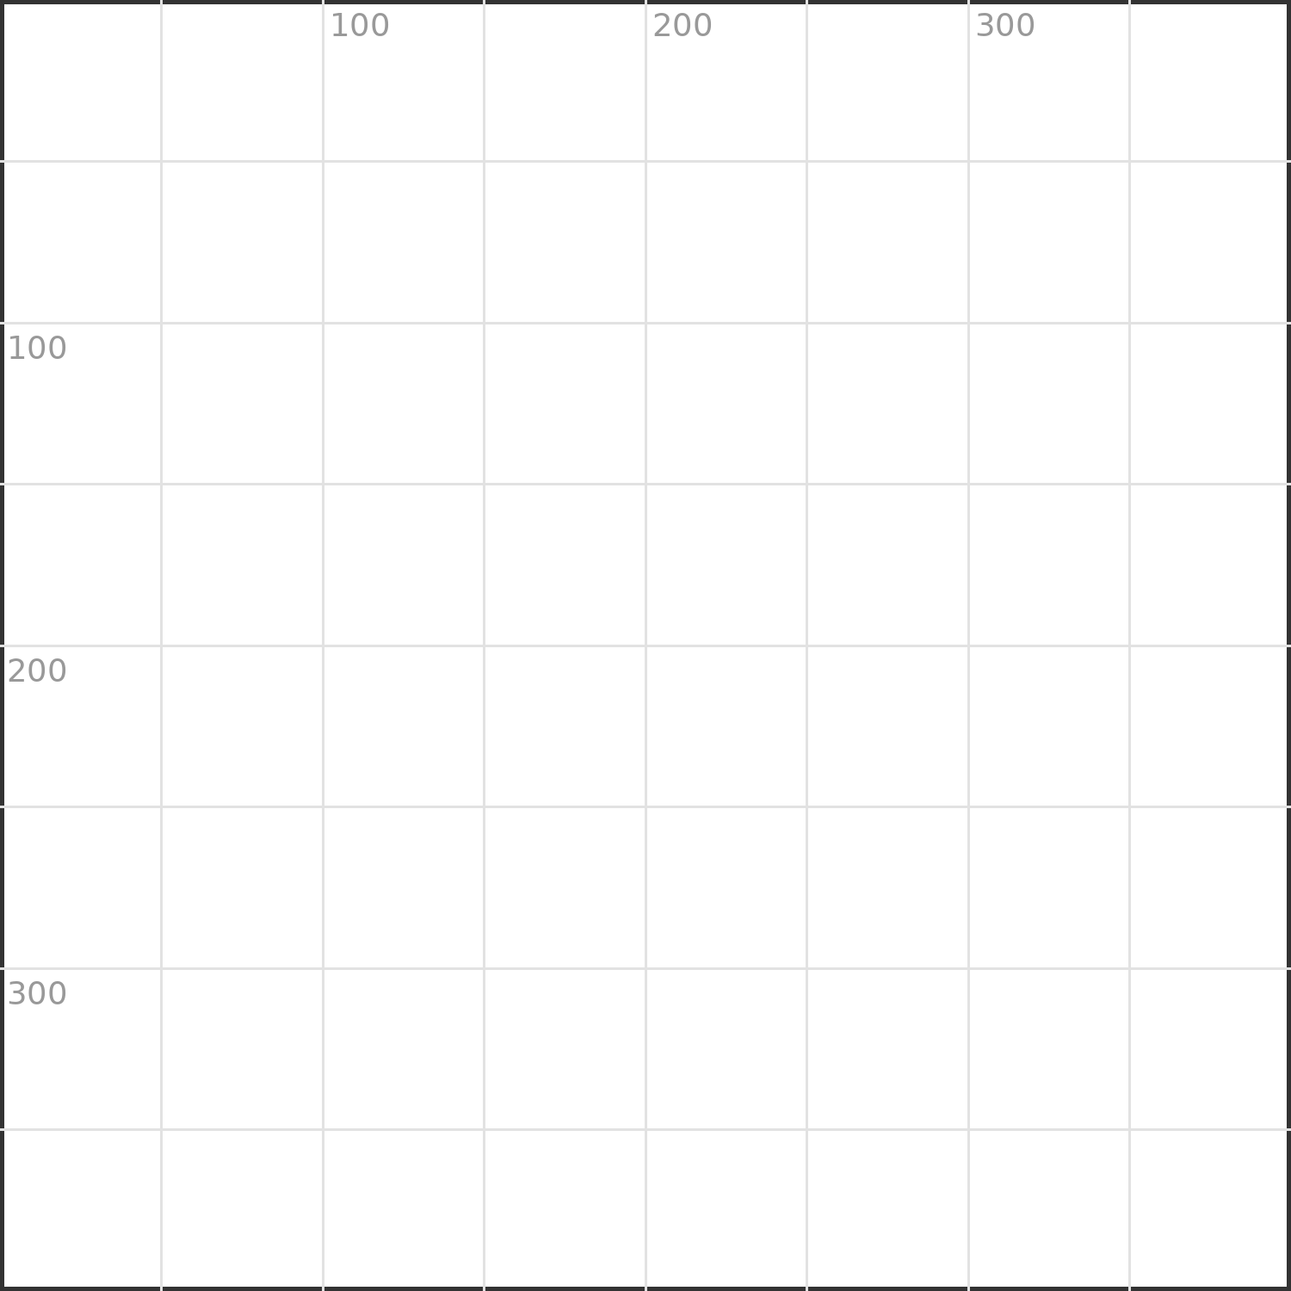
Why is using a variable for x better than typing the number twice?

PART 2 — keep going if you finish early.
Add a third circle that is always 120 to the right of the second one. Write its center x using the variable x.

Name | Date | Period
Partner | Points ___ / ___ | Marked by
Warm-up 16 — Naming and debugging
START HERE
A | Pace check — circle one: ( ) feeling good ( ) a bit distracted ( ) stuck — I could use help
B | ☐ got it ☐ shaky ☐ not yet I can choose clear variable names.
C | ☐ got it ☐ shaky ☐ not yet I can find a simple bug in an expression.
D | Looking back at last class — one thing that clicked, and one thing still fuzzy:
E | If you finish early today, what will you try next?
Vocabulary — write each in your own words
identifier

readability

debugging

comment (#)

Part 1 — core work
Which name is clearer for a player's score — s or score? Why does it matter once the program gets long?

livs = 3
lives = livs - 1
This code has a typo bug. Find it and write the corrected two lines.

PART 2 — keep going if you finish early.
Add a comment (#) that explains what lives = lives - 1 does in a game.

