Smart Automatic Cart System

Hardware Used: Power Supply module, Arduino UNO, RFID, RFID tags, LCD Display, Switch Button, Buzzer, GSM Module and Breadboard.

Setup:

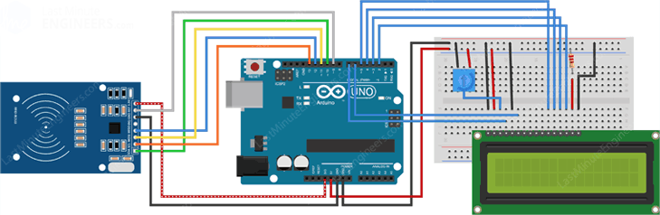

* Did all the necessary hardware connections as shown in diagram above.
* Programmed the Arduino UNO using Arduino IDE, We wrote a logic for performing the addition and deletion of items as per the signal being received from RFID reader.
* Loaded the programme onto Arduino UNO.
* Program the GSM Module to send notification to the user about the changes being made in the bill.

Working:

* When the system is powered up, display the initial data “Smart Automatic Cart”.
* Scan the RFID card of the items if the button is on item will be added and if it’s off the item will be removed; multiple scanning of the RFID card will change the quantity of that item.
* Any changes to the items present inside the cart are displayed onto the LCD screen connected to the Arduino.
* Once the shopping is done, shopkeeper can use his administrator card to get the details of the final bill. This same amount also gets reflected on the screen of the cart.

Drawbacks:

This idea is not cost effective for small shops.

Even when the user needs to buy a single item, he would have to carry it in a cart.

Future Plans:

We can create a Paywave debit card type system so that user can use his RFID card to make payment, which will make the process much faster.

We can also add a functionality to link the cart with a cellular device so that user can increase/decrease the count of items using his mobile. This will make our idea much more user friendly.