# Finance Tracker - Documentation

## Code Purpose and Features

This code helps users **track their personal finances** by recording income and expenses, managing budgets, and visualizing financial data through charts. It is designed to be simple yet powerful for personal use.

## Features

* Add income and expense transactions with details like amount, category, date, and notes.
* Set monthly budget limits.
* View monthly financial summaries including income, expenses, budget, remaining budget, and savings.
* Filter transactions by month, category, and type.
* Export filtered transaction data as CSV.
* Visualize income and expenses with pie charts.
* Compare budget vs actual spending with bar charts.

## Technologies Used

* **Python 3.13 (Latest)**
* **Tkinter** for GUI
* **tkcalendar** for date picking widget
* **matplotlib** for plotting charts
* **csv** module for data persistence
* Standard Python libraries (datetime, os, traceback)

## Setup & Run Instructions

Follow the steps below to set up and run the code:

1. **Install Python 3.13** on your system from [python.org](https://python.org" \t "_new).
2. Install required Python packages using pip:

pip install tkcalendar matplotlib

1. **Save the code** to a file, e.g., finance\_tracker.py.
2. Run the code:

**Finance\_Tracker.py**

1. The code creates and uses a transactions.csv file in the same folder to store your financial data.

## Sample UI Screenshots

### Main window: Transaction & Budget Set

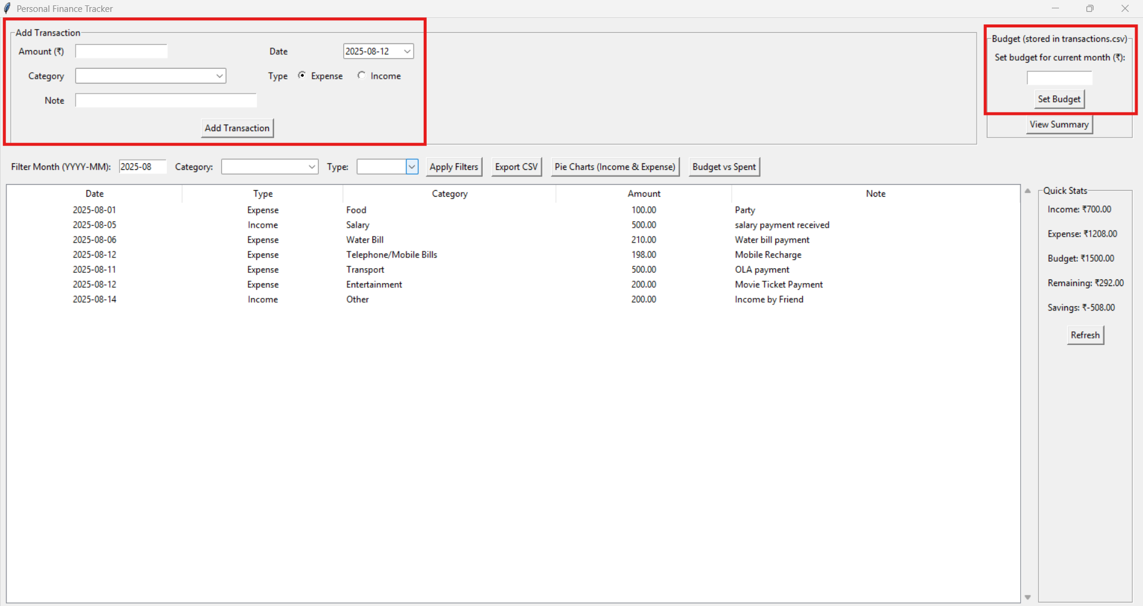

### Filter & Transaction History Table

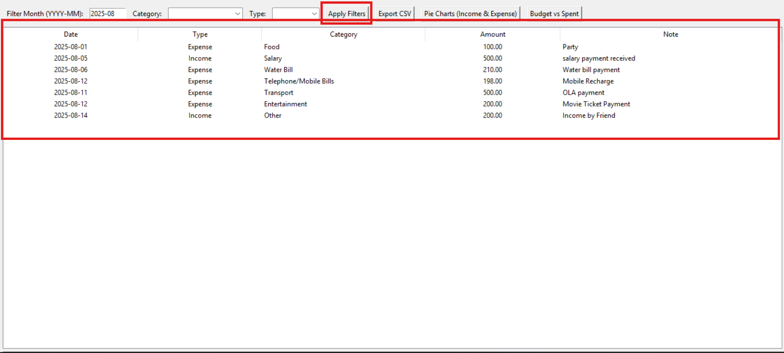

### Pie Charts: Income & Expense Distribution

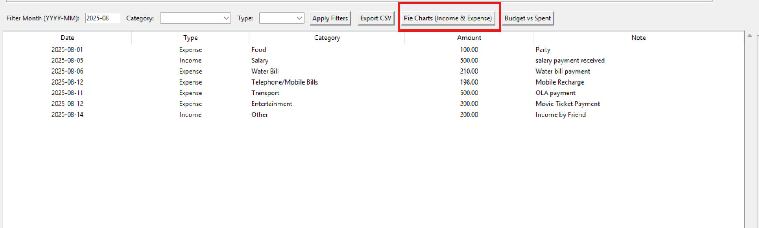

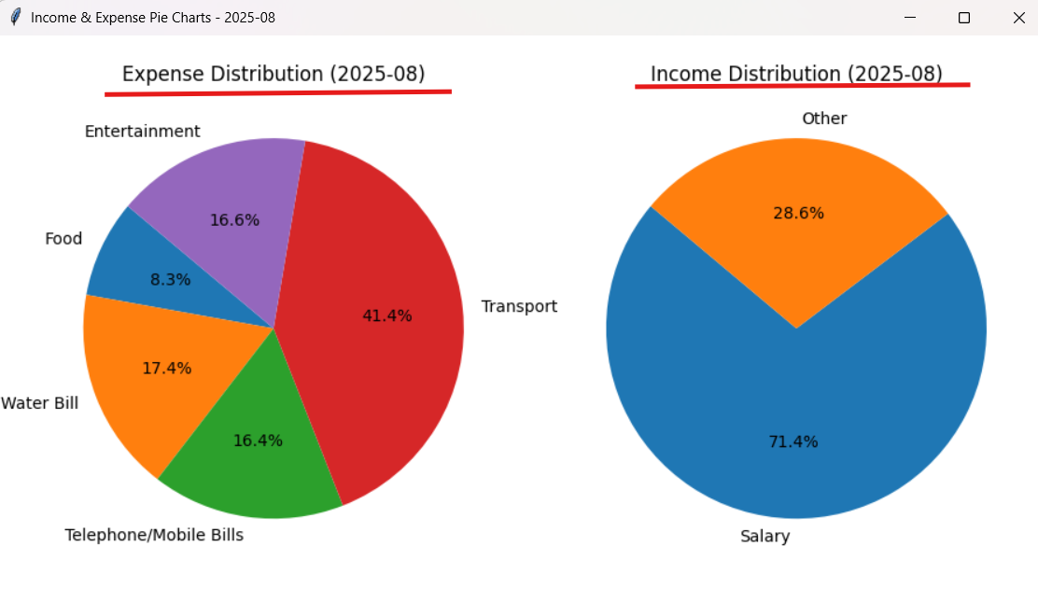

### Bar Chart: Budget vs Spent



