Full-Stack development project VibeCheck 🎵

Develop a full-stack application for discovering and rating music events.
Users will be able to:
- Browse music artists
- View live events
- See average ratings
- Submit their own event ratings
- Explore content visually using images
You will implement:
- A backend with Spring Boot & Spring Data JPA (POS)
- A PostgreSQL database (POS)
- A frontend with React & Material UI (WMC)
No login or user accounts are required for this project.

Technology Stack
Backend
- Java 21+
- Spring Boot
- Spring Data JPA
- PostgreSQL
- REST API
- Maven
Frontend
- React
- Material UI
- Axios
- Zustand
- React Router

Domain Model:

Artist: Represents a musician or band.
Event: Represents a live concert.
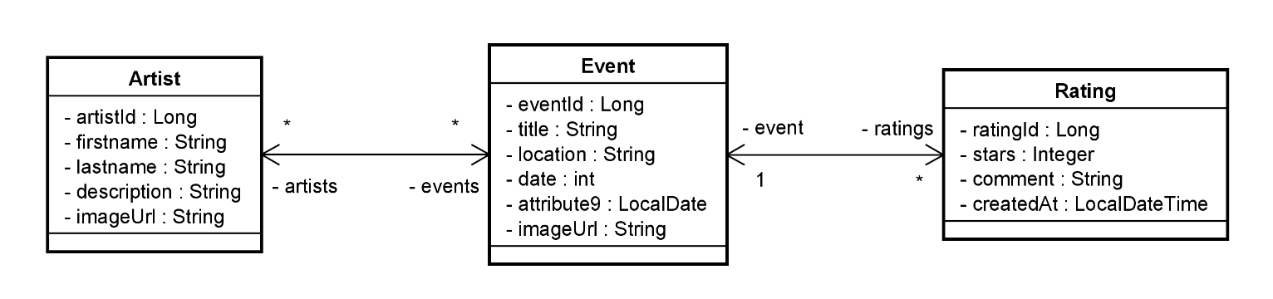
Rating: Represents a rating and comment for an event.
Requirements:
- Implement correctly all relationships: for the entity-classes and in the postgresql database
- Images must be stored as URLs only
Example: https://images.unsplash.com/photo-1507874457470-272b3c8d8ee2
Fill the postgres database with the values from the given Json-file

REST API Requirements
You must provide at least the following endpoints:
Artist API
Method | Endpoint
GET | /api/artists
GET | /api/artists/{artistId}

Event API
Method | Endpoint
GET | /api/events
GET | /api/events/{eventId}
GET | /api/events/artist/{artistId}

Rating API
Method | Endpoint
GET | /api/ratings/event/{eventId}
POST | /api/ratings

Backend Technical Requirements:
- REST Controllers
- Service Layer
- Repository Layer
- DTOs (no direct entity exposure)
- Pagination for events
- Proper HTTP status codes

Frontend Requirements (React + MUI)
You must implement the following views:

1. Artist Overview Page
- List of all artists
- Image, name, genre
- Click to view related events

2. Event Overview Page
- List of all events
- Image, title, date, location
- Average rating shown

3. Event Detail Page
- Event details
- List of all ratings
- Average rating calculation

4. Rating Form
- Star rating (1–5)
- Comment input
- Submit rating to backend
- Automatic refresh after submit

MUI Component Requirements
You must use at least:
- AppBar
- Card
- CardMedia
- Grid
- Typography
- TextField
- Button
- Rating

Required Frontend Functionality
You must implement:
- Data loading from the backend
- Event filtering by genre
- Sorting events by rating
- Controlled form inputs
- Loading indicators
- Error handling
- Clean responsive layout

Good luck and enjoy building VibeCheck! 🎵🔥

