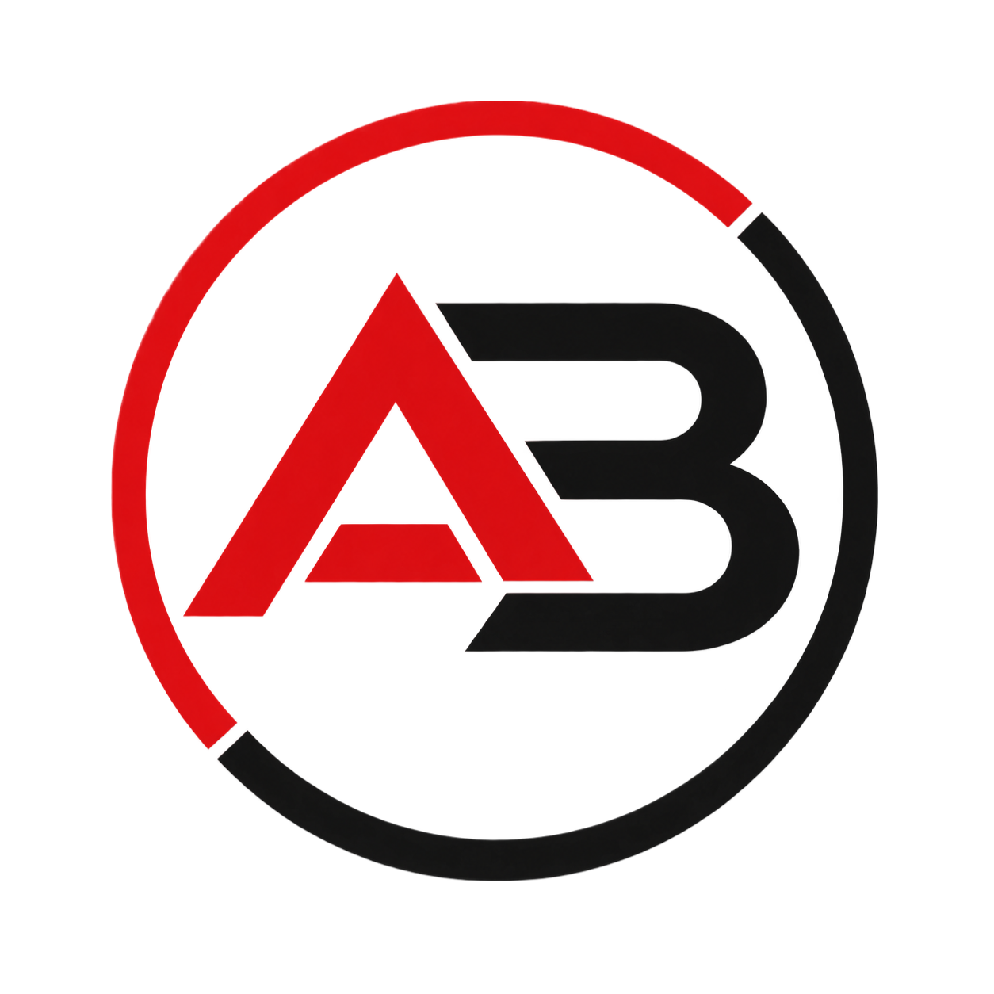
AB SYSTEMS TECH
SOFTWARE, HARDWARE AND IT SUPPORT SOLUTIONS
Brand Manual
Visual identity guidelines and correct logo usage

1. Introduction
This brand manual establishes the official guidelines for the correct use of AB Systems Tech's visual identity. Its purpose is to ensure that the logo, colors, and corporate typography are applied consistently across all media: website, client portal, stationery, social media, uniforms, vehicles, and advertising materials.
A consistently applied visual identity conveys professionalism and builds client trust — two core values for a technology services company like AB Systems Tech.

1.1 Brand values
- Professionalism: every piece of communication reflects seriousness and technical quality.
- Trust: the brand conveys reliability to clients who depend on its technology.
- Dynamism: technology is constantly evolving, and the brand reflects that.
- Approachability: human, accessible support behind every technical service.

2. The Logo
The AB Systems Tech logo is made up of the stylized initials “A” and “B” inside a laptop screen, framed by a two-tone circular ring. The ring, split between red and black, represents the continuous movement and constant evolution inherent to technology; the laptop screen reinforces the company's direct link to software development, hardware, and technical support.
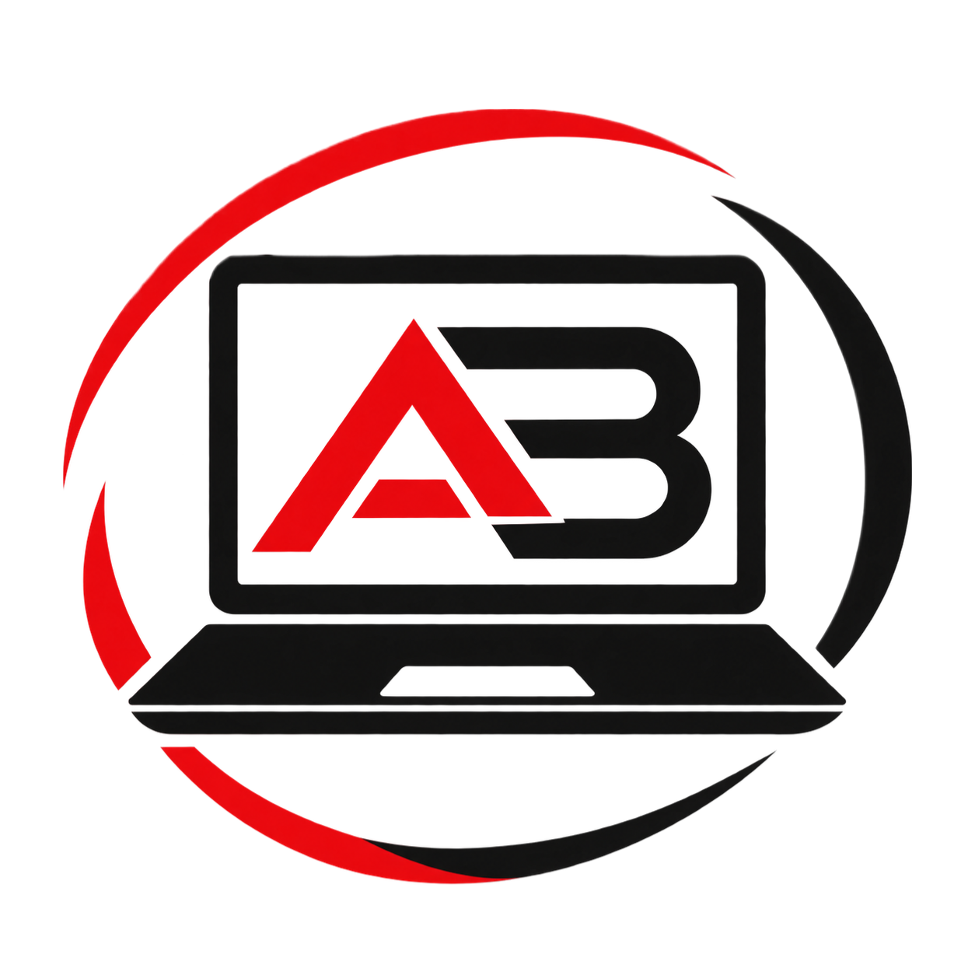

2.1 Primary version and icon mark
The full version (with the laptop screen) is the institutional version, recommended for covers, presentations, and formal stationery. The circular icon mark (without the screen) is the simplified version, intended for uses where space is limited: app icon, website favicon, social media, and stamps.
Icon mark — simplified version for limited spaces

3. Clear Space and Minimum Size
To preserve the logo's legibility and visual impact, a clear space free of text, images, or other graphic elements must always be maintained around it. This space is measured in “X” units, equivalent to the radius of the icon mark's ring.
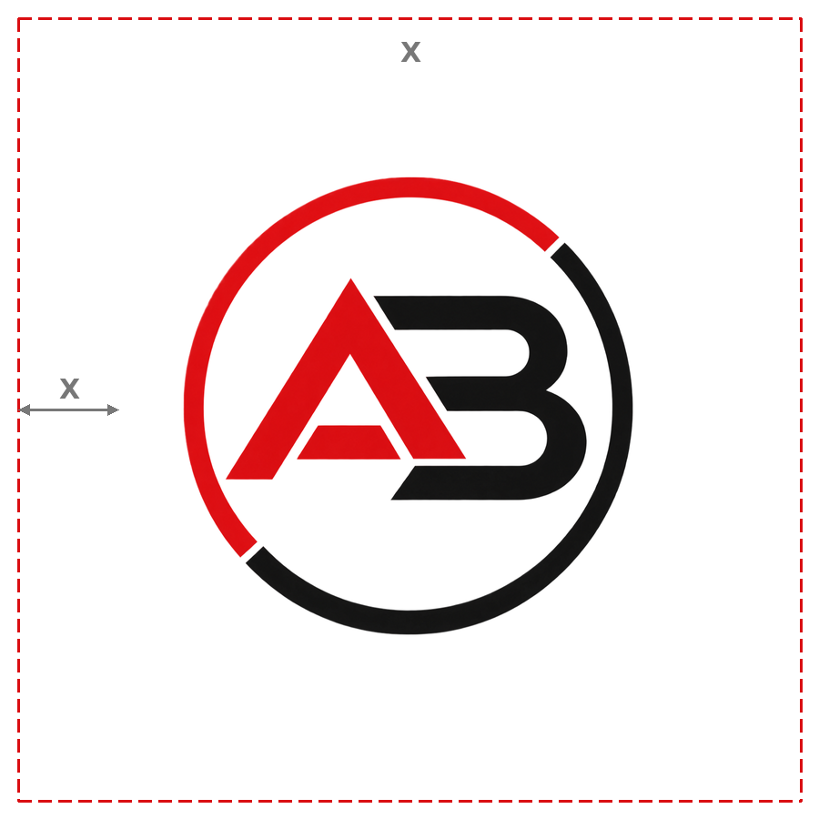

3.1 Minimum reproduction size
To ensure the icon's legibility on screens and printed media, the logo should not be reproduced below the following sizes:
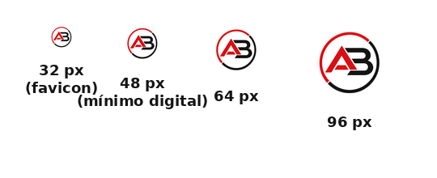
- Digital: 48 px wide minimum (favicon from 32 px).
- Print: 1.5 cm wide minimum.

4. Corporate Color Palette
The AB Systems Tech palette is based on the contrast between red and black on a white background, reinforcing a technological, serious, and distinctive image.
Color | HEX | RGB | CMYK
AB Red | HEX #DA0E12 | RGB 218, 14, 18 | CMYK 0, 94, 92, 15
AB Black | HEX #141414 | RGB 20, 20, 20 | CMYK 0, 0, 0, 92
White | HEX #FFFFFF | RGB 255, 255, 255 | CMYK 0, 0, 0, 0

4.1 Color usage
- Red is used as an accent color: to highlight the letter “A”, calls to action, active icons, and emphasis elements.
- Black is used as the main text color, for the letter “B”, and for the interface's structural elements.
- White is used as the predominant background, prioritizing visual clarity and legibility.
- A neutral gray (#555555) is recommended as a supporting color in digital interfaces, for secondary text.

5. Corporate Typography
A geometric sans-serif typeface with firm strokes is recommended, consistent with the angular style of the icon mark.

5.1 Primary typeface — Montserrat
Use: titles, headings, the brand name, and calls to action. Recommended weights: Bold and ExtraBold.

5.2 Secondary typeface — Open Sans
Use: body copy, paragraphs, forms, and platform content (website, client portal, and internal system). Recommended weights: Regular and SemiBold.
In Microsoft Word and Excel documents where these fonts are not available, Calibri or Arial may be used as a substitute.

6. Correct and Incorrect Uses

6.1 Correct uses
- Always reproduce the logo from the original files, without manually recreating it.
- Use the full icon mark on a white or light background.
- Respect the minimum clear space described in section 3.
- Keep the original proportions when scaling the logo.
- Use the single-color version (black or white) when the background requires it.

6.2 Incorrect uses
- Do not distort, stretch, or rotate the logo.
- Do not change the logo's official colors (red and black) to other tones.
- Do not place the logo on low-contrast backgrounds or patterns that hinder legibility.
- Do not add shadows, gradients, outlines, or additional effects.
- Do not separate or recombine the icon mark's elements (letters, ring, and screen) in a way different from the original.
- Do not use the logo below the established minimum size.

7. Brand Applications
AB Systems Tech's identity must remain consistent across all touchpoints with clients and employees:
- Corporate website and client portal: icon mark in the header, favicon based on the simplified version.
- Internal system (backoffice): icon mark in the navigation bar and on generated documents (invoices, reports).
- Corporate stationery: business cards, letterhead, and email signatures.
- Social media: icon mark as the profile photo; corporate color palette in posts.
- Uniforms and technical gear: icon mark on chest or back, in black or white depending on the garment color.
- Technical service vehicles: full logo on side doors, maintaining the clear space.

8. Voice and Tone of Communication
AB Systems Tech's written and verbal communication — on the website, client portal, Helpdesk, and social media — must be:
- Clear: direct explanations, without unnecessary technical jargon for the end client.
- Professional: correct writing and respectful treatment at all times.
- Approachable: human language that conveys a willingness to help, especially in technical support.
- Reliable: following through on committed response times and ticket resolution.

9. Final Considerations
This manual should be updated as the brand evolves or new applications are developed (uniforms, vehicles, advertising campaigns). It is recommended to always keep the original logo files in vector format (SVG/AI) in addition to the high-resolution PNG, to ensure correct reproduction across any medium.

