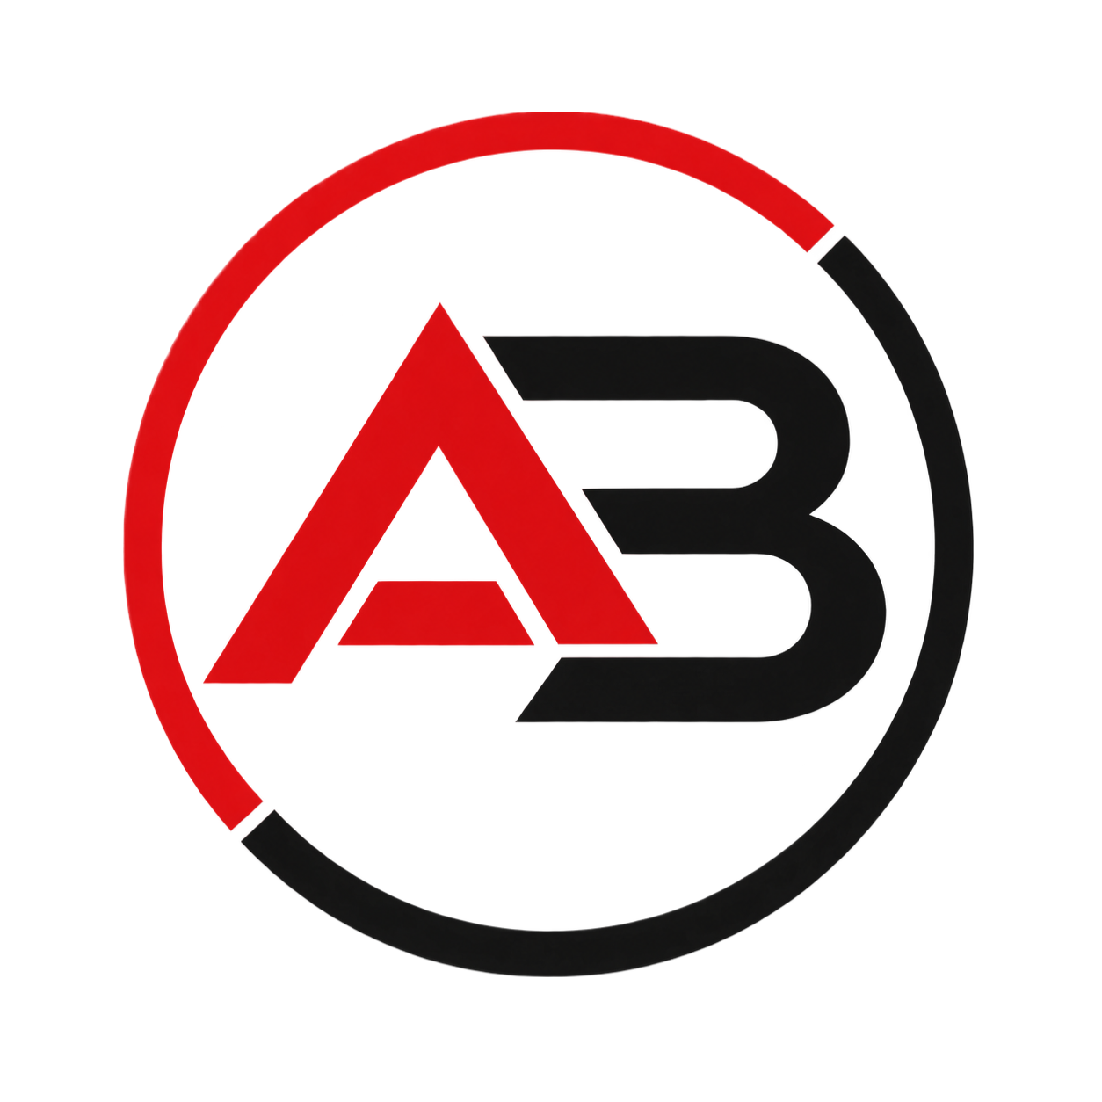
AB SYSTEMS TECH
SOFTWARE, HARDWARE AND IT SUPPORT SOLUTIONS
Digital Platform Specification and Proposal Document
Corporate Website, Customer Portal, and Internal Management System (CRM, Projects, HR, Helpdesk, Accounting, and Billing)

1. Executive Summary
AB Systems Tech is a Colombian company focused on delivering comprehensive technology services: custom software development, hardware and software repair, and IT support. This document defines the scope, architecture, and functional modules of the digital platform that will support the company's commercial and service operations.
The platform comprises three complementary fronts: (1) a public corporate website to professionally showcase the services, (2) a customer portal where clients can authenticate and generate support tickets directed to employees, and (3) an internal business management system made up of the CRM, Project Management, Employee Management, Helpdesk, Accounting, and Billing modules.
The purpose of this document is to serve as a solid, formal foundation for the design, quoting, phase planning, and technical development of the solution.

2. About the Company

2.1 Identity
Trade name: AB Systems Tech.
Nature: a technology services company based in Colombia, with global reach for its remote services (software development and IT support) and national reach for services that require physical presence.

2.2 Services Offered
Coverage note: hardware repair requires physical intervention and is therefore only available within Colombia. Custom software development and remote IT support can be offered globally, as they do not depend on physical presence.
Service | Coverage
Custom software development | Global
Remote IT support | Global
On-site IT support | Colombia
Hardware and software repair | Colombia (requires physical intervention on the equipment)

- Custom software development for companies and individuals.
- Hardware and software repair (computer equipment and devices).
- IT support, both remote and on-site, tracked through tickets.

2.3 Value Proposition
AB Systems Tech aims to stand out by offering a professional digital experience from the very first contact: a website that conveys trust and clarity about its services, and a portal where clients can track their requests in real time, rather than relying solely on phone calls or informal messages.

3. Project Objectives

3.1 General Objective
Design and develop a comprehensive digital platform for AB Systems Tech that professionally showcases its services, manages customer relationships through a self-service ticketing portal, and internally manages commercial, project, human resources, accounting, and billing operations.

3.2 Specific Objectives
- Build a responsive corporate website presenting the company and its services.
- Implement a customer portal with secure authentication and ticket creation/tracking.
- Develop a Helpdesk module for employees to manage and respond to customer-generated tickets.
- Implement a CRM to record and track potential and existing customers.
- Implement a Project Management module to plan and control development and support work.
- Implement an Employee Management (HR) module with profiles, roles, and permissions.
- Implement an Accounting and Billing module integrated with the rest of the system.
- Ensure a scalable, secure, and maintainable architecture over the medium and long term.
- Offer the entire platform (website, customer portal, and internal system) in both Spanish and English.

4. Project Scope
The project comprises three main components that operate in an integrated way under a single brand identity:
Component | Description | Users
Corporate Website | Public informational page: services, about us, contact, and portal access. | Visitors / general public
Customer Portal | Authenticated session where the customer creates and tracks support tickets. | Customers
Internal System (Backoffice) | CRM, Projects, Employees, Helpdesk, Accounting, and Billing. | Employees and administrators

The following are out of the initial scope of this document: a native mobile application and advanced AI-driven automation; these may be evaluated in later phases once the core functionality is operational.

5. User Roles
Role | Description | Main access
Visitor | A person browsing the website without authenticating. | Public pages, contact form
Customer | A company or individual with contracted services. | Customer portal, ticket creation and tracking, own history and invoices
Employee | Technician, developer, or support agent. | Helpdesk, assigned projects, CRM (based on permissions), logging their own time/attendance
Administrator | Owner(s) or person responsible for operations. | All modules: CRM, Projects, Employees, Accounting, Billing, and general configuration

6. General Solution Architecture
A layered architecture is proposed, separating the public site, the customer portal, and the internal backoffice, all consuming a shared services layer (API) and a central database, with role-based access control (RBAC).

6.1 Architecture Layers
- Web presentation layer: public corporate site and customer portal.
- Internal presentation layer: administrative panel for employees and administrators.
- API / business logic layer: exposes the CRM, Projects, Employees, Helpdesk, Accounting, and Billing services.
- Data layer: central relational database with logical separation by module.
- Authentication and authorization layer: session control and role-differentiated permissions.

6.2 Design Principles
- Modular architecture: each module (CRM, Projects, Helpdesk, etc.) is designed to be decoupled so it can evolve independently.
- Security by design: password encryption, role-based access control, and audit logging for sensitive operations (billing, accounting).
- Progressive scalability: start with a low-cost infrastructure and scale as the volume of customers and employees grows.

7. Functional Modules

- Portal access: login/sign-up button for customers.
- Language selector: all site content available in Spanish and English.

7.2 Customer Portal and Helpdesk
The core customer service module. The customer logs in, creates tickets describing their need (technical support, repair, development request), and tracks the status of each one.
- Customer registration and login.
- Ticket creation with category, priority, and attachments.
- Ticket history and real-time status (open, in progress, resolved, closed).
- Customer notifications on status changes or employee responses.
- Helpdesk view for employees: ticket inbox, assignment, prioritization, and response.
- Support metrics: response and resolution time per ticket.

7.3 CRM (Customer Management)
An internal module for the sales and support team to manage relationships with potential and existing customers.
- Registration of leads and existing customers.
- Interaction history: calls, emails, meetings, and associated tickets.
- Tracking of sales opportunities by stage (contact, proposal, closing).
- Customer segmentation by contracted service type.

7.4 Project Management
A module for planning and controlling software development work and support/repair tasks handled as projects.
- Creation of projects linked to a customer and/or a ticket.
- Tasks with owners, due dates, and status (pending, in progress, completed).
- Kanban-style visual board for team tracking.
- Logging of hours and progress per project.

7.5 Employee Management (HR)
An administrative module for managing AB Systems Tech's staff.
- Employee profiles: contact details, position, and department.
- Assignment of roles and permissions within the system.
- Assignment of tickets and projects per employee.
- Workload dashboard per employee (active tickets and projects).

7.6 Time Tracking (Attendance and Hours Worked)
A module complementary to Employee Management, focused on recording and controlling the time worked by each employee.
- Clock-in/clock-out recording from the internal system.
- Automatic calculation of hours worked per day, week, and month.
- Logging of hours per project and per ticket, allowing time invested to be cross-referenced with the Projects and Helpdesk modules.
- Tracking of exceptions: late arrivals, leave, sick leave, and overtime.
- Attendance and productivity reports per employee, available to administrators.
- A foundation for payroll calculation, integrable in the future with the Accounting module.

7.7 Accounting Module
A module supporting the company's basic financial operations.
- Recording of income and expenses associated with the services provided.
- Consolidation of accounting information coming from billing.
- Basic financial reports (income by period, by service type, by customer).

7.8 Billing
A module responsible for generating and managing the billing of services provided to customers.
- Invoice generation linked to tickets, projects, or one-off services.
- Invoice statuses: pending, paid, overdue.
- Billing history visible to the customer from their portal.
- Integration with the Accounting module for automatic income recording.

7.8.1 Payment Methods
The Billing module will integrate national and international payment methods, allowing customers to pay directly from their portal:
Scope | Method | Description
National | PSE (Pagos Seguros en Línea) | Payment via PSE through a payment gateway, allowing direct debit from any affiliated Colombian bank (not limited to a single institution), with automatic confirmation of the payment status on the invoice.
National | Llave | Payment via Llave (immediate interbank transfer using a Bancolombia alias/key), as an agile national payment alternative.
International | PayPal | International payments through a recognized/verified business PayPal account, for customers outside Colombia.
International | Wise Business | An international business account to get paid in 20+ currencies (USD, EUR, GBP, etc.) at the real market exchange rate, with invoices and payment links, and API integration to automatically reconcile the payment status.

In all cases, payment confirmation must be automatically reflected in the invoice status and generate the corresponding entry in the Accounting module.

8. Non-Functional Requirements
Category | Requirement
Security | Secure authentication, encrypted passwords, role-based access control (RBAC), and audit logging in the accounting and billing modules.
Availability | The platform must be continuously available, prioritizing the customer portal and the Helpdesk.
Usability | A clear, professional interface, adapted to mobile and desktop devices.
Language | The platform (website, customer portal, and internal system) must be available in Spanish and English, with a language selector for the user.
Scalability | The ability to grow in number of customers, employees, and tickets without redesigning the base architecture.
Maintainability | Modular, documented code that allows each module to evolve independently.

9. Proposed Technology Stack
A modern, internally consistent stack is proposed, aimed at a cost-controlled deployment during the initial stages:
Layer | Proposed technology
Frontend (Website and Portal) | Next.js (React)
Backend / API | Spring Boot (Java 21) with hexagonal architecture
Database | PostgreSQL
Authentication | JWT / session management with role-differentiated permissions
Internationalization (i18n) | A Next.js i18n library (next-intl / next-i18next) for Spanish and English
File storage | Cloudflare R2 or Supabase Storage
Payments | PSE (multi-bank) and Llave (national); PayPal and Wise Business (international)
Infrastructure / deployment | Railway, AWS ECS Fargate, or Google Cloud, depending on budget
Domain and email | A dedicated domain with an associated corporate email

10. Implementation Phases

Phase 1 — MVP
- Corporate website (Home, Services, About Us, Contact).
- Customer portal with authentication and ticket creation.
- Basic Helpdesk for employees.

Phase 2 — Sales and Project Management
- CRM module.
- Project Management module.

Phase 3 — Full Internal Operations
- Employee Management module.
- Time Tracking module (attendance and hours worked).
- Accounting module.
- Billing module integrated with Accounting and the customer portal, with payments via PSE, Llave, PayPal, and Wise Business.

