­

A Minor Project Final Report on

**Nutritional information extraction using Mask R-CNN deep learning model with food images**

Submitted in Partial Fulfillment of the Requirements

for the Degree of **Bachelor in Software Engineering**

Under Pokhara University

Submitted by :

Mohan Kumar Dhakal 161657

Jitendra Bhatta 161747

Keshav Kunwar 161749

Sumit Paudel 161752

Under the supervision of

Asst.Prof. Chandra Prakash Bhatta

Date:31st Dec, 2019



**Department of Software Engineering**

**NEPAL COLLEGE OF**

**INFORMATION TECHNOLOGY**

Balkumari,Lalitpur,Nepal

**Abstract**

*Health has been a major concern for people, as foods are probably the most important factor in determining one’s health taking care of what goes inside has been a challenge to monitor .Through this project we are determined in providing ML based image recognition system to help track their nutritional intake. In this application we have used* ***Mask R-CNN*** *(deep learning algorithm) to classify food and provide approximate nutritional value the image contains. Macronutrients such as protein, carbohydrate, fats are present in every food we eat and are also the building blocks of our health. This application updates user on how much such macronutrients they have consumed so that they could monitor their macros intake. It also has flexibility that user can change the amount of food than the application has predicted and application will automatically updates it’s nutritional contents in the database accordingly.*

**Keywords**: Deep-Learning, Mask R-CNN, Protein, *Carbohydrate*, Fats, Micronutrients, ML,

**Table of Contents**

Abstract………………………………………………………………………………………….ii

Table of contents…………………………….…………………………………………….……..iii

List of figures………………………………...………………………………………………..…iv

List of Tables…………………………………………………………………………….……….iv

1. Introduction………………………………………………………………….……….……1
   1. Problem Statement………………………………………………….………........2
   2. Project Objectives………………………………………………….………..…….3
   3. Significance of study…………………………………………….…………….....3
2. Scope and Limitation………………………………………………….………….….....4
   1. Scope ………………………………………………………….………………..…4
   2. Limitation…………………………………………………….……………….…..4
3. Literature review…………………………………………………………………..….....5
4. Use case Diagram…………………………………………………………….….…........6
5. Activity Diagram………………………………………………..……..………………...7
6. Proposed Methodology…..………………………………………..…………..….….....8
7. Tools and Technology used……………………………………………………….........9
8. Final Outcome………………………………………………………………………......10
9. Model Architecture………………………………………………………………………10
10. Class Diagram……………………………………………………………………………11
11. ER-Diagram……………………………………………………………………………...12
12. Model Accuracy………………………………………………………………………….13
13. Project task and time schedule…………………………………………………….......14
    1. Project Schedule…………………………………………………………….......15
    2. Gantt chart…………………………………………………………………..……16
14. References…………………………………………………………………………….….17.

**List of Figures**

1. Use case Diagram…………………………………………………………………….6
2. Activity Diagram …………………………………………………………………….7
3. Proposed Methodology……………………………………………………………..…8
4. Gantt Chart…………………………………………………………………………..16
5. Model Architecture…………………………………………………………………..10
6. Class Diagram………………………………………………………………………..11
7. ER-Diagram…………………………………………………………………………..12
8. Accuracy………………………………………………………………………………13

**List of Tables**

1. Tools and technology used………………………………………………………………...9

2.Project Schedule………………………………………………………………………..…...15

**1. Introduction**

Knowing about nutrients of foods that we consume is very important for maintaining a healthy lifestyle. Though we all want to be conscious about what we eat, the process hasn’t been quite easy till date to take care.

Our application provides the fact of nutrients we consume with the help of photo that we capture. It asks camera permission to capture and upload image and tries to classify the food in the image using the Mask R-CNN model which is a popular model for object classification in an image used by many. After successfully completing the classification process we take the name of the food and query on the database to extract additional nutritional information and show it in user device. For the easy extraction and timely update of information we have chosen MYSQL as a database and Apache Server.

In initial phase the application uses Facebook or Instagram account of user for login and create user profile based on his/her consumption inside the app. The user capture an image of the food they are consuming and our application provides them with exact nutritional information about some very common Asian foods such as Momo,Chowmein and French Fries and later provides monthly, weekly and yearly report.

**1.1 Problem Statement**

According to World Health Organization [1], almost 20% of deaths worldwide are due to an unhealthy diet. The problem here is not about consuming sufficient food; the problem is about people not knowing what’s in their diet. If people are able to estimate their nutrient of food using the images of their food, they can easily decide on the amount of nutrients they need to stay fit and healthy. If we can understand how much calories from each macro comes in our food, then this problem will be somewhat controlled.

Almost every person has smartphone in their hand today, people can get all the nutritional information regarding the food they consume which helps them control the unnecessary food from entering their body. People can easily monitor on doctor’s prescription by knowing the amount of macronutrient they consume by just a simple image click.

**1.2 Project Objectives**

Our project objectives are to:

* Provide user the nutritional information about that food they have consumed and help them reach their fitness goal.
* Eliminate the irritating process of searching food preference in text-based database just to know about their nutrients value.
* It adjusts itself to the amount so don’t need to manually calculate nutrients value for different quantity.

**1.3 Significance of Study**

The significance of study of this android application is to provide user with the information about the food they consume in their mobile screen. As android is one of the leading mobile operating system with around 70% market share we can provide the critical information about user’s food preference in just a few clicks in the their device to majority. This will significantly save the user’s time to search and surf to the internet for the same purpose time and again. Using real time images we have also reduced user’s time of typing in the name of the food to search for it’s nutrition value and manually calculate it’s nutritional value according to quantity.

1. **Scope and Limitations**

**2.1 Scope**

The application has following scopes:

* It can be a useful application to be informed about what goes inside our body.
* With this application user don’t have to remember the name of the food they consume and manually calculate it’s nutritional value.
* User can also review their daily nutritional intake as we have the feature of editing and saving information locally and in remotely.

**2.2 Limitations**

The application has limitations as mentioned below:

* This requires android version more than 4.0 (Kit Kat) to run.
* This application only has information about few common foods.
* The amount of food it predicts might not be exact though user can manually change the value according to their preference and the application will remember this.

**3. Literature review**

Mask R-CNN [2] is developed based on Faster R-CNN, which is a region-based Convolutional Neural Network. A Convolutional Neural Network (ConvNet/CNN) is a Deep Learning algorithm that can take in an input image, assign importance (learnable weights and biases) to various aspects/objects in the image and can differentiate one type of image from the other.

Mask R-CNN is developed by the group of researcher in FAIR(Facebook AI Researcher group). This model effectively masks the object found in an image with bounding boxes.

For object detection it uses annotated images which were provided through VGG image annotator [3].

Mask R-CNN have been extensively been used by many big giants, a good implementation of this model can be found in Analytics Vidhya[4] where they have used this model for car detection in the road through a motion video.

Recently the implementation of Mask R-CNN was done by one of the employee at Leapfrog Technology [5] which was a reference point for us to learn and explore more about it.

MyFitnessPal [6] is an application that helps people monitor their nutrition intake. It has more than five million foods in their database which motivates users to live a healthy lifestyle.

1. **Use Case Diagram**

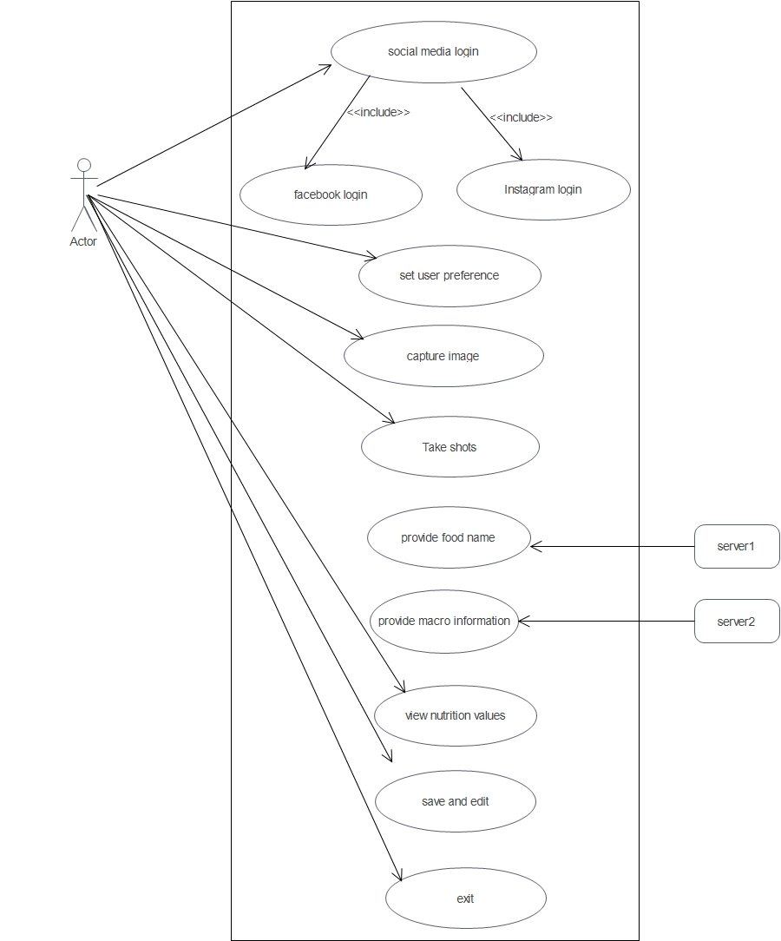

**Fig. Use Case Diagram**

**5. Activity Diagram**

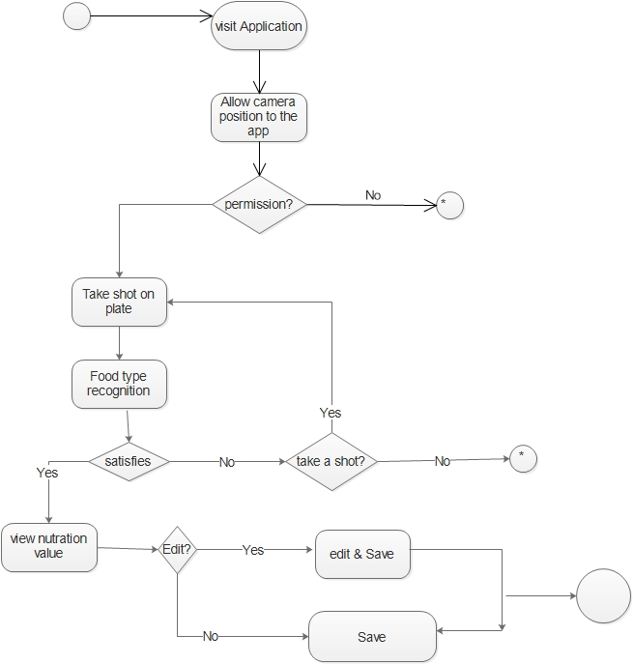

**Fig. Activity Diagram**

**6. Proposed Methodology**

Based on the nature and requirement of a project waterfall model has been chosen for developing the application. Using this model we can simplify the process of making an application. As our requirements are clear and well defined earlier we take waterfall model as a perfectly suitable model for us.

Our Final product will go through the below mentioned steps in waterfall model:

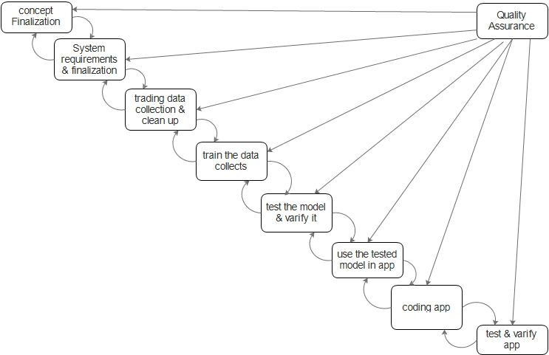

**Fig. Waterfall Model of software development process**

1. **Tools and technology used**

While developing the software we have make use of following tools and technologies for different purpose as mentioned below.

|  |  |
| --- | --- |
| **Tools and Technology** | **Uses** |
| Java/Python | Programming Language for android with native support/ language for Deep Learning |
| Android Studio/VS Code/PyCharm | Native environment for android application development/Server site coding/For Deep learning |
| Adobe XD | User Interface design using Adobe Experienced Design |
| R-CNN | Popular Deep learning model for instance segmentation of images. |

**­­­­ Table 1.Tools and technology used**

1. **Final outcomes**

Our application is informative and useful for almost everyone who wants to maintain their healthy lifestyle.

Our final outcomes are:

* Reliable nutritional information regarding the food consumed.
* Periodic report on calorie and macronutrients intake.

1. **Model Architecture**

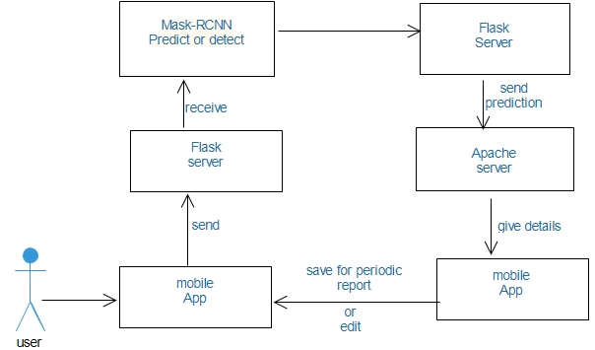

1. **Class Diagram**

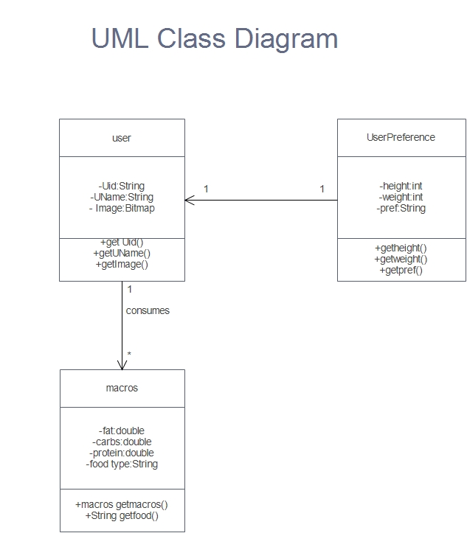

**11. ER Diagram**

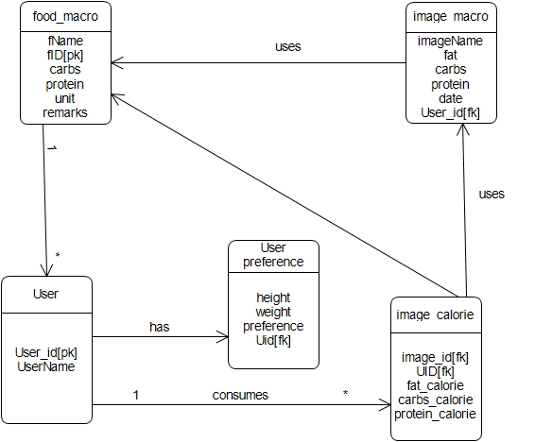

**Fig. ER.Diagram**

**12. Model Accuracy**

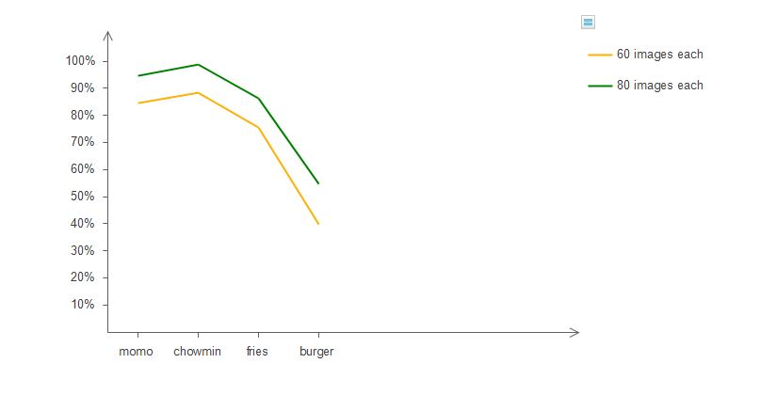

**Fig. model accuracy**

**13.Project time and task schedule**

The project schedule has been designed as per requirements and constraints involved. This project has been completed in around 2 month. Learning Deep learning algorithms and implementing R-CNN model as we mentioned above has been challenging part and has been given more time. Once the training is completed with the data collected by us we simply used it in the application we are developing. We have chosen Local machine for the training process and for now the model is deployed in our own laptop so the product isn’t ready for deployment.

**13.1 Project Schedule**

|  |  |
| --- | --- |
| **TASK** | **APPROX.DURATION(in days)** |
| Learning the basics of Deep Learning | 10 |
| Implementing basic Python ML specific libraries | 5 |
| Learning about Mask R-CNN model and it’s use cases | 15 |
| Image Data Collection and image Annotation | 5 |
| Model training ,testing and validation | 3 |
| UI/UX design | 2 |
| Database design and implementation | 5 |
| Application Coding and debugging | 2 |
| Final Documentation | Ongoing |

**Table 2 Fig. Project Schedule**

**13.2 Gantt Chart**

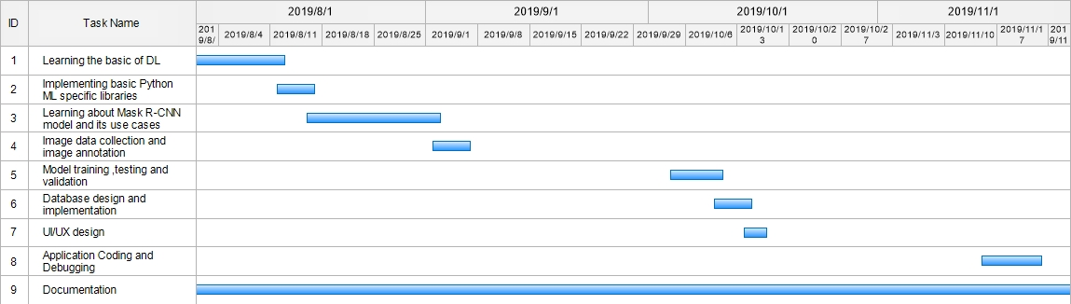

**Fig. Gantt Chart**

1. **References**

[1]<https://www.who.int/> accessed at 26 ,July 2019 at 12:52 pm

[2]<https://arxiv.org/abs/1703.06870> accessed at 27, July 2019 at 2:30pm.

[3] <http://www.robots.ox.ac.uk/~vgg/software/via/via_demo.html> accessed at 19 ,august 2019 at 2:00pm

[4] <https://www.analyticsvidhya.com/blog/2018/07/building-mask-r-cnn-model-detecting-damage-cars-python/> accessed at 23 ,October 2019 at 6:30 pm

[5]<https://www.lftechnology.com/blog/image-calorie-estimation-deep-learning/>accessed at 27 , July 2019 at 5:00 pm.

[6] <https://www.myfitnesspal.com/> accessed at 20,December 2019 at 6:00 pm