Abstract--Basic guidelines for the preparation of a technical work for the IEEE Power Engineering Society are presented. This document is itself an example of the desired layout (inclusive of this abstract) and can be used as a template. The document contains information regarding desktop publishing format, type sizes, and typefaces. Style rules are provided that explain how to handle equations, units, figures, tables, abbreviations, and acronyms. Sections are also devoted to the preparation of acknowledgments, references, and authors' biographies. The abstract is limited to 150 words and cannot contain equations, figures, tables, or references. It should concisely state what was done, how it was done, principal results, and their significance.
Preparation of a Formatted Technical Work for the IEEE Power Engineering Society
J. W. Hagge, Senior Member, IEEE, and L. L. Grigsby, Fellow, IEEE

Index Terms--The author shall provide up to 10 keywords (in alphabetical order) to help identify the major topics of the paper. The thesaurus of IEEE indexing keywords should be referenced prior to selecting the keywords to ensure that the words selected are acceptable. The thesaurus is posted at http://www.ieee.org/organizations/pubs/ani_prod/keywrd98.txt. It is also available by sending an e-mail (with no message necessary) to <keywords@ieee.org>. A large ASCII file of the keywords (220 kb, approximately 55 pages) will be returned to you via e-mail. Before using this option, be sure your local e-mail has the capacity to receive a file as large as this one.

Nomenclature
A nomenclature list, if needed, should precede the Introduction.

Introduction
THIS document provides an example of the desired layout for a PES technical work and can be used as a Microsoft Word template. It contains information regarding desktop publishing format, type sizes, and typefaces. Style rules are provided that explain how to handle equations, units, figures, tables, abbreviations, and acronyms. Sections are also devoted to the preparation of acknowledgments, references, and authors’ biographies. For additional information including electronic file requirements for text and graphics, please refer to the IEEE Power Engineering Society Author’s Kit. The kit may be obtained from the PES web site at http://www.ieee.org/power, or the PES Executive Office, 445 Hoes Lane, Piscataway, NJ 08855-1331, USA, phone: +1 732 562 3883, fax: +1 732 562 3881, e-mail: pes@ieee.org. The PES Author's Kit also contains a Session Summary Submission Cover Sheet, a Discussion Submission Cover Sheet, and an IEEE Copyright Form.

Technical Work Preparation
Please use automatic hyphenation and check your spelling. Additionally, be sure your sentences are complete and that there is continuity within your paragraphs. Check the numbering of your graphics (figures and tables) and make sure that all appropriate references are included.

Template
This document may be used as a template for preparing your technical work. When you open the file, select "Page Layout" from the "View" menu (View | Page Layout), which allows you to see the footnotes. You may then type over sections of the document, cut and paste into it (Edit | Paste Special | Unformatted Text), and/or use markup styles. The pull-down style menu is at the left of the Formatting Toolbar at the top of your Word window (for example, the style at this point in the document is "Text"). Highlight a section that you want to designate with a certain style, then select the appropriate name on the style menu.

Format
If you choose not to use this document as a template, prepare your technical work in single-spaced, double-column format, on paper 21.6×27.9 centimeters (8.5×11 inches or 51×66 picas). Set top and bottom margins to 16.9 millimeters (0.67 inch or 4 picas) and left and right margins to about 16.9 millimeters (0.67 inch or 4 picas). Do not violate margins (i.e., text, tables, figures, and equations may not extend into the margins). The column width is 88.9 millimeters (3.5 inches or 21 picas). The space between the two columns is 4.2 millimeters (0.17 inch or 1 pica). Paragraph indentation is 4.2 millimeters (0.17 inch or 1 pica). Use full justification. Use either one or two spaces between sections, and between text and tables or figures, to adjust the column length.

Typefaces and Sizes
Please use a proportional serif typeface such as Times Roman or Times New Roman and embed all fonts. (See your software’s “Help” section if you do not know how to embed fonts.) Table I provides samples of the appropriate type sizes and styles to use.

TABLE I
Samples of Times Roman Type Sizes and Styles Used for Formatting a PES Technical Work

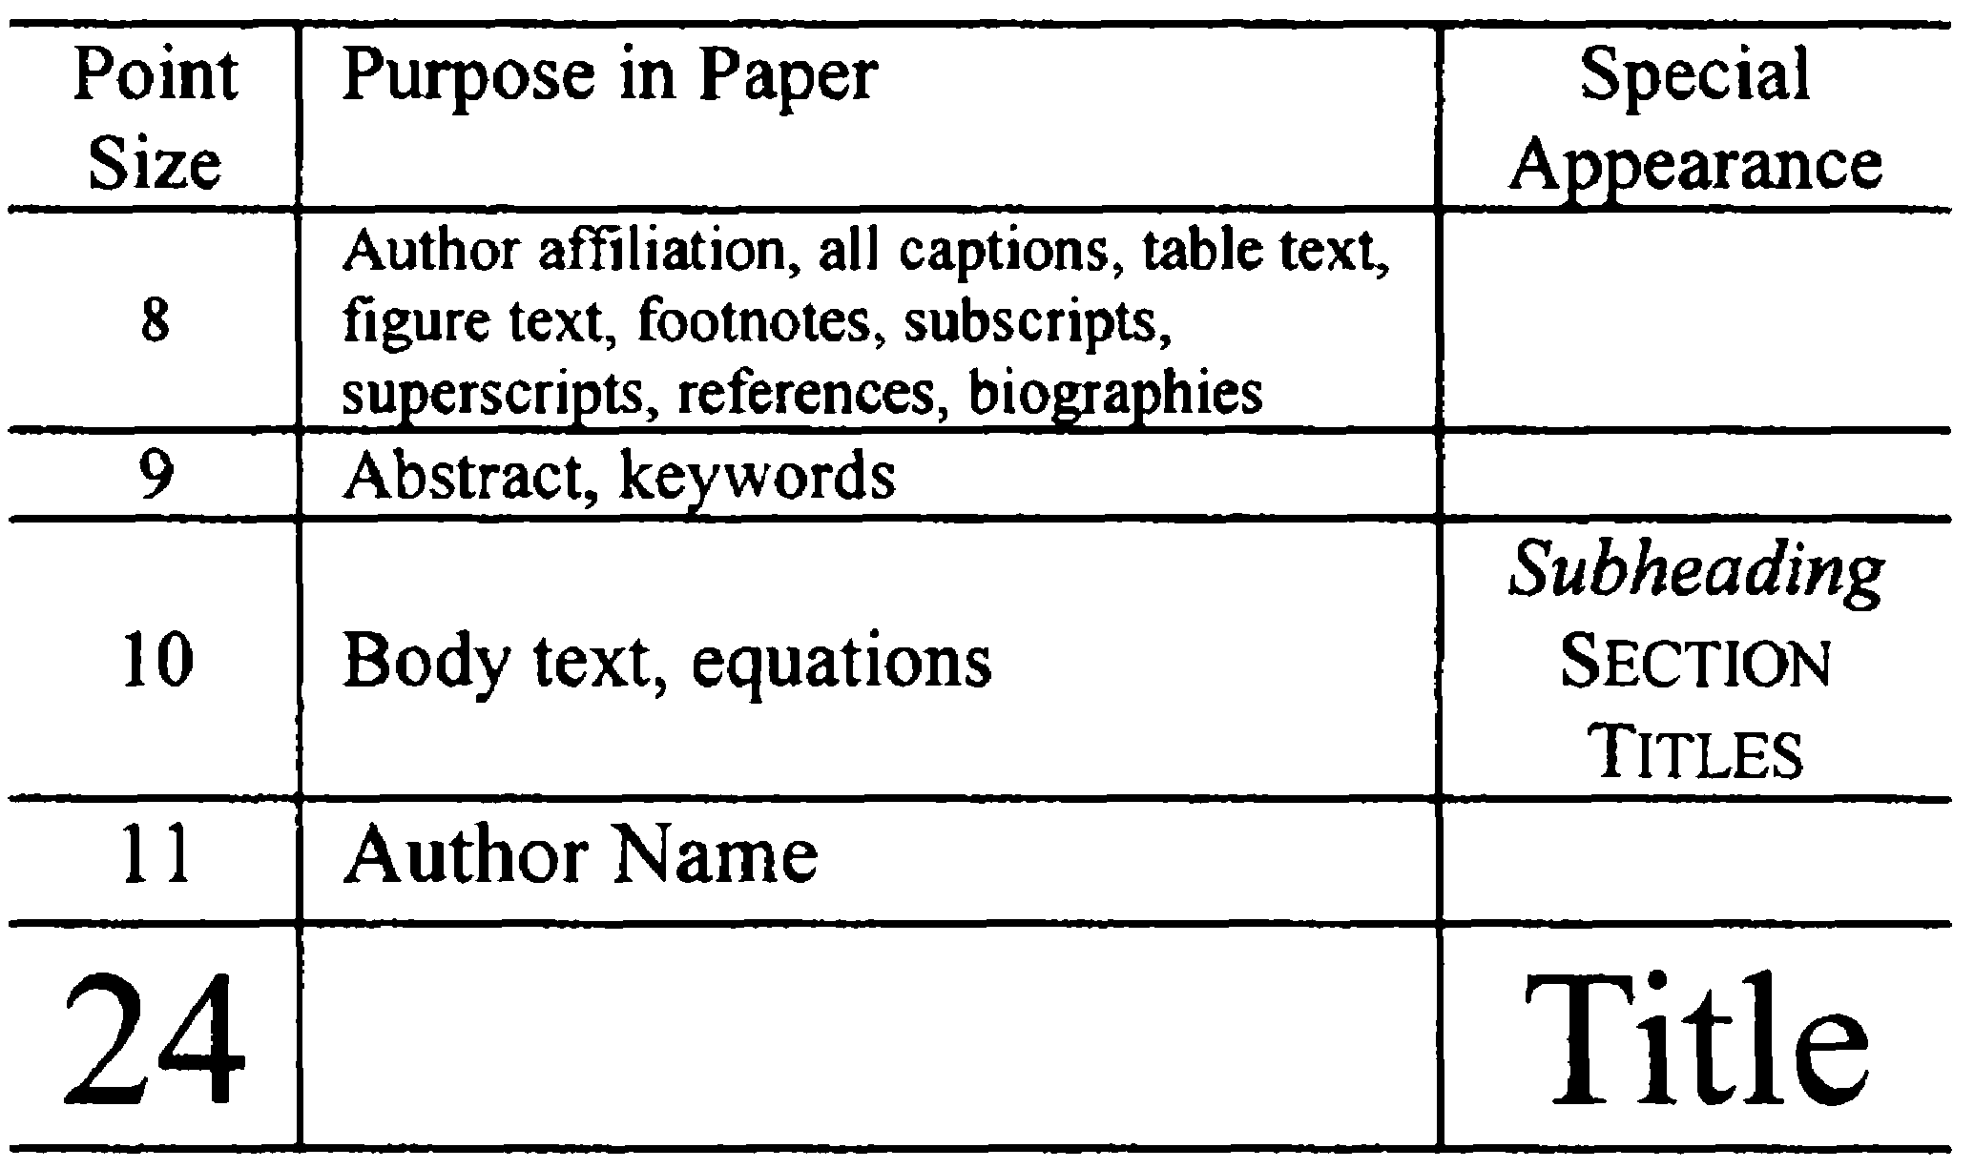

Section Headings
A primary section heading is enumerated by a Roman numeral followed by a period and is centered above the text. A primary heading should be in capital letters.
A secondary section heading is enumerated by a capital letter followed by a period and is flush left above the section. The first letter of each important word is capitalized and the heading is italicized.
A tertiary section heading is enumerated by an arabic numeral followed by a parenthesis. It is indented and is followed by a colon. The first letter of each important word is capitalized and the heading is italicized.
A quaternary section heading is rarely necessary, but is perfectly acceptable if required. It is enumerated by a lowercase letter followed by a parenthesis. It is indented and is followed by a colon. Only the first letter of the heading is capitalized and the heading is italicized.

Figures and Tables
Figure axis labels are often a source of confusion. Try to use words rather than symbols. As an example, write the quantity "Magnetization," or "Magnetization, M," not just "M." Put units in parentheses. Do not label axes only with units. As in Fig. 1, write "Magnetization (kA/m)" or "Magnetization (kA·m⁻¹)," not just "kA/m." Do not label axes with a ratio of quantities and units. For example, write "Temperature (K)," not "Temperature/K." Figure labels should be legible, approximately 8- to 10-point type.
Large figures and tables may span both columns, but may not extend into the page margins. Figure captions should be below the figures; table captions should be above the tables. Do not put captions in "text boxes" linked to the figures. Do not put borders around your figures.
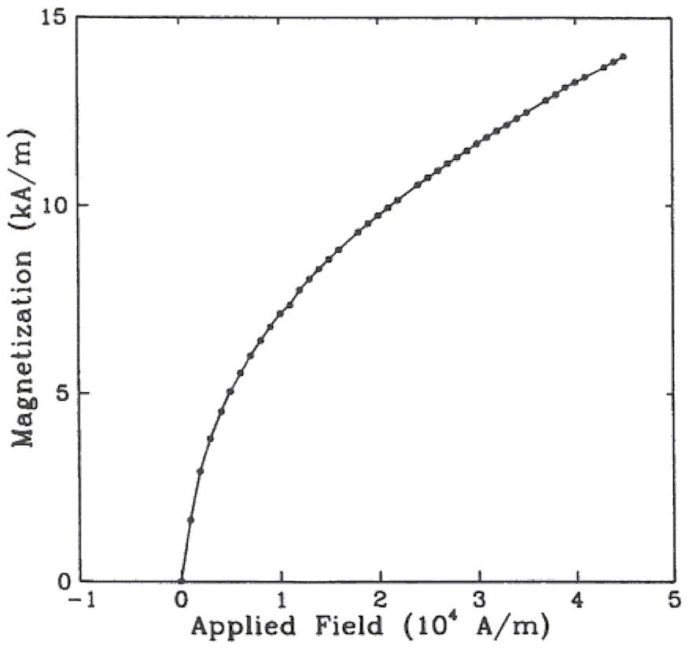

Fig. 1. Magnetization as a function of applied field. (Note that "Fig." is abbreviated and there is a period after the figure number followed by two spaces.)

All figures and tables must be in place in the text near, but not before, where they are first mentioned. Use the abbreviation "Fig. 1," even at the beginning of a sentence.
Digitize your tables and figures. To insert images in Word, use Insert | Picture | From File.

Numbering
Number reference citations consecutively in square brackets [1]. The sentence punctuation follows the brackets [2]. Multiple references [2], [3] are each numbered with separate brackets [1]-[3]. Refer simply to the reference number, as in [3]. Do not use "Ref. [3]" or "reference [3]" except at the beginning of a sentence: "Reference [3] shows…."
Number footnotes separately with superscripts (Insert | Footnote). Place the actual footnote at the bottom of the column in which it is cited. Do not put footnotes in the reference list. Use letters for table footnotes.
Check that all figures and tables are numbered correctly. Use arabic numerals for figures and Roman numerals for tables.
Appendix figures and tables should be numbered consecutively with the figures and tables appearing in the rest of the paper. They should not have their own numbering system.

Units
Metric units are preferred for use in IEEE publications in light of their global readership and the inherent convenience of these units in many fields. In particular, the use of the International System of Units (Systeme Internationale d'Unites or SI Units) is advocated. This system includes a subsystem of units based on the meter, kilogram, second, and ampere (MKSA). British units may be used as secondary units (in parentheses). An exception is when British units are used as identifiers in trade, such as 3.5-inch disk drive.

Abbreviations and Acronyms
Define less common abbreviations and acronyms the first time they are used in the text, even after they have been defined in the abstract. Abbreviations such as IEEE, SI, MKS, CGS, ac, dc, and rms do not have to be defined. Do not use abbreviations in the title unless they are unavoidable.
See Appendix A of the Author’s Kit for additional information and standard abbreviations.

Math and Equations
Use either the Microsoft Equation Editor or the MathType commercial add-on for MS Word for all math objects in your paper (Insert | Object | Create New | Microsoft Equation or MathType Equation). "Float over text" should not be selected.
To make your equations more compact, you may use the solidus ( / ), the exp function, or appropriate exponents. Italicize Roman symbols for quantities and variables, but not Greek symbols. Use a long dash rather than a hyphen for a minus sign. Use parentheses to avoid ambiguities in denominators.
Number equations consecutively with equation numbers in parentheses flush with the right margin, as in (1). Be sure that the symbols in your equation have been defined before the equation appears or immediately following.
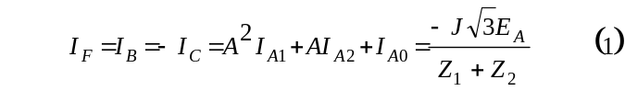where I_{F} is the fault current.
Use "(1)," not "Eq. (1)" or "equation (1)," except at the beginning of a sentence: "Equation (1) is .…"

Appendix
Appendixes, if needed, appear before the acknowledgment.

Acknowledgment
The following is an example of an acknowledgment. (Please note that financial support should be acknowledged in the unnumbered footnote on the title page.)
The authors gratefully acknowledge the contributions of I. X. Austan, A. H. Burgmeyer, C. J. Essel, and S. H. Gold for their work on the original version of this document.

References
References are important to the reader; therefore, each citation must be complete and correct. There is no editorial check on references; therefore, an incomplete or wrong reference will be published unless caught by a reviewer or discusser and will detract from the authority and value of the paper. References should be readily available publications.
List only one reference per reference number. If a reference is available from two sources, each should be listed as a separate reference. Give all authors' names; do not use et al.
Samples of the correct formats for various types of references are given below.
Periodicals:
- J. F. Fuller, E. F. Fuchs, and K. J. Roesler, "Influence of harmonics on power distribution system protection," IEEE Trans. Power Delivery, vol. 3, pp. 549-557, Apr. 1988.
- E. H. Miller, "A note on reflector arrays," IEEE Trans. Antennas Propagat., to be published.
- R. J. Vidmar. (1992, Aug.). On the use of atmospheric plasmas as electromagnetic reflectors. IEEE Trans. Plasma Sci. [Online]. 21(3), pp. 876-880. Available: http://www.halcyon.com/pub/journals/21ps03-vidmar

Books:
- E. Clarke, Circuit Analysis of AC Power Systems, vol. I. New York: Wiley, 1950, p. 81.
- G. O. Young, "Synthetic structure of industrial plastics," in Plastics, 2nd ed., vol. 3, J. Peters, Ed. New York: McGraw-Hill, 1964, pp. 15-64.
- J. Jones. (1991, May 10). Networks. (2nd ed.) [Online]. Available: http://www.atm.com

Technical Reports:
- E. E. Reber, R. L. Mitchell, and C. J. Carter, "Oxygen absorption in the Earth's atmosphere," Aerospace Corp., Los Angeles, CA, Tech. Rep. TR-0200 (4230-46)-3, Nov. 1968.
- S. L. Talleen. (1996, Apr.). The Intranet Architecture: Managing information in the new paradigm. Amdahl Corp., Sunnyvale, CA. [Online]. Available: http://www.amdahl.com/doc/products/bsg/intra/ infra/html

Papers Presented at Conferences (Unpublished):
- D. Ebehard and E. Voges, "Digital single sideband detection for interferometric sensors," presented at the 2nd Int. Conf. Optical Fiber Sensors, Stuttgart, Germany, 1984.
- Process Corp., Framingham, MA. Intranets: Internet technologies deployed behind the firewall for corporate productivity. Presented at INET96 Annu. Meeting. [Online]. Available: http://home.process.com/ Intranets/wp2.htp

Papers from Conference Proceedings (Published):
- J. L. Alqueres and J. C. Praca, "The Brazilian power system and the challenge of the Amazon transmission," in Proc. 1991 IEEE Power Engineering Society Transmission and Distribution Conf., pp. 315-320.

Dissertations:
- S. Hwang, "Frequency domain system identification of helicopter rotor dynamics incorporating models with time periodic coefficients," Ph.D. dissertation, Dept. Aerosp. Eng., Univ. Maryland, College Park, 1997.

Standards:
- IEEE Guide for Application of Power Apparatus Bushings, IEEE Standard C57.19.100-1995, Aug. 1995.

Patents:
- G. Brandli and M. Dick, "Alternating current fed power supply," U.S. Patent 4 084 217, Nov. 4, 1978.

Biographies
A technical biography for each author must be included. It should begin with the author’s name (as it appears in the byline) and IEEE membership history. A photograph and an electronic file of the photo should also be included for each author. The photo should be black and white, glossy, and 2.54 centimeters (1 inch) wide by 3.18 centimeters (1.25 inches) high. The head and shoulders should be centered, and the photo should be flush with the left margin. The space required for the biographies and photos is included in the eight-page limit. The following is an example of the text of a technical biography:
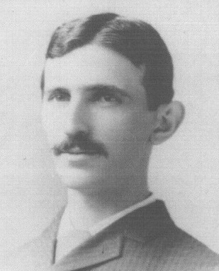
Nikola Tesla (M’1888, F’17) was born in Smiljan in the Austro-Hungarian Empire, on July 9, 1856. He graduated from the Austrian Polytechnic School, Graz, and studied at the University of Prague.
His employment experience included the American Telephone Company, Budapest, the Edison Machine Works, Westinghouse Electric Company, and Nikola Tesla Laboratories. His special fields of interest included high frequency.
Tesla received honorary degrees from institutions of higher learning including Columbia University, Yale University, University of Belgrade, and the University of Zagreb. He received the Elliott Cresson Medal of the Franklin Institute and the Edison Medal of the IEEE. In 1956, the term "tesla" (T) was adopted as the unit of magnetic flux density in the MKSA system. In 1975, the Power Engineering Society established the Nikola Tesla Award in his honor. Tesla died on January 7, 1943.
Editor's Note: J. W. Hagge was chair of the PES Technical Council and L. L. Grigsby was chair of the PES Publications Department when the original version of this document was published (January 1, 1993).

 Financial support should be acknowledged here. Example: This work was supported in part by the U.S. Department of Commerce under Grant BS123. The paper title should be in uppercase and lowercase letters, not all uppercase. The name and affiliation (including city and country) of each author must appear on the paper. Full names of authors are preferred in the author line, but are not required. Initials are used in the affiliation footnotes (see below). Put a space between authors' initials. Do not use all uppercase for authors' surnames. Examples of affiliation footnotes: J. W. Hagge is with Nebraska Public Power, District Hastings, NE 68902 USA (e-mail: j.hagge@ieee.org). L. L. Grigsby is with the Department of Electrical Engineering, Auburn University, Auburn, AL 36849 USA (e-mail: l.grigsby@ieee.org).

