High School Soccer Training and Strategy Playbook

Spanish inspired football in the 4 2 3 1
Prepared for Coach Fausto Garay
Build a team that controls space, handles pressure, creates clear chances, and competes with discipline through CIF playoffs. This manual connects a Spanish-inspired playing identity to tryout decisions, individual technique, practice design, match adjustments, and player development.
Our starting formation is the 4-2-3-1. Our default attacking organization becomes a 3-2-5 when one fullback advances and the opposite fullback narrows beside the center backs. We defend primarily in a 4-4-1-1, with a coordinated high press when the moment is right. The goalkeeper is additional to every formation count.
The central coaching task: teach players to see an advantage, create it together, and use it before it disappears. Possession serves progression and chance creation. A well-chosen forward ball, dribble, switch, or longer pass belongs in this identity.
Designed for: a high school varsity program, with adaptations for developing players, 16-24 available players, one or two coaches, and limited field access. All practice measurements are in yards unless explicitly stated otherwise. Equipment and opposition should be adjusted to the actual roster and field.
How to use it: start with the quick launch plan and tryout system, teach the base team model, then follow the season sequence. Use the technique cards to correct individual actions and the numbered practices to connect those actions to the game. Finish sessions with a game in which players must recognize the solution themselves.
Evidence and design: UEFA and FIFA resources inform the principles. The formation choices, dimensions, scoring rules, training doses, and progression thresholds are practical coaching recommendations created for this manual, not professional academy standards or promised outcomes. Winning CIF is an aspiration; consistent preparation, availability, execution, and adaptation are the controllable work.
2026 coaching edition

Navigation and practice index

Find the part you need
The document is organized as a field manual. Each main page begins with a searchable heading. Technique identifiers use T, practices use D, and complete sessions use S. References appear in brackets and are listed at the end.
Part | Contents | Pages
Launch and identity | First fourteen days, shared language, formation maps | 3 to 5
Team tactics | Build up, midfield progression, final third, transitions, defending | 6 to 12
Player roles | Responsibilities and observable behaviors for every position | 13 to 15
Tryouts | Three-day schedule, weighted scoring, selection and feedback | 16 to 18
Season planning | Fourteen-week installation and one-game or two-game weeks | 19 to 21
Technique cards T1 to T18 | Step-by-step mechanics, corrections, progression checks | 22 to 30
Practice library D1 to D24 | Setup, sequence, rotations, coaching, scoring and adaptations | 31 to 44
Complete sessions S1 to S8 | Seven 90-minute plans, shorter alternatives and a 60-minute taper | 45 to 52
Competition | Set pieces, opponent plans, match management and CIF run-in | 53 to 60
Development tools | Individual plans, evaluation forms, film and match dashboards | 61 to 65
References | Verified coaching resources and competition source links | 66 to 67

Practice library at a glance
IDs | Main purpose
D1 D2 D3 D4 | Scanning, receiving, rondos and third-player combinations
D5 D6 D7 D8 | Attracting pressure, building out and breaking midfield lines
D9 D10 D11 D12 | Wide combinations, cutbacks, finishing and winger duels
D13 D14 D15 D16 | Counterpressing, defensive transitions, pressing and block defending
D17 D18 D19 D20 | Aerial and second balls, goalkeepers, throw-ins and set pieces
D21 D22 D23 D24 | Full team rehearsal, game states, speed and position stations

Fast route for a new coach: read Launch, Base formation, Building from the goalkeeper, Tryout design, and Session S1. Install only three team calls at first: Reset, Hunt, and Home.

Launch the team in fourteen days

Establish repeatable behaviors before adding complexity
Before the first legal team session: confirm the athletic department calendar, eligibility and clearance, field access, emergency procedures, equipment, and staff roles. Prepare numbered pinnies, two evaluation sheets per player, and a ball for every player when possible. Count the full supervised training schedule under the applicable school and CIF rules.
Stage | Team teaching | Coach action
Tryout days 1 to 3 | Compete, scan, support, react after losing the ball | Observe comparable repetitions and small-sided decisions
Training days 1 and 2 | Base positions, Reset, pass and move | Use S1; film ten build-up attempts
Training days 3 and 4 | Double-pivot stagger and goalkeeper escape | Use S2; rehearse short and longer exits
Training days 5 and 6 | One fullback up, five attacking lanes | Use S3; stop repeated same-lane crowding
Training days 7 and 8 | Hunt or Home after loss; compact midblock | Use S5; count protected and unprotected turnovers
Training days 9 and 10 | Wide combinations and cutback arrivals | Use S4; give each player a role on crosses
First competition review | Keep three strengths and choose one priority | Review clips with players; revise the next week

First team meeting, 12 minutes: explain the identity in two minutes; show the base diagram in three; demonstrate Reset, Hunt, and Home in three; let the captains organize a two-minute walk-through; finish with players describing their closest supporting teammate and first job after a turnover.
Five observable standards: a receiver checks relevant space before the ball arrives; the ball carrier usually has two reachable support options; the pivots occupy different heights or angles; the far side preserves usable width; the nearest player responds immediately after a loss while teammates protect the middle.
What to praise: a midfielder checking over a shoulder before receiving, a fullback staying back so others can attack, a striker creating space with a run, and a substitute entering with a clear assignment. Naming these actions makes the identity visible beyond the score.
If the team struggles early: enlarge the practice space, reduce the number of defenders, and rehearse a safe longer exit. Keep the identity, but reduce the complexity. Introduce high pressing after the block and recovery responsibilities are understood.

Establish a Spanish inspired identity

Teach principles that travel across formations
Spanish football has varied across teams and eras. UEFA's EURO 2024 observations highlight Spain's genuine winger width and fullback combinations. This manual adapts those ideas to a high school 4-2-3-1; it does not claim that Spain used this exact system. [1, 2]
With the ball: stretch the opponent with width and depth, form diagonal passing options, and attract a defender before releasing the free player. Play forward when a teammate can receive usefully. If the forward pass is closed, retain the ball to change the opponent's position. Once a line is broken, support quickly and attack the next advantage.
Without the ball: protect central routes, move together, and press on a shared trigger. Direct the ball toward an area where teammates can help. Win the ball with balance and timing, then make a controlled first action.
After losing the ball: hunt only when pressure and cover are available. Otherwise recover inside and goal-side. After winning it: look forward first, exploit a clear numerical or positional advantage, or secure possession if the forward route is poor.
Team word | Meaning and visible response
Reset | Use a support player behind the ball and reorganize
Turn | Receiver has checked space and can face forward
Set | Receiver lays the ball back to a supporting player
Switch | Transfer toward the less crowded side
Fix | Draw a defender toward you before releasing a teammate
Third | A supporting third player becomes the forward option
Hold | One player maintains protective position while another advances
Hunt | Nearby players press with cover after losing possession
Home | End the chase and recover into the defensive block
Squeeze | Shorten the team while pressure controls the ball
Drop | Protect space behind when the opponent can pass forward

A coaching test: ask, "Who became free when your opponent moved?" This directs attention toward the problem players must solve. Avoid demanding one-touch play everywhere; a useful second touch can attract pressure or protect the ball.

Base formation and numbering
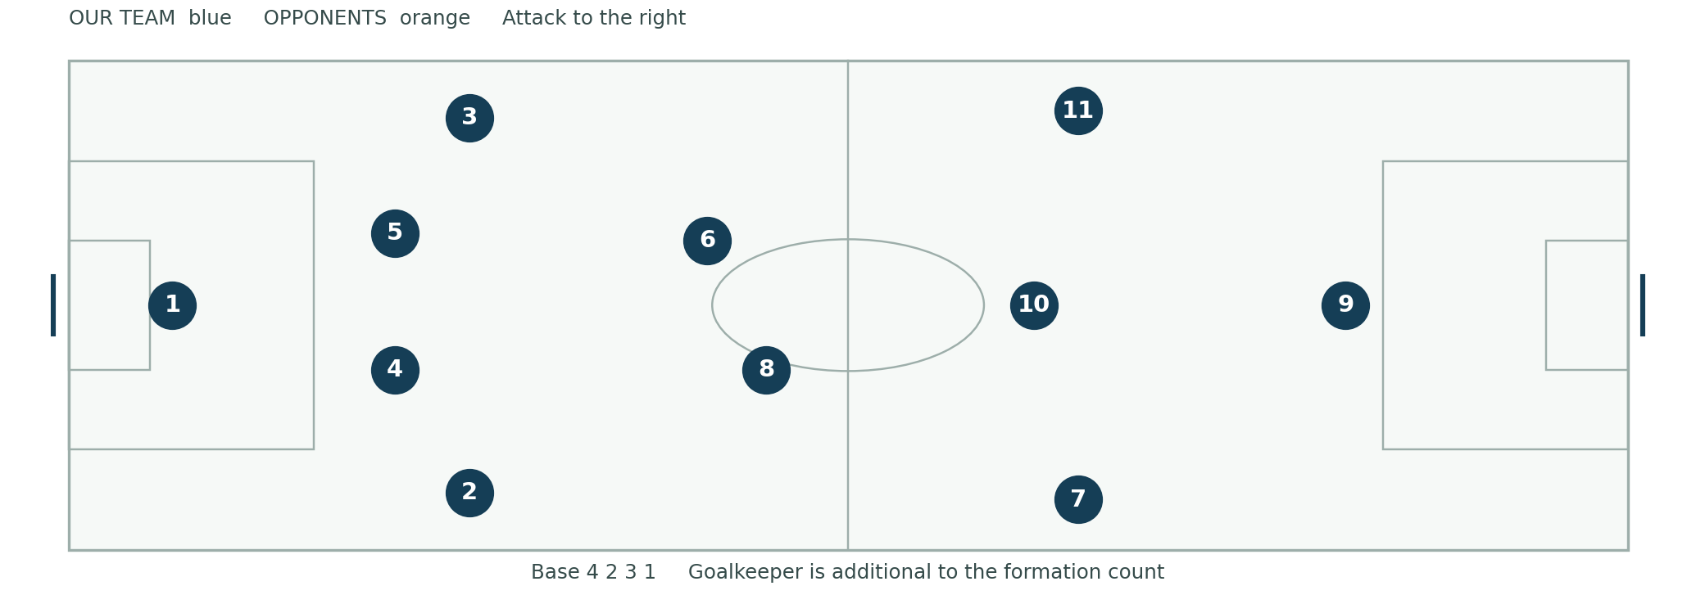
Orientation: our goalkeeper is at the left; we attack toward the right. These are role numbers, not required jersey numbers. Left and right are from our team's attacking perspective. Diagrams are schematic rather than scale drawings.
Line | Roles | Starting responsibility
Goalkeeper | 1 | Protect goal, support circulation, cover space behind
Back four | 2 right back 4 right center back 5 left center back 3 left back | Build with width, protect depth, advance selectively
Double pivot | 6 holding midfielder 8 connecting midfielder | Offer different angles, protect central transitions
Attacking three | 7 right winger 10 attacking midfielder 11 left winger | Create width, find pockets, support striker
Striker | 9 | Occupy center backs, threaten depth, connect attacks

Starting distances: use approximately 10-16 yards between nearby support players in early practices. In the midblock, begin around 8-12 yards between defensive lines and a team length near 30-35 yards, then adjust to pressure, speed, opponent and field. These are teaching references, not fixed match measurements.
First correction: if a player has no passing option, check the nearest teammates' angles before criticizing the passer. A formation drawing describes a starting organization; the ball and opponents determine the next movement.

Attack with a stable three two five
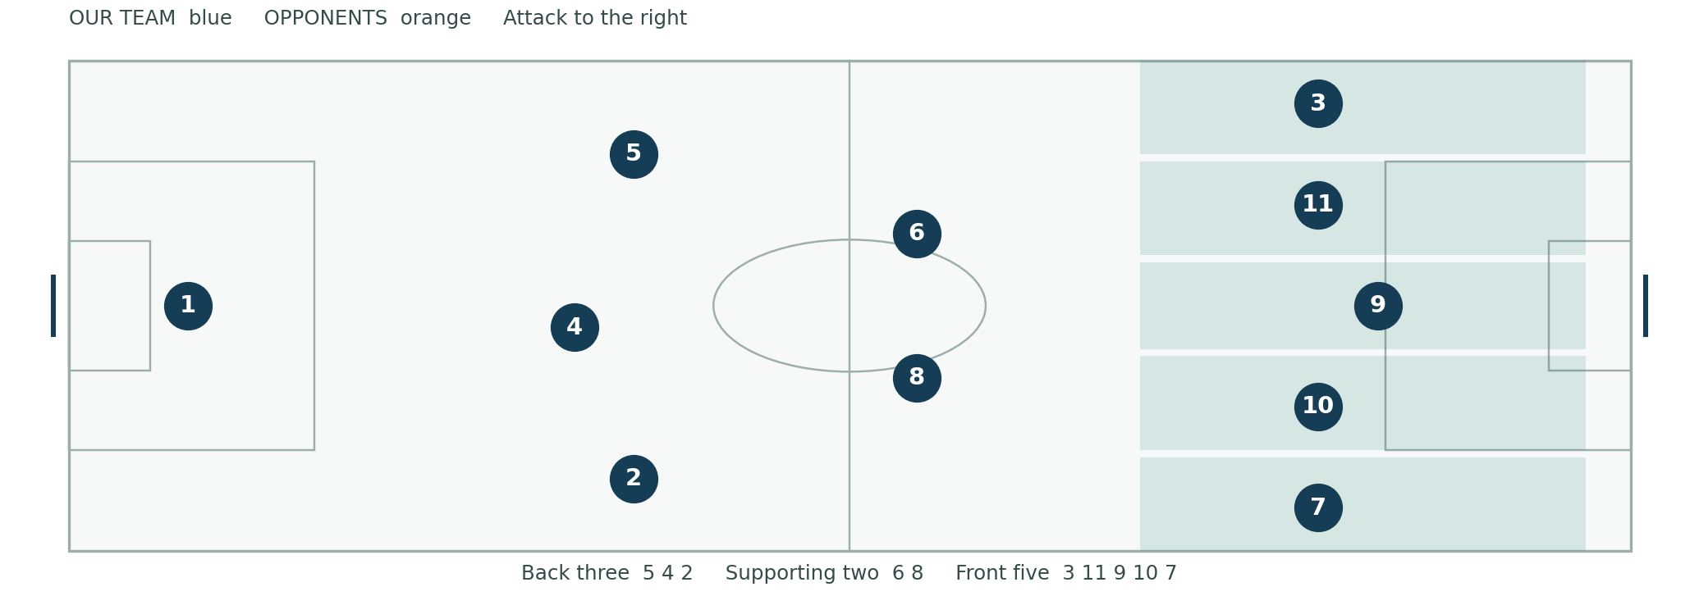
Default example: 3 advances into the left wide lane. Player 11 moves into the left half-space. Player 9 occupies the center. Player 10 uses the right half-space. Player 7 holds the right wide lane. Behind them, 6 and 8 support; 5, 4 and a narrowed 2 form the protective back three. All ten outfield players are accounted for.
Mirror it: when 2 advances, 7 moves inside, 10 uses the left half-space, 11 holds left width, and 3 narrows into the back three. Rehearse each side separately before asking players to exchange fluidly.
Rest defense means: the players positioned to control a counterattack while we attack. A 3+2 structure is our default. Keep one more covering defender than the opponent's highest central attackers when feasible. If opponents leave three forwards high, keep an additional fullback or pivot behind the attack rather than blindly preserving five high attackers.
Advanced option: a 2-3-5 can use 4 and 5 at the back; 2, 6 and 3 across a supporting midfield line; and 11, 8, 9, 10 and 7 across the front. Here the fullbacks support underneath rather than both racing beyond the ball. Use it only when 8's advance and counterattack coverage are rehearsed.
Teach it: walk the base shape into the attacking shape with a left-sided ball, then a right-sided ball. Ask each player to name who protects behind their movement. Add opponents and stop only if two players repeatedly occupy the same useful lane or central protection disappears.

Build from the goalkeeper
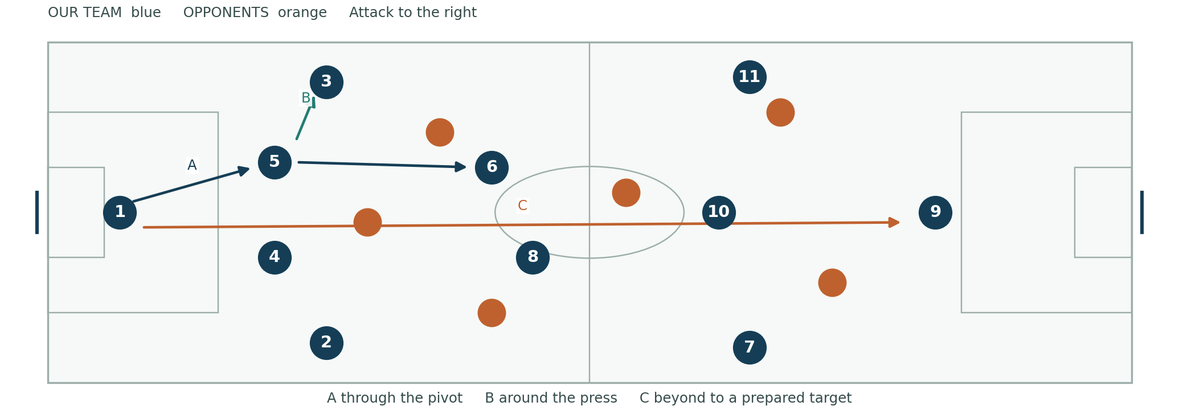
Read before the restart: 1 identifies the opponent's first line, 4 and 5 offer playable angles, and 6 and 8 stagger. Fullbacks stay reachable. The striker pins or checks away before showing. An open short option must also have a reasonable next action.
Route A through: 1 passes to 5; 5 carries until an opponent commits; 6 moves off the opponent's cover shadow; 5 finds 6, who turns only after scanning. Player 8 supports beyond at a different angle. If 6 is tightly marked, 6 sets back and 5 finds 8 or switches through 1.
Route B around: 1 to 5 to 3 when the winger's press leaves that route open. Player 11 either holds depth or checks inside to connect; 6 provides the return pass. If the sideline becomes a trap, 3 uses the inside support or resets early rather than receiving square and stationary against two opponents.
Route C beyond: if the opponent locks the short options or the surface makes a central pass unreliable, 1 or a center back plays toward a prepared channel or the striker. Player 9 contests or secures; 10 supports underneath; the near winger runs beyond; 6 and 8 organize the second ball. The back line advances only as ball pressure permits. [1]
Risk rule: never force a central pass into a closed receiver near our goal merely to satisfy a possession instruction. If the short exit fails twice, pause and diagnose angle, timing and pressure; then change the route. Train D6 with opponents allowed to counter to goal so decisions carry realistic consequences.

Progress through midfield
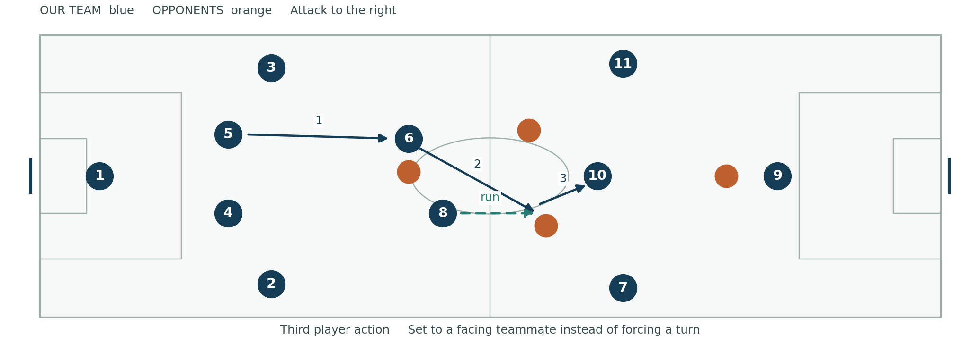
Find space between lines: 10 moves on a defender's shoulder where both passer and next target are visible. Player 9 threatens behind to stop the back line stepping freely. The far winger holds width long enough to stretch the block. Players 6 and 8 avoid standing directly behind the same opponent. FIFA coaching resources emphasize scanning and receiving orientation for these actions. [3, 4]
Third-player example: 5 passes into 6, who is facing our goal. As the pass travels, 8 moves beyond the nearest opponent. Player 6 sets the ball diagonally to 8; 8 receives facing forward and finds 10 or a winger. The first receiver does not have to turn to help the team progress. The third player must move while the ball travels, not wait for the set pass.
Carry to create a decision: if no opponent closes a center back, the center back advances with the ball. A pivot stays available behind or beside the carry; the opposite center back protects depth. Release when a midfielder steps forward, creating space behind that midfielder.
Overload then switch: combine on one side until the opponent shifts. Move the ball through a pivot or the back line to the far winger. The switch is useful when the far player can attack before the block arrives; avoid slow extra passes that allow the defense to reset.
Coach's questions: "Which opponent did your movement take away?" "Could you receive facing forward, or did you need a set?" "When 8 went beyond, who remained behind the ball?" Rehearse in D4 and D8, then remove zone restrictions in the final game.

Create chances in the final third
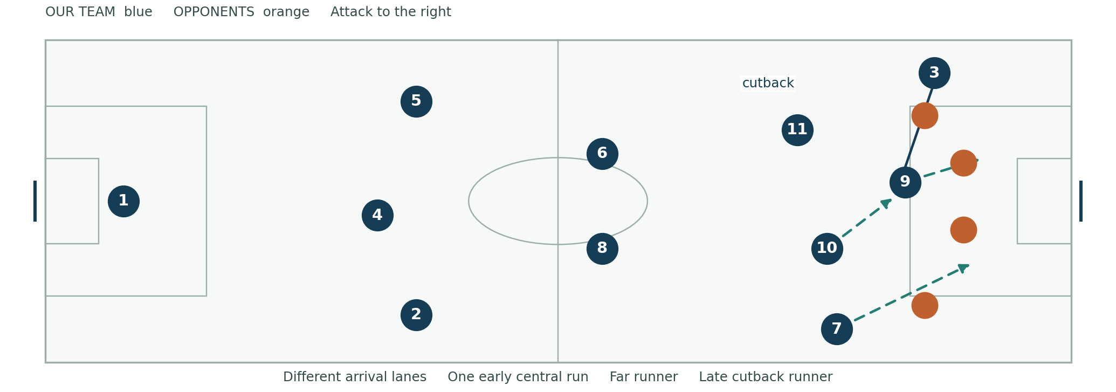
Wide triangle: winger, fullback and 10 or near pivot create three different angles. If the winger stays wide, the fullback can underlap or support underneath. If the winger carries inside, the fullback can overlap once protection is set. The supporting player reads the dribbler's touch before moving; two players should not run into the same corridor. [1]
Three complementary runs: 9 attacks the near-central space, the opposite winger attacks the far-post space, and 10 arrives later near the penalty spot or cutback lane. Change exact lanes to avoid defenders and keep the runs onside. Player 8 stays near the edge for recycling unless another player explicitly covers that responsibility.
Cutback decision: after beating the outside defender, the carrier scans across goal before the last touch. If the goalkeeper guards the near post and defenders retreat toward goal, pass backward toward a late runner. If the low cross is open across the goalmouth, use it. If there is no receiver, retain or reset. A forced cross is not required.
Against a low block: preserve width, move the block with a quick switch, and create a 2v1 outside. Allow the striker to set a pass to a facing midfielder. Use selective shots when defenders refuse to step, while keeping rebound and counterattack coverage. Avoid filling the box with all midfielders.
Practice transfer: reward a well-created shot and organized coverage, not a cutback at any cost. D9-D12 isolate combinations, arrivals and duels; S4 puts them into a game. Track controlled box entries and clear shooting chances as well as goals.

React after losing possession
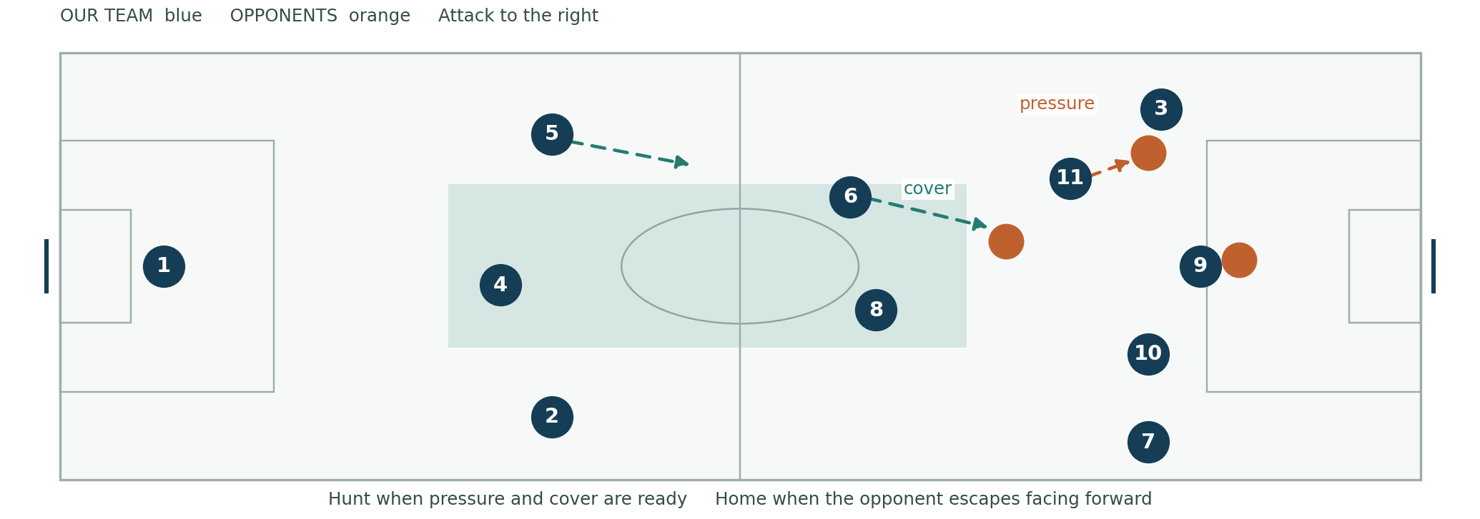
The decision comes first: can the nearest player affect the ball immediately, can two teammates close nearby escape routes, and is central depth protected? If yes, call Hunt. If the opponent already faces forward with a clean escape or our support is too far away, call Home. FIFA counterpressing guidance likewise connects immediate pressure with closing routes and protecting against the counter. [5, 6]
First player: close the carrier under control and block the most dangerous forward route. Aim to force a sideways touch or backward pass. Do not dive into a tackle from behind.
Second player: protect the next central pass at an angle behind the first. Third player: close the nearest escape receiver or intercept the predictable release. Pivots and back line: protect depth, identify runners, and squeeze only when pressure makes a forward pass difficult.
The five-second cue: use five seconds in practice to prompt a decisive response, not to justify five seconds of aimless chasing. End the hunt sooner if the press is broken. After a regain, secure the first useful pass, then exploit the opponent's disorganization.
Recovery sequence: nearest defender delays; other players sprint through inside lanes; wide players recover toward the midfield line; 6 screens the striker; fullbacks recover into the back four. The player nearest the ball should not be left defending a 3v1 while others watch.
Coach it: in D13, count regains and forced backward passes, but also record times the team correctly abandons the hunt. A good transition defense sometimes wins by delaying, recovering and conceding no clear chance.

Defend in a connected block
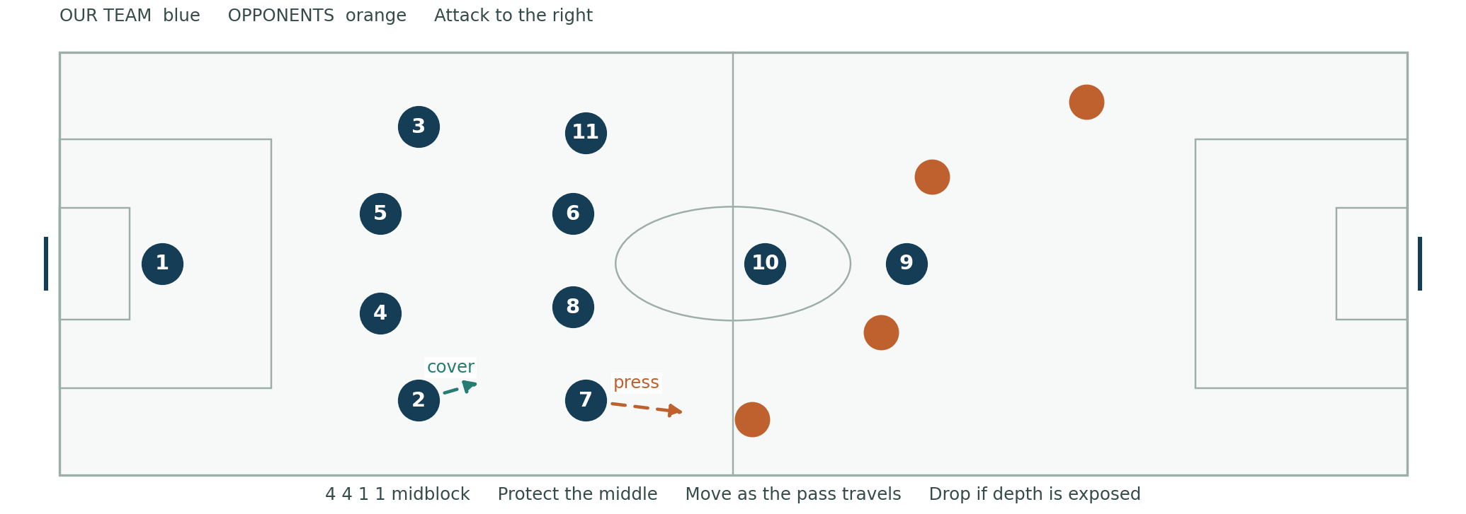
Home shape: 7 and 11 recover alongside 6 and 8; 10 screens in front of them and supports 9. The back four remain connected. Player 9 directs the first pass; 10 protects access into the opponent's pivot. Begin as a 4-4-1-1. When 10 joins 9 to press, the shape briefly resembles a 4-4-2.
Ball on our right: 7 approaches the carrier with an angle that protects the inside; 2 covers behind and controls the wide runner; 8 shifts across without abandoning the central route; 6 covers inside; 11 narrows enough to protect the far interior while retaining awareness of the far winger. Player 10 screens the return into midfield.
Pressure determines the line: if the ball carrier is under real pressure with head down, defenders can move up together. If the opponent has time and body shape to pass behind, drop and protect depth. The goalkeeper communicates early and adjusts support position.
Box defending: the nearest defender pressures the cross; the near center back protects the near central corridor; the second center back tracks the central striker; the far fullback checks the far runner; a pivot protects the cutback zone. These are starting references. Track actual opponents and communicate exchanges rather than guarding empty grass.
Correction sequence: first address the nearest pressure angle; then cover distance; then far-side narrowing; then back-line height. Coaching all four at once overwhelms players. Use D16 to let players experience how one uncoordinated step opens a lane. [7]

Press high with shared triggers

A repeatable sideline trap
Trigger choices: a slow pass toward an outside defender, a heavy touch, a receiver facing their own goal, or a back pass that lets the whole team advance. A trigger is permission only when the block is close enough to support the press. One isolated sprint is not a team press.
Example against a back four: 9 approaches the near center back on a curved route that discourages the return across the center. Player 10 denies the opposition pivot. When the pass travels to their left back, our 7 presses from inside toward the touchline. Our 2 controls their winger; 8 controls the inside release; 6 protects the central space; the far winger narrows. If their goalkeeper remains free, accept a reset and reorganize rather than chasing without cover.
Back-line task: 4 and 5 identify the highest threats and prepare for the ball over the press. The far fullback narrows. Player 1 judges the space behind. If the opponent can strike a clean long pass, protect depth; do not insist on an offside trap.
Abort conditions: our winger arrives late, their receiver turns inside cleanly, the opponent creates an unmarked central outlet, or our back line cannot advance. Call Home, delay the ball and rebuild the 4-4-1-1. A failed press should trigger collective recovery.
Against a back three: 9 directs toward an outside center back; the near winger can jump to that player only if our fullback and pivot can cover the next wide and inside options. Otherwise use the midblock. Avoid asking one winger to press two separated players.
Measure D15: out of ten opposition build-ups, count traps completed, controlled long balls forced, clean central escapes, and shots conceded. A forced long ball is successful only if our team is prepared for its landing and second ball.

Goalkeeper and center back profiles

Player 1
In possession: scan before receiving, offer a supporting angle outside the goalmouth when appropriate, and use the first touch to open the next pass. Identify short, medium and longer outlets before a restart. Pass to the teammate's safer foot or into useful space. Do not treat every short pass as safe.
Defending: organize the line, judge whether to hold or cover space behind, set feet before the shot, and communicate on crosses. A keeper's call must identify a decision: Keeper, Away, Hold, or Drop. Distribute after securing the ball and checking the opponent's recovery shape.
Development priorities: T18, D6 and D18. Observe ten pressured distributions: were the choice, pass weight and next team action useful? Separately assess shot handling, starting position and decisions on crosses. Field-player passing scores should not substitute for goalkeeper evaluation.

Players 4 and 5
In possession: split to create an angle but remain close enough for a realistic switch; carry when no one presses; release when an opponent commits; support the pivot's set pass. The far center back protects a central counterattack route as the other carries.
Defending: one engages the forward while the other covers; both adjust to ball pressure and runner speed. Check the far shoulder before a cross and establish clear marking exchanges. Clear to a useful wide area when pressure prevents controlled possession.
Development priorities: T2, T5, T6, T14 and T16; D6, D14 and D17. Record decisions to step or drop in ten clips. Praise early prevention as well as visible tackles.
Role conference prompt: "When your partner steps out, which space becomes yours?" Require an on-field demonstration. A confident answer without the movement is not yet match learning.

Fullback and double pivot profiles

Players 2 and 3
In possession: start at a playable angle; read whether the winger needs an outside run, inside run or support behind. Only one fullback advances beyond the ball by default. The other narrows beside the center backs. Announce the exchange before leaving protection.
Defending: approach the winger under control, guide toward team support, and stop the first easy cross. Check for a second runner before focusing entirely on the ball. On the far side, narrow to protect the far-post route while keeping sight of the wide opponent.
Progression: begin with clean receiving and 1v1 defending; add the wide triangle; then add the decision to advance or hold. Use D9, D12 and D24. Review whether the team retained balance after each attacking run, not simply the number of overlaps.

Player 6
In possession: offer a diagonal outlet, check both shoulders, play forward when the route is useful, and recycle when it is closed. Stay available behind the advanced midfielders. Move outside a cover shadow rather than asking for a pass through an opponent.
Defending: screen central passes, identify the opponent's highest midfielder, and organize the first recovery. Avoid being drawn to the touchline at the same time as 8 unless another player covers the middle.

Player 8
In possession: connect 6 to 10, arrive at a different height from 6, and support the third-player action. Advance beyond the ball only when coverage is clear. In our default 3-2-5, 8 remains in the supporting two; a late box run is an exchange, not an automatic obligation.
Defending: shift toward pressure, cover the inside release, and recover through the middle. Player 8 must recognize when to delay rather than chase.
Pair evaluation: in ten midfield possessions, count useful staggering, forward-facing receptions, and losses that leave both pivots ahead of the ball. Use D4, D7 and D8. [3, 4]

Attacking midfielder winger and striker profiles

Player 10
In possession: find a pocket between lines, move away then return on the defender's blind side, and receive with a useful next action. If tightly marked, set the ball and move rather than forcing a turn. Arrive late for cutbacks. When 11 moves inside in our left-sided 3-2-5, use the opposite half-space.
Defending: screen the opponent's pivot, join 9 only on a shared press, and recover centrally after the press is broken. Measure: forward-facing receptions, useful set passes and chances created, using D4 and D8.

Players 7 and 11
In possession: preserve width until a coordinated rotation releases it. Receive to attack the defender's front foot, threaten outside and inside, and change pace after the move. The far winger attacks the far-post space when the cross is genuinely available. Recover width if the attack is recycled.
Defending: close from inside to outside when trapping wide, track the fullback's run according to the team exchange, and recover into the midfield four. Measure: useful 1v1 outcomes, entries into the box, far-side run timing and recovery behavior. Use D9-D12.

Player 9
In possession: occupy defenders with depth, time a curved run to remain onside, and check short when a facing teammate can use the set. Protect a pass with legal body position and connect the third player. Attack crosses with a change of speed rather than waiting beside the center back.
Defending: initiate the press with an angle, screen the return route, and remain available as an outlet when the team retreats. Measure: runs that create space, retained set passes, clear chances reached and press coordination. Goals matter, but these actions explain future chances.
Selection principle: choose complementary roles. Two gifted midfielders who both abandon central protection may be a weaker pairing than a balanced duo. Coach a secondary position for each player so injuries and substitutions do not erase the team model.

Design fair and informative tryouts

Assess football decisions as well as isolated technique
Use three 90-minute days, with comparable opportunities across positions and two independent assessors where possible. Number players and record context. Do not make the first cut from a running test or a single finishing exercise. Observe returners and new players with the same criteria.
Criterion | Weight | Evidence
Technique under pressure | 25 | First touch, pass choice and execution, weaker foot
Perception and decisions | 25 | Scanning, support angles, risk judgment, timing
Tactical contribution | 20 | Role discipline, pressing and transition coverage
Physical execution | 15 | Acceleration, repeat efforts, balance, recovery
Coachability and team behavior | 15 | Applies feedback, communicates, competes respectfully

Scoring anchors: 1 means the action rarely appears even with support; 2 appears in simple situations; 3 appears under moderate pressure; 4 appears consistently in live play; 5 appears consistently and helps teammates solve the game. Use N/O for not observed. Do not replace missing evidence with zero. Collect another observation before calculating a final score.
Calculation: add each rating divided by five and multiplied by its weight. A player scoring 4, 3, 4, 3 and 5 earns 20+15+16+9+15 = 75/100. Keep position fit, growth and availability notes beside the number. The score informs selection; it does not create a precise scientific ranking.
Goalkeepers: keep the same category weights, but rate goalkeeper-specific evidence: handling and distribution, decisions on shots and crosses, starting position and organization, footwork and recovery, response to feedback. Include D18 and live game observations.
Practical staffing: one coach runs the exercise and one observes. With one coach, use longer live blocks and record short notes between rounds; film from a fixed supervised position if school policy permits. Match pinnie numbers to names privately. Never publish individual scores to teammates.

Run the three tryout days

Each day totals ninety minutes
Minutes | Day 1 technical baseline | Day 2 pressure and roles | Day 3 match evidence
0 to 15 | Progressive movement warm-up | Progressive movement warm-up | Progressive movement warm-up
15 to 35 | Four technical stations | Position stations D24 | 6v6 plus keepers D22
35 to 55 | 4v4 games and rotation | Build-out D6 and press D15 | 11v11 or scaled game D21
55 to 80 | 7v7 plus keepers or scaled | 8v8 plus keepers | Match with changed role assignments
80 to 86 | Repeat a key coached action | Feedback and retest | Targeted retests for uncertain players
86 to 90 | Cool-down and next-day brief | Cool-down and questions | Cool-down and selection timeline

Day 1 stations: use four groups of 4-6. In each five-minute rotation, work for four minutes and use one minute for water, recording and movement. Station A: pairs pass through a two-yard gate from eight yards, then receive across the body. Station B: 1v1 through either of two exit gates in a 12x10 area. Station C: 2v1 in a 16x12 channel, finishing in a mini-goal. Station D: finishing from a ground pass with a live defender recovering from behind. Rotate server, attacker and defender; goalkeepers get a separate observation block without excessive shots.
Day 2 feedback test: give one concise cue, such as "check your far shoulder as the passer prepares." Observe the next five opportunities, then return later without reminding. Improvement matters more than apparent compliance in the first repetition.
Day 3 game fairness: switch teammates and opposition; give candidates minutes in a primary and secondary role; track approximate minutes and touches. With fewer than 22, use an appropriately sized 8v8 or 9v9 including keepers. Never label a reduced-sided shape a complete 4-2-3-1 evaluation.
Physical observation: after a complete warm-up and before fatigue, use two timed 10-yard accelerations with at least 60 seconds of recovery if needed. Compare individuals across days with the same surface and method. Assess repeat efforts in games; avoid an exhaustion test that obscures technique or excludes late-developing athletes.

Select the squad and communicate roles

Build depth for the way the team will play
Roster map: list each position with a first option, a competing option and an emergency option. An illustrative 20-player squad might include two goalkeepers, seven defenders, six midfielders and five forwards, with overlap across roles. Adjust roster size to school policy, participation goals, actual talent and match rules.
Selection meeting: compare independent notes before averaging scores. Examine repeated match evidence, response to instruction and role balance. Review candidates near the selection line in the same exercise. Do not penalize a player for a position they were never allowed to demonstrate.
Define playing roles privately: likely starter, rotational contributor, developing varsity player, or JV development pathway where available. Explain that roles can change through observable work. Do not promise minutes that scheduling, health or match circumstances may prevent.
A useful feedback conversation: "Your receiving touch held up in the possession games. When we lost the ball, you chased outside and left the central pass open. Over the next two weeks, your target is to recover inside first on four of five observed losses. We will revisit film and D14 together."
For a player not selected: identify one demonstrated strength, one or two concrete development priorities, and the next available opportunity. Use respectful private communication under school procedures. Avoid vague labels such as "not athletic enough" or comparing the student publicly with another player.
After selection: repeat the baseline game during week 2, so tryout ranking does not become a permanent identity. Captains should model communication and accountability rather than receive automatic tactical authority. Build leadership through rotating responsibility for setup, warm-up organization and group reflection.
Availability record: maintain a simple confidential log of attendance, restrictions communicated by authorized staff, and position coverage. Injury restrictions are not a character score. Where a player misses evaluation through an approved reason, arrange the appropriate additional observation rather than guessing.

Install the model across fourteen weeks

Advance by performance and adapt to the competition calendar
Week | Primary installation | Practices | Evidence before adding complexity
1 | Tryouts and base positions | D1 D2 D24 | Players identify support and recovery roles
2 | Passing and receiving under pressure | D2 D3 D4 | Useful first touch in 7 of 10 sampled actions
3 | Short and longer build-out exits | D5 D6 | 6 of 10 exits reach a controlled target
4 | Double-pivot and third-player play | D4 D7 D8 | Pivots stagger in 7 of 10 sampled possessions
5 | Wide triangles and one fullback up | D9 D12 D21 | Coverage maintained in 8 of 10 wide attacks
6 | Cutbacks and complementary runs | D10 D11 | Three distinct arrival lanes appear repeatedly
7 | Hunt or Home after turnovers | D13 D14 | Team chooses together in 7 of 10 losses
8 | Connected midblock and press | D15 D16 | Clean central escapes decrease from baseline
9 | Second balls and defending crosses | D16 D17 | Landing, cover and cutback roles are clear
10 | Opponent-specific build-up choices | D6 D21 | Players change route without constant prompting
11 | Restarts and match situations | D19 D20 D22 | Named assignments survive substitutions
12 | Strongest patterns under pressure | D8 D10 D21 | Match chances reflect rehearsed principles
13 | Run-in and playoff rehearsal | D20 D22 | Team handles lead, deficit and shootout routine
14 | Freshness and execution | Short D9 D15 D20 | Clear roles, availability and sharp decisions

Interpret the targets: these are provisional teaching thresholds, not population norms. Use the same observer and game format where feasible; compare with the team's own baseline. A pattern that works without defenders is ready for opposition, not automatically ready for competition.
If time is shorter: combine weeks 2-3, 4-5 and 7-8, then revisit each theme within the weekly games. Preserve defending, transition coverage and restarts even if the attacking curriculum must be shortened. If the season is longer, repeat cycles with faster decisions and stronger opposition.

Plan the week around matches

One match on Friday
Day | Time | Focus and practical load
Monday | 85 to 90 min | Main learning and demanding football; S2 or S5
Tuesday | 85 to 90 min | Main tactical game; short quality speed before fatigue
Wednesday | 70 to 80 min | Opponent solution and controlled team rehearsal
Thursday | 50 to 60 min | Sharp short games, restarts and role clarity
Friday | Match | Progressive warm-up and competition
Saturday | School-approved recovery or rest | Individual needs and nonstarter plan
Sunday | Rest | Respect applicable school and section requirements

Two matches on Tuesday and Friday
Day | Time | Focus and practical load
Monday | 50 to 60 min | Tuesday plan and brief sharp actions
Tuesday | Match | Record player minutes and match demands
Wednesday | 40 to 60 min | Starters recover; nonstarters train separately as appropriate
Thursday | 50 to 60 min | Friday preparation; restarts and short games
Friday | Match | Monitor fatigue and use prepared substitutes
Weekend | Individualized rest and recovery | Avoid adding a conditioning session automatically

Load record: about 15-30 minutes after the session, ask for effort on a 0-10 scale. Multiply session minutes by the reported effort to create a simple internal comparison: 75 minutes x 6 = 450 arbitrary units. Do not compare this number as a fitness ranking across players. Include match exposure and other known sport demands when interpreting it.
Daily adjustment: ask privately about unusual fatigue, soreness, illness and sleep. New pain or concerning symptoms go to the athletic trainer; the coach does not diagnose readiness. If technical quality and concentration fall across the group, reduce the work or enlarge the space rather than demanding more punishment running.
Nonstarters: provide meaningful, coached football minutes on an appropriate day. A player who played ten minutes needs a different plan from one who played the full match. Use small groups, live duels and position work without jeopardizing readiness for the next game.

Prepare movement speed and strength

Establish a repeatable preparation routine
FIFA's injury-prevention resources identify the FIFA 11+ for players aged 14 and older. Have qualified staff teach its official progressions if adopting that program. The routine below is a practical session framework, not a substitute for the full official protocol. [8]
Fifteen-minute practice preparation: minutes 0-3 easy running, side steps, backward movement and ball carries; 3-6 dynamic ankle, hip and trunk movements; 6-10 controlled squat, split squat, single-leg balance and low jump-and-stick patterns; 10-13 progressive accelerations and decelerations; 13-15 passing and brief changes of direction. For athletes who require longer preparation, extend the warm-up and shorten the main activity. Demonstrate quiet landings and knee alignment over the foot.
Quality speed block: after preparation, use four to six accelerations over 10-20 yards. Allow 60-90 seconds between efforts. Add a football decision, such as a visual gate cue or a curved run from the defender's shoulder. Stop the block when speed, landing control or mechanics deteriorate. D23 gives the complete organization.
Teach deceleration: start with a gentle five-yard approach; lower the center of mass; use several shortening steps; keep the trunk controlled and knees flexed; finish balanced enough to move again. Add speed gradually, then add a cut selected by a visual cue. Do not begin with maximal sharp cuts from a long sprint.
Supervised strength example: twice weekly when the schedule permits, preferably after the main football work and away from the next match if it causes soreness. Use a squat pattern, split squat or step-up, hip hinge, calf raise, row or push-up, and trunk control. Start with two controlled sets of 6-10 suitable repetitions for dynamic movements and short controlled holds for trunk work; qualified strength staff set resistance and progression. Teach movement before increasing load. Reduce volume during congested match weeks.
Condition with football: use demanding games with planned recoveries rather than repeated exhaustion runs. Small games emphasize frequent accelerations; larger spaces expose longer running. Neither replaces every other demand. Build exposure progressively and keep water and recovery breaks available. Follow the school's heat, air quality, concussion and emergency policies.

Scanning and short passing

T1 Scan to make a decision
Purpose: know the pressure, next target and available space before receiving. Scanning must change the action; head movement by itself is not the goal.
How to teach: 1. Before asking for the ball, look away from it briefly to locate the nearest defender and a possible next teammate. 2. Recheck relevant space as the passer prepares; return the eyes to the ball for contact. 3. Adjust the body angle so ball and target are easier to see. 4. Decide whether to turn, set, protect or let the ball run. 5. Scan again after moving the ball because the picture has changed.
Practice: in D1, a defender changes sides as the server prepares the pass. The receiver identifies the defender and exits through the other gate, or sets back if both routes are blocked. Begin at walking pace, then add real pressure. Avoid a color-call task that becomes disconnected from the football decision.
Correction: if the player looks but still turns into pressure, ask what they saw, recreate the picture and show the available set pass. Cue: "See the pressure, choose the touch." Progress: seven useful choices in ten live receptions across two sessions, then test without reminders in a game. [3]

T2 Pass with the inside of the foot
How to teach: 1. Approach at a comfortable angle. 2. Place the supporting foot beside the ball, generally pointing toward the target. 3. Open the passing hip and firm the ankle. 4. Strike through the middle of the ball with the broad inside surface. 5. Follow through toward the target and immediately move into a new supporting angle. Adjust power to distance, surface and the receiver's next action.
Practice: pairs eight yards apart pass through a two-yard gate; after each pass, move two yards sideways so the next pass requires a new angle. Work 60 seconds, switch feet, then add a defender who can intercept.
Correction: wobbling passes usually need a firmer ankle and cleaner contact; passes behind the receiver need an earlier look and a target in useful space. Cue: "Firm ankle, useful foot." Progress: eight of ten passes arrive with playable weight through the gate on each foot, then maintain useful execution in D2. A stationary test alone does not establish match proficiency.

First touch and receiving on the half turn

T3 Direct the first touch
How to teach: 1. Check pressure before the pass. 2. Move to meet the ball rather than wait flat-footed. 3. Present the inside or outside surface that takes the ball toward the chosen space. 4. Cushion contact by yielding slightly through the receiving leg. 5. Put the ball within reach of the next action; under pressure this may be close, while open space allows a longer touch. 6. Accelerate or pass before the opponent closes.
Practice: use a 10x10 square with two exit gates. Server passes from outside, defender begins two yards behind the receiver, and the receiver must keep the ball and exit a gate or return to the server. Alternate receiving direction and feet. Give each player six receiving turns before rotating.
Correction: a touch under the body usually needs earlier movement and a more open angle; a touch too far away needs softer contact. Do not demand a forward touch when pressure makes a set safer. Cue: "Touch for your next job." Progress: seven of ten touches lead to a retained useful action with a live defender.

T4 Receive on the half turn
How to teach: 1. Move diagonally out of the defender's shadow. 2. Check the far shoulder. 3. Set the hips side-on enough to see the passer and the next target. 4. When safe, receive on the foot farther from the passer so the ball travels across the body. 5. Take a forward or diagonal touch and release before the next defender arrives. If pressure is tight, use the protected foot and set instead.
Practice: in a 15x12 channel, a receiver starts between a server and a target. A defender approaches from either shoulder. Receiver chooses to turn into the free side or set to the server, who can play around. Rotate every four attacks so every player experiences all roles.
Correction: do not turn the exercise into a compulsory back-foot movement. The correct receiving foot depends on pressure and the next action. Cue: "Open if free; set if tight." Progress: eight correct turn-or-set decisions in ten attempts, followed by successful choices in D8. [4]

Shielding and driven ground passes

T5 Protect and set the ball
How to teach: 1. Identify pressure before the ball arrives. 2. Place the body between opponent and ball with knees flexed and a stable stance. 3. Keep the ball on the foot farther from the defender. 4. Use an arm for balance and awareness without pushing or striking. 5. Take a small touch away from the defender's reach. 6. Find the supporting teammate and set with enough pace for that player to continue. Turn only when space appears.
Practice: a 12x10 area contains attacker, defender and supporting server. Attacker receives with back to defender, protects briefly, then sets or turns through either gate. Defender can win and counter to the server's end line. Rotate after four attacks. Begin with controlled contact and increase pressure only when balance is reliable.
Correction: players wrestling with arms need better foot and hip position, not more force. Players standing on the ball need a small moving touch. Cue: "Body protects; feet escape." Progress: retain or connect on seven of ten live receptions without fouling.

T6 Drive a pass along the ground
How to teach: 1. Scan the target and the interception lane. 2. Set the supporting foot beside the ball and flex the knee. 3. Firm the ankle and contact the ball centrally with a strong inside surface or low instep, according to distance. 4. Keep the body controlled over the strike to prevent unnecessary lift. 5. Follow through toward the receiver and support the next pass. Use the lowest force that arrives before pressure.
Practice: groups of four in a 25x12 channel. Two outside players connect through a central receiver while a rotating defender blocks a lane. Receiver chooses set, turn or bounce. Alternate 15-25-yard ground passes with shorter connections. Rotate every 90 seconds.
Correction: if the ball skips upward, check low contact and a leaning-back torso; if it is too hard for a nearby receiver, adjust the decision rather than praising power. Cue: "Beat the defender, help the receiver." Progress: seven of ten longer passes reach the intended foot or space with a controllable first touch, then repeat under live interception pressure.

Dribbling and changing direction

T7 Beat a defender with a change of pace
How to teach: 1. Approach with the head lifting between touches. 2. Take smaller touches as the defender comes within tackling range. 3. Threaten one route with body and ball. 4. Read the defender's weight or front foot. 5. Push the ball into the other available route and accelerate for three to five steps. 6. Put the body between recovering defender and ball when appropriate, then pass, cross or finish.
Practice: in D12, two gates offer inside and outside routes. Do not reward repeated tricks without forward advantage. Let defenders counter after winning so dribblers must recognize safe moments and recovery responsibilities.
Correction: a move too far from the defender rarely commits them; a move too close may run into a planted foot. Adjust the starting distance to the player's speed. Cue: "Move them, then leave." Progress: reach a useful gate or create a shot on six of ten balanced 1v1 attempts against comparable opposition.

T8 Turn out of pressure
How to teach three options: inside cut: place the inside surface across the ball and redirect behind the approach; outside cut: use the outer surface to push away from pressure, then accelerate; pullback: stop or draw the ball backward with the sole, reposition the standing foot, then escape on an angle. In every turn, bend the knees, protect the ball and look for the new target.
Practice: pairs in a 12x12 area. Attacker dribbles toward a line while defender approaches from a coach-selected side. Attacker chooses a turn and exits either side gate. Switch roles after four attacks. Begin with a trailing defender, then allow genuine tackles.
Correction: if a player turns directly into the defender, replay the approach and identify the defender's direction. If the ball stays underneath the feet, improve the exit touch and acceleration. Cue: "Turn into space, not just away." Progress: seven retained escapes in ten live attempts and a useful next pass. Teach the choice among turns rather than demanding one named move in every situation.

Combination play and through passes

T9 Use a wall pass or a third player
How to teach: 1. Ball carrier approaches to engage the defender. 2. Support player offers a diagonal option outside the defender's reach. 3. Carrier passes and accelerates beyond as the defender turns. 4. Support player sets into the runner's path with the appropriate surface and pace. 5. If the return route is blocked, use the third player or retain the ball. 6. Re-form support behind the attack.
Practice: 3v2 in a 20x15 channel with two mini-goals. Attackers score normally or combine to release a runner behind the first defender. Defenders counter to the opposite line. Rotate the starting carrier every attack and defenders every two minutes.
Correction: a runner moving before the defender commits may be easy to follow; a support player too close removes the passing angle. Cue: "Pass, move past, show the angle." Progress: create a controlled line break on six of ten attacks, with players free to choose another solution if defenders protect the combination.

T10 Weight a through pass
How to teach: 1. Scan the runner, last defender and goalkeeper. 2. Hold or carry the ball long enough to read movement without delaying past the chance. 3. Runner begins onside and curves toward space. 4. Pass into the space the runner can reach first, usually away from the defender and short of the goalkeeper. 5. Match force to the surface and runner's speed. 6. Support the runner's next action.
Practice: server and two attackers face two defenders plus a keeper in a 35x25 channel. Offside is active. Let attackers choose a through pass, dribble, set or wide release. Rotate the passer and both runners so one player does not take every sprint.
Correction: repeated offsides often require coordinated timing, not simply asking the striker to run slower. A pass reaching the goalkeeper first needs less weight or a different target lane. Cue: "Pass to the race we can win." Progress: six of ten attempted passes create a retained advantage or clear chance, with offside errors recorded separately.

Switches and crossing decisions

T11 Switch the point of attack
How to teach: 1. Before receiving, locate the far-side option and the opponent's shift. 2. Open the body or set to a facing teammate. 3. Choose a ground transfer through support when it can arrive quickly; use a longer lofted pass only when the lane and execution justify it. 4. For the lofted strike, place the support foot beside the ball, firm the ankle and contact below center with controlled follow-through. 5. Aim for the receiver's usable space and advance in support while protection remains set.
Practice: in D5, draw defenders into one outer zone and transfer to the other. Avoid imposing a pass count once players recognize the switching opportunity. Correction: a floated ball that lets defenders recover needs a faster route or earlier decision. Cue: "Move them, find the free side." Progress: seven of ten switches arrive before the defense can fully close, followed by a useful next action.

T12 Deliver a cross or cutback
How to teach: 1. Check the box before the final dribble. 2. Separate from the defender with a touch that leaves room to strike. 3. Choose near, central, far or backward based on actual runners. 4. For a low cross, contact through the middle with the inside or instep; for a cutback, turn the hip and pass backward into the late runner's path. 5. Follow the delivery in support without abandoning counterattack coverage assigned to your role.
Practice: D10 starts with a wide combination, one active crossing player, three runners and three defenders plus a goalkeeper, with supporting players as listed in the drill. Alternate sides and rotate crossing and finishing roles every two attacks. Recover balls safely before the next serve.
Correction: "cross earlier" is incomplete without a target. Show when the runner is free and when the goalkeeper can intercept. Cue: "See the runner before the strike." Progress: deliver six of ten balls into a reachable advantage zone while preserving attacking balance. Include blocked crosses and missed targets in the record rather than counting only successful service.

Finishing and off ball runs

T13 Finish with control and purpose
How to teach: 1. Scan the goalkeeper and pressure while approaching. 2. Adjust the final steps instead of reaching for the ball. 3. Plant the support foot beside the ball and keep the head stable through contact. 4. Use the inside for placement or instep for power as the situation requires. 5. Strike a chosen target, follow through, and prepare for a rebound without endangering the goalkeeper. 6. In a 1v1, observe whether the keeper sets or advances and choose a controlled finish accordingly.
Practice: D11 uses a cutback, a through-ball choice and a rebound action. Keep lines short and use ground service initially. Correction: leaning back often lifts a desired low shot; excessive force can hide poor final steps. Cue: "Arrive balanced, hit the target you saw." Progress: compare clear-chance conversion across at least two sessions under equivalent pressure; require useful placement, not only shots on target without a defender.

T14 Time runs to create separation
How to teach: 1. Observe ball pressure, passer's body shape and the defensive line. 2. Start where the defender cannot easily see ball and runner together. 3. Move away briefly or change pace to disrupt marking. 4. Accelerate as the passer gains a passing window. 5. Curve or delay to remain onside. 6. If a teammate occupies the first lane, take a complementary lane rather than following them.
Practice: two attackers and a passer face two defenders plus keeper. One attacker checks, the other threatens depth; then exchange. Add a third attacker for near, central and far arrivals. Use full offside decisions when the exercise represents match play.
Correction: if the runner is always early, use a clear trigger such as the passer's controlled touch forward. If the runner watches from a stationary position, teach a small preparatory movement and change of speed. Cue: "Move when the pass becomes possible." Progress: seven onside, playable runs in ten opportunities. Also count runs that deliberately free a teammate even if they do not receive.

Defending duels and aerial balls

T15 Defend a one versus one
How to teach: 1. Close distance quickly while the pass travels. 2. Shorten steps and decelerate before tackling range. 3. Adopt a low, balanced, slightly side-on stance that guides toward team support. 4. Watch the ball while tracking the attacker's movement. 5. Delay until a heavy touch or exposed ball gives a safe tackling chance. 6. If beaten, recover toward goal and the inside lane before chasing the ball from a poor angle.
Practice: defender protects two gates in a 12x10 channel; attacker has 10 seconds to beat either. Defender scores by winning and exiting with control. Rotate every three attacks and change starting angles.
Correction: diving in needs better braking distance; backing away forever needs clearer cover and a closer engagement point. Cue: "Fast approach, patient feet." Progress: prevent a controlled entry on six of ten matched duels while reducing fouls. The defender can succeed by delaying, not only by winning a tackle.

T16 Judge aerial balls and win the next action
How to teach: 1. Read the flight and move early to the likely landing space. 2. Check the opponent and teammate to avoid collisions. 3. Choose chest, thigh, foot, header or clearance according to height, pressure and safety. 4. For an allowed header, use a stable trunk, eyes tracking the ball, contact on the forehead and a controlled action through the ball; never lead with the elbow or challenge recklessly. 5. Land balanced and prepare for the second ball. Support players position around the landing zone rather than all jumping for the first contact.
Practice: D17 begins with hand service over short distance and ground control decisions. Add low-volume, age-appropriate heading only with school approval, qualified instruction and a suitable progression. Do not repeatedly launch high-speed balls at tired players. Any suspected concussion requires removal and the school's medical procedure. [9]
Correction: late jumping often starts with poor flight judgment; recreate the flight with gentler service. Cue: "Read, arrive, connect." Progress: track purposeful first contact and team control of the next ball separately. A won header straight to the opponent is not a completed defensive action.

Throw ins and goalkeeper fundamentals

T17 Restart with a legal useful throw
How to teach: 1. Identify a teammate with room to control and a supporting next option. 2. Face the field and grip the ball with both hands. 3. At delivery, keep part of both feet on or behind the touchline in the legal position. 4. Bring the ball from behind and over the head with both hands in a continuous action. 5. Deliver to a controllable foot, thigh or space, then re-enter to support. 6. The receiver checks away and returns at an angle rather than standing against the line.
Practice: D19 provides short, set-and-return, and down-line choices against live pressure. Give each player at least six throws across both touchlines. Check technique under the rules used for the actual competition.
Correction: a lifted trailing foot needs a simpler stationary start; a throw directly into pressure needs better movement before delivery. Cue: "Legal feet, moving target." Progress: eight of ten legal throws reach a controllable target and the team retains the next action on six of ten pressured restarts.

T18 Set handle and distribute as a goalkeeper
How to teach: 1. Move with short adjustment steps and set feet as the attacker prepares to strike. 2. Keep a balanced stance with hands ready in front. 3. For a manageable central low ball, get the body behind it and bring hands down with a secure barrier; for a chest-height ball, meet it with soft hands and secure to the body. 4. If catching is unsafe, direct the parry away from immediate central danger. 5. Recover stance before the next action. 6. After securing, scan and choose a roll, throw or foot pass that helps the team retain or progress.
Practice: D18 integrates manageable service, footwork and distribution. Qualified goalkeeper coaching should teach diving and high-ball mechanics progressively; do not improvise collision drills. Correction: repeated spills may come from moving feet at contact or service beyond current ability. Cue: "Move, set, secure, see." Progress: record secure handling of suitable service and quality of the next distribution separately. Train the 2026-27 NFHS eight-second possession limit and its corner-kick consequence. [10]

Practices D1 and D2

D1 Scan receive and escape
Setup: four players per 14x12 area: server, receiver, defender and target. Mark two two-yard gates on the far end. Server starts at the near end, receiver centrally, defender two yards behind receiver, target beyond the gates. Use one active ball and spare balls beside the server.
Run it: 1. Defender moves toward either shoulder as server prepares. 2. Receiver checks, separates and asks for the ball. 3. Receiver turns through a free gate and passes to target, or sets back when pressure blocks the turn. 4. After a set, server may pass around the defender to the target. Defender can intercept and counter across the near line. Out-of-bounds restarts with server.
Dose and rotation: two four-minute blocks with a one-minute teaching break. Rotate server to receiver to defender to target every four attacks. With eight players run two areas; with five add a second target and alternate.
Coach: watch from the receiver's far shoulder. Freeze only when the scan should have changed the decision. Ask, "Where was the pressure?" Then replay immediately.
Adjust: simplify with a walking defender; progress to a defender free to tackle immediately. Do not require a turn on every reception. Measure: useful turn-or-set choices out of ten and controlled forward exits. Transfer: pivots and 10 finding space between lines. See T1, T3 and T4.

D2 Four versus two rondo
Setup: six players in a 12x12 square, four around the outside and two inside. Outside players may move along their edges; defenders work together. One ball, four cones and spares at two corners.
Run it: retain the ball for a point after five passes. A defender who wins must dribble out or pass to the other defender for a defensive point. The nearest outside player reacts to prevent that exit. Restart with a fresh ball after an exit; let play continue after an unsuccessful interception.
Dose and rotation: four 90-second rounds with 30 seconds between. Assign defender pairs by round so every player defends; do not send the same struggling passer inside repeatedly.
Coach: create two visible passing angles, move as the ball travels, and pass to a usable foot. Ask defenders to press with cover. Adjust: enlarge to 15x15 or use 4v1; tighten gradually or add a brief two-touch round, then restore free touches. Measure: retained useful actions and exits prevented, not only longest pass streak. Transfer: support around 6 and immediate reaction after loss.

Practices D3 and D4

D3 Six versus three with a central connector
Setup: nine players in an 18x18 square. Five possession players operate around the area and one connector inside; three defend anywhere inside. Place spare balls at the coach. The connector is a possession teammate, not a neutral who switches teams.
Run it: possession earns a point by finding the connector and then a different outside teammate, or by completing six passes without forcing the middle. Defenders earn a point by winning and exiting over any line under control. Outside players may step inward to offer angles. Restart from the coach after an exit.
Dose and rotation: three three-minute rounds, one-minute feedback between. Change the three defenders each round; change the connector halfway through each round. Share connector exposure across the squad over repeated sessions.
Coach: receiver checks both shoulders and chooses a set when crowded. Outside players move off the defenders' shadows. Avoid rewarding a forced central pass just because it was assigned.
Adjust: increase area or allow 6v2; progress with defenders permitted to mark tightly and outside receivers allowed only two seconds to act. Measure: controlled connector receptions and useful next actions; log central turnovers separately. Transfer: 10 receiving between the lines; 6 connecting the back line.

D4 Third player with a live decision
Setup: five players in a 22x16 area: A at near end, B inside, C beyond, two defenders centrally. Put two three-yard target gates on the far line. A, B and C attack; defenders counter over the near line.
Run it: A carries or passes to B. As B receives, C changes angle beyond the first defender. B can turn, set to A, or release C; A can use C directly if B attracts pressure. Score by dribbling through either gate under control. Offside is not applied in this introductory gate exercise; restore it in the later directional game.
Dose and rotation: three three-minute rounds with one-minute feedback. Rotate attacking roles each restart; exchange defenders after each round and keep exposure balanced.
Coach: insist on movement during the pass and a support angle that leaves the receiver facing forward. Rehearse one example slowly, then let defenders choose what to deny.
Adjust: begin 3v1 or widen the area; progress to 3v3 with a keeper as end target if players are ready. Measure: line breaks created by a third player and retained attacks after the break. Transfer: 5 to 6 to 8, or 6 to 9 to 10. See T9.

Practices D5 and D6

D5 Attract pressure and switch
Setup: twelve players, three teams of four, in a 36x24 area split into three 12x24 zones. Team A begins in the left zone, B in the right, C defends. Two C players press the ball zone; two occupy the middle to intercept. Place balls by the coach.
Run it: A attempts to transfer to B after drawing the press; it may pass through a gap or use a controlled lofted transfer. On a successful switch, two C defenders press the new ball zone and the other two protect the middle. If C wins, the team that lost possession becomes the defending four and C occupies its vacated outer zone. Pause briefly to establish positions before the next ball when needed.
Dose and rotation: three four-minute rounds with one-minute breaks. Rotate which defenders press and intercept after each transfer so the same players do not do all running.
Coach: circulate to move the press, then switch when the far teammate can receive. Adjust: start with one presser and three middle defenders; progress to three pressers and one interceptor. Avoid a compulsory long pass if a ground lane is open. Measure: controlled switches out of attempts and whether the receiver can progress. Transfer: side-to-side circulation through pivots.

D6 Build out against a real press
Setup: fourteen players on a 55x50 half-field area: goalkeeper, back four, two pivots and one target 10 build against six pressers. Use the main goal and three three-yard target gates on the halfway edge. Target 10 operates near that edge. Six pressers use two forwards, three midfielders and one covering defender.
Run it: start with 1. Builders score by passing to 10 for controlled possession beyond the first pressure or by dribbling a target gate. Pressers score in the main goal after a regain. Keep turnovers live for up to ten seconds, then reset from the goalkeeper. Offer short, around and longer exits without a mandated sequence.
Dose and rotation: three four-minute rounds with one-minute coaching breaks. Rotate pressers and building roles between rounds; let both keepers distribute if available.
Coach: stagger pivots, move off cover shadows and prepare for the second ball on longer exits. Observe from behind the press. Adjust: reduce to four pressers or use a larger area; progress to seven pressers with an extra player. Measure: controlled exits per ten attempts and central turnovers producing shots. Transfer: the actual match build-out choices.

Practices D7 and D8

D7 Double pivot under pressure
Setup: ten players in a 30x22 rectangle: two near-end center-back targets, two far-end attacking targets, two pivots inside, and four defenders inside. Targets support possession from their end lines. The six possession players face four defenders.
Run it: start at a near target. The possession team seeks a controlled far-target reception through or around the defense, then reverses direction. Pivots may set back, turn or combine; the two targets at the starting end can switch the ball. Defenders who win score by dribbling an end line. Restart from the nearest target after a ball leaves.
Dose and rotation: three three-minute rounds with one-minute feedback. Change pivots and target players each round; ensure defenders also experience possession roles.
Coach: pivots start at different heights and avoid being hidden by one defender. One offers beyond while the other remains a safe connection. Adjust: begin with three defenders; progress by making one far target temporarily unavailable so receivers must recheck the picture. Measure: useful staggered positions in ten sampled moments, and retained forward progressions. Transfer: the 6 and 8 partnership.

D8 Find the attacking midfielder between lines
Setup: fourteen players in a 45x36 area split into three horizontal thirds. Two teams of six plus two neutral end targets outside opposite end lines. Each team starts with two players in each third. One player per team may move into an adjacent third to support, then returns when the ball leaves that zone. The end targets support the attacking team.
Run it: score by passing to the far end target after a controlled middle-third reception. Teams may circulate backward and around; do not force every pass through a marked receiver. After scoring, keep possession and attack the other direction. On a turnover, change direction immediately. Offside is not used in the zoned learning version.
Dose and rotation: three four-minute rounds, one-minute breaks. Rotate players through defensive, midfield and attacking thirds; change neutral targets each round. Finish with four minutes of free 6v6 plus targets, removing the zones.
Coach: support should allow the central receiver to face forward or find a facing teammate. Adjust: enlarge central third or add a neutral inside; progress by removing zones and applying offside in a later goal game. Measure: useful between-line receptions and next-pass retention. Transfer: 10 and inside wingers receiving beyond midfield pressure.

Practices D9 and D10

D9 Wide triangle with a protected counter
Setup: nine players on a 35x25 wide channel beside a full-size goal. Four attackers: fullback, winger, 10 and striker. Four defenders: fullback, winger, center back and pivot. One goalkeeper. Put a mini-goal near halfway for defenders to counter toward.
Run it: coach serves to the attacking fullback. Winger, fullback and 10 choose overlap, underlap, bounce or reset, then try to serve 9 or carry inside to finish. One attacker must remain behind the attack as protection. Defenders can counter to the mini-goal; keep that transition live for eight seconds before resetting.
Dose and rotation: three four-minute rounds with one-minute breaks. Change attacking and defending roles each round; switch sides in the next block. Rotate the striker frequently to manage repeated sprints.
Coach: start the run when the carrier's touch and the defender's movement create room. The holding player must influence the counter, not stand by a cone. Adjust: remove a defender or permit an additional reset target; progress to equal numbers with a second central runner. Measure: controlled entries, useful deliveries and counters stopped. Transfer: 3-11-10 or 2-7-10 combinations with coverage.

D10 Cutback and complementary arrivals
Setup: eleven players in the final 40x50: two wide servers, three attackers, three defenders, one keeper and two rotating support players at the top. The supports replace wide servers and runners between attacks. Mark a near, central and far reference with flat cones outside the running lanes.
Run it: coach starts with either wide player. As the wide player receives, 9 threatens near-central space, the far attacker attacks far-post space and the third arrives later for a cutback. The near support offers a reset. Defenders play fully live; they clear or find the far support to end the attack. Rotate the spare support into the next wide service.
Dose and rotation: three four-minute blocks with one-minute feedback. Alternate sides each attack, allow defenders to reset, and rotate attackers, defenders and service roles between blocks.
Coach: runners look across the line and change speed; the crosser selects the actual free target. Adjust: begin without one defender, then restore three and allow the wide defender to stop service. Measure: arrivals in different lanes, reachable deliveries and clear shots per ten attacks. Transfer: coordinated box occupation, not automatic crossing.

Practices D11 and D12

D11 Finish from three match pictures
Setup: ten players in a 35x40 area with one goal: one goalkeeper, three servers at left, central and right positions, three attackers and three recovering defenders. Use one attack at a time; other players remain clear behind the service line. Keep spare balls outside the goalmouth.
Run it: coach identifies the service: low cutback, pass into a striker's feet with a supporting runner, or ball behind for a timed run. One or two attackers become active according to the service, with the same number of defenders recovering. Allow one safe rebound attempt; end after that attempt, secure goalkeeper possession or controlled clearance. No second ball is served until the keeper is ready and the area is safe.
Dose and rotation: three four-minute blocks with one-minute breaks. Rotate server to attacker to defender every three attacks. Keep service quality manageable and reduce keeper exposure if technique deteriorates.
Coach: prepare the final steps, see the goalkeeper and choose placement or power. Adjust: give the attacker more recovery advantage; progress to level starting positions and a choice of service. Measure: clear chances reached, on-target shots and goals by chance type; never mix poor service with finishing failure. Transfer: varied, pressure-based finishing.

D12 Winger duel with inside and outside choices
Setup: six players in a 22x18 channel: two attackers, two defenders and two targets. Mark an outside exit gate and an inside exit gate on the far line. One attacker faces one defender; two targets wait beyond the gates. The spare pair rests behind the start line.
Run it: server, taken from the spare pair, passes to the attacker. Attacker beats the defender and connects with either target for a point. Defender wins a point by recovering possession and exiting the near line. Limit each duel to about ten seconds to encourage a decision, then reset.
Dose and rotation: four two-minute rounds with 45 seconds between. Rotate attackers, defenders and targets every round; alternate left and right channels. Give at least 30 seconds between a player's maximal duels where needed.
Coach: approach under control, commit the defender and accelerate after the move. Defender closes then brakes. Adjust: widen the area or start defender a yard farther away; progress by adding a recovering defender and a supporting fullback for a 2v2. Measure: useful exits and controlled next passes, not tricks attempted. Transfer: winger decisions against a fullback.

Practices D13 and D14

D13 Hunt or Home after a loss
Setup: twelve players in a 32x26 area: two teams of five and two neutrals playing with possession. Put a mini-goal outside each end. Neutrals remain inside and change allegiance immediately when possession changes.
Run it: retain for five passes to score one point. After a regain, the new possession team may attack either mini-goal within six seconds for two points or retain and restart its pass count. The losing team chooses to Hunt with cover or protect the nearest goal routes. Play continues if the counterattack window expires; do not blow the whistle to rescue a disorganized team.
Dose and rotation: four three-minute rounds with one-minute recovery and feedback. Rotate neutrals each round. Use the break to ask whether the last hunt was supported.
Coach: nearest pressures, next closes the central pass, deeper players control depth. Call Home when the carrier escapes facing forward. Adjust: larger area with three neutrals eases possession but lengthens recovery; smaller area increases pressure. Change one variable at a time. Measure: correct shared decisions in ten losses, counters conceded and regains. Transfer: immediate collective response rather than indiscriminate chasing.

D14 Delay recover and protect the middle
Setup: nine players on a 45x35 area with a full-size goal: keeper, three recovering defenders, four attackers and one resting defender who rotates. Mark two wide starting gates near halfway. Three attackers begin against two defenders; a fourth attacker and third defender recover from five yards behind the play.
Run it: coach serves to an attacker. Attackers seek a quick shot; defenders delay and guide away from the middle while recovering help arrives. If defenders win, they clear under control or pass through a starting gate. End after a shot, controlled exit or 15 seconds. Reset all players before the next ball.
Dose and rotation: three four-minute blocks with one-minute breaks. Rotate recovery defender after every two attacks; rotate all roles between blocks. Provide enough time between recovery sprints.
Coach: first defender slows the attack without diving in; recovering players run inside and communicate assignments. Adjust: let the third defender start closer or reduce attackers to three; progress to 4v3 with a later fourth recovery runner if numbers allow. Measure: attacks delayed until help arrives and clear chances prevented. Transfer: surviving a broken counterpress.

Practices D15 and D16

D15 Press toward a sideline trap
Setup: fourteen players in a 55x50 area: a building team of goalkeeper, back four and pivot; a pressing team of six outfield players plus an outlet target near halfway; and a second goalkeeper resting then rotating. The pressing six use 9, 10, two wingers and two pivots. Three gates mark build-out targets at halfway.
Run it: goalkeeper starts every attack. Builders score through a controlled gate exit. Pressers use their trigger to trap wide, regain and attack the main goal. The pressing outlet stays available for a secure pass after regain; it is not an extra high presser. Keep the transition live for eight seconds, then reset. Swap the outlet with a presser each round.
Dose and rotation: three four-minute rounds with one-minute breaks. Rotate building and pressing roles; change keeper after each round. Start with a walk-through of one trap.
Coach: 9 curves the run, 10 screens, near winger jumps as the pass travels, near pivot closes inside, far players narrow. Without a full defensive line in this reduced version, discuss but do not claim to evaluate all depth coverage. Test that in D21.
Adjust: allow builders a second pivot for a harder press or slow the initial service for learning. Measure: supported traps, forced long passes and clean central escapes per ten starts. Transfer: coordinated triggers and recovery decisions.

D16 Midblock and box defending
Setup: seventeen players across a 60x55 area: one keeper, a defending back four plus midfield four, and eight attackers in a 2-3-3. Put two mini-goals near halfway for defensive counterattacks. The coach starts with one of the attacking two.
Run it: attackers circulate and try to score. Defenders shift as a connected 4-4, guide wide, defend service and protect cutbacks. On a regain, defenders may attack either mini-goal. Restart from the coach after a goal or controlled exit. Add 10 and 9 as numbers allow to rehearse the full 4-4-1-1.
Dose and rotation: three five-minute blocks with one-minute breaks. Exchange comparable attacking and defending roles between blocks and alternate starting sides.
Coach: travel on the pass, communicate runner exchanges and drop when the carrier can pass behind. Adjust: remove an attacker or reduce width; progress to free 9v9 plus keepers with full offside and realistic restarts. Measure: central entries conceded, uncontested cutbacks and far-post runners left free. Transfer: whole-line defending and controlled counter outlets.

Practices D17 and D18

D17 First contact and second ball
Setup: ten players in a 30x30 area: two teams of four inside and two outside servers on opposite sides. Place two mini-goals at opposite ends. Mark a central landing corridor without placing cones where players may land.
Run it: server delivers a manageable ground or aerial ball into the central corridor. Two designated players contest or control the first contact; teammates position for the next ball. Whichever team secures possession attacks its mini-goal. End after a shot, ball out or 15 seconds. Alternate service direction and type.
Dose and rotation: three three-minute blocks with one-minute breaks. Rotate servers every block and first-contact players every two starts. Limit intentional heading volume under school guidance; use chest, thigh and foot choices as well.
Coach: arrive early, communicate and keep support around rather than underneath the contest. No reckless jumping or blind collisions. Adjust: begin with unopposed gentle service and a live second ball; progress to controlled contested service. Measure: purposeful first contacts and team-controlled second balls as separate totals. Transfer: longer build-out exits and defending direct opponents. See T16 and school concussion procedures. [9]

D18 Goalkeeper actions connected to team play
Setup: six players in a 30x25 area: keeper, two servers, two wide outlets and one active forward. Use the main goal and two three-yard outlet gates. Place a second keeper as observer if available, swapping each block.
Run it: server plays a manageable shot or pass that the keeper secures. Keeper scans and distributes to a free outlet, while forward can press the distribution. Outlet returns by foot; keeper chooses a first touch and passes to the other side, or plays longer to a gate if the press closes short options. Reset only after a goal, clean exit or ball out.
Dose and rotation: four two-minute blocks with one-minute recovery and technical feedback. Rotate servers, outlets and forward each block; keep service within the keeper's ability. Use a qualified keeper coach for advanced handling and diving.
Coach: set before the shot, secure then scan, and choose a pass with a useful next action. Train release within the applicable possession time. Adjust: remove forward for initial learning; progress to a second presser with two additional players and a larger area. Measure: handling security, distribution decision and retained next action separately. Transfer: a keeper participating in the team's build-up. [10]

Practices D19 and D20

D19 Throw in with three solutions
Setup: eight players in a 24x18 area beside a real touchline: thrower, three teammates and four defenders. Put an exit gate at each end. Start defenders two yards from receivers, then let them mark freely. Coach holds spare balls outside the field.
Run it: thrower reads three options: a short check toward the ball; a set-and-return involving the thrower after re-entry; or a run down the line behind the marker. Receivers exchange starting positions so the defense must choose. The attacking team scores by retaining three actions or exiting a gate. Defenders counter to the opposite gate after winning. Replay illegal throws with a correction, then resume live competition.
Dose and rotation: three four-minute rounds with one-minute breaks. Change thrower every three restarts and exchange team roles between rounds. Repeat on both touchlines.
Coach: one player comes short, one threatens behind, one provides inside support. Do not crowd the thrower. Adjust: start 4v3; progress to a narrow pressured touchline with equal numbers. Measure: legal throws and retained next actions out of ten, recorded separately. Transfer: keeping possession at a common restart.

D20 Restarts with a live second phase
Setup: sixteen players in a 40x55 final-third area: one keeper, seven attacking players and eight defending players. On corners, designate one taker, four box attackers and two short or edge players. Defenders include assigned markers and two counter outlets. Use two mini-goals near halfway.
Run it: rehearse one attacking routine slowly, then allow full defending and a live counterattack. On a clearance, attackers must win or protect the second phase; defenders seek a mini-goal. Alternate corners, wide free kicks and defensive restarts between blocks. Start each repetition only after the keeper and coach confirm readiness.
Dose and rotation: three five-minute blocks with one-minute breaks. Rotate takers and role backups; rehearse substitutions by calling one player out and asking the replacement to state the assignment.
Coach: legal movement, no holding or obstruction, timing to delivery, central counter protection. Adjust: use a short walk-through, then realistic service and defenders; progress with the score and clock. Measure: assignment errors, useful first contacts, second-ball control and counters conceded. Transfer: restart reliability under playoff pressure.

Practices D21 and D22

D21 Full team game with an observation focus
Setup: 22 players on a full field, two goalkeepers and two teams of ten outfield players. Our team uses the 4-2-3-1. The opponent uses the likely next opponent's shape. With 18-20 players, use 9v9 or 10v10 including keepers and explicitly identify which full-team relationships are absent.
Run it: play normal rules and realistic restarts. Coach observes one theme: build-out choices, attacking balance, pressing coordination or box arrivals. Award normal goals. If using a bonus, add only one, such as an extra point for a goal following a controlled wide overload, and remove it in the final block.
Dose and rotation: three six-minute blocks with two-minute breaks, fitting a 22-minute slot. Use the breaks for one intervention and lineup changes. Rotate substitutes according to planned role minutes, not errors made.
Coach: allow a sequence to finish before correcting. Show one representative picture, ask a player for the solution, then replay. Adjust: limit the coached theme, not every player's touches; use a smaller field for fewer players but retain width and depth relationships. Measure: ten sampled situations for the chosen theme plus goals and clear chances. Transfer: whether learning survives free play.

D22 Score and clock challenge
Setup: fourteen players in a 55x40 area: two keepers and two teams of six outfield players. Use full-size goals when available. Have score cards or a visible board and a clear running clock. Explain whether practice time is running or stopped; actual competition clock rules may differ.
Run it: play four separate scenarios: level with four minutes left; leading by one with four left; trailing by one with four left; ten-player tactical simulation in a larger group where feasible. In this reduced version, remove one outfield player from a team to model a numerical disadvantage, then discuss the limits of the analogy. Reset the score and assignments between scenarios.
Dose and rotation: four four-minute games with one-minute coaching breaks, 19 minutes total. Rotate who experiences each score state and disadvantage.
Coach: leading team keeps outlets and central protection; trailing team increases pressure and box presence with named coverage. Avoid aimless clearances or reckless fouls. Adjust: lengthen the clock for learning or add a late restart. Measure: appropriate choices, clear chances and transition exposure in each state. Transfer: calm decisions under match pressure.

Practices D23 and D24

D23 Acceleration deceleration and a football cue
Setup: groups of four per 25x12 lane: runner, visual cue partner, pass server and observer. Mark a start, a ten-yard acceleration segment, a five-yard braking segment and two angled exit gates. Use flat markers beyond the braking zone.
Run it: runner accelerates on a visual cue, brakes through short controlled steps, then follows the cue partner toward one gate to receive and pass. Begin at moderate speed with a planned direction. Progress to an unplanned direction only when braking is controlled. The pass arrives after balance is regained, not during an uncontrolled stop.
Dose and rotation: each player completes four to six quality efforts, usually in an eight-to-ten-minute block. Rotate roles each effort, providing about 60-90 seconds between a player's fast runs. Do not turn the waiting interval into additional sprints.
Coach: forward intent during acceleration, controlled trunk and hip position during braking, eyes up before the pass. Adjust: shorten approach and reduce speed for learning; progress approach speed before adding sharper cuts. Stop if pain or loss of control appears. Measure: consistent timing only with a reliable method, plus balanced stopping and useful next action. Transfer: closing a defender, escaping pressure and arriving ready to play.

D24 Position stations with shared tactical goals
Setup: 20 players in four groups of five. Use four areas: A center backs and goalkeeper, 25x20; B pivots and 10, 22x16; C wide triangle, 25x18; D striker and box defending, 25x20. Four spare balls per area. Group players by current needs and rotate station exposure across sessions.
Run it: A plays 3v2 to gates, teaching a keeper and two center backs to attract and release. B plays 3v2 through an end target gate, teaching turn, set and third player. C plays 3v2 to an outside gate or inside target, teaching overlap choice. D plays 2v2 with one server, teaching striker separation and defender cover; finish through a gate unless a safe goal and keeper are available.
Dose and rotation: four four-minute blocks with one-minute moves, 19 minutes total. Roles change every minute inside each area. With one coach, use only two stations at once and make the other groups play the same task; avoid four unobserved technical lessons.
Coach: choose one cue at each station and record one example per player. Adjust: remove one defender for learning, then restore pressure. Measure: decisions appropriate to the station and one change after feedback. Transfer: position skills connected to shared team principles.

Practice layouts for possession and build up
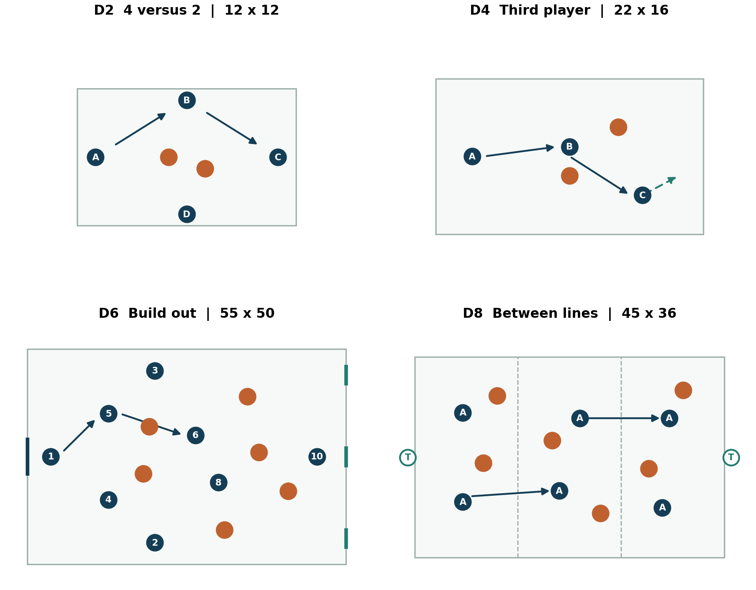
Diagram key: filled blue circles are the possession team; orange circles are defenders; outlined circles are targets or neutrals as labeled. Solid arrows show passes, dashed arrows show player movement, and shaded strips show reference zones. Arrows illustrate a possible solution; defenders remain free to change it.
D2: outside players create new angles along the square, with defenders pressing and covering. D4: the central receiver sets to a supporting third player when turning is blocked. D6: the keeper can play through, around or beyond the press; the main goal makes turnovers consequential. D8: the middle receiver uses space between lines, then the final game removes zone restrictions.
Set up before players arrive: mark outer dimensions first, add reference zones second, place goals and spare balls third, then assign pinnies. Walk the first attack and the defensive counterattack so both teams know where and how to score.

Practice layouts for chances and transitions
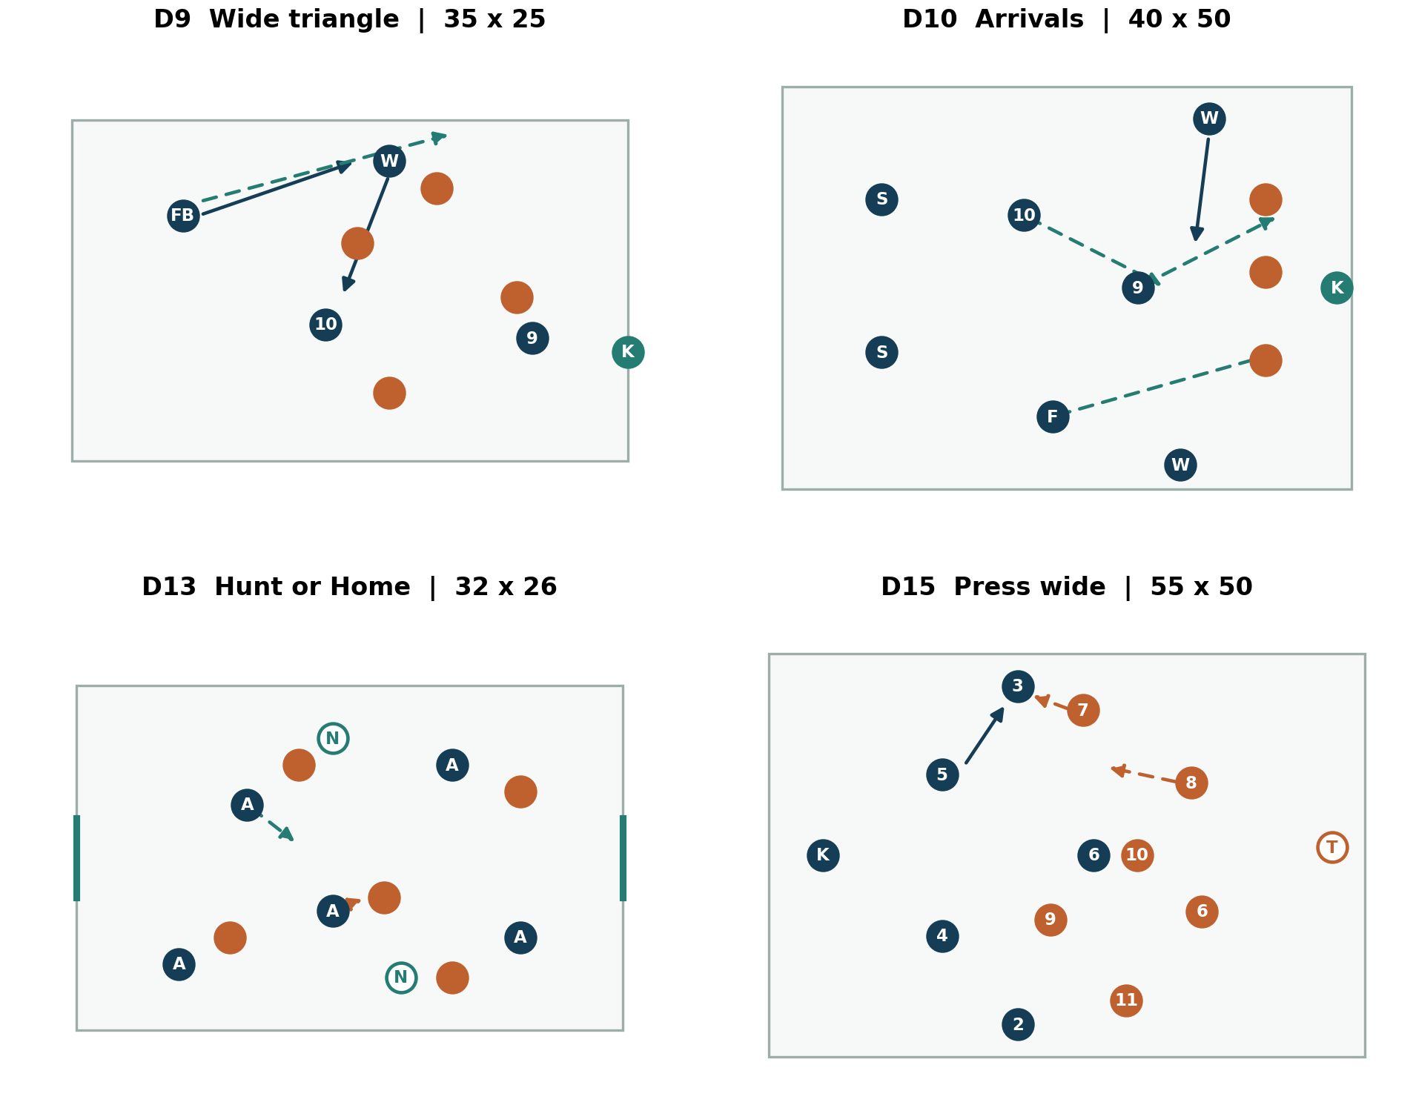
D9: three wide attackers combine while one protects behind and the striker provides depth. D10: three runners attack complementary spaces rather than forming a line on the goalkeeper. D13: after loss, pressure and cover decide whether to Hunt; the goal routes make an unsupported chase costly. D15: the near winger jumps as the wide pass travels, with the inside pass screened.
Field adaptation: diagrams preserve relationships rather than promise exact scale. Use the dimensions and player totals in the individual practice cards. If space shrinks, shorten passing distances and reduce players rather than crowding a full-size game into a narrow strip.
Coach positioning: stand where the key decision is visible. Behind the receiver reveals scanning; behind the press reveals cover shadows; beside the box reveals arrival timing; behind the attacking team reveals counterattack protection. Move during the exercise and avoid blocking a passing lane.

Session S1 establish the identity

Ninety minutes for early preseason
Objective: players scan, create support angles, and respond after a loss. Players and equipment: 18-22 players, one ball each if possible, two goals, pinnies, flat cones and spare balls. With fewer players, use multiple small areas and a reduced final game. Time slots include explanation, water and transitions; use the listed number of rounds rather than trying to fit every library variation.
Clock | Activity | Implementation
0 to 15 | Progressive preparation | Movement routine then passing on the move
15 to 25 | D1 scanning | Two four-minute blocks and brief feedback
25 to 37 | D2 rondos | Four short rounds; rotate defenders deliberately
37 to 52 | D4 third player | Three three-minute games with teaching and water
52 to 74 | D21 team game | Three six-minute blocks with two-minute intervals
74 to 85 | D19 throw-ins | Two four-minute rounds plus demonstrations
85 to 90 | Cool-down and reflection | Players describe one useful scan and next action

Before play: demonstrate a receiver turning into pressure, then replay with a set pass and moving third player. Keep the demonstration under 45 seconds. State three calls: Reset, Hunt, Home.
During the final game: observe only support angles and the first response to losing the ball. In block one, allow play to flow and record a baseline. In block two, give one intervention. In block three, remain quiet for several minutes to see what players retain.
Success check: sample ten receptions and ten turnovers. Record whether the first touch had a useful purpose and whether nearby players reacted together. Choose one team priority for the next session; do not score all 18 techniques at once.
If limited to 75 minutes: use 15 preparation, 8 D1, 10 D2, 12 D4, 20 final game, 5 throw-ins and 5 reflection. If limited to 60: use 12 preparation, 8 D1, 10 D2, 10 D4, 15 game and 5 reflection. Extend preparation if needed by shortening another activity.

Session S2 build out with three routes

Ninety minutes for goalkeeper and back line connections
Objective: recognize when to play through, around or beyond pressure. Players: ideally 20-22. Run a parallel D4 or keeper distribution group for players outside the D6 fourteen-player block. Swap groups so all receive coached repetitions. Main cues: "Show the next pass" and "Short if useful; beyond if closed."
Clock | Activity | Implementation
0 to 15 | Progressive preparation | Receiving and passing included at the end
15 to 25 | D23 quality acceleration | Four efforts each with full recovery
25 to 35 | D4 third player | Two short blocks with turn-or-set choices
35 to 53 | D6 build-out | Three four-minute games with role and route coaching
53 to 75 | D21 team game | Three six-minute games and two-minute intervals
75 to 85 | D19 defensive-third throw | Two short live blocks with a safe reset option
85 to 90 | Cool-down | Players name their first and second build-out options

First D6 block: pressers begin in a compact line that makes central passes difficult; builders may use fullbacks. Second block: pressers take away fullbacks; builders seek the staggered pivots or play beyond. Third block: pressers choose freely. This produces decisions rather than a rehearsed passing dance.
Longer exit: organize 9 at the target, 10 beneath, near winger beyond and pivots around the second ball. The goalkeeper announces the target area; defenders advance while respecting the opponent's depth threat.
Success check: ten build-up starts, controlled exits, useful longer contacts, and shots conceded from central turnovers. A successful exit requires a controlled next action, not merely passing over a cone line.
75 minutes: 15 preparation, 8 speed, 8 D4, 16 D6, 18 game, 5 restarts, 5 reflection. 60 minutes: 15 preparation, 8 D4, 15 D6, 17 game, 5 reflection. In congested weeks omit the speed block and prioritize tactical clarity.

Session S3 connect the double pivot and the ten

Ninety minutes for midfield progression
Objective: receive at different heights, use a third player and keep protection behind the ball. Players: 18-22 with parallel grids. Equipment: cones for thirds, pinnies in three colors, goals and spare balls. Main question: "Can the next player face forward?"
Clock | Activity | Implementation
0 to 15 | Progressive preparation | Hip movement and receiving across the body
15 to 25 | D2 passing angles | Short rounds with free touches initially
25 to 40 | D7 double pivot | Three three-minute blocks, rotate pivot pairs
40 to 58 | D8 between lines | Three four-minute blocks and concise interventions
58 to 80 | D21 team game | Three six-minute blocks with two-minute intervals
80 to 85 | Quick restarts | Throw-in to pivot and a supported reset
85 to 90 | Reflection | Pivots explain who covers when the other advances

D7 coaching: when both pivots are hidden behind one opponent, freeze the picture for ten seconds. Move one player two or three yards diagonally, ask how the angle changed, then replay. Avoid pulling both pivots back alongside the center backs unless the opponent's press requires that adaptation.
D8 coaching: reward controlled receptions and useful set passes. If defenders block the middle, allow a switch around them. Remove the zones for a final short block within the allotted time so players must find the pockets themselves.
Team game: first block focuses on 6 and 8; second on 10 finding the far shoulder; third is free play. Ask an assistant to record five clips showing good or missed opportunities, including at least two positive examples.
Success check: useful staggering in seven of ten sampled possessions and fewer unsupported central turnovers than the previous session. If performance falls with live pressure, revisit D7 with one fewer defender before increasing complexity.
75 minutes: 15 preparation, 8 rondo, 12 D7, 15 D8, 20 game, 5 reflection. 60 minutes: 15 preparation, 10 D7, 12 D8, 18 game, 5 reflection.

Session S4 create wide advantages and cutbacks

Ninety minutes for final third execution
Objective: produce a wide advantage, attack different finishing lanes and retain counterattack coverage. Players: 18-22; run D12 in parallel for players not active in the wide group. Equipment: full-size goals, mini-goals, pinnies and flat reference cones.
Clock | Activity | Implementation
0 to 15 | Progressive preparation | Include passing, balance and controlled strikes
15 to 25 | D12 winger decisions | Three short rounds with adequate recovery
25 to 40 | D9 wide triangle | Three four-minute blocks, alternate sides
40 to 58 | D10 cutbacks | Three four-minute blocks with role changes
58 to 80 | D21 team game | Three six-minute games and two-minute intervals
80 to 85 | Finishing review | Few quality repetitions with safe keeper workload
85 to 90 | Reflection | Identify the holding player on each side

D9 detail: teach the winger to hold width while the fullback reads the defender. If the defender blocks outside, underlap or bounce inside; if the winger dribbles inward and the outside lane opens, overlap. If neither route opens, retain. Require the designated holding player to affect the defensive counter.
D10 detail: have runners start outside their eventual target spaces. Player 9 changes speed toward the near-central route; the far winger checks the line before moving far; 10 arrives later. Let defenders deny the preferred route so the server learns to select the actual free player.
Final game: our team builds into the left-sided 3-2-5 for one block, mirrors right for one block and chooses freely in the last. The advanced fullback must be accompanied by the opposite fullback narrowing behind.
Success check: ten wide attacks: controlled box entries, distinct arrival lanes, clear shots and counters conceded. One useful shot with good balance is better evidence than several forced crosses.
75 minutes: 15 preparation, 8 duels, 12 D9, 15 D10, 20 game, 5 reflection. 60 minutes: 15 preparation, 12 D9, 12 D10, 16 game, 5 reflection.

Session S5 choose Hunt or Home

Ninety minutes for transitions
Objective: react together after loss and recover centrally when the first press is beaten. Players: 18-22 in parallel games and transition groups. Main cues: "Nearest affects the ball" and "Cover before chase." The physical demand can be high; use this away from matches when possible.
Clock | Activity | Implementation
0 to 15 | Progressive preparation | Include braking, lateral movement and passing
15 to 25 | D15 trigger rehearsal | Two four-minute blocks and a brief walk-through
25 to 41 | D13 Hunt or Home | Four three-minute rounds and short recoveries
41 to 57 | D14 defensive transition | Three four-minute blocks and recovery intervals
57 to 80 | D21 team game | Three six-minute blocks with feedback and water
80 to 85 | D19 pressured restart | One short live block
85 to 90 | Cool-down | Players describe one correct recovery decision

First D13 instruction: the ball winner has a choice to counter or retain. This stops the losing team from knowing the answer in advance. The first defender guides; the next two protect the direct escapes. End the hunt early if the opponent faces forward beyond the pressure.
D14 instruction: a recovering defender who sprints straight toward the ball may leave the goal route open. Stop one example, show the inside recovery path, then replay with the same attackers. Praise a delay that lets teammates recover even when no tackle occurs.
Final game: give no bonus for a regain if the team conceded an immediate open route behind the press. Observe whether the 3+2 structure was present before the loss. Repositioning before a turnover is often the best transition correction.
Success check: shared decisions out of ten losses, unsupported chases, clear counters conceded and attacks delayed until help arrives. Ask players what made each Hunt possible.
75 minutes: 15 preparation, 8 press, 14 D13, 12 D14, 21 game, 5 reflection. 60 minutes: 15 preparation, 12 D13, 12 D14, 16 game, 5 reflection. Reduce rounds if recovery or movement quality deteriorates.

Session S6 defend direct and wide attacks

Ninety minutes for block and box organization
Objective: control landing zones, protect the cutback and defend the far-post runner. Players: 18-22, with D17 in parallel if the D16 group uses 17. Preparation: confirm heading instruction and medical procedures; use manageable service and avoid fatigue-driven aerial volume.
Clock | Activity | Implementation
0 to 15 | Progressive preparation | Include controlled landing and change of direction
15 to 27 | D17 first and second ball | Three short blocks with varied safe service
27 to 47 | D16 block and box | Three five-minute blocks plus feedback
47 to 62 | D15 pressing decisions | Three short blocks with an abort and recovery
62 to 80 | D21 game | Two eight-minute games with two-minute interval
80 to 85 | Defensive corner walk-through | Assign roles and one substitution
85 to 90 | Reflection | Each defender names the nearest coverage partner

Block instruction: wide midfielder approaches from inside, fullback protects the runner and crossing lane, pivots close central passes, far winger narrows. Back line drops when the passer can play behind, then squeezes when a pressured backward pass lets the group advance.
Box instruction: defenders check both ball and runner; a pivot owns the likely cutback space while remaining responsive to actual attackers. The goalkeeper calls early. If two defenders follow one striker, clarify the exchange and replay before adding more opponents.
Direct-ball instruction: one contests when safe, one covers depth, midfield supports the second ball. Players must communicate before the ball arrives. Do not grade the exercise only by the first header.
Success check: first-contact quality, controlled second balls, unmarked far-post arrivals and uncontested cutback shots. Keep these separate so a failure in one area does not hide behind a general "defending" score.
75 minutes: 15 preparation, 10 second balls, 18 block, 10 press, 17 game, 5 reflection. 60 minutes: 15 preparation, 8 second balls, 15 block, 17 game, 5 reflection.

Session S7 rehearse competition situations

Ninety minutes for restarts and match decisions
Objective: execute named restart assignments and adapt to score, time and substitutions. Players: full squad. Equipment: score board, visible clock, goals, match balls and role cards. Before the session, confirm that practice scenarios follow the actual competition's rules.
Clock | Activity | Implementation
0 to 15 | Progressive preparation | Finish with short passing and controlled strikes
15 to 25 | D3 connection game | Two short rounds and changes of connector
25 to 43 | D20 restarts | Three five-minute blocks with role feedback
43 to 62 | D22 clock challenges | Four four-minute games and one-minute intervals
62 to 80 | D21 game | Two eight-minute blocks and two-minute interval
80 to 85 | Penalty routine | Limited high-quality individual practice
85 to 90 | Reflection | Players state their first job after entering as a substitute

Restart block one: attacking corner A and its counterattack protection. Block two: defensive corners and clearances. Block three: a wide free kick plus the opponent's immediate counter. Announce a substitution and require players to exchange responsibilities before the ball is served.
Clock challenges: leading team keeps at least one outlet and protects central transitions; trailing team adds pressure and a named runner without sending every player forward. The team with a numerical disadvantage practices a compact response and safe exit.
Penalty practice: establish the player's chosen target, approach and reset routine before adding pressure. Rotate and recover balls; avoid a prolonged shootout that leaves keepers facing excessive service. Practice the full administrative and order process separately once the actual playoff procedure is confirmed.
Success check: assignment errors after substitutions, restarts producing useful first contact, disciplined score-state choices and clarity of penalty roles. Evaluate process even when a practice penalty is missed.
75 minutes: 15 preparation, 8 D3, 15 restarts, 17 situations, 15 game, 5 reflection. 60 minutes: 15 preparation, 15 restarts, 15 situations, 10 game, 5 reflection.

Session S8 sharpen before a playoff match

Sixty minutes on the day before competition
Objective: leave players clear, confident and physically ready. Use familiar actions and reduce total work. This is an example taper session, not a fixed prescription for athletes with different workloads or restrictions.
Clock | Activity | Implementation
0 to 15 | Progressive preparation | Familiar movement routine and sharp passing
15 to 23 | Short D2 or D3 | Two or three lively rounds with generous recovery
23 to 35 | Two key team patterns | Build-out escape and wide entry, opposed at controlled volume
35 to 45 | Restart rehearsal | One attacking and one defensive routine with backups
45 to 53 | Short game | Two three-minute games with two-minute recovery
53 to 57 | Penalty and finishing routine | Small number of chosen quality repetitions
57 to 60 | Team brief | Starting plan, first adjustment and next-day logistics

Two patterns only: rehearse the route most likely to defeat the opponent's press and the chance-creation pattern our players execute best. If a correction requires an entirely new system, save it for a longer training cycle. A playoff preparation session should consolidate learning.
Confidence comes from clarity: each player states a first task with and without the ball. The substitute knows which position and restart responsibility may become theirs. The goalkeeper knows the short and longer exits. Captains know how to call Home when the press cannot be supported.
Before leaving: confirm arrival time, travel, equipment, food and hydration plans under school guidance, and the next communication point. Staff check opponent notes and rule procedures privately so players receive a focused message.
If only 45 minutes: 12 preparation, 6 connection game, 10 patterns, 9 restarts, 5 finishing and 3 brief. If players need a longer warm-up, shorten the ball work accordingly. Do not add conditioning because the shorter session feels too easy.
Readiness check: ask three players at random to explain the first press trigger and the longer build-out target. If their answers differ, clarify the plan once for the whole group. Finish with a familiar successful action rather than an exhausting contest.

Attacking corners with counterattack protection
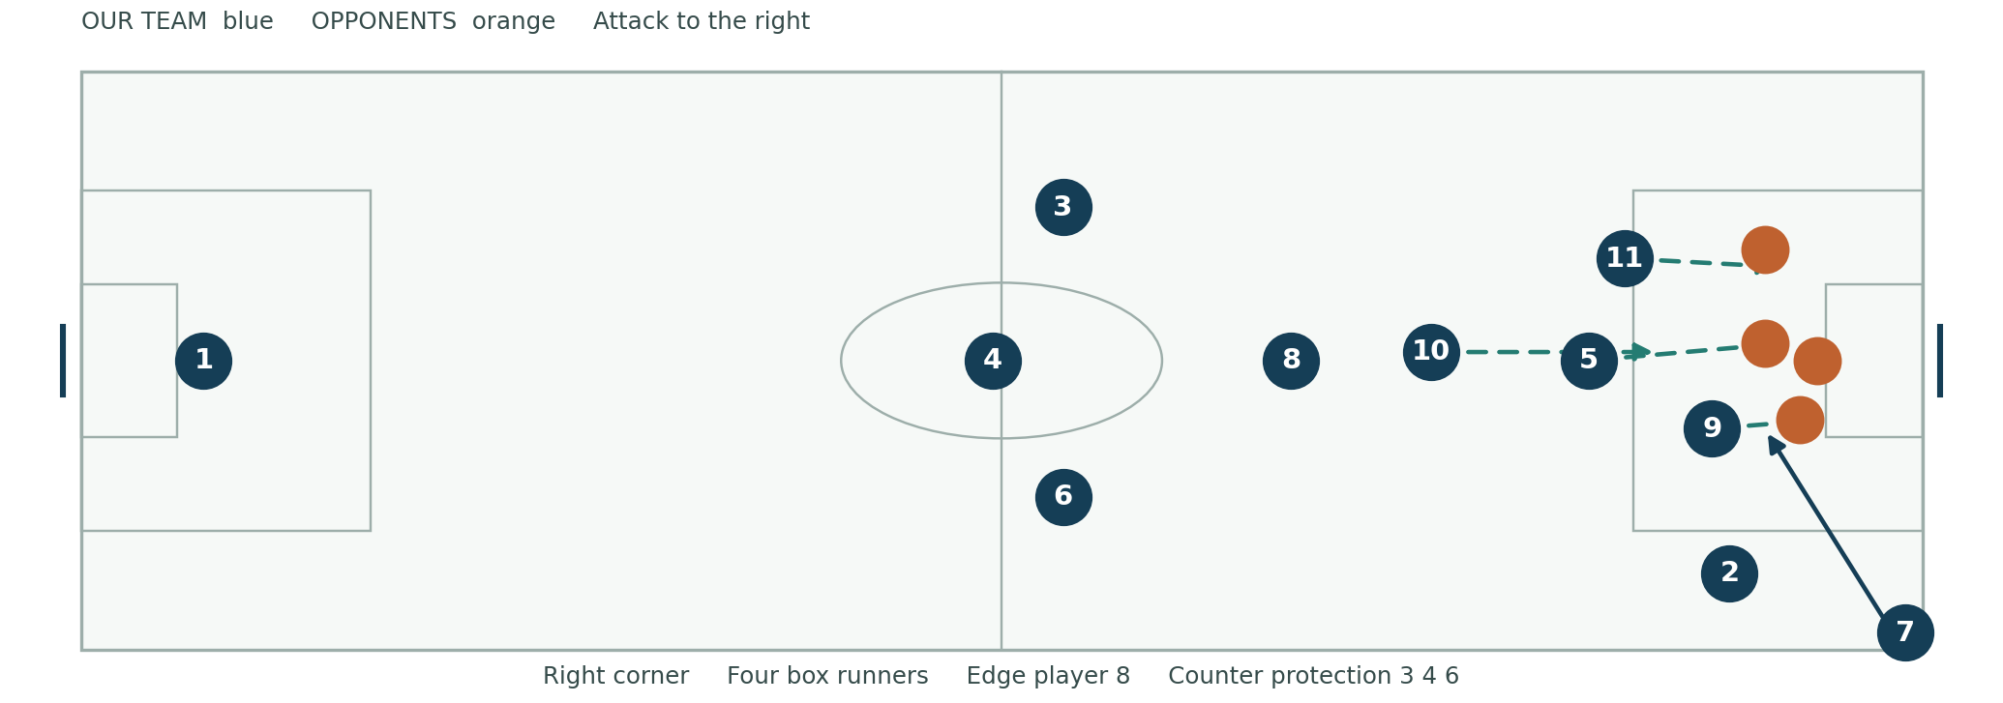
Corner A from our attacking right: 7 takes; 2 offers short. In the box, 9 attacks a near-central route, 5 attacks central space, 11 attacks far space, and 10 arrives later. Player 8 stays near the edge for the second ball. Players 3, 4 and 6 protect the counter. Player 1 remains in goal with an appropriate covering position. The ten outfield assignments are complete.
Execution: start the runs when the taker begins the approach, with timing adjusted to delivery speed. Runners create separation through movement, not illegal holding, screening or pushing. The taker selects the trained target area based on the defense and service ability. If defenders crowd the main zone and leave 2 free, use the short option and combine before crossing.
Second phase: 8 reads the clearance and either shoots with a clear lane, recycles to the free side, or protects a developing counter. The three cover players identify the opponent's outlets before delivery. If three dangerous opponents stay high, add a fourth protective player and reduce a box run.
Mirror from the left: 11 takes, 3 offers short, 7 becomes the far-side box runner, and 2 replaces 3 in protection; other assignments remain. Rehearse both sides and backups. In D20, keep the counter live so the covering players learn a real task.

Defend corners with explicit assignments
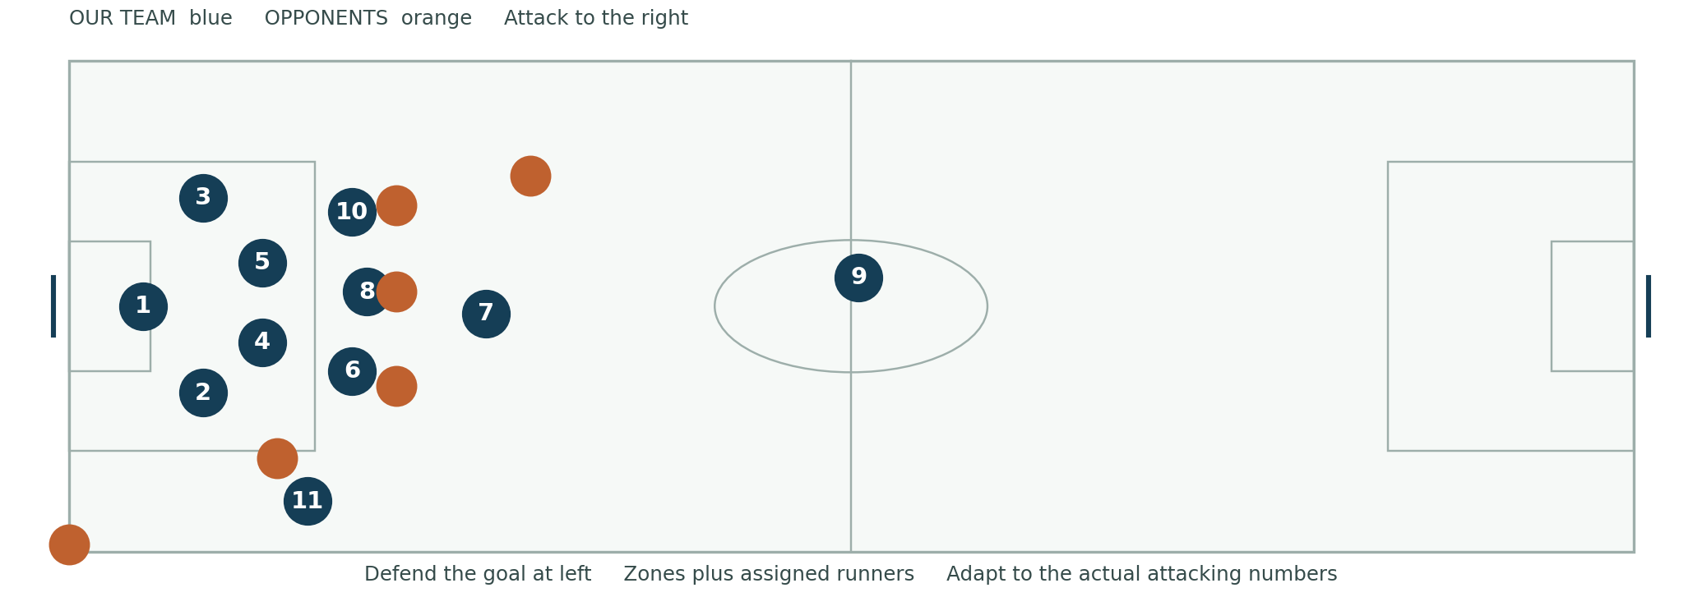
Starting hybrid example: 1 organizes and claims when appropriate. Players 4 and 5 protect central goalmouth zones; 2 protects the near corridor; 3 controls the far corridor. Players 6, 8 and 10 track three designated dangerous runners. Player 7 begins near the edge to contest a clearance, 11 covers the short option, and 9 provides an outlet. This accounts for ten outfield players. Adjust immediately if the opponent's actual numbers or movements require it.
Before service: the captain and keeper identify the short option, primary aerial threats, near run and edge shooter. Each player checks ball and opponent. If the opposition sends more runners into the box, 7 or 9 must help; preserving an outlet does not justify leaving a clear threat unmarked.
On delivery: attack the ball when it enters the assigned reachable space, communicate, and keep arms legal. Markers stay aware of movement without holding. The keeper calls clearly; defenders do not stop competing on an uncertain shout. On the far side, defend the runner and the ball rather than standing beside the post and watching.
After clearance: 7 pressures the next receiver if able, midfield pushes out together, and the line follows only when the ball is controlled or pressured. If a shot or pass can come immediately, protect goal and depth first. On the opponent's short corner, 11 delays and a designated nearby defender supports; the remaining group adjusts to the reduced box numbers.
Training test: run six corners with changing runners, one short corner and one substitution. Log unassigned threats, first contact and second-phase shots. Fix an assignment error before demanding greater bravery.

Free kicks throw ins and penalty routines

Attacking wide free kick
Use a taker, three or four timed runners, an edge receiver and named counter protection. Check the offside line before delivery; a free kick is not a corner. The taker signals the target zone, and runners delay until the service cue. A short pass is valid when it creates a clearer chance than lofting into a prepared defense. Train the clearance and counterattack as part of the same repetition.

Defensive free kick
The goalkeeper sets the wall according to the angle, distance and actual shooting threat. The captain confirms markers and the short option. Defenders protect runners and depth rather than stepping blindly. Follow the applicable required distance and referee instructions. Establish who attacks a rebound and who tracks a far-side runner. Practice both a shot and a disguised pass from the same starting picture.

Three throw in calls
Short: receiver checks away, then returns at an angle with inside support. Return: receiver sets back to the thrower after legal re-entry; a third player offers forward. Channel: one receiver pulls short while another runs down the line. Keep an option behind the ball when field position permits. In our defensive third, retain or clear to a planned channel; avoid a blind throw into the center under pressure.

Individual penalty routine
Pick a practiced target and approach, take a normal settling breath, focus on the intended strike and complete the chosen routine. Train consistency before adding teammate noise or a score challenge. Goalkeepers establish a repeatable preparation routine and follow the competition's line and movement requirements. Do not encourage interference, delay or unsafe conduct.
Shootout preparation: designate a provisional order, alternates and goalkeeper contingency; check the actual eligibility, substitution, tie-breaking and sudden-death procedures before the match. Rehearse the administrative sequence and waiting behavior as well as the kicks. The penalty miss is a team event; no public blame or punishment.
Backup standard: every set-piece role has a second player. Before a substitute enters, identify the position, marking assignment, restart job and first transition responsibility. Put these on a single staff role sheet.

Adapt to the opponent without losing the identity
Opponent pattern | Our response | What to watch
Two high strikers | Use goalkeeper and staggered pivots; create a spare defender; keep fullbacks reachable | Pass into a pivot who can turn or set
One striker and packed midfield | Center back carries to commit a midfielder; 10 moves behind that midfielder | Carry must have cover behind
Aggressive player-to-player press | Use third player, coordinated exchanges or a prepared longer channel | Do not force short possession into a locked receiver
Low narrow block | Hold width, switch quickly, isolate winger and vary overlap or underlap | Preserve central counterattack cover
Direct fast forwards | Protect depth, pressure the passer, organize landing and second ball | A high line without pressure invites a race
Back three with wingbacks | Test space behind wingback, pin outside center back, press selectively | Wide presser needs cover for both inside and outside outlets

Opponent plan should fit on one page: identify their first build-out route, main chance creator, highest transition threat, defensive weakness and strongest restart. Select one pressing trigger and two attacking solutions. Give players observable cues rather than a long description of the opponent's formation.
Against a stronger opponent: keep central distances manageable, use a midblock, and press the moments we can support. Retain the first pass after a regain when a counter is not truly available. A well-prepared longer exit can relieve pressure and create territory without abandoning the identity.
Against a weaker opponent: avoid pushing both pivots and fullbacks forward because the opponent has been passive. Increase circulation speed, carry to commit and keep five useful attacking lanes. Set goals for clear chances and protected attacks, not just possession percentage.
If our first plan fails: determine whether the problem is execution or the opponent's structure. A bad first touch needs a technique correction; an opponent marking every short outlet may require a different route. Make one change, observe several possessions, then reassess. Never add three tactical instructions because one pass went wrong.

Manage score time and numerical changes

Protect a lead
Keep an outlet and use possession where the next pass is supported. Advance a fullback selectively, protect central transitions and avoid unnecessary fouls near the box. Fresh wide players can preserve pressure and recovery speed. A 4-4-1-1 is still the default; a deeper block should be a deliberate adjustment rather than an uncontrolled retreat.
Final minutes: play toward useful wide areas with support, take legal restarts with clear decisions, and maintain concentration on second balls. Avoid aimless central clearances that immediately return. If the opponent overloads the box, assign extra tracking help and retain a realistic exit.

Chase a goal
Increase the press only if the team can support it. Move 10 closer to 9, add a late runner and create quicker wide entries. If switching to a 4-4-2, state exactly who partners 9, who occupies both wide roles and which two players protect midfield. A useful example is 10 joining 9, 7 and 11 wide, 6 and 8 central, back four retained.
Last attacking restart: sending an extra player forward is a conscious risk decision based on score and remaining time. Name the counter protection. Players should know the tradeoff before the taker begins.

Play with ten players
Start with 4-4-1 if protecting central space is the priority: back four, two central midfielders, two wide midfielders and one striker. If the missing role is not already a midfielder, make the necessary exchange. The striker directs the ball rather than chasing both center backs. Press in short supported moments, protect the far post and use a clear outlet.

Play against ten players
Use width and quick circulation to create the free player. Stay patient without slowing every action. Keep protection behind attacks and avoid reducing the game to repeated crowded crosses. The extra player should create a positional advantage, not an excuse to abandon structure.
Practice: D22 rehearses the decision process. In the full-team game, use actual match personnel so each adjustment accounts for every player. State a return-to-base call if the tactical change is no longer needed.

Coach match day with a clear process

Before kickoff
Staff: confirm lineup and role backups, restrictions communicated by medical staff, opponent plan, restart assignments, substitutions, and emergency contacts. Check goals, surface and equipment through the school's normal procedures. Agree which assistant observes build-out, transitions and restarts. With one coach, track only two themes.
Example 30-minute preparation: 0-8 progressive running, mobility and ball touches; 8-15 passing and controlled directional work; 15-21 brief accelerations and small combinations; 21-26 position actions and a few controlled finishes; 26-30 calm team brief and organization. Goalkeepers follow a coordinated preparation with suitable handling and distribution, without excessive shots. Adjust length for athlete needs and weather.
Team brief: give the build-out route, press trigger and main defensive threat. Ask a captain to repeat the plan. Keep tactical detail for trained patterns; match day is too late to teach a new formation from scratch.

During play
Use short, familiar calls. Track whether the team can exit pressure, create clear chances and protect transitions. A substitute receives four tasks: position, nearest support partner, pressing or recovery job, and restart assignment. Follow the actual substitution and re-entry rules rather than importing professional match limits.

At halftime
Give players a moment to settle and hydrate. Ask one question about the game picture, name two things working, and give one or two actionable corrections. Show the correction on a small board. Confirm the first action after the restart and all changed roles. Keep staff discussion away from the players' limited recovery time.

After the match
Give a brief factual response, acknowledge effort and leave detailed analysis until emotions settle. Collect minutes and any health concerns through school procedures. During the next review, use a small number of clips and choose the next practice priority.
Coaching language: replace "stop losing it" with "show the pivot a diagonal option before the pass." Replace "work harder" with "recover inside, then find the runner." The instruction should describe an action the player can execute.

Build a CIF playoff run

Four weeks before the expected postseason
Prioritize availability, role clarity, restart reliability and the team's most productive patterns. Use the actual section calendar to place this phase. Keep the 4-2-3-1 base familiar and rehearse the adjustments that are likely to be needed in close matches.
Run-in stage | Training priority | Staff task
Four weeks out | Fix the most costly recurring match error | Review ten examples and choose one corrective practice
Three weeks out | Opponent variety and role backups | Give substitutes meaningful repetitions in expected roles
Two weeks out | Close games and restarts | Rehearse leading, trailing, short-handed and penalties
Final league week | Preserve intensity with less unnecessary volume | Confirm eligibility, availability and section deadlines
Between playoff rounds | Recover, review, rehearse and sharpen | Keep the opponent plan brief and update assignments

Between rounds with about 72 hours: immediately after the match, start school-approved recovery and record minutes; next day, separate recovery needs from nonstarter work; the following session, rehearse only the opponent's key picture and our best solutions; before the next match, prioritize readiness. The athletic trainer and actual schedule determine individual participation.
Scouting priorities: identify how the opponent exits a press, where it creates its best chances, which player runs behind, how it defends the far side, and what it does on corners and long throws. Watch repeated sequences rather than one highlight. Note the source and uncertainty of each observation.
Taper principle: remove extra repetitions before removing familiar game speed. Use fewer well-rested actions, short tactical games and rehearsed restarts. Avoid introducing a hard new fitness test or unfamiliar strength work during the run-in.
Championship behavior: respond to an early goal, missed chance or disputed decision with the next role. Captains organize teammates; substitutes remain prepared; staff keep communication calm. The team's identity should remain visible when the game becomes uncomfortable.
Controllable targets: fewer unprotected turnovers, better clear-chance quality, reliable restart coverage, and substitutes who execute immediately. These support winning; they do not guarantee a bracket result.

Confirm the CIF competition requirements

Complete with the athletic director for the actual section and season
CIF sections and competition levels can use different calendars and postseason procedures. Keep this operational sheet with the current official bulletin. If coaching Christian Unified in the San Diego Section, confirm the San Diego documents; do not substitute Southern Section instructions. This manual does not prescribe playoff dates or a universal overtime format.
Item to confirm | Record the approved answer | Owner
First legal practice and contest dates | __________________________ | Athletic director
Practice limits and what activities count | __________________________ | Athletic director
Eligibility clearance and transfer status | __________________________ | Athletic director
Outside competition and club conflicts | __________________________ | Athletic director
League schedule and qualification process | __________________________ | Head coach and AD
Division placement and seeding procedures | __________________________ | Head coach and AD
Roster submission and reporting deadlines | __________________________ | Team administrator
Match length clock and tie procedures | __________________________ | Head coach and officials
Overtime penalties and eligible kickers | __________________________ | Head coach and officials
Substitutions re-entry and injury removal | __________________________ | Head coach and officials
Cards ejections and suspension reporting | __________________________ | Athletic director
Venue equipment staffing and travel | __________________________ | Host and AD
Emergency heat air quality and medical plans | __________________________ | AD and athletic trainer

Current rules point: the 2026-27 NFHS changes extend goalkeeper possession from six to eight seconds and change exceeding that limit to a corner kick. Train prompt decisions after a secure catch; do not teach an outdated six-second rule or rely on professional broadcast habits. Use the current rulebook and local interpretations for full application. [10]
Reviewed season and section: ____________________ Bulletin date: __________ Staff approval: ____________________ Update this sheet when the bulletin changes.

Coach learning rather than constant dependence

A repeatable feedback cycle
Observe: watch several actions before deciding what is wrong. Diagnose: separate perception, decision, execution and team support. Intervene: give one specific cue or show one picture. Replay: recreate the situation immediately. Retest: observe later without prompting. A player who succeeds only when the coach calls the answer has not yet learned to recognize it.
Example: the pivot loses the ball while turning. Ask what pressure was seen. If the scan was missing, teach the information habit. If the scan was good but the first touch was poor, teach contact and body angle. If no support existed, fix teammates' positions. Different causes require different corrections.
Choose the right intervention: a five-second comment while play continues can correct a familiar detail; a short freeze can expose a positional problem; a guided replay can teach timing. Stop the whole group only when the problem is shared. Avoid a two-minute lecture after every turnover.
Questions that improve decisions: "What made that pass possible?" "Who protected behind your run?" "What changed when their defender stepped?" Allow a brief answer, then test it physically. Use questions to reveal understanding, not to embarrass a player who made an error.
Differentiate: developing players get more space, predictable service and a clear first choice. Intermediate players get a live defender and two options. Advanced players get less time, an unpredictable transition and responsibility to support teammates. Every group eventually returns to a representative game.
Progress only one major variable at a time: reduce space, add pressure, speed up service or increase decision options. Changing all four at once can make failure impossible to diagnose. If the exercise produces repeated uncontrolled turnovers, restore enough success for learning, then rebuild pressure.
Leadership: rotate who explains the drill, organizes a line or leads reflection. Captains can reinforce shared calls, but coaches retain responsibility for instruction and student welfare. Praise evidence: "You held while the fullback went, so we stopped the counter."
Weekly staff review: select one team improvement and one individual action per player group. The next practice should show what the review changed.

Build individual player progression

Use a four stage learning ladder
Stage | Evidence | Suitable practice
1 Understand | Player explains and demonstrates slowly | Short demonstration and predictable service
2 Execute | Action repeats with manageable pressure | Technique card and reduced opposition
3 Decide | Player selects the action against live choices | Small-sided game with realistic alternatives
4 Transfer | Action appears without prompts in competition | Free game and match clips

Six-week example for a developing pivot: weeks 1-2, improve shoulder checks and the first touch in D1; weeks 3-4, choose turn or set against live pressure in D7; weeks 5-6, maintain useful support and decisions in D21 and match clips. A player advances when the evidence supports it, not simply because two weeks passed.
Goal design: choose one observable behavior, a baseline, a practice, a review date and a transfer check. Example: "Across the next ten sampled receptions in live play, choose a useful turn or set at least seven times, then repeat it in a second session." If the current baseline is three, target five first. Avoid treating an arbitrary threshold as a universal talent standard.
Two-week conference: player describes one strength and one difficulty; coach shows one successful and one missed example; they agree on one cue and two practice opportunities; schedule a brief retest. Keep the written plan short enough for the player to remember.
Feedback for substitutes: use the same ladder. A player who rarely plays needs planned game exposure and a specific task, not only encouragement. Use training film or controlled matches when competitive minutes are limited.
Signs to pause progression: repeated poor movement, no useful decision after scanning, confusion about scoring, or loss of concentration. Simplify the task, restore recovery and check understanding. If pain or health concerns appear, follow medical staff direction.
End of season: compare the first and latest match samples, identify one role the player improved, and set two realistic offseason priorities within school rules. Preserve evidence of growth beyond goals and assists.

Player evaluation and development form
Player ____________________ Grade ______ Date __________ Evaluator ____________________
Primary role __________ Secondary role __________ Observed minutes ______ Context ____________________
Criterion | Weight | Rating 1 to 5 or N O | Specific observed action
Technique under pressure | 25 | __________ | __________________________
Perception and decisions | 25 | __________ | __________________________
Tactical contribution | 20 | __________ | __________________________
Physical execution | 15 | __________ | __________________________
Coachability and team behavior | 15 | __________ | __________________________

Weighted score: sum rating / 5 x weight = ______ / 100. Complete missing observations before calculating. Position fit and context notes: ______________________________________________________
Evidence sample: situation and opponent ____________________ action seen ____________________ outcome ____________________ repeated on another day ____________________
Current learning stage: Understand / Execute / Decide / Transfer
One demonstrated strength: ______________________________________________________
One priority action: ______________________________________________________
Baseline and target: ______________________________________________________
Practice and cue: ______________________________________________________
Two planned opportunities: 1 ____________________ 2 ____________________
Review date: __________ Transfer evidence to collect: ____________________
Player reflection: What do I need to notice before the action? ____________________
Next review result: ______________________________________________________
Coach reminder: record concrete actions and the conditions in which they occurred. Keep health information in the school's appropriate confidential system, not on a publicly shared selection form.

Practice planner and observation form
Date __________ Session __________ Players ______ Staff ______ Available area ____________________
One team objective: ______________________________________________________
Two player actions that show it: 1 ____________________ 2 ____________________
Main cue: ____________________ Question: ____________________
Clock | Activity and player count | Setup and scoring | Main observation
______ | ____________________ | ____________________ | ____________________
______ | ____________________ | ____________________ | ____________________
______ | ____________________ | ____________________ | ____________________
______ | ____________________ | ____________________ | ____________________
______ | ____________________ | ____________________ | ____________________
______ | ____________________ | ____________________ | ____________________

Equipment and setup: ______________________________________________________
Simpler version: ____________________ Harder version: ____________________
Rotation and waiting time plan: ______________________________________________________
Goalkeeper plan: ______________________________________________________
Restricted or separate work directed by staff: _________________________________
Sample to record: action ____________________ successful ____ attempts ____
Transfer test in the final game: ______________________________________________________
Postsession reflection: What changed after the intervention? ____________________
What remains unclear? ______________________________________________________
What will change next session? ______________________________________________________
Load record: duration ______ minutes x effort rating ______ = ______ arbitrary units. Record individual differences when useful. Use with observations and staff input; do not use one number as a medical readiness decision.

Match dashboard and role sheet
Opponent ____________________ Date __________ Competition ____________________
Our starting route: ____________________ Press trigger: ____________________
Their main threat: ____________________ Our first adjustment: ____________________
Indicator | Us | Opponent | Definition for the observer
Controlled build-out exits | ____ / ____ | ____ / ____ | Reach a target beyond first press and retain next action
Controlled box entries | ____ | ____ | Carry or receive inside box with usable control
Clear chances | ____ | ____ | Chosen team definition of unobstructed close scoring opportunity
Transition chances conceded | ____ | ____ | Opponent chance before our block reorganizes
Unprotected central losses | ____ | ____ | Central loss with inadequate immediate cover
Useful restart first contacts | ____ / ____ | ____ / ____ | Contact supports shot retention or safe clearance

Sampling: if observing ten events rather than the full match, label the totals as a sample. Agree on definitions before kickoff. Compare trends across similar contexts rather than claiming professional expected-goals precision from a hand count.
Responsibility | First player | Backup | Substitute notified
Corner taker and short option | __________ | __________ | __________
Corner counter protection | __________ | __________ | __________
Defensive main runner markers | __________ | __________ | __________
Defensive short corner | __________ | __________ | __________
Wide free kick and edge | __________ | __________ | __________
Penalty taker and alternate | __________ | __________ | __________
Emergency goalkeeper | __________ | __________ | __________

Halftime: keep ____________________ change ____________________ first action ____________________
Three film clips: strength __________ recurring problem __________ successful adjustment __________
Next practice priority: ______________________________________________________

Coaching references and evidence notes

Playing model and teaching principles
The material below distinguishes source-supported principles from this manual's original coaching design. Exercise dimensions, scoring systems, team calls, weekly timing and thresholds are adaptable recommendations. The sources do not validate a guaranteed route to a championship or endorse this exact 4-2-3-1 implementation.
1 UEFA EURO 2024 technical report
UEFA, September 16, 2024. Supports the discussion of winger width, fullback relationships and the tactical legitimacy of playing over a press. The manual adapts these observations rather than reproducing Spain's exact system.
https://www.uefa.com/uefaeuro/history/news/0291-1bde164db7c4-e4b2f7db6f83-1000--euro-2024-technical-report/
2 Spain 2 1 England midfield superiority analysis
UEFA, July 15, 2024. Explains changes in midfield positioning against close marking. Useful for coaching the relationship between an opponent's marking and the spaces that become available.
https://www.uefa.com/uefaeuro/history/news/028f-1b5f837d5c3f-65487261b9af-1000--spain-2-1-england-how-la-roja-s-midfield-superiority-made/
3 Playing and receiving in between opponents
FIFA Training Centre, March 12, 2024. Supports scanning, positioning on defenders' shoulders and receiving orientation. D1 and the technique cards are original adaptations with their own dimensions and progression criteria.
https://www.fifatrainingcentre.com/en/practice/talent-coach-programme/build-and-progress/passing-activation-playing-and-receiving-in-between-opponents.php
4 Midfielders receiving on the half turn
FIFA Training Centre. Supports the choice between turning and setting under pressure. Use it to study body orientation and awareness rather than requiring every receiver to turn.
https://www.fifatrainingcentre.com/en/practice/talent-coach-programme/build-and-progress/passing-circuit-midfielders-receiving-on-the-half-turn.php
5 Preparing and executing counter pressing
FIFA Training Centre, Anne Pochert session. Supports immediate pressure, closing escape routes and protecting against attacks behind the defense. The Hunt or Home language and decision measures are this manual's coaching framework.
https://www.fifatrainingcentre.com/en/practice/elite-sessions/transition-to-defending/preparing-and-executing-counter-pressing.php

Health rules and competition resources
6 Counter pressing
FIFA Training Centre, Noureddine Boubou session. Supports central protection and collective response after a loss.
https://www.fifatrainingcentre.com/en/practice/elite-sessions/transition-to-defending/counter-pressing.php
7 Defending as a unit
FIFA Training Centre. Supports coordinated pressure, cover and compactness; useful for studying the timing of the first and supporting pressers.
https://www.fifatrainingcentre.com/en/practice/elite-sessions/out-of-possession/defending-as-a-unit.php
8 Injury prevention and health promotion
FIFA Health and Medical. Starting point for official injury-prevention resources, including the FIFA 11+ for players aged 14 and older. Qualified staff should teach the official protocol if adopted; the manual's warm-up framework is not presented as the complete FIFA 11+.
https://inside.fifa.com/health-and-medical/injury-prevention
9 Responding to a sports related concussion
CDC HEADS UP, September 15, 2025. Remove an athlete immediately for a suspected concussion, keep them out the same day and obtain appropriate medical clearance. Coaches should not diagnose severity or make a medical return decision.
https://www.cdc.gov/heads-up/response/index.html
10 Soccer comments on the rules 2026 27
NFHS, July 14, 2026. Confirms the goalkeeper eight-second possession limit and corner-kick consequence. Obtain the current complete rules and competition interpretations for application.
https://nfhs.org/resources/sports/soccer-comments-on-the-rules-2026-27

Official competition locations for staff verification
CIF State: current championship and sport medicine material. Confirm the current governing documents with the athletic director.
https://www.cifstate.org/
CIF San Diego Section: use the current boys or girls soccer material and season bulletin when applicable. Calendar and postseason fields remain on the confirmation sheet until verified by staff.
https://www.cifsds.org/
NFHS soccer rules: current rules changes and official resources.
https://nfhs.org/sports/soccer/rules
Edition review: October 18, 2026. Recheck rule changes and section bulletins before each season and postseason. General tactical instruction applies across boys and girls programs; individual readiness and actual competition requirements guide implementation.

