CLIENT LOGO WITH NAMES
1 Thungela Resources

2 Glencore
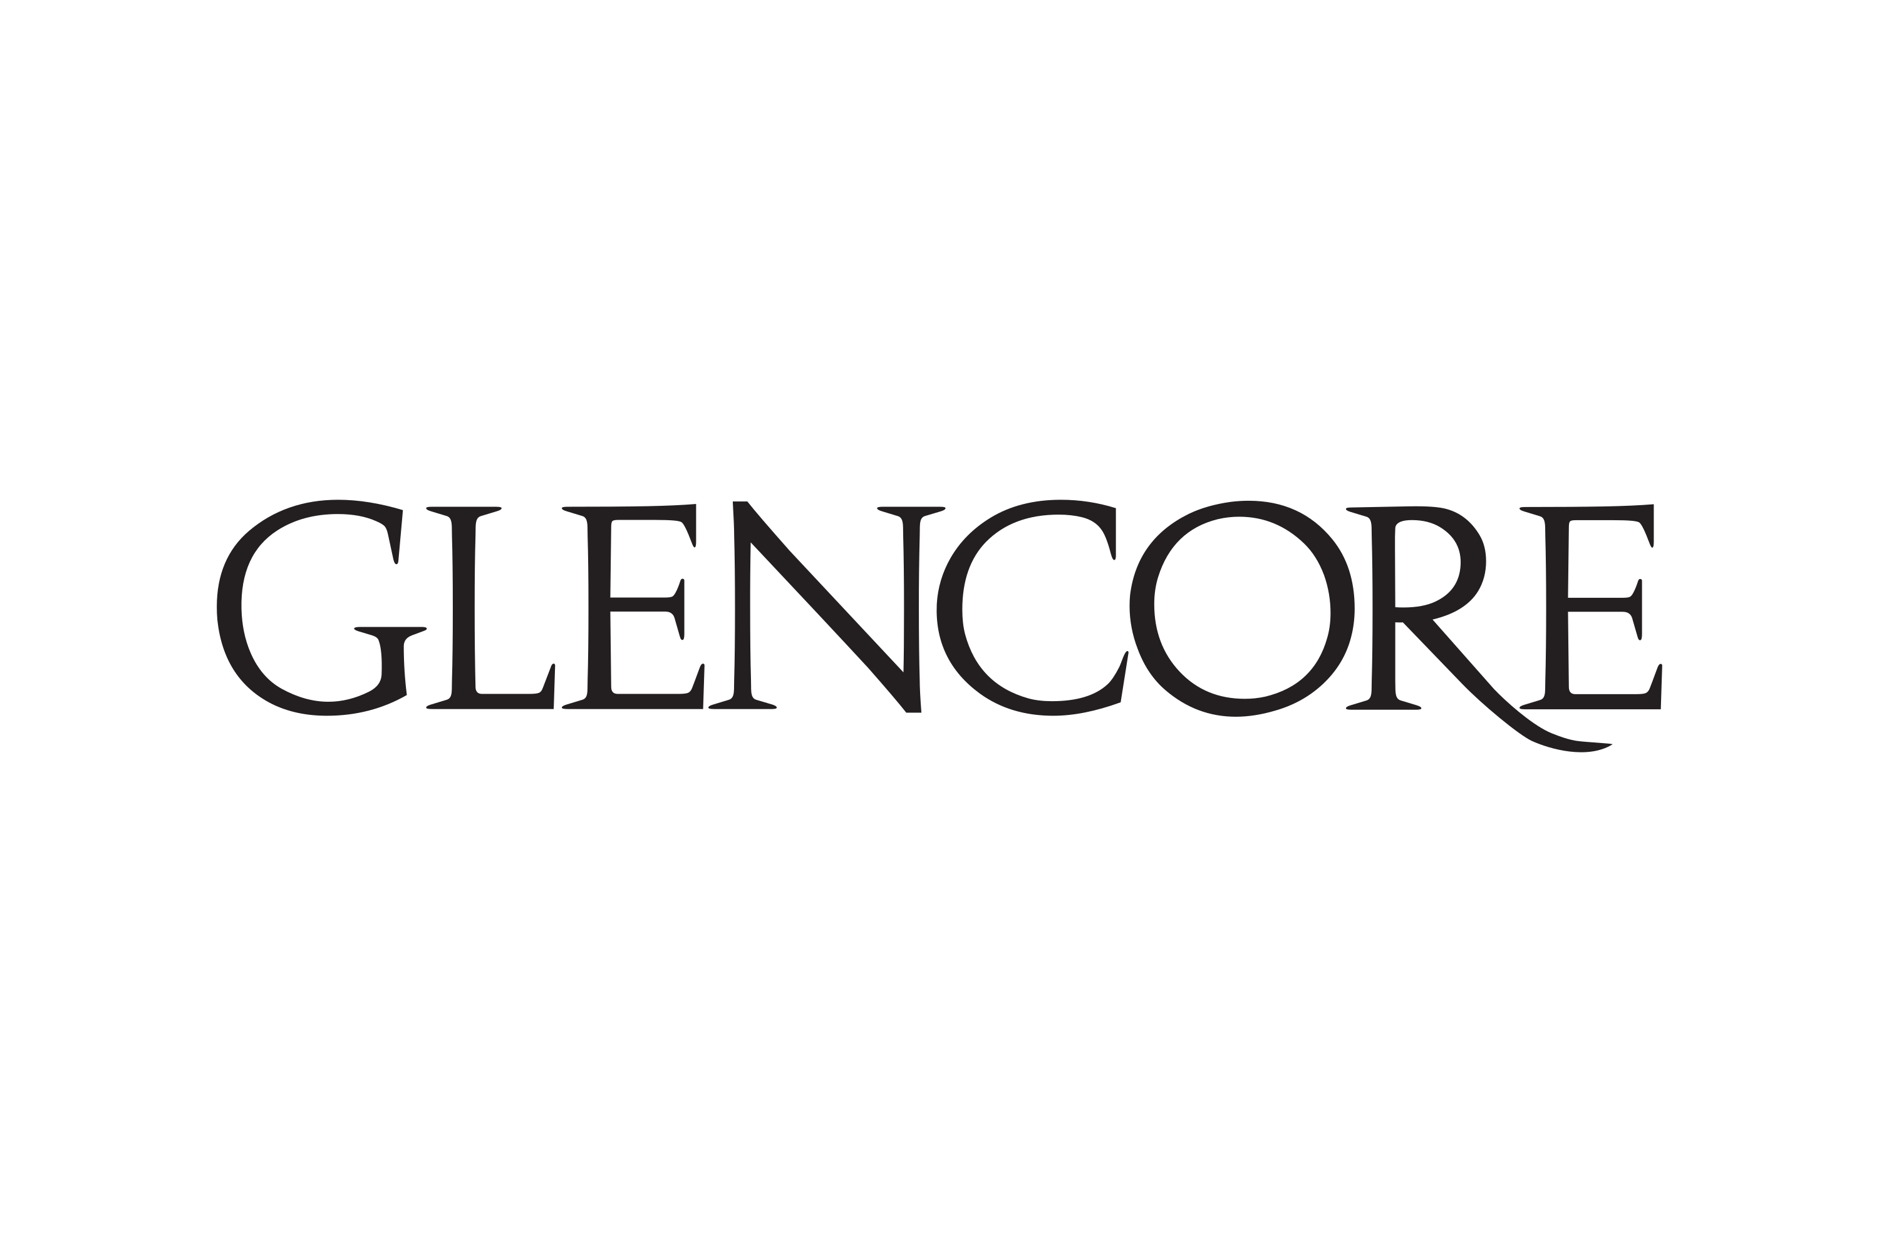

3 Transnet

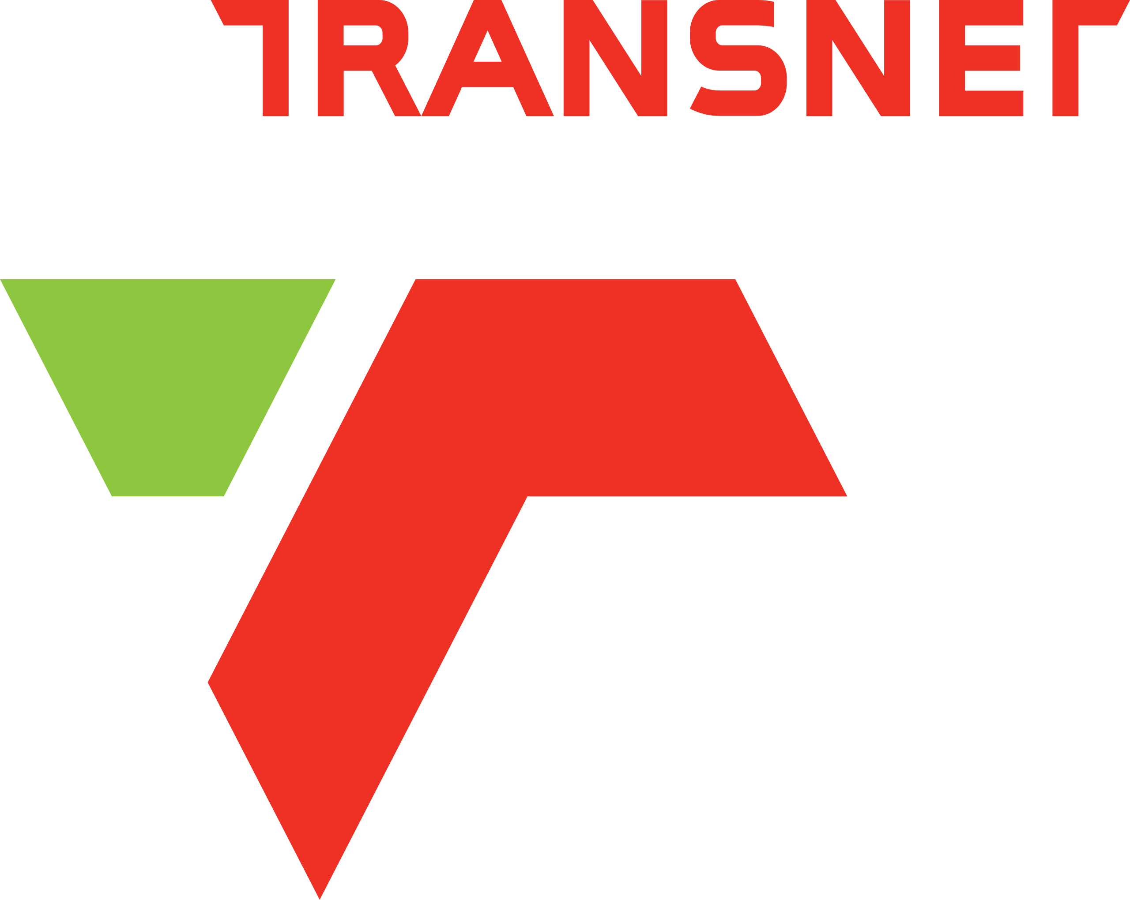

2 Georaphical Coordinates

- Phola Plant: 26°03'21.7"S 29°01'02.4"E
- Greenside RLT: 25°56'30.7"S 29°11'22.2"E
- Isibonelo Coal Mine: -26.435372270015396, 29.21112215760047
- Landau MRD : -25.91534884536279, 29.169439706958293
- Umsimbithi Mine: -25.846623707792215, 29.86540228128284
- Eskom Power Stations: Kusile Power Station(-25.909646040580206, 28.91527772883556), Kendal Power Station: -26.08966068731775, 28.96724703253338, Duvha PowerStation -25.95731760936331, 29.34369921534223.
- Zibulo Colliery (-26.199215914935703, 29.01072340184891)

SSSS

S
5 Anglo American
4 Eskom

3. Community Sponsorship Programs
So in this program Siyaphusha Consortium Sponsored a team of young brilliant future soccer stars called Chakalaka Football Stars From Phola Ogies as part of their giving back to the community program. The football team takes part is part of the Hollywoodbets Regional League in Nkangala.\
I will attach the pictures of the team bellow along with a a link of the teams soccer page in facebook along with the actual teams spornsership post where they show gratitude to siyaphusha consortium.
Facebook link of the post: https://www.facebook.com/61558207000279/posts/pfbid02VvpCAKgNxD3uQP5b2nLHmg8Qnw1DEUn16pb7KqU42TCf4aYQnVj4Vp2GwrNXDfrpl/?app=fbl
Teams Facebook page: https://www.facebook.com/p/Chakalaka-Future-Stars-61558207000279/
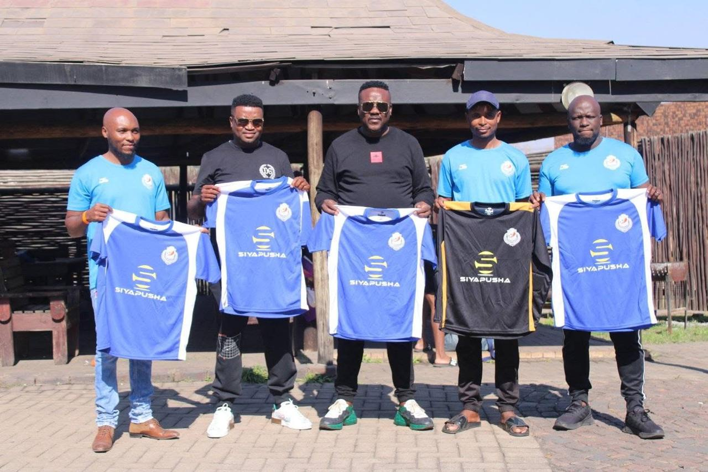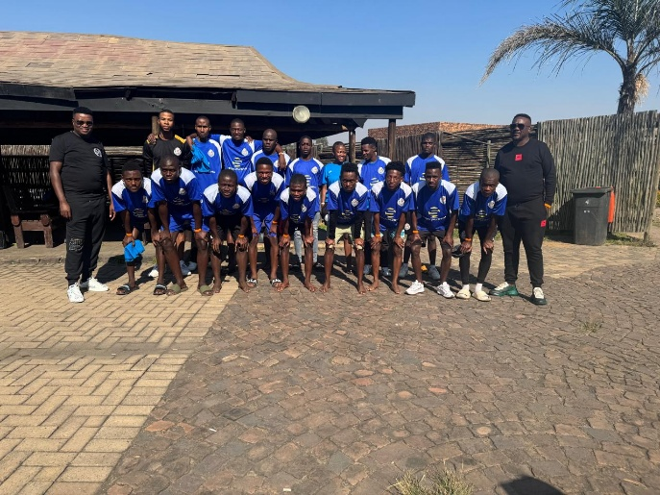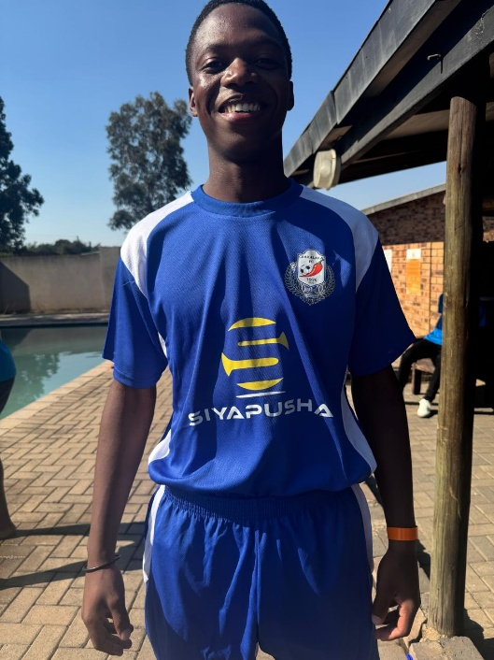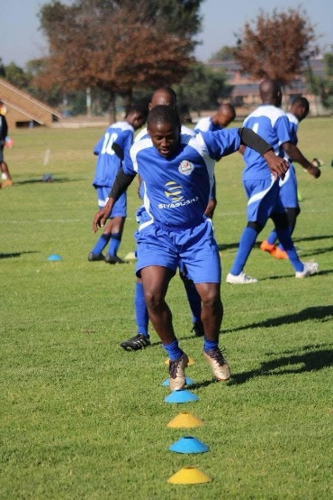
COMMUNITY PROJECT 2 : Early Childhood Development.
So Siyaphusha Saw the need to invest in the future of the country by empowering the young ones who hold the future of the county with the necessary resources like books crayons, stationary, tables chairs and other school use for toodlers in a early childhood care center. Below are the pictures pertaining to the project

