Мережа Animals
Мережа Asia

Мережа Animals

Структура мережі.
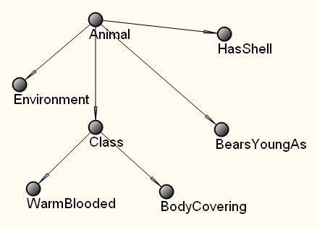.

Таблиці умовних ймовірностей

Animal
Monkey | Penguin | Platypus | Robin | Turtle
0,2 | 0,2 | 0,2 | 0,2 | 0,2

Environment
Animal | Air | Land | Water
Monkey | 0 | 1 | 0
Penguin | 0 | 0,5 | 0,5
Platypus | 0 | 0 | 1
Robin | 0,5 | 0,5 | 0
Turtle | 0 | 0,5 | 0,5

HasShell
Animal | True | False
Monkey | 0 | 1
Penguin | 0 | 1
Platypus | 0 | 1
Robin | 0 | 1
Turtle | 1 | 0

BearsYoungAs
Animal | Live | Eggs
Monkey | 1 | 0
Penguin | 0 | 1
Platypus | 0 | 1
Robin | 0 | 1
Turtle | 0 | 1

Class
Animal | Bird | Mammal | Reptile
Monkey | 0 | 1 | 0
Penguin | 1 | 0 | 0
Platypus | 0 | 1 | 0
Robin | 1 | 0 | 0
Turtle | 0 | 0 | 1

WarmBlooded
Class | True | False
Bird | 1 | 0
Mammal | 1 | 0
Reptile | 0 | 1

BodyCovering
Class | Fur | Feathers | Scales
Bird | 0 | 1 | 0
Mammal | 1 | 0 | 0
Reptile | 0 | 0 | 1

Мережа Asia

Структура мережі.
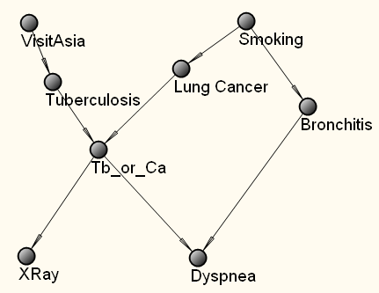

Таблиці умовних ймовірностей
VisitAsia
Visit | NoVisit
0,01 | 0,99

Smoking
Smoking | NoSmoking
0,5 | 0,5

Tuberculosis
VisitAsia | Present | Absent
Visit | 0,05 | 0,95
NoVisit | 0,01 | 0,99

Lung Cancer
Smoking | present | Absent
Smoking | 0,1 | 0,9
NoSmoking | 0,01 | 0,99

Tb_or_Ca
Tuberculosis | Lung Cancer | True | False
Present | present | 1 | 0
Present | Absent | 1 | 0
Absent | present | 1 | 0
Absent | Absent | 0 | 1

XRay
Tb_or_Ca | abnormal | normal
True | 0,98 | 0,02
False | 0,05 | 0,95

Bronchitis
Smoking | Present | Absent
Smoking | 0,6 | 0,4
NoSmoking | 0,3 | 0,7

Dyspnea
Tb_or_Ca | Bronchitis | True | False
True | Present | 0,9 | 0,1
True | Absent | 0,7 | 0,3
False | Present | 0,8 | 0,2
False | Absent | 0,1 | 0,9

