Prahari — Presentation & Project Guide
  - Slide-by-slide script, every diagram explained simply, and the whole project in plain words
FinSpark’26 · Bank of Maharashtra · Problem Statement 1 — Privileged Access Misuse & Insider Threat Detection
Repository: github.com/positromen/FinSpark-26-Trial
Table of Contents

1 How to read this guide
This document has five parts. Read them in order the first time; after that, jump to whatever you need.
- The whole project in plain words — what Prahari is, told like a story, with everyday examples.
- The 16 slides — for each slide: what it is for, what you must put on it, what you could add, and a simple script of what to say out loud.
- Every diagram explained simply — all seven pictures, walked through box by box.
- Every word explained simply — a plain-English dictionary of every technical term we use.
- Cheat-sheet — the exact numbers, names, passwords and facts to memorise.
Throughout, anything you can literally read aloud in the demo is written in plain, short sentences.

2 PART 1 — The whole project in plain words

2.1 The one-sentence version
Prahari watches the most powerful people inside a bank, notices in real time when one of them starts doing something dangerous, automatically stops them, and keeps the proof safe from future super-computers.

2.2 The problem, told simply
A bank protects itself from outsiders — hackers on the internet — with firewalls and antivirus. That is like locking the front door.
But some people are already inside the bank with keys: the database admins, the IT staff, and outside vendors/contractors. These are called privileged users — think of them as staff who hold the master key to every locker. If one of them turns bad, is careless, or has their account stolen, the front-door lock does not help at all. The danger is already inside.
The competition (Bank of Maharashtra, FinSpark’26) asked us to catch this insider danger. It says the insider can be one of three kinds:
- Malicious — a bad person on purpose. Example: a contractor whose contract ended, but whose account was never switched off, quietly logs in at 2 in the morning and copies 5,000 customers’ details to steal them.
- Negligent — a good person being careless. Example: a vendor whose access expired two weeks ago is still logging in from their personal laptop and opening customer files. No bad intent — but a serious rule-break.
- Compromised — a good person whose account was stolen by a hacker. Example: a normal employee’s login suddenly appears from another country, on a device never seen before, doing things inhumanly fast.
On top of that, the bank must keep its secrets and its records safe even from future quantum computers — because a criminal can steal encrypted data today and unlock it years later once quantum computers are strong enough. This is called “harvest now, decrypt later.”

2.3 Our solution, told simply
Prahari (a Hindi word meaning “sentinel / guard”) sits between the privileged staff and the important bank systems and does four things for every session (a session = one login-to-logout period):
- Watches and records. Every action (a database query, a file open, a config change, a bulk export) is written down like a CCTV recording — you can replay it later, command by command.
- Scores the risk, live. Every action gets a risk score from 0 to 100, calculated instantly by two “brains” working together: a rule engine (a checklist of known-bad behaviours) and an AI model (learns what “normal” looks like and flags the unusual). It always explains why in plain English.
- Responds automatically. Based on the score, Prahari either allows the action, asks for extra verification (step-up MFA), holds it for a second manager’s approval (maker-checker), or blocks it outright and locks the account.
- Protects the proof. The bank’s stored passwords go in a quantum-safe vault, and every record in the audit log is chained and digitally signed so that if anyone edits even one letter, the system instantly proves the tampering.

2.4 What we actually built (it’s real, not slides)
It is a working two-sided web app:
- The Employee Portal — what a bank staff member sees. They log in and do their job. Every action is scored and enforced live.
- The SOC Console — what the Security Operations Centre analyst sees. A live control room: which sessions are active, their risk, alerts, the AI’s reasoning, the session replay, a risk heatmap, the access review, and the quantum-safe audit log.
You can run it on two computers at once on the same Wi-Fi: an employee acts on one, and the security team watches it happen live on the other, with no refreshing.

2.5 The six things the competition asked for — all done
- Detect misuse of privileged accounts — done (rule engine).
- Identify insider threats in real time — done (live scoring + WebSocket push).
- AI-driven behavioural analysis — done (IsolationForest + per-user baselines).
- Risk-based access control — done (allow / MFA / maker-checker / block).
- Protect critical administrative systems — done (blocks the action before damage; locks the account).
- Quantum-proof cryptography — done (ML-KEM-768 vault + ML-DSA-65 signed audit log).

3 PART 2 — The 16 slides
The official template has 16 slides. Below, each slide has four boxes:
- GOAL — What it is for — the template’s own instruction.
- NEED — Must include — put this on the slide.
- OPTIONAL — Could include — add if you have room or the judges probe deeper.
- SCRIPT — Say this — a short script you can read almost word-for-word.
Keep slides light (few words, one picture). The detail lives in your mouth (the script) and in this guide, not on the slide.

3.1 Slide 1 — Title
GOAL — Team name, team bio, date.
NEED — Must include:
- Project name: Prahari — with the tagline “Privileged-Access Insider-Threat Detection & Management for Banks.”
- Team name, each member’s name, the date.
- Problem statement line: PS1 — Privileged Access Misuse & Insider Threat Detection.
OPTIONAL — Could include: the GitHub link (github.com/positromen/FinSpark-26-Trial); a one-line hook: “Catch a risky insider in real time — and keep the proof quantum-safe.”
SCRIPT — Say this: > “Good morning. We are team [name]. Our project is Prahari — the Hindi word for sentinel. It solves Problem Statement 1: catching privileged-access misuse and insider threats inside a bank, in real time, and protecting the evidence with quantum-safe cryptography.”

3.2 Slide 2 — Problem Statement
GOAL — State the problem you chose and why.
NEED — Must include:
- Banks defend well against outsiders, but the costliest breaches come from trusted insiders who already hold privileged access.
- The three insider types: malicious, negligent, compromised — with a one-line example of each.
- The “harvest now, decrypt later” quantum risk to stored secrets and audit records.
OPTIONAL — Could include: dormant/vendor accounts never de-provisioned; tamperable audit logs; the RBI compliance angle.
SCRIPT — Say this: > “A bank’s firewall stops outsiders, but it is blind to the DBA, the sysadmin, or the vendor who already has the master key. The problem statement names three faces of this insider: malicious — a dormant vendor account that wakes at 2 AM and bulk-exports 5,000 customer records; negligent — a vendor whose access expired but who still pulls files from a personal laptop; and compromised — a normal account suddenly logging in from another country on a new device. We chose this because it is the highest-impact risk for a bank, and it let us combine three hard things — real-time AI, access control, and post-quantum cryptography — into one solution.”

3.3 Slide 3 — Pre-Requisite
GOAL — Assumptions, required access, data, tools, environments, inputs.
NEED — Must include:
- Assumption: privileged activity is available as a stream of events. For the demo, a built-in simulator produces it; in production it comes from the bank’s PAM/SIEM logs.
- Inputs per event: who (user), what (action), which system (resource), how much data (records touched), from where (IP/location), on what (device), and when (timestamp).
- Environment: Python 3.11+, a browser; runs fully offline on SQLite. One-time internet only to install and to build the quantum library.
OPTIONAL — Could include: access to the IAM directory (roles, vendor/dormant flags, access-expiry dates); no secrets stored in the repo; .env-based config.
SCRIPT — Say this: > “Our only assumption is that privileged activity arrives as events — user, action, system, data volume, location, device, time. In a real bank that feed comes from existing PAM and SIEM tools; for the demo we generate the same shape with a simulator. It runs completely offline on SQLite — important for an unreliable venue Wi-Fi.”

3.4 Slide 4 — Tools or Resources
GOAL — Technologies, frameworks, libraries used.
NEED — Must include (a simple table works):
- Backend: Python, FastAPI (web server), SQLAlchemy (database), SQLite (storage, swappable to PostgreSQL).
- AI: scikit-learn IsolationForest + per-user behavioural baselines.
- Post-quantum crypto: liboqs — ML-KEM-768 (FIPS 203) and ML-DSA-65 (FIPS 204); AES-256-GCM for the payload.
- Real-time: WebSocket.
- Frontend: React + Vite + Tailwind.
- Testing: pytest — 31 automated tests.
OPTIONAL — Could include: PBKDF2 password hashing + signed tokens; Docker; one-command run script.
SCRIPT — Say this: > “Standard, production-grade tools. Python and FastAPI for the backend, scikit-learn’s IsolationForest for the AI, React for the two dashboards, and — the special part — real NIST post-quantum algorithms via liboqs. Everything is covered by 31 automated tests.”

3.5 Slide 5 — Supporting Functional Documents
GOAL — User flows, process notes, logic flows, references.
NEED — Must include: name the documents you ship in the repo —
- README (quick start + demo accounts),
- DOCUMENTATION (full technical doc with diagrams),
- DEMO_SCRIPT (click-by-click narration),
- this Presentation & Project Guide.
- Two user flows: Employee Portal (login -> act -> allow/MFA/hold/block) and SOC Console (watch -> investigate -> respond).
OPTIONAL — Could include: the logic-flow diagrams (detection -> score -> response, the vault, the audit chain).
SCRIPT — Say this: > “Everything is documented in the repo — a README, a full technical document with all the diagrams, a click-by-click demo script, and a presentation guide. We also map two user journeys: the employee doing their job, and the analyst watching and responding.”

3.6 Slide 6 — Key Differentiators & Adoption Plan
GOAL — What makes you different, and how a bank would adopt it.
NEED — Must include — Differentiators:
- We handle all three insider types, each with a different, correct response — most tools only do anomaly detection.
- Explainable AI — every score comes with plain-English reasons and per-user factors, not a black box.
- Real PAM features — session recording/replay and an access review — plus live enforcement that blocks the action mid-way.
- Working post-quantum vault and tamper-evident audit log.
Adoption plan (low risk -> high):
- Monitor mode — deploy read-only beside existing tools; learn baselines; no blocking.
- Assist mode — turn on step-up MFA and maker-checker for medium risk.
- Enforce mode — auto-block clear attacks; move crown-jewel credentials into the quantum-safe vault.
OPTIONAL — Could include: integrations (CyberArk/BeyondTrust PAM, Splunk/QRadar SIEM, the bank’s SSO).
SCRIPT — Say this: > “Three differentiators. One: we cover all three insider types with distinct responses. Two: the AI is fully explainable. Three: we ship real post-quantum crypto, not a promise. Adoption is staged — start in monitor-only mode to build trust, then switch on step-up verification, and finally auto-blocking.”

3.7 Slide 7 — GitHub Repository Link & supporting diagrams
GOAL — Repo link + diagrams/screenshots.
NEED — Must include:
- github.com/positromen/FinSpark-26-Trial
- The architecture diagram (see Part 3, Diagram 1).
- A note: one-command offline run; 31 tests; prebuilt UI committed.
OPTIONAL — Could include: the demo accounts table; a QR code to the repo.
SCRIPT — Say this: > “Here is the repository. It runs with a single command, fully offline, and ships with 31 passing tests and the prebuilt UI. This is our architecture at a glance — I’ll walk through it properly on the architecture slide.”

3.8 Slide 8 — Business Potential and Relevance
GOAL — Future potential, real-world use, long-term value.
NEED — Must include:
- Insider incidents are among the costliest breach types; one misused privileged account can expose millions of customer records and trigger regulatory penalties.
- Directly supports RBI expectations: least privilege, immutable audit trails, privileged-access oversight.
- Quantum-readiness now aligns with global migration timelines (NIST FIPS 203/204).
OPTIONAL — Could include: expansion — transaction-fraud correlation, just-in-time access, workforce-wide insider-risk scoring; deployable as an internal platform or SOC-as-a-service.
SCRIPT — Say this: > “Every bank with privileged users needs this. A single misused admin account can leak millions of records and draw regulatory fines. Prahari maps directly to RBI’s governance expectations, and its post-quantum layer future-proofs the bank against ‘harvest now, decrypt later’. It extends naturally to transaction-fraud correlation and just-in-time access.”

3.9 Slide 9 — Uniqueness of Approach and Solution
GOAL — What is innovative or original.
NEED — Must include:
- One engine, three insider types — and a type-aware policy: negligence is sent to a human review, never auto-blocked like an attack.
- Rules + AI fused into one explainable 0–100 score with a per-user “unusual for this person” layer.
- PAM + UEBA + post-quantum in one offline-capable product — a combination competitors don’t ship together.
- Live enforcement — it stops the action in progress and locks the account; a blocked user cannot simply log in again.
- Tamper-evident, quantum-safe audit — you literally cannot silently edit the log.
SCRIPT — Say this: > “The novelty is the combination. One engine classifies the insider type and responds appropriately — we never hard-block mere negligence. The AI explains itself per user. And we put PAM, behavioural AI, and NIST post-quantum crypto into a single product that runs offline — which nobody else ships together.”

3.10 Slide 10 — User Experience
GOAL — How users interact; why it is simple.
NEED — Must include:
- Two role-based experiences, one login.
- Employee Portal: a clean action console; feedback is instant and obvious — green allowed, an amber MFA pop-up, an orange held-for-approval, or a full-screen red BLOCKED.
- SOC Console: one screen of situational awareness — live sessions, risk gauge, typed alerts, the AI’s reasoning, timeline, session replay, heatmap, access review, and one-click Lock / Approve / Dismiss with confirmation.
- Colour-coded insider types; new alerts flash; everything is explained in plain words.
OPTIONAL — Could include: dark, control-room SOC theme; keyboard-friendly; a live LIVE connection indicator.
SCRIPT — Say this: > “Two audiences, one app. The employee just does their job and gets immediate, self-explanatory feedback. The analyst sees a single control-room screen — every alert is colour-coded by insider type and written in plain English, so triage takes seconds. And the analyst can lock, approve, or dismiss a session in one click, with a confirmation that it’s sealed to the audit chain.”

3.11 Slide 11 — Scalability
GOAL — Scale across branches, users, systems, volumes.
NEED — Must include:
- Stateless scoring — add more servers behind a load balancer to handle more load.
- SQLite -> PostgreSQL by changing one line (pure ORM).
- WebSocket fan-out via a Redis/Kafka broker for many SOC screens and high event rates.
- Ingests real PAM/SIEM feeds — millions of events per day — on the same event schema.
- The AI retrains per role/shift; the scoring is sub-second.
SCRIPT — Say this: > “It scales three ways. The scoring service is stateless, so you just add servers. Storage moves from SQLite to Postgres with one connection string. And it plugs into existing PAM/SIEM feeds at bank scale — millions of events a day — because everything maps to the same event schema.”

3.12 Slide 12 — Ease of Deployment and Maintenance
GOAL — How practical to implement, run, maintain.
NEED — Must include:
- One command (run.ps1 / run.sh) sets up everything and runs fully offline.
- Docker ready.
- Config via .env; no secrets in the repo.
- Small, modular, type-hinted code; 31 automated tests guard every change.
- Post-quantum crypto sits behind one swappable module.
SCRIPT — Say this: > “One command brings up the database, the AI, both dashboards and the API — offline. It’s containerised, fully tested, and the crypto is behind a single interface so providers can be swapped without touching the app. A new engineer can run it in under a minute.”

3.13 Slide 13 — Security Considerations
GOAL — Cyber risks, data protection, access control, compliance.
NEED — Must include:
- Data minimisation — we score on activity metadata, not customer money data / PII.
- Credential protection — the vault seals secrets with ML-KEM-768 + AES-256-GCM (quantum-safe).
- Audit integrity — every entry is hash-chained and ML-DSA-65 signed; tampering is provable.
- Enforcement is server-side — blocked accounts stay locked; a challenged action isn’t saved until it’s actually allowed (no gaming the score).
- Access control — passwords are PBKDF2-hashed, sessions use signed tokens, and SOC APIs are analyst-only.
- Offline by design — no external calls at run time; keys never committed.
SCRIPT — Say this: > “Security is the point of the product, so it’s security-first internally too. We only look at activity metadata, never customer PII. Credentials go in a quantum-safe vault. The audit log is hash-chained and post-quantum signed, so tampering is mathematically provable. Enforcement is server-side — you can’t bypass it from the browser — and the SOC endpoints are locked to analysts only.”

3.14 Slide 14 — Architecture Diagram & Images
GOAL — A clear architecture diagram.
NEED — Must include: the architecture picture (Part 3, Diagram 1) and a one-line caption. Optionally the scoring and post-quantum diagrams.
SCRIPT — Say this (point at the boxes left to right): > “Privileged activity comes in on the left and is normalised into sessions. It fans out to two detectors — the behavioural AI and the rule engine — which feed one scoring engine that produces a 0-to-100 score with reasons. The score drives the response — allow, MFA, maker-checker, or block — and lights up the SOC console. And wrapping the whole thing is the post-quantum security layer: the ML-KEM vault and the ML-DSA-signed audit log.”

3.15 Slide 15 — Solution Screenshots, Video & GitHub Link
GOAL — Prototype screenshots, demo video, GitHub, proof it works.
NEED — Must include (drop real screenshots):
- Login page.
- Employee Portal with the full-screen BLOCKED overlay.
- SOC Console — live blocked session + a flashing CRITICAL alert.
- AI Model Insights — feature bars + the risk-score trajectory.
- Audit Chain — green VERIFIED, then red FAILED after tamper.
- The GitHub link and the demo video link.
SCRIPT — Say this: > “These are real screenshots from the running product — not mock-ups. Here’s the block landing live, the SOC alert firing, the AI explaining the score feature by feature, and the audit chain catching a tamper. The repository and a full demo video are linked.”

3.16 Slide 16 — Thank You
GOAL — Team names, roles, contacts, closing note.
NEED — Must include: names, roles, one contact, and a closing line.
SCRIPT — Say this: > “That’s Prahari — detect with explainable AI plus rules, respond in real time, and keep the proof quantum-safe. Thank you — we’re happy to take questions or run the live demo.”

4 PART 3 — Every diagram explained simply
We have seven diagrams. For each: what it is, a walk through every box, and why it matters. Imagine each picture is a little comic strip that reads left-to-right and top-to-bottom.

4.1 Diagram 1 — System Architecture (the big picture)
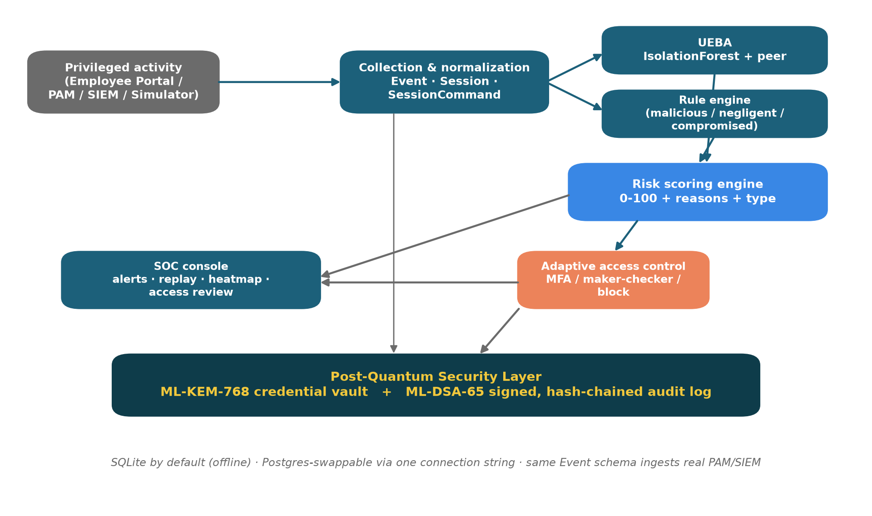
System architecture — six modules from ingestion to the post-quantum layer.
Think of a factory conveyor belt with six stations. A “raw material” (a privileged action) enters on the left and comes out the other side either allowed or blocked, with a permanent, tamper-proof receipt.
- Box 1 — Privileged activity (grey, top-left). Where actions come from: our Employee Portal, or in a real bank, the PAM/SIEM logs, or our simulator. (The raw material.)
- Box 2 — Collection & normalization (teal). Turns every action into a tidy, standard record — a Session with Events and a recorded command trail. (Cleaning and labelling the raw material so every later station understands it.)
- Box 3 — UEBA (teal, top-right). The AI brain: it learned what “normal” looks like and measures how unusual this session is. (A station that says “hmm, this looks weird.”)
- Box 4 — Rule engine (teal). The checklist brain: fixed known-bad patterns (dormant account woke up, 5,000 records exported, out-of-role access…). (A station with a printed list of forbidden moves.)
- Box 5 — Risk scoring engine (blue). Combines the two brains into one number 0–100, plus the plain-English why and the insider type. (The station that adds it all up.)
- Box 6a — Adaptive access control (orange). Turns the number into an action: allow / step-up MFA / maker-checker / block. (The gate that opens, half-opens, or slams shut.)
- Box 6b — SOC console (teal). Shows everything to the human security team, live.
- The wide dark bar at the bottom — Post-Quantum Security Layer. Wraps everything: the ML-KEM-768 vault (locks secrets) and the ML-DSA-65 signed, hash-chained audit log (a receipt no one can forge). (The tamper-proof printer under the whole belt.)
Why it matters: it shows the judges that this is a complete pipeline, not a single trick — ingestion, two kinds of detection, scoring, response, a human console, and a crypto safety net.

4.2 Diagram 2 — Data Model (the database tables)
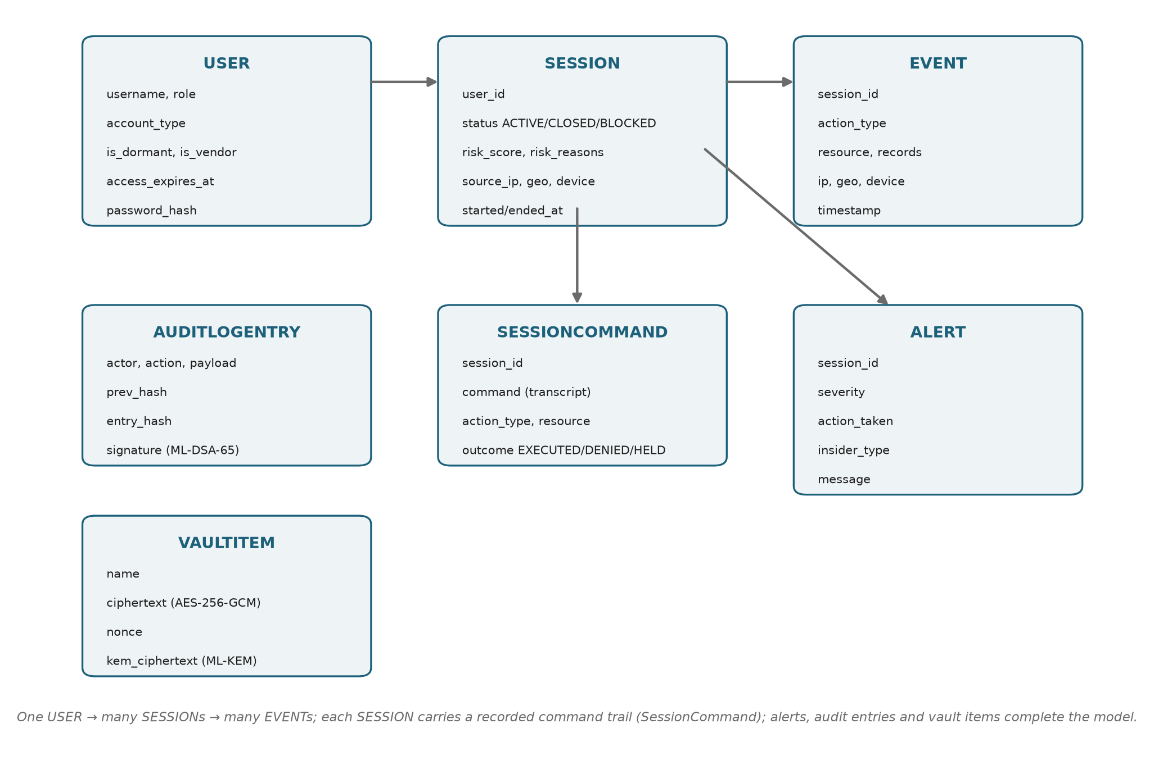
Entity model — the seven tables and how they connect.
This is the filing-cabinet layout — seven drawers and how they reference each other.
- USER — every privileged person: their name, role, whether they are dormant or a vendor, and when their access expires. (The staff directory.)
- SESSION — one login-to-logout window: its status (active/closed/blocked), its risk score, and where it came from (IP, location, device). (One visit to the building.)
- EVENT — one single action inside a session (a query, an export…), with how many records it touched and when. (One thing the person did during the visit.)
- SESSIONCOMMAND — the recording: the actual command line typed, with an outcome (executed / denied / held). (The CCTV transcript of the visit.)
- ALERT — a warning raised for a risky session: severity, the action taken, and the insider type. (The note the guard writes.)
- AUDITLOGENTRY — one tamper-proof record: who/what/when, the hash of the previous entry, and a post-quantum signature. (A page in a sealed logbook where every page locks the one before it.)
- VAULTITEM — one stored secret, encrypted; the key is sealed with post-quantum crypto. (A locked box inside the safe.)
The arrows mean “one-to-many”: one USER has many SESSIONS; one SESSION has many EVENTS and a command recording. Why it matters: it proves the data is properly structured and that “session recording” and “access expiry” are first-class, real features — not just words.

4.3 Diagram 3 — Scoring Pipeline (how the number is made)
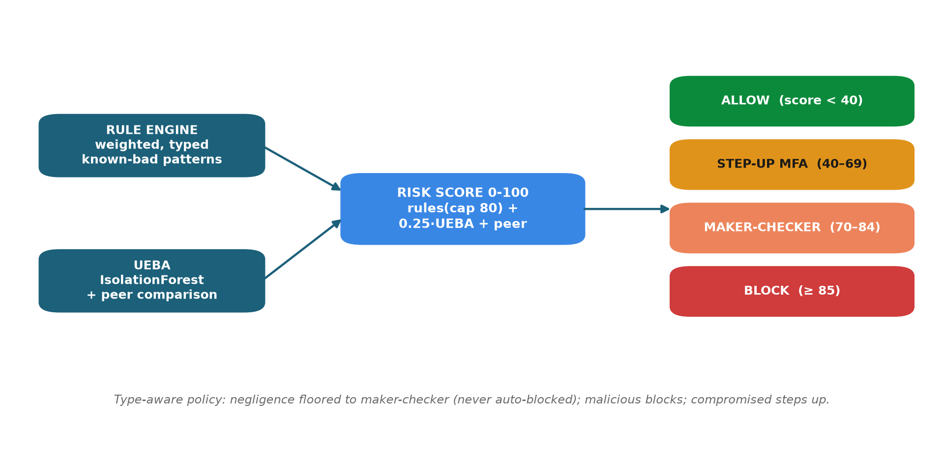
Scoring — rules and AI fuse into a 0–100 score that maps to the response ladder.
Read it left to right. Two inputs on the left flow into one score in the middle, which points at a ladder on the right.
- Left, top — Rule engine. Produces “rule points” (each broken rule adds weight), capped so rules alone can’t dishonestly max the score.
- Left, bottom — UEBA. Produces the AI anomaly (0–100), which contributes up to 25 points (it’s a nudge, not the whole story).
- Middle — the sum. score = rule points + 0.25 × AI anomaly + a peer-comparison bonus, capped at 100.
- Right — the response ladder (four rungs, colour-coded):
  - 0–39 -> ALLOW (green)
  - 40–69 -> STEP-UP MFA (amber)
  - 70–84 -> MAKER-CHECKER (orange)
  - 85–100 -> BLOCK (red)
The caption line is the clever bit: negligence is floored to maker-checker and never auto-blocked — a careless employee is sent to a human, not slammed like an attacker.
Why it matters: it shows the AI and the rules cooperate, the score is explainable, and the response is proportionate to the risk.

4.4 Diagram 4 — The Three Insider Types (one engine, three responses)
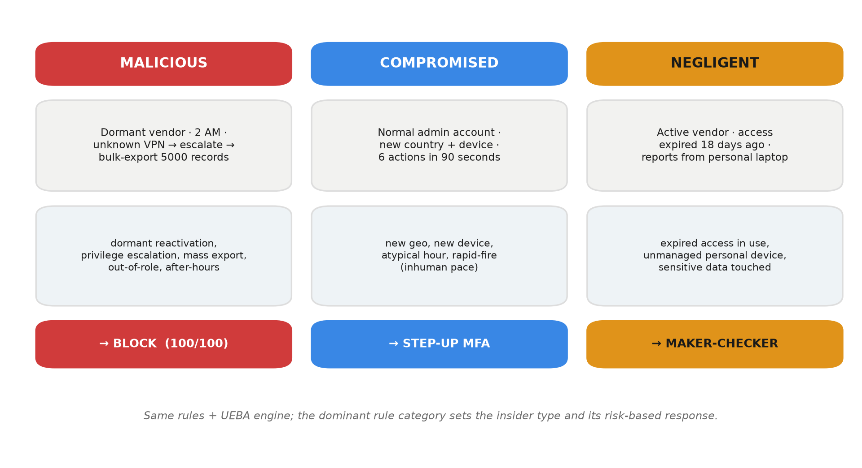
Three insider types — one engine, three distinct, correctly-typed responses.
Three columns, one per insider type. Each column reads top to bottom: who they are -> the signals we detect -> the response.
- MALICIOUS (red). Dormant vendor, 2 AM, unknown VPN -> escalates privilege -> tries to export 5,000 records. Signals: dormant reactivation, privilege escalation, mass export, out-of-role, after-hours. Response: BLOCK (score 100).
- COMPROMISED (blue). A normal admin account suddenly from a new country + new device, six actions in ninety seconds. Signals: new location, new device, atypical hour, inhuman speed. Response: STEP-UP MFA.
- NEGLIGENT (amber). An active vendor whose access expired 18 days ago, pulling reports from a personal laptop. Signals: expired access still in use, unmanaged personal device. Response: MAKER-CHECKER review.
Why it matters: the competition explicitly asks for all three. This one picture proves we handle each distinctly and correctly — the single most important slide for scoring points against the problem statement.

4.5 Diagram 5 — Live Enforcement (what happens the instant you click)
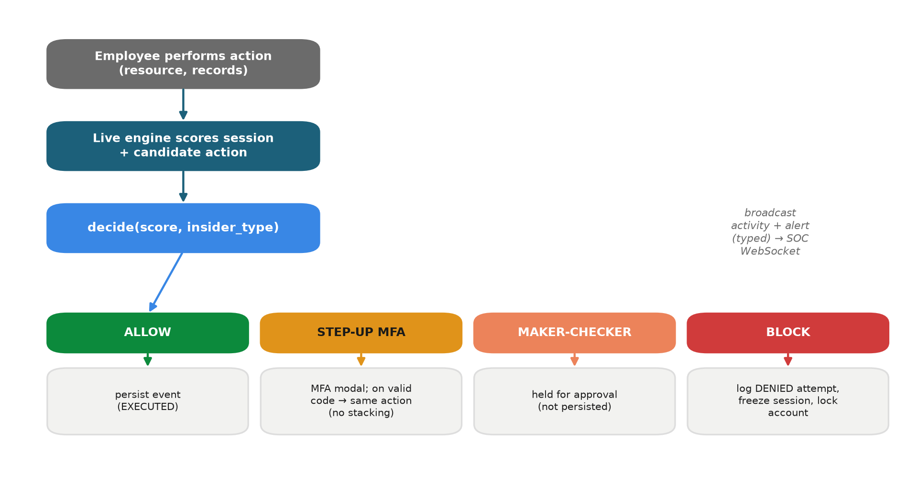
Live enforcement — every action is scored and routed to one of four responses before it takes effect.
A flowchart of one action, top to bottom.
- Employee performs an action (chooses a system + record count).
- The live engine scores the whole session so far including this new action.
- decide(score, insider_type) picks the outcome, which branches four ways:
  - ALLOW -> the action is saved and completes.
  - STEP-UP MFA -> a code pop-up; enter the code and the same action proceeds (it is not re-counted — no score inflation).
  - MAKER-CHECKER -> held for a second approver (not saved yet).
  - BLOCK -> the attempt is logged as DENIED, the session is frozen, and the account is locked.
- On the right, a note: every action is broadcast to the SOC console over WebSocket, so the security screen updates instantly.
Why it matters: it proves enforcement happens before the action takes effect (not after the damage), and that it’s genuinely live across screens.

4.6 Diagram 6 — Post-Quantum Credential Vault
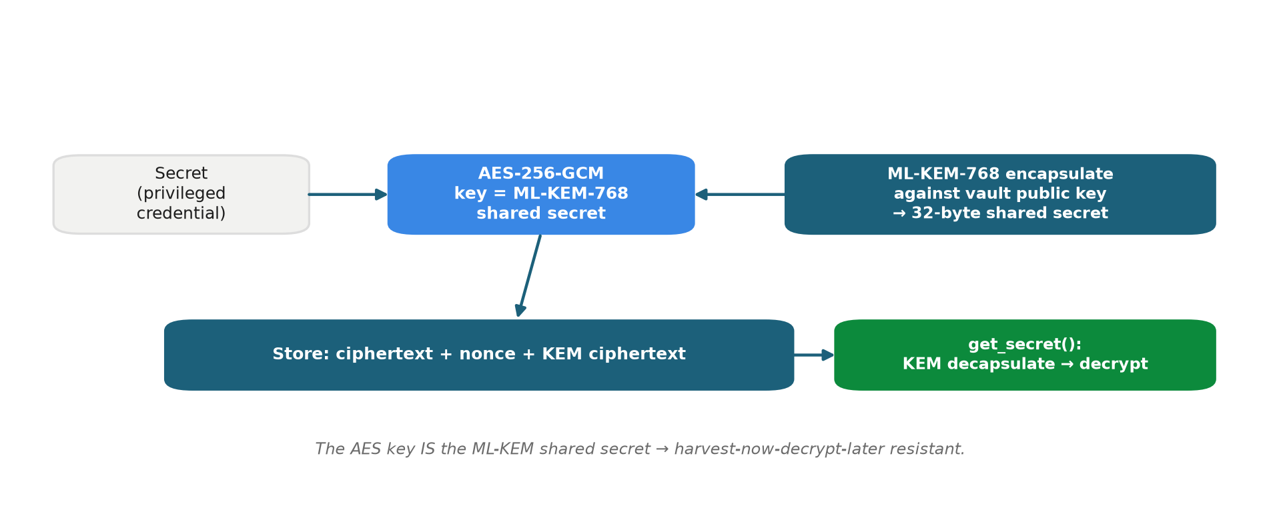
Credential vault — a secret is sealed with AES-256-GCM under an ML-KEM-768 shared secret.
How a password is stored so that even a future quantum computer can’t read it. Read left to right.
- Secret (e.g., a database root password) ->
- AES-256-GCM encryption locks it with a key that is ->
- the shared secret produced by ML-KEM-768 (the post-quantum key-agreement, sealed against the vault’s public key) ->
- Stored: the locked text + the sealed key. To read it back, you must run ML-KEM decapsulate with the vault’s secret key, then decrypt.
The key insight (bottom caption): the AES key is the ML-KEM shared secret. So data copied today cannot be unlocked later — that defeats “harvest now, decrypt later.”
Why it matters: it shows the post-quantum protection is real and specific, not a buzzword.

4.7 Diagram 7 — Tamper-Evident Audit Chain
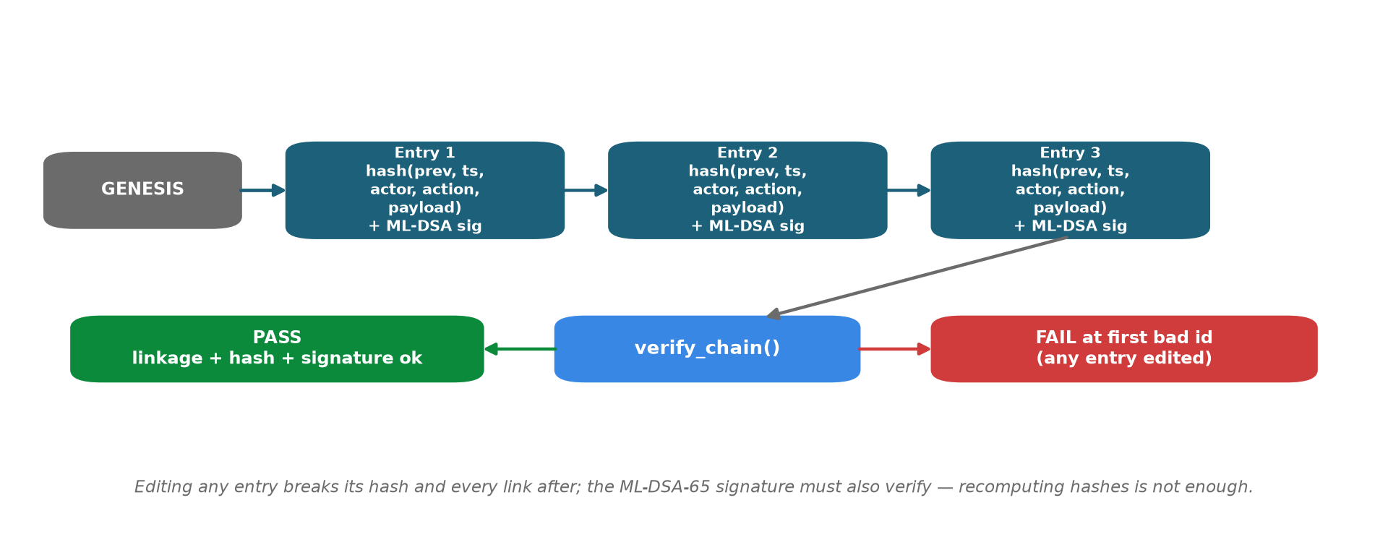
Audit chain — each entry hash-links the previous and is ML-DSA-65 signed; any edit fails verification.
How the logbook proves it was never edited. Read left to right.
- GENESIS -> Entry 1 -> Entry 2 -> Entry 3 … each entry contains a hash (fingerprint) of the previous entry and its own ML-DSA-65 digital signature.
- On the right: verify_chain() checks every link and every signature.
  - If all good -> PASS.
  - If anyone edited even one entry -> the fingerprint no longer matches and the signature no longer verifies -> FAIL, pointing at the exact broken entry.
Because each page locks the page before it (like a blockchain) and each page is signed with a post-quantum signature, a tamperer would have to forge a NIST post-quantum signature — which is the whole point of choosing ML-DSA.
Why it matters: in the live demo you click Tamper, and the chain instantly turns red at entry #1 — a dramatic, undeniable proof.

5 PART 4 — Every word explained simply
- Privileged user — a staff member with powerful access (admin, DBA, IT, vendor). The person with the master key.
- Insider threat — danger from someone already inside with access, not an outside hacker.
- PAM (Privileged Access Management) — the discipline of controlling, recording, and reviewing what privileged users do. CCTV + rules for the master-key holders.
- SOC (Security Operations Centre) — the bank’s security control room; analysts watch and respond.
- Session — one login-to-logout period for a user.
- Event — one action inside a session (query, file open, export…).
- Rule engine — a fixed checklist of known-bad behaviours; each match adds “weight.”
- UEBA (User & Entity Behaviour Analytics) — AI that learns each user’s normal behaviour and flags the unusual. A guard who knows everyone’s habits.
- IsolationForest — the specific AI algorithm we use; it’s good at spotting “odd ones out” without needing labelled examples of attacks (unsupervised). It notices the item that doesn’t fit.
- Per-user baseline — each person’s own usual hours, devices, locations, and data volumes, so we can say “this is unusual for this person.”
- Feature vector — the seven numbers describing a session (login hour, action count, records touched, distinct systems, config changes, off-network?, new device?) that the AI reads.
- Risk score (0–100) — the single number combining rules + AI + peer comparison.
- Insider type — malicious / negligent / compromised — decided by which rule family carries the most weight.
- Response ladder — allow -> step-up MFA -> maker-checker -> block, chosen by the score.
- Step-up MFA — asking for an extra one-time code to continue a medium-risk action. “Prove it’s really you.”
- Maker-checker — a high-risk action is held until a second authorised person approves it. “Two keys to launch.”
- Block — refuse the action and lock the account.
- WebSocket — a live, always-open connection that lets the server push updates to the screen instantly (no refresh). A phone line left open.
- Post-quantum cryptography (PQC) — new encryption that stays safe even against future quantum computers.
- ML-KEM-768 — the NIST post-quantum key-agreement algorithm (FIPS 203); used to seal the vault’s keys.
- ML-DSA-65 — the NIST post-quantum digital-signature algorithm (FIPS 204); used to sign each audit entry.
- AES-256-GCM — strong, standard symmetric encryption used to lock the actual secret (the key for it comes from ML-KEM).
- Hash / hash chain — a “fingerprint” of data; a chain where each entry embeds the previous entry’s fingerprint, so editing one breaks all the following ones. Blockchain-style tamper evidence.
- Audit log — the permanent record of everything that happened.
- Harvest now, decrypt later — a criminal steals encrypted data today to decrypt it years later with a quantum computer; PQC defeats this.
- PBKDF2 — a safe way to store passwords (slow, salted hashing) so they can’t be reversed.
- Token — a signed pass the browser shows on each request to prove who is logged in.
- FastAPI / Uvicorn — the Python web-server tools serving the API.
- SQLite / PostgreSQL — the database; SQLite for the offline demo, Postgres for scale.
- SIEM — a bank’s central log-collection system; a real source of the events we score.

6 PART 5 — Cheat-sheet (memorise these)
One-liner: Prahari catches risky insiders — malicious, negligent, or compromised — in real time, responds automatically, and keeps the proof quantum-safe.
Run it: .\run.ps1 -Reset -> open http://localhost:8000. Second computer on the same Wi-Fi uses the LAN URL the script prints.
Demo accounts (password prahari123):
Login | Who | Use for
soc_admin | SOC analyst | the SOC Console
rmehta | normal DBA | a normal employee
ext_dsouza | dormant vendor | the malicious attacker
ext_rao | expired vendor | the negligent case
Step-up MFA code: 246810.
The three scenarios and their outcomes:
Type | Story | Score | Response
Malicious | dormant vendor, 2 AM, export 5,000 records | 100 | BLOCK
Compromised | new country + device, rapid-fire | ~54 | STEP-UP MFA
Negligent | expired vendor, personal laptop | ~63 | MAKER-CHECKER
Rule weights (roughly): dormant reactivation 30 · privilege escalation 25 · after-hours 20 · mass export (>=1000) 30 · out-of-role 15 · new-geo 16 · new-device 12 · atypical-hour 8 · rapid-fire 8 · expired-access 30 · unmanaged-device 30.
Score formula: min(rule points (cap 80) + 0.25 × AI anomaly + 10 peer bonus, 100).
Crypto: vault = ML-KEM-768 + AES-256-GCM; audit = ML-DSA-65 signatures over a hash chain.
Proof it works: 31 automated tests pass; the three scenarios land on three different responses; tamper breaks the audit chain instantly; runs fully offline; works live across two computers.
Six judged outcomes — all delivered: detect misuse · real-time · AI behavioural · risk-based access control · protect admin systems · quantum-proof crypto.

Prahari — the sentinel for privileged access.

