Prahari — Complete Technical Documentation
  - Privileged-Access Insider-Threat Detection & Management for Banks
FinSpark’26 · Bank of Maharashtra · Problem Statement 1 — Privileged Access Misuse & Insider Threat Detection
Repository: github.com/positromen/FinSpark-26-Trial
Table of Contents

1 Executive Summary
Prahari (“sentinel”) is a Privileged Access Management (PAM) and insider-threat detection platform for banks. It sits between privileged staff — DBAs, sysadmins, network and application admins, and vendors — and critical systems, and does four things for every privileged session:
- Watches every privileged action as a normalized, recorded session with a replayable command trail.
- Scores each session 0–100 in real time, fusing a rule engine with AI behavioural analytics (UEBA) and peer comparison, always with a human-readable why.
- Responds adaptively — ALLOW / STEP-UP MFA / MAKER-CHECKER / BLOCK — tagged with the detected insider type.
- Protects its own credentials and audit log with NIST post-quantum cryptography (ML-KEM-768 vault and ML-DSA-65 signed hash-chain).
It ships as a real two-sided product: an Employee Portal where staff act and enforcement happens live, and a SOC Console where analysts watch, replay sessions, review access, and verify the audit chain. It runs fully offline on SQLite and is one connection string away from PostgreSQL.
All six judged outcomes are delivered: detect misuse of privileged accounts; identify insider threats in real time; AI-driven behavioural analysis; risk-based access control; protect critical administrative systems; and quantum-proof cryptography for credentials and audit artefacts.

2 Problem and Context
Traditional bank security — firewalls, antivirus, perimeter IAM — is built for outsiders. It is largely blind to a trusted insider who already holds privileged access. Problem Statement 1 names three insider archetypes explicitly, all of which must be demonstrable: malicious, negligent, and compromised.
Common failure modes in privileged access:
- Dormant and vendor accounts never deactivated — a classic entry point.
- Privilege escalation performed outside the grant process.
- Mass export of customer records; after-hours bulk access.
- Expired vendor access still in daily use (negligence).
- Account takeover — new geography or device, inhuman action pace (compromise).
- Tamperable audit logs — the insider edits the evidence.
- “Harvest-now, decrypt-later” — credentials and evidence encrypted with classical cryptography today may be broken by future quantum computers.
Why we chose it. It carries the highest business impact for a bank — fraud loss, RBI compliance, and customer trust — and it lets us combine real-time AI/UEBA, PAM controls, and post-quantum cryptography into one coherent, defensible solution.

3 Solution Overview
Prahari performs four steps, in order, for every privileged session: record and normalize the activity, score it, enforce an adaptive response, and protect the resulting evidence with post-quantum cryptography. Two role-based experiences sit behind one login:
- Employee Portal — a privileged-access console where staff perform actions (query, file access, configuration change, privilege escalation, bulk export). Each action is scored and enforced live before it takes effect.
- SOC Console — the analyst’s control room: live sessions, a risk gauge, insider-type-tagged alerts, a why-flagged panel, a session timeline, privileged-session replay, a risk heatmap, a PAM access review, and post-quantum audit verify / tamper controls.

4 System Architecture
Six modules carry activity from ingestion through analytics, scoring, response, and the post-quantum security layer.
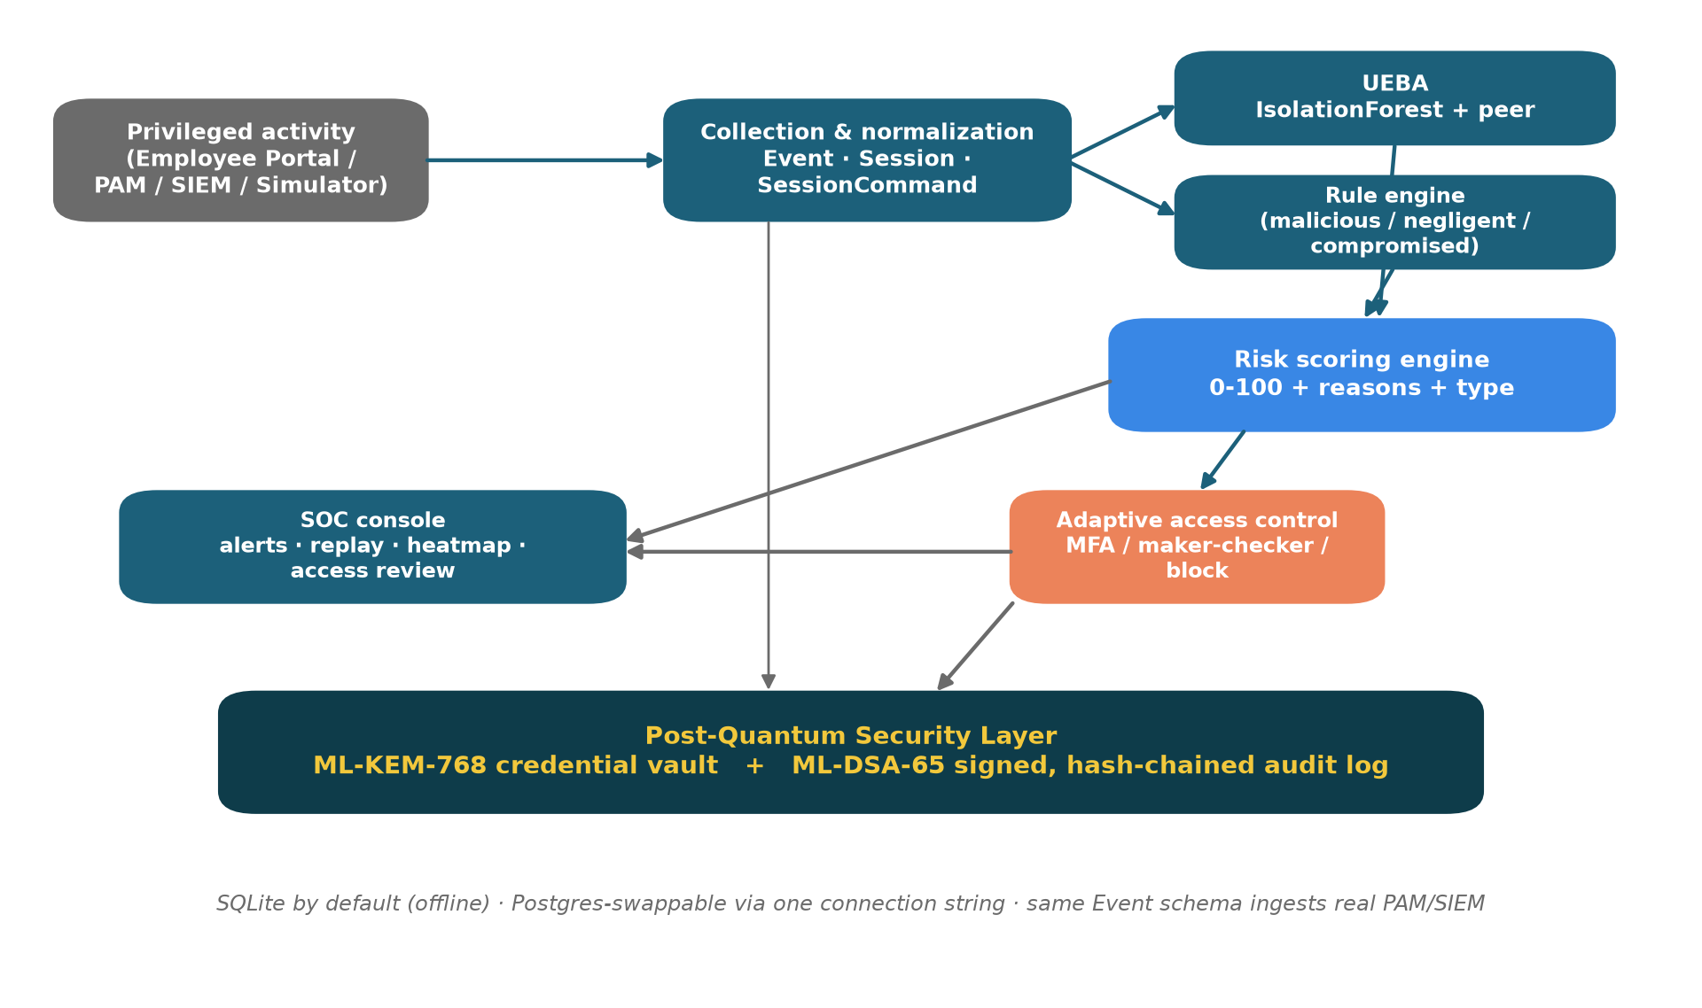
Prahari system architecture — six modules from ingestion to the post-quantum security layer.
The Employee Portal, and in production any PAM/SIEM feed, map onto the same normalized Event schema; the built-in simulator produces the same shape for the demo.
Technology stack
Layer | Choice
Backend / API | Python 3.14, FastAPI + Uvicorn
Storage | SQLAlchemy ORM · SQLite (default) -> PostgreSQL-swappable
AI / UEBA | scikit-learn IsolationForest + peer baselining
Post-quantum crypto | liboqs-python — ML-KEM-768 (FIPS 203), ML-DSA-65 (FIPS 204); AES-256-GCM
Authentication | PBKDF2-HMAC-SHA256 passwords + HMAC-signed tokens (standard library)
Real-time | FastAPI WebSocket
Frontend | React 19 + Vite + Tailwind 4 (+ Recharts)
Packaging | Docker + docker-compose · run.ps1 / run.sh
Testing | pytest (31 tests)

5 Data Model
Seven ORM entities capture the workforce, their recorded sessions and actions, the detection output, and the post-quantum artefacts.
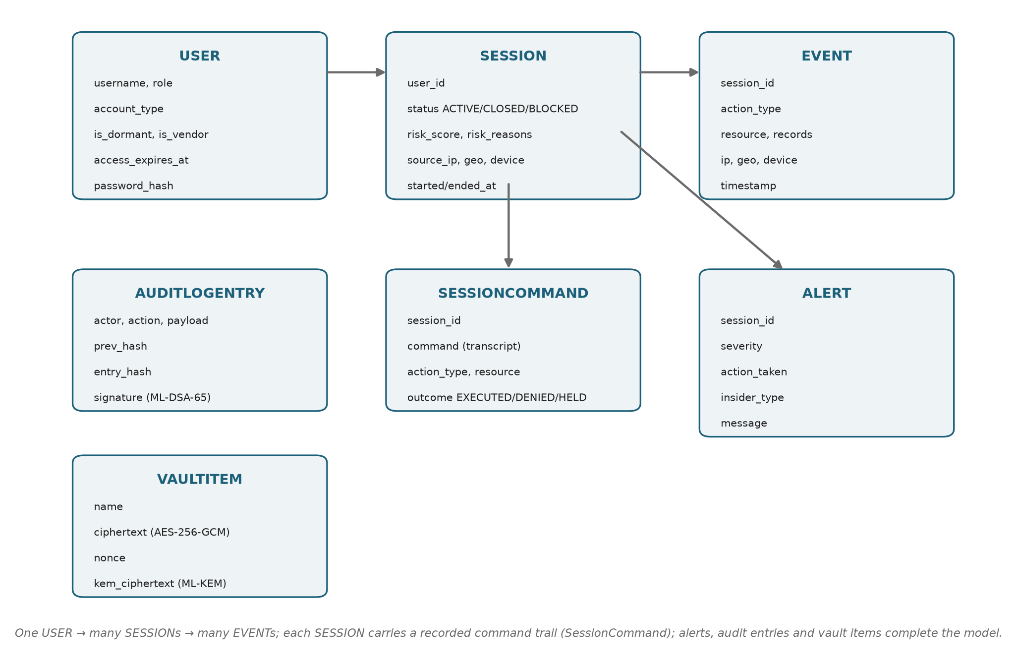
Entity model — users, sessions, events, recorded commands, alerts, audit entries and vault items.
SessionCommand is the privileged-session recording: every action writes a realistic command line (for example, psql core-banking-db -c "COPY customers TO '/tmp/out.csv' CSV;" -- 5000 rows) with an outcome, so a session replays like a terminal transcript.
Seeded cast (all password prahari123):
Username | Role | Notes
rmehta, spatil | DBA | permanent staff
akulkarni, pjoshi | SYSADMIN | permanent staff (akulkarni = compromised-scenario subject)
vdeshmukh | NET_ADMIN | permanent staff
nshinde | APP_ADMIN | permanent staff
ext_dsouza | CONTRACTOR | dormant vendor, access expired 120 days -> malicious attacker
ext_rao | CONTRACTOR | active vendor, access expired 18 days -> negligent subject
soc_admin | SOC_ANALYST | logs into the SOC console (account_type = ANALYST)

6 Detection Engine
Two detectors feed one scorer.

6.1 Rule engine
Each rule returns a reason, a weight, and an insider_type tag.
Rule | Fires when | Weight | Type
DORMANT_REACTIVATION | a dormant account logs in | 30 | malicious
PRIVILEGE_ESCALATION | a privilege-change event occurs | 25 | malicious
AFTER_HOURS_ACCESS | activity between 00:00 and 06:00 | 20 | malicious
MASS_EXPORT | at least 1000 records in one session | 30 | malicious
NO_BUSINESS_RELATIONSHIP | resource outside the user’s role | 15 | malicious
NEW_GEO | login location is not the home location | 16 | compromised
NEW_DEVICE | unrecognized device with a foreign location | 12 | compromised
ATYPICAL_HOUR | login in an off-shift hour (06, 20–23) | 8 | compromised
RAPID_FIRE | at least 5 actions within 180 seconds (inhuman pace) | 8 | compromised
EXPIRED_ACCESS_IN_USE | the user’s access grant has lapsed | 30 | negligent
UNMANAGED_DEVICE | sensitive data from a new device at the home location | 30 | negligent
The dominant insider type of a session is the category carrying the most rule weight (tie-break priority: malicious, then compromised, then negligent).
Device disambiguation. A new device with a foreign geography reads as account takeover (NEW_DEVICE, compromised); a new device from the home location reads as a personal, unmanaged laptop (UNMANAGED_DEVICE, negligent). This keeps the two families cleanly separated.

6.2 UEBA — behavioural analytics
Every session becomes a 7-feature vector: login_hour, event_count, total_records, distinct_resources, config_changes, offsite_ip, new_device.
- An IsolationForest (100 trees) is trained on closed historical sessions, including cumulative prefixes of each session — so live sessions (which arrive one action at a time) are in-distribution and normal early activity is not flagged merely for being short.
- The raw anomaly is normalized to 0–100 against the baseline distribution (median maps to 0, first percentile maps to 100).
- Peer comparison measures the session’s record volume against the same-role average — for example, “5000× more records than CONTRACTOR peers”.

6.3 Risk scoring
The final score fuses the two detectors:
$$\text{score}=min​\left( \text{rule_weight (capped at 80)} + 0.25×\text{UEBA_anomaly} + \text{peer_bonus (10 if}≥5×\text{peers)}, 100\right)$$
UEBA is a secondary nudge (at most 25 points): the stable, explainable rule engine sets the band; the behavioural model refines within it. Every score ships a reason list (the “why-flagged” panel) and the insider type.
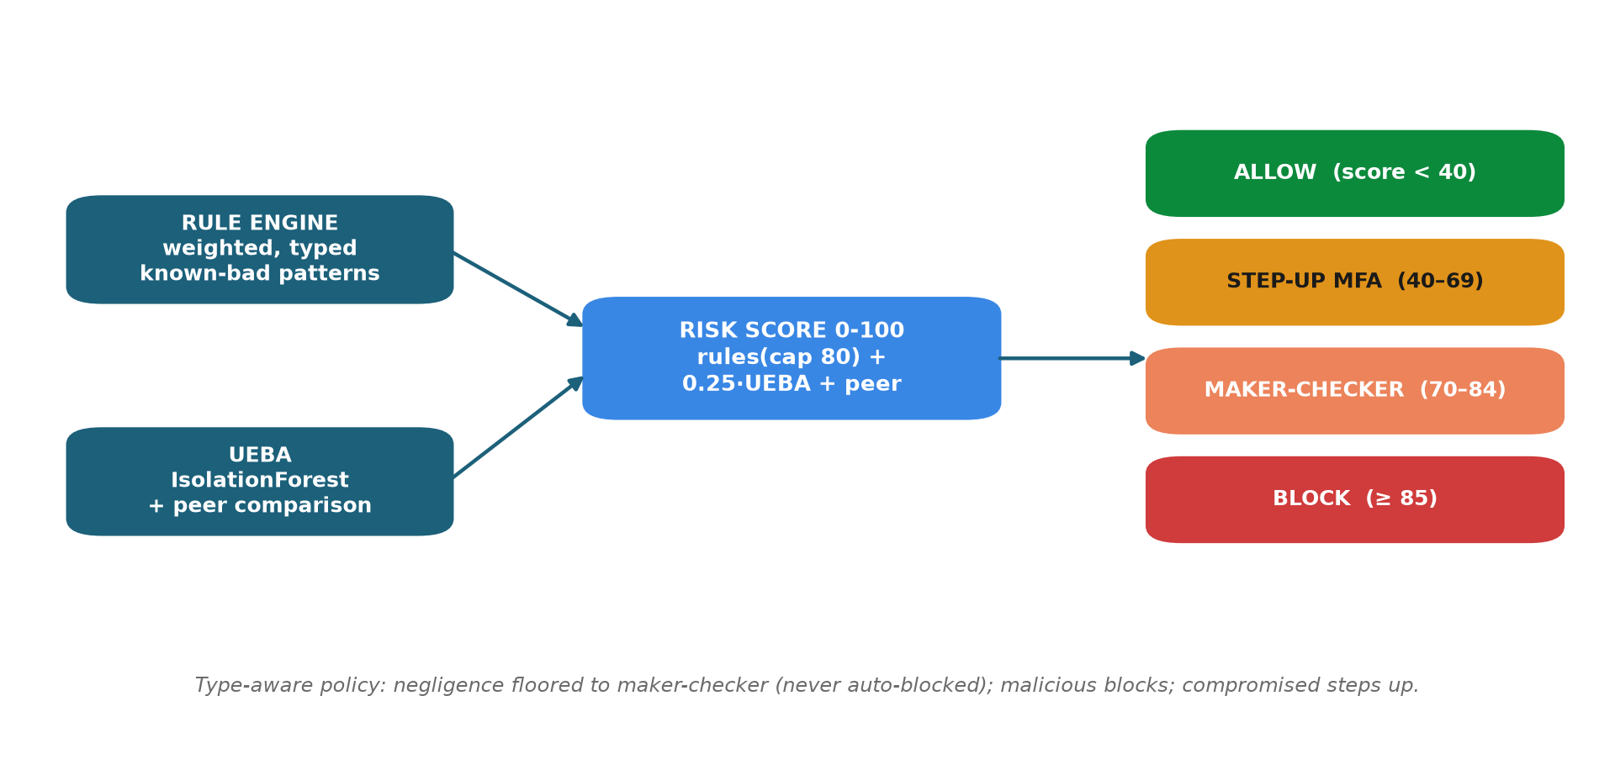
Scoring pipeline — rules and UEBA fuse into a 0–100 score that maps onto the response ladder.

7 The Three Insider Types
Three scripted scenarios (one SOC button each) prove three distinct response paths. The behaviour is verified live and by automated tests on an independent random seed.
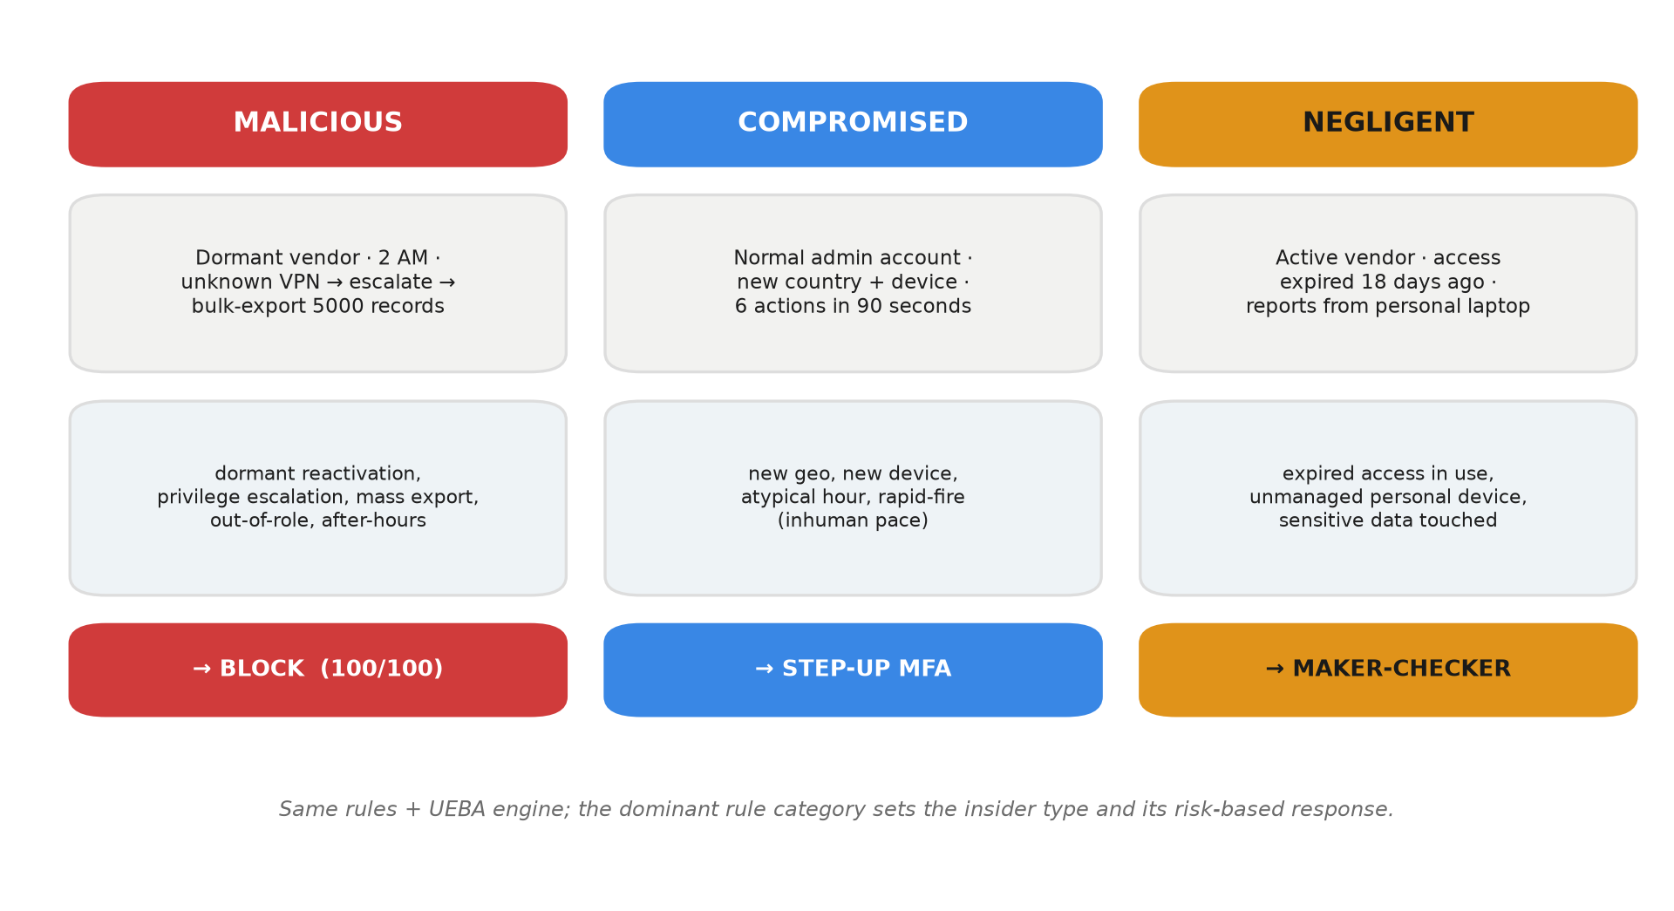
Three insider types — one engine, three distinct, correctly-typed responses.
Scenario | Dominant signals | Score band | Response
Malicious | dormant + escalation + mass-export + out-of-role + after-hours | >= 85 | BLOCK
Compromised | new geo + new device + atypical hour + rapid-fire | 40–69 | STEP-UP MFA
Negligent | expired access + unmanaged device | 70–84 | MAKER-CHECKER
Type-aware policy. Negligence is a control failure to remediate with a human second-check, not an attack to hard-block — so a negligent session is floored to maker-checker review and never escalated to an automated block. Malicious blocks; compromised steps up. This is enforced in decide(score, insider_type).

8 Adaptive Response and PAM

8.1 Live enforcement
Each portal action re-scores the whole session including the candidate action, then enforces the decision before the action takes effect.
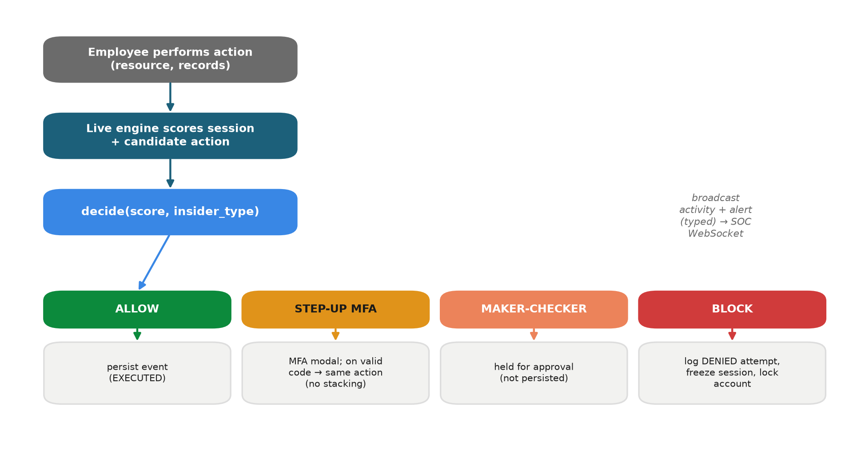
Live enforcement — every action is scored and routed to one of four responses before it takes effect.
Key safety properties:
- Blocked accounts stay locked. A blocked session is returned on re-login; a blocked user cannot open a fresh session to continue.
- No score-gaming. Challenged actions (MFA or maker-checker) are not persisted until actually allowed, so retrying does not inflate the session.
- Server-side enforcement. The API refuses to execute; the UI overlay is cosmetic.

8.2 PAM surface
- Privileged-session recording (GET /soc/sessions/{id}/commands) — the replayable command trail; blocked commands show as DENIED (struck through), held ones as HELD.
- Access review (GET /soc/access-review) — every privileged account with standing-risk flags (DORMANT / VENDOR / EXPIRED) and a risk rating, surfacing lingering access before anything happens.
- Maker-checker approval (POST /soc/sessions/{id}/approve) — an analyst approves a held session; the approval is written to the signed audit log.

9 Post-Quantum Security Layer
All post-quantum operations sit behind one abstraction, app/security/pqc.py, exposing kem_keypair, kem_encapsulate, kem_decapsulate, sign, and verify over ML-KEM-768 (FIPS 203) and ML-DSA-65 (FIPS 204).

9.1 Credential vault
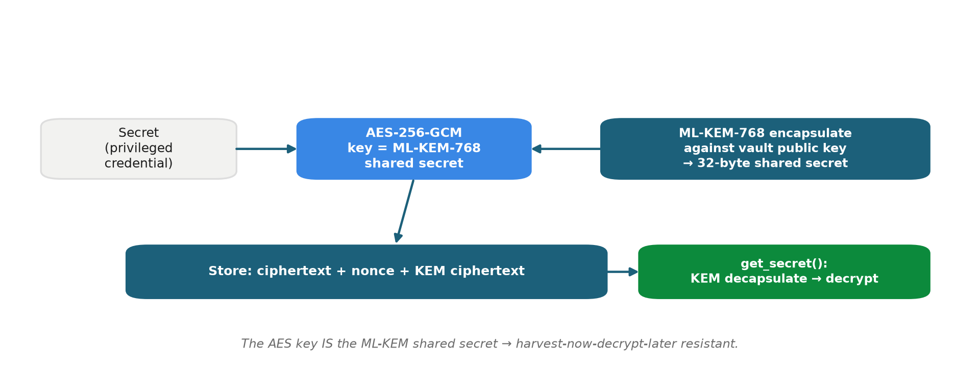
Credential vault — a secret is sealed with AES-256-GCM under an ML-KEM-768 shared secret.
The AES key is the ML-KEM shared secret; decryption requires the vault’s KEM secret key. Data recorded today cannot be decrypted later, even by a quantum adversary.

9.2 Tamper-evident audit log
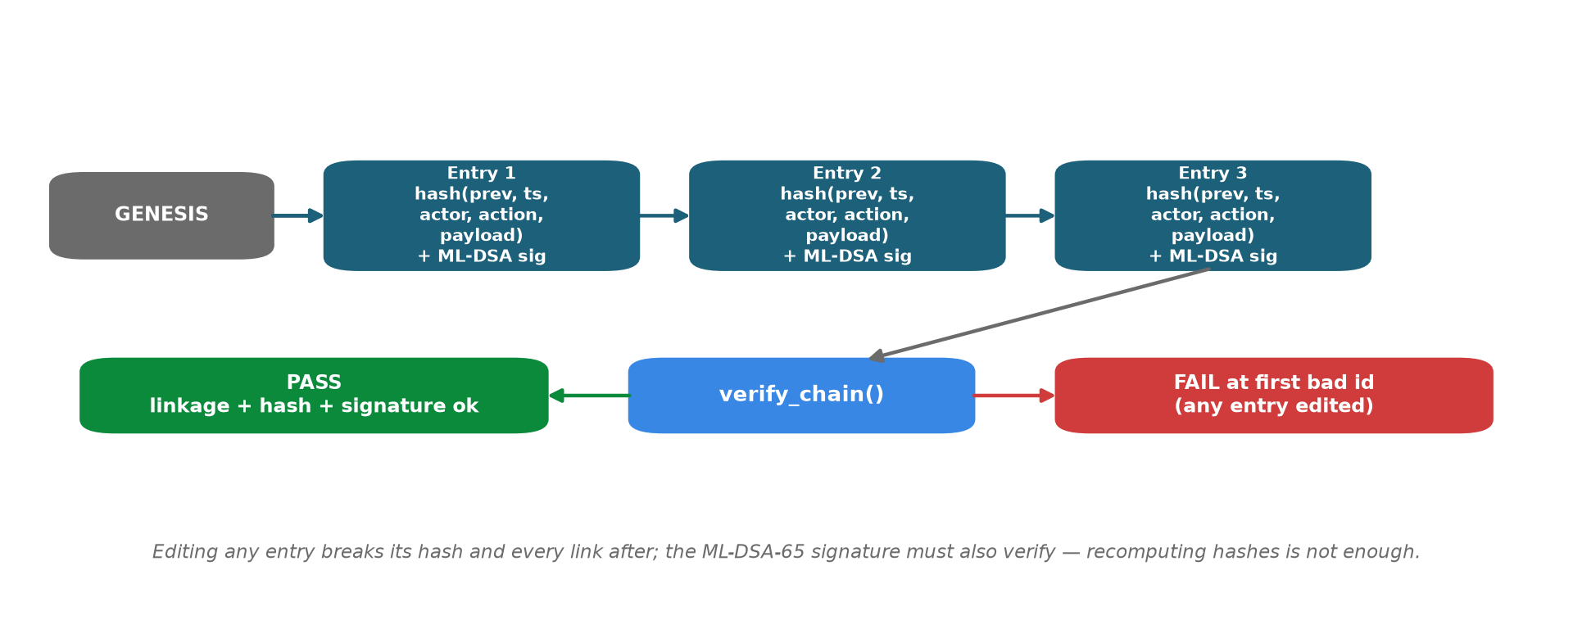
Audit chain — each entry hash-links the previous and is ML-DSA-65 signed; any edit fails verification.
Each entry hash-chains the previous entry and is ML-DSA-65 signed. Editing any entry breaks its hash and every subsequent link; recomputing hashes is not enough, because the signature must still verify with the audit public key. POST /demo/tamper flips one record live, and verify_chain() then fails at the exact entry.

10 Authentication and Authorization
- Passwords — PBKDF2-HMAC-SHA256 (200,000 rounds, per-user salt), in app/security/auth.py.
- Tokens — compact HMAC-SHA256-signed, JWT-like tokens with expiry, verified on every request.
- Roles — EMPLOYEE routes to the Employee Portal; ANALYST routes to the SOC Console. SOC endpoints are gated with require_analyst (HTTP 403 for employees). The WebSocket feed is broadcast-only.
This layer is demo-grade by design; a production deployment swaps in the bank’s IdP/SSO behind the same dependency.

11 API Reference
Method | Endpoint | Auth | Purpose
POST | /auth/login | – | issue token (username / password)
GET | /auth/me | any | current identity
POST | /portal/bootstrap | employee | open live session + catalog + resources
POST | /portal/action | employee | perform action -> scored and enforced
POST | /portal/logout | employee | close session
GET | /soc/overview | analyst | users, scored history, heatmap, live sessions
GET | /soc/live | analyst | active / blocked sessions (typed)
GET | /soc/alerts | analyst | recent alerts (typed)
GET | /soc/access-review | analyst | PAM dormant / vendor / expired table
GET | /soc/sessions/{id}/commands | analyst | session recording replay
GET | /soc/sessions/{id}/events | analyst | session events
POST | /soc/sessions/{id}/approve | analyst | maker-checker approval
POST | /demo/scenario/{kind} | analyst | run scripted malicious / compromised / negligent
POST | /demo/tamper | analyst | edit an audit entry (proves detection)
GET | /audit, /audit/verify | analyst | list / verify the signed chain
GET | /pqc/info | any | active PQC provider and algorithms
POST, GET | /vault/secrets | analyst | store / retrieve a PQC-wrapped secret
WS | /ws/feed | – | live activity / alert / tamper frames
GET | /health | – | liveness
Interactive API docs are served at /docs (FastAPI / OpenAPI).

12 Frontend
React 19 + Vite + Tailwind 4, dark SOC theme, served by FastAPI from frontend/dist (same-origin, offline).
- Login (pages/Login.jsx) — role-routed, with a demo-account helper.
- Employee Portal (pages/Portal.jsx) — action console, connection badge, live risk gauge, activity timeline, MFA modal, maker-checker banner, and a full-screen BLOCK overlay.
- SOC Console (pages/SocConsole.jsx) — three scenario buttons, an audit banner, and panels: live sessions (typed), risk gauge, why-flagged, alerts (typed), timeline, session recording (terminal replay), heatmap, and access review.
The colour system reserves status colours (good / warning / serious / critical), colour-codes insider types (malicious red, compromised blue, negligent amber), uses tabular numerics, flashes on new alerts, and never encodes meaning by colour alone.

13 Security Considerations
- Data minimization — scores on privileged-activity metadata; no customer PII required.
- Credential protection — an ML-KEM-768-wrapped AES-256-GCM vault for privileged secrets.
- Audit integrity — hash-chained and ML-DSA-65-signed entries; tampering is cryptographically evident.
- Enforcement — server-side; blocked accounts stay locked; a challenged action is not persisted until actually allowed (no score-gaming, no bypass by re-login).
- Authorization — role-gated APIs; analyst-only SOC and PQC endpoints.
- Offline by design — no external calls at runtime; keys kept out of version control; .env-driven configuration; least-privilege demo accounts.
- Explainability and compliance — every decision has a plain-English reason, an immutable trail, and access reviews for standing, dormant and expired grants.

14 Scalability
- Stateless scoring — scale horizontally behind a load balancer; each request scores one session.
- Storage — SQLite to PostgreSQL by changing one connection string (pure ORM, no raw SQL).
- Real-time fan-out — WebSocket behind a Redis or Kafka broker to serve many SOC clients and high event throughput.
- Ingestion — generalizes to enterprise PAM/SIEM feeds (millions of privileged events per day) on the same Event schema.
- Machine learning — models retrain per role and shift nightly; a feature store holds baselines; the UEBA interface accepts an autoencoder upgrade with no application changes.
- Post-quantum operations — ML-KEM encapsulation and ML-DSA signing are sub-millisecond, negligible next to a database write.

15 Deployment and Running
# Windows PowerShell
.\run.ps1 # venv + deps + seeded DB + UI + API (offline)
.\run.ps1 -Reset # wipe and reseed for a clean demo
# Git Bash / Linux / macOS
./run.sh # same, POSIX
docker compose up --build # container alternative
Then open http://127.0.0.1:8000. The first run on a fresh machine needs internet once (pip install plus a one-time liboqs build); afterwards it is fully offline. Run tests with .venv/Scripts/python -m pytest.

16 Testing
The suite contains 31 pytest tests, including:
- test_simulator — user seeding, normal-day realism, determinism.
- test_detection — every rule, normal-versus-attack scoring, quiet-on-normal.
- test_scenarios — the three insider scenarios land on distinct, correct paths and the type-aware policy holds (negligence never auto-blocks), on an independent seed.
- test_phase3 — attack block, alert, and the WebSocket loop.
- test_portal — authentication, role gating, live enforcement, MFA without event stacking, and blocked-stays-locked.
- test_pqc — KEM round-trip, sign/verify with forgery rejection, vault round-trip, and audit chain clean / tamper / signature-forgery.

17 Demo Walkthrough
Full narration is in DEMO_SCRIPT.md. In brief (two browser windows, side by side):
- SOC Console (soc_admin) — quiet, with a green heatmap.
- Employee Portal (rmehta) — a normal query is ALLOWED; an export of 1000 records triggers STEP-UP MFA (code 246810).
- Attacker (ext_dsouza) — escalate then export 5000 records -> full-screen BLOCK; the account is locked.
- SOC lights up — a red live session at 100, a flashed CRITICAL alert tagged malicious, the why-flagged panel, the session replay (export struck through as DENIED), and a red heatmap cell.
- Two more insider types — the SOC buttons run Compromised -> MFA and Negligent -> maker-checker, each correctly typed.
- PAM access review — dormant, vendor and expired flags.
- Quantum-safe evidence — Verify Chain (green) then Tamper (red, FAILED at the exact entry).

18 Roadmap
- PS2 correlation — link a privileged record-change to a suspicious downstream transaction.
- Just-in-time access and automated entitlement reviews.
- Autoencoder UEBA upgrade behind the same interface.
- Enterprise integrations — CyberArk / BeyondTrust PAM, Splunk / QRadar SIEM, IdP / SSO.
- Workforce-wide insider-risk scoring beyond privileged accounts.

19 Repository Map
PRAHARI/
app/
main.py FastAPI app + lifespan + static UI mount
config.py pydantic settings (.env)
pam.py session-command recording + access review
api/routes.py REST + WebSocket endpoints
api/ws.py WebSocket broadcast manager
detection/rules.py rule engine (3 insider types, typed)
detection/ueba.py IsolationForest + peer baseline (prefix-trained)
detection/score.py 0-100 risk score + reasons + insider type
detection/response.py type-aware adaptive response
detection/live.py live per-action scoring & enforcement
models/entities.py ORM entities
security/auth.py PBKDF2 passwords + HMAC tokens
security/pqc.py ML-KEM-768 / ML-DSA-65 abstraction
security/vault.py quantum-safe credential vault
security/audit.py hash-chained + signed audit log
simulator/ normal-day generator, 3 scenarios, seeder
frontend/ React app (pages/ + components/) + prebuilt dist/
tests/ 31 pytest tests
docs/ this documentation + submission deck
DOCUMENTATION.md DEMO_SCRIPT.md PROJECT_STATUS.md README.md
run.ps1 run.sh Dockerfile docker-compose.yml requirements.txt
Prahari — the sentinel for privileged access. Detect with AI and rules, explain every decision, respond in real time, and keep the proof quantum-safe.

