Techfest 2026-27
The Wrecking Ball Challenge
Round 1: Submission Template

TEAM IDENTIFICATION
- Team ID & Name: TM-47C20DF8A48 | StarDust
- Institution: Madan Mohan Malaviya University of Technology, Gorakhpur
- Team Lead Contact: Abhishek Kumar Singh | abhishekkrsingh2345@gmail.com | 8429339626

1. Mechanical Architecture & Enclosure Design (CAD Evidence)
- CAD Renders Provided:
- Isometric View Render: Figure 1 below (full-resolution files and STEP model: [GOOGLE DRIVE LINK])
- Cross-Sectional View Render: Figure 2 below (true section of the CAD solids on the mid-plane)
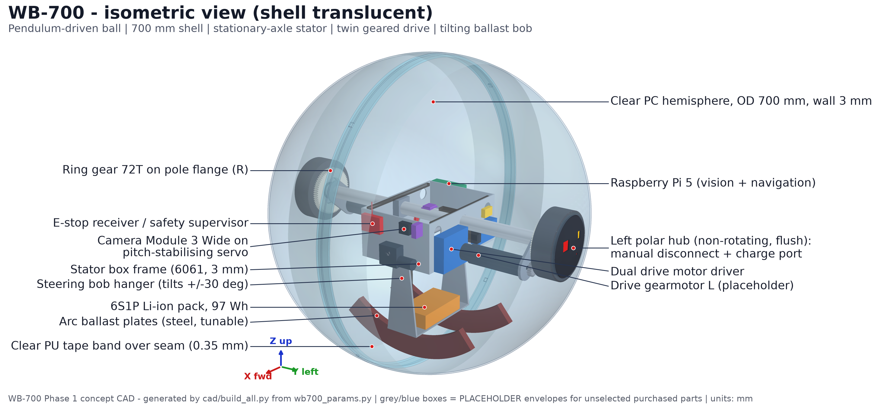
Figure 1 - Isometric view render of the WB-700 CAD assembly (68 parts; shell drawn translucent).
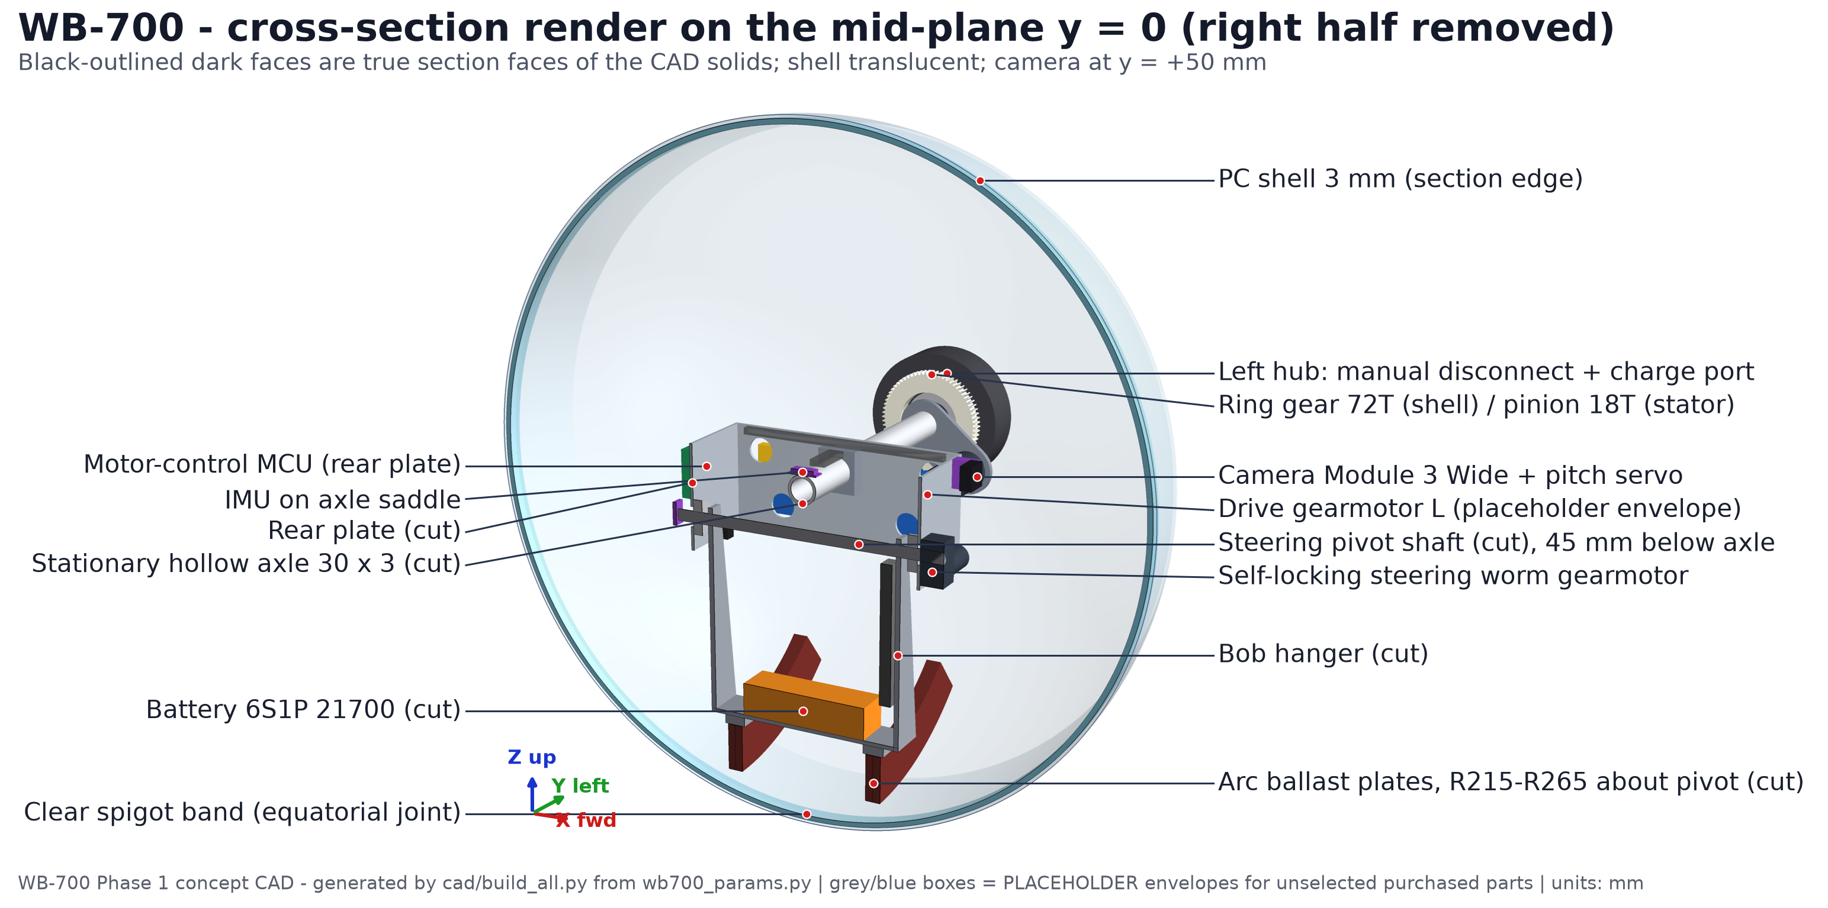
Figure 2 - Cross-sectional view render on the mid-plane y = 0. Dark, black-outlined faces are true section faces.
- Shell Integrity:
- Material: Polycarbonate: two clear thermoformed PC hemispheres, 3.0 mm nominal wall, joined on the equator by a clear PC spigot band and clamped by a single M12 bolt through the axle. A replaceable clear polyurethane protective tape band (0.35 mm, 3M 8671 class) covers the rolling band and seam. PC is chosen for impact toughness and optical clarity, because the camera looks out through the shell.
- Exact Outer Diameter: 700 mm = 2.297 ft (shell); 700.7 mm = 2.299 ft over the tape band. Measured on the CAD in every direction, all calipers are 696.3-700.7 mm (2.284-2.299 ft), strictly inside 2.0-2.5 ft, with 86.7 mm and 61.3 mm margin. The rule still holds with ±7 mm forming tolerance.
- The 0.5-Foot Limit Rule: No external sensor mounts or camera pods. Protrusion beyond the outer shell: 0 mm, against the 152.4 mm (0.5 ft) limit. The camera, computer, actuators, battery and electronics are all inside the shell. The two polar hubs are flush and recessed 1.0 mm below the sphere surface, so the largest non-shell feature sits 1.0 mm inside the surface (Figure 3).
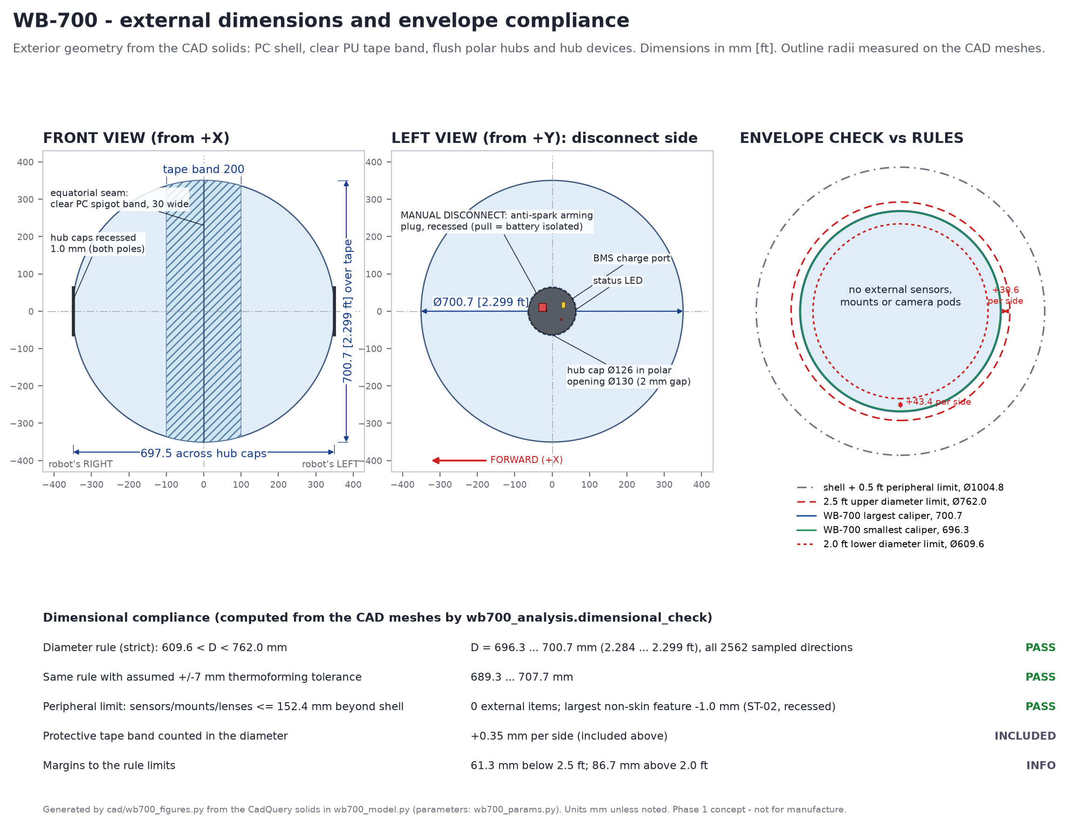
Figure 3 - External dimensions and envelope check, computed from the CAD meshes.
- CoG & Drive Mechanism: a two-axis pendulum (barycentre-offset) drive. A gravity-held internal frame, the stator, hangs on a stationary hollow axle; the shell turns around it on two 61908 pole bearings. Drive: two 24 V gearmotors on the stator turn 72-tooth ring gears bolted to the hemisphere poles (4:1). The reaction swings the stator forward, the CG moves ahead of the contact point, and the ball rolls. Steering: a self-locking worm gearmotor tilts a heavy steering bob (6S battery + laser-cut steel ballast arcs, 5.34 kg) ±30° about a pivot 45 mm below the axle. This leans the ball about ±22.9° and it turns (Figure 5). The lean is a static estimate; turning radius and gate navigation are Phase 2 results. At both ±30° extremes the frame and bob stay at least 20.0 mm from the shell, with no clashes. Axle and shell joint: the right hub's M12 bolt, with disc springs, threads into the stationary axle and draws the two hubs together. Each hub's boss carries a 61908 bearing inner race, and the outer races sit in pole flanges bonded and screwed to the hemispheres. The light, spring-limited axial preload therefore runs hub → bearing → flange → hemisphere and closes the equatorial spigot joint, while the shell still turns freely on the bearings. The ring gears bolt to the flanges, so gear alignment follows the bearing axis. Bearing shoulders, spacers and circlips are detailed in Phase 2. Balance: the stator and bob (10.15 kg) hang 146.2 mm below the axle as one pendulum, which gives a strong restoring moment; the MCU adds active pitch damping, and a servo keeps the camera at a constant look-down angle. Initial calculated CoG relative to the geometric centre (X forward, Y left, Z up): (x, y, z) = (+1.4, -0.4, -87.2) mm, total mass 17.00 kg. This comes from the CAD mass table (Figure 4). 3.03 kg of the total is placeholder hardware, and the ballast (2-6 plates) tunes the CG from -61.9 to -107.0 mm.
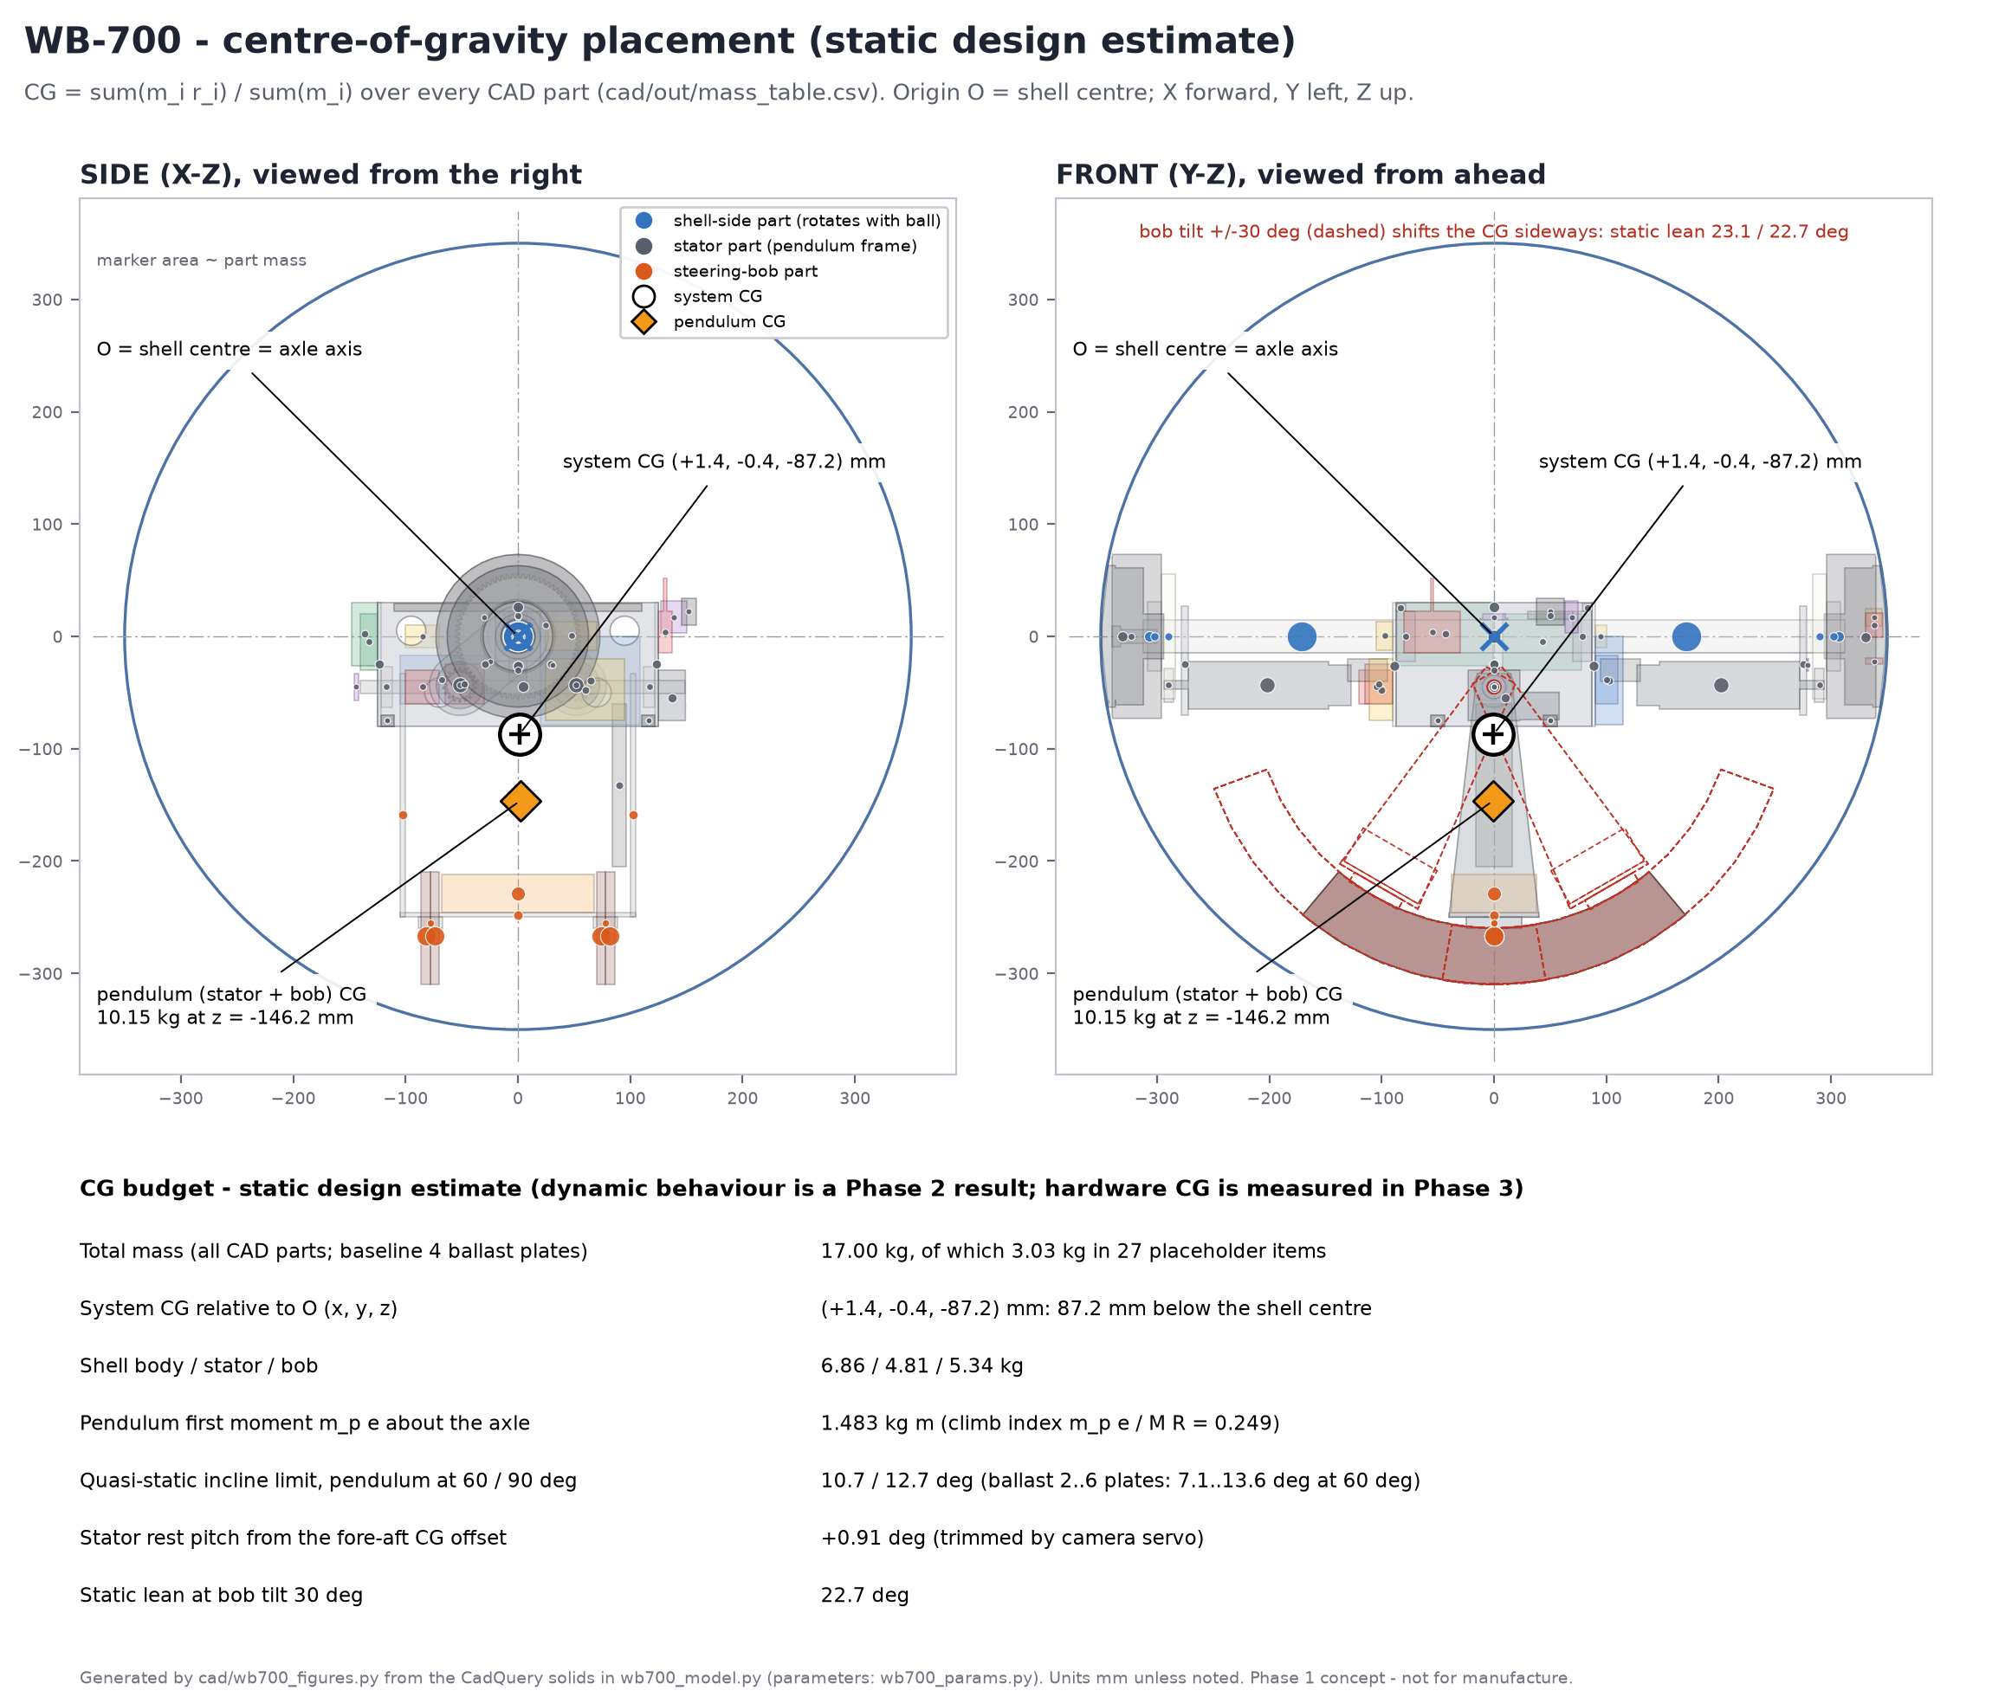
Figure 4 - Component CGs (marker area proportional to mass), system CG and pendulum CG from the CAD mass table.
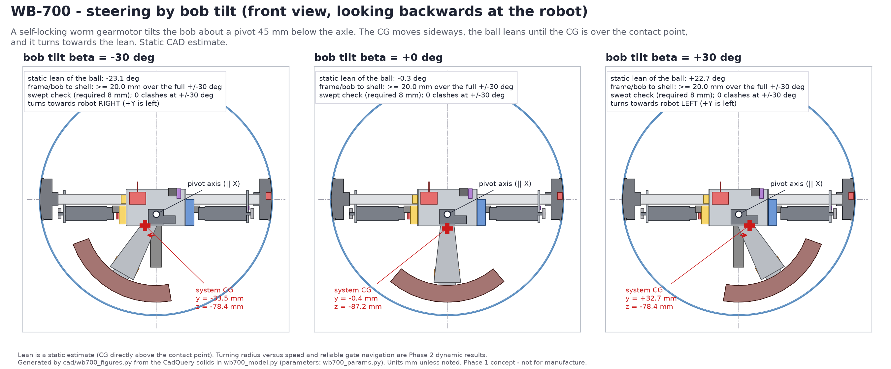
Figure 5 - Steering by bob tilt at -30°, 0° and +30°: pivot, sideways CG shift, static lean and clearance to the shell.
- Ramp-Climbing Capability: preliminary and conditional. Techfest gives the ramp heights (0.2, 0.4 and 0.8 ft = 60.96, 121.92 and 243.84 mm) but not their slopes or entry geometry, so torque is given against angle. Required shell torque T = M g R (sin a + c_rr cos a), with M = 17.00 kg, R = 0.350 m and c_rr = 0.03 (assumed): 11.9 N m at 10°, 16.8 N m at 15°, 21.6 N m at 20°. A pendulum drive can react at most m_p e g sin(phi) = 14.6 N m (pendulum horizontal) or 12.6 N m at the 60° working limit. Setting the two equal, including rolling resistance, gives a steady climbing limit of about 10.7° with 4 ballast plates (7.1-13.6° with 2-6 plates). For a steeper ramp, the energy needed for the 0.8 ft rise corresponds to a run-up of about 1.31 m/s at 20° and 1.53 m/s at 30° (Figure 6). These are energy estimates only: they do not show that the robot keeps traction, survives the ramp entry or stays controllable at the crest, which Phase 2 checks. Motor operating points (per motor, at the gearmotor output; 18T/72T m1.5 spur stage, 4:1, 95 % efficient): steady climb at the 10.7° limit needs 1.66 N m continuous at 55 rpm (0.5 m/s, assumed); cruising at 2.0 m/s needs 0.23 N m at 218 rpm; holding the pendulum horizontal needs 1.91 N m for a short time. Selection: 2 × 24 V brushed DC planetary gearmotors (42 mm class) with Hall encoders. Targets per motor at 24 V: rated (continuous) ≥ 2 N m, stall ≥ 4 N m, no-load ≥ 320 rpm. At the 18.0 V minimum pack voltage this still gives about 3.0 N m stall, 240 rpm unloaded (enough for 218 rpm at cruise load) and about 107 rpm at the climb torque. Software caps the current. The exact part is fixed in Phase 2 once the ramp geometry is confirmed.
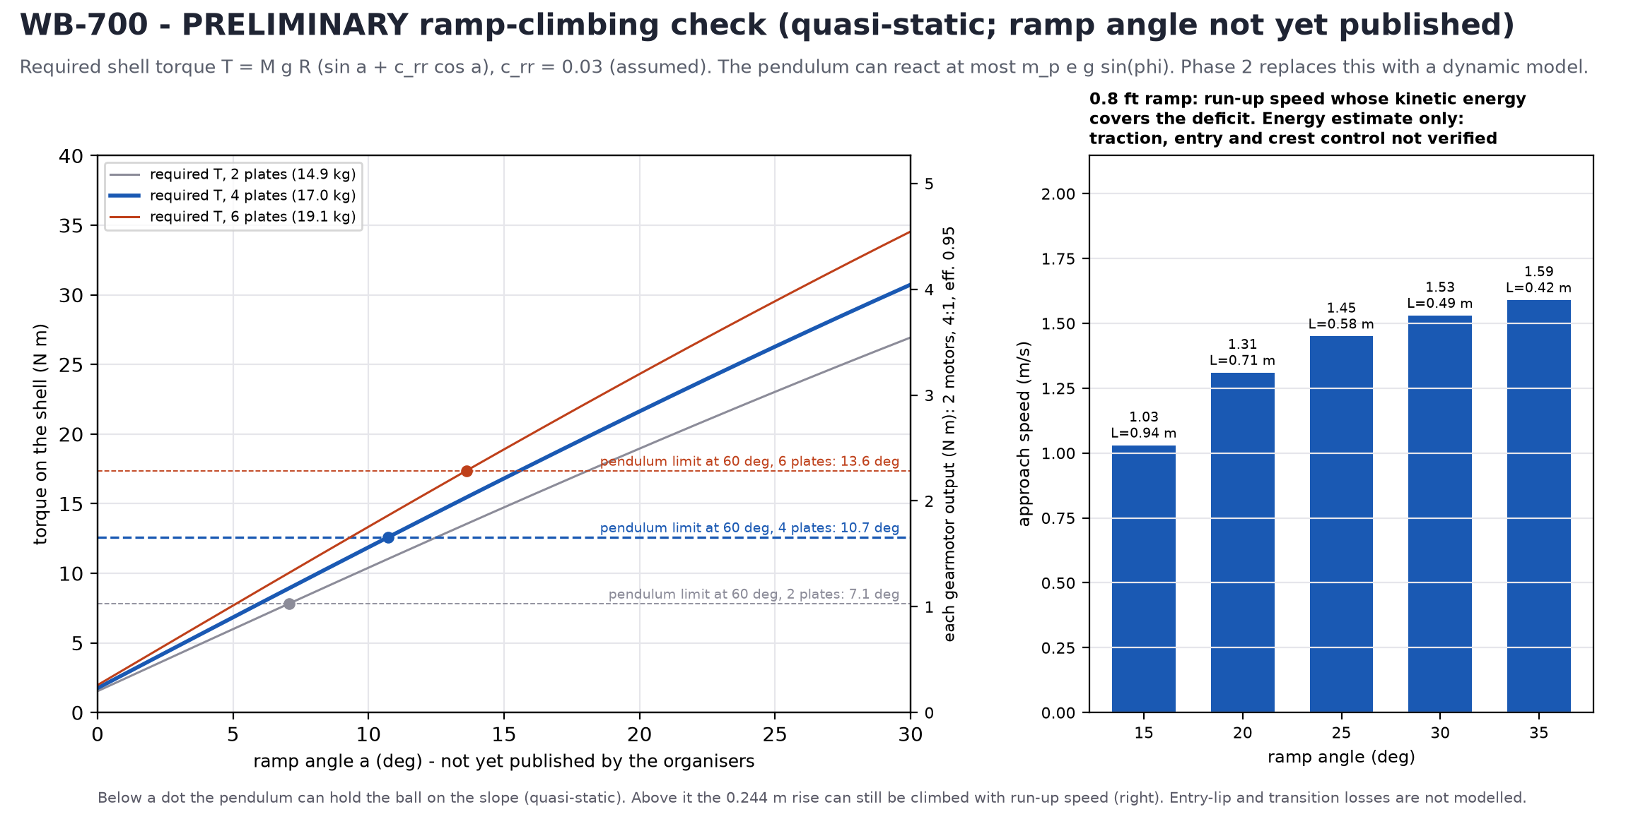
Figure 6 - Required vs. available shell torque, and run-up speed for the 0.8 ft (0.244 m) rise. Preliminary and quasi-static; run-up values are energy estimates only.

2. Electrical & Power System Architecture
- Electrical Block Diagram: Figure 7 (system block diagram), Figure 8 (power distribution) and Figure 9 (microcontroller, sensor interfaces and motor drivers).
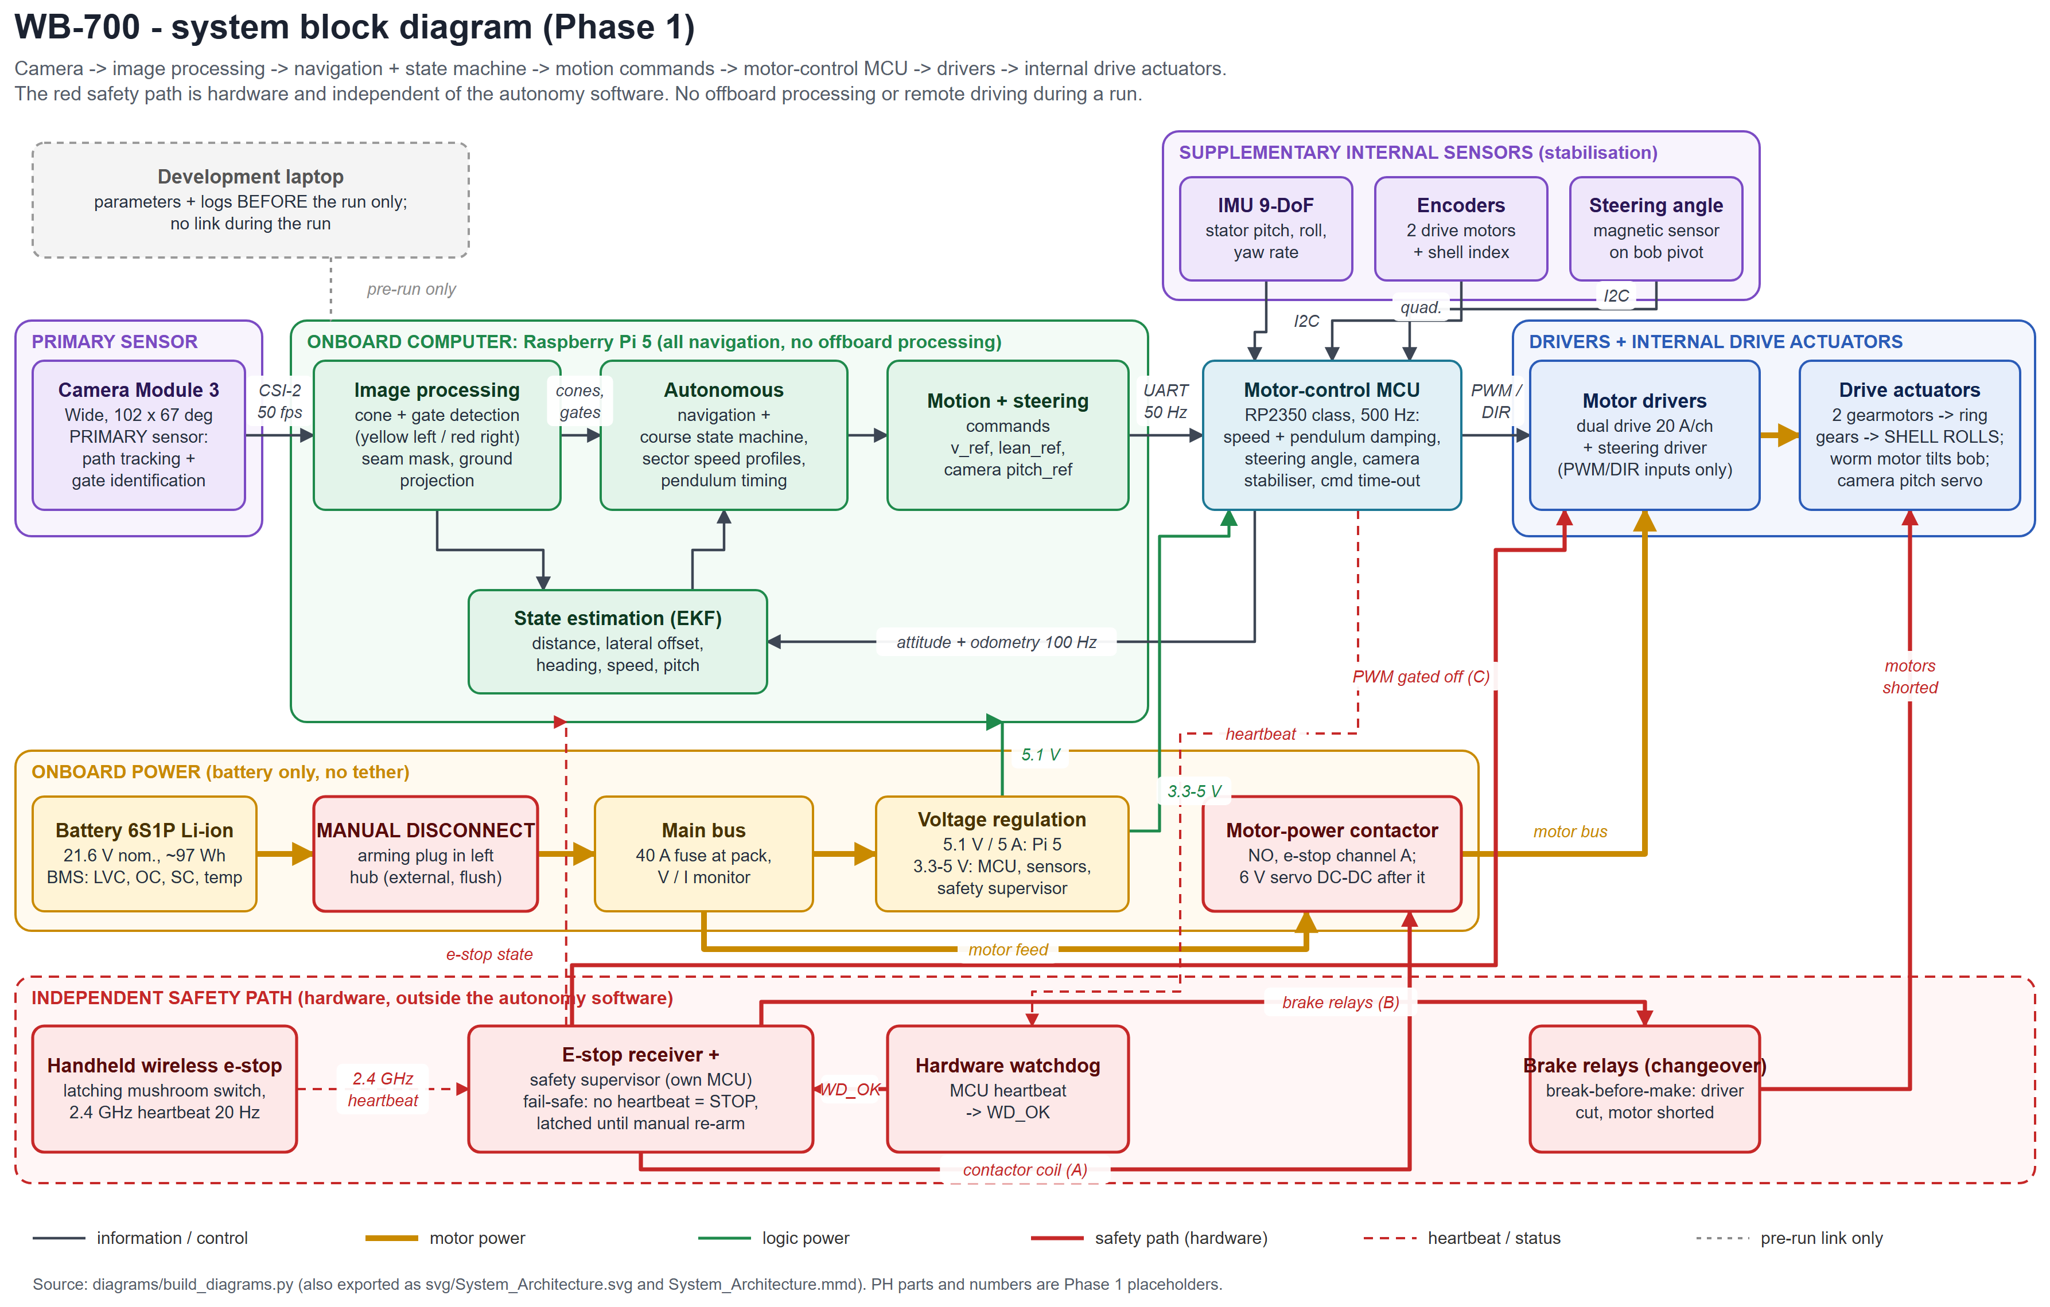
Figure 7 - System block diagram: information flow, power and the independent hardware safety path (red).
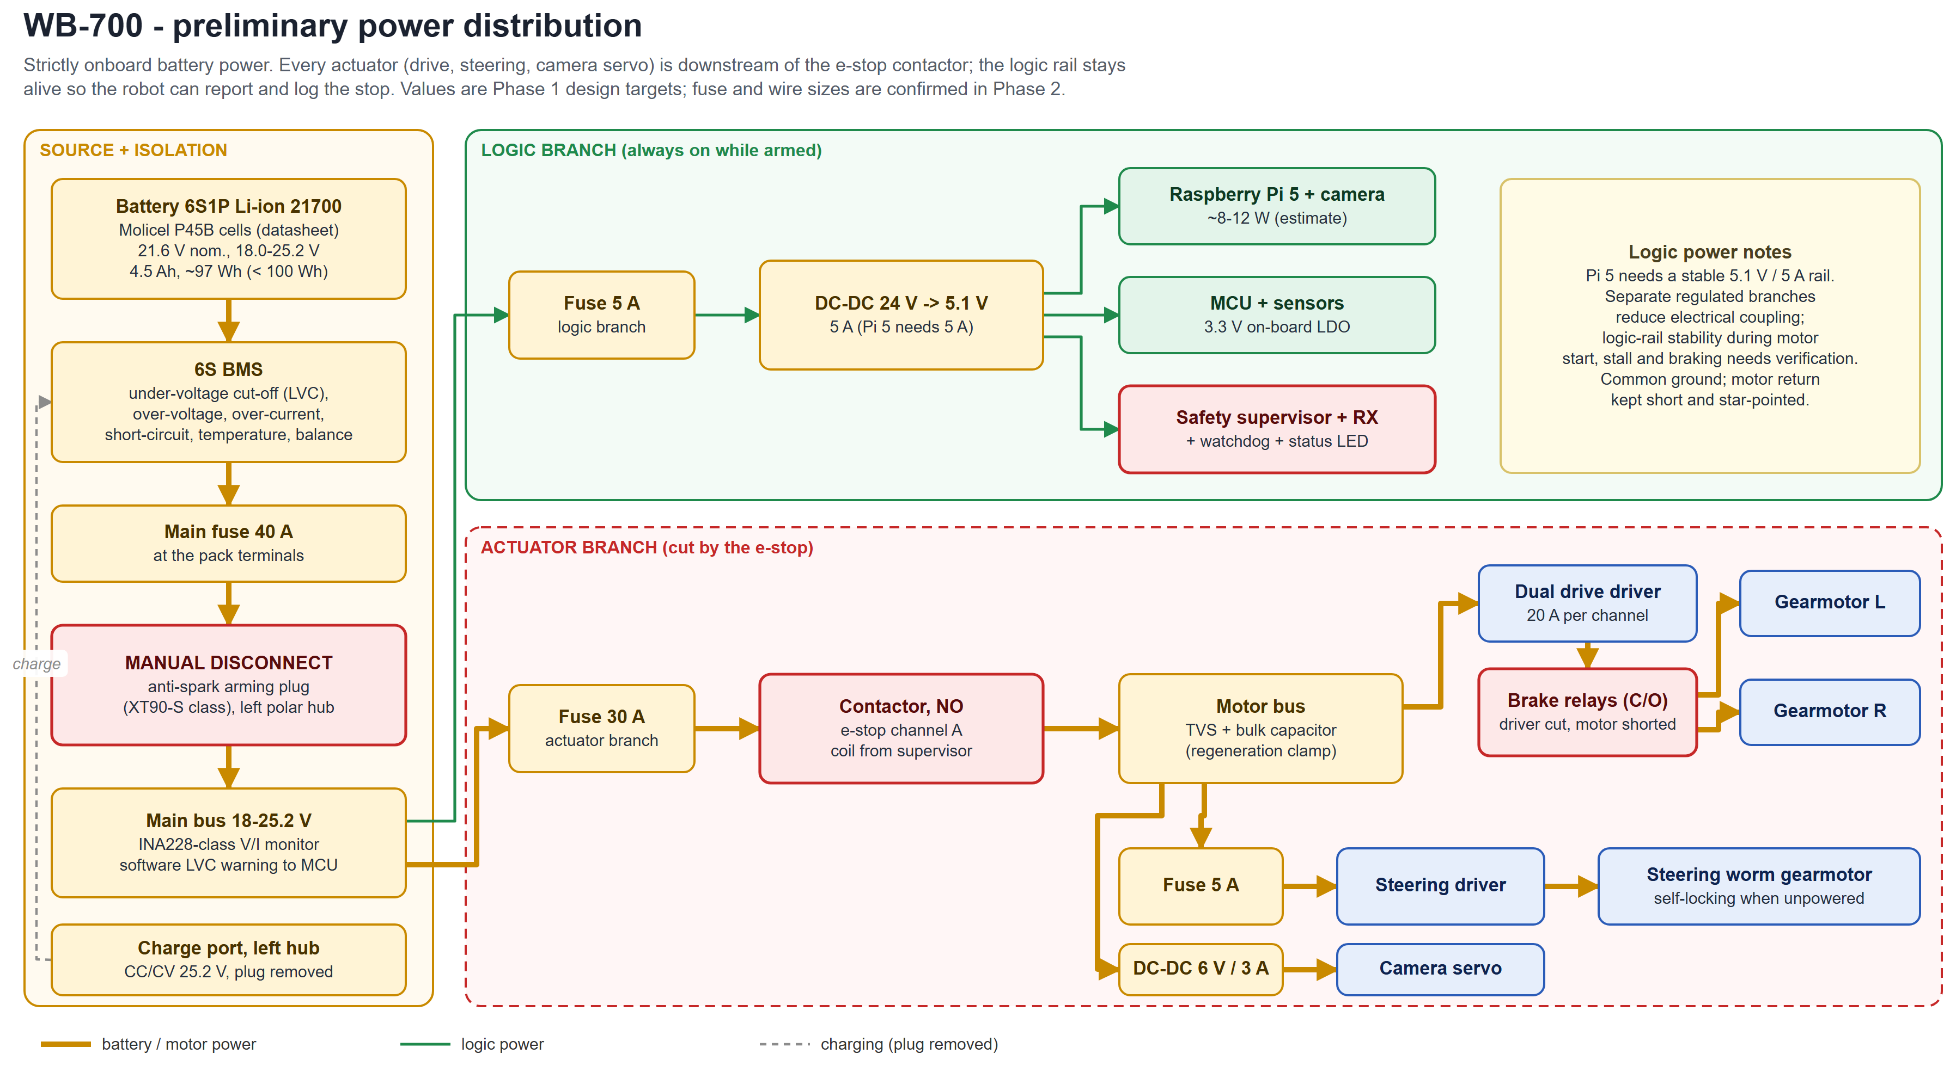
Figure 8 - Power distribution: every actuator is downstream of the e-stop contactor.
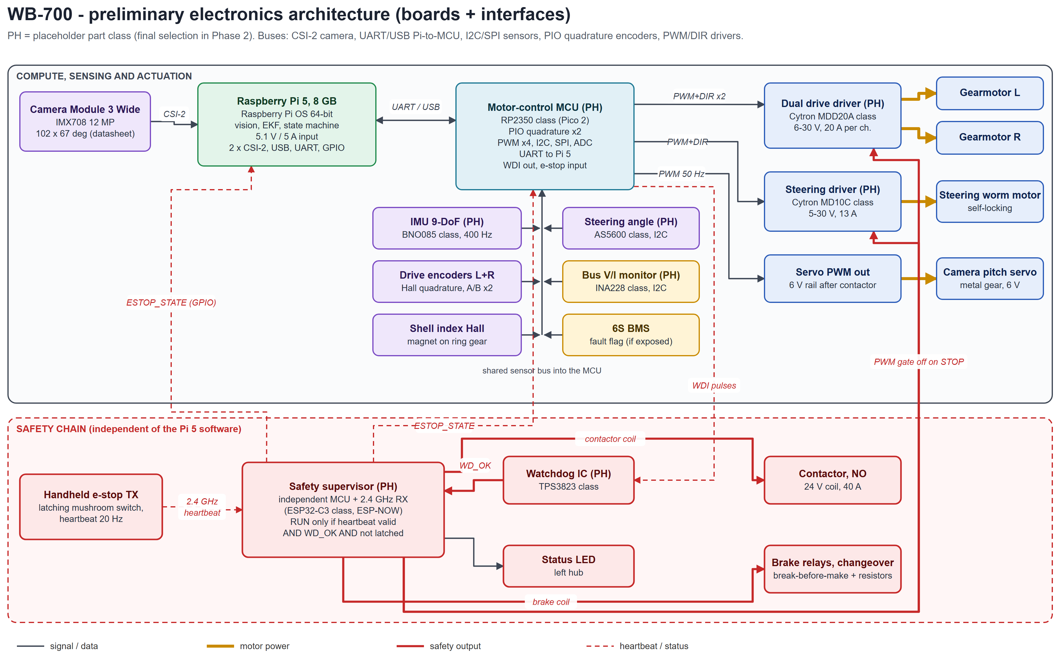
Figure 9 - Microcontroller, sensor interfaces, motor drivers and safety chain (PH = placeholder part class).
- Power Source & BMS:
- Confirmation: Strictly battery-powered: YES. No tether, external power line or remote power feed. Charging uses a hub port between runs, with the arming plug removed.
- Chemistry, Voltage & Capacity: Lithium-ion 21700 (Molicel P45B), 6S1P: 21.6 V nominal (18.0-25.2 V), 4.5 Ah, ≈97 Wh. The pack is kept under 100 Wh for transport.
- Safeguards: the 6S BMS provides cell-level low-voltage cut-off (LVC), over-voltage, over-current, short-circuit and temperature protection, and balancing. There is a 40 A main fuse plus branch fuses (30 A actuators, 5 A logic, 5 A steering). A bus voltage/current monitor lets the MCU make a controlled stop at a software LVC threshold above the BMS cut-off.
- Actuation & Motor Control:
- Motor Specs: drive: 2 × 24 V planetary gearmotors, ≥ 320 rpm no-load, ≥ 2 N m rated (continuous), ≥ 4 N m stall at 24 V; operating point 1.66 N m at 55 rpm. Steering: self-locking worm gearmotor (JGY-370 class), ≥ 30 rpm, ≥ 4 N m. Camera: 6 V metal-gear micro servo. These are target specifications; parts are confirmed in Phase 2.
- Driver Boards: propulsion: Cytron MDD20A class (dual channel, 6-30 V, 20 A continuous / 60 A peak per channel), one channel per drive motor. Steering: Cytron MD10C class (5-30 V, 13 A continuous). Both take PWM/DIR from an RP2350-class motor MCU. The 25.2 V maximum is inside the 30 V rating, and a TVS diode with bulk capacitance clamps regenerative spikes.
- Safety Fail-Safes:
- Wireless Kill-Switch: a handheld transmitter with a latching mushroom button sends a 2.4 GHz heartbeat at 20 Hz. An independent safety supervisor (its own MCU and receiver) allows motion only while valid heartbeats arrive and a hardware watchdog confirms the motor MCU is alive. A STOP press, heartbeat loss (> 250 ms), watchdog trip or supervisor fault does three fail-safe things: (A) opens the normally-open motor-power contactor, removing power from every driver and actuator; (B) gates the PWM inputs of both Cytron drivers to zero through a supervisor-controlled gate with pull-downs, so the drivers cannot command the motors even if the MCU misbehaves (the MDD20A and MD10C have PWM/DIR inputs only, with no enable pin); (C) releases changeover brake relays. Each relay's normally-open side connects a drive motor to its driver and its normally-closed side shorts the motor through a braking resistor. Break-before-make means a motor is never connected to the driver and to the short at the same time. The stop latches until a manual re-arm, and the link carries no driving commands. This stops all motor actuation immediately; it does not stop the sphere instantly. The ball coasts, slowed by rolling resistance and the shorted motors, and on a slope it can still roll. Phase 2 quantifies the stopping distance.
- Manual Disconnect: an anti-spark arming plug (XT90-S class) recessed in the LEFT polar hub. The hub does not rotate and is flush with the sphere, so it can be reached from outside whenever the ball is stationary. Pulling the plug isolates the battery from all loads (Figure 3, left view).

3. Software & Vision-Based Navigation Pipeline
- Software Flowchart: Figure 10 (vision / AI stack and course state machine).
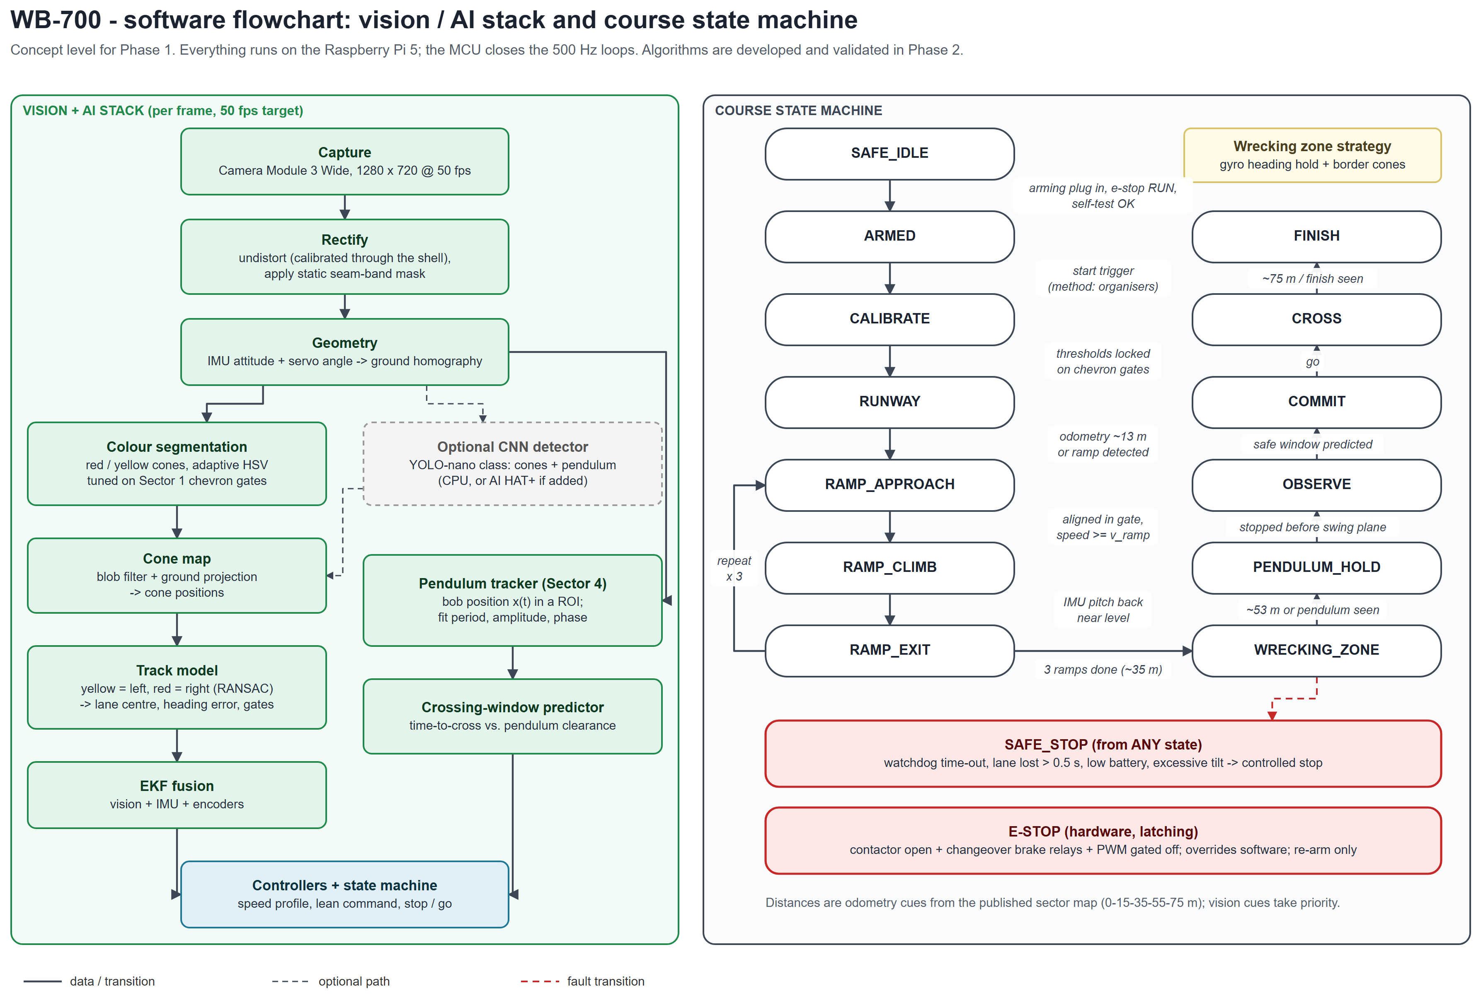
Figure 10 - Vision / AI stack and course state machine (concept; algorithms are validated in Phase 2).
- Primary Vision Processing: a Raspberry Pi Camera Module 3 Wide (102° × 67°) on the stator, at 1280 × 720 and 50 fps, is calibrated through the installed shell. A ray-cast over the CAD shows 0.0 % of the view blocked by internal parts in all 9 checked poses (bob at -30°, 0° and +30°, camera servo at 0°, 12° and 24° down). The stator only pitches about the axle, the same axis the shell turns about, so the clear seam band stays in a fixed image stripe (6.7-7.1 % of the image) that is masked in software. These are CAD sightlines only: image quality through curved, scuffed polycarbonate is untested and is checked in Phases 2 and 3. IMU attitude plus the servo angle give a ground-plane homography. Adaptive HSV segmentation finds yellow (left) and red (right) cones, with thresholds tuned on the Sector 1 chevron gates. RANSAC boundary fits give the lane centre, heading error and gates. An optional lightweight CNN (YOLO-nano class) cross-checks under poor lighting.
- State Estimation & Control: an EKF fuses the vision lane measurements, the IMU (stator pitch, roll and yaw rate) and both drive encoders (shell rotation relative to the stator, plus a once-per-revolution shell index). It estimates distance, lateral offset, heading, speed and pendulum pitch. The MCU closes 500 Hz loops for drive speed with pendulum-pitch damping, the steering-bob angle and camera stabilisation. The Pi 5 runs lane-centring (a lean command) and the sector speed profiles. In the wrecking zone the robot holds heading on the gyro and border cones and keeps its momentum.
- Obstacle Handling Logic (Sector 4): the robot stops at a hold line before the swing plane. On a level floor, holding needs almost no drive torque, so the encoder and IMU loop can keep station. It tracks the pendulum bob in a region of interest over 2-3 swings and fits x(t) = A sin(2πt/T + φ) to get period, amplitude and phase with a confidence estimate. Crossing policy: it commits only if the predicted clear interval is at least t_req = t_delay + t_cross + t_margin, where t_cross is the time for the whole 0.70 m sphere to leave the hold line and clear the swing corridor. With the CAD-based launch acceleration of about 1.44 m/s² (pendulum at 60°), a 0.3 m hold distance, a 0.5 m corridor (assumed; the pendulum size is not yet published) and a 1.5 m/s speed cap, t_cross ≈ 1.5 s. With 0.15 s sensing delay and a 0.5 s margin, it needs a clear window of about 2.2 s. If confidence drops before the commit point, it stays at the hold line and re-tracks for another cycle. After committing it does not stop or reverse inside the corridor, because continuing clears it sooner than backing out. The crossing policy never overrides emergency stop or a detected safety fault; safety shutdown remains active in every operating state.
Supporting material (optional): Phase 1 Technical Design Document, CAD model (STEP) and full-resolution figures at [GOOGLE DRIVE LINK]. All values are CAD-based design estimates or preliminary calculations; no physical testing has been carried out yet.

