**Governing equations for reactive flows**

Zisen Li

2016.01

This is a brief summary of the governing equations used for simulating reactive flows.

1. **Governing equations**

Governing equations are given as follows:

Mass conservation:



Momentun conservation:



Species conservation:



Total internal energy conservation:



In these equations, surface stress tensor, including static pressure, is



Mass diffusion is considered as





Besides, the total energy includes



and the corresponding total enthalpy is



Variances of different kind of energy and their corresponding forms of energy conservation are listed in Table 1 and Table .

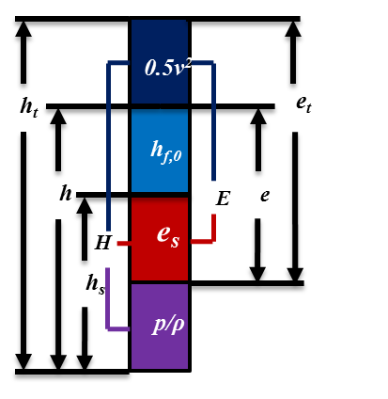

Fig.1 Energy forms based on different definitions

**Table 1 Different energy forms per unit mass**

|  |  |  |
| --- | --- | --- |
| **Energy Forms** | **Energy** | **Enthalpy** |
| sensible |  |  |
| sensible + chemical |  |  |
| total |  |  |
| total – chemical |  |  |

**Table 2 Different energy equation forms**

|  |  |  |  |  |  |  |  |
| --- | --- | --- | --- | --- | --- | --- | --- |
| **#** | **Unsteady term** | **Heat release** | **Heat flux** | **Surface work** | | **Volume work** | **Source term** |
| 1 |  |  |  |  |  |  |  |
| 2 |  |  |  |  |  |  |  |
| 3 |  |  |  |  |  |  |  |
| 4 |  |  |  |  |  |  |  |
| 5 |  |  |  |  |  |  |  |
| 6 |  |  |  |  | + |  |  |
| 7 |  |  |  |  |  |  |  |
| 8 |  |  |  |  | + |  |  |
| 9 |  |  |  |  |  |  |  |
| 10 |  |  |  |  |  |  |  |

In Table 2, heat flux for total energy is ; heat flux for sensible energy is ; heat flux for energy in *Cp* form is (assuming that ***Cp,k*** doesn’t change with position ***x***); heat flux for energy in ***Cv*** form is -. While heat release term in different equations are: , , .