**A summary for solution procedure (laminar DNS/ turbulent flamelet model)**

Zisen Li

2015.07.06

This is a brief summary of the solution procedure implemented for NS equation or more comprehensive reactive flow with turbulence terms.

**I. DNS with detailed chemistry and transportation**

1. **Governing equations**

Governing equations are given as follows:

Mass conservation:



Momentun conservation:



Species conservation:



Total internal energy conservation:



In these equations, surface stress tensor, including static pressure, is



Mass diffusion is considered as





Besides, the total energy includes



and the corresponding total enthalpy is



Variances of different kind of energy and their corresponding forms of energy conservation are listed in Table 1 and Table 2.

**Table 1 Different energy forms per unit mass**

|  |  |  |
| --- | --- | --- |
| **Energy Forms** | **Energy** | **Enthalpy** |
| sensible |  |  |
| sensible + chemical |  |  |
| total |  |  |
| total – chemical |  |  |

**Table 2 Different energy equation forms**

|  |  |  |  |  |  |  |  |
| --- | --- | --- | --- | --- | --- | --- | --- |
| **#** | **Unsteady term** | **Heat release** | **Heat flux** | **Surface work** | | **Volume work** | **Source term** |
| 1 |  |  |  |  |  |  |  |
| 2 |  |  |  |  |  |  |  |
| 3 |  |  |  |  |  |  |  |
| 4 |  |  |  |  |  |  |  |
| 5 |  |  |  |  |  |  |  |
| 6 |  |  |  |  | + |  |  |
| 7 |  |  |  |  |  |  |  |
| 8 |  |  |  |  | + |  |  |
| 9 |  |  |  |  |  |  |  |
| 10 |  |  |  |  |  |  |  |

In Table 2, heat flux for total energy is ; heat flux for sensible energy is ; heat flux for energy in *Cp* form is (assuming that ***Cp,k*** doesn’t change with position ***x***); heat flux for energy in ***Cv*** form is -. While heat release term in different equations are: , , .

It should be noted that, for different situations, different forms of energy equation as well as mass/momentum equations have been adopted with corresponding simplications and modifications. For laminarSMOKE, #10 form of energy equation is used in the code. Next, we focus on the numerical solution procedure and its implementation in OpenFOAM/Cantera.

1. **Numerical solvers**

**2.1 Pimple (PISO-Simple) method [****1****]**

This section gives an introduction to compressible Pimple algorithm, which is a pressure-based combination of PISO and simple method, and was proposed by Peric [1]. Then, the extension of this method to application for turbulent flow with LES and its implementation in OpenFOAM is briefly introduced.

First, the original governing equation with no reaction term or external body force is solved:









i. Guess  at point ***P***.

ii. Predict 



iii. Solve energy equation to predict .

iv. Use mass conservation to correct pressure ***p***.

For compressible flow, and ***p*** is fully coupled. Here, we consider the mass flow rate at surface *e* belongs to a certain control volume.



 and  is the correction we desire for.  should satisfy mass conservation, that is







among which  is approximated by , and we the state equation between  and  is introduced by



here we call  as compressibility, and denote it as . Then we get



 can be obtained from the previous time step () and we solve the above equation to obtain  and . As a result, the corrected  and  are calculated.

**2.1 Pimple for multispecies reactive flow**

In this section, we consider a reacting gas mixture in laminar conditions. The usual conservation equations of mass, momentum, species and energy, assuming Newtonian fluid, are solved [2] (the same equations used in laminarSMOKE).









Solution procedure for multi-species reactive flow is similar to that of single component with no reaction. Here, only the solution diagram for the code in laminarSMOKE is given (not finished).

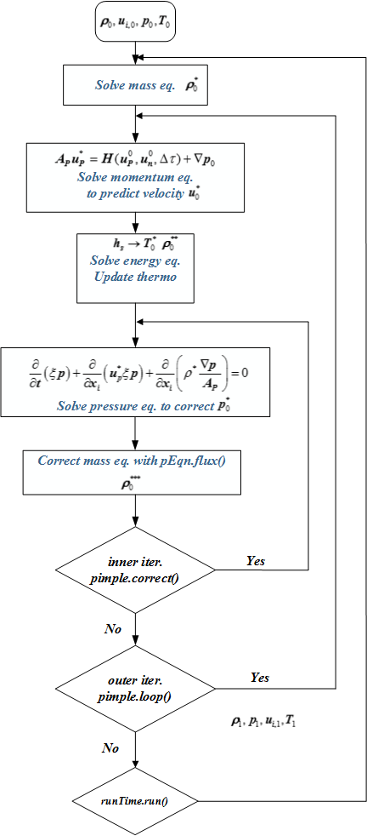

Fig. 1 Flow diagram for numerical solver with Pimple algorithm for flows with single component and no reaction.

**II. Flamelet model**

This section we consider turbulent flow simulated by flamelet model.

1. **Flamelet for RANS**

**3.1 Governing equations**

Mass and momentum conservation are kept same and form #6 energy equation (***hs***) is used. The filtered form of LES and RANS are similar, both for RANS (ensemble) and LES (space) filter. To be specific, for any quantity *φ*(*x,t*), its Favre averaged value is



For RANS



and for LES



For RANS filter equations are

Mass 



Momentum 



Mixture fraction 



Variance of mixture fraction 



Turbulent kinetic energy, 



Disspation rate 



Closure:

1: , 

2: , 

3: , , , , **Reference**

[1] Demirdžić I, Lilek Ž, Perić M. A collocated finite volume method for predicting flows at all speeds. Int J Numer Methods Fluids. 1993;16:1029-50.

[2] Cuoci; A, Alessio F, Tiziano F, Eliseo R. Numerical Modeling of Laminar Flames with Detailed Kinetics Based on the Operator-Splitting Method. Energy & Fuels. 2013;27:7730–53.