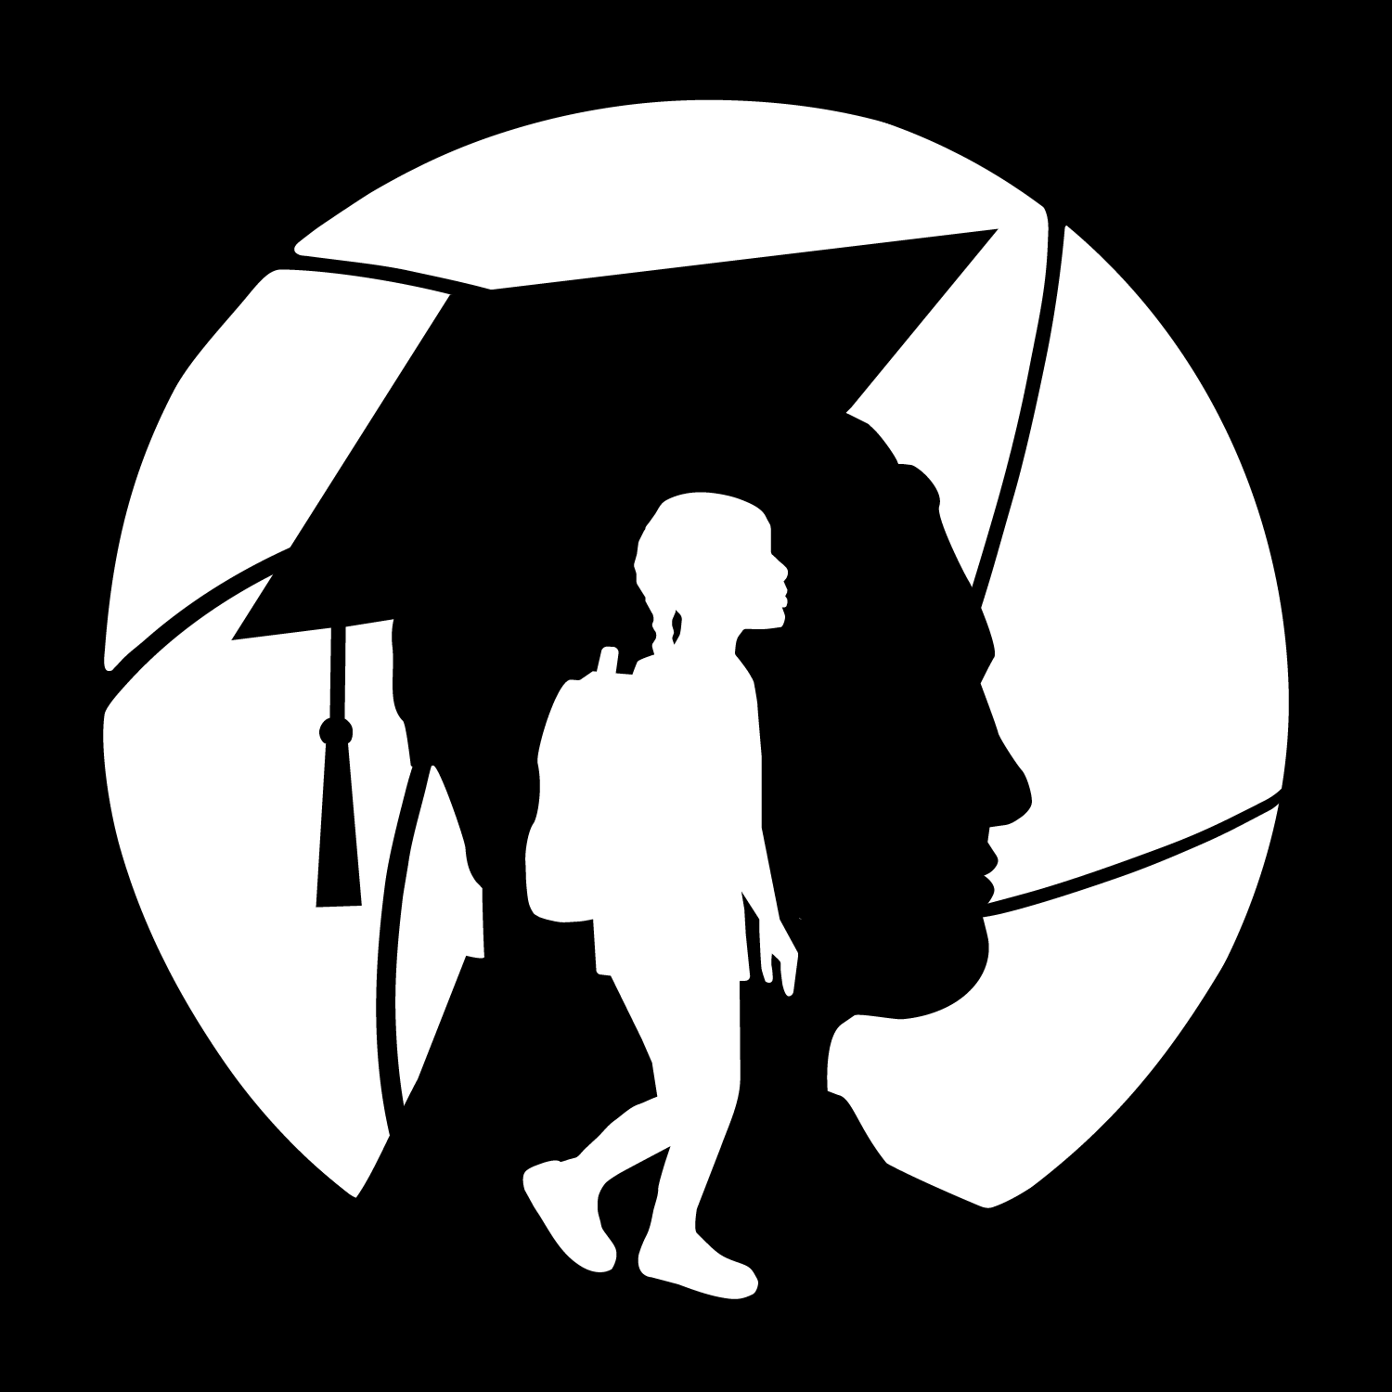
IB Extended Math Syllabus
Mrs. Yan
✉️ yyan@henrico.k12.va.us
📍floating - I’m available for student meetings during AE

Course Overview
Students enrolled in IB Extended Math are assumed to have mastered Geometry and Algebra 2 concepts. IB Extended Math is similar to a precalculus course that develops students’ understanding of number and algebraic,transcendental functions, geometry and intro to calculus . The content of this course serves as appropriate preparation for either the Applications & Interpretations or Analysis & Approach Diploma Program courses. The course also helps students prepare for future course work in any math, science, medical, or engineering field. Technology tools will be used to assist in teaching and learning.
Course Requirements & Supplies
You should use a binder or a folder to keep any handouts organized(quiz or test paper, will check by the end of each marking period), a notebook, a pencil case with pencils, erasers in it, and bring your charged laptop to class each day. Highly recommend your own TI 84.

School-Specific Focus and Goals
IB Courses: As an International Baccalaureate World School, we partner with the IB organization to align our purpose, culture, and environment with its standards—placing student learning at the center of all we do.
IB Mission Statement: The International Baccalaureate® aims to develop inquiring, knowledgeable and caring young people who help to create a better and more peaceful world through intercultural understanding and respect. To this end the organization works with schools, governments and international organizations to develop challenging programs of international education and rigorous assessment. These programs encourage students across the world to become active, compassionate and lifelong learners who understand that other people, with their differences, can also be right.

Class Expectations, Norms, and Academic Integrity
Academic Integrity Policy
J. R. Tucker HS and Henrico County are committed to ensuring that the integrity of all academic programs and community members is not violated. As such, students are expected to conduct themselves in an honorable manner in all academic work. Students suspected of violating this policy shall be addressed in accordance with the provisions of this policy.
This includes:
- Cheating
- Facilitating academic dishonesty
- Plagiarism
- Other forms as listed in the policy such as submitting a blank or wrong digital document
- Use of artificial intelligence

Artificial intelligence (AI): any software or technology that can perform tasks that would normally require human intelligence, such as learning, decision-making, problem-solving, or composition.

Determination of an integrity violation involving AI is ultimately at the discretion of the instructor.

Other things we need to be aware:
- Minor behaviors (knock door, bathroom, find teacher, tardy,etc)
- Seek help when needed.
- Embrace challenges and maintain a growth mindset.
- Participate actively and respectfully in discussions and activities.

Attendance Policy
Students are expected to attend all class meetings.
- Any absence requires an email to the instructor to their Henrico County Public Schools email address from the student’s Henrico County Public Schools email address.
- Use the Absence Action table for any absence.

Absence Action | Expected Absence – appointments, field trips, early release for sports, personal events, etc. | Unexpected absence – illness
Email instructor - | 48 hours before the class meets | Within 24 hours of missing class
What to include | Reason for absence  Length of absence | Reason for absence  Estimated date of return
Student follow up | Check class schedule, syllabus, course announcements and ask classmates for notes | Check class schedule, syllabus, course announcements and ask classmates for notes
If missing a major or minor assessment | Plan to take upon return; arrange with instructor before the absence | Arrange a make-up date with the instructor on the day you return. Must be made up within one week of the original assessment date.

Henrico County Public Schools Secondary Device Policy
To ensure a learning environment free from unnecessary disruptions, cell phones and unauthorized electronic devices are required to be out of visible sight, and silenced, or in airplane mode during the school day, and during instruction-related after-school activities (tutoring, homework help, make-up work, etc.), unless being used for instructional purposes with the teacher’s permission. Unauthorized electronic devices include, but are not limited to, cell phones and smart devices with cellular service or Wi-Fi connectivity.

Coursework and Major Projects

Q1 | Q2 | Q3 | Q4
- Alg II review and enhancement; Family of Functions; | - Number and Algebra | - Law of Sines/Law of Cosines;Geometry | - Intro to calculus

Changes to Syllabus Policy
This schedule of content, assignments, and assessments may vary depending on student progress. Any changes to the syllabus or class schedule timeline will be communicated by Schoology announcement, Parent Square, and verbal announcement. Changes may also be housed in a digital class schedule.

Grading Policy
Grades will be assigned according to the school’s grading scale:
Quarter grades will be based on the following categories:
- Homework: 10%
- Classwork: 20%
- Quizzes: 30%
- Tests/Projects: 40%
The final exam will count as 8% Final Exam/EOC Assessment of the semester two average.

Attendance and Make-up Work
Missed work due to absence or tardiness may be made up when the absence/tardy is
excused. Only work that is missed during an excused absence can be made up for credit.
The responsibility for work missed when a student is absent from school lies with the student. During absences, students are encouraged to consult Schoology for missed work.
Upon return to school, students must contact their teachers for additional make-up work.
Students have the number of days they were absent plus 1 to make up work.

Late Work Policy
Students are expected to submit all assignments on time in the instructor designated format and location.
- Any submission made after the due date and due time or in the wrong format is considered late.
- Students must communicate to the instructor that the assignment will be or is late.
- Each assignment/ assignment type will specify if it can be submitted late for full or partial credit.
- An NTI in the gradebook is the indicator that an assignment will be graded, for full or partial credit, as listed for that assignment/ assignment type.
- A zero in the gradebook is the indicator that an assignment will not be graded or that the timeframe to submit late work has been exceeded.

Examples of behaviors that will result in a late assignment include but are not limited to:
- Arriving to class late
- Leaving class to print and then submit
- Submitting after the due date and time
- Absence from class (expected/unexpected)
- Experiencing problems with the digital submission
- HCPS computer problems

Support to Succeed Policy
The School Board of Henrico County is committed to ensuring the success of all students in grades PK-12. The Board recognizes circumstances may arise that prohibit students from functioning at their highest level. Therefore, Support to Succeed has been created to help students understand the impact of failure and how to correct mistakes.
1. Retest for Success
- Any student in grades 2-12 who earns a D or an F on a test can remediate with the teacher and opt to be reassessed one time per test. The reassessment can be done in a multitude of developmentally appropriate ways as determined by the teacher. Reassessment methods may include, but are not limited to, taking a different test, submitting a project/alternative assignment or a writing sample, conducting a formalized test correction procedure, etc. This re-test procedure does not apply to diagnostic assessments (which are not counted as part of a student grade), semester and/or final exams.
- In grades 10-12, students are responsible for requesting and following through on any reassessment opportunities following a D or an F on an eligible test.
- For all high school credit-bearing courses (in either middle or high school), teachers are responsible for making students and parents/legal guardians aware of the policy at the beginning of the grading period in their course syllabus.
- Henrico County Public Schools Principals will provide an annual notice to students and parents/legal guardians regarding this policy.
- Teachers are expected to offer remediation and a retest within two weeks of the request for a retest. Students requesting a reassessment must do so within one week of receiving the grade. For any student, the highest grade attainable to replace the original test grade is 70%. The test grade used will be the higher of the two scores, not to exceed 70%.
- Teachers have the ability to work with students in other ways to assess and help students to demonstrate mastery of the content.
2. Marking Period Success: Middle and High School
In an effort to keep students from becoming discouraged and succumbing to failure, students who approach the end of the marking period with an overall grade of less than 65% will have the option to raise their marking period grade based on the remediation plan that is established by the teacher. Students transferring within and into HCPS schools and programs mid-course are eligible for this opportunity.
Henrico County Public Schools secondary Principals will provide an annual notice to students and parents/legal guardians regarding this policy. For all high school credit-bearing courses (in either middle or high school), teachers are responsible for making students and parents/legal guardians aware of the policy at the beginning of the grading period in their course syllabus.
In grades 10-12, students are responsible for requesting and following through on potential marking period remediation and adjustments.

Once the student has successfully completed the approved remediation plan, the student will then be eligible to receive a marking period grade which will not be lower than 65%.
There are limits on how many marking periods students may avail themselves of this option, which are as follows:
a. In high school credit-bearing courses in middle or high schools, students successfully completing remediation requirements may raise their course grade to 65% in one marking period per course.
b. In non-high school credit-bearing courses in middle school, students successfully completing remediation requirements may raise their course grade to 65% in up to two marking periods per course.

AI Use on Academic Work
AI can help you learn, but turning in AI-generated work as your own goes against the Honesty and Integrity rules in the Code of Student Conduct. Each teacher decides how much AI you can use, so follow the When Can I Use AI? guide to understand what’s allowed, how to give credit, and the skills you’re using when AI supports your learning.
When Can I - Use AI?
Level | AI Use Level | What it Means | Giving AI Credit | Skills
The default level for all schoolwork is AI 0: No AI Use Allowed.
AI 0  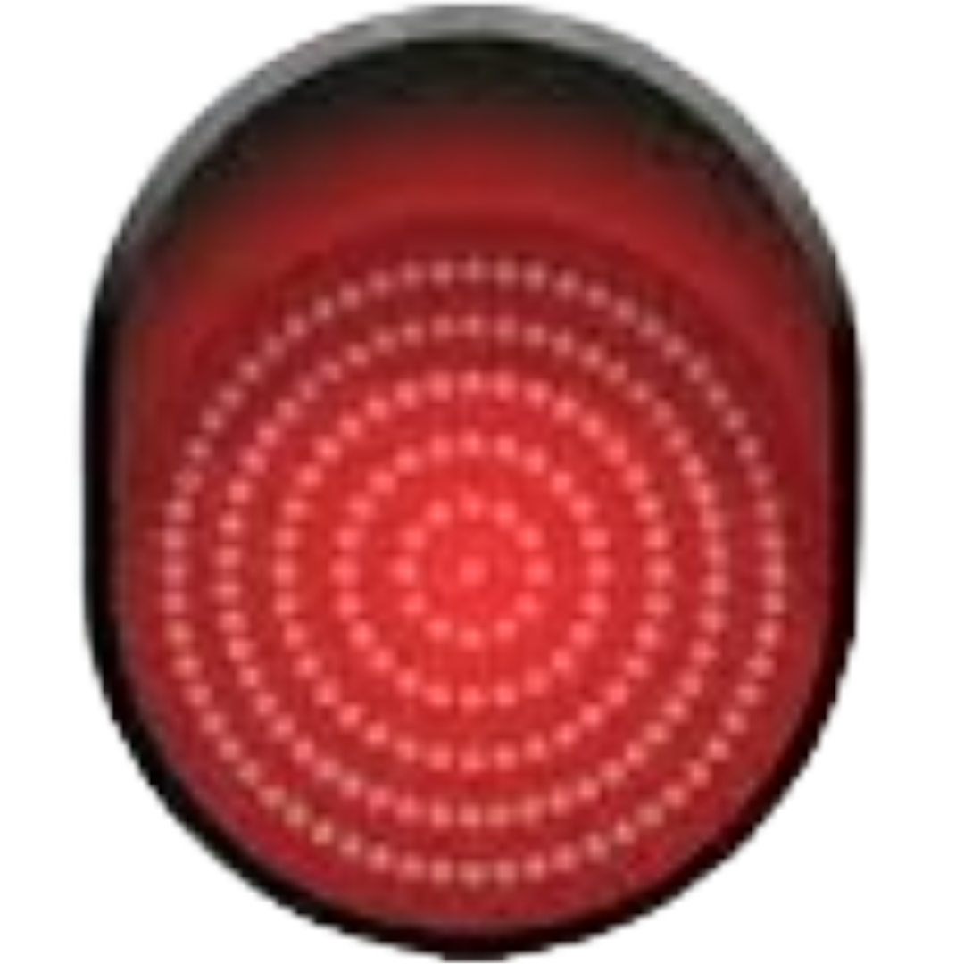 | No AI Use  Allowed | You cannot use AI tools for this work. | Not needed because AI is not used. | Being a responsible digital citizen.
AI 1   | Teacher-Assigned  AI Use Allowed | You can use a specific AI tool chosen by your teacher for a specific task. | Share how you used AI and cite as directed by the teacher. | Learning how to use technology responsibly.
AI 2   | Teacher-Approved  AI Use Allowed | You can choose any approved AI tool from the HDRM list with your teacher’s permission. | Share what approved AI you used, how you used it, and cite as directed by the teacher. | Becoming an independent learner.
Approved AI Tools:
Students should only use AI tools listed on the Henrico Digital Resources Menu (HDRM). Using unapproved AI tools is against the Student Acceptable Use Policy in the Code of Student Conduct.
Citing AI Use:
When your teacher allows you to use approved AI tools you must cite AI-generated content in your academic work. AI sources should be recorded using NoodleTools and formatted as directed by your teacher.

Required Assessments

Testing Procedure
Students are expected to be present and take all major and minor assessments on-time. During assessments:
- Electronics (cell phones, smart watches, etc.) are turned off and turned in to the instructor until all students are finished
- Personal belongings are to be placed in the designated area
- Reading material is under the student desk/chair.
- Talking is prohibited until the last person is finished.
- Bathroom breaks are at the instructor’s discretion until all have finished
- Only 1 test and 1 quiz per semester can be made up in this class
- A make up format may be different from the original format at the instructor’s discretion.
- There are no state mandated assessments for this course (no SOL test).

Acknowledgment Statement:
I have read and understand the expectations outlined in this syllabus. I agree to follow the policies and procedures described.
Student Name (Printed): __________________________
Student Signature: __________________________
Parent/Guardian Name (Printed): __________________________
Parent/Guardian Signature: __________________________
Date: ______________

