MYP – Chemical Foundations
As seems to be the case with most things, the Greeks are credited with first positing: “What is anything made of?” From that original question, chemistry finds its roots. We’re only pretty sure that everything is comprised of atoms, and atoms constitute molecules, molecular compounds, and formula units. There are only 90 naturally occurring elements. It’s 1-92, with Technetium (Tc) and Promethium (Pm) being exceptions. It’s unbelievable that just 90 building blocks can constitute our world—and basically the universe!
Atoms are the foundational building blocks of everything and are identified by their proton count. Each one gets a name called an element. Different ratios of these building blocks have radically different properties. A very easy example is molecules containing hydrogen and oxygen:
- H₂ is an unbelievably combustible molecule with the highest energy density of any molecule.
- O₂ is an excellent oxidizing agent and required for us to breathe.
- H₂O is highly stable liquid—even more stable than H₂ and O₂ in their elemental states.
- H₂O₂ is a somewhat unstable oxidizing agent used as a disinfectant for this characteristic.
Fundamental Definitions/Jargon
I apologize for just talking at you, but it is easiest to throw this information right at you! Using these vocab words correctly is crucial to talking-the-talk of chemistry!
- Molecules are 2 or more atoms held together by chemical bonds (shared electrons).
- Formula units are 2 or more atoms held together by electrostatic interactions (charges).
- Compounds are molecules or formula units that contain more than 1 type of element/atom.
- Ions are atoms/things with charges; you can have monoatomic ions or polyatomic ions!
  - Cations are positively charged.
    - E.g., Ca²⁺ is a cation while NH₄⁺ is a polyatomic cation or molecular cation
    - Things ending in “—ium” are usually positively charged or could become positively charged.
      - Ca²⁺ gets the name “calcium ion” and NH₄⁺ gets the name “ammonium,” to reuse the examples above.
    - Most metals end in “—ium,” because they only form positively charges! Those without that suffix are usually named from Latin (Iron → Ferrum → Fe; Silver → Argentum → Ag, etc.)
  - Anions are negatively charged.
    - E.g., Cl⁻ is an anion while SO₄²⁻ is a polyatomic anion or molecular anion
    - Things that end in “—ide,” “—ate,” or “—ite” are usually negatively charged.
      - Cl⁻ gets the name “chloride” instead of chlorine and SO₄²⁻ gets the name “sulfate” to reuse the examples above.
    - Nonmetals when holding a negative charge get the suffix “—ide”. (Oxygen oxide; bromine bromide; and more)
- Polyatomic elements are those that exist in their natural state as molecules. All elements exist monoatomically (meaning as individualized atoms) except…
  - The diatomic elements, Br₂ I₂ N₂ Cl₂ H₂ O₂ F₂ (abbreviated “BrINClHOF” and called “brinklehoff”)
  - Phosphorus exists as a tetraatomic molecule: P₄
  - Sulfur and Selenium exist as an octaatomic molecule: S₈ and Se_{8’}

A Particulate View of the World
The world is mostly comprised of vibrating, rotating, and/or moving elements, molecules, and compounds. It would not be a bad simplification to view any particle—which is a term we use to encompass any small unit of the world—as a sphere zooming around or vibrating. I think your intuition is good enough to tell you that solids contain mostly vibrational particulate movement, liquids allow for some free movement, and gases are entirely disperse. Let’s diagram the following as little spheres!
Solid | Liquid | Gas
Things exist as solids, liquids, or gases primarily based on three things:
- Intermolecular forces (IMFs), which are the attractive forces between molecules.
  - Chemical bonds hold atoms together, but a water molecule is attracted to other water molecules through IMFs—specifically hydrogen “bonding” (which is not a bond!)
- Pressure, which is defined as the force that something exerts over an area
  - Particles under high pressure are likelier to exist as a liquid or solid, because they are forced closer together and collide more frequently, which allows for a better opportunity for IMFs to form.
- Temperature, which is defined as the average kinetic energy of a sample of particles.
  - You will find that temperature has a massive impact on just about every aspect of chemistry. It is a deciding factor on the state of matter of a compound (as are intermolecular forces and pressure), exponentially increases all reaction rates, changes the states of equilibrium, and more!
  - Hopefully you recall that kinetic energy is equal to $\frac{1}{2}$mv², where m is mass and v is velocity. It’s why speeding I your car is a big deal! Your speed is exponentially related to kinetic energy. Reckless driving at 85 mph in a 70 zone is a 21% increase in speed, which is a 47% increase in kinetic energy! Temperature is just a measure of this speed.
All that I mentioned above was a mediocre overview of Kinetic Molecular Theory. It would not be bad to view almost all particles as magnets moving around, where the magnetic attraction/repulsion is caused by IMFs, the frequency that the magnets collide is caused by pressure, and the speed at which the magnets run into each other is caused by temperature.
Solids are held together by IMFs; gases have had their IMFs completely overcome. Liquids are somewhere in the middle!
Mixtures vs. Pure Substances
- A mixture is a combination of elements, molecules, and/or compounds which are not all chemically bound.
  - Mixtures can be homogenous or heterogenous:
  - Homogenous mixtures have uniform composition (if you took a sample of the mixture from anywhere in the emixture, the samples would be the same; think orange juice or kool-aid)
  - Hetereogenous mixtures are different throughout (think trail mix or bird seed).
- A pure substance may contain many atoms, but they are all chemically bound. Think pure table salt (NaCl) or gluocose (C₆H₁₂O₆) or graphite (elemental carbon).
Thank you for allowing me to ramble. Let’s talk temperature.
Temperature
Let’s talk temperature! There are three scales. The F-Word, Celsius, and Kelvin.
The F-Word (Fahrenheit) is the scale used by the US and very few other places. We will never use it. Don’t say the F-Word in my class. Here’s the conversion if you care, but you will never be presented a problem in ºF.
${}_{ }^{\text{o}}{\text{C}}\text{= }\frac{\text{5}}{\text{9}}\text{(}{}_{ }^{\text{o}}{\text{F}} \text{- }\text{32)}$ and ${}_{ }^{\text{o}}{\text{F}}\text{= }\frac{\text{9}}{\text{5}}{}_{ }^{\text{o}}{\text{C}} \text{+} \text{32}$
Celsius is the scale used by the intelligent parts of the world. It is based around water’s freezing and boiling points, where water freezes at 0 ºC and boils at 100 ºC at atmospheric pressure. Place 100 increments between the two and you’ve got the Celsius scale. It’s great! We’ll use it all year! But, it’s still suboptimal.
Kelvin is the absolute temperature scale! An absolute scale is one which starts at a true zero point. We can have negative temperatures in Celsius—and do every winter—but we cannot have negative Kevlin temperatures, because 0 Kelvin is Absolute Zero, or no particle movement/vibration/rotation whatsoever. It is a theoretical point and is unachievable. Absolute scales do not need “degrees,” because they do not reference arbitrary points.
Kelvin and Celsius are the same scale! A difference of 1 Kelvin is also a difference of 1 ºC! Just offset by 273.15 (we’ll use 273). So our “formula” becomes:
$Celsius=Kelvin-273$ or $Kelvin=Celsius+273$
Get used to converting between them:
Kelvin | 0 |  |  | 300 |  |  | 250
Celsius |  | 0º | 100º |  | 20º | 327º |  | -10º | 25º
We will one day have an entire unit on gases and how their volume and pressure are affected by temperature, but if you’re curious now, it’s completely proportional. Doubling temperature doubles pressure or volume. Halving pressure halves temperature.
$$\frac{{\text{P}}_{\text{1}}{\text{V}}_{\text{1}}}{{\text{T}}_{\text{1}}}\text{=}\frac{{\text{P}}_{\text{2}}{\text{V}}_{\text{2}}}{{\text{T}}_{\text{2}}}$$
Physical vs. Chemical Properties & Changes
Physical Properties are those that depend on simply how much of something you have. Envision a metric or measurement that you could apply to something else entire. Let’s see which examples of physical properties you can come up with on your own! Physical changes are less interesting in a chemistry course.
Examples of Physical Properties | Examples of Physical Changes
Chemical Properties are those that depend on the chemical identity of the species of interest. These are properties unique to the chemical. Chemical reactions can be written for any chemical change.
Examples of Chemical Properties | Examples of Chemical Changes
Units of Measurement
The metric system is called that because it’s about taking measurements. In 1960 an intenational agreement was set up to establish the Système Internationale or SI system. We can measure all sorts of things using SI units! Here’s a table of all the things we could measure—there are more, of course.
Dimension Being Measured | SI Unit | Abbreviation(s)
mass | kilogram
temperature | Kelvin
time | second
amount | mole
length | meter (metre)
volume | liters
electric current | ampere (ampère)
pressure | Pascals
luminous intensity | candela
charge | coulombs
SI Prefixes
The SI system is based around base units of 10, and we use prefixes and abbreviations to change the meaning of our units to make the numbers friendlier. No one wants to say 0.065 L when you could just say 65 mL. Here are the ones I want you to know. You must memorize these.
Prefix | Symbol | Value | Common language | Common Example
Tera | T | 1 x 10¹² | Trillions | TB – Terabyte
Giga | G | 1 x 10⁹ | Billions | GB – Gigabyte
Mega | M | 1 x 10⁶ | Millions | MB – Megabyte
Kilo | k | 1 x 10³ | Thousands | kg - kilogram
Hecto | h | 1 x 10² | Hundreds | hac – hectares
Deca | Da | 1 x 10¹ | Tens | Dam – decameter
Base | - | 1 | Ones
Deci | d | 1 x 10⁻¹ | Tenths | dm – decimeter
Centi | c | 1 x 10⁻² | Hundredths | cm – centimeter
Milli | m | 1 x 10⁻³ | Thousandths | mg – milligram
Micro | μ | 1 x 10⁻⁶ | Millionths | μL – microliter
Nano | n | 1 x 10⁻⁹ | Billionths | nm – nanometer
Pico | p | 1 x 10⁻¹² | Trillionths | pm – picometer
Femto | f | 1 x 10⁻¹⁵ | Quadrillionths | fm – femtometer
Taking a Measurement
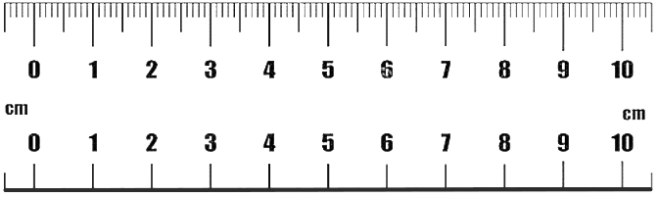
Obviously, one of the bigger parts of any science class is actually doing experiments, where we will need to take measurements. In chemistry, we follow strict rules about how many digits we use when taking measurements. We’ll use a measurement of length as an example with a ruler.
1
2
3

Which ruler would give us better results? How would we read these rulers differently? I hope it’s very clear that the ruler on the top is more powerful than the one on the bottom. We actually get to read a different measurement with each ruler.
To take a measurement, you must estimate 1 decimal place beyond the graduation ticks on your instrument.
All measurements must include units.
The top ruler has graduation lines for the tenths place, which means we must estimate the hundredths place. A reading of line 1 could be “8.80 cm.” You could argue for ± 0.01 cm from that reading, but you certainly can not see a difference between 8.800 and 8.801 cm on the top ruler.
The bottom ruler only has whole-number centimeters. It is less powerful, so the reported measurement must be less powerful. A reading of line 1 could be “8.8 cm.” Again, you could argue ± 0.1 cm, but you certainly can not see a difference between 8.80 and 8.81 cm on the bottom ruler.
 | Line 1 | Line 2 | Line 3
Top ruler
Bottom ruler
It is better analytical lab practice to read your instruments separately as group members rather than having one person read their measurement out loud.
Let’s give it a shot:

If he hasn’t already, someone yell at Mr. Knapik to get some graduated cylinders out so we can practice reading those. Don’t forget to read the meniscus—the bottom of the curve of the water/solution! Write something intelligent about your readings here:
Accuracy vs./& Precision
Accuracy & precision are two different ideas in science. Accuracy is how close your data (set) is to the true or accepted value. Meanwhile, Precision, is how close your data set is to each other. An easy way to visualize it is on targets. Obviously to comment on precision, you need multiple trials to comment on it—accuracy can be commented on for a single data point or by averaging a set of data points!
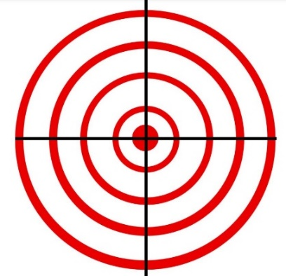  Accurate and Precise | Accurate and Imprecise | Inaccurate and Precise
Tragically still Accurate | Inaccurate and Imprecise | You make one!
Now let’s give it a shot with data sets. This is more representative of what you’ll analyze in a lab setting.
Example: Three groups are determining the density of a sample of silver. The accepted density of silver is 10.50 g/cm³. Which group is the most accurate and which group is the most precise?
Trial | Group 1 | Group 2 | Group 3
1 | 10.54 g cm⁻³ | 9.91 g cm⁻³ | 10.34 g cm⁻³
2 | 10.46 g cm⁻³ | 9.90 g cm⁻³ | 10.51 g cm⁻³
3 | 10.47 g cm⁻³ | 9.92 g cm⁻³ | 10.65 g cm⁻³
Average/Mean
Range
Range is not actually how we would determine precision; it would require us to do something called error propagation, which accounts for the strength of your mass-measuring instrument and your volume-measuring instrument.
Of note:
- Accuracy can only be improved by being better and having better instruments. If you are finding the concentration of an acid and have access to volumetric pipettes (can read 25.00 mL) and choose to use a graduated cylinder instead (can read 25.0 mL), then you’ve chosen a worse instrument. Bad, scientist.
- Precision can only be improved by carefully repeating an experiment. If your data looks like lab group 2, then maybe one of your instruments was miscalibrated or this is a standard component of error of that lab! You did good science—not everyone’s a winner! The tools or procedure let you down.
- Random error can only be reduced by averaging the results of repeated trials.
Percent Yield
Percent yield can be thought of as your “percent correctness.” It is calculable so long as you have an experimental value and an accepted/true value to measure against it. It is impossible to be 100% “correct” in chemistry; things always go a little sideways. This will, quantitatively, present itself as a percent yield below or above 100%.
It is calculated as follows:
$Percent Yield= \frac{Experimental Value}{Theoretical Value}×100\%$ or $Percent Yield= \frac{Measured Value}{Actual Value}×100\%$
If these definitions are confusing to you, here’s the Mr. Knapik way to remember it!
Percent Error
Percent error is calculated very similarly. Percent yield and percent error usually add up to 100%. Percent error kind of tells you how “bad” your data is.
$\text{Percent Error= }\frac{\text{Theoretical - Experimental }}{\text{Theoretical }}$ or $\text{Percent Error= }\frac{\text{Actual- Measured }}{\text{Actual }}$
If these definitions are confusing to you, here’s the Mr. Knapik way to remember it!
Example:
Calculate the percent yield and error for Group 2 on the previous page!  Percent Yield:  Percent Error: | Trial | Group 2
 | 1 | 9.91 g cm⁻³
 | 2 | 9.90 g cm⁻³
 | 3 | 9.92 g cm⁻³
Example:
A bathroom scale indicates that I weigh 160 lbs. The calibrated doctor’s scale says 172 lbs. What is the percent error of the bathroom scale?

Example:
A student uses a ruler to determine a circle has a diameter of 3.9 centimeters. The true diameter is 3.6 centimeters. What is the student’s percent error?

Scientific Notation
Scientific notation is a way to display very large or very small numbers. It’s overwhelmingly common, so using it and being comfortable converting in-and-out of it will be important throughout this course. It always follows the same form: $[Coefficient] × {10}^{Exponent}$
For example, in the value “2.00 x 10⁴”, the coefficient is 2.00, the base is 10, and the exponent is 4. The base will always be 10 for scientific notation, hence the second equation above.
What number does 2.00 x 10⁴ represent, though?
- Well, 10⁴ is equal to 10,000, and 2.00 is just itself.
- 2.00 multiplied by 10,000 is 20,000, so “2.00 x 10⁴ is mathematically equal to 20,000.
We can also represent very small numbers. To do that, we will have a negative exponent instead. Let’s look at 2.00 x 10⁻⁴.
- 10⁻⁴ is equal to 0.0001, and 2.00 is just itself
- 2.00 multiplied by 0.0001 is 0.0002, so “2.00 x 10⁻⁴ is mathematically equal to 0.0002.
Here’s some practice converting between them
Value (Sci. Notation) | Value (Expanded)
1.01 x 10²
 | 11000
8.11 x 10⁻³
 | 0.12
4.99 x 10⁹
 | 444400
Math with Scientific Notation
- Addition/subtraction suuuucks for scientific notation, so we aren’t going to do it. Just use a calculator.
- Multiplication/division is really easy. Simply multiply the two coefficients and multiply the two base-10s (adding the exponents). Stitch them together and make sure the new coefficient is between 1 and 10!
Mental Math with Scientific Notation
Something Mr. Knapik will stress a lot this year is “reality checking” your answers to problems, which means running through some quick mental math to predict your answer before punching it into the calculator. I know your middle school teachers have made you into Desmos fiends, but doing simple multiplication and division in your head is too helpful to ignore. Crash out, kids.
1. | 0.14 * 6.022 x 10²³ | Predicted answer Calculated answer
2. | $$\frac{2.71x{10}^{6}}{3.00x{10}^{-7}}$$
3. | (4.0x10⁴)(5.021x10⁻³)(7.34993x10²)
4. | 0.470 / 0.623
Sig Figs
Significant figures or (less commonly) significant digits help scientists decide how many digits matter when taking measurements and doing calculations. These are the “rounding rules” that some of you all inquired about. The concept can be confusing until you do labwork and lab calculations with sig figs—i.e., I’m sure we’ll have a lab soon.
Tha Rules (better summarized by the Pacific-Altantic Rule)
Condition | Example
Nonzero numbers are always significant | 1
Any zero between significant digits is signficant | 101
All final zeroes to the right of the decimal are signficant | 1.0
Placeholder zeroes are not significant | 0.1
Counted & defined numbers have an infinite number of significant figures. | 13 tables  1000 mL in 1 L
The Pacific-Altantic (P—A) Rule
The Pacific-Altantic Rule always works for counting significant digits. Diagram and explain the rule:
Some practice:
Count the number of sig figs in the following numbers. Use either the P—A rule or “tha rules” to identify them.
Number | Sig Figs | Number | Sig Figs | Number | Sig Figs
100 |  | 100. |  | 1.0 x 10²
404 |  | 0.020 |  | 87.0
83.1 |  | 200.02 |  | 81.00 x 10³
Math with Sig Figs
When we have two measured values and need to manipulate them in some way, we have to respect sig figs. The idea is that our data can only be as good as our worst instrument (the weakest link in the chain). We have to cater to whatever our worst measurement is.
Addition & Subtraction
When adding/subtracting numbers, we go by the least number of decimal places.
- E.g., 0.010 + 1.0 = 1.0 | - E.g., 0.4990 – 0.10 = 0.40
Multiplication & Division
When multiplying/dividing numbers, we go by the least number of signficant digits.
- E.g., 1.0 x 888 = 890 | - E.g., 0.405 / 2.0 = 0.20
You should re-evaluate your significant digits each step of a multi-stage mathematical process!
Sig Fig Practice Break
You should try to do as much of this in your head as possible! Get used to minimal calculator use, or at least get your mental math up to sanity-check your answers!
- 212.2 + 26.7 + 402.09  Answer: | - 1.0028 + 0.221 + 0.10337  Answer:
- 52.331 + 26.01 – 0.9981  Answer: | - 7.255 – 6.8350  Answer:
- 2.01 x 10² + 3.014 x 10³  Predicted answer:  Calculated answer: | - 6.022 x 10²³ x 1.05 x 10²  Predicted answer:  Calculated answer:
$$\frac{\text{2.526}}{\text{3.1}}\text{+} \frac{\text{0.470}}{\text{0.623}}\text{+}\frac{\text{80.705}}{\text{0.4326}}$$  Predicted answer:  Calculated answer: | $$\frac{\text{0.102 ×} \text{0.0821} \text{×} \text{273}}{\text{1.01}}$$  Predicted answer:  Calculated answer:
$$\frac{\text{9.42×}{\text{10}}^{\text{2}}\text{+} \text{8.234×}{\text{10}}^{\text{2}}\text{+} \text{1.625×}{\text{10}}^{\text{3}}}{\text{3}}$$  (3 is exact)  Predicted answer:  Calculated answer: | $$\frac{\text{9.875×}{\text{10}}^{\text{2}} \text{-} \text{9.795×}{\text{10}}^{\text{2}}}{\text{9.875×}{\text{10}}^{\text{2}}}\text{ ×100}$$  (100 is exact)  Predicted answer:  Calculated answer:

Dimensional Analysis (Unit Conversions)
This is perhaps the most important part of this unit. Being able to map out problems like this is going to be vital moving forward. Please, please do whatever it takes to understand this conecptually. My awarding of extra credit is partially based off showing your work, and solving problems later this year will be nearly impossible without these skills.
Subtopic 1: The Basics
The fundamental idea of DA is to convert between units—you may have previously done unit conversions. We can further utilize this in chemistry to solve complex problems by simply analyzing their dimensions (their units), hence the name dimensional analysis. Though it may not appear that way, we are simply “multiplying by 1 but expressed weirdly.” We will begin with everyday examples:
1. Let’s work with dozens!
Problem: convert 156 eggs to dozens. | Work shown:  $$\text{156 }\text{eggs}\text{ × }\frac{\text{1 dozen}}{\text{12 }\text{eggs}}\text{=13.0 dozens}$$
Intuitively, you may know to divide by 12. That will work for some common-language problems. We’d prefer to write it out in this format, with units included when doing chemistry. The unit of “eggs” cancels, leaving us with just dozens.
2. Gross(es) are a dozen dozens! 144 of something!
Problem: convert 20.06 grosses to things | Work shown:  $$\text{20.06 }\text{grosses}\text{ × }\frac{\text{144 things}}{\text{1 }\text{gross}}\text{=2,888 things}$$
Intuition might have been a little harder here, as we don’t often work with grosses. BUT if you’re willing to start with the unit, carry it to the bottom of the next step, and make that step “equal 1,” you just can’t go wrong!

3. Let’s make it weird:
If two Double Stuf Oreos are 140 Calories (yes, really) and one Caesar salad from Walmart is 700 Calories, how many Walmart Caesar salads could Mr. Knapik eat in the place of 1.5 sleeves of Double Stuf Oreos, given a sleeve is 13 cookies?
Important questions to consider when answering this question are:
- Where are we starting?
  - Well, Mr. Knapik is eating a sleeve of Oreos, so we are starting with sleeves of Oreos
- Where are we going?
  - We want to figure out how much salad could replace these Oreos
- How are we going to get there?
  - We can convert sleeves to Oreos, Oreos to Calories, and Calories to salads! We have conversion for all of those!
$$\text{1.5 }\text{sleeves}\text{×}\frac{\text{13 }\text{Oreos}}{\text{1 }\text{sleeve}}\text{×}\frac{\text{140 }\text{Cal}}{\text{2 }\text{Oreos}}\text{×}\frac{\text{1 salad}}{\text{700 }\text{Cal}}\text{=1.95 salads }\text{→ } \text{2 salads}$$
Can you maybe see what Mr. Knapik means by saying each step “equals 1?” There are 13 Oreos in 1 sleeve; there are 140 Cal in 2 Oreos, there is 1 salad in 700 Cal of salad. Who needs intuition!
Subtopic 2: Metric conversions
The metric system is infinitely better than the U.S. (imperial) system. Everything is in base units of 10 besides time—and even part of that is. Doing very standard conversions between metric units with different prefixes is a foundational skill of any chemist, so let’s unlock this part of our skill tree!
- Distance is a good place to begin!
Problem: how many cm are run during a 5k? | Work shown:  $$\text{5 }\text{km}\text{ × }\frac{\text{1,000 }\text{m}}{\text{1 }\text{km}}\text{×}\frac{\text{100 cm}}{\text{1 }\text{m}} \text{=} \text{5×}{\text{10}}^{\text{5}}\text{ cm}$$
If you didn’t know that there were 100,000 cm in one meter, I don’t blame you! It’d take me a second to think about it, too. So, it might be easier to solve problems involving prefix conversions by converting to the “base” unit—the unit without a prefix. In this case, I think it was!
You’re going to hear Mr. Knapik ask “are there a lot of meters in a kilometer or a lot of kilometers in a meter?” when sanity checking the numbers you’ve filled in in each step. You should be asking yourself similar questions, too!
- Masses are up next!
Problem: how many ng are in 5.8 x 10⁻⁴ kg of copper (II) sulfate? | Work shown:  $$\text{5.8×}{\text{10}}^{\text{-4}} \text{kg} \text{×} \frac{\text{1,000 g}}{\text{1 kg}} \text{×} \frac{\text{1×}{\text{10}}^{\text{9}}\text{ ng}}{\text{1 g} } \text{=} \text{5.8 ×}{\text{10}}^{\text{8}}\text{ ng}$$
It genuinely does not matter if you know what copper (II) sulfate is. You could replace it with steel or wood or even get rid of it entirely. We just care about the masses here. We don’t necessarily know how many ng are in a kg, but we know how both of them relate to grams.
Do you see how you could have done that math in your head?
- Let’s make it weird:
Problem: King Gizzard’s: The Silver Cord is a phenomenal 2-disc album. Mr. Knapik wants this to be available on his phone even at the busiest of swim meets, so he downloaded it. Of course, he had to download the uncompressed version for optimal listening. It’s 1.67 GB. How many floppy disks would this require to storge, if a floppy disk could—at best—store 2.88 MB?
We should probably break this down:
- Where are starting?
  - Looks like we’re starting with 1.67 GB
- Where are we going?
  - We want to know how many floppy disks it would take to store 1.67 GB
- How are we getting there?
  - We know each disk stores 2.88 MB, and GB and MB can both be converted with bytes!
$$\text{1.67 GB ×}\frac{\text{1×}{\text{10}}^{\text{9}}\text{ B}}{\text{1 GB}}\text{×}\frac{\text{1 MB}}{\text{1×}{\text{10}}^{\text{6}} \text{B}}\text{×}\frac{\text{1 disk}}{\text{2.88 MB}}\text{=} \text{579.8} \text{→} \text{580. disks!}$$
Though I will never ask you for Imperial unit conversions on an assessment, they are good to know!
 | Length | Mass | Volume
 | 1 m = 1.094 yd | 1 kg = 2.205 lb | 1 L = 0.264 gal
 | 2.54 cm = 1 in | 453.6 g = 1 lb | 1 ft³ = 28.32 L

Mostly Straightforward Dimensional Analysis Practice
Here are some problems ripped straight from my college textbook!
- Perform each of the following conversions.
- 8.43 cm to millimeters | - 2.41 x 10² cm to meters
- 294.5 nm to centimeters | - 1.445 x 10⁴ m to kilometers
- 235.3 m to millimeters | - 903.3 nm to micrometers

- Perform each of the following conversions.
- How many kilograms are in 1 teragram? | - How many nanometers are in 6.50 x 10² terameters?
- How many kilograms are in 25 femtograms? | - How many liters are in 8.0 cubic decimeters?
- How many microliters are in 1 milliliter? | - How many picograms are in 1 microgram?
- Perform the following conversions.
  - Congratulations! You and your spouse are the proud parents of a new baby, born while you are studying in a country that uses the metric system. The nurse has informed you that your baby weighs 3.91 kg and measures 51.4 cm. Convert your baby’s weight to pounds and ounces and her length to inches (rounded to the nearest quarter inch). One kilogram is 2.20 pounds and one cm is 0.394 inches.

  - The circumference of the earth is 25,000 mi at the equator. What is the circumference in kilometers? in meters? One mile is 1.61 km.

  - A rectangular solid measures 1.0 m by 5.6 cm by 2.1 dm. Express its volume in cubic meters, liters (one liter is equivalent to one dm³), cubic inches, and cubic feet.

Subtopic 3: Conversions between units!
Calling this “interdimensional analysis” wouldn’t be wrong, but it would make you look like a nerd. Nothin’ wrong with that!
I think the easiest examples of this would be the concepts of speed and density; these are both called “derived units,” because they require more than one base unit. Speed is a combination of distance and time, which means it can be used to convert between distance and time; density is a combination of mass and volume, which means it can be used to convert between mass and volume.
Problem:  If I am travelling 110 km/h, how many minutes will it take to travel the 2.8 km I have to drive down I-64? | Work shown:  $$\text{2.8 }\text{km}\text{ × }\frac{\text{1 }\text{h}}{\text{110 }\text{km}}\text{× }\frac{\text{60 min}}{\text{1 }\text{h}}\text{ = 1.5 min}$$
We can see that speed is used as a conversion between distance and time here in the same way that 60min/1h is used! Don’t view speed as its own formula (like, speed = distance/time), just view it as a tool in your dimensional analysis toolbox. What dictates whether speed is used as h/km or km/h is based on the step before; we started in km, therefore km needs to be on the bottom.
Problem:  What mass, in grams, does a 15-cm³ sphere of poly(styrene) foam have, given the density of poly(styrene) foam is approximately 0.021 g/cm³? | Work shown:  $$\text{15} {\text{cm}}^{\text{3}}\text{ ×} \frac{\text{0.021 }\text{g}}{\text{1} {\text{cm}}^{\text{3}}}\text{=}{\text{ 0.31}}_{\text{5}}\text{ g}$$
Density is being used just like speed. It’s a conversion factor; do not use density as a formula as you would have in middle school. It’s beneath you.

Subtopic 4: Converting two units simultaneously & squared/cubic units
Just as we’ve been dropping a unit from the numerator of one step to the denominator of the next step, you can swap that. Squared units must be converted twice and cubic units must be converted thrice. Easier to look at it than to talk about it.
Problem:  Convert our speed of 110 km/h to meters per second with a single equation. | Work shown:  $$\frac{\text{110 }\text{km}}{\text{1 }\text{h}}\text{ × }\frac{\text{1000 m}}{\text{1 }\text{km}}\text{× }\frac{\text{1 }\text{h}}{\text{3600 s}}\text{ = }\frac{\text{31 m}}{\text{1 s}}\text{ or 31 m/s}$$

As you can see, we first converted km to m as we normally would. The time conversion happens in the step after; hours is in the denominator in the beginning, so converting out of hours will require it to be in the numerator spot later on. Please do not do this in two separate calculations!
Problem:  Convert 1 dm³ to cm³; note that a dm³ is equal to a L and a cm³ is equal to a mL in volume! | Work shown:  $$\text{1 }{\text{dm}}^{\text{3}}\text{ × }{\left(\frac{\text{10 cm}}{\text{1 dm}}\right)}^{\text{3}}\text{ = 1000 }{\text{cm}}^{\text{3}}$$  or  $$\text{1 }{\text{dm}}^{\text{3}}\text{ × }\frac{\text{10 cm}}{\text{1 dm}}\text{ × }\frac{\text{10 cm}}{\text{1 dm}}\text{ × }\frac{\text{10 cm}}{\text{1 dm}}\text{ = 1000 }{\text{cm}}^{\text{3}}$$
If a unit is cubed or squared, it must be converted multiple times. It might be easy to envision with a cube; each of the distances you’re converting are the length, width, and height separately. I prefer the version with parentheses, but it’s totally your choice. To make life simpler, we use the Liter as a volume unit in the metric system, albeit not in DP Chem.
Less Straightforward Dimensional Analysis Practice
You try! You may need the mini table at the bottom of page 12. There’s a variety of cases.
- The latest model Corvette has an engine with a displacement of 6.20 L. What is the displacement in units of cubic inches?

- Compare the difficulty of these two conversions:
  - Express the density of poly(styrene) foam in units of kg/m³, given its density of 0.021 g/cm³.

  - Express the density of poly(styrene) foam in units of kg/kL, given its density of 0.021 g/cm³.

- The world record for the hundred-meter dash is 9.58 s. What is the corresponding average speed in units of…
- m/s | - km/h
- ft/s | - mi/h
  - At this speed, how long would it take to run 1.00 x 10² yards?

- The contents of one 40. lb bag of topsoil will cover 10. square feet of ground to a depth of 1.0 inch. What number of bags is needed to cover a plot that measures 200. by 300. m to a depth of 4.0 cm?

- A 194-g sample of caffeine (C₈H₁₀N₄O₂) contains 6.02 x 10²³ molecules of caffeine. If a typical 10-hour energy drink contains 422 mg of caffeine, how many molecules of caffeine are present in the drink?

- The density of osmium is reported by one source to be 22,610 kg/m³.
  - What is this density in g/cm³?

  - What is the mass of a block of osmium measuring 10.0 cm x 8.0 cm x 9.0 cm?
Test Practice!
Obviously, dimensional analysis will be a large component of your test; seeing as we just finished it, it is laregly underrepresented in the practice problems below.
- A person with high cholesterol has 250 mg of cholesterol per 100.0 mL of blood. If the total blood volume of the person is 5.4 L, what is the total mass (in grams) of cholesterol present in the person’s blood?

- For each of the following, decide which block is more dense: the orange (left) block, the blue (right) block, or it cannot be determined. Explain you answers.
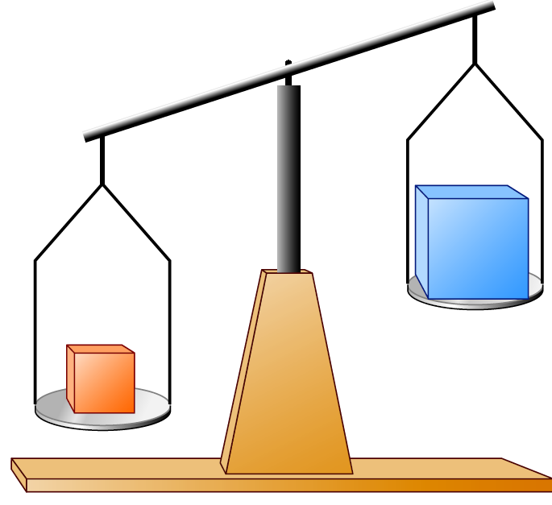 | 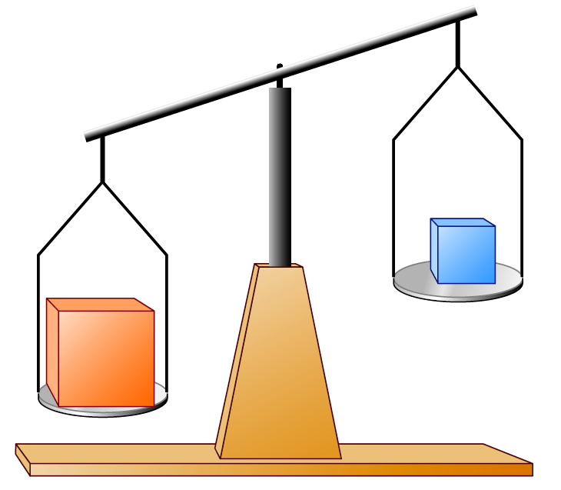
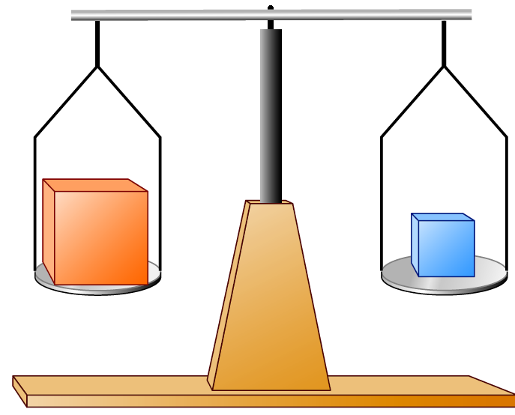 | 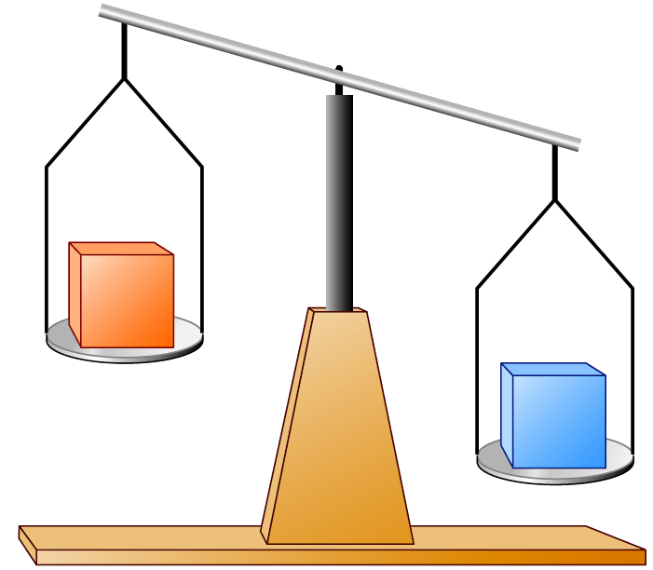

- The radius of a neon atom is 69 pm, and its mass is 3.35 x 10⁻²³ g. What is the density of the atom in grams per cubic centimeter (g/cm³)? Assume the nucleus is a sphere with volume, $\text{V=} \frac{\text{4}}{\text{3}}\text{π}{\text{r}}^{\text{3}}$.

- Which of the following statements is(are) true?
  - A spoonful of sugar is a mixture.
  - Only elements are pure substances.
  - Air is a mixture of gases.
  - Gasoline is a pure substance.
  - Compounds can be broken down only by chemical means.

- Draw a picture showing the markings (graduations) on glassware that would allow you to make each of the following volume measurements of water and name the glassware (the numbers given are as precise as possible).
a. 128.7 mL | b. 18 mL | c. 23.45 mL
- Suppose a teaspoon of magnesium filings and a teaspoon of powdered sulfur are placed together in a metal beaker. Would this constitute a mixture or a pure substance? Suppose the magnesium filings and sulfur are heated so that they react with each other, forming magnesium sulfide. Would this still be a “mixture”? Why or why not?

- Match each description below with the following microscopic pictures. More than one picture may fit each description. A picture may be used more than once or not at all.
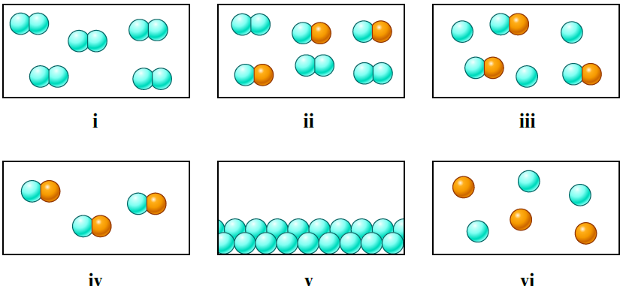
a. a gaseous compound | b. a mixture of two gaseous elements
c. a solid element | d. a mixture of gaseous element and gaseous compound
- The properties of a mixture are typically averages of the properties of its components. The properties of a compound may differ dramatically from the properties of the elements that combine to produce the compound. For each process described below, state whether the material being discussed is most likely a mixture or a compound, and state whether the process is a chemical change or a physical change.
  - An orange liquid is distilled, resulting in the collection of a yellow liquid and a red solid.

  - A colorless, crystalline solid is decomposed, yielding a pale yellow-green gas and a soft, shiny metal.

  - A cup of tea becomes sweeter as sugar is added to it.
- The average daytime temperatures on the earth and Jupiter are 72 ºF and 313 K, respectively. Calculate the difference in temperature, in ºC between these two planets.

- Use the figure below to answer the following questions.
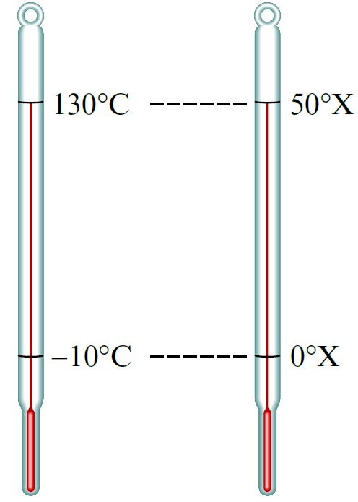 | a. Derive the relationship between ºC and ºX.  b. If the temperature outside is 22.0 ºC, what is the temperature in units of ºX?  c. Convert 58.0 ºX to units of ºC, K, and ºF

- The beakers below have different precisions.
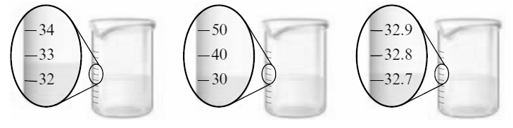
  - Label the amount of water in each of the three beakers to the correct number of significant figures.
First beaker: Second beaker: Third beaker:
  - Is it possible for each of the three beakers to contain the exact same amount of water? If no, why not? If yes, did you report the volumes as the same in part a? Explain.

  - Suppose you pour the water from these three beakers into one container. What should be the volume in the container reported to the correct number of significant figures?

- Is there a difference between a homogenous mixture of hydrogen (H₂) and oxygen (O₂) in a 2 : 1 ratio, and a sample of water vapor? Explain.

MYP Chemical Foundations Notes Coversheet
Std. | Descriptor
CH1.a  CH1.b  CH1.c  CH1.d  CH1.f | The student will demonstrate an understanding of scientific and engineering practices by…  - asking questions and defining problems  - ask questions that arise from careful observation of phenomena, examination of a model or theory, unexpected results, and/or to seek additional information  - determine which questions can be investigated within the scope of the school laboratory or field  - make hypotheses that specify what happens to a dependent variable when an independent variable is manipulated  - generate hypotheses based on research and scientific principles  - planning and carrying out investigations  - plan and conduct observational and experimental investigations; identify variables, constants, and controls where appropriate  - plan and conduct investigations or test design solutions in a safe and ethical manner including considerations of environmental, social, and personal effects  - select and use appropriate tools and technology to collect and record data  - determine appropriate sample size and techniques  - interpreting, analyzing and evaluating data  - construct and interpret data tables showing independent and dependent variables, repeated trials, and means  - use data to build and revise models or to support an explanation for phenomena  - apply mathematical concepts and processes  - analyze data using tools, technologies, and/or models to make valid and reliable scientific claims  - differentiate between accuracy and precision of measurements  - construct, analyze, and interpret graphical displays of data and consider limitations of data analysis  - constructing and critiquing conclusions and explanations  - construct and revise explanations based on valid and reliable evidence obtained from a variety of sources, including models, theories, simulations, peer review, and students’ own investigations  - make quantitative and/or qualitative claims based on data  - apply scientific ideas, principles, and/or evidence to provide an explanation of phenomena  - compare and evaluate competing arguments in light of currently accepted explanations and new scientific evidence  - make and support a claim using empirical evidence and scientific evidence  - evaluate a claim by applying scientific reasoning, theory, and/or models to link evidence to assess the extent to which the reasoning and data support the explanation or conclusion  - differentiate among scientific hypothesis, theory, and law  - obtaining, evaluating, and communicating information  - compare, integrate, and evaluate sources of information presented in different media or form ats to address a scientific question or solve a problem  - gather, read, and evaluate scientific and/or technical information from multiple authoritative sources, assessing the evidence and credibility of each source  - communicate scientific and/or technical information about phenomena in multiple formats

