**Исходные данные:**

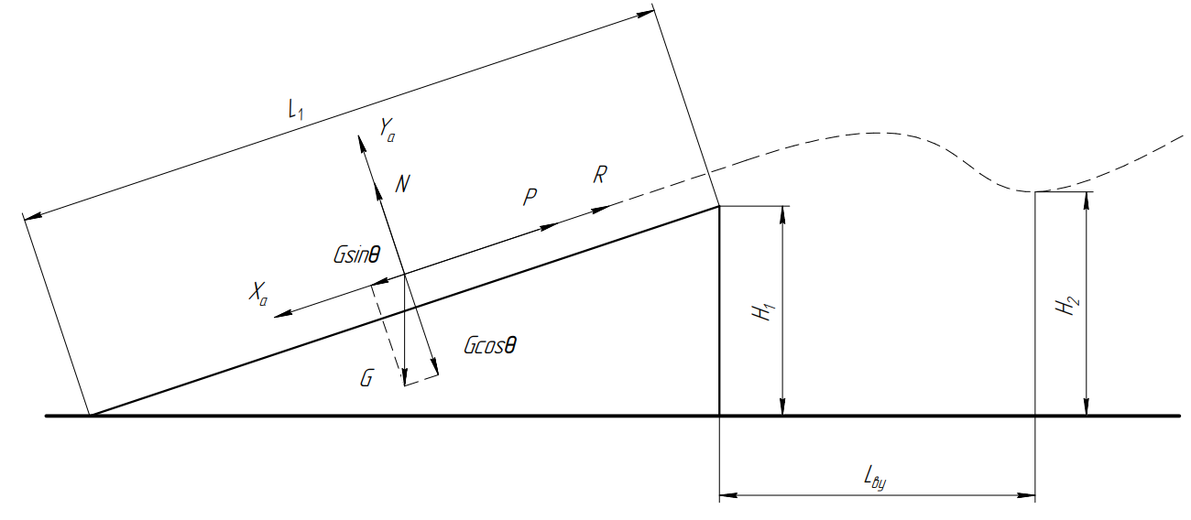

|  |  |  |  |  |  |  |  |  |  |
| --- | --- | --- | --- | --- | --- | --- | --- | --- | --- |
|  |  |  |  |  |  |  |  |  |  |
|  |  |  |  |  |  |  |  |  |  |

|  |  |  |  |  |  |  |  |
| --- | --- | --- | --- | --- | --- | --- | --- |
|  |  |  |  |  |  |  |  |
| 5 | 0.7423 | 0.01071 | 9.62 | 149.64 | 273.63 | 14.85 | 48.85 |
| 6 | 0.832 | 0.01155 | 9.45 | 167.72 | 273.18 | 13.44 | 51.82 |
| 7 | 0.9234 | 0.0124 | 9.28 | 186.14 | 272.63 | 12.34 | 53.96 |
| 8 | 1.0163 | 0.01329 | 9.11 | 204.87 | 272.01 | 11.44 | 55.58 |
| 9 | 1.1099 | 0.01439 | 8.94 | 223.74 | 271.30 | 10.69 | 56.87 |
| 10 | 1.2021 | 0.01576 | 8.77 | 242.33 | 270.51 | 10.05 | 57.93 |
| 11 | 1.2872 | 0.01769 | 8.60 | 259.48 | 269.63 | 9.49 | 58.85 |
| 12 | 1.36 | 0.02034 | 8.43 | 274.16 | 268.68 | 9.01 | 59.69 |
| 13 | 1.4054 | 0.02399 | 8.26 | 283.31 | 267.64 | 8.57 | 60.49 |
| 14 | 1.4279 | 0.02964 | 8.10 | 287.84 | 266.52 | 8.18 | 61.34 |
| 15 | 1.4242 | 0.04001 | 7.93 | 287.10 | 265.32 | 7.83 | 62.46 |
| 16 | 1.373 | 0.06022 | 7.77 | 276.78 | 264.04 | 7.51 | 64.25 |
| 17 | 1.3028 | 0.08512 | 7.60 | 262.63 | 262.68 | 7.21 | 66.43 |

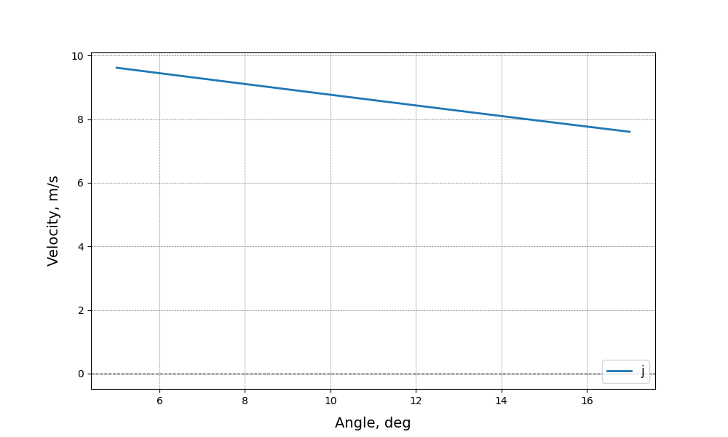

$$j(θ)$$

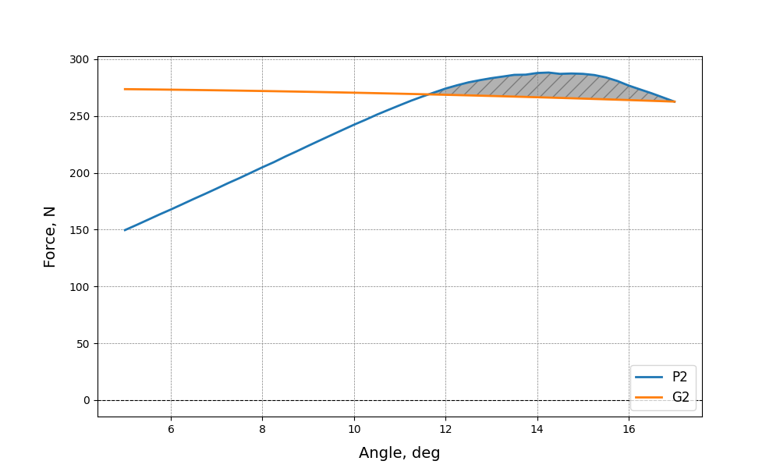

$$P_{2}\left(θ\right), G_{2}(θ)$$

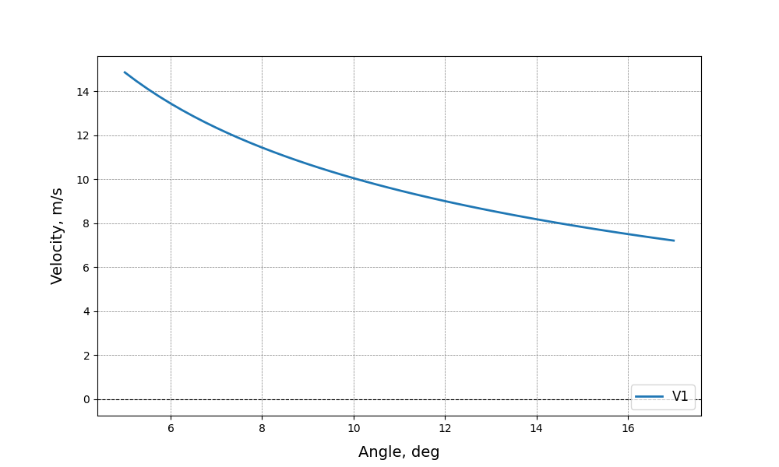

$$V_{1}(θ)$$

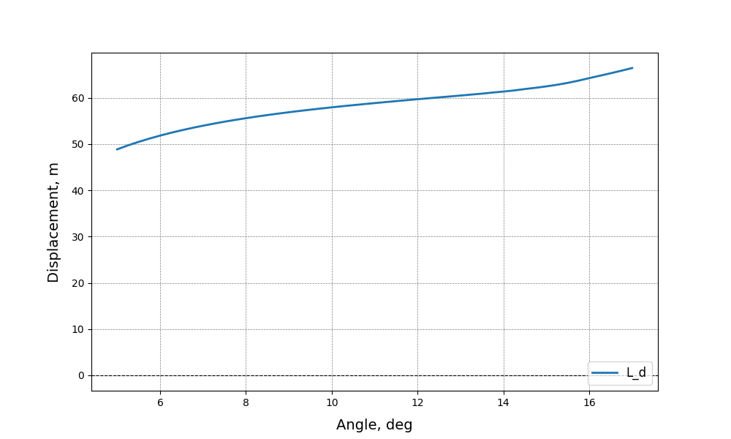

$$L_{ву}(θ)$$